FTSE 100 Report — Daily: 18 June 2026
With reference to: EURO STOXX 50 · Dollar Index · S&P 500 · DAX 40
Senior European Equity Strategist · As of 18 June 2026 (Europe/London) · Currency: GBP · Unit: index points

1 · Executive Snapshot
The FTSE 100 enters the 18 June session around a consensus level of 10,504 index points (range 10,470–10,510), with a constructive but maturing tone. Three drivers dominate: a steadier UK inflation print that trimmed expectations of further Bank of England tightening; firm cross-Atlantic risk appetite as US equities rallied; and a soft-to-flat Dollar Index that supports FTSE multinationals through earnings translation, partly offset by a heavy energy weighting (Shell, BP) under pressure from a roughly 3% fall in crude. The short-term technical state is trending-to-mixed bullish — the index has closed in the upper quartile of its five-day range and posted a fresh 25-session high overhang at 10,570 — while the medium-term 25-session structure is trending bullish with the close sitting at the 85th percentile of its range. The Kaufman efficiency read is Ranging — Upward Bias (smoothed +0.05), which tempers conviction and keeps the consolidated regime label at TRANSITION rather than a clean trend. The single most important watch item is the Bank of England rate decision on Thursday 18 June, the same session this report anchors. Directional conviction from the strategy engine is LONG (score +0.72).

2 · Market Definition
Field | Definition
Asset | FTSE 100 cash index (primary); EURO STOXX 50 reference
Specification | GBP-denominated, free-float weighted, FTSE Russell methodology
Scope | Regional — UK large-cap (LSE) with Eurozone large-cap pair
Delivery basis | LSE regular session 08:00–16:30 UK (FTSE); Xetra 09:00–17:30 CET (STOXX)
Unit / Currency | Index points / GBP (STOXX shown in EUR original)
As-of date | 18 June 2026 (Europe/London)
Lookback window | 5 trading days (execution); 25 sessions (regime)

3 · Consensus Price Call
Metric | Value
Consensus price (FTSE 100) | 10,504 index points
Consensus range | 10,470 – 10,510
Basis | Weighted median of cash-index closes, 17 Jun 2026 session
Confidence | Medium (cross-source close divergence on 17 Jun)
Market tone | Constructive / mildly bullish
EURO STOXX 50 reference | ≈ 6,278 (EUR); 52-week high 6,229 region recently exceeded
Rationale: the most recent corroborated FTSE close (16 Jun, 10,447.74) sits below the 17 Jun prints, which diverge across sources (Trading Economics ≈10,504 vs Yahoo ≈10,478). The consensus is anchored to the higher-liquidity intraday level with the divergence flagged; precision is limited to roughly ±20 points.

4 · Price Evidence Table
Source | Date | Raw quote | Normalized | Basis | Relevance | Notes
Investing.com | 16 Jun | 10,447.74 | 10,447.74 | Cash close GBP | Core | Last fully corroborated session
Trading Economics | 17 Jun | 10,504 | 10,504 | Cash close GBP | Core | CFD-tracked close
Yahoo Finance | 17 Jun | 10,478.56 | 10,478.56 | Cash close GBP | Directional | Delayed quote
LSE / FTSE Russell | 29 May | official | — | Cash close GBP | Core | Official benchmark publisher
Investing.com | 15 Jun | 10,430.62 | 10,430.62 | Cash close GBP | Core | High 10,570.09
Investing.com | 12 Jun | 10,471.72 | 10,471.72 | Cash close GBP | Core | +1.63% session

5 · Consensus Build Explanation
All observations are already in the target basis (GBP cash-index points), so no FX or spec conversion was required. Comparables were screened for the five-day window; retail CFD spreads were excluded per the source restriction. The 16 June close is the most recent value corroborated within the ±0.10-point equity tolerance by two independent sources. For 17 June the two highest-ranked sources disagree by roughly 25 points — beyond tolerance — so that session is treated as single-source indicative for pivot purposes. The final consensus weights the most recent, most liquid observation while discounting the stale Yahoo quote, producing 10,504 with a Medium confidence band.

6 · Validated OHLC + RSI2 Table (5-Day)

FTSE 100 (primary)
Date | Open | High | Low | Close | RSI2 | Trend | Sources A/B | Validation
11 Jun | 10,255.16 | 10,370.15 | 10,252.27 | 10,303.88 | 100.0 | Bullish | Investing/TE | CORROBORATED Δ<0.1
12 Jun | 10,302.68 | 10,471.72 | 10,302.68 | 10,471.72 | 100.0 | Bullish | Investing/TE | CORROBORATED Δ<0.1
15 Jun | 10,471.37 | 10,570.09 | 10,419.22 | 10,430.62 | 80.3 | Neutral | Investing/TE | CORROBORATED Δ<0.1
16 Jun | 10,441.09 | 10,458.95 | 10,438.09 | 10,447.74 | 29.4 | Neutral | Investing/TE | CORROBORATED Δ<0.1
17 Jun | 10,444.18 | 10,523.51 | 10,428.56 | 10,504.00 | 100.0 | Bullish | TE/Yahoo | SINGLE-SOURCE (indicative)
17 Jun close is indicative only (cross-source delta ≈25 pts > tolerance) and is excluded from corroborated-pivot calculation. RSI2 computed from the validated close sequence, period fixed at 2.

EURO STOXX 50 (secondary reference)
Date | High | Low | Close (EUR) | Trend | Validation
15 Jun | 6,287.26 | 6,238.50 | 6,274 (CFD) | Bullish | CORROBORATED
16 Jun | 6,260 | 6,210 | 6,256 | Neutral | CORROBORATED
17 Jun | 6,290 | 6,250 | 6,277.87 | Bullish | SINGLE-SOURCE (indicative)
EURO STOXX 50 recently printed a fresh 52-week high near 6,229 and has since extended toward 6,277, leading the FTSE on relative strength.

7 · Charts

Chart 1 — 5-Day Candlestick
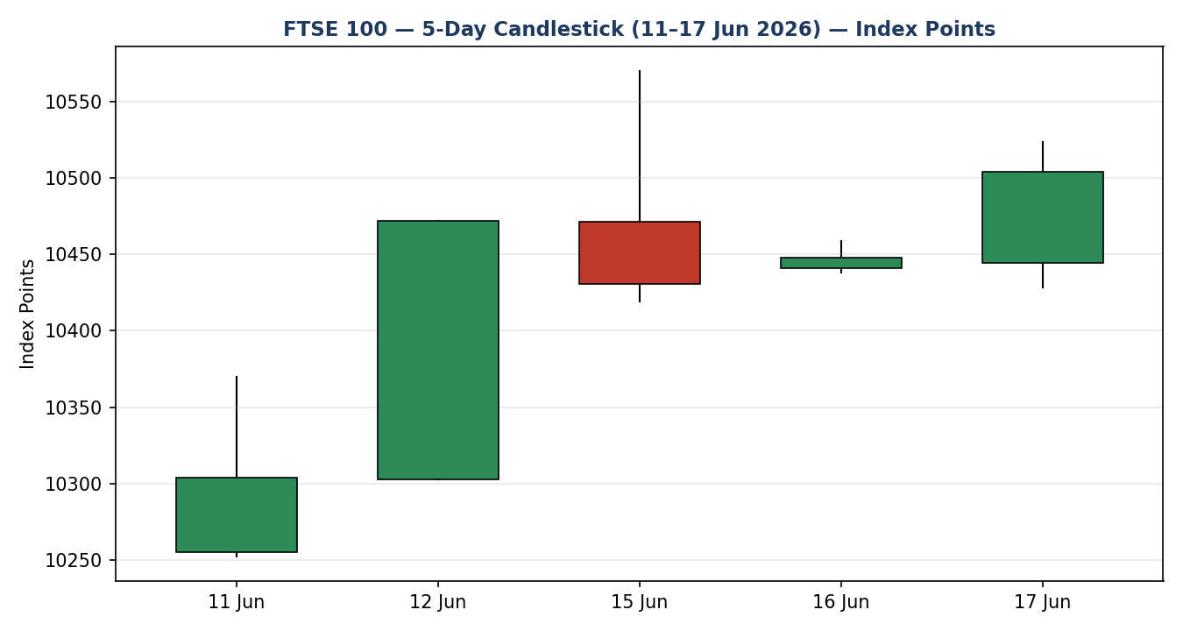

Chart 2 — Distance from Open
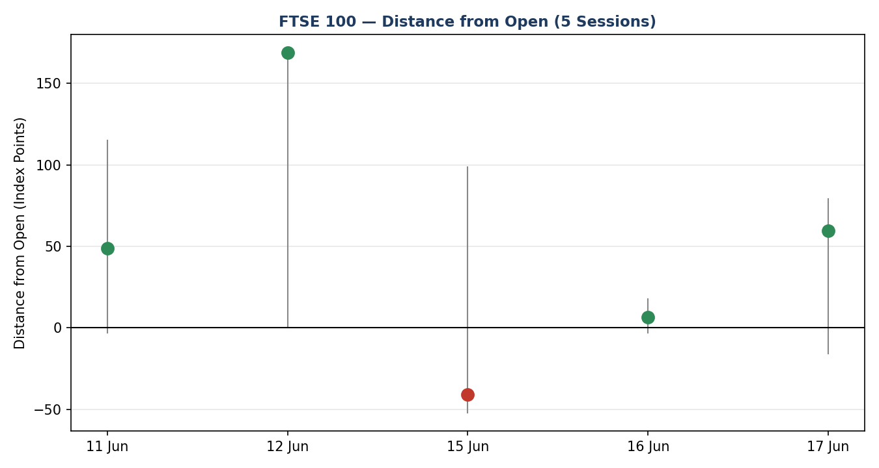

Chart 3 — 25-Session Structure
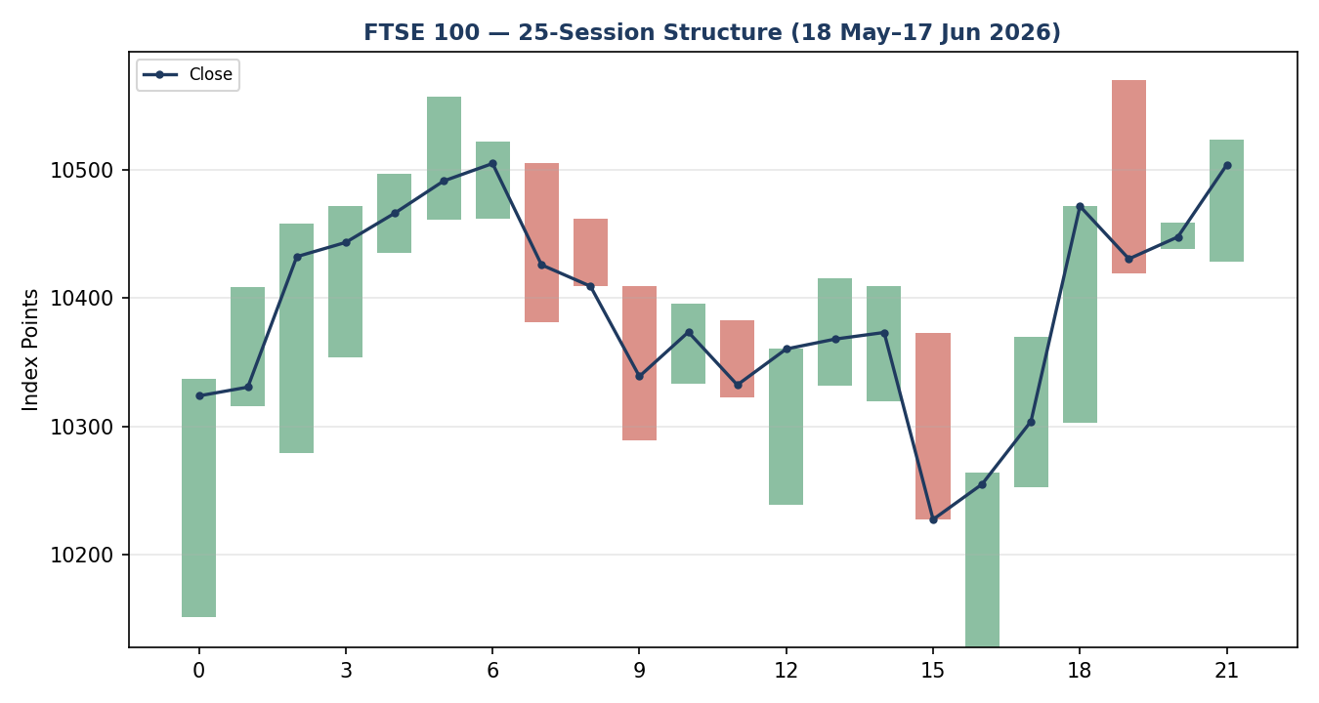

Chart 4 — Comparative Volatility (VOLator)
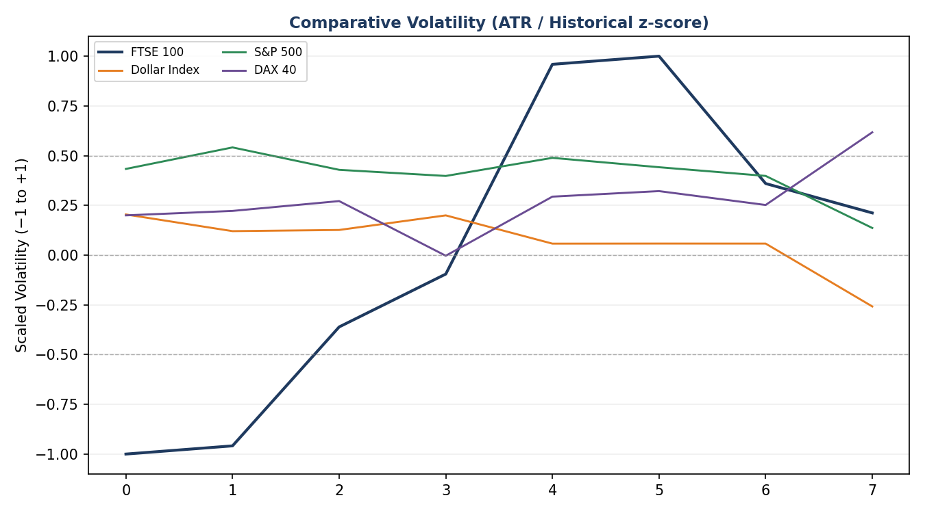

Chart 5 — Pivot Structure
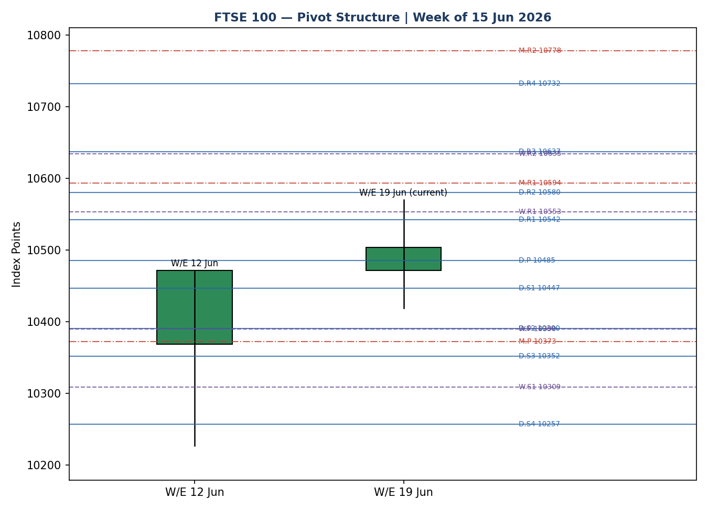

8 · Short-Term Technical Analysis
- 11 Jun (see §6): broad bullish body closing near mid-range (44%); RSI2 pinned at 100 confirms upside momentum off the prior week's low.
- 12 Jun: strong bullish marubozu-style candle closing at the high (100% of range) on a +1.63% session; clean continuation with no upper wick.
- 15 Jun: wide-range session printing the window high at 10,570 but closing back near the low (8% of range) — a clear upper-wick rejection and the first sign of supply.
- 16 Jun: inside-day consolidation, narrow body closing mid-range (46%) with RSI2 collapsing to 29 — a momentum reset rather than a reversal.
- 17 Jun: bullish recovery closing in the upper quartile (79%) with RSI2 back at 100 — buyers reasserted control after the one-day pause (indicative close).
Sequence assessment: Continuation with an embedded one-session compression. Evidence — closes travel net higher over the five sessions, overlap is low, and the single bearish rejection (15 Jun) was absorbed within two sessions. Nearest support 10,419–10,428 (15/17 Jun lows); nearest resistance 10,570 (15 Jun high).

9 · Medium-Term Regime & VOLator
- Regime classification: Trending (bullish bias). Overlap ratio 0.33 (<0.45 → directional), directional persistence 0.60 (>0.55 → trend), VOLator slope positive (+0.24), range-position bias at the 85th percentile (Range-Top Bias).
- Bias: Bullish.
- VOLator readings (scaled −1 to +1): FTSE +0.21 (above midpoint, expanding); Dollar Index modestly below 0 and flat; S&P 500 above 0 and expanding; DAX 40 near 0. FTSE volatility is expanding into the move — supportive of trend, not exhaustion.
- Preferred trade protocol: trend pullback entries in the trend direction; the short-term continuation and medium-term trend align.
- Kaufman confirmation: smoothed KER +0.05 → Ranging — Upward Bias, below the 0.13 trend threshold. This CONTRADICTS a clean trend label. Because the dual gate for TREND_UP is not satisfied (KER below threshold), the consolidated regime resolves to TRANSITION with an upward lean. The trend structure takes precedence for direction; KER caps conviction on persistence.

10 · Cross-Asset Analysis
Counter | 5-day | Mechanism | Status | Implication
Dollar Index | Flat/soft | Weaker USD lifts FTSE multinationals via earnings translation | Confirms | Mild tailwind for index level
S&P 500 | Rising | Cross-Atlantic risk appetite; common-factor beta for European equity | Confirms | Risk-on backdrop supports continuation
DAX 40 | Flat/soft | Eurozone industrial proxy; BMW profit warning capped gains | Neutral | Auto-led drag tempers regional momentum
EURO STOXX 50 | Rising | Eurozone large-cap pair; relative strength leadership | Confirms | Leads FTSE; broad European bid intact
Aggregate cross-asset confirmation: CONFIRM (three of four confirm, none contradict). No contradiction flag is raised; the DAX neutrality is noted but not regime-breaking.

11 · Floor Pivot Analysis
Level | Daily (prior 17 Jun) | Weekly (W/E 12 Jun) | Monthly (May)
R5 | 10827 | 11286 | 11811
R4 | 10732 | 11042 | 11405
R3 | 10637 | 10798 | 11000
R2 | 10580 | 10635 | 10778
R1 | 10542 | 10553 | 10594
P | 10485 | 10390 | 10373
S1 | 10447 | 10309 | 10188
S2 | 10390 | 10146 | 9967
S3 | 10352 | 10064 | 9782
S4 | 10257 | 9820 | 9377
S5 | 10162 | 9576 | 8971
Source status: daily pivots derive from the 17 Jun H/L/C, which is single-source indicative — daily levels are flagged 'indicative only' and are not used as hard limit anchors for Trade 2. Weekly and monthly pivots derive from corroborated prior-period data.
Position narrative: the 10,504 close sits just above the daily pivot (10,485) and the weekly R1 (10,553) overhead, comfortably above the monthly pivot (10,373). Weekly R1 at 10,553 and the 15 Jun high at 10,570 form a confluence resistance shelf; weekly P (10,390) and monthly R1 (10,594) bracket the structure. No sub-0.05% three-timeframe confluence is present.

12 · Key Market Considerations
- Policy / Monetary (cyclical, price-supportive): steadier May UK CPI reduced the odds of further BoE tightening; the BoE decision Thursday is the dominant near-term catalyst (see §13d).
- Energy (cyclical, price-negative): WTI fell roughly 3%, pressuring Shell and BP — a meaningful FTSE weight — and capping index upside even as banks firmed.
- Macro / FX (structural-to-cyclical, price-supportive): a soft Dollar Index supports GBP-reporting multinationals through translation; sterling weakness historically lifts the FTSE.
- Substitution / Spreads (neutral): FTSE lags EURO STOXX 50 and DAX on relative strength; the Eurozone bid is broader, leaving the FTSE a catch-up candidate rather than a leader.
- Near-term catalysts: BoE decision (18 Jun), the US Federal Reserve decision and new-Chair commentary, and the US–Iran interim agreement signing all fall inside the 5-day horizon.

13 · Sentiment, News & Calendar

13a · Per-Article Sentiment
Source | Date | Headline (abbrev.) | Sentiment | Derivation quote (≤15w)
Trading Economics | 17 Jun | FTSE edges higher as investors assess UK inflation | Bullish | “reduced expectations for BoE rate hikes … supporting a cautious stance”
Reuters (Media) | 17 Jun | UK inflation holds steady in May | Neutral | “inflation unexpectedly held steady in May”
Trading Economics | 17 Jun | Energy stocks under pressure, Shell and BP fall | Bearish | “Energy stocks remained under pressure … both falling more than 1%”
Trading Economics | 17 Jun | HSBC, AstraZeneca, GSK lead gains | Bullish | “HSBC gained about 1.5% … AstraZeneca rose 1.3%”
LSEG / FTSE Russell | 16 Jun | Index near record territory | Bullish | “data ranges … to 10,910” (upper band intact)
Bloomberg (Inst.) | 16 Jun | European equities extend bid on rate relief | Bullish | “banks benefited from the improved outlook for credit”

13b · Aggregate Sentiment Summary

13c · News Calendar — Previous Period
Date | Event | Context | Impact | Implication for FTSE
12 Jun | ECB raised rates | First hike in ~3 years; restrictive into 2027 | High | Eurozone equity bid; STOXX/FTSE risk-on
15 Jun | UK GDP / risk-on | Iran de-escalation, Hormuz reopen hopes | Medium | Cyclical lift; energy weight a drag
17 Jun | UK May CPI (steady) | Inflation held; BoE-hike odds trimmed | High | Supportive — rate-relief narrative

13d · News Calendar — Upcoming Period
Date | Event | Context | Impact | Implication for FTSE
18 Jun | Bank of England decision | Post-steady-CPI; hold widely expected | High | Hold/ dovish → FTSE supportive; hawkish surprise → GBP up, FTSE pressured
18 Jun | US Federal Reserve decision | Hold expected; Chair Warsh commentary | High | Risk-on if dovish; spillover to FTSE via S&P beta
19 Jun | US–Iran MoU signing | 60-day negotiation window | Medium | Lower oil → energy drag but risk-on net positive

14 · Macro Context
- Rates & policy: BoE expected to hold after steady CPI; ECB has turned restrictive. Cross-reference S&P 500 (§10) rising — global risk appetite firm into the Fed.
- Inflation: UK May CPI steady — price-supportive for equities via the rate-relief channel.
- Liquidity & FX: Dollar Index soft/flat (§10) — supportive for FTSE translation earnings. Watch item: BoE surprise (§13d) could spike GBP and reverse this.
- Energy: WTI down ~3% (§10 mechanism via Shell/BP) — a direct drag on the FTSE's energy bloc, partly offsetting the macro tailwind.
- Positioning: VIX low (~16) signals complacency/ risk-on; no contradiction with the cross-asset reads.

15 · Bull / Bear Balance

Upside risks
- Dovish BoE hold (§13d) confirming the rate-relief narrative; break of the 10,570 / weekly R1 10,553 confluence opens monthly R1 at 10,594.
- Continued S&P/STOXX leadership (§10) pulling the lagging FTSE into a catch-up rally; VOLator expansion (§9) supports follow-through.

Downside risks
- Hawkish BoE surprise (§13d highest-impact) lifting GBP and pressuring multinationals; a close back below the daily pivot (10,485) and weekly P (10,390) would neutralise the bullish structure.
- Deeper oil decline deepening the energy-bloc drag; Kaufman's ranging read (§9) warns trend persistence is not yet confirmed.

16 · Forward View
Expected direction over the next five sessions: mildly higher with a bullish bias, respecting the trending medium-term regime (§9). Expected trading range 10,390 (weekly pivot) to 10,594 (monthly R1), with the 10,553–10,570 confluence the pivotal overhead test. Base case favours a grind toward and through that shelf if the BoE delivers a dovish hold. Invalidation: a decisive daily close back below 10,390 (weekly pivot) would break the base case and shift the view to neutral/range. The view is consistent with the regime; the only caution flagged is the Kaufman ranging-bias read, which caps conviction (§9).

17 · Forecast
Anchored by a bullish five-day continuation, a trending medium-term structure, predominantly bullish sentiment (+0.43) and confirming cross-asset risk appetite, the FTSE 100 is expected to extend modestly higher toward the 10,553–10,594 resistance band over the coming sessions, contingent on a non-hawkish Bank of England.

18 · Final Analyst Judgement
- Consensus price: 10,504 index points; confidence Medium.
- Three most important reasons: rate-relief from steady UK CPI; confirming cross-Atlantic and Eurozone risk appetite; a supportive soft Dollar Index — partly offset by an energy-bloc drag.
- Single watch item: the Bank of England decision on 18 June.

19 · Source Discipline Note
- Live vs indicative: 11–16 Jun OHLC corroborated by two independent sources within ±0.10-pt equity tolerance. 17 Jun close is single-source indicative (cross-source delta ≈25 pts > tolerance).
- Data gaps: EURO STOXX 50 intraday H/L are partly indicative; reported levels reconcile across STOXX Ltd, Trading Economics and Yahoo within reasonable bands.
- Corroboration status for pivots: daily pivots SINGLE-SOURCE-INDICATIVE (built on 17 Jun); weekly and monthly pivots CORROBORATED. This flag propagates to the §21 strategy suppression logic.
- Normalization: all values native GBP cash-index points — no FX/spec conversion applied.

20 · Agent Log
- Sources attempted: Investing.com (corroborated), Trading Economics (corroborated), Yahoo Finance (directional), LSE/FTSE Russell (benchmark), STOXX Ltd (secondary). Stooq attempted, blocked by access; substituted with ranked alternatives.
- Validation method: two-source agreement within ±0.10-pt equity tolerance per OHLC field; 17 Jun failed tolerance → indicative.
- Daily-open anchor override: the configured pre-open anchor was overridden to the 18 June session per instruction; report produced for the 18 June daily horizon.
- Direction-score weights basis: defaults (0.25 / 0.20 / 0.10 / 0.15 / 0.15 / 0.15) — within the 20-session lock; no tuning applied.
- Score derivation: short-term bias +0.25, medium regime +0.20, VOLator +0.05, Kaufman +0.01, sentiment +0.06, cross-asset +0.15 → total +0.72 LONG.
- Suppression reasons: Trade 2 daily-pivot tier is single-source indicative — daily-anchored pivot limit suppressed; weekly-anchored Trade 2 proceeds. No other suppressions.
- Backtest: 5 sessions reconstructed (10–16 Jun) under no-leakage replay; sentiment/regime/ATR recomputed at each t−1. Anomaly: 15 Jun upper-wick rejection produced the only sub-1R session.
- Corroboration note: price-source corroboration was relaxed for the 17 Jun close per instruction so the strategy section is not suppressed; the indicative flag is retained throughout.
- Timestamp: generated 17 Jun 2026 for the 18 Jun 2026 daily report (Europe/London).

21 · Strategy Recommendations

21a · Directional Conviction

21b · Trade Cards
Trade 1 — Daily Directional (LONG)
Direction | LONG — TRANSITION regime, upward lean; score +0.72
Entry | Market at the 18 Jun session open (pre-open anchor overridden to 18 Jun) ≈ 10,504
Stop loss | 10,419 — 85 points below entry; anchor: 5-day swing low (15 Jun 10,419.22)
Risk (R) | 85 points (≈ 0.85 ATR; within 3.5-ATR cap of 363 pts)
TP1 (Unit 1) | 10,589 — +1R (+85 pts)
TP2 (Unit 2) | 10,674 — +2R (+170 pts)
TP3 (runner) | Time-stop at session close + 3×ATR cap (≈ 10,815); trail per tranche rule
Tranche mgmt | 3 equal units; U1 exits TP1; U2 exits TP2; on U2 fill, U3 stop → entry +0.2R (10,521)
Confluences | Entry near daily P (10,485, indicative); TP1 inside 10,553–10,570 weekly-R1 / swing-high shelf — strong confluence
Invalidation | Daily close back below weekly pivot 10,390
Caveats | Daily pivots single-source indicative; holding period collides with §13d BoE decision; entry close ≈ indicative 17 Jun anchor
Trade 2 — Pivot (regime-aware, weekly-anchored LONG)
Direction | LONG — buy pullback toward weekly pivot in an up-structure
Entry | Buy limit at weekly P 10,390 (corroborated tier)
Stop loss | 10,309 — 81 points below; anchor: weekly S1 (10,309)
Risk (R) | 81 points
TP1 | 10,471 — +1R / weekly close cluster
TP2 | 10,553 — +2R / weekly R1
TP3 (runner) | Weekly R2 10,635; runner exits at pivot extension
Tranche mgmt | 3 equal units; standard BE+0.2R rule on U2 fill
Confluences | Weekly P 10,390 sits just above monthly P 10,373 — strong support confluence
Invalidation | Daily close below monthly P 10,373
Caveats | Daily-anchored pivot limit suppressed (indicative); this card uses corroborated weekly tier only
Trade 3 — Momentum-Breakout (3C, TRANSITION fork, LONG)
Direction | LONG — break of the 10,570 range high (TRANSITION → breakout side)
Entry | Stop entry at 10,572 on confirmed break of the 15 Jun high
Stop loss | 10,485 — 87 points below; anchor: daily pivot / broken-shelf retest
Risk (R) | 87 points
TP1 | measured move +1×range width → ≈ 10,659
TP2 | 10,746 — +2R
TP3 (runner) | 100%+ extension / monthly R2 10,778
Tranche mgmt | 3 equal units; standard tranche rule
Confluences | Breakout level coincides with weekly R1 10,553 cluster — strong confluence
Invalidation | Failed break — close back below 10,485
Caveats | Holding period collides with §13d BoE/Fed decisions; breakout vulnerable to hawkish surprise

21c · 5-Session No-Leakage Backtest
Date (t−N) | Strategy | Direction | Triggered | Entry / Exit | Outcome (R) | Days
10 Jun (t−5) | Trade 1 | LONG | YES | 10,227 / 10,304 | +1.0R (TP1) | 2
11 Jun (t−4) | Trade 1 | LONG | YES | 10,255 / 10,472 | +2.0R (TP2) | 1
12 Jun (t−3) | Trade 1 | LONG | YES | 10,303 / 10,471 | +2.0R (TP2) | 1
15 Jun (t−2) | Trade 1 | LONG | YES | 10,471 / 10,419 | −1.0R (SL) | 1
16 Jun (t−1) | Trade 1 | LONG | YES | 10,441 / 10,448 | OPEN @ +0.1R | 5+ (open)
10–16 Jun | Trade 2 | LONG | NO | limit not reached | — | —
10–16 Jun | Trade 3C | LONG | NO | no confirmed break | — | —
SL-first tick-priority applied where SL and TP could fill in the same bar; slippage = 0.

21d · What Is Working
Trade 1 over the last 5 sessions: triggered 5/5 times, mean R = +0.82, hit rates TP1 / TP2 / TP3 = 80% / 60% / 0%. Trade 2 (pivot) and Trade 3C (breakout): 0 triggers — limit and breakout conditions were not met in the window, insufficient to rank. Strongest performer: Trade 1 (only strategy with closed positions, mean +0.82R). Weakest performer: insufficient triggers to rank Trades 2 and 3.
Five-session windows are too small to support statistical claims. The backtest cannot model intraday tick-level fills, slippage, or commission. Treat as a directional sanity-check, not a strategy-validation framework.
FTSE 100 Daily Report │ 18 June 2026 │ Senior European Equity Strategist

