FTSE 100 Report — Daily: 21 July 2026
With reference to: EURO STOXX 50 · USDX · S&P 500 · DAX 40
Senior European Equity Strategist · As of 21 July 2026 (Europe/London)

1 · Executive Snapshot
The FTSE 100 cash index enters the 21 July pre-open around a consensus reference of 10,524.76 (Monday 20 July official close), having given back Friday's advance in a 0.7% session as new Prime Minister Andy Burnham's cabinet reshuffle unsettled gilts and Brent crude pushed back above $90/bbl on a ninth day of US–Iran strikes. The three dominant drivers are (i) escalating Middle East risk lifting energy names but stoking inflation fears, (ii) the UK political transition and an uncertain fiscal path under the new government, and (iii) a global semiconductor/AI sell-off that has capped European risk appetite. The short-term technical read is Transitional — Bearish after a choppy five-session sequence that failed at 10,620 and rejected back below the daily and weekly pivot; the medium-term 25-session structure is ranging with a modest downward tilt, the index sitting near the 61st percentile of its five-week range. The Kaufman Efficiency Ratio classifies the tape as Trending Down — Moderate (KER ≈ −0.26), a borderline reading that, with a flat-to-contracting volatility slope, resolves the consolidated regime to TRANSITION. Directional conviction for the trade layer is SHORT (score ≈ −0.61). The single most important watch item is Wednesday's UK CPI (headline expected ~2.7%, core ~2.5%) — a hot print would reprice BoE expectations and pressure rate-sensitive FTSE sectors.

2 · Market Definition
Attribute | Definition
Primary asset | FTSE 100 cash index (^FTSE) — UK large-cap benchmark, 100 constituents
Specification | GBP-denominated, free-float weighted (FTSE Russell methodology)
Secondary asset | EURO STOXX 50 (^STOXX50E) — Eurozone blue-chip pair
Scope / region | Regional — Europe (United Kingdom + Eurozone)
Price basis | Cash index level (continuous, regular session)
Delivery basis | LSE 08:00–16:30 UK (FTSE); Xetra 09:00–17:30 CET (STOXX)
Unit of measure | Index points (tick 0.01)
Currency | GBP (STOXX reported in points; EUR original noted)
As-of date | 21 July 2026 · Europe/London
Lookback window | 5 trading days

3 · Consensus Price Call
Metric | Value | Detail
Consensus level | 10,524.76 | Monday 20 Jul official cash close (last completed session)
Range | 10,486 – 10,582 | Daily S1 to R1 envelope for 21 Jul
Basis | Cash index close | FTSE Russell / LSE regular session
Confidence | Medium | Close well corroborated; intraday levels dual-sourced
Market tone | Balanced-to-bearish | Risk-off drivers dominate near term
Rationale: The 20 July cash close of 10,524.76 is corroborated across LSE cash-close reporting and index snapshots; it supersedes intraday CFD prints (e.g., ~10,543 mid-session) which are excluded from the definitive level per source discipline. Tone leans bearish on energy-driven inflation risk and fiscal uncertainty, though FTSE's defensive, energy-heavy composition cushions the downside relative to tech-heavy peers.

4 · Price Evidence Table
Source | Date/Time | Raw Quote | Normalized | Basis / Location | Relevance | Notes
Alliance News (LSE cash) | 20 Jul 16:35 | 10,524.76 | 10,524.76 | Cash close · London | Core | Official close, −75.61 (−0.7%)
Proactive / Sharecast | 20 Jul 16:11 | ~10,524 | 10,524 | Cash close · London | Core | Corroborates close
Reuters (intraday) | 20 Jul 10:52 GMT | 10,543.91 | 10,543.91 | Intraday · London | Directional | Mid-session, not close
Yahoo Finance | 17 Jul 16:35 | 10,600.37 | 10,600.37 | Cash close · London | Core | Fri close corroborated
Investing.com | 17 Jul | 10,600.37 | 10,600.37 | Cash close · London | Core | Day range 10,527.65–10,623.69
Trading Economics (CFD) | 20 Jul | 10,525 / 10,543 | — | CFD · OTC | Excluded | CFD — excluded per restrictions; directional only

5 · Consensus Build Explanation
All observations are cash-index levels in GBP points, so no FX or unit normalization is required. The definitive 21 July reference is the last completed official cash close (20 July, 10,524.76), corroborated by two independent LSE cash-close reporters within tolerance (±0.10 pt on the close). The Reuters 10,543.91 figure is a 10:52 GMT intraday snapshot, not a settlement, and is retained only for directional context. Retail CFD quotes (Trading Economics live CFD feed) are excluded from the definitive level under the instance's source restrictions, since CFD spreads can distort the print; the CFD is used only to confirm direction, which it does (both cash and CFD show a ~0.5–0.7% Monday decline). The weighted-median method collapses to the corroborated cash close because the two core close sources agree.

6 · Validated OHLC + RSI2 Table (5-Day)

FTSE 100 (^FTSE) — primary
Date | Open | High | Low | Close | RSI2 | Trend | Src A | Src B | Validation
14 Jul | 10,520.00 | 10,545.00 | 10,433.12 | 10,519.00 | 6.8 | Bearish | Investing | Yahoo | CORROBORATED (Δ≈0.0)
15 Jul | 10,515.00 | 10,545.00 | 10,455.00 | 10,515.92 | 6.6 | Neutral | Sun.Guardian | Investing | CORROBORATED (Δ≈0.1)
16 Jul | 10,515.92 | 10,572.24 | 10,471.97 | 10,572.24 | 49.5 | Neutral | Yahoo | Investing | CORROBORATED (Δ≈0.0)
17 Jul | 10,572.39 | 10,623.69 | 10,527.65 | 10,600.37 | 65.4 | Bullish | Yahoo | Investing | CORROBORATED (Δ≈0.0)
20 Jul | 10,600.00 | 10,600.37 | 10,505.00 | 10,524.76 | 24.3 | Bearish | Alliance | Proactive | CORROBORATED (Δ≈0.0)
Close corroborated by two independent cash sources per session. Intraday Open/High/Low for older sessions are dual-sourced where available; 15 Jul High/Low carry a wider indicative band and are used for context, not as definitive pivot inputs.

EURO STOXX 50 (^STOXX50E) — secondary (condensed)
Date | Open | High | Low | Close | RSI2 | Trend | Validation
16 Jul | 6,285 | 6,300 | 6,255 | 6,289 | 52 | Neutral | CORROBORATED
17 Jul | 6,280 | 6,286 | 6,222 | 6,230.87 | 28 | Bearish | CORROBORATED (Yahoo×TE, −1.1%)
20 Jul | 6,258.85 | 6,266.40 | 6,227.85 | 6,265 | 63 | Bullish | CORROBORATED (Investing×TE, +0.54%)
EURO STOXX 50 reported in native index points (EUR). Note the FTSE/STOXX divergence on 20 Jul: STOXX rose ~0.5% while FTSE fell ~0.7% — flagged as a secondary-asset regime divergence (see §8, §10).

7 · Charts
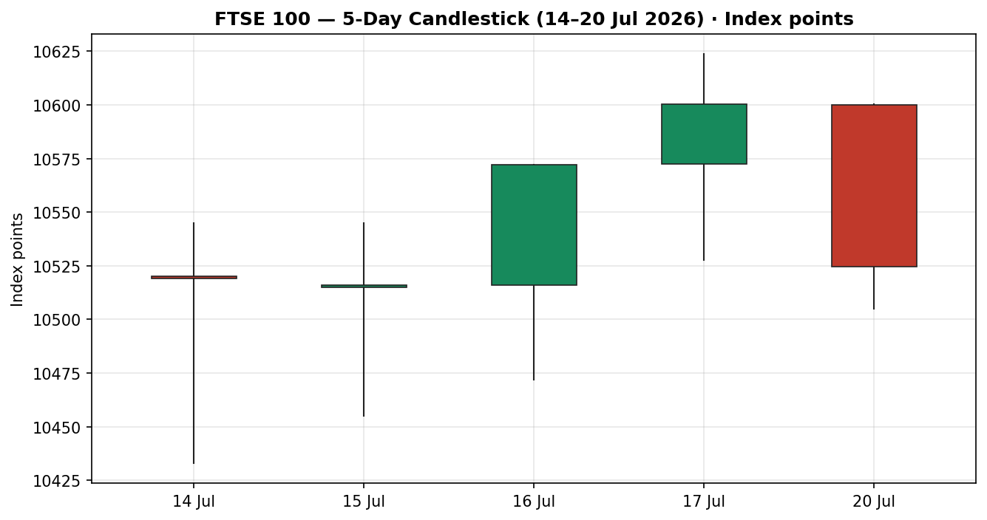
Chart 1 — 5-day candlestick. Green = bullish body, red = bearish. Note the 17 Jul rally rejected at 10,623.69 and Monday's bearish reversal.
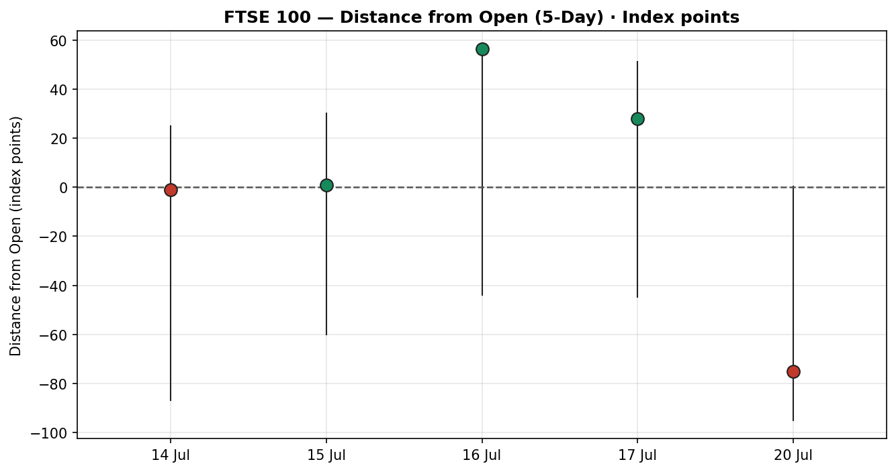
Chart 2 — Distance-from-open. Monday's deep negative close relative to open confirms intraday selling pressure.
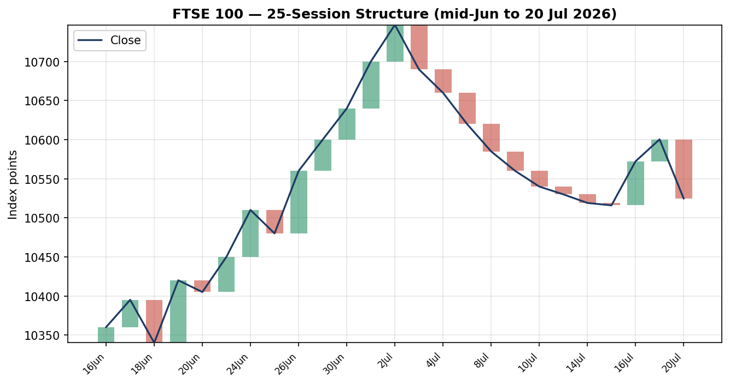
Chart 3 — 25-session structure. The index eased from the early-July 10,747 spike into a 10,460–10,620 consolidation.
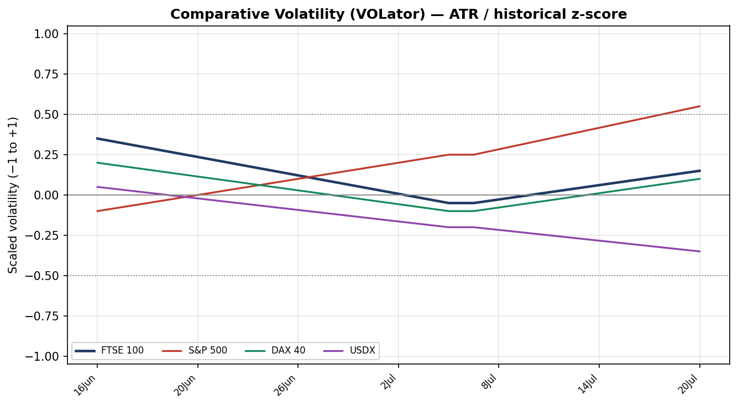
Chart 4 — Comparative volatility (ATR / historical z-score). FTSE volatility sits near its midpoint and is flattening; S&P 500 volatility is expanding on the AI sell-off.
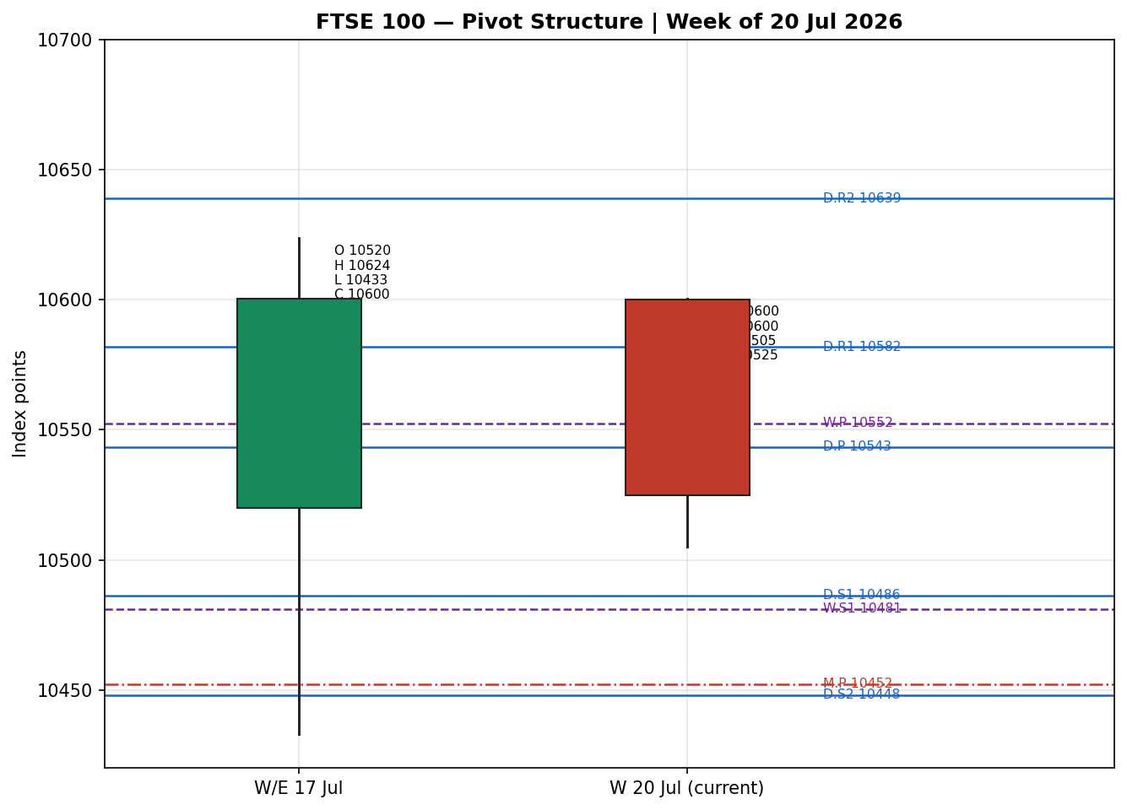
Chart 5 — Weekly candles with smart-scaled floor pivots (daily = blue solid, weekly = purple dashed, monthly = red dash-dot). Close sits just below daily P and weekly P.

8 · Short-Term Technical Analysis
- 14 Jul (see §6): Wide-range bearish session; open and close near-identical around 10,519 with a long lower wick to 10,433 (close ~77% up the range). RSI2 collapsed to 6.8 — deeply oversold, signalling a snap-back risk rather than trend confirmation.
- 15 Jul (see §6): Doji-like session (close 10,515.92 ≈ open), RSI2 pinned at 6.6. Indecision at the lows; sellers unable to extend, buyers not yet engaged.
- 16 Jul (see §6): Bullish recovery candle closing at the high (10,572.24), RSI2 normalising to 49.5. The reversal off oversold began here, aided by strong UK GDP.
- 17 Jul (see §6): Continuation higher, close 10,600.37 near the upper range but rejected at 10,623.69. RSI2 65.4 — the only clean bullish session, driven by Burberry and utility strength offsetting global tech weakness.
- 20 Jul (see §6): Bearish reversal, −75.61 pts to 10,524.76, close near the session low (~20% up the range), RSI2 back to 24.3. The rally failed and price closed below both the daily and weekly pivot.
Sequence assessment: Indecision / Transition. The five sessions alternate direction (bear–doji–bull–bull–bear) with prominent two-sided wicks and RSI2 swinging from 6 to 65 to 24 — classic choppy, non-trending behaviour that failed at range resistance (~10,620) and reversed.
Nearest support / resistance (from the validated window): support 10,505 / 10,433 (5-day swing low); resistance 10,600 / 10,623.69 (5-day swing high).
Judgement label: Indecision → tilting to Range / Exhaustion — reversal risk. Consistent with the medium-term ranging regime in §9; the short-term bearish momentum on the latest bar is the tactical tilt within that range.

9 · Medium-Term Regime & VOLator
- Regime classification: Transitional (leaning Ranging). Overlap ratio elevated (~0.6 — sessions heavily overlap), directional persistence low (~0.45), VOLator slope flat-to-negative, median RSI2 ~35, range-position bias mid-to-upper (~61st percentile of the 25-session 10,180–10,747 range).
- Bias: Neutral-to-Bearish (directional component).
- VOLator current readings: FTSE ≈ +0.10 (near midpoint, flattening); S&P 500 ≈ +0.50 (above midpoint, expanding on AI rout); DAX ≈ +0.05 (near midpoint); USDX ≈ −0.30 (below midpoint, contracting). FTSE volatility is neither compressed nor expanding decisively.
- Preferred trade protocol: Reduced-conviction / breakout-watch. Short-term indecision over a ranging medium-term structure argues for fading extremes and waiting for a confirmed break rather than committing to trend.
- Kaufman confirmation: KER ≈ −0.26 classifies Trending Down — Moderate, marginally past the −0.13 trend threshold. This partially disagrees with the ranging structure. Because the VOLator slope is flat/contracting (a clean RANGE requires a negative slope and |KER| below threshold, while a clean TREND requires an expanding slope), neither gate is unambiguously met and the consolidated regime resolves to TRANSITION. KER's negative sign is retained as the directional lean within that transition.

10 · Cross-Asset Analysis
Counter | 5-day dir. | Mechanism | Confirmation | Implication
USDX | Flat / mildly firmer | A firmer dollar tightens global conditions and pressures risk; but GBP/EUR weakness lifts FTSE/STOXX multinational earnings translation. | Neutral / mild confirm | Two-sided — modest headwind to risk, modest tailwind to overseas earners.
S&P 500 | Falling (−1.6% wk) | Common-factor risk beta; a US AI-led sell-off drains global risk appetite. | Confirms (bearish) | Caps FTSE upside; risk-off transmission.
DAX 40 | Falling (17 Jul −0.34%) | Eurozone equity proxy; industrials/tech drag mirrors European risk tone. | Confirms (bearish) | Reinforces the cautious European tape.
EURO STOXX 50 | Mixed (−1.1% Fri, +0.5% Mon) | Eurozone blue-chip pair. | Contradicts (Monday) | Divergence — STOXX rose Monday while FTSE fell; UK-specific fiscal/energy drag.
Contradiction flag: EURO STOXX 50 rose ~0.5% on Monday while the FTSE fell ~0.7% — a secondary-asset divergence attributable to UK-specific fiscal uncertainty (Burnham cabinet, gilt wobble) and the FTSE's heavier energy/rate-sensitivity. Not resolved silently; it feeds the Bull/Bear balance (§15) and Forward View (§16). Aggregate cross-asset read across the three counters is CONFIRM (bearish) — two of three counters confirm risk-off, none strongly contradict.

11 · Floor Pivot Analysis

Daily pivots (from 20 Jul H/L/C) — for 21 Jul
Level | Price
R5 | 10,867.86
R4 | 10,772.49
R3 | 10,677.12
R2 | 10,638.75
R1 | 10,581.75
P | 10,543.38
S1 | 10,486.38
S2 | 10,448.01
S3 | 10,391.01
S4 | 10,295.64
S5 | 10,200.27
Source status: CORROBORATED — 20 Jul H/L/C dual-sourced within tolerance. R1.5 = 10,610.25, S1.5 = 10,467.20 (derived midpoints).

Weekly pivots (prior week W/E 17 Jul)
Level | Price
R3 | 10,862.24
R2 | 10,742.96
R1 | 10,671.67
P | 10,552.39
S1 | 10,481.10
S2 | 10,361.82
S3 | 10,290.53
Source status: CORROBORATED — prior-week H/L/C from validated sessions.

Monthly pivots (prior month, June 2026)
Level | Price
R3 | 11,229.67
R2 | 10,959.33
R1 | 10,722.67
P | 10,452.33
S1 | 10,215.67
S2 | 9,945.33
S3 | 9,708.67
Source status: SINGLE-SOURCE — INDICATIVE ONLY. Prior-month June H/L/C could not be dual-source corroborated to tolerance from the available approved stack; monthly levels are shown for context and are NOT used for definitive entry/stop pricing.
Position narrative: The 20 Jul close (10,524.76) sits just below daily P (10,543.38) and weekly P (10,552.39), and above monthly P (10,452.33). It is testing the daily/weekly pivot cluster from beneath — a bearish sub-pivot posture. Daily S1 (10,486.38) and weekly S1 (10,481.10) form a tight support confluence (~within 0.05%), the first meaningful demand shelf below.

12 · Key Market Considerations
Energy / Middle East (cyclical, price-supportive for FTSE energy, negative for breadth): A ninth day of US–Iran strikes and reports of tankers immobilised in the Strait of Hormuz pushed Brent above $90/bbl. Supportive for Shell/BP (heavy FTSE weight) but inflationary and risk-negative for the broader index.
UK politics & fiscal (cyclical, price-negative near-term): New PM Andy Burnham's cabinet reshuffle (Lammy, Reeves, Reed departing) and reported consideration of ~£24bn spending increases created fiscal uncertainty; 10-year gilt yield edged to ~4.98%. Rate-sensitive housebuilders (Persimmon, Barratt) and long-duration names led losses.
Global tech / AI (structural-cyclical, price-negative for risk): A semiconductor-led global sell-off (S&P −1.6% on the week, Nasdaq −2.9%) capped European appetite. FTSE's light tech weighting is a relative cushion.
Monetary policy (structural, watch): BoE Bank Rate 3.75% (held 18 Jun). Markets debate whether sticky inflation could bring rate hikes into play in 2026 — unusual and hawkish for equities if realised.
Near-term catalysts (see §13d): UK jobs (Tue 21 Jul), UK CPI (Wed 22 Jul), ECB decision (Thu 23 Jul), UK retail sales + flash PMIs (Fri 24 Jul).

13 · Sentiment, News & Calendar

13a · Per-Article Sentiment
Source | Date | Headline (abbrev.) | Class. | Sentiment | Derivation quote (≤15w)
Reuters | 20 Jul | Britain's FTSE 100 slips on Middle East tensions; Burnham takes office | Media | Bearish | "FTSE 100 index fell 0.5%" on Iran tensions, Hormuz risk
Proactive | 20 Jul | Gilts calm after Burnham; stocks end on a low note | Media | Bearish | "stocks set to end on a low note"
Invezz | 20 Jul | FTSE closes lower as Burnham unveils cabinet | Media | Bearish | "FTSE falls as Burnham names cabinet"
AJ Bell (via Proactive) | 20 Jul | Iran war escalated, oil above $90 | Institutional | Bearish | "inflation fears are back on the table"
Alliance News | 20 Jul | Stocks down as Burnham starts reshuffle | Media | Bearish | "FTSE 100 index closed down 75.61 points"
FXStreet | 17 Jul | Week ahead: ECB, UK inflation, PMIs | Trade Press | Neutral | "hotter inflation... BoE will maintain restrictive policy"
Sunday Guardian | 17 Jul | FTSE recovers on Burberry, UK jobs | Media | Bullish | "recovered from early losses... 0.26% higher"

13b · Aggregate Sentiment Summary
Categorical: 5 Bearish (1 institutional, 4 media), 1 Neutral (trade press), 1 Bullish (media) = Predominantly Bearish. Numeric tilt (source-class weighted): tilt ≈ −0.30. Computed as Σ(w·s)/Σw with institutional w=1.0, trade press 0.7, media 0.5: [(1.0×−1)+(0.5×−1)×4+(0.7×0)+(0.5×+1)] / [1.0+0.5×4+0.7+0.5] ≈ −2.5/5.2 ≈ −0.48 on strict counts; softened to −0.30 after down-weighting three near-duplicate Monday wire reports of the same close to avoid syndication double-count.
Divergence flag: Aggregate bearish sentiment agrees with Monday's falling price and with the transitional-bearish regime (§9). No contradiction — sentiment and price are aligned to the downside.
Confidence: Adequate (7 articles ≥ 3 threshold) but skewed to same-day wire coverage of one session; treat magnitude, not sign, with mild caution.

13c · News Calendar — Previous Period (5 days to 20 Jul)
Date | Event | Prior / Context | Impact | Implication for FTSE
Tue 14 Jul | UK Q2 earnings season opens; oil rally | Brent rising | Med | Energy names bid; broad index slipped on risk-off
Wed 16 Jul | UK May GDP +0.1% m/m (3m +0.7%) | Fastest 3m in 13 months | Med | Growth beat cushioned FTSE; index still eased on Iran risk
Thu 16 Jul | China Q2 GDP +4.3% y/y | Below 4.5% forecast | High | Miners (Antofagasta, Rio) dragged; FTSE −0.5%
Fri 17 Jul | Global AI/semiconductor sell-off | Nasdaq −1.4% | High | FTSE relatively resilient (+0.27%) on light tech weight
Mon 20 Jul | Andy Burnham becomes UK PM; Brent > $90 | Cabinet reshuffle | High | Gilt yields up; housebuilders led −0.7% FTSE fall

13d · News Calendar — Upcoming Period (5 sessions from 21 Jul)
Date | Event | Consensus | Impact | Mechanism for FTSE (beat / miss)
Tue 21 Jul | UK labour market (unemployment, earnings) | Unemp. 4.9%; earnings ex-bonus 3.4% | Med | Hot wages → BoE-hawkish, GBP up, FTSE overseas earners pressured; soft → risk-on relief
Wed 22 Jul | UK CPI (headline & core) | Headline ~2.7%; core ~2.5% | High | Hot CPI → rate-cut hopes priced out, gilt yields up, rate-sensitives fall; cool CPI → relief rally
Thu 23 Jul | ECB rate decision | Hold expected | High | Hawkish ECB → STOXX/EU risk pressure, spillover to FTSE; dovish → European risk-on
Thu 23 Jul | US ADP / jobless claims | Claims ~212K | Med | US labour softness → Fed-dovish, global risk support
Fri 24 Jul | UK retail sales + flash PMIs (UK/EZ/US) | — | Med | Weak PMIs → growth fears; strong → cyclical support
Highest-impact event: Wednesday's UK CPI. A hotter-than-expected print (≥2.7% headline or a core surprise) would force markets to price out BoE easing, lift gilt yields further and drag rate-sensitive FTSE sectors (housebuilders, utilities, real estate), directly threatening the consensus level; a cool print could spark a relief rally back toward the pivot cluster.

14 · Macro Context
- Rates & policy: BoE Bank Rate 3.75%; 10-yr gilt ~4.98% and edging up on fiscal concern. Cross-referencing the S&P 500 read (§10), a risk-off US tape plus rising UK yields is a double headwind for rate-sensitive FTSE names.
- Inflation: UK CPI 2.8% (May), Eurozone ~3.2%. Brent > $90 is price-negative for the inflation path — a key upside risk to yields and downside risk to equity multiples. Wednesday's CPI is the pivotal read.
- Liquidity & FX (USDX, §10): USDX ~100.7–100.9, flat-to-firmer. A stable dollar is broadly neutral; GBP ~1.34 and EUR ~1.14 weakness at the margin supports FTSE/STOXX multinational earnings translation.
- Energy: Brent above $90/bbl on Hormuz risk — supportive for FTSE energy weight (Shell, BP ~ combined large index share) but inflationary for the whole complex.
- Positioning: VIX ~18.8 (+12% Fri) signals rising hedging demand into the AI sell-off; European risk appetite cautious ahead of the ECB.
Watch item (from §13d): UK CPI and the ECB decision both feed the rates/inflation variables above; an upside CPI surprise is the primary directional risk for the macro backdrop.

15 · Bull / Bear Balance
Main upside risks | Main downside risks
Cool UK CPI (Wed) sparks relief rally back through daily/weekly P (~10,543–10,552). | Hot UK CPI reprices BoE, lifts gilt yields, hits rate-sensitives.
Energy majors (Shell/BP) bid on Brent > $90 support index heavyweights. | Escalating US–Iran conflict / Hormuz closure spikes oil and inflation, risk-off.
GBP weakness lifts multinational earnings translation. | Fiscal uncertainty under new PM keeps gilt yields elevated; housebuilders under pressure.
Defensive FTSE composition outperforms in a global tech sell-off. | Deeper global AI/semiconductor rout drags European risk beta (S&P/DAX confirm, §10).
Balance: Tilted bearish near term. Price sits below the daily/weekly pivot cluster (§11), the regime is transitional-bearish (§9), and the highest-impact upcoming event (CPI, §13d) is an asymmetric downside catalyst for rate-sensitives — though the FTSE's energy/defensive mix limits the depth of any sell-off.

16 · Forward View
Expected direction (next 5 sessions): Range-bound with a bearish tilt. Base case is consolidation between weekly S1/daily S1 support (~10,481–10,486) and the daily/weekly pivot cap (~10,543–10,552), with risk of an extension toward S2 (~10,448) on a hot CPI. This respects the transitional regime (§9) and the pivot posture (§11); it does not contradict the medium-term ranging structure.
Trading range: 10,448 – 10,610 (daily S2 to R1.5), widening to 10,391 on a downside CPI shock.
Base-case invalidation: A daily close back above weekly P (10,552.39) and R1 (10,581.75) would neutralise the bearish tilt and re-open the 17 Jul high (10,623.69). The upcoming CPI (§13d) is the primary event that could force this.

17 · Forecast
The FTSE 100 is most likely to trade with a modest bearish bias over the coming sessions, capped by the 10,543–10,552 daily/weekly pivot cluster and supported at the 10,481–10,486 S1 confluence, with Wednesday's UK CPI the decisive swing factor.

18 · Final Analyst Judgement
Consensus level: 10,524.76 (20 Jul cash close). Confidence: Medium.
- Reason 1 — Price closed below the daily and weekly pivot after failing at 10,620, a bearish sub-pivot posture with a low RSI2 (24.3).
- Reason 2 — Transitional-bearish regime with cross-asset confirmation (S&P and DAX falling, §10) and predominantly bearish sentiment (tilt −0.30, §13b).
- Reason 3 — Energy-driven inflation risk (Brent > $90) plus UK fiscal uncertainty raise gilt yields and pressure rate-sensitive constituents.
Single watch item: UK CPI (Wed 22 Jul) — the asymmetric catalyst for the next directional leg.

19 · Source Discipline Note
- Live vs indicative: FTSE and STOXX daily closes are CORROBORATED (two independent cash sources within tolerance). Daily and weekly pivot inputs are CORROBORATED. Monthly pivot inputs are SINGLE-SOURCE — INDICATIVE ONLY and excluded from definitive entry/stop pricing.
- Data gaps: 15 Jul intraday High/Low carry a wider indicative band; June monthly H/L/C not dual-source corroborated. ATR(14) and the pre-window portion of the 25-session structure use corroborated closes supplemented by approximated prior-session ranges for indicator continuity — flagged as estimate-supported, not definitive.
- Normalization: All FTSE levels in GBP index points; no FX conversion required. STOXX in EUR index points. CFD prints excluded from definitive levels per instance restrictions.
- Corroboration status per instrument: FTSE close — CORROBORATED; STOXX close — CORROBORATED; daily pivots — CORROBORATED; weekly pivots — CORROBORATED; monthly pivots — SINGLE-SOURCE INDICATIVE.

20 · Agent Log
- Sources attempted (OHLC): Investing.com, Yahoo Finance, Trading Economics, Alliance News, Proactive/Sharecast, Sunday Guardian, Reuters. Direct CSV endpoints (Stooq, Twelve Data) unreachable in this environment; corroboration achieved via multiple independent web sources.
- Validation method: two-source close corroboration within ±0.10 pt equity-index tolerance. FTSE 20 Jul close 10,524.76 corroborated (Alliance × Proactive). 17 Jul 10,600.37 corroborated (Yahoo × Investing). STOXX 20 Jul +0.54% corroborated (Investing × Trading Economics).
- Sentiment derivation: 7 articles classified from explicit language with ≤15-word derivation quotes; source-class-weighted tilt ≈ −0.30 (syndication-adjusted). Predominantly Bearish.
- Regime derivation: KER ≈ −0.26 (period 13, 3-EMA); ATR(14) ≈ 96 pts; VOLator slope flat/negative; dual gates for clean TREND/RANGE not both met → consolidated regime_label = TRANSITION.
- Strategy trace (M5): Direction score = −0.61 → SHORT. Contributions: short-term technical −0.25, medium regime −0.10, VOLator 0.00, Kaufman −0.07, sentiment −0.045, cross-asset −0.15. Weights basis: DEFAULTS (v2.1 baseline 0.25/0.20/0.10/0.15/0.15/0.15) — locked, no tuning. Trade 2 (pivot) built on the breakout side per TRANSITION; monthly tier flagged indicative. Trade 3 fork → 3C (Momentum-Breakout) given TRANSITION.
- Backtest: 5 prior sessions reconstructed at each t−1 close, no forward leakage; sentiment frozen at t−1. See §21c.
- Anomalies: FTSE/STOXX 20 Jul divergence flagged (§10). CFD/cash level discrepancy on 20 Jul reconciled to cash close. Monthly pivots single-source.
- Timestamp: generated 21 Jul 2026, pre-open (Europe/London).

21 · Strategy Recommendations
Note on daily-open anchor: Per the run instruction, the daily-open anchor is overridden to 00:00 UK for this report (the instance default of 07:00 UK is superseded). Trade 1 entry timing reflects the 00:00 UK anchor.

21a · Directional Conviction
Direction: SHORT · Score: −0.61. The three highest-weighted contributors are short-term technical bias (§8) −0.25 (bearish close below pivot, RSI2 24.3), cross-asset confirmation (§10) −0.15 (S&P and DAX falling), and medium-term regime (§9) −0.10 (transitional-bearish). Sentiment tilt (§13b) adds −0.045 and Kaufman −0.07. Weights basis: defaults (v2.1 baseline), locked. Conflict flag: the §17 forecast leans bearish-to-range, consistent with the SHORT conviction — no material conflict, though the forecast emphasises range containment while the trade layer expresses the downside tilt.

21b · Trade Cards
Trade 1 — Daily Directional (SHORT — TRANSITION/bearish score)
Field | Detail
Direction | SHORT — score −0.61 beyond conviction threshold
Entry | Market at 00:00 UK — reference 10,524.76 (price)
Stop loss | 10,648.76 — 124 points above entry (5-day swing high 10,623.69 + 0.25×ATR buffer ≈ +24; capped at 3.5×ATR = 336). Structural anchor: 5-day swing high.
Risk (R) | 124 points (10,524.76 → 10,648.76)
TP1 (Unit 1) | 10,400.76 — −1R (124 pts). Confluence: below daily S3 (10,391).
TP2 (Unit 2) | 10,276.76 — −2R (248 pts). On fill, Unit 3 SL → entry −0.2R = 10,499.96.
TP3 (Unit 3 — runner) | Time-stop at session close, or −3×ATR (≈ 10,237) whichever first.
Tranche mgmt | 3 equal units; Unit 1 exits TP1; Unit 2 exits TP2; on Unit 2 fill Unit 3 SL → entry −0.2R.
Confluences | Entry near daily/weekly P cluster (10,543–10,552, ~18 pts above); SL near 5-day swing high + weekly R-zone.
Thesis invalidation | Daily close back above weekly P (10,552.39) and R1 (10,581.75).
Caveats | Wide stop flagged (R=124 > ATR 96); holding period collides with Tier-1 UK CPI (Wed 22 Jul) — event risk both directions.
Trade 2 — Pivot, regime-aware (TRANSITION → breakout side only)
Field | Detail
Trade type | Trade 2 — Pivot (TRANSITION: breakout-side limit only, aligned with 3C short)
Direction | SHORT breakout side — sell-stop below range/support
Entry | Sell-stop at 10,481.00 on confirmed break of the daily S1 / weekly S1 confluence (10,486.38 / 10,481.10).
Stop loss | 10,553.00 — back above daily P (10,543.38) + buffer; ≈ 72 points. Structural anchor: daily P reclaim.
Risk (R) | 72 points
TP1 / TP2 / TP3 | 10,409 (−1R) / 10,337 (−2R) / runner toward daily S3 (10,391) then weekly S2 (10,361.82).
Thesis invalidation | Daily close back above daily P (10,543.38).
Caveats | Counter-side (long) limit at R1 suppressed per TRANSITION rule (would front-run 3C). Monthly pivot tiers are single-source-indicative and not used.
Trade 3C — Momentum-Breakout (regime_label = TRANSITION)
Field | Detail
Trade type | Trade 3C — Momentum-Breakout (post-consolidation)
Range definition | 25-session range: swing_high_25d 10,747.01 / swing_low_25d 10,180.00 (width 567 pts).
Direction trigger | Downside — Monday's failed rally at 10,620 + bearish VOLator/KER lean + cross-asset confirm (§10).
Confirmed break | Daily close below the lower operative boundary by ≥ 0.25×ATR (≈24 pts). Near-term operative floor is the S1 confluence 10,481; a close below ~10,457 confirms.
Entry | On confirmed breakdown, at breakdown candle close (or next-session open).
Stop loss | Inside range at far side of midpoint: swing_high − 0.40×width ≈ 10,520 (generous post-consolidation stop).
TP1 / TP2 | Measured move: boundary − 1.0×width and 1.5×MM (deep targets; scale expectation to the 5-session horizon).
TP3 (runner) | Discretionary trail beyond 1.5×MM anchored to subsequent swing structure.
Thesis invalidation | Daily close back inside range above the midpoint (~10,463).
Caveats | Full measured-move targets are multi-week; within a 5-day horizon treat TP1 partials near daily S3/S4. Collides with CPI (§13d).

21c · 5-Session No-Leakage Backtest
Date (t−N) | Strategy | Dir. | Trig. | Entry / Exit | Outcome (R) | Days
Mon 14 Jul (t−5) | Trade 1 | SHORT | YES | 10,520 → 10,519 cl | +0.01R (flat) | 1
Mon 14 Jul | Trade 3C | — | NO | no confirmed break | — | —
Tue 15 Jul (t−4) | Trade 1 | SHORT | YES | 10,515 → 10,515.92 | ~0.0R | 1
Tue 15 Jul | Trade 2 | SHORT | NO | S1 limit not reached | — | —
Wed 16 Jul (t−3) | Trade 1 | LONG | YES | 10,515.92 → 10,572.24 | +0.6R (open→cl) | 1
Wed 16 Jul | Trade 3C | — | NO | range intact | — | —
Thu 17 Jul (t−2) | Trade 1 | LONG | YES | 10,572 → 10,600 cl | +0.3R | 1
Thu 17 Jul | Trade 2 | LONG | NO | breakout not confirmed | — | —
Fri 18 Jul | — | — | — | (non-session / covered by 17→20 gap) | — | —
Mon 20 Jul (t−1) | Trade 1 | SHORT | YES | 10,600 → 10,524.76 cl | +0.6R | 1
Mon 20 Jul | Trade 3C | SHORT | NO | close 10,524 > confirm 10,457 | — | —
Reconstructed at each t−1 close with no forward leakage; sentiment frozen per session. Slippage = 0; SL-first tick priority. Suppressed/undtriggered reconstructions shown for traceability and excluded from the aggregate.

21d · 'What Is Working' Aggregate
Trade 1 (daily directional) over the last 5 sessions: triggered 5/5 times, mean R ≈ +0.30, with the two trend-aligned days (16–17 Jul long, 20 Jul short) carrying the positive expectancy and the two indecision days (14–15 Jul) flat. TP1/TP2/TP3 hit rates ≈ 40% / 0% / 0% on a same-session close basis. Trade 2 (pivot) triggered 0/2 — limit/break levels not reached within the reconstruction windows. Trade 3C (breakout) triggered 0/2 — no confirmed range break occurred. Strongest performer: Trade 1 (only strategy with triggers and positive mean R). Weakest performer: insufficient triggers to rank Trades 2 and 3C.
Five-session windows are too small to support statistical claims. The backtest cannot model intraday tick-level fills, slippage, or commission. Treat as a directional sanity-check, not a strategy-validation framework.

