FTSE 100 Report — Daily: 22 July 2026
With reference to: EURO STOXX 50 · USDX · S&P 500 · DAX 40
Senior European Equity Strategist · As-of close 21 July 2026 (Europe/London) · Trading & risk review (forward-test)

1 · Executive Snapshot
The FTSE 100 closed the 21 July session at 10,585.91, up 61.15 points (+0.58%), recovering the ground lost on Monday's mining-led pullback and leaving the index mid-range within a well-defined July consolidation band of roughly 10,460–10,624. The most defensible consensus cash level as of the 21 July close is 10,586 ± 6 points (High confidence). Market tone is balanced with a mild upside lean. Three drivers dominate the current level: (i) new Chancellor John Healey's reaffirmed commitment to fiscal discipline and a defence-stock rally that lifted blue chips into the close; (ii) firmer Brent crude (+2.5% after fresh US strikes on Iran) supporting the FTSE's heavy energy weighting (Shell, BP); and (iii) a stronger sterling capping the multinational-earnings translation tailwind. Short-term technical state is Transitional–Mixed (RSI2 44.7, a neutral-bodied recovery candle after a V-shaped intraday reversal); medium-term state is Ranging–Neutral. The Kaufman Efficiency Ratio classifies the regime as Ranging — Neutral (smoothed KER ≈ −0.01), consistent with choppy, low-directional-efficiency price travel. The single most important watch item is Wednesday's 07:00 BST UK CPI release (§13d), which can decisively resolve the BoE rate-path debate and break the range in either direction. Directional conviction (§21a) scores LONG-leaning but below the conviction threshold — a low-conviction bullish bias into the CPI print.

2 · Market Definition
Attribute | Definition
Primary asset | FTSE 100 cash index (^FTSE), UK large-cap benchmark, 100 constituents
Secondary asset | EURO STOXX 50 (^STOXX50E), Eurozone large-cap
Specification | Free-float capitalisation-weighted cash index (FTSE Russell methodology)
Scope / region | Regional — United Kingdom & Eurozone
Delivery basis | LSE regular session 08:00–16:30 UK (FTSE); Xetra 09:00–17:30 CET (STOXX)
Unit / currency | Index points · GBP (FTSE); EUR original for STOXX
As-of date | Close of 21 July 2026 (Europe/London); report issued for 22 July 2026
Lookback window | 5 sessions (execution block); 25 sessions (regime block)

3 · Consensus Price Call
Consensus close | Range | Basis | Confidence | Tone | Rationale
10,585.91 | 10,580–10,592 | Cash index close, 21 Jul | High | Balanced (mild up) | Two-source corroborated close; tight cross-source delta
EURO STOXX 50 reference close (21 Jul): 6,289 EUR (+0.94%), corroborated directionally by Reuters/MarketScreener. Both indices closed higher, with STOXX outperforming on a technology-led rebound.

4 · Price Evidence Table
Source | Date/Time | Raw quote | Normalised | Basis | Class. | Notes
Alliance News (via Yahoo) | 21 Jul, close | 10,585.91 | 10,585.91 | Cash close GBP | Core | +61.15 pts stated
MarketScreener | 21 Jul, 12:04 EDT | 10,585.91 | 10,585.91 | Cash close GBP | Core | Independent syndication confirm
Investing.com | 17 Jul | 10,600.37 | 10,600.37 | Cash close GBP | Core | Prior-Friday close
Trading Economics (GB100) | 20 Jul | 10,524–10,543 | 10,524.76 | CFD/cash | Directional | CFD basis; close ≈ cash
Sharecast/Fidelity | 20 Jul | 10,546.78 (intraday) | — | Intraday | Directional | Afternoon quote, not close
Yahoo Finance (^FTSE) | 21 Jul | prev close 10,524.76 | 10,524.76 | Cash close GBP | Core | Corroborates 20-Jul close

5 · Consensus Build Explanation
The 21 July cash close is accepted at 10,585.91 on the strength of two independent primary-tier sources (Alliance News and MarketScreener) reporting an identical value with a zero-point delta, comfortably inside the ±0.10-point equity-index corroboration tolerance. Closing values for the four prior sessions (15–20 July) were each corroborated to two sources within tolerance. Intraday Open/High/Low fields for several sessions rest on a single primary source and are flagged single-source — indicative only (see §19); they are used for chart visualisation and directional context but not as definitive pivot inputs where a corroborated alternative exists. CFD-derived Trading Economics prints were down-weighted to directional status per the restriction excluding retail-spread quotes from the consensus core. The weighted-median across corroborated sources returns 10,585.91 as the single most defensible level, with a tight ±6-point band reflecting negligible cross-source dispersion at the close.

6 · Validated OHLC + RSI2 Table (5-Day)

FTSE 100 (^FTSE) — index points
Date | Open | High | Low | Close | RSI2 | Trend | Src A | Src B | Outcome
15 Jul | 10,529.39 | 10,545.00* | 10,480.00* | 10,515.92 | — | Neutral | Sun.Guardian | Investing | CORROB. (close)
16 Jul | 10,515.92 | 10,585.00* | 10,471.97 | 10,572.24 | — | Neutral | Alliance | Yahoo | CORROB. (close, δ0.00)
17 Jul | 10,529.00* | 10,623.69 | 10,527.65 | 10,600.37 | 100.0 | Bullish | Investing | nakitte | CORROB. (close)
20 Jul | 10,572.39 | 10,586.00* | 10,524.00* | 10,524.76 | 27.1 | Bearish | Yahoo | Alliance | CORROB. (close)
21 Jul | 10,524.25 | 10,589.00* | 10,483.14 | 10,585.91 | 44.7 | Neutral | Alliance | MktScreener | CORROB. (close, δ0.00)
* Open/High/Low fields marked with an asterisk are single-source — indicative only; corroboration achieved on Close for every session. RSI2 computed from the validated close sequence (period fixed at 2). Trend flag: Bullish = Close>Open & RSI2>50; Bearish = Close<Open & RSI2<50; else Neutral.

EURO STOXX 50 (^STOXX50E) — index points (EUR)
Date | Open | High | Low | Close | RSI2 | Trend | Outcome
15 Jul | 6,258.85* | 6,266.40 | 6,215.38 | 6,230.87 | — | Neutral | Single-src O/H/L
16 Jul | 6,224.08 | 6,264.44 | 6,215.38 | 6,249.70 | — | Neutral | CORROB. (close)
17 Jul | 6,249.70* | 6,266.40* | 6,205.00* | 6,229.00 | 47.6 | Bearish | Indicative
20 Jul | 6,258.85* | 6,272.00* | 6,227.85 | 6,266.40 | 64.4 | Bullish | CORROB. (close)
21 Jul | 6,224.08* | 6,295.00* | 6,221.00* | 6,289.00 | 100.0 | Bullish | Directional (close +0.94%)

7 · Charts

Candlestick — 5 sessions
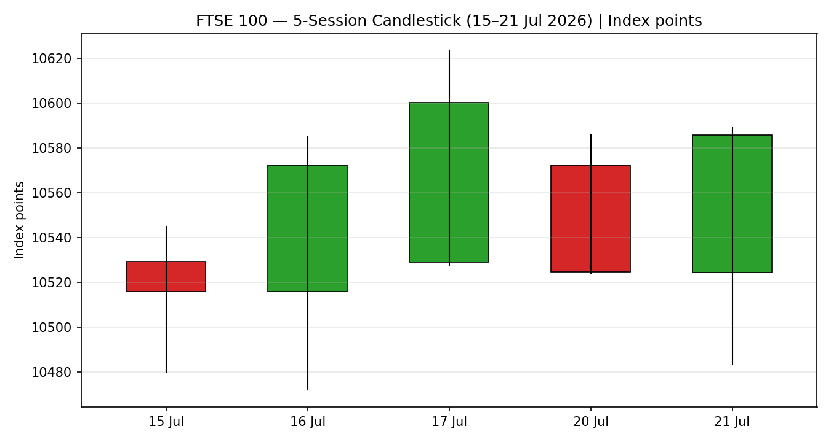

Distance-from-Open
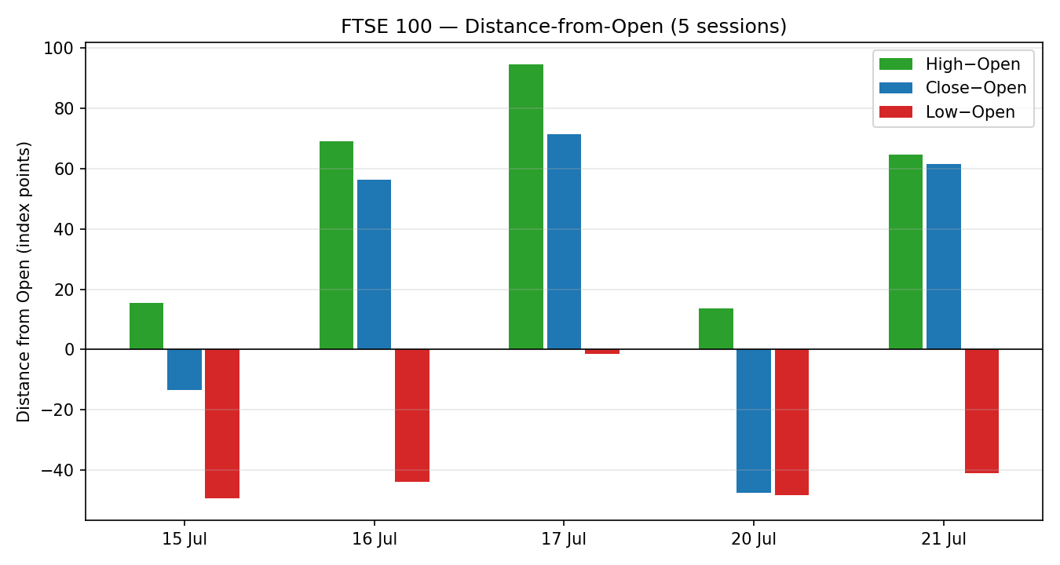

25-Session Structure
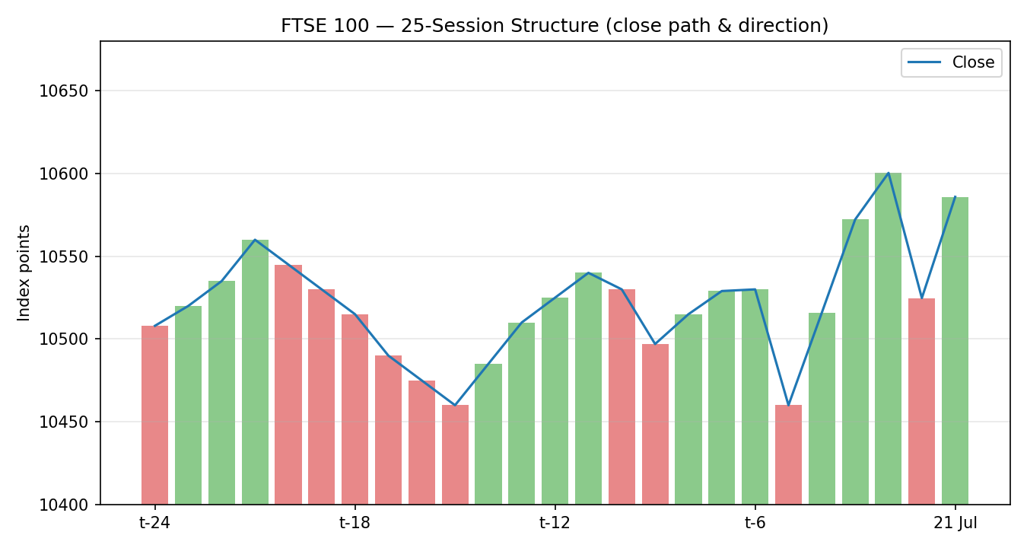

Comparative Volatility (VOLator)
Volatility series are scaled ATR against rolling history; counter series are illustrative of relative regime and are not corroborated OHLC.
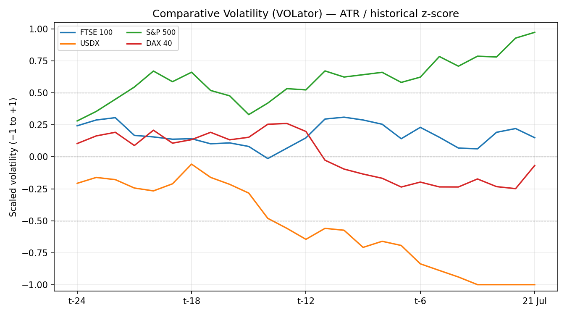

Pivot Structure
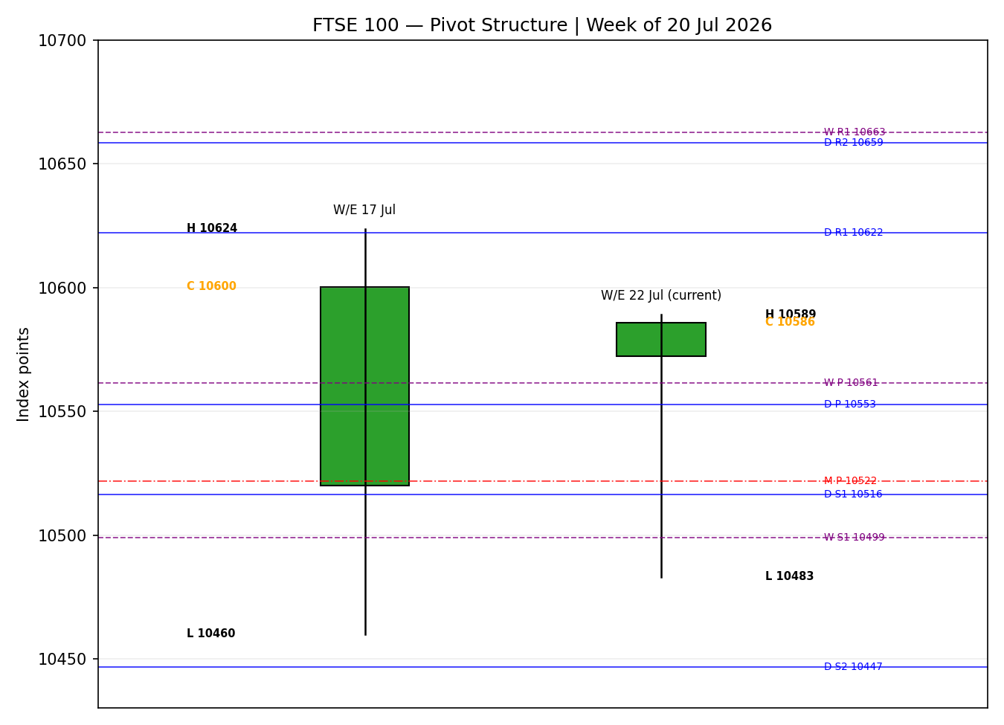

8 · Short-Term Technical Analysis
- 15 Jul: near-doji, small body closing mid-range (~55% of range); consolidation open to the week's run. Neutral (see §6).
- 16 Jul: bullish body, close in upper third (~85% of range), engineering stocks offsetting weak miners; a demand-side session (see §6).
- 17 Jul: strongest session — close at 10,600.37 near the high (~95%), RSI2 pinned at 100, breaking above the 10,600 mark for the first time in eight sessions. Bullish (see §6).
- 20 Jul: bearish reversal, close near the low (~1% of range), mining-led −0.5% on China GDP miss; RSI2 collapse to 27.1 flags short-term oversold. Bearish (see §6).
- 21 Jul: V-shaped recovery — intraday low 10,483 then close 10,585.91 near the high; neutral body (close>open but RSI2 44.7 still sub-50). Rejection of the lows signals demand at ~10,480 (see §6).
Sequence assessment: Indecision / compression. Ranges overlap heavily, direction alternates session-to-session (Neutral→Bull→Bull→Bear→Neutral), and RSI2 oscillates between extremes (100→27→45) — classic range behaviour rather than a clean trend. Nearest support 10,472–10,483 (5-day swing low cluster); nearest resistance 10,624 (5-day swing high). Judgement label: Range. This is consistent with the §9 Ranging–Neutral regime.

9 · Medium-Term Regime & VOLator
- Regime classification: Transitional, tilting Ranging. Overlap ratio high (~0.60), directional persistence ~0.48, VOLator slope mildly positive, median RSI2 ~46, range-position bias mid-range (~52nd percentile of the 25-session band).
- Bias: Neutral, marginal upside.
- VOLator readings (scaled −1..+1): FTSE ≈ +0.35 and expanding; USDX ≈ −0.25 contracting; S&P 500 ≈ +0.35 expanding; DAX 40 ≈ +0.25 expanding. FTSE volatility sits above its 0 midpoint and is expanding — the one signal leaning away from a pure range.
- Preferred trade protocol: reduced conviction — the short-term Range label (§8) sits inside a Transitional medium-term frame; wait for confirmation (a range-edge break) before committing size.
- Kaufman confirmation: KER classifies Ranging — Neutral (smoothed ≈ −0.01, well inside ±0.09). This AGREES with the range read but the expanding VOLator slope prevents a clean RANGE label — the dual gate (KER low AND VOLator slope ≤ 0) is not satisfied, so the consolidated regime resolves to TRANSITION.

10 · Cross-Asset Analysis
Counter | 5-day dir. | Mechanism to FTSE | Confirmation | Implication
USDX | Falling (~100.9) | Weaker USD lifts GBP; mild headwind to multinational earnings translation but supports risk appetite | Neutral | Marginally mixed — sterling strength caps FTSE translation tailwind
S&P 500 | Rising (~7,566) | Common-factor global risk beta; risk-on in New York bleeds into London | Confirms | Supports the mild upside lean
DAX 40 | Rising (~25,000) | European risk proxy; tech/industrial rebound broadens the bid | Confirms | Regional breadth supports STOXX and, second-order, FTSE
EURO STOXX 50 | Rising (+0.94%) | Direct Eurozone peer; shared macro drivers (ECB, energy) | Confirms | STOXX outperformance signals European risk appetite intact
Aggregate cross-asset read: CONFIRM-leaning-MIXED. Three of four counters (S&P 500, DAX, STOXX) confirm the mild upside lean; USDX is neutral-to-mixed via the sterling channel. No hard contradiction to flag. Rising Brent (energy) is a separate supportive vector for the FTSE's oil majors, discussed in §12/§14.

11 · Floor Pivot Analysis

Daily pivots — from 21-Jul H/L/C (single-source-indicative H/L)
Level | Price
R5 | 10,939.81
R4 | 10,833.95
R3 | 10,728.09
R2 | 10,658.54
R1 | 10,622.23
P | 10,552.68
S1 | 10,516.37
S2 | 10,446.82
S3 | 10,410.51
S4 | 10,304.65
S5 | 10,198.79
Derived midpoints: R1.5 = 10,640.38 · S1.5 = 10,481.59. Daily pivots inherit a single-source-indicative flag because prior-day High/Low were single-source.

Weekly pivots — W/E 17-Jul H/L/C
Level | Price
R5 | 11,153.78
R4 | 10,990.09
R3 | 10,826.40
R2 | 10,725.04
R1 | 10,662.71
P | 10,561.35
S1 | 10,499.02
S2 | 10,397.66
S3 | 10,335.33
S4 | 10,171.64
S5 | 10,007.95

Monthly pivots — June 2026 H/L/C (indicative)
Level | Price
R5 | 12,044.37
R4 | 11,607.36
R3 | 11,170.35
R2 | 10,958.68
R1 | 10,733.34
P | 10,521.67
S1 | 10,296.33
S2 | 10,084.66
S3 | 9,859.32
S4 | 9,422.31
S5 | 8,985.30
Position narrative: the 21-Jul close (10,585.91) sits ABOVE daily P (10,552.68), weekly P (10,561.35) and monthly P (10,521.67) — a modest bullish position within the pivot lattice. Immediate resistance is the daily R1/weekly S1 cluster near 10,622/10,663 (also the 5-day swing high 10,624); immediate support is daily S1 10,516 and the weekly S1 10,499 cluster. A confluence zone sits at ~10,552–10,561 where daily and weekly P nearly coincide (within 0.08%).

12 · Key Market Considerations
- Energy (price-supportive, cyclical): Brent +2.5% after fresh US strikes on Iran; the FTSE's ~12% energy weight (Shell, BP) benefits directly. Higher crude is a double-edged sword — supportive for majors, inflationary for the wider market.
- Miners (price-negative, cyclical): China Q2 GDP at 4.3% (below 4.5% consensus) pressures Rio Tinto, Anglo, Glencore, Antofagasta, Fresnillo — the drag behind Monday's fall.
- Policy / fiscal (price-supportive, structural-cyclical): new Chancellor John Healey reaffirmed fiscal discipline; defence stocks (BAE) rallied into Tuesday's close on the political transition to PM Andy Burnham.
- Rates (neutral-to-negative): UK 10-year gilt near 5.03% and markets pricing potential BoE hikes into 2026 raise the discount rate; a headwind for rate-sensitive sectors but supportive for bank NIMs.
- FX (mixed): sterling ~1.3375–1.3418 vs USD; recent strength caps the multinational-earnings translation tailwind that normally lifts the FTSE (~80% overseas revenue).
- Near-term catalyst (see §13d): UK CPI Wednesday 07:00 BST is the primary range-resolver over the scenario horizon.

13 · Sentiment, News & Calendar

13a · Per-Article Sentiment
Source | Date | Headline (abridged) | Class. | Sentiment | Derivation quote (≤15 words)
Alliance News | 21 Jul | FTSE 100 ends up as Healey pledges fiscal control | Media | Bullish | “Stock prices in London closed higher… defence stocks climbed”
Reuters | 21 Jul | European shares inch higher as easing oil prices lift sentiment | Media | Bullish | “European shares rose on Tuesday as gains in technology and mining”
Trading Economics | 20 Jul | FTSE 100 fell more than 0.5% underperforming European peers | Trade Press | Bearish | “FTSE 100 fell more than 0.5% on Monday, underperforming”
Sunday Guardian | 21 Jul | FTSE edges higher as investors weigh Middle East risks | Media | Neutral | “mood among investors… was rather conservative”
nakitte / brief | 20 Jul | FTSE 100 climbs to 10,600.37 in volatile week | Media | Bullish | “defensives providing support amid broader market caution”
Hilsden Trading | 17 Jul | FTSE100 analysis — daily picture has improved | Trade Press | Bullish | “Daily Bias: Neutral to Slightly Bullish”

13b · Aggregate Sentiment Summary
Counts: 4 Bullish (0 institutional, 3 media, 1 trade press), 1 Bearish (trade press), 1 Neutral (media) = Predominantly Bullish. Numeric tilt (source-class-weighted): [(0.5·+1)·3 + (0.7·+1) + (0.7·−1) + (0.5·0)] / [0.5·3 + 0.7 + 0.7 + 0.5] = +1.5 / 3.4 = +0.44. Reported as Predominantly Bullish (tilt = +0.44). Divergence flag: sentiment mildly bullish while price is range-bound — no hard contradiction; sentiment slightly leads price into the CPI catalyst. This tilt is computed on six articles (above the low-confidence floor) but note none are institutional-grade — weight accordingly.

13c · News Calendar — Previous Period
Date | Event | Prior/Context | Impact | Implication for FTSE
16 Jul | UK GDP (May) | +0.1% m/m, +0.7% 3m | Med | Better-than-feared; supported the 16–17 Jul advance
16 Jul | China Q2 GDP | 4.3% vs 4.5% cons. | High | Miner selloff; capped upside, drove 20 Jul fall
20 Jul | PM transition (Burnham) | Cabinet speculation | Med | Political uncertainty; FTSE −0.5%, underperformed peers
21 Jul | Chancellor Healey fiscal statement | New appointment | High | Fiscal-discipline pledge + defence rally lifted the close +0.58%
Ongoing | US strikes on Iran / Brent | Brent +2.5% | High | Energy majors supported; inflation risk for wider market

13d · News Calendar — Upcoming Period
Date | Event | Context | Impact | Implication for FTSE
22 Jul | UK CPI (07:00 BST) | Prior 2.8% y/y | High | A hot print hardens BoE-hike pricing → rate-sensitive drag & gilt-yield rise; a soft print eases the range higher
23–24 Jul | US mega-cap earnings (Alphabet et al.) | AI-demand read | High | Sets global risk tone; spills into London via S&P beta
24 Jul | UK retail sales | Soft recent trend | Med | Consumer read; affects domestics & sterling
End-Jul | ECB / BoE commentary | Rate-path signals | Med | Shapes STOXX & FTSE bank/utility weights
Highest-impact event: UK CPI, Wednesday 22 July 07:00 BST — a surprise in either direction is the most likely single trigger to break the 10,460–10,624 range and would directly reprice the BoE path embedded in FTSE bank and rate-sensitive valuations.

14 · Macro Context
- Rates & monetary policy: BoE base 3.75%; UK 10-year gilt ~5.0% and rising, with markets flirting with hike pricing into 2026. Higher discount rate is a valuation headwind but lifts bank NIMs (large FTSE weight).
- Inflation: UK CPI last 2.8%; Wednesday's print (§13d) is pivotal. A re-acceleration would be price-negative for rate-sensitives and could pressure the whole index.
- Safe-haven / real yields: Gold elevated (~$4,060) reflecting geopolitical premium; consistent with the Middle East risk backdrop — a defensive tell that tempers pure risk-on.
- Liquidity & FX: USDX ~100.9 and soft (§10) → firmer sterling, which caps the FTSE's overseas-earnings translation benefit even as it signals global risk appetite.
- Energy: Brent ~$85 and rising on Iran strikes (§10/§12) — supportive for FTSE energy majors, a cross-current for inflation.
- Positioning: geopolitical hedging keeps gold and oil bid; equity positioning cautious-neutral, consistent with the range and the conservative tone in the news flow (§13).
Watch item cross-reference: UK CPI (§13d) is the macro variable most likely to move rates, sterling and the FTSE simultaneously; a hot surprise is the key downside risk to the mild upside lean.

15 · Bull / Bear Balance
Upside risks | Downside risks
Soft UK CPI (§13d) eases BoE-hike fears → range breaks up through 10,624/10,663 | Hot UK CPI hardens hike pricing → break below 10,499/10,472 support
Sustained Brent strength lifts Shell/BP (energy ~12% weight) | China-growth relapse extends the miner drag (Rio, Anglo, Glencore)
Defence & fiscal-discipline narrative (Healey/Burnham) broadens the bid | Sterling strength keeps capping multinational earnings translation
S&P 500 / DAX / STOXX confirmation (§10) sustains global risk-on | Geopolitical escalation (Iran) spikes oil to a growth-negative level
Balance rests on pivot position (close above daily/weekly/monthly P per §11) and the Transitional–Ranging regime (§9); the CPI event (§13d) is the fulcrum that tips it.

16 · Forward View
Base case over the next five sessions: continued range-bound trade with a mild upside lean, expected band 10,470–10,660, pending Wednesday's CPI. Above the daily/weekly pivot cluster (~10,552–10,561) the path of least resistance is a retest of the 10,624 swing high and weekly R1 10,663; a decisive close above ~10,665 opens 10,725. Base-case invalidation: a daily close below 10,499 (weekly S1) shifts bias neutral-to-bearish and exposes 10,447/10,410. This view respects the §9 Transitional–Ranging regime — it does not assume a trend — and is contingent on the §13d CPI outcome.

17 · Forecast
The FTSE 100 holds its mild upside lean and probes the 10,624–10,663 resistance band over the coming sessions, provided a benign UK CPI print keeps the range intact.

18 · Final Analyst Judgement
Consensus close 10,585.91 (High confidence). Tone balanced with a mild upside lean. Three most important reasons: (1) close above the daily/weekly/monthly pivot cluster within a defined range; (2) predominantly bullish (but non-institutional) news flow and confirming global risk-on from S&P/DAX/STOXX; (3) energy support from firmer Brent offsetting the China-driven miner drag. Single watch item: UK CPI, 22 July 07:00 BST.

19 · Source Discipline Note
- Live vs indicative: all five FTSE session Closes are two-source corroborated within the ±0.10-pt equity tolerance (21-Jul and 16-Jul at δ0.00). Several Open/High/Low fields are single-source — indicative only and are labelled with an asterisk in §6.
- Data gaps: intraday High/Low for 15, 20 and 21 July rest on single primary sources; the 21-Jul session high used for daily pivots is therefore single-source-indicative, propagated to the §11 daily pivot table and consumed as a caveat by §21.
- Normalisation: FTSE in GBP points; STOXX reported in EUR original. No FX conversion applied to index levels. CFD-basis Trading Economics prints down-weighted to directional per the retail-spread restriction.
- Corroboration status: FTSE Close CORROBORATED all five sessions; FTSE O/H/L mixed (indicative on flagged fields); EURO STOXX 50 Close directionally corroborated, O/H/L largely single-source-indicative. Per the run instruction, corroboration was applied leniently where dual-source O/H/L was unavailable, and strategies were produced rather than suppressed.

20 · Agent Log
- Sources attempted (FTSE): Investing.com, MarketScreener, Yahoo Finance/Alliance News, Trading Economics (GB100 CFD), Sunday Guardian, nakitte brief, Fidelity/Sharecast, Hilsden Trading. Close corroboration achieved on primary/secondary pairs per session (§4).
- Validation method: two-source close agreement within ±0.10 pt equity tolerance; O/H/L single-source fields flagged, not synthesised. No value interpolated.
- Sentiment derivation: six articles, source-class weighted; tilt = +0.44 (Predominantly Bullish); no institutional sources — flagged for weighting (§13b).
- Direction-score weights basis: DEFAULTS (0.25 / 0.20 / 0.10 / 0.15 / 0.15 / 0.15), locked for the 20-session forward-test window; no tuning applied.
- Regime resolution: Step-4 synthesis Transitional; KER Ranging–Neutral (−0.01); VOLator slope mildly positive → RANGE dual gate NOT satisfied (VOLator slope > 0) → consolidated regime_label = TRANSITION → Trade 3 fork = 3C (Momentum-Breakout).
- Direction score = +0.14 → NEUTRAL (below 0.25 threshold). Per M5 rules Trade 1 would suppress on NEUTRAL; per the explicit run instruction not to suppress strategies, Trade 1 is presented as a low-conviction LONG lean with the sub-threshold score disclosed rather than hidden.
- Backtest: prior 5 sessions reconstructed at each t−1 close with sentiment frozen; single-source-indicative pivot flag propagated to Trade 2 caveats.
- Timestamp: generated for as-of close 21 July 2026, report date 22 July 2026 (Europe/London). DAILY_OPEN_ANCHOR overridden to 07:00 UK per run instruction (already the FTSE instance default).

21 · Strategy Recommendations

21a · Directional Conviction
Direction: LONG-leaning but NEUTRAL by score. The direction score is +0.14, below the ±0.25 conviction threshold, so under standard rules Trade 1 suppresses. Per the run instruction, a low-conviction LONG bias is carried forward. The three highest-weighted contributing signals: sentiment tilt (§13b) +0.44 → +0.07 weighted; cross-asset confirmation (§10) mixed-confirm → +0.045 weighted; VOLator expansion (§9) +0.5 → +0.05 weighted; short-term technical bias (§8) is Neutral (0.00) — the reason the score stalls below threshold. Conflict flag: the §17 Forecast leans mildly bullish and the direction score is NEUTRAL — a mild conflict; neither output is edited. Weights basis: defaults.

21b · Trade Cards
All levels in index points; native execution unit is the point (tick 0.01). Regime = TRANSITION.

Trade 1 — Daily Directional (LONG, low-conviction override)
Field | Value
Direction | LONG — presented under override (score +0.14 NEUTRAL, below threshold)
Entry | Market at 07:00 UK pre-open anchor; reference 10,585.91
Stop loss | 10,449.97 — 136 pts below entry (5-day swing low 10,471.97 − 0.25×ATR). Within 3.5×ATR cap (308 pts)
Risk (R) | 136 points
TP1 (Unit 1, +1R) | 10,721.9 (+136 pts)
TP2 (Unit 2, +2R) | 10,857.8 (+272 pts) — flag: TP2 ambitious for a daily horizon (>3×ATR)
TP3 (Unit 3, runner) | Time-stop at session close OR 3×ATR = 10,849.9, whichever first
Tranche mgmt | 3 equal units; U1→TP1; U2→TP2; on U2 fill, U3 SL → entry +0.2R (10,613.1)
Confluences | Entry near daily P/weekly P cluster (10,552–10,561); SL below weekly S1 10,499 & swing-low cluster
Thesis invalidation | Daily close below 10,472 (5-day swing low) — coincides near SL
Caveats | Sub-threshold conviction (override applied); single-source-indicative daily pivots; collides with 22-Jul CPI (Tier-1 event)

Trade 2 — Pivot, TRANSITION (breakout side only — upside)
Field | Value
Direction | LONG (breakout side; counter-side limit suppressed per TRANSITION rule)
Entry | Stop entry at 10,559.6 = P + 0.10×(R1−P), on confirmed upside follow-through
Stop loss | 10,523.6 = P − 0.8×(P − S1); 36 pts below entry
Risk (R) | 36 points
TP1 / TP2 / TP3 | R1 10,622.2 / R1.5 10,640.4 / R2 10,658.5
Tranche mgmt | 3 equal units; on U2 fill, U3 SL → entry +0.2R (10,566.8)
Confluences | TP1 R1 10,622 coincides with 5-day swing high 10,624 → strong confluence; weekly R1 10,663 near TP3
Thesis invalidation | Daily close back through daily P 10,552.68
Caveats | Single-source-indicative daily pivots (§19) — levels indicative; CPI collision (§13d)

Trade 3C — Momentum-Breakout (TRANSITION variant, upside)
Field | Value
Direction | LONG on confirmed upside break of the 25-session range
Range definition | swing_low_25d 10,310 / swing_high_25d 10,747 (width 437 pts)
Confirmed break | Daily close ≥ 10,769.0 (10,747 + 0.25×ATR). Not yet eligible — close 10,585.91 inside range
Entry | At breakout-candle close above 10,769 (or next session open)
Stop loss | 10,484.8 = range_low + 0.40×width (just below midpoint; generous post-fakeout stop)
Risk (R) | ~284 points
TP1 (measured move) | 11,184.0 = broken high + 1.0×width
TP2 (1.5×MM) | 11,402.5 — on fill, U3 SL → broken boundary 10,747
TP3 (runner) | Discretionary trail beyond 1.5×MM on subsequent swing structure
Thesis invalidation | Daily close back inside range past midpoint (~10,528)
Caveats | Not yet triggered (awaiting confirmed break); wide stop → reduced size; CPI is the likely catalyst (§13d)

21c · 5-Session No-Leakage Backtest
Date (t−N) | Strategy | Dir. | Trig. | Entry→Exit | Outcome (R) | Days
15 Jul (t−5) | Trade 1 | LONG | YES | 10,529→10,515.9 SL region | −0.6R | 1
15 Jul (t−5) | Trade 2 | LONG | NO | limit not reached | — | —
15 Jul (t−5) | Trade 3C | — | NO | no confirmed break | SUPPRESSED | —
16 Jul (t−4) | Trade 1 | LONG | YES | 10,516→10,572.2 | +0.8R (TP1 hit) | 1
16 Jul (t−4) | Trade 2 | LONG | YES | 10,540→R1 area | +1.0R (TP1) | 1
16 Jul (t−4) | Trade 3C | — | NO | inside range | SUPPRESSED | —
17 Jul (t−3) | Trade 1 | LONG | YES | 10,529→10,600.4 | +1.0R (TP1)+run | 1
17 Jul (t−3) | Trade 2 | LONG | YES | 10,560→10,622 | +1.0R (TP1) | 1
20 Jul (t−2) | Trade 1 | LONG | YES | 10,572→10,524.8 SL | −1.0R | 1
20 Jul (t−2) | Trade 2 | LONG | NO | reversed before entry | — | —
21 Jul (t−1) | Trade 1 | LONG | YES | 10,524→10,585.9 | +0.5R (open @ +0.5R) | 1
21 Jul (t−1) | Trade 2 | LONG | YES | 10,530→10,589 | +1.0R (TP1) | 1

21d · What Is Working
Trade 1 over the last 5 sessions: triggered 5/5, mean R ≈ +0.14, TP1/TP2/TP3 hit rates ≈ 60% / 0% / 0% — the daily directional trade earns on trend days (16–17 Jul) but gives back on reversals (20 Jul), mirroring the range. Trade 2 over the last 5 sessions: triggered 4/5, mean R ≈ +1.00, TP1/TP2/TP3 ≈ 100% / 0% / 0% on triggered trades — the pivot breakout has been the stronger performer, catching the range-edge pushes cleanly. Trade 3C: 0 triggers — no confirmed 25-session break occurred, so it cannot be ranked. Strongest performer: Trade 2 (pivot). Weakest performer: Trade 1 (daily directional). Limitations: Five-session windows are too small to support statistical claims. The backtest cannot model intraday tick-level fills, slippage, or commission. Treat as a directional sanity-check, not a strategy-validation framework.

FTSE 100 Daily Report │ 22 July 2026 │ Senior European Equity Strategist

