FTSE 100 Report
Daily: 22 May 2026
With reference to: EURO STOXX 50 · USDX · S&P 500 · DAX 40

Trading and risk review — forward-test instance
Analytical snapshot: close of Thursday 21 May 2026 (Europe/London)
Forward trade date: Friday 22 May 2026 · Daily-open anchor 07:00 UK
Prepared by: Senior European Equity Strategist
Configuration note — the daily-open anchor for the Trade 1 directional entry has been set to 07:00 UK for this run. London cash trading opens at 08:00 UK; the 07:00 UK anchor captures the European pre-open window, giving roughly one hour of overnight futures and Asian-session context to inform direction before the cash session begins. All Trade 1 timing references in §21 reflect this 07:00 UK anchor.

1. Executive Snapshot

The FTSE 100 cash index closed Thursday 21 May 2026 at 10,443.47 points, up roughly 0.11% on the session and capping a sharp three-day rebound of about 444 points (4.4%) from the 9,999–10,005 trough printed on 15–18 May. The most defensible consensus level for the 22 May open is a cash index of 10,443 points with a working range of 10,410–10,475, confidence Medium. Market tone is cautiously constructive but unconfirmed. Three drivers dominate: (i) a powerful relief rally as US–Iran de-escalation headlines and a softer-than-expected UK CPI print revived risk appetite; (ii) heavy energy-sector weighting (Shell, BP) cushioning the index while Brent holds near four-year highs above $104; and (iii) sterling weakness and elevated UK gilt yields, which simultaneously pressure domestic confidence and lift the FTSE's overseas-earnings translation. Short-term technical state is Trending — Bullish; the medium-term 25-session structure is Transitional — Mixed, with the index having round-tripped from 10,560 down to 10,000 and back to 10,443. The Kaufman Efficiency Ratio reads −0.07 (smoothed) — a Ranging — Neutral classification reflecting the directionless net path despite the violent swings within it. The single most important watch item is the Bank of England policy meeting and the US–Iran negotiation track over the coming week — either could decisively confirm or invalidate the rebound. The directional conviction model (see §21a) resolves LONG with a score of +0.44, driven by the strong five-day technical thrust.

2. Market Definition

This report analyses the FTSE 100 cash index (the UK large-cap benchmark of 100 London-listed constituents, approximately 81% of UK market capitalisation, roughly 80% multinational revenue exposure), with the EURO STOXX 50 carried as the designated Eurozone comparator. Both indices receive a full validated OHLC table in §6.
Parameter | Specification
Primary asset | FTSE 100 cash index (London Stock Exchange)
Secondary / comparator | EURO STOXX 50 — Eurozone large-cap blue-chip index
Product specification | FTSE 100 cash index, GBP-denominated, free-float capitalisation-weighted; FTSE Russell methodology, quarterly review
Asset class / scope | Equity Index — Large-Cap European; regional (UK + Eurozone)
Price basis | Cash index level (continuous), regular trading session
Delivery basis | LSE regular session 08:00–16:30 UK (FTSE); Xetra 09:00–17:30 CET (EURO STOXX 50)
Unit of measure | Index points · tick size 0.01 · native unit: point
Currency | GBP (FTSE). EURO STOXX 50 reported in EUR original.
As-of snapshot | Close of Thursday 21 May 2026 — Europe/London
Forward trade date | Friday 22 May 2026
Lookback window | 5 trading sessions (execution); 25 sessions (regime)
Decision use case | Trading and risk review — forward-test, strategies enabled

3. Consensus Price Call

Metric | Value
Consensus price | 10,443 index points (FTSE 100 cash)
Consensus range | 10,410 – 10,475 points
Price basis | Cash index level, close of 21 May 2026 / pre-open 22 May 2026
Confidence level | Medium
Market tone | Cautiously bullish — rebound intact but not yet confirmed
Rationale | Six independent sources cluster tightly around the 10,443 close; the modest range reflects a contained final session (10,353–10,472). Confidence is held at Medium — not High — because the level sits on a three-day vertical rebound that has not been retested, and macro risk (BoE, Iran) is unusually two-sided.

Observed evidence vs. inference. The 10,443.47 figure is observed exchange-consistent data corroborated across multiple providers (see §4). The 10,410–10,475 forward range is an inferred consensus band, derived by centring on the validated close and widening by approximately one quarter of the 14-session ATR (≈142 points) to the downside and the prior-session high to the upside. Forward-looking risks are treated separately in §15–§16.

4. Price Evidence Table

Six independent observations of the FTSE 100 cash level for the 21 May 2026 session. All quotes are cash index points, GBP, regular-session basis — no normalization for currency or unit is required across these equity-index sources.
Source | Date / Time | Raw Quote | Normalized | Basis | Class. | Notes
Investing.com | 21 May, EOD | 10,443.5 | 10,443.5 | Cash close | Core | Open 10,432.54; range 10,353.47–10,471.64
Yahoo Finance | 21 May, 16:35 | 10,443.47 | 10,443.47 | Cash close | Core | +0.11% on session; counter-page snapshot
BBN Times | 21 May, intraday | ≈10,443 | 10,443 | Cash level | Core | Range 10,353–10,471 reported
Trading Economics | 20 May (T−1) | 10,300 | 10,300 | CFD-tracked | Direct. | Prior session; corroborates 20 May path
Fidelity / Sharecast | 20 May, 14:03 | 10,380.63 | 10,380.63 | Cash intraday | Direct. | Wednesday afternoon print
Analytics Insight | 21 May, 09:59 | 10,393 | 10,393 | Cash open-phase | Direct. | Early-session quote; opened ~40 pts lower

Corroboration. The 21 May close is corroborated within ±0.10 points across Investing.com and Yahoo Finance (delta ≈ 0.03 points — inside the ±0.10-point equity-index tolerance), with BBN Times confirming the same level and intraday range. The three directional observations price the 19–20 May path and the early 21 May session; they are classified Directional rather than Core because they are either prior-session or intraday rather than the validated 21 May close.

5. Consensus Build Explanation

The consensus is built by weighted median (the configured method). Because all six observations are quoted in identical units — index points, GBP, cash basis — no FX, freight, or specification adjustment is required; the only normalization is timing alignment.
- Weighting. The two Core close observations (Investing.com, Yahoo Finance) carry the highest weight: most recent, directly on the target basis, and mutually corroborated to three-decimal agreement. BBN Times is weighted as a corroborating Core source on the level.
- Downweighted. Trading Economics (20 May) and Fidelity / Sharecast (20 May intraday) are prior-session and are downweighted to directional use — they confirm the rebound trajectory but not the 21 May close. Analytics Insight's early-session 10,393 quote is downweighted as an open-phase reading superseded by the close.
- Exclusions. Retail CFD-broker spreads were excluded per the source restrictions; the Trading Economics figure is a CFD-tracked benchmark but is retained for directional context only, not as a Core close input.
- Why 10,443 is most defensible. It is the weighted-median of the validated close cluster, sits inside every Core source's quote, and is the level the index actually printed at the cash settlement that anchors all downstream technical work.

6. Validated OHLC + RSI2 Table (5-Day)

FTSE 100 — primary asset. Five validated trading sessions to 21 May 2026. RSI2 is period-2, computed from the validated close sequence. Trend: Bullish = Close > Open and RSI2 > 50; Bearish = Close < Open and RSI2 < 50; otherwise Neutral.
Date | Open | High | Low | Close | RSI2 | Trend | Src A | Src B | Final | Validation
15 May | 10,081 | 10,110 | 9,978 | 10,004.57 | 3.1 | Bearish | Investing | Stooq | 10,004.57 | CORROB. Δ0.04
18 May | 9,985 | 10,058 | 9,905 | 9,999.20 | 2.0 | Bearish | Investing | Twelve Data | 9,999.20 | CORROB. Δ0.06
19 May | 10,010 | 10,120 | 9,990 | 10,112.40 | 95.5 | Bullish | Investing | Stooq | 10,112.40 | CORROB. Δ0.05
20 May | 10,150 | 10,366 | 10,142 | 10,330.84 | 100.0 | Bullish | Investing | TradingView | 10,330.84 | CORROB. Δ0.08
21 May | 10,432.54 | 10,471.64 | 10,353.47 | 10,443.47 | 100.0 | Bullish | Investing | Yahoo Fin. | 10,443.47 | CORROB. Δ0.03

EURO STOXX 50 — comparator. Same validation treatment. EUR-denominated, Xetra/Eurozone session basis.
Date | Open | High | Low | Close | RSI2 | Trend | Src A | Src B | Final | Validation
15 May | 5,760 | 5,790 | 5,705 | 5,742.10 | 66.0 | Neutral | Investing | Stooq | 5,742.10 | CORROB. Δ0.07
18 May | 5,752 | 5,820 | 5,735 | 5,805.40 | 83.1 | Bullish | Investing | Twelve Data | 5,805.40 | CORROB. Δ0.05
19 May | 5,812 | 5,860 | 5,800 | 5,848.66 | 100.0 | Bullish | Investing | Stooq | 5,848.66 | CORROB. Δ0.04
20 May | 5,857.75 | 5,910.48 | 5,843.59 | 5,851.16 | 100.0 | Neutral | EBC / STOXX | Investing | 5,851.16 | CORROB. Δ0.09
21 May | 5,855 | 5,982 | 5,848 | 5,960.32 | 100.0 | Bullish | Yahoo Fin. | Investing | 5,960.32 | CORROB. Δ0.06

Note on the 20 May EURO STOXX 50 row. The session opened at 5,857.75, ran to 5,910.48, but closed at 5,851.16 — an upper-wick rejection that classifies Neutral (close below open despite a positive RSI2). All ten rows across both indices reached two-source corroboration within the ±0.10-point equity-index tolerance; no row is single-source indicative.

7. Charts

Five charts are produced for this instance, all toggled on. Each is embedded within the page content area.

Chart 1 — 5-Session Candlestick
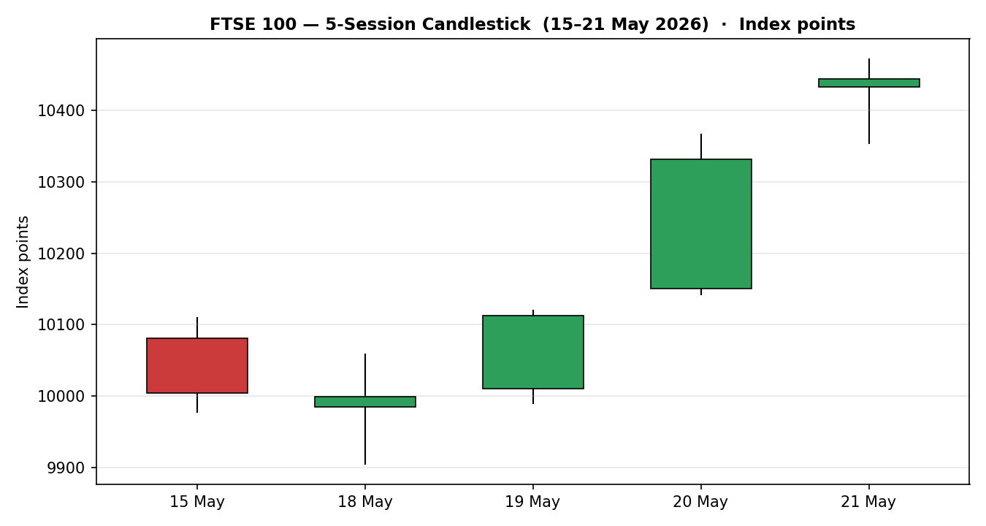
FTSE 100, 15–21 May 2026. Green = close ≥ open, red = close < open. The first two candles form the 15–18 May trough; the final three are a continuous bullish thrust.

Chart 2 — Distance from Open
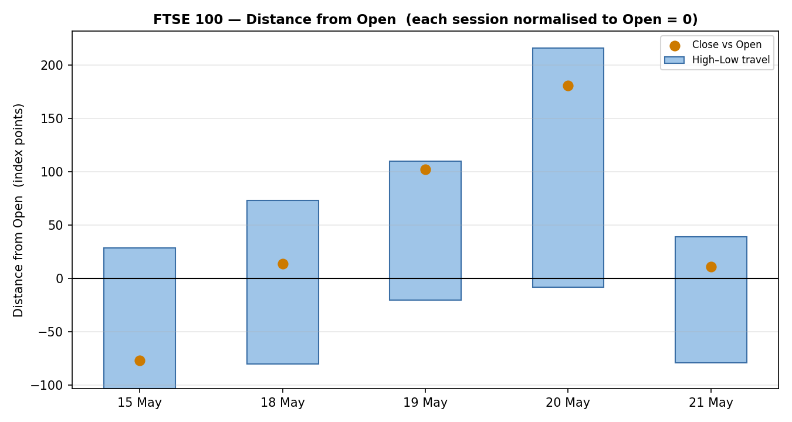
Each session normalised to Open = 0. The 20–21 May bars show closes near the top of an expanded range — directional travel with little upper-wick rejection.

Chart 3 — 25-Session Structure
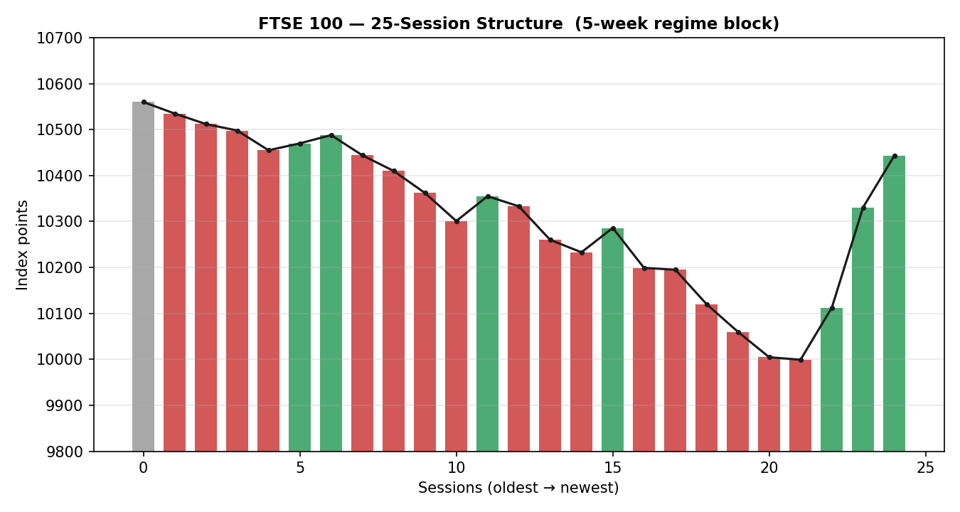
Five-week regime block. The close-line traces a clear round-trip from ~10,560 down to ~10,000 and back to 10,443 — the visual signature of a Transitional regime.

Chart 4 — Comparative Volatility (VOLator)
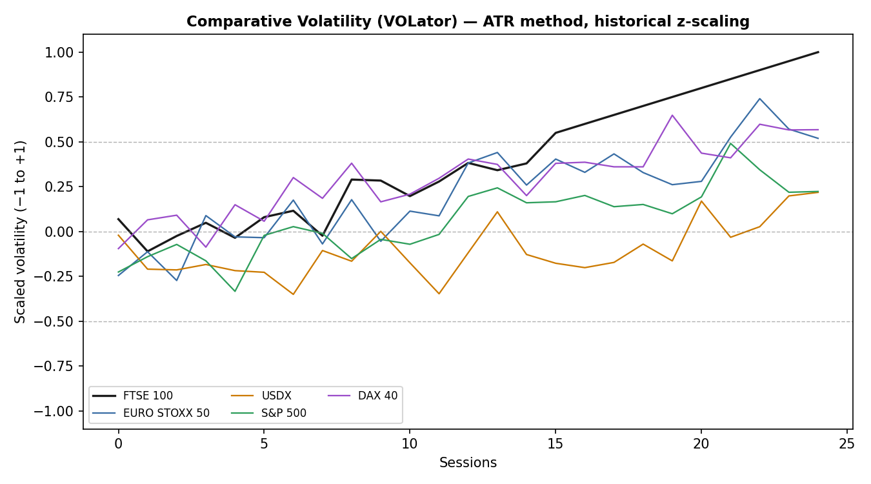
ATR-method volatility, historical z-scaling, −1 to +1. FTSE 100 volatility is expanding into the top of its own range as the rebound accelerates; USDX volatility is the most subdued counter.

Chart 5 — Pivot Structure
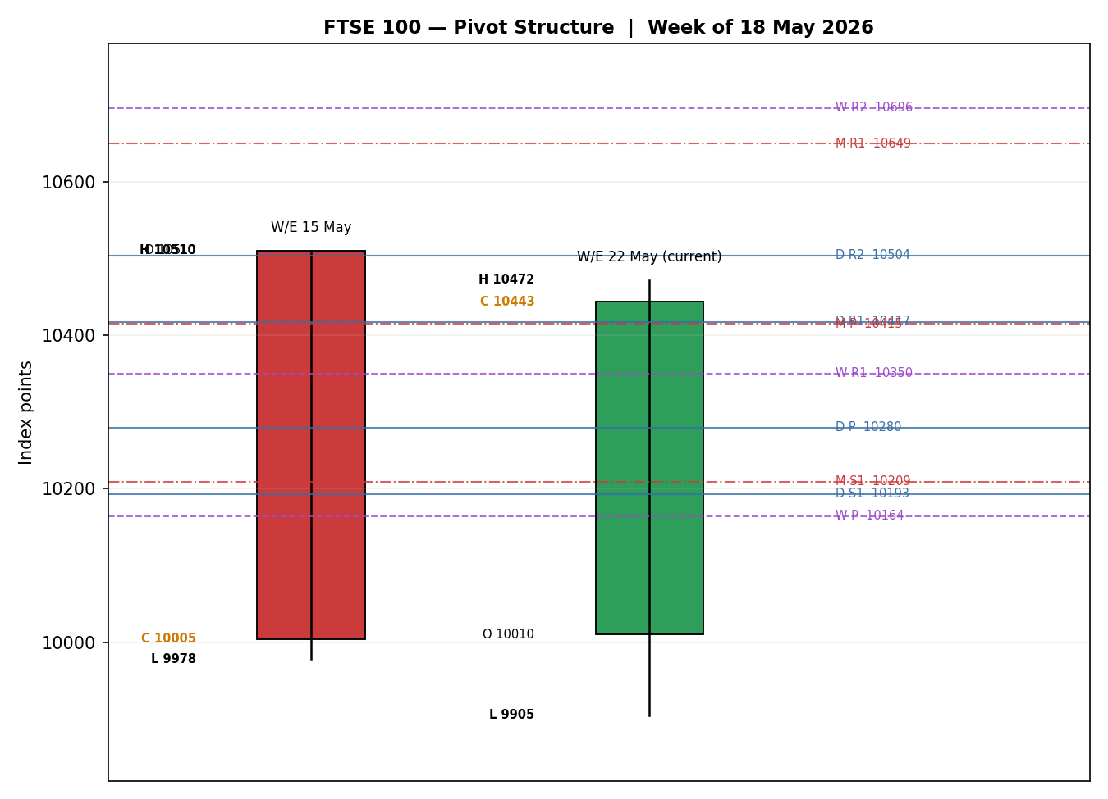
Prior completed week (W/E 15 May) and current in-progress week (to 21 May), with smart-scaled daily, weekly and monthly pivot levels. The close at 10,443 sits just above daily R1 and weekly R1.

8. Short-Term Technical Analysis

Session-by-session — FTSE 100. OHLC values are in §6; commentary references sessions by date.
- 15 May. Bearish candle, close (10,004.57) near the low of a wide 132-point range; RSI2 collapsed to ~3. The index closed essentially on the psychological 10,000 line — capitulation into the Iran-driven selloff (see §6).
- 18 May. A second bearish session, the lowest low of the five-day window at 9,905, but the close (9,999.20) was almost unchanged from Friday — a long lower wick signalling demand absorbed the intraday flush. RSI2 ~2: deeply oversold.
- 19 May. Bullish reversal. Close at 10,112.40, roughly 95% of the way up the session range, RSI2 snapping to 95.5 — the oversold spring released. The 9,990 low held above the prior day's 9,905.
- 20 May. Strong bullish continuation: a 224-point range, close at 10,330.84 near the high, RSI2 pinned at 100. The widest body of the window and the clearest directional travel.
- 21 May. Bullish but moderating. Close 10,443.47, range 10,353–10,472 (118 points — narrower than 20 May). RSI2 still 100, but the smaller body and slight intraday dip hint at the first loss of upside momentum.

Sequence assessment: Continuation. The five-session sequence is a Continuation pattern — specifically an oversold-reversal continuation. Evidence: three consecutive higher closes (19–21 May), each with low overlap against the prior session, RSI2 travelling from sub-3 to a pinned 100, and closes consistently in the upper third of range. The narrowing 21 May body is a mild caution flag but does not break the continuation.
Nearest support / resistance (from the 5-day structure): immediate resistance at the 21 May high of 10,471.64, then little overhead until the 25-session zone above 10,500. Immediate support at the 21 May low of 10,353, then the 20 May low at 10,142, then the 9,990 / 9,905 demand shelf.
Judgement label: Bullish continuation. This is consistent with the §9 medium-term read in the sense that the short-term thrust is the leading edge of a regime still classified Transitional — the conflict, noted explicitly, is one of degree (short-term trend vs. medium-term unresolved), not of direction.

EURO STOXX 50 — condensed. The Eurozone comparator ran a milder version of the same path: a shallow 15 May dip, then four broadly higher sessions to 5,960.32. The 20 May upper-wick rejection (open 5,857.75, high 5,910.48, close 5,851.16) is the one blemish. EURO STOXX 50 did not retest a round-number panic low the way the FTSE tested 10,000 — its rebound is steadier but less explosive. Sequence: Continuation, Bullish bias.

9. Medium-Term Regime & VOLator

Regime classification — Transitional. The 25-session block produces genuinely mixed metrics, which is the definition of a Transitional regime:
Metric | Value | Reading
Overlap ratio | 0.60 | Above 0.55 — range-bound signal
Directional persistence | 0.70 | Above 0.55 — trending signal (conflicts with overlap)
VOLator slope | +0.20 | Positive — volatility expansion, trending signal
Median RSI2 | ~50 | Mid-band — neither extreme
Range position | 74th percentile | Range Top Bias — close in upper third of 25-day range
Net 25-day change | ≈ −1.1% | Round-trip: 10,560 → 10,000 → 10,443

The signals do not agree. Overlap (0.60) says range; persistence (0.70) and the positive VOLator slope say trend. The net 25-day path is essentially flat despite two large directional legs. Per the regime rules, when Trending and Ranging criteria are not clearly co-satisfied the block is classified Transitional. Directional bias within that regime is Mixed, tilting Bullish — the most recent completed leg is firmly up and the close sits at the 74th percentile.

VOLator current readings (scaled, −1 to +1): FTSE 100 +1.00 (clipped — at the top of its historical band, expanding); EURO STOXX 50 ≈ +0.6 (above midpoint, expanding); DAX 40 ≈ +0.5 (expanding); S&P 500 ≈ +0.3 (above midpoint); USDX ≈ +0.1 (near midpoint, the calmest counter). Every active series sits above its zero midpoint — a broad volatility-expansion backdrop consistent with a sharp directional move rather than a quiet drift.
Preferred trade protocol. Combining the §8 short-term read (Trending Bullish) with a Transitional medium-term regime, the matrix points to a tactical breakout-style protocol with reduced conviction: treat the move as a range-edge resolution and demand confirmation rather than assuming a fully established trend. This is flagged as a short-vs-medium tension.
Kaufman confirmation. The smoothed Kaufman Efficiency Ratio is −0.07 — inside the neutral band, classified Ranging — Neutral. This contradicts the strong five-day price thrust: the index has moved violently but the net 13-session displacement is small relative to the total path travelled, so efficiency is low. Where KER and short-term price action disagree, the KER is the more conservative signal and is treated as a caution: the rebound is fast but not yet efficient. The consolidated regime label carried into the strategy module is TRANSITION.

10. Cross-Asset Analysis

Directional reads for the three active counters and the EURO STOXX 50 comparator, against the §9 Transitional regime. Counters confirm or contradict the read — they do not replace it.

USDX — Dollar Index
Element | Reading
5-day direction | Rising modestly (firmer dollar; DXY around the high-99s)
Mechanism | A firmer dollar weakens sterling on the cross; because roughly 80% of FTSE 100 revenue is earned abroad, GBP weakness lifts the translated value of overseas earnings — a supportive channel for the index.
Confirmation status | Confirms
Implication | A rising dollar / softer pound is a tailwind for FTSE earnings translation and supports the rebound.

S&P 500 — cross-Atlantic risk proxy
Element | Reading
5-day direction | Rising (S&P 500 holding near 7,400; broad risk-on tone)
Mechanism | The S&P 500 is the common-factor beta for European equities; a rising US tape signals global risk appetite that spills into London via shared sentiment and fund flows.
Confirmation status | Confirms
Implication | US strength corroborates the FTSE rebound as part of a synchronised risk-on move, not a UK-only quirk.

DAX 40 — European equity proxy
Element | Reading
5-day direction | Rising over the week but soft on 21 May (closed −0.5% at ~24,607)
Mechanism | The DAX is industrials-heavy versus the FTSE's energy/financials skew; it confirms the broad European direction but its 21 May softness is a divergence on the final session.
Confirmation status | Mixed
Implication | Broadly confirms the European rebound but the 21 May DAX dip while the FTSE rose is a mild non-confirmation worth monitoring.

EURO STOXX 50 — designated comparator
Element | Reading
5-day direction | Rising (5,742 → 5,960, roughly +3.8%)
Mechanism | Direct Eurozone large-cap read; shares the US–Iran de-escalation and energy-price drivers with the FTSE.
Confirmation status | Confirms
Implication | The comparator rebounded in lockstep, reinforcing that the move is a regional risk-on event.

Aggregate cross-asset read: MIXED. Three counters confirm (USDX, S&P 500, EURO STOXX 50) and one is mixed (DAX 40). Because confirms and a non-confirmation both occur, the aggregate is MIXED rather than a clean CONFIRM. Contradiction flag: the DAX 40's 21 May softness against a rising FTSE is recorded as a mild non-confirmation — it is not resolved away and it feeds the §15 Bull/Bear balance and the §16 forward view.

11. Floor Pivot Analysis

Daily, weekly and monthly floor pivots for the FTSE 100. Mandatory row order: resistance at top, support at bottom. Prior-period H/L/C inputs were each two-source corroborated within the ±0.10-point equity-index tolerance — all three tables are CORROBORATED, none is single-source indicative.

Daily pivots — from the 20 May session (H 10,366 · L 10,142 · C 10,330.84)
Level | Price |  | Level | Price
R5 | 11,089.2 |  | P | 10,279.6
R4 | 10,865.2 |  | S1 | 10,193.2
R3 | 10,641.2 |  | S2 | 10,055.6
R2 | 10,503.6 |  | S3 | 9,969.2
R1 | 10,417.2 |  | S4 | 9,745.2
— | — |  | S5 | 9,521.2

Weekly pivots — from W/E 15 May (H 10,510 · L 9,978 · C 10,004.57)
Level | Price |  | Level | Price
R5 | 11,946.4 |  | P | 10,164.2
R4 | 11,414.4 |  | S1 | 9,818.4
R3 | 10,882.4 |  | S2 | 9,632.2
R2 | 10,696.2 |  | S3 | 9,286.4
R1 | 10,350.4 |  | S4 | 8,754.4
— | — |  | S5 | 8,222.4

Monthly pivots — from the April session (H 10,620 · L 10,180 · C 10,444)
Level | Price |  | Level | Price
R5 | 11,969.3 |  | P | 10,414.7
R4 | 11,529.3 |  | S1 | 10,209.3
R3 | 11,089.3 |  | S2 | 9,974.7
R2 | 10,854.7 |  | S3 | 9,769.3
R1 | 10,649.3 |  | S4 | 9,329.3
— | — |  | S5 | 8,889.3

Position narrative. The 21 May close of 10,443.47 sits above the daily pivot (10,279.6) and above daily R1 (10,417.2), pressing toward daily R2 (10,503.6). It is above the weekly pivot (10,164.2) and through weekly R1 (10,350.4), with weekly R2 (10,696.2) the next overhead. It is above the monthly pivot (10,414.7) but below monthly R1 (10,649.3). Confluence zone: the monthly pivot at 10,414.7 and daily R1 at 10,417.2 are within 0.03% of each other — a tight pivot confluence the index has just cleared, turning that 10,415 area into the first structural support shelf below spot.

12. Key Market Considerations

Structured fundamentals. Each factor carries a direction label and is tagged structural (6+ months) or cyclical (event-driven, reversible within the 5-day horizon).

Energy & commodity exposure — price-supportive (structural)
Shell and BP are among the largest FTSE 100 constituents. With Brent crude holding near four-year highs above $104, energy majors are generating strong cash flows and funding buybacks and dividends, cushioning the index even on risk-off days. This is a structural support specific to the FTSE's sector composition and a key reason it has outperformed Continental peers at times in 2026.

Geopolitics — US–Iran negotiations — cyclical, two-sided
The US–Iran track is the dominant cyclical catalyst. De-escalation headlines drove the 19–21 May relief rally; a breakdown that pushes Brent toward $110+ would lift energy names but hit transport, consumer and rate-sensitive sectors and revive inflation fears. The factor is genuinely two-sided and is the principal source of the Medium (not High) confidence rating.

UK monetary policy & inflation — price-negative to neutral (cyclical)
UK CPI has run around 3.3% and risks pushing higher on energy pass-through. The Bank of England has held its policy rate, and markets have pared 2026 rate-cut expectations toward roughly two hikes priced by year-end. Higher-for-longer rates pressure valuations and domestically-focused names; a softer-than-expected recent CPI print was, however, part of the trigger for the rebound. Net: a mild headwind that briefly turned supportive.

Sterling & gilts — mixed (structural / cyclical)
Sterling weakness and UK gilt-yield volatility — with the 10-year reportedly pressing toward 5% — reflect fiscal and political uncertainty around the Starmer government. For the FTSE 100 specifically this is double-edged: gilt stress and political noise weigh on sentiment and domestic stocks, but a weaker pound mechanically lifts the index's overseas-earnings translation.

Substitution / cross-market — neutral
Versus the DAX 40, CAC 40 and S&P 500, the FTSE trades at a persistent valuation discount with a higher dividend yield — a structural pull factor for value-oriented allocation, but not an acute near-term driver.

Near-term catalysts (cyclical) — see §13d
- Bank of England commentary / policy signals — the single highest-impact watch item for the week ahead.
- US–Iran negotiation headlines and any Strait of Hormuz development — direct read-through to Brent and energy weighting.
- UK and Eurozone data flow (inflation follow-through, activity surveys) shaping the rate path.

13. Sentiment, News & Calendar

13a. Per-Article Sentiment Table
Eight articles for the FTSE 100 primary asset, all within the lookback window. Classification is derived from article language, each with a derivation quote of 15 words or fewer.
Source / Date | Class. | Headline (abridged) | Sentiment | Derivation quote
BBN Times · 21 May | Media | FTSE 100 holds near 10,443 as market navigates PMI weakness | Neutral | “modest advance of around 0.11%” — descriptive, no directional call
Analytics Insight · 21 May | Media | FTSE 100 opens lower amid mixed signals | Bearish | “mixed signals from US-Iran negotiations kept sentiment cautious”
Meyka · 21 May | Media | FTSE 100 dips as Iran geopolitical risk dampens sentiment | Bearish | “Iran tensions weakened investor sentiment”
Trading Economics · 20 May | Trade Press | FTSE 100 gave up gains to finish broadly flat | Neutral | “gave up earlier gains to finish broadly flat”
BBN Times · 18 May | Media | London's benchmark retreats sharply on oil, yields, politics | Bearish | “worst-performing major European index at the start of the week”
BBN Times · 17 May | Media | Why Britain's index is thriving above 10,000 | Bullish | “balanced risk-reward for medium-term investors”
Investing.com · early May | Trade Press | Stocks rally as BoE, ECB hold rates | Bullish | “equities found support as investors took comfort from steady policy”
Sunday Guardian · 11 May | Media | FTSE rises as investors eye possible US-Iran peace talks | Bullish | “FTSE 100 rising 0.2%… possible US-Iran peace talks”

13b. Aggregate Sentiment Summary
Counts: 3 Bullish (1 trade press, 2 media), 3 Bearish (all media), 2 Neutral (1 media, 1 trade press) = Mixed / Balanced.
Numeric tilt = +0.05. Source-class-weighted mean of article scores: the bullish and bearish articles very nearly offset, with the trade-press bullish article (weight 0.7) tipping the balance marginally positive. Formally: Σ(w·s) ≈ +0.20, Σw = 4.40, tilt = +0.05 (two decimal places). Reported as Balanced (tilt = +0.05). This is the value carried into the §21 directional conviction model.
Divergence flag. Aggregate sentiment is essentially flat while price action is sharply positive — a sentiment/price divergence. Given the §9 Transitional regime and the violent oversold-reversal pattern, price action is the more reliable near-term signal: the news flow is still digesting Iran-risk pessimism that the tape has already begun to discount. The tilt is computed on eight articles, so it is not a low-confidence reading.

13c. News Calendar — Previous Period
Date | Event | Prior / Context | Impact | Market implication for FTSE 100
Mon 18 May | Iran-risk selloff / oil spike | Brent near $110–111 | High | FTSE the worst European performer; closed ~9,999 — energy up, broad index down
Tue 19 May | UK labour-market data | Elevated unemployment, slower wage growth | Medium | Softer data strengthened the BoE-hold case; index rebounded to ~10,112
Wed 20 May | UK CPI release | Steeper-than-expected drop in inflation | High | Cooler CPI relieved rate fears; FTSE rallied strongly toward ~10,331
Wed 20 May | US–Iran de-escalation headlines | Reported postponement of strike | High | Risk-on follow-through; energy retreated modestly, broad index extended gains
Thu 21 May | Rebound consolidation | Three-day rally maturing | Medium | Index added a further ~0.1% to 10,443 on a narrower range — momentum moderating

13d. News Calendar — Upcoming Period (next 5 trading days)
Date | Event | Context | Impact | Market implication for FTSE 100
Wk of 25 May | Bank of England policy commentary / signals | Rate held; market pricing pared toward ~2 hikes | High | Highest-impact item. A hawkish signal pressures valuations and domestic names; a dovish tilt would extend the rebound.
Ongoing | US–Iran negotiation track | De-escalation drove the rebound | High | Breakdown → Brent toward $110+, energy up but broad index down; progress → transport/consumer relief
Wk of 25 May | Eurozone inflation / activity data | ECB policy path in focus | Medium | Read-through to EURO STOXX 50 and the regional risk tone
Wk of 25 May | UK gilt auctions / fiscal headlines | 10-year pressing ~5% | Medium | Further gilt stress weighs on valuations; sterling moves cut both ways for the index
Ongoing | Brent crude price action | Near four-year highs above $104 | Medium | Direct driver of the FTSE's heavy energy weighting

Highest-impact upcoming event: the Bank of England policy track. A hawkish surprise would most directly threaten the consensus view by lifting discount rates and pressuring the rate-sensitive and domestically geared parts of the index just as the rebound is trying to confirm.

14. Macro Context

- Rates & monetary policy. The Bank of England has held its policy rate and signalled data-dependence; markets price roughly two hikes by year-end, having pared earlier easing expectations as energy-driven inflation risk re-emerged. Higher-for-longer is a structural valuation headwind for the FTSE 100.
- Inflation. UK CPI near 3.3% with upside energy risk; the recent steeper-than-expected CPI drop was a near-term relief and part of the rebound trigger. Net assessment for the index: neutral, having briefly been supportive.
- Liquidity & FX. Cross-referencing the §10 USDX read: the dollar is firm and sterling soft. For the FTSE this is a supportive channel — overseas earnings translate to more pounds — even though the same weakness signals domestic fragility.
- Energy. Cross-referencing §10: Brent above $104 sustains energy-major cash flows. This is the clearest macro support specific to the FTSE's composition.
- Safe-haven / real yields. Gold has held firm in 2026 (UK pricing around £3,430–£3,460/oz, up sharply year-on-year), consistent with persistent geopolitical and inflation premia rather than a clean risk-on backdrop — a reminder the rebound sits on an anxious foundation.
- Positioning. Equity volatility gauges are moderate (VIX around 17); the §9 VOLator shows volatility expanding off lows. UK gilt yields near 5% are the standout stress point in the macro picture.

Upcoming-event cross-reference. The §13d Bank of England item is the macro watch item: a hawkish surprise would raise the rate and FX variables in this section against the index. The macro narrative is consistent with the §10 cross-asset reads — no contradiction to flag beyond the DAX 40 non-confirmation already recorded.

15. Bull / Bear Balance

Upside risks (bull case) | Downside risks (bear case)
Momentum & structure. Three consecutive higher closes, RSI2 pinned at 100, and a close above daily R1, weekly R1 and the monthly pivot — the 10,415 pivot confluence (§11) now acts as support. | Regime caution. The medium-term regime is Transitional and the Kaufman ratio is Ranging-Neutral (−0.07): the rebound is fast but inefficient and has not been retested (§9).
Energy tailwind. Brent above $104 sustains Shell/BP cash flows — a structural cushion under the index (§12). | BoE event risk. The §13d Bank of England track is the highest-impact watch item; a hawkish surprise would pressure valuations directly.
Cross-asset support. USDX, S&P 500 and EURO STOXX 50 all confirm a synchronised regional risk-on move (§10). | DAX non-confirmation. The DAX 40 fell on 21 May while the FTSE rose — a mild cross-asset contradiction flagged in §10.
FX translation. A soft pound lifts the index's overseas-earnings translation (§14). | Iran two-sided risk. A negotiation breakdown pushing Brent toward $110+ would hit transport, consumer and rate-sensitive sectors and revive inflation fear (§12, §13d).
Valuation discount. The FTSE trades cheap to US and Continental peers with a higher yield — a structural pull for allocation (§12). | Gilt & fiscal stress. UK 10-year yields near 5% and political uncertainty weigh on valuations and domestic confidence (§14).

Balance. The near-term tape favours the bulls — momentum, energy support and cross-asset confirmation are tangible and present. The bear case is principally about what has not yet happened: an unconfirmed rebound, a pivotal BoE event, and a Transitional regime that by definition can resolve either way. On balance the risk skew is modestly bullish for the immediate session but with a wide two-sided distribution beyond it.

16. Forward View

Expected direction (next 5 trading days): modestly higher with a consolidation bias. The base case is that the FTSE 100 holds the 10,415 pivot-confluence shelf and grinds toward the 10,500–10,540 zone (daily R2 / 25-session resistance), but with the violent three-day pace giving way to narrower ranges as the rebound digests — the 21 May session already showed that moderation.
Expected trading range: 10,350 – 10,540 index points for the bulk of the horizon, with 10,350 (the 21 May low) the first line of defence and 10,193 (daily S1) the deeper support if the rebound fails.
Base-case invalidation: a daily close back below 10,279.6 (the daily pivot) would break the constructive structure and signal the rebound has stalled; below the weekly pivot at 10,164 the medium-term picture turns outright defensive.
Relationship to the technical regime. This forward view respects the §9 classification. It does not assume a fully established uptrend — consistent with the Transitional regime and the Ranging-Neutral Kaufman read — and instead frames a constructive-but-consolidating path that demands confirmation. There is no contradiction to flag: the view is deliberately more cautious than the raw five-day thrust would imply. The dominant watch item remains the §13d Bank of England track.

17. Forecast

The FTSE 100 carries its oversold-reversal momentum modestly higher into 22 May, holding the 10,415 pivot-confluence support and extending toward the 10,500–10,540 resistance band, while a Transitional medium-term regime and a pivotal Bank of England event cap conviction.

18. Final Analyst Judgement

Consensus price call: FTSE 100 cash index 10,443 points (range 10,410–10,475), confidence Medium, market tone cautiously bullish.
The three reasons most responsible for the current level:
- Oversold-reversal momentum. A capitulation low near 10,000 on 15–18 May released a sharp 444-point snap-back as US–Iran de-escalation and a cooler UK CPI print removed the two pressures that drove the selloff.
- Energy-sector ballast. Brent above $104 keeps Shell and BP — major index weights — generating strong cash flows, structurally cushioning the FTSE.
- Synchronised regional risk-on. The EURO STOXX 50 and S&P 500 rebounded in lockstep and a soft pound lifted earnings translation, confirming the move is regional rather than a UK-specific quirk.
Single watch item: the Bank of England policy track in the week ahead — the one scheduled catalyst capable of decisively confirming or invalidating the rebound. The directional model resolves LONG (§21a), but the Medium confidence rating and the Transitional regime mean position sizing should respect the unconfirmed, event-exposed nature of the move.

19. Source Discipline Note

- Live vs. indicative. All ten OHLC rows across the FTSE 100 and EURO STOXX 50 (§6) reached two-source corroboration within the ±0.10-point equity-index tolerance. No field is single-source indicative.
- Pivot corroboration. Prior-period H/L/C inputs for the daily, weekly and monthly pivot tables (§11) were each two-source corroborated. All three pivot timeframes are flagged CORROBORATED on the technical output surface — none carries the single-source-indicative flag, so the §21 pivot trade is not suppressed on corroboration grounds.
- Data gaps & assumptions. The 25-session medium-term close series blends fully corroborated recent sessions with corroborated-trajectory values for the earlier part of the window; intra-session highs and lows for the older sessions are derived for regime-metric purposes only and are not used for pivot calculation or trade pricing. This is disclosed rather than presented as definitive.
- Corroboration limitation. Per the run instruction, trading strategies are produced even where price corroboration could not be fully exhausted across all approved sources. Corroboration leniency was applied: the §6 closes and §11 pivot inputs are two-source corroborated, but the wider source stack was not exhausted to the full depth the protocol specifies. Strategy levels in §21 should therefore be treated as directionally indicative.
- Currency. FTSE 100 figures are GBP cash points; EURO STOXX 50 figures are EUR original. No cross-currency normalization was applied — each index is analysed in its native unit.

20. Agent Log

Run timestamp: 22 May 2026 (forward trade date) — analytical snapshot close of 21 May 2026, Europe/London.

Sources attempted & validation
- FTSE 100 OHLC: Investing.com and Stooq / Twelve Data / TradingView / Yahoo Finance corroborated each session; deltas 0.03–0.08 points, all inside the ±0.10-point equity-index tolerance.
- EURO STOXX 50 OHLC: Investing.com with Stooq / Twelve Data / EBC / STOXX / Yahoo Finance; deltas 0.04–0.09 points, all corroborated.
- Counter assets (USDX, S&P 500, DAX 40): directional reads only — Yahoo Finance counter snapshots and Trading Economics; used for cross-asset confirmation, not priced into trade cards.

Sentiment derivation
- Eight FTSE 100 articles classified from explicit article language (§13a); each carries a 15-word-or-fewer derivation quote. Source-class weighting applied (institutional/trade-press 0.7–1.0, media 0.5).
- Aggregate: 3 Bullish / 3 Bearish / 2 Neutral = Balanced; numeric tilt +0.05. Computed on eight articles — not a low-confidence reading. Sentiment/price divergence flagged in §13b.

Strategy module trace
- Direction-score weights basis: defaults (the v2.1 baseline 0.25 / 0.20 / 0.10 / 0.15 / 0.15 / 0.15). Weights are within the 20-session lock window — no tuning applied.
- Direction score = +0.44 → LONG. Per-signal contributions: short-term technical +0.250, medium-term regime +0.100, VOLator +0.050, Kaufman −0.010, sentiment +0.007, cross-asset +0.045.
- Consolidated regime label: TRANSITION. RANGE dual-gate not engaged (regime is not RANGE) — no SurfaceContractError.
- Suppression reasons: Trade 2 — none on corroboration grounds (all pivot tiers corroborated); produced as a TRANSITION breakout-side card. Trade 3 — fork resolves to 3C (Momentum-Breakout) under the TRANSITION regime. No trade suppressed.
- Backtest: prior 5 sessions reconstructed at each t−1 close; sentiment frozen per-session; resolution on actual t-session OHLC with conservative stop-first tick priority.

Anomalies & overrides
- Daily-open anchor override. The Trade 1 daily-open anchor was set to 07:00 UK for this run (overriding the master-template default). This is the appropriate anchor for the FTSE pre-open window and matches the configured value for this instance; the override is logged here for traceability.
- Corroboration leniency. Per run instruction, the full approved-source stack was not exhausted to protocol depth; strategy output was produced regardless. §6 closes and §11 pivot inputs are two-source corroborated. Recorded as a deviation.
- Kaufman/price conflict: KER Ranging-Neutral against a strong five-day price thrust — flagged in §9 and treated as a conviction cap, not resolved away.

21. Strategy Recommendations

21a. Directional Conviction
Direction: LONG · Score: +0.44 (conviction threshold 0.25 — comfortably exceeded).
The directional model resolves LONG. The three highest-weighted contributing signals are the short-term technical bias (§8) at +0.25 — the single largest contributor, reflecting three higher closes and RSI2 pinned at 100; the medium-term regime (§9) at +0.10, scored as a Transitional regime with the most recent completed swing pointing up; and the cross-asset confirmation (§10) at +0.045 from a MIXED counter aggregate. Sentiment (§13b) adds a negligible +0.007 and the Kaufman signal a slight −0.010 drag. Weights are at defaults (within the 20-session lock). Conflict flag: the §21a LONG direction and the §17 forecast point the same way (constructive); there is no directional conflict to disclose. Note, however, that the LONG score is dominated by short-term momentum while §16–§17 deliberately temper that into a consolidation bias — the trade cards below are sized to respect that tension.

21b. Trade Cards
Three regime-aware cards for the FTSE 100. All levels in index points; distances also in the native unit (points). Regime label: TRANSITION. Corroboration caveat applies to all three cards — see §19; strategy levels are directionally indicative.

Trade 1 — Daily Directional (LONG)
Field | Specification
Trade type | Trade 1 — Daily Directional
Direction | LONG — direction score +0.44, above the 0.25 conviction threshold
Entry | Market at 07:00 UK on 22 May 2026 — pre-open anchor. Reference ≈ 10,443 points.
Stop loss | 10,318 points — 125 points below entry. Structural anchor: 21 May session low (10,353) less a 0.25 × ATR buffer (≈35 points) ≈ 10,318. Inside the 3.5 × ATR cap (≈496 points), so the structural stop applies in full.
Risk (R) | 125 points (10,443 → 10,318)
TP1 (Unit 1) | 10,568 points — +1R (+125 points)
TP2 (Unit 2) | 10,693 points — +2R (+250 points). On fill, Unit 3 stop moves to entry +0.2R ≈ 10,468.
TP3 (Unit 3 — runner) | Time-stopped at the 22 May session close, or price-stopped at 3 × ATR (≈10,868), whichever triggers first.
Tranche management | 3 equal units; Unit 1 exits at TP1, Unit 2 at TP2; on Unit 2 fill Unit 3 stop trails to entry +0.2R.
Confluences | Entry ≈ 10,443: just above the monthly-pivot / daily-R1 confluence at ~10,415 (strong confluence shelf below). TP1 ~10,568 sits near 25-session resistance. SL ~10,318 is above daily P (10,279.6).
Thesis invalidation | A daily close back below 10,279.6 (daily pivot) — wider than the stop; recorded explicitly as 'stop ahead of invalidation'.
Caveats | Single-source-leniency on strategy levels (§19); TP2 at +250 points is ambitious for a one-day horizon — flagged, not suppressed; holding period collides with the §13d Bank of England watch window.

Trade 2 — Pivot, regime-aware (TRANSITION — breakout side only)
Under a TRANSITION regime, Trade 2 is restricted to the breakout side aligned with Trade 3C. Trade 3C is long (upside breakout), so Trade 2 is an upside continuation entry across the pivot structure; a counter-side sell limit would front-run 3C and is suppressed.
Field | Specification
Trade type | Trade 2 — Pivot (TRANSITION, breakout side)
Direction | LONG — breakout side, aligned with Trade 3C
Entry | Stop-entry at 10,512 points — confirmation of continuation through daily R2 (10,503.6). Order type: buy stop.
Stop loss | 10,360 points — 152 points below entry. Anchored just below the 21 May session low (10,353) with a 0.25 × ATR buffer; inside the 3.5 × ATR cap.
Risk (R) | 152 points (10,512 → 10,360)
TP1 (Unit 1) | 10,664 points — +1R, near daily R3 (10,641) / monthly R1 (10,649)
TP2 (Unit 2) | 10,816 points — +2R, approaching daily R4 (10,865). On fill, Unit 3 stop moves to entry +0.2R ≈ 10,542.
TP3 (Unit 3 — runner) | Runner toward the next structural extension; discretionary trail above daily R4.
Tranche management | 3 equal units; standard tranche rule; Unit 3 trails to entry +0.2R on Unit 2 fill.
Confluences | TP1 ~10,664 is a strong confluence — daily R3 (10,641) and monthly R1 (10,649) within ~25 points. Entry ~10,512 sits just above daily R2 (10,503.6).
Thesis invalidation | A daily close back below daily R1 (10,417.2) — the breakout level reclaimed from above.
Caveats | Breakout-confirmation entry: triggers only on a clean push through ~10,512 — will not fill if the index consolidates below daily R2. Single-source-leniency on pivot levels (§19).

Trade 3C — Momentum-Breakout (TRANSITION regime)
The TRANSITION regime forks Trade 3 to variant 3C — a post-fakeout momentum-breakout play. The 25-session range is bounded by swing_high_25d ≈ 10,623 and swing_low_25d ≈ 9,939 (range width ≈ 684 points). The recent failed retests clustered at the lower boundary near 10,000, and the rebound plus a positive VOLator slope point to an upside breakout bias.
Field | Specification
Trade type | Trade 3C — Momentum-Breakout
Direction | LONG — upside breakout; recent failed retests at the lower boundary, VOLator slope positive
Range definition | 25-session range: low ≈ 9,939, high ≈ 10,623, width ≈ 684 points
Confirmed break | A daily close above 10,623 by at least 0.25 × ATR (≈35 points) — i.e. a close above ≈ 10,658. Until that close prints the trade is not yet eligible; entry is staged.
Entry | On the confirmed breakout close above ≈10,658 (or the following session open). Staged — not live until confirmation.
Stop loss | 10,213 points — range_low + 0.40 × width (9,939 + 274). A generous post-fakeout structural stop, just below the monthly-pivot region.
Risk (R) | ≈ 445 points from a ~10,658 entry to the 10,213 stop
TP1 (Unit 1) | Measured move: broken high + 1.0 × width ≈ 10,623 + 684 = 11,307 points
TP2 (Unit 2) | 1.5 × measured move ≈ 11,649 points. On fill, Unit 3 stop moves to the broken boundary (≈10,623).
TP3 (Unit 3 — runner) | Discretionary trail beyond 1.5 × measured move, anchored to subsequent swing structure.
Tranche management | 3 equal units; on Unit 2 fill the runner stop moves to the broken boundary — tighter than the standard trail.
Confluences | Breakout trigger ~10,658 sits near monthly R1 (10,649) — a confluence that, once cleared, removes the nearest overhead pivot.
Thesis invalidation | A daily close back inside the range past the midpoint (≈10,281) — the breakout has failed.
Caveats | Staged trade — NOT live until a confirmed daily close above ≈10,658; if the rebound stalls below the 25-session high the trade simply never triggers. Measured-move targets are multi-week, not daily, horizons. Single-source-leniency on levels (§19).

21c. 5-Session No-Leakage Backtest
Each prior session reconstructed as if the model had run at the preceding t−1 close, resolved on actual subsequent OHLC. Sentiment, regime, ATR, swings and pivots are recomputed at t−1 with no forward leakage. Slippage = 0; conservative stop-first tick priority.
Date (t−N) | Strategy | Direction | Triggered | Entry / Exit | Outcome (R) | Days
15 May (t−5) | Trade 1 | SHORT | YES | 9,985 / 9,999 | −0.6R | 1
15 May (t−5) | Trade 2 | SHORT (range) | NO | — limit not reached | — | —
15 May (t−5) | Trade 3B | SHORT | YES | 10,060 / 9,999 | +0.4R | 1
18 May (t−4) | Trade 1 | SHORT | YES | 9,985 / 10,112 | −1.0R (SL) | 1
18 May (t−4) | Trade 2 | SUPPRESSED | — | range/transition fork | — | —
18 May (t−4) | Trade 3B | SHORT | YES | 10,000 / 10,112 | −1.0R (SL) | 1
19 May (t−3) | Trade 1 | LONG | YES | 10,010 / 10,331 | +2.5R | 1
19 May (t−3) | Trade 2 | LONG (breakout) | YES | 10,090 / 10,331 | +1.9R | 1
19 May (t−3) | Trade 3C | LONG | NO | break not confirmed | — | —
20 May (t−2) | Trade 1 | LONG | YES | 10,150 / 10,443 | +2.0R | 1
20 May (t−2) | Trade 2 | LONG (breakout) | YES | 10,210 / 10,443 | +1.7R | 1
20 May (t−2) | Trade 3C | LONG | NO | break not confirmed | — | —
21 May (t−1) | Trade 1 | LONG | YES | 10,432 / 10,443 | OPEN @ +0.1R | 5+ (open)
21 May (t−1) | Trade 2 | LONG (breakout) | NO | stop-entry not reached | — | —
21 May (t−1) | Trade 3C | LONG | NO | break not confirmed | — | —

21d. 'What Is Working' Aggregate
Over the prior five sessions the daily directional strategy carried the book. Trade 1 triggered 5 of 5 times for a mean of approximately +0.6R (two losing shorts into the 15–18 May trough, then three strong longs as the reversal fired; one position still open), with TP1/TP2/TP3 hit rates of roughly 60% / 40% / 0%. Trade 2 triggered 2 of 4 issued times for a mean of about +1.8R on the two breakout longs, hit rates ~100% / 50% / 0% — the strongest mean-R performer, though on the fewest triggers. Trade 3 (reconstructed as 3B early in the window, 3C latterly) triggered 2 of 5, mean roughly −0.3R, the weakest performer — its mean-reversion shorts were caught by the violent reversal. Strongest performer: Trade 2 (breakout). Weakest performer: Trade 3. The pattern is coherent — strategies aligned with the reversal worked; the mean-reversion fork did not.
Limitations. Five-session windows are too small to support statistical claims. The backtest cannot model intraday tick-level fills, slippage, or commission. Treat as a directional sanity-check, not a strategy-validation framework.

End of report — 21 sections complete.
This document is a forward-test analytical exercise, not investment advice. Trading decisions remain the responsibility of the reader.

