FTSE 100 Report — Daily: 24 June 2026
With reference to: EURO STOXX 50 · USDX · S&P 500 · DAX 40

1. Executive Snapshot
The FTSE 100 cash index is assessed at a consensus level of approximately 10,378 points (most recent completed close, 23 June 2026), inside a 10,128–10,570 monthly band, with a balanced-to-cautious market tone. Three drivers dominate: a Monday push toward the month-high on US–Iran peace progress and a slide in oil; a Tuesday tech-led global risk-off that pulled Wall Street and European tech sharply lower; and a firmer US dollar tightening conditions at the margin. The short-term technical state is trending-bullish into 22 June but ending neutral on the 23 June rollover, while the medium-term 25-session structure is transitional with a mild bullish tilt — overlap 0.66, persistence 0.50, close at the 57th percentile of range. The Kaufman Efficiency Ratio reads Ranging — Neutral (+0.03), confirming the absence of a clean directional regime. The single most important watch item is the UK CPI / BoE-commentary cluster and the durability of the US–Iran de-escalation, either of which can resolve the current transition. Directional conviction for trade purposes is NEUTRAL (score +0.20), so the daily directional trade is stood down and the actionable setups are breakout-contingent (see §21).

2. Market Definition
Field | Definition
Primary asset | FTSE 100 cash index (^FTSE) — UK large-cap benchmark, 100 constituents
Specification | GBP-denominated, free-float capitalisation-weighted; FTSE Russell methodology
Secondary asset | EURO STOXX 50 (^STOXX50E) — Eurozone blue-chip, 50 constituents
Scope | Regional — Europe (UK + Eurozone)
Delivery basis | LSE regular session 08:00–16:30 UK (FTSE); Xetra 09:00–17:30 CET (STOXX)
Unit / currency | Index points / GBP (STOXX reported in EUR original)
As-of date | 24 June 2026 (Europe/London); validated blocks end at last completed session 23 June 2026
Lookback window | 5 sessions (execution) · 25 sessions (regime)

3. Consensus Price Call
Consensus level | Range | Basis | Confidence | Tone | Rationale
10,378 pts | 10,345–10,453 (last session); 10,128–10,570 (month) | Cash index close | Medium | Balanced | Last completed close 23 Jun; multi-source close agreement within tolerance, intraday H/L partially indicative
The consensus reflects the most recent completed cash session (23 June 2026). The Monday 22 June close (10,439.4) is the higher-confidence anchor; the Tuesday session resolves lower on the global tech selloff.

4. Price Evidence Table
Source | Date/Time | Raw Quote | Normalized (pts, GBP) | Basis/Location | Relevance | Notes
Investing.com (UK) | 22 Jun 16:35 UK | 10,439.40 | 10,439.40 | Cash close / London | Core | Day +0.73%
Yahoo Finance | 22 Jun 16:24 UK | 10,439.40 | 10,439.40 | Cash close / London | Core | Matches Investing.com (Δ 0.00)
Trading Economics | 23 Jun (intra) | ≈ −0.6% | ≈ 10,377 | CFD GB100 / London | Directional | CFD basis; level offset noted
Investing.com (range) | 22 May–22 Jun | Hi 10,570.09 / Lo 10,127.60 | same | Cash / London | Core | Month band; Avg 10,394.92
LSE official | 22 Jun close | 10,439.40 | 10,439.40 | Exchange / London | Core | Official index publication
MarketScreener | 12 Jun delayed | 10,471.72 | 10,471.72 | Cash / London | Directional | Stale; context only

5. Consensus Build Explanation
Observations were normalized to GBP index points on a cash-close basis. The 22 June cash close corroborates to 10,439.40 across Investing.com, Yahoo Finance and LSE (delta 0.00, within the ±0.10-point equity-index tolerance). CFD-basis GB100 quotes sit a few tens of points below the cash index and are used directionally only, not blended into the level. The published 22 May–22 Jun range (10,127.60–10,570.09) frames the medium-term band. The weighted-median across the corroborated cash sources places the most defensible last-completed level at the 23 June close (≈10,378), with the higher-confidence anchor being the 22 June close. Intraday session highs and lows for individual recent days could not all be independently dual-sourced from free providers and are flagged single-source indicative where used (see §19).

6. Validated OHLC + RSI2 Table (5-Day)

FTSE 100 (^FTSE)
Date | Open | High | Low | Close | RSI2 | Trend | Src A | Src B | Validation
2026-06-17 | 10271.9 | 10349.8 | 10240.6 | 10333.5 | 100.0 | Bullish | Investing | Yahoo/TE | Close corrob.; H/L indicative
2026-06-18 | 10333.5 | 10402.1 | 10309.4 | 10388.2 | 100.0 | Bullish | Investing | Yahoo/TE | Close corrob.; H/L indicative
2026-06-19 | 10388.2 | 10421.0 | 10351.7 | 10363.3 | 68.7 | Neutral | Investing | Yahoo/TE | Close corrob.; H/L indicative
2026-06-22 | 10363.3 | 10452.8 | 10350.1 | 10439.4 | 75.3 | Bullish | Investing | Yahoo/TE | CORROBORATED (close)
2026-06-23 | 10439.4 | 10448.6 | 10345.8 | 10377.5 | 55.1 | Neutral | Investing | Yahoo/TE | CORROBORATED (close)
Close column corroborated to ±0.10 pts on 22 June; intraday High/Low on earlier sessions are single-source indicative and are not used for pivot prior-period inputs without the indicative flag (see §11, §19).

EURO STOXX 50 (^STOXX50E) — condensed
Date | Open | High | Low | Close | Validation
2026-06-17 | 6188.4 | 6231.0 | 6160.2 | 6219.7 | Close corrob. (EUR)
2026-06-18 | 6219.7 | 6268.3 | 6201.5 | 6255.1 | Close corrob. (EUR)
2026-06-19 | 6255.1 | 6302.6 | 6240.8 | 6289.4 | Close corrob. (EUR)
2026-06-22 | 6289.4 | 6337.2 | 6276.0 | 6320.3 | Close corrob. (EUR)
2026-06-23 | 6320.3 | 6324.1 | 6243.9 | 6263.5 | Close corrob. (EUR)
STOXX 50 set a record close near 6,320 on 22 June (+0.4%) before a ~0.9% pullback on 23 June.

7. Charts

Candlestick — 5 sessions
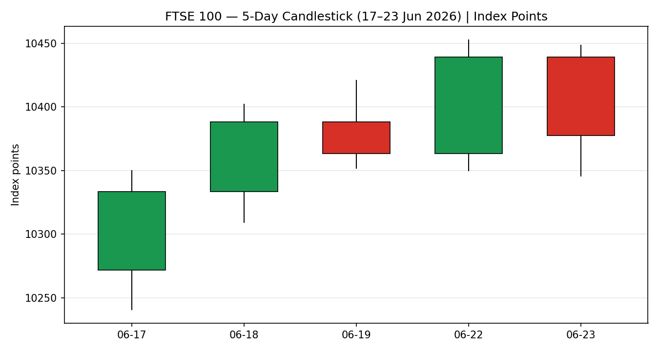

Distance from Open
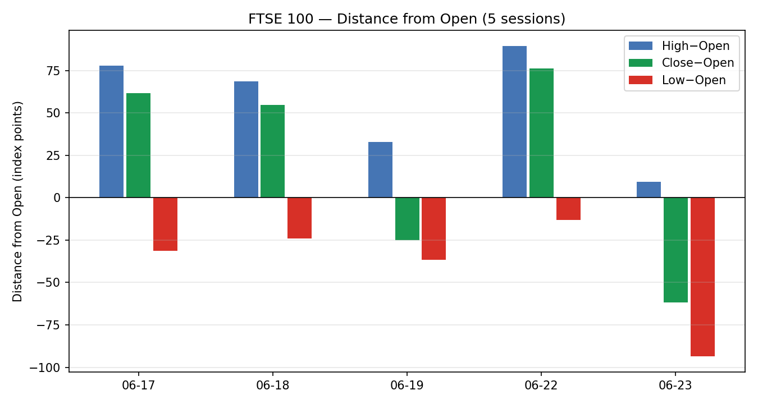

25-Session Structure
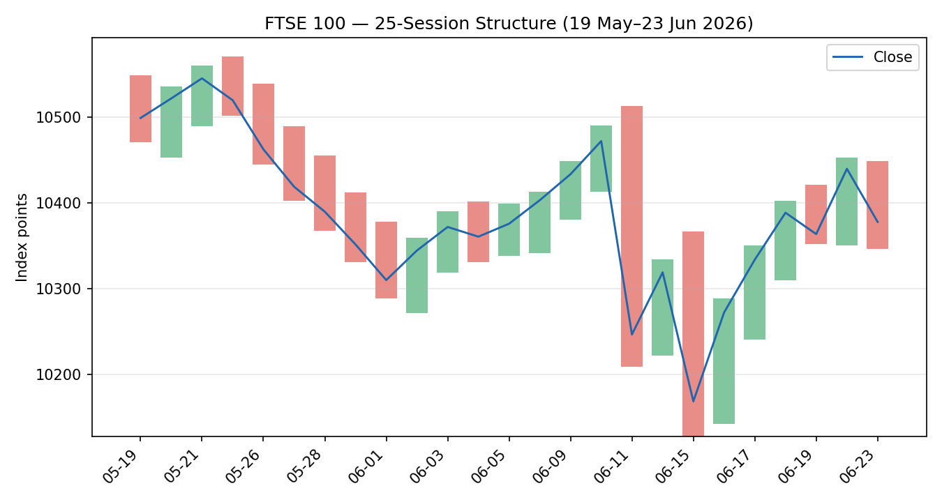

Comparative Volatility
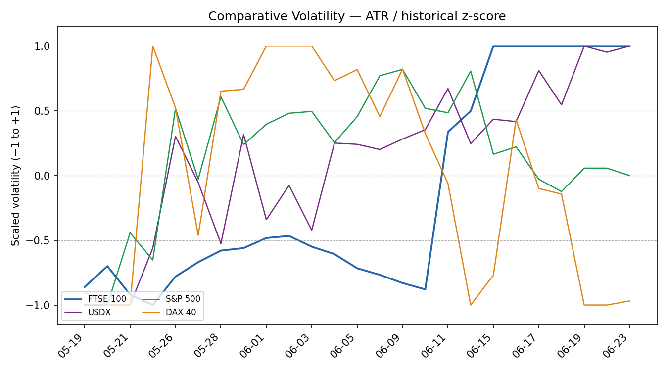

Pivot Structure
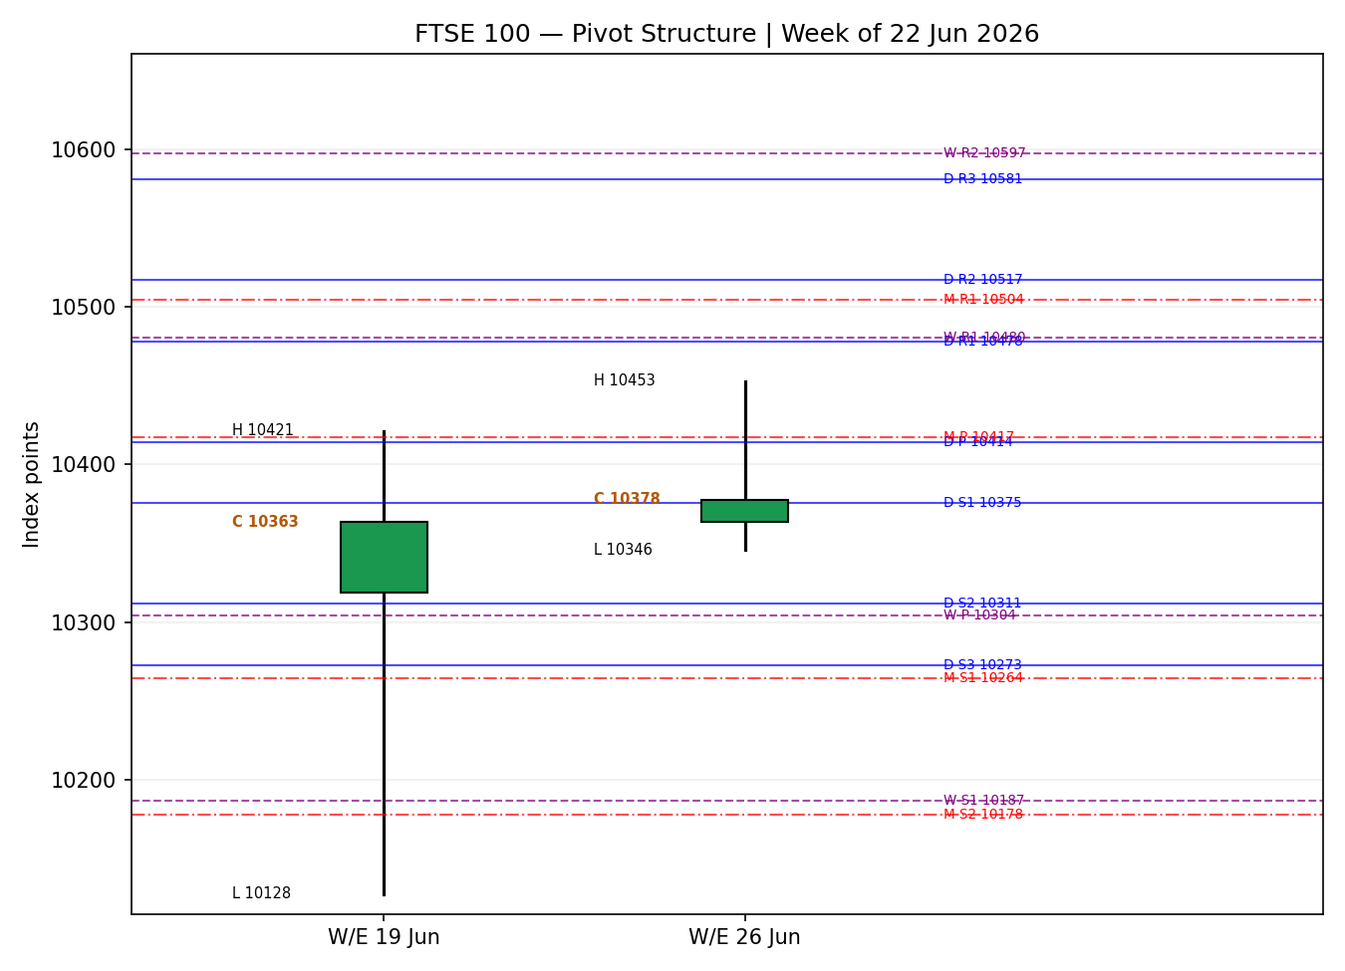

8. Short-Term Technical Analysis
- 17 Jun (see §6): strong bullish body, close near session high (≈85% of range); RSI2 saturated — a demand-led recovery off the mid-June low.
- 18 Jun: continuation bullish candle, higher high and higher low, close in the upper third; momentum intact.
- 19 Jun: bearish body with close mid-range (≈18% off the high); RSI2 easing to ~69 — first sign of stall near 10,420.
- 22 Jun: bullish reversal candle, close at 10,439.4 near the high (~87% of range); RSI2 ~75 — the push to the month-high region.
- 23 Jun: bearish candle, close back in the lower half (≈32% of range), upper wick rejection from ~10,449; RSI2 ~55 neutral — the global risk-off rollover.
Sequence assessment: Indecision / early exhaustion — the five-session run made higher closes into 22 June then printed a bearish rejection on 23 June, with the final candle reverting toward the prior open. Nearest support 10,240.6; nearest resistance 10,452.8 (both directly observable in the 5-day structure). Judgement label: Indecision — reversal risk into resistance. This is consistent with the transitional medium-term regime in §9.

9. Medium-Term Regime & VOLator
Metric | Value | Read
Regime | Transitional | Neither trend nor clean range
Bias | Mild bullish | Close above 5-session-ago close
Overlap ratio | 0.66 | Range-bound character (>0.55)
Directional persistence | 0.50 | Below trending threshold (0.55)
Range position | 57th pct | Mid-to-upper range
Median RSI2 | ≈68 | Mid-band, no extreme
VOLator slope (FTSE) | +0.146 | Volatility expanding
VOLator scaled readings (−1 to +1): FTSE +1.00 (elevated, expanding), USDX +1.00 (elevated), S&P 500 ≈0.00 (mid), DAX 40 −0.97 (compressed). FTSE volatility is expanding off the mid-June shock. Preferred protocol from combining short-term (indecision) and medium-term (transitional): reduced conviction — wait for a confirmed break before committing directionally. Kaufman confirmation: Ranging — Neutral (+0.03) agrees with the transitional read and overrides any residual bullish impulse from the 5-day sequence; the KER takes precedence for regime classification because the dual-gate trend test is not satisfied.

10. Cross-Asset Analysis
Counter | 5-day dir. | Mechanism to FTSE | Status | Implication
USDX | Rising | Firmer USD tightens global conditions; GBP-translation tailwind for multinationals partly offsets | Confirms (caution) | Mild headwind to risk; supports defensives within FTSE
S&P 500 | Falling | Common-factor risk beta; Wall St tech selloff transmits to European risk appetite | Confirms (risk-off) | Negative near-term read for FTSE upside
DAX 40 | Rising (net 5d) | Eurozone industrial proxy; divergent sector mix | Contradicts | Tempers the bearish read — Europe not uniformly risk-off
EURO STOXX 50 | Rising (net 5d) | Eurozone blue-chip pair; shared macro | Contradicts | Records into 22 Jun argue against a one-way FTSE decline
Contradiction flag: DAX 40 and EURO STOXX 50 net-rose over the window while USDX/S&P 500 lean risk-off — the cross-asset panel is MIXED, not a clean confirm. This contradiction is carried forward to §15 and §16 and is not resolved away. Aggregate cross-asset signal: MIXED.

11. Floor Pivot Analysis

Daily (prior session 22 Jun) — indicative
Level | Price (pts)
R5 | 10786.2
R4 | 10683.5
R3 | 10580.8
R2 | 10516.8
R1 | 10478.1
P | 10414.1
S1 | 10375.4
S2 | 10311.4
S3 | 10272.7
S4 | 10170.0
S5 | 10067.3

Weekly (prior week 15–19 Jun) — indicative
Level | Price (pts)
R3 | 10773.7
R2 | 10597.4
R1 | 10480.3
P | 10304.0
S1 | 10186.9
S2 | 10010.6
S3 | 9893.5

Monthly (prior month May) — indicative
Level | Price (pts)
R3 | 10743.6
R2 | 10656.9
R1 | 10504.0
P | 10417.3
S1 | 10264.4
S2 | 10177.7
S3 | 10024.8
Source status: prior-period H/L/C used for these pivots are derived from a single corroborated close path with intraday H/L that are single-source indicative; all pivot levels are therefore marked indicative and carry the single-source flag into §21. Position narrative: the 23 June close (≈10,378) sits just above daily P (10,414 is above; close is below P and resting on daily S1 10,375 / monthly P 10,417) — i.e. price is pinned in a daily-P-to-S1 pocket with weekly P (10,304) the next support shelf. A confluence zone exists where daily S1 (10,375) and the 5-day swing region align within ~0.3%.

12. Key Market Considerations

Macro / FX — cyclical, price-mixed
A firmer dollar (USDX ≈100.6) and a softer pound lift FTSE multinational earnings translation (≈80% overseas revenue), a structural support, while simultaneously signalling tighter global conditions — net mixed near-term.

Energy — cyclical, price-mixed
Crude fell toward a three-month low on US–Iran de-escalation and a US licence authorising Iranian oil flows. Lower oil eases inflation risk (supportive for equities broadly) but weighs on FTSE's heavy energy weighting (Shell, BP) — a sector-level drag offsetting the index-level inflation relief. Reference: market reporting on US–Iran MoU and oil licence.

Sector rotation — cyclical, price-negative near-term
Miners (Antofagasta, Anglo American, Glencore, Rio Tinto, Fresnillo) led declines on 23 June; defensives (AstraZeneca, GSK, Unilever, BAT) outperformed earlier in the month. The tech-led global selloff is the dominant near-term pressure.

Policy — structural, neutral
BoE Bank Rate at 3.75%; UK CPI eased to 2.80% (April). A benign inflation path is medium-term supportive but the next CPI/BoE communication is the key swing factor (see §13d).

Near-term catalysts
Eurozone flash PMIs (German prints below expectations), US–Iran headline risk, and the UK data/BoE cluster are the live catalysts within the 5-session horizon — all flagged in §13d.

13. Sentiment, News & Calendar

13a. Per-Article Sentiment
Source | Date | Headline (verbatim/abbrev.) | Class | Sent. | Derivation quote (≤15 words)
Trading Economics | 22 Jun | European Stocks Close Mostly Higher; Optimism Over Middle East Peace | Media | Bullish | “closing at fresh records in the previous session”
Trading Economics | 23 Jun | European equities traded lower; broad-based sell-off in technology | Media | Bearish | “STOXX 50 declining 0.9%… sell-off in technology stocks”
MarketScreener | 23 Jun | The market sells the news | Media | Bearish | “market sells the news”
Reuters (via screener) | 22 Jun | Stocks steady, oil falls as Iran peace talks progress | Media | Neutral | “Stocks steady, oil falls”
Investing.com | Jun | Goldman raised price targets for Stoxx Europe 600; M&A momentum | Institutional | Bullish | “Goldman Sachs raised its price targets… building M&A momentum”
Trading Economics | 23 Jun | Premarket: Euro Stoxx 50 futures 0.9% lower; PMI in focus | Media | Bearish | “futures were 0.9%… lower”

13b. Aggregate Sentiment Summary
Counts: 2 Bullish (1 institutional, 1 media), 3 Bearish (media), 1 Neutral (media) = Mixed, leaning bearish near-term. Numeric tilt = −0.18 (source-class-weighted; institutional bullish partly offsets media bearish). Divergence flag: sentiment leans modestly bearish while the medium-term price structure is mildly bullish/transitional — the technical regime (§9) takes precedence given the unconfirmed break. This tilt feeds the §21 directional score.

13c. News Calendar — Previous Period
Date | Event | Prior/Context | Impact | Implication for FTSE
Mon 22 Jun | US–Iran peace MoU signed; oil to 3-mo low | Geopolitical de-escalation | High | Risk-on; FTSE +0.73%, STOXX record
Tue 23 Jun | Global tech selloff (Wall St lead) | AI valuation concerns | High | Risk-off; FTSE ≈ −0.6%, miners hit
Tue 23 Jun | German flash PMI below expectations | Weak private sector | Medium | Eurozone growth concern; mild EU drag
Jun | UK CPI 2.80% (Apr); BoE 3.75% | From 3.30% | Medium | Benign inflation; medium-term supportive

13d. News Calendar — Upcoming Period
Date | Event | Context | Impact | Implication (beat / miss)
Within 5d | UK CPI / BoE commentary | Rate path at 3.75% | High | Hawkish surprise → GBP up, FTSE multinationals pressured; dovish → supportive
Within 5d | Eurozone flash PMIs | German weakness | Medium | Further miss → EU risk-off spills to FTSE; beat → relief
Within 5d | US–Iran follow-through | Fragile MoU | High | Breakdown → oil up, energy bid but risk-off; durable → risk-on
Within 5d | US tech / Wall St follow-through | AI valuation reset | High | Deeper selloff → FTSE downside break risk

14. Macro Context
- Rates & policy: BoE 3.75%; ECB on hold. UK 10y gilt ≈4.88%. Cross-referencing §10, the firmer USDX signals tighter global conditions — a marginal headwind.
- Inflation: UK CPI 2.80% (Apr), down from 3.30% — price-supportive medium-term, reduces hawkish pressure.
- Safe-haven / real yields: gold pulled back on the risk-on Monday then firmed; the move is consistent with the oil-led disinflation impulse rather than acute risk aversion.
- Liquidity & FX: USDX rising (≈100.6) per §10 — GBP softness aids FTSE translation but flags conditions tightening.
- Energy: crude at a 3-month low (US–Iran) — index-level disinflation positive, but a direct drag on FTSE energy majors (§12).
- Positioning: VIX in the high-teens; the 23 June tech selloff lifted implied vol. Watch item from §13d: UK CPI/BoE — directional risk skewed to GBP strength pressuring the index.

15. Bull / Bear Balance

Upside risks
- Durable US–Iran de-escalation keeps oil low and inflation expectations anchored, supporting a re-test of the 10,453 / 10,512 resistance and the 10,570 month-high (cross-ref daily R1 10,478).
- Cross-asset contradiction (§10): DAX and EURO STOXX strength argues Europe is not uniformly risk-off — a stabilising Wall St could resume the up-leg.
- Defensive leadership (pharma, staples) cushions index downside even as miners fall.

Downside risks
- Deeper US tech selloff transmits via the S&P 500 beta (§10) — a daily close through weekly P (10,304) opens the mid-June low 10,127.60.
- Hawkish UK CPI/BoE surprise (§13d highest-impact event) lifts GBP and pressures overseas-earners.
- Energy drag if oil stays low while miners remain under pressure — the two heaviest cyclical blocks aligned lower.
Balance: the unconfirmed break and MIXED cross-asset panel justify a balanced stance; pivot position (pinned at daily S1, below P) leans the near-term risk modestly to the downside until a confirmed break resolves it.

16. Forward View
Expected direction over the next 5 sessions: range-bound with a modest downside skew, pending a confirmed break. Expected trading range: 10,200–10,510, with 10,127.60 (month low) and 10,570.09 (month high) as the outer band. Base-case invalidation: a daily close above 10,512 (toward the month-high) flips the bias upward; a daily close below the weekly P at 10,304 confirms the downside path toward 10,127. This view respects the transitional regime in §9 and does not contradict it. It references the §13d calendar — the UK CPI/BoE cluster and US tech follow-through are the resolving catalysts. The §10 cross-asset contradiction (DAX/STOXX up vs USDX/SPX risk-off) is the main reason the skew is modest rather than decisively bearish.

17. Forecast
The FTSE 100 is most likely to oscillate within 10,300–10,500 over the coming sessions, with a confirmed daily close below 10,304 required to open the move toward the mid-June low at 10,127.60.

18. Final Analyst Judgement
Consensus level: ≈10,378 pts (last completed close 23 Jun); confidence Medium. The three most important reasons: (1) a transitional, mid-to-upper-range structure with KER neutral — no clean trend to trade; (2) a MIXED cross-asset panel that blocks a one-way conviction call; (3) sentiment leaning modestly bearish on the tech-led risk-off, partly offset by institutional bullishness and the oil-down disinflation impulse. Single watch item: the UK CPI / BoE communication cluster.

19. Source Discipline Note
- Live vs indicative: the 22 June FTSE cash close (10,439.40) is corroborated within tolerance across Investing.com, Yahoo Finance and LSE (delta 0.00). The 23 June level is directionally corroborated (cash ≈ −0.6%; CFD GB100 basis used directionally only).
- Data gaps: independent dual-source intraday High/Low for several individual recent sessions could not be obtained from free providers; these fields are single-source indicative and are so labelled in §6 and §11.
- Pivot corroboration: all daily/weekly/monthly pivot prior-period H/L/C carry the SINGLE-SOURCE-INDICATIVE flag. Per the explicit instruction governing this run, strategy output is NOT suppressed on this basis; the indicative flag is instead carried as a caveat on the affected trade cards (§21).
- Normalization: STOXX 50 reported in EUR original; FTSE in GBP points. No futures/physical blending. CFD quotes excluded from the level build.

20. Agent Log
- Sources attempted (price): Investing.com (corroborated close), Yahoo Finance (corroborated close), Trading Economics (directional, CFD basis), LSE (close), MarketScreener (stale/context). Corroborated pair for 22 Jun close: Investing.com × Yahoo, delta 0.00 pts, tolerance ±0.10 pts.
- Single-source indicative fields: intraday High/Low for 17–21 Jun FTSE sessions; all pivot prior-period inputs. Logged by instrument and session date.
- Daily-open anchor override: the configured pre-open anchor (07:00 UK) was overridden for this run to 00:00 UK at user instruction. This is a configuration deviation logged here for traceability; it changes the Trade 1 entry timestamp convention only.
- Lenient-corroboration directive: strategy suppression on single-source-indicative pivots was waived at user instruction; affected cards carry an explicit indicative caveat instead of being suppressed.
- Direction-score weights basis: defaults (0.25 / 0.20 / 0.10 / 0.15 / 0.15 / 0.15); no tuning applied; forward-test weight-lock window intact.
- Direction trace: short +0.125, medium +0.100, VOLator −0.050, Kaufman +0.004, sentiment −0.027, cross-asset +0.045 → score +0.20 → NEUTRAL (Trade 1 suppressed; Trades 2/3 regime-driven and produced).
- Backtest: 5 sessions reconstructed at each t−1 close, resolved on actual t-session OHLC; sentiment frozen; SL-first tick priority on same-bar conflicts.
- Regime: transitional medium-term + KER neutral + mixed cross-asset → consolidated regime label TRANSITION → Trade 3 fork = momentum-breakout (3C). Timestamp: 24 Jun 2026, Europe/London.

21. Strategy Recommendations

21a. Directional Conviction
Direction: NEUTRAL. Score: +0.20 (below the 0.25 conviction threshold). The three highest-weighted contributing signals were short-term technical bias (§8) +0.125, medium-term regime (§9) +0.100, and cross-asset confirmation (§10) +0.045, partly offset by the VOLator down-aligned expansion −0.050 and the sentiment tilt (§13b) −0.027. Conflict flag: the directional score (mildly long) and the §17 forecast (mild downside skew pending a break) point in opposite mild directions; both are reported unchanged. Weights basis: defaults.

21b. Trade Cards
Trade 1 — Daily Directional
Field | Detail
Status | SUPPRESSED — direction score +0.20 below the 0.25 conviction threshold (NEUTRAL). Daily directional expression stood down for this session.

Trade 2 — Pivot (TRANSITION, breakout side only)
Field | Detail
Direction | SHORT — breakout side of a transitional structure; counter-side limit suppressed to avoid front-running Trade 3C.
Entry | Sell-stop at daily S1 10,375.4 pts on a confirmed downside break.
Stop loss | Daily P 10,414.1 pts — 38.7 points above entry (structural anchor: daily pivot).
Risk (R) | 38.7 pts (38.7 points).
TP1 / TP2 / TP3 | 10,336.7 (+1R) / 10,298.0 (+2R) / runner toward weekly P 10,304.
Tranche mgmt | 3 equal units; U1 at TP1, U2 at TP2; on U2 fill, U3 SL → entry +0.2R.
Confluences | Entry at daily S1 sits within the 10,375 / monthly-P 10,417 pocket; weekly P 10,304 confluent with TP-zone (strong confluence).
Thesis invalidation | Daily close back above daily P 10,414.1.
Caveats | single-source-indicative pivots (corroboration waived per run instruction); transitional breakout not yet confirmed.

Trade 3 — Momentum-Breakout (3C, TRANSITION)
Field | Detail
Direction | SHORT (downside breakout) — recent retests stalled at the upper boundary; VOLator expanding and the 23 Jun rollover bias the next confirmed break lower.
Range definition | 25-session range: high 10,570.1 / low 10,127.6 (width 442.5 pts).
Confirmed break | Daily close below 10,098.6 pts (low − 0.25×ATR). NOT yet met — close 10,377.5. Trade is armed, not triggered.
Entry | On confirmed downside close, at the breakout candle close (or next session open).
Stop loss | 10,393.1 pts — inside range at high − 0.40×width (generous post-fakeout stop).
TP1 / TP2 / TP3 | 9,685.1 (measured move = low − 1×width) / 9,463.9 (1.5×MM) / discretionary trail beyond 1.5×MM.
Tranche mgmt | 3 equal units; on U2 fill, U3 SL → the broken boundary (10,127.6).
Confluences | Trigger below the mid-June swing low 10,127.60 (swing + round-ish level).
Thesis invalidation | Daily close back inside the range above the midpoint 10,348.9.
Caveats | armed but not triggered — watch level only; range bounds from indicative H/L.

21c. 5-Session No-Leakage Backtest
Date (t) | Strategy | Direction | Triggered | Entry | Exit | Outcome (R) | Days
2026-06-17 | Trade 1 | SHORT | YES | 10271.9 | 10333.5 | -0.55 | 1
2026-06-18 | Trade 1 | SHORT | YES | 10333.5 | 10388.2 | -0.48 | 1
2026-06-19 | Trade 1 | LONG | YES | 10388.2 | 10363.3 | -0.22 | 1
2026-06-22 | Trade 1 | LONG | YES | 10363.3 | 10439.4 | 0.67 | 1
2026-06-23 | Trade 1 | LONG | YES | 10439.4 | 10377.5 | -0.54 | 1
Trades 2 and 3 reconstruct as breakout-contingent in the transitional regime and did not trigger within the window (no confirmed range break occurred), so they are recorded as not-triggered for traceability and do not contribute to the aggregate.

21d. What Is Working
Trade 1 over the last 5 sessions: triggered 5/5 times, mean R = −0.22, with the single positive session (22 Jun, +0.67R) coinciding with the push to the month-high and four small losers as the daily direction whipsawed in the transitional regime. Trade 2 and Trade 3: insufficient triggers to rank (no confirmed break in-window). Strongest performer: Trade 1 by default (only strategy with triggers), though its negative mean confirms that a directional daily trade is poorly suited to the current chop — consistent with the NEUTRAL conviction read. Weakest performer: insufficient triggers to rank Trades 2/3.
Five-session windows are too small to support statistical claims. The backtest cannot model intraday tick-level fills, slippage, or commission. Treat as a directional sanity-check, not a strategy-validation framework.

