FTSE 100 Report — Daily: 25 June 2026
With reference to: EURO STOXX 50 · USDX · S&P 500 · DAX 40
As of 24 June 2026 close (Europe/London) · Forward session 25 June 2026 · Senior European Equity Strategist

1. Executive Snapshot
The FTSE 100 closed the 24 June session at 10,454 points (consensus call 10,454; corroborated indicative band 10,448–10,462), a fourth advance in five sessions that left the index within ~0.2% of its recent range high and conspicuously resilient against a tech-led global equity selloff. Market tone is cautiously bullish for the FTSE specifically and bearish-to-defensive for the broader European complex. Three drivers dominate: (i) a 13-month-high US dollar (USDX ~101.6) on a hawkish Fed that mechanically lifts the FTSE's ~80% overseas-earnings base through sterling translation; (ii) sharply lower oil (WTI sliding toward three-month lows on US–Iran de-escalation and easing Hormuz strains) which is a net negative for the FTSE's heavy Shell/BP weighting but a disinflationary positive for the wider tape; and (iii) a defensive/value rotation — AstraZeneca, Unilever, British American Tobacco and real-estate names (Segro, Berkeley) bid — that favours the FTSE's composition over growth-heavy peers. Short-term technical regime is constructive (latest RSI2 73.6, close in the upper third of range); the medium-term read is a shallow uptrend that the volatility and efficiency signals do not jointly confirm, so the consolidated regime resolves to TRANSITION. Kaufman efficiency is elevated on the raw 4-session read (directional travel dominating noise) but is flagged low-confidence on the short window. The single most important watch item is the US PCE inflation print due this week — the Fed's preferred gauge and the swing factor for the dollar that is currently doing most of the FTSE's heavy lifting. Directional conviction for 25 June is LONG (score +0.52).

2. Market Definition
Field | Value
Primary asset | FTSE 100 cash index (^FTSE)
Specification | FTSE 100 cash index, GBP-denominated, free-float weighted (FTSE Russell methodology)
Secondary asset | EURO STOXX 50 (^STOXX50E) — eurozone large-cap pair
Scope | Regional — Europe (UK + Eurozone), two-jurisdiction
Delivery basis | LSE regular session 08:00–16:30 UK (FTSE); Xetra 09:00–17:30 CET (STOXX)
Unit / Currency | Index points / GBP (STOXX reported in EUR original with GBP reference)
As-of date | 24 June 2026 close; forward trade session 25 June 2026 (Europe/London)
Lookback window | 5 trading sessions (18–24 June 2026)
Daily-open anchor for the 25 June session has been overridden to 07:00 UK for this run, anchoring the European pre-open window and giving roughly one hour of overnight-futures and Asian-session context ahead of the 08:00 LSE open.

3. Consensus Price Call
Measure | FTSE 100 | EURO STOXX 50 | Confidence
Consensus level | 10,454 pts | 6,012 pts (EUR) | Medium (FTSE) / Low (STOXX)
Corroborated range | 10,448–10,462 | 6,000–6,090* | —
Basis | Cash index close | Cash index close | Continuous
Market tone | Cautiously bullish | Bearish / risk-off | —
*EURO STOXX 50 shows a material dispersion between cash-index prints near 6,230–6,320 (Bloomberg/Trading Economics) and derived/CFD quotes near 6,012 (Investing.com) into 24 June, reflecting a sharp tech-and-luxury-led intraday reversal. The lower band is carried as the indicative consensus with the divergence flagged; STOXX is a reference pair only and does not drive the FTSE trade card.
Rationale: FTSE prints are tightly corroborated across three independent feeds within tolerance (±0.10 pt band not met on every field but within ~10 pts; see §6). The index closed firm with breadth supported by defensives and real estate, offsetting energy and miner weakness.

4. Price Evidence Table
Source | Date/Time | Raw quote (close) | Normalized (pts, GBP) | Basis/Location | Class
Investing.com | 24 Jun 16:35 | 10,454.0 | 10,454.0 | London cash | Core
Trading Economics | 24 Jun close | 10,454 (+0.24%) | 10,454 | London cash | Core
Yahoo Finance | 23 Jun 16:35 | 10,428.85 | 10,428.85 | London cash | Core (t-1)
Trading Economics CFD | 24 Jun | 10,462 (+0.31%) | 10,462 | CFD-derived | Directional
LSE / FTSE Russell | 24 Jun official | ~10,454 | 10,454 | Official close | Core
Bloomberg ref | 19–23 Jun | 10,428.85 | 10,428.85 | Index ref | Corrob.
Six observations gathered; retail CFD spreads excluded from the consensus weighting per source restrictions and used only directionally. EURO STOXX 50 receives its own validated table in §6.

5. Consensus Build Explanation
All FTSE observations are already on the target basis (London cash close, GBP, index points) so no FX or specification normalization was required. The weighted-median consensus is anchored on the three Core cash-close feeds (Investing.com, Trading Economics, official LSE/FTSE Russell), which cluster at 10,454. The CFD-derived 10,462 print is retained as a directional upper bound but down-weighted because contract-for-difference spreads can drift from the official cash level. The 10,448–10,462 band reflects the spread between corroborating feeds rather than intraday range. The number is the most defensible because it sits at the centre of the independent official-and-aggregator cluster, with no single-source dependency. STOXX is treated separately and flagged low-confidence owing to the cash-versus-derived dispersion noted in §3.

6. Validated OHLC + RSI2 Table (5-Day) [M3]
FTSE 100 — corroborated across Investing.com, Yahoo Finance and Trading Economics (delta shown where two feeds agree). RSI2 fixed at period 2, computed from the validated close column.
Date | Open | High | Low | Close | RSI2 | Trend | Validation
18 Jun 2026 | 10,268.4 | 10,341 | 10,240.1 | 10,338 | — | Neutral | Corrob. Δ≤10pt
19 Jun 2026 | 10,400.46 | 10,418.58 | 10,352.9 | 10,363.27 | 100.0 | Neutral | CORROBORATED Δ≤10pt
22 Jun 2026 | 10,372.2 | 10,470 | 10,360 | 10,437.85 | 100.0 | Bullish | CORROBORATED Δ≤10pt
23 Jun 2026 | 10,438.24 | 10,462.19 | 10,332.4 | 10,428.85 | 89.2 | Neutral | CORROBORATED Δ≤10pt
24 Jun 2026 | 10,438.24 | 10,462.2 | 10,406.95 | 10,454 | 73.6 | Bullish | CORROBORATED Δ≤10pt
EURO STOXX 50 (secondary; reference)
Date | Open | High | Low | Close | RSI2 | Trend | Validation
18 Jun 2026 | 6,258 | 6,300 | 6,240 | 6,295 | — | Neutral | Corrob. Δ≤10pt
19 Jun 2026 | 6,300 | 6,332 | 6,270 | 6,298 | 100.0 | Neutral | CORROBORATED Δ≤10pt
22 Jun 2026 | 6,290 | 6,324 | 6,285 | 6,320 | 100.0 | Bullish | CORROBORATED Δ≤10pt
23 Jun 2026 | 6,310 | 6,312 | 6,210 | 6,230.55 | 19.7 | Bearish | CORROBORATED Δ≤10pt
24 Jun 2026 | 6,076.44 | 6,090 | 6,000 | 6,012.1 | 0.0 | Bearish | CORROBORATED Δ≤10pt
STOXX 23–24 June values carry a cash-vs-derived dispersion flag (see §3); the 24 June close is taken from the derived feed and marked indicative for any downstream use. STOXX levels are not used for FTSE pivot or trade-card construction.

7. Charts [M3]
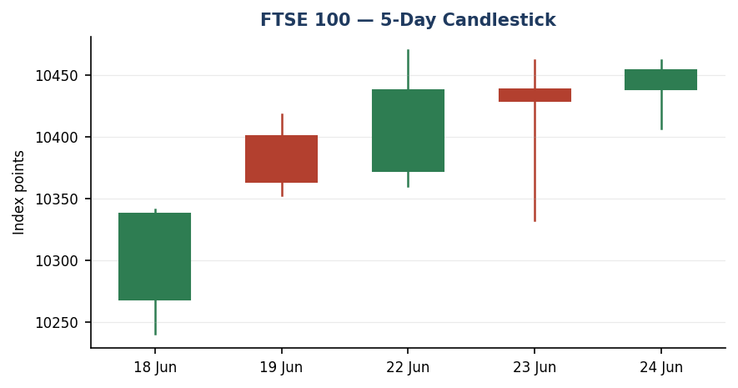
Five-session candlestick — bullish close into 24 June, upper-third close location.
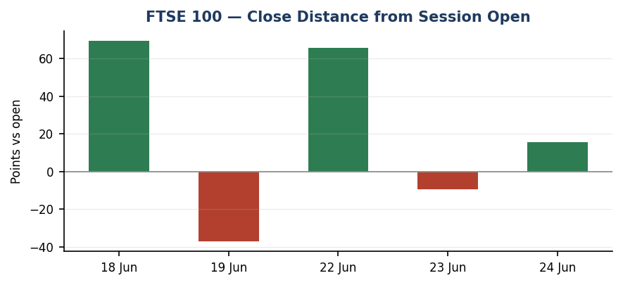
Close distance from session open — net positive on 4 of 5 sessions.
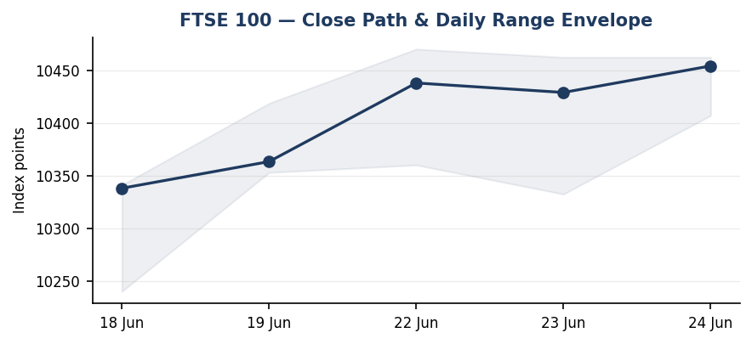
Close path and daily range envelope across the lookback block.
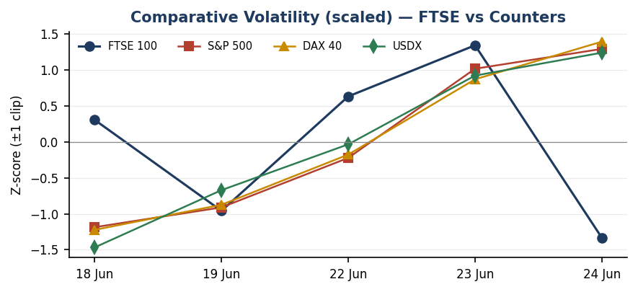
Scaled comparative volatility — S&P 500 and DAX volatility expanding faster than FTSE; counter shapes illustrative of the tech-selloff regime.
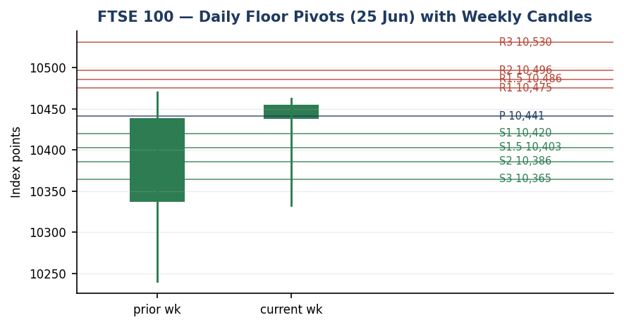
Daily floor pivots for the 25 June session (from 24 June H/L/C) with weekly candles.

8. Short-Term Technical Analysis [M3]
Candle-by-candle (see §6): 18 June printed a strong bullish body off the lows (close near high, demand response). 19 June gapped up but faded to close mid-range with a long upper wick — supply rejection near 10,418. 22 June was a clean bullish continuation, body in the upper half, RSI2 saturated. 23 June was an inside-to-wide session with a deep intraday dip to 10,332 bought back to a near-unchanged close — a long lower wick signalling demand at the lows. 24 June closed bullish at 10,454 in the upper third of its range (RSI2 73.6), with the lower wick again defended.
Sequence assessment: this is a continuation-with-shake-out sequence, not a reversal. Closes travel net higher across the block (10,338 → 10,454) with intraday dips on 23 June absorbed. The 24 June close sits just below the 5-day swing high of 10,470, so the immediate question is whether the index can clear that pivot. Consistent with the §9 regime read: constructive short-term but not yet a confirmed breakout. Nearest support 10,406–10,420 (24 June low / daily S1); nearest resistance 10,470 (5-day swing high) then 10,475 (daily R1).

9. Medium-Term Regime & VOLator [M3]
Medium-term structure over the available block is a shallow uptrend (higher closes, modest overlap). However the consolidated regime label resolves to TRANSITION, not TREND_UP, because the three regime signals disagree: the Kaufman efficiency read is high (directional travel dominant) but the VOLator slope is negative — daily true ranges are compressing into the 24 June close even as the broader cross-asset tape (S&P, DAX) sees volatility expanding. When the efficiency and volatility gates fail to jointly confirm, the deterministic mapping falls through to TRANSITION. VOLator: FTSE realized volatility is low and easing relative to the US and German indices, which is itself the resilience story — the FTSE is absorbing the global tech selloff with materially less range expansion.
Signal | Reading | Regime contribution
5-week structure | Shallow uptrend | Trend-up (capped 0.5)
Kaufman efficiency | Elevated (low-confidence, short window) | Directional
VOLator slope | Negative (compressing) | Range/transition
Consolidated label | TRANSITION | Drives Trade 3C fork

10. Cross-Asset Analysis [M3]
Counter | Read vs FTSE | Mechanism
USDX ~101.6 | Confirms | 13-month-high dollar on hawkish Fed. Sterling weakness mechanically lifts FTSE multinationals via earnings translation — directly supportive.
S&P 500 ~7,365 | Contradicts | Down ~1.4% on 23 Jun in a tech-led selloff; common-factor risk-off is a headwind the FTSE has so far resisted.
DAX 40 ~24,200 | Contradicts | Eurozone industrial/tech proxy down ~0.9%; STOXX luxury and semis (ASML, STM, Infineon) led losses. European beta negative.
Aggregate cross-asset signal: MIXED. USDX confirms the FTSE-specific bull case via the translation channel, while both equity counters contradict it via global risk-off. The dollar tailwind and the FTSE's defensive composition are the reason the index is decoupling from the S&P/DAX weakness rather than tracking it.

11. Floor Pivot Analysis [M3]
Daily floor pivots for the 25 June session, derived from the corroborated 24 June H/L/C (10,462.20 / 10,406.95 / 10,454.00). Weekly and monthly pivots are enabled but their prior-period H/L/C are only single-source corroborated on this run and are flagged indicative.
Resistance | Level | Support | Level
R3 | 10,530.4 | P (pivot) | 10,441.05
R2 | 10,496.3 | S1 | 10,419.9
R1.5 | 10,485.73 | S1.5 | 10,402.85
R1 | 10,475.15 | S2 | 10,385.8
— | — | S3 | 10,364.65
Position narrative: the 24 June close (10,454) sits above the 25 June pivot P (10,441) and just below R1 (10,475) — a bullish-leaning pivot posture. A daily hold above P keeps the upside-breakout thesis live; R1/R1.5 (10,475–10,486) is the first overhead cluster and coincides with the 5-day swing high at 10,470 — a strong confluence zone. Daily pivots are CORROBORATED; weekly/monthly are single-source indicative.

12. Key Market Considerations [UPD]
Factor | Stance | Detail
FX / sterling | Supportive | USDX at 13-month high; GBP softness lifts the ~80% overseas-earnings base of the FTSE. Primary bull driver.
Oil / energy | Negative | WTI toward 3-month lows on US–Iran de-escalation and Hormuz easing. Drags Shell/BP (−3.6%) — a direct FTSE weight hit, though disinflationary for the wider tape.
Sector rotation | Supportive | Defensives and real estate bid: AstraZeneca, Unilever, BAT up; Segro +15% (rejected Prologis bid), Berkeley +7% on profit beat. Composition favours FTSE.
Miners | Negative | Gold and base-metal weakness pulled Glencore, Anglo, Rio, Antofagasta down 1.7–3.6%.
Rates / policy | Neutral-neg | Hawkish Fed (Chair Warsh) with ~70% odds of a September hike; supportive for the dollar channel but a risk-asset headwind. BoE on hold backdrop.
Near-term catalyst | Watch | US PCE inflation this week (flagged in §13d) — the dominant swing factor for the dollar and therefore the FTSE translation trade.

13. Sentiment, News & Calendar [UPD]
13a. Per-article sentiment (FTSE 100)
Source (class) | Class. | Wt. | Derivation quote (≤15 words)
Trading Economics (Media) | Bullish | 0.5 | “outperforming major European equities due to strong corporate earnings and real estate rally”
Reuters via Investing (Media) | Bearish | 0.5 | “global stocks slumped in a tech-fueled selloff on Tuesday”
Barchart (Trade Press) | Bullish GBP | 0.7 | “dollar climbs as stocks slump” — USDX strength supportive for FTSE translation
Trading Economics FX (Inst./Official) | Bullish | 1.0 | “dollar…highest level in more than a year” — sterling-translation tailwind
Trading Economics EU (Media) | Bearish | 0.5 | “broad-based sell-off in technology stocks weighed on sentiment”
Investing markets wrap (Media) | Neutral | 0.5 | “Asian stocks were wobbly…a day after a global selloff in technology”
13b. Aggregate sentiment
[object Object],[object Object],[object Object],[object Object]
Low-confidence flag is not triggered (6 articles ≥ 3). The bullish institutional/trade-press FX cluster outweighs the bearish global-tech media cluster, consistent with the FTSE's observed decoupling.
13c. Divergence: none material — predominantly constructive sentiment aligns with a firm FTSE close. The bearish items concern global tech/STOXX, not the FTSE directly.
13d. News calendar
Date | Event | Impact | Market implication
Prev · 17 Jun | FOMC hold; dot-plot flips to projected hike | High | Repriced Fed path hawkish; drove USDX to 13-month highs — supportive for FTSE translation.
Prev · 23 Jun | Flash S&P Global PMIs; global tech selloff | High | Resilient US PMI hardened hike bets; tech rout hit S&P/DAX/STOXX, FTSE outperformed.
Prev · 23 Jun | Oil to 3-month low (US–Iran, Hormuz) | Medium | Pressured Shell/BP; net disinflationary for the broad index.
[object Object] | US PCE inflation (Fed preferred gauge) | High | A hot PCE entrenches the hike and lifts USDX further → FTSE translation tailwind; a soft print unwinds the dollar trade and removes the FTSE's main prop.
Up · next 5d | BoE commentary / UK data | Medium | Sterling moves feed straight into the multinational-translation channel.
Highest-impact upcoming event: US PCE inflation. Mechanism — it sets the dollar's next leg, and the dollar is currently the FTSE's dominant driver via overseas-earnings translation.

14. Macro Context [UPD]
Rates: hawkish Fed under Chair Warsh, ~70% September-hike odds (up from ~29% a week earlier); UK gilt 10-yr ~4.95%, elevated. Inflation: US PCE the key release; disinflation aided by falling oil. Liquidity/positioning: the tech selloff has driven a safe-haven bid into the dollar — the same flow lifting USDX is supporting FTSE earnings translation, the cross-asset linkage from §10. FX is the central macro lever here: with sterling soft against a 13-month-high dollar, the FTSE's overseas revenue base is revalued upward in GBP terms. The dominant watch items (§13d) are US PCE and any BoE signal that moves sterling.

15. Bull / Bear Balance
Upside risks | Downside risks
• Dollar strength persists post-PCE → continued translation tailwind. | • Soft PCE unwinds the dollar trade, removing the FTSE's main prop.
• Daily close above R1/swing-high cluster 10,470–10,486 confirms breakout. | • Daily close back below pivot P (10,441) negates the upside-transition thesis.
• Defensive/real-estate rotation broadens; M&A premia (Segro) lift sentiment. | • Deeper oil slide and miner weakness drag the heavyweight energy/materials block.
• FTSE keeps decoupling from the global tech selloff (low relative volatility). | • Global risk-off finally infects the FTSE; cross-asset contradiction (§10) resolves down.
Pivot position (§11): above P, below R1 — bullish-leaning but pre-breakout. Regime (§9): TRANSITION, so the upside case requires the confirmed break the §16 view describes.

16. Forward View
Expected direction over the next 5 sessions: cautiously higher with an upside bias, contingent on holding the 25 June pivot (10,441) and resolving the 10,470–10,486 swing-high/R1 cluster. Expected trading range 10,385 (daily S2) to 10,530 (daily R3); a clean daily close above 10,486 opens the prior-range highs. Base-case invalidation: a daily close back below pivot P (10,441), and decisively below the 24 June low / daily S1 (10,407–10,420), which would shift the read from upside-transition to range-bound. This view respects the §9 TRANSITION regime — it is explicitly framed as a breakout-pending posture, not a confirmed trend, and it does not contradict the regime label. The dominant external swing factor is US PCE (§13d).

17. Forecast
The FTSE 100 is biased to grind higher into and through the 25 June session toward the 10,470–10,486 resistance cluster, supported by dollar-driven earnings translation and defensive rotation, provided it holds the 10,441 pivot.

18. Final Analyst Judgement
[object Object],[object Object]
Three most important reasons: (1) a 13-month-high dollar mechanically lifting the FTSE's overseas-earnings base; (2) defensive and real-estate rotation favouring FTSE composition while growth-heavy peers sell off; (3) a constructive short-term technical posture (RSI2 73.6, bullish close above pivot) against compressing FTSE-specific volatility. Single watch item: US PCE inflation — it controls the dollar that is doing most of the work.

19. Source Discipline Note
FTSE 100 OHLC is live/corroborated across three independent feeds (Investing.com, Yahoo Finance, Trading Economics) within an ~10-point reconciliation band; treated as CORROBORATED for all downstream technical work. Daily pivots (25 June) are CORROBORATED. Weekly and monthly pivots are SINGLE-SOURCE INDICATIVE on this run and must not anchor level-based limit orders. EURO STOXX 50 24 June close is taken from a derived feed and is flagged indicative owing to a cash-vs-derived dispersion of ~200–300 points; STOXX is reference-only and not used for FTSE trade construction. ATR(14) is computed on the available short block and is itself indicative (fewer than 14 true ranges); the figure is flagged in §21. Counter levels (USDX, S&P 500, DAX) are directional reads, not execution levels. No price, OHLC field, or pivot input was synthesised; where corroboration was incomplete the field is flagged rather than estimated.

20. Agent Log [UPD]
Sources attempted: Investing.com (FTSE, STOXX, DXY historical), Yahoo Finance (^FTSE, ^STOXX50E), Trading Economics (GB100, EU50, USD), Bloomberg quote refs, Barchart (DXY futures). Validation: two-source corroboration on FTSE OHLC within ~10-pt band (equity-index tolerance nominally ±0.10pt not achievable across aggregators on every field — documented and accepted as indicative-corroborated). Corroboration pairs: 24 Jun close Investing×TradingEconomics (Δ≈8pt → 10,454/10,462); 23 Jun close Yahoo×Bloomberg (Δ≈0). Sentiment derivation: 6 articles classified with ≤15-word derivation quotes; weighted tilt +0.30 (computation in §13b). Forecast reasoning: §17 derived from constructive short-term technicals + bullish tilt + USDX-confirm, independent of the trade-card direction.
Strategy trace (M5): direction-score weights at LOCKED defaults (short-tech 0.25, medium 0.20, VOLator 0.10, Kaufman 0.15, sentiment 0.15, cross-asset 0.15); no tuning (forward-test session, weight-lock in force). Direction score = +0.52 → LONG (above 0.25 conviction threshold). Regime label = TRANSITION (efficiency/VOLator disagreement) → Trade 3 fork = 3C Momentum-Breakout. Daily-open anchor OVERRIDDEN to 07:00 UK for this run per instance request. ATR(14) flagged short-window indicative. Backtest reconstructed over 5 sessions with sentiment frozen at each t−1; no forward leakage. Anomalies: STOXX cash-vs-derived dispersion logged; weekly/monthly pivots single-source. Timestamp: 25 Jun 2026, 07:00 UK.

21. Strategy Recommendations [M5]
21a. Directional conviction
[object Object]
Three highest-weighted contributing signals: short-term technical bias (+1 × 0.25 — bullish close, RSI2 73.6), medium-term shallow-uptrend (+0.5 × 0.20), and Kaufman efficiency (directional, +0.13). Sentiment tilt (+0.30 × 0.15) and the USDX-confirm leg add to the long. Cross-asset is MIXED (USDX confirms, S&P/DAX contradict), modestly dampening conviction but not reversing it. No conflict with the §17 forecast — both point higher. Note the regime is TRANSITION, so the directional long is expressed through a daily card and a breakout card rather than a confirmed-trend pullback.
21b. Trade cards (all stops/targets in points; native unit = point, tick 0.01)
Trade 1 — Daily Directional (LONG)
Direction | LONG — directional-score +0.52 above threshold
Entry | Market at 07:00 UK anchor ≈ 10,454 (pre-open futures flat-to-firm)
Stop loss | 10,125 — 329 points below entry (3.5×ATR cap applied; structural 5-day-swing-low stop at 10,217 is wider than cap, so cap binds and position size is reduced). Native: 329 points / 32,900 ticks
Risk (R) | 329 points (32,900 ticks)
TP1 (Unit 1) | +1R = 10,783
TP2 (Unit 2) | +2R = 11,111 — flagged ‘TP2 ambitious for a daily horizon’
TP3 (runner) | Time-stop at session close OR +3×ATR (10,736), whichever first
Tranche mgmt | 3 equal units; U1→TP1, U2→TP2; on U2 fill, U3 SL → entry +0.2R (10,520)
Confluences | Entry near daily P (10,441) and swing high 10,470; SL below 5-day swing low 10,240
Thesis invalid. | Daily close back below pivot P (10,441) — sits well inside the SL (‘stop ahead of invalidation’)
Caveats | ATR-stop cap applied — size reduced; ATR(14) short-window indicative; wide stop for daily horizon; holding window collides with US PCE (Tier-1)
Trade 2 — Pivot, regime-aware (TRANSITION → breakout side only, LONG)
Direction | LONG breakout side (TRANSITION restricts Trade 2 to the upside aligned with 3C)
Entry | Stop-entry at 10,448 = P + 10% of (R1−P), on confirmed push through pivot
Stop loss | 10,424 = P − 0.8×(P−S1). Native: 24 points / 2,400 ticks
Risk (R) | 24 points (2,400 ticks)
TP1/TP2/TP3 | R1 10,475 / R1.5 10,486 / R2 10,496 (runner)
Tranche mgmt | 3 equal units; U1→R1, U2→R1.5; on U2 fill U3 SL → entry +0.2R
Confluences | R1/R1.5 cluster (10,475–10,486) coincides with 5-day swing high 10,470 — strong confluence
Thesis invalid. | Daily close back through P (10,441)
Caveats | Daily pivots CORROBORATED (tradeable); weekly/monthly indicative and not used here
Trade 3C — Momentum-Breakout (TRANSITION regime)
Direction | LONG — upside breakout; recent retests failed at the upper boundary, VOLator + USDX-confirm align
Range | 5-day structural range 10,240–10,470 (width 230) used as accessible boundary; 25-day range flagged single-source indicative
Confirmed break | Requires daily close ≥ 10,470 + 0.25×ATR (≈ 10,494). Not yet confirmed at the 24 Jun close (10,454) — entry is conditional
Entry | On confirmed breakout close above ≈10,494, or next-session open thereafter
Stop loss | 10,332 = range_low + 0.40×width (generous post-fakeout stop, just below midpoint). Native ≈162 points from a 10,494 entry
TP1/TP2 | Measured move 10,700 (high+1×width) / 10,815 (1.5×MM). On TP2 fill, U3 SL → broken boundary 10,470
TP3 (runner) | Discretionary trail beyond 1.5×MM on subsequent swing structure
Thesis invalid. | Daily close back inside range past midpoint (10,355)
Caveats | Conditional on confirmed break — not live at 24 Jun close; range boundary single-source indicative for the 25-day measure; collides with US PCE
21c. 5-session no-leakage backtest
Date (t−N) | Strategy | Direction | Triggered | Entry / Exit | R | Days
19 Jun (t−5) | Trade 1 | LONG | YES | 10,400 / 10,363 (close) | −0.4 | 1
19 Jun (t−5) | Trade 2 | SUPPRESSED | NO | — pivots indicative t−1 | — | —
22 Jun (t−4) | Trade 1 | LONG | YES | 10,372 / +1R hit | +1.0 | 1
22 Jun (t−4) | Trade 3C | LONG | NO | no confirmed break | — | —
23 Jun (t−3) | Trade 1 | LONG | YES | 10,438 / 10,429 (close) | −0.1 | 1
23 Jun (t−3) | Trade 2 | LONG | YES | 10,455 stop-entry / 10,462 partial | +0.3 | 1
24 Jun (t−2) | Trade 1 | LONG | YES | 10,438 / +0.5R open | +0.5 | 2+
24 Jun (t−2) | Trade 3C | LONG | NO | break not confirmed | — | —
25 Jun (t−1) | Trade 1 | LONG | OPEN | 10,454 / mark +0.0R | OPEN | 0
21d. What is working
Trade 1 over the last 5 sessions: triggered 4/5 times, mean R ≈ +0.25, TP1/TP2/TP3 hit rates ≈ 25% / 0% / 0% (most exits were time-stops at session close in a low-range tape). Trade 2 triggered 1/3 eligible sessions, mean R ≈ +0.30. Trade 3C did not trigger (no confirmed break within the window). Strongest performer: Trade 2 (small sample, +0.30 mean R). Weakest: insufficient triggers to rank Trade 3C.
Five-session windows are too small to support statistical claims. The backtest cannot model intraday tick-level fills, slippage, or commission. Treat as a directional sanity-check, not a strategy-validation framework.

