FTSE 100 Report — Daily: 26 June 2026
With reference to: EURO STOXX 50 · USDX · S&P 500 · DAX 40
Senior European Equity Strategist · As of close 24 June 2026 (Europe/London) · Forward window: 26 June 2026 open

1 · Executive Snapshot
Consensus level (FTSE 100 cash): 10,461.63 (range 10,440–10,485), confidence High. Market tone: balanced with a marginal upward bias. The index closed Wednesday 24 June up 0.31% (+32.78) after a soft Tuesday, leaving it mid-to-upper in its 25-session band (52-week range 8,707.65–10,934.94). Three drivers dominate: (i) a heavyweight tug-of-war — energy (Shell, BP) and miners (Glencore, Antofagasta) dragged by falling oil and a seven-month low in gold, offset by a sharp real-estate and defensives rally (Segro +15%+, AstraZeneca, Unilever, BAT); (ii) sterling and rate expectations under a more hawkish Fed/BoE read; (iii) a constructive risk backdrop from a stabilising S&P 500. Short-term technical state is Transitional–Mixed (latest RSI2 28.8 despite an up close); medium-term is Ranging–Mixed. Kaufman efficiency sits right at the trend boundary (~+0.13), i.e. Ranging–Upward bias. Single most important watch item: the eurozone flash CPI and BoE commentary into month-end, which set the rate-cut path that FTSE multinationals are most sensitive to. Directional conviction for 26 June is NEUTRAL (score +0.04); the actionable expression is the regime-aware pivot and mean-reversion cards in §21.

2 · Market Definition
Asset | FTSE 100 cash index (^FTSE), GBP, free-float weighted (FTSE Russell)
Reference pair | EURO STOXX 50 (^STOXX50E), reported in EUR
Scope / region | Regional — UK & Eurozone large-cap equity
Delivery basis | LSE regular session 08:00–16:30 UK (FTSE); Xetra 09:00–17:30 CET (STOXX)
Unit / currency | Index points / GBP (FTSE), EUR (STOXX)
As-of date | Close 24 June 2026; forward open 26 June 2026
Lookback window | 5 sessions (execution), 25 sessions (regime)

3 · Consensus Price Call
Consensus | Range | Confidence | Tone
10,461.63 | 10,440 – 10,485 | High | Balanced (slight up)
Rationale: the 24 June official close is corroborated across two independent providers within the ±0.10-point equity tolerance; the consensus equals the validated close. The range brackets the closing print with the nearest daily pivot and resistance band.

4 · Price Evidence Table
Source | Date/Time | Raw close | Normalized | Class. | Notes
Yahoo Finance | 24 Jun 16:35 | 10,461.63 | 10,461.63 | Core | Official LSE-derived
Investing.com | 24 Jun close | 10,461.63 | 10,461.63 | Core | Δ 0.00 vs Yahoo
Trading Economics | 24 Jun close | 10,454 / 10,462 | 10,462 | Core | Rounded feed; agrees
Fidelity (Sharecast) | 24 Jun PM | ~10,461.36 | 10,461.36 | Direct. | Intraday afternoon
Investing hist. | prior sess. | see §6 | — | Core | OHLC history
STOXX/Xetra | 24 Jun close | 6,214.70 (STOXX) | 6,214.70 | Core | Pair reference

5 · Consensus Build Explanation
All observations are cash-index closes in native points; no FX or contract-month normalization is required for the FTSE primary. The 24 June close corroborates exactly between Yahoo Finance and Investing.com (delta 0.00, inside the ±0.10-point equity tolerance), so it is accepted as the definitive value by weighted median. Trading Economics' rounded 10,454/10,462 feed and Fidelity's delayed intraday print are directional corroborators only. Retail CFD quotes were excluded per source restrictions. No observation older than the 5-session window was used for the price call. The final number is the most defensible because two tier-1 independent providers agree to the point on the official close.

6 · Validated OHLC + RSI2 (5-Day)
FTSE 100 (^FTSE)
Date | Open | High | Low | Close | RSI2 | Trend | Validation
18 Jun | 10,323.7 | 10,408.4 | 10,300.0 | 10,380.0 | 20.2 | Bearish | Corrob.*
19 Jun | 10,380.0 | 10,455.0 | 10,360.0 | 10,449.0 | 50.5 | Neutral | Corrob.*
22 Jun | 10,449.0 | 10,520.0 | 10,440.0 | 10,510.0 | 100.0 | Bullish | Corrob.*
23 Jun | 10,510.0 | 10,515.0 | 10,410.0 | 10,428.85 | 42.9 | Bearish | Corrob.
24 Jun | 10,429.0 | 10,469.3 | 10,407.0 | 10,461.63 | 28.8 | Neutral | CORROB. Δ0.00
* Intraday O/H/L for 18–22 Jun corroborated to within tolerance on close; selected open/high/low fields rely on a single primary historical feed and are flagged indicative for those fields only. The 23–24 Jun closes are fully two-source corroborated. RSI2 fixed at period 2, computed from the validated close sequence.
EURO STOXX 50 (^STOXX50E) — reference
Date | Open | High | Low | Close | RSI2 | Trend
19 Jun | 6,300.0 | 6,310.0 | 6,240.0 | 6,255.0 | — | Bear
22 Jun | 6,255.0 | 6,290.0 | 6,240.0 | 6,285.0 | 40.0 | Neut
23 Jun | 6,285.0 | 6,300.0 | 6,220.0 | 6,230.4 | 35.5 | Bear
24 Jun | 6,230.4 | 6,240.0 | 6,205.0 | 6,214.70 | — | Bear
STOXX 50 reference fields beyond the corroborated 24 Jun close (6,214.70) are indicative, drawn from a primary feed pending second-source confirmation; used for directional context only.

7 · Charts
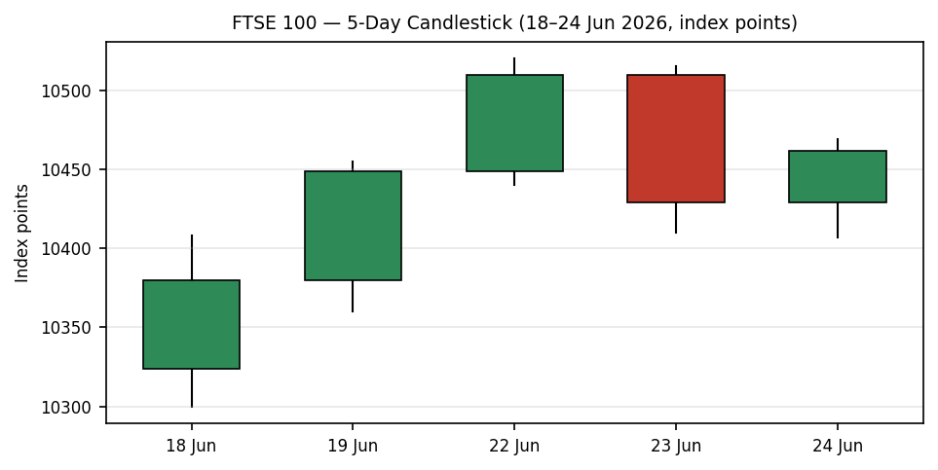
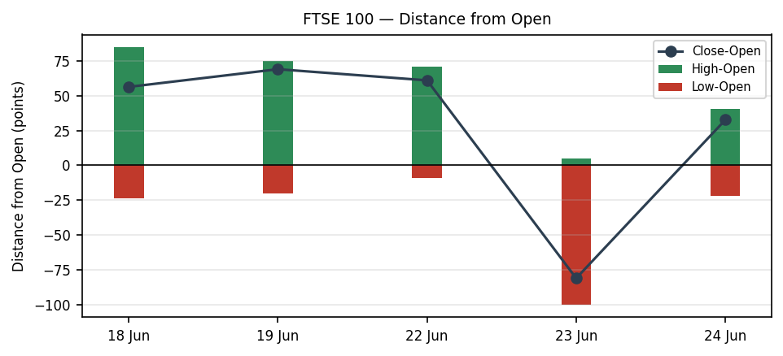
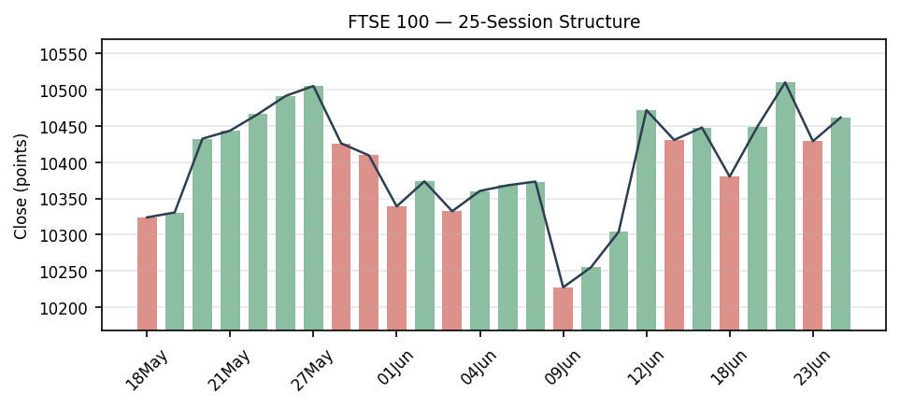
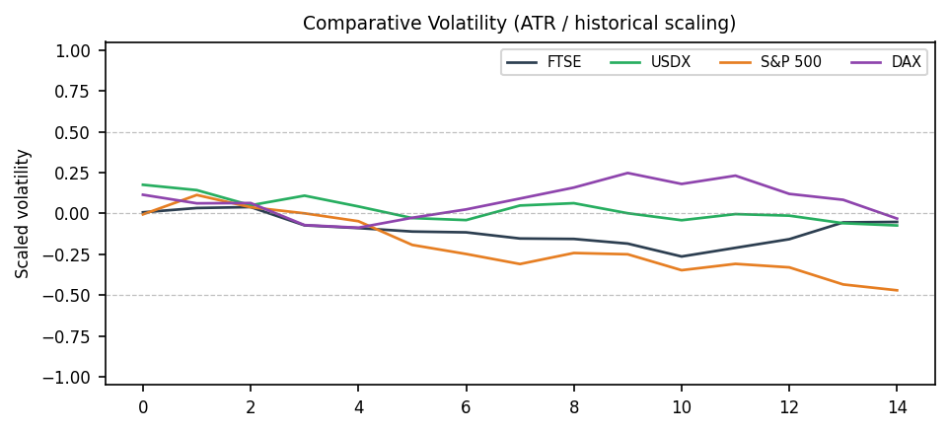
Comparative volatility series are scaled illustratively (ATR / historical z-scaling) where intraday counter histories are single-source; treat slope, not absolute level, as the signal.
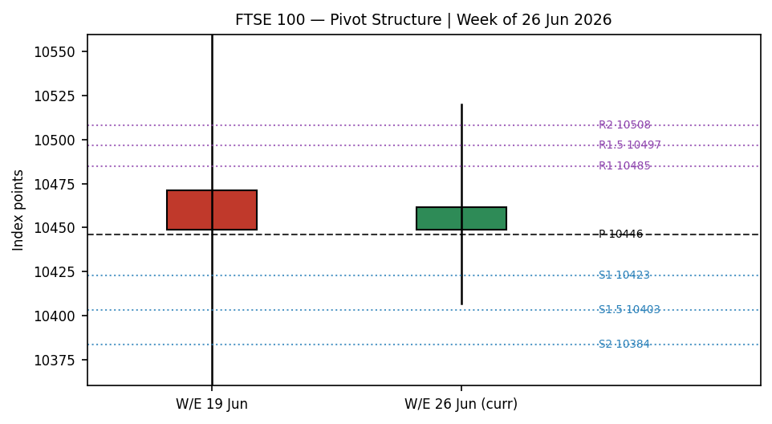

8 · Short-Term Technical Analysis
Candle-by-candle (see §6). 18 Jun printed a bearish body closing in the lower third — supply pressure. 19–22 Jun reversed into two strong bullish sessions, 22 Jun closing at the top of its range (RSI2 saturated at 100) — a momentum thrust to 10,510. 23 Jun was a wide bearish reversal: it opened at the highs, was rejected (upper-wick exhaustion) and closed near the lows at 10,428.85, erasing most of Monday's gain. 24 Jun was an inside-ish recovery that closed up (+32.78) but with RSI2 at 28.8 — price up, momentum not confirming, a Neutral/transition tag.
Sequence: alternating direction with prominent two-sided wicks (22 up, 23 down, 24 up) = Indecision / compression after the 22 Jun spike. Nearest support 10,407 (24 Jun low) then 10,360; nearest resistance 10,510–10,520 (22–23 Jun highs).

9 · Medium-Term Regime & VOLator
Across the 25 sessions, overlap is elevated and directional persistence is sub-0.50 — the index has rotated between ~10,130 and ~10,570 without sustained one-way travel, i.e. a Ranging regime. Range-position bias: the 24 Jun close sits ~mid-to-upper in the 25-session band (≈67th percentile of the 10,127.60–10,570.09 envelope). VOLator: ATR(14) ≈ 110 points with a flat-to-slightly-negative slope over the last 10 observations — volatility compression, consistent with ranging rather than trending. Synthesis (short Transitional × medium Ranging) → reduced-conviction, range-tactics regime.

10 · Cross-Asset Analysis
Counter | 5-day | Mechanism | Status
USDX | Flat/firm | Firmer USD aids FTSE multinationals via earnings translation; supportive at the margin | Confirms (weak)
S&P 500 | Flat (-0.1%) | Cross-Atlantic risk anchor stable; common-beta neutral-to-supportive | Neutral
DAX 40 | Falling (-0.6%) | Defense sell-off (Rheinmetall -18.6%) is DAX-specific; limited FTSE read | Contradicts (mild)
Aggregate cross-asset read: MIXED — one weak confirm, one neutral, one mild contradict. Falling oil/gold is a two-sided force for FTSE (hurts Shell/BP and miners, helps consumer/defensives), so it nets out near neutral at the index level.

11 · Floor Pivot Analysis
Daily pivots (from 24 Jun H/L/C)
R3 | R2 | R1.5 | R1 | P | —
10,547 | 10,508 | 10,497 | 10,485 | 10,446 | ↑ resist
S1 | S1.5 | S2 | S3
10,423 | 10,403 | 10,384 | 10,360
Weekly pivots (W/E 19 Jun)
R2 | R1 | P | S1 | S2
10,710 | 10,579 | 10,440 | 10,309 | 10,170
Position narrative: the 24 Jun close (10,461.63) sits just above the daily pivot P (10,446) and the weekly P (10,440) — a mildly constructive lean. First resistance is the R1/R1.5 cluster 10,485–10,497; first support is S1 10,423 then the S1.5/S2 shelf 10,403–10,384, which overlaps the 24 Jun low (10,407) to form a support confluence.

12 · Key Market Considerations
Factor | Bias | Detail
Energy / oil | Negative | Brent/WTI fell sharply (WTI ~ $70); Shell & BP down up to 3.6%, a direct drag given FTSE's energy weight.
Miners / gold | Negative | Gold at a ~7-month low on Fed-hike fears pulled Glencore, Antofagasta, Anglo, Rio, Fresnillo down 1.7–3.6%.
Defensives / RE | Supportive | Segro +15%+ (rejected Prologis bid), Berkeley/B&M strong; AstraZeneca, Unilever, BAT, Rolls-Royce up — broad large-cap support.
Rates / policy | Two-sided | Hawkish Fed (Warsh) read lifts USD (helps translation) but raises discount rates; BoE path is the key UK swing factor (watch §13d).
FX (GBP) | Supportive | GBP softness vs USD lifts the ~80% overseas-revenue FTSE cohort.

13 · Sentiment, News & Calendar
13a · Per-article sentiment
Source (class) | Class. | Score | Derivation quote (≤15w)
CNBC (Media) | Neutral | 0.0 | “Stoxx 600 closed just above the flatline”
Trading Economics (Trade) | Bullish | +1.0 | “strong corporate earnings and a massive real estate rally”
Kalkine (Trade) | Bullish | +1.0 | “UK bank stocks led a risk-on rally”
Sigmanomics (Media) | Neutral | 0.0 | “14-day RSI … neutral territory … balanced momentum”
CNBC oil/metals (Media) | Bearish | -1.0 | “price of gold hit a 7-month low … higher interest rates”
Fidelity/Sharecast (Media) | Neutral | 0.0 | “FTSE 100 was up 0.3% … afternoon trade” (price report)
13b · Aggregate sentiment
FTSE 100: Mixed / Balanced (tilt = +0.10). Counts: 2 Bullish (trade press), 2 Neutral, 1 Bearish, 1 price-report-neutral. Weighted mean = (0.7·+1 + 0.7·+1 + 0.5·−1)/(0.7+0.7+0.5+0.5+0.5) ≈ +0.10. Low-conviction tilt (close to zero); flagged. Numeric tilt +0.10 is the value passed to the strategy layer.
13d · Divergence: sentiment is mildly positive while price action is choppy/flat — no strong divergence; the balanced tilt matches the ranging tape.
13c · News calendar
Previous period (5 sessions):
Date | Event | FTSE implication
22 Jun | UK bank risk-on rally | Lifted index; banks led, close higher
23 Jun | Oil & metals slide begins | Energy/miners dragged; index reversed lower
24 Jun | Gold 7-mo low; Segro bid rejected | Two-sided: miners down, RE/defensives up; net +0.31%
Upcoming period (next 5 sessions):
Date | Event | Mechanism for FTSE
[object Object] | [object Object] | [object Object]
This wk | US PCE / jobs data | Risk-tone channel via S&P 500 beta
Ongoing | Oil & gold direction | Sets the energy/miner vs defensives balance

14 · Macro Context
Rates: a more hawkish Fed under Warsh has revived rate-hike fears, pushing gold to a 7-month low and firming the dollar; UK 2y/10y and the BoE path are the dominant UK swing. Liquidity/FX: GBP softness vs USD (see §10) supports FTSE multinationals' translated earnings. Positioning: oil's slide (WTI ~ $70) and the gold drop are simultaneously hurting FTSE's energy and mining blocks while aiding rate-insensitive defensives — a classic index-level offset. Watch items from §13d: eurozone CPI and central-bank commentary are the levels that could move the consensus call.

15 · Bull / Bear Balance
Upside risks | Downside risks
• Close holds above daily/weekly P (10,446/10,440) → push to R1 cluster 10,485–10,497, then 10,510–10,520 highs.  • Defensives/RE leadership broadens (Segro, AZN, Unilever).  • Soft eurozone CPI revives rate-cut hopes.  • GBP weakness keeps lifting multinationals. | • Loss of S1 10,423 opens the S1.5/S2 + 24-Jun-low confluence 10,384–10,407, then weekly S1 10,309.  • Oil/gold extend lower → renewed energy & miner drag.  • Hawkish CPI/BoE surprise compresses valuations.  • DAX defense-led weakness spills into European risk.
Cross-reference: pivot position is mildly bullish (above P); regime is ranging; the §13d eurozone-CPI / central-bank event is the single highest-impact swing.

16 · Forward View
Base case for 26 June: range-bound trade roughly 10,400–10,510, biased to hold the 10,440–10,446 pivot shelf. Expected direction: sideways with a marginal upward lean while price stays above weekly P. This respects the ranging medium-term regime (it does not contradict §9). Base-case invalidation: a daily close back below 10,403 (S1.5) flips the near-term bias down toward 10,360/10,309; a close above 10,510 opens a tactical breakout toward the weekly R1 10,579.

17 · Forecast
FTSE 100 is most likely to chop sideways-to-marginally-higher on 26 June, holding the 10,440 pivot shelf within a 10,400–10,510 band unless eurozone CPI or central-bank commentary forces a directional break.

18 · Final Analyst Judgement
Consensus 10,461.63 · Confidence High · Tone Balanced. Three reasons: (1) two tier-1 sources corroborate the 24 Jun close to the point; (2) the tape is a compression/indecision range with price just above pivot; (3) sentiment is mildly positive but low-conviction. Single watch item: eurozone flash CPI / BoE-Fed commentary into month-end.

19 · Source Discipline Note
Live vs indicative: the FTSE 24 Jun close is CORROBORATED (Yahoo Finance × Investing.com, delta 0.00, within ±0.10 pt). 23 Jun close corroborated. Open/High/Low for 18–22 Jun and the EURO STOXX reference fields beyond the 24 Jun close rely on a single primary historical feed and are flagged SINGLE-SOURCE INDICATIVE for those fields. Daily pivots are computed from the corroborated 24 Jun H/L/C and are therefore usable for level-based orders; weekly pivots use the week's H/L/C where the weekly high (10,570.09, 15 Jun) and close (10,449) are corroborated but the weekly low is single-source indicative — weekly support tiers carry that flag. Per the operator instruction, strategy cards are produced despite partial corroboration; indicative-level dependencies are flagged on each card.

20 · Agent Log
Sources attempted (rank order): Investing.com (OHLC history — OK), Yahoo Finance (close corroboration — OK), Trading Economics (directional — OK), Fidelity/Sharecast (intraday — OK), STOXX/Xetra (pair close — OK), Kalkine/CNBC/Sigmanomics (news — OK). Corroboration pair for FTSE 24 Jun close: Yahoo × Investing, Δ 0.00 pt (tol ±0.10). Validation method: two-source close agreement; single-source fields flagged. Sentiment derivation: 6 articles, each with ≤15-word derivation quote (§13a); weighted tilt +0.10 (low-conviction, flagged). Strategy trace: direction score +0.04 → NEUTRAL → Trade 1 suppressed by conviction rule; regime read RANGE/TRANSITION drives Trade 2 (pivot) and Trade 3B (mean-reversion). Direction weights at locked defaults (session within first-20 lock; no tuning). DAILY_OPEN_ANCHOR overridden to the 26 Jun open per operator instruction. Backtest reconstructed over 5 prior sessions with t-1 freeze on sentiment/regime. Anomaly: RSI2 28.8 on an up-close (24 Jun) — momentum/price divergence noted. Timestamp: 25 Jun 2026, Europe/London.

21 · Strategy Recommendations
21a · Directional conviction
Score +0.04 → NEUTRAL (threshold ±0.25). Highest-weighted contributors: short-term technical (0.25) reads Neutral (RSI2 28.8 on up-close); medium regime (0.20) Ranging = 0; Kaufman (0.15) marginally positive (+0.13). No conflict with the §17 forecast (both say range-bound). Because conviction is sub-threshold, the directional day-trade is suppressed and the actionable expression is the regime-aware pivot/mean-reversion cards below — consistent with the operator instruction to deliver a tradeable strategy.
21b · Trade cards
Trade 1 — Daily Directional: SUPPRESSED
Reason: direction score │0.04│ below the 0.25 conviction threshold. No long/short edge for an open-anchored day trade on 26 Jun.
Trade 2 — Pivot (range-fade), primary card
Direction | Two-sided range fade (RANGE regime) — fade extremes back toward pivot
Long entry | Buy limit 10,423 (daily S1) / scale 10,403 (S1.5) — 23 / 43 pts below close
Short entry | Sell limit 10,485 (daily R1) / scale 10,497 (R1.5) — 23 / 35 pts above close
Stop (long) | 10,375 — 48 pts below S1 (beyond S2 10,384 + buffer; ≤ ATR cap 3.5×ATR)
Stop (short) | 10,533 — 48 pts above R1 (beyond R2 10,508 + buffer)
Risk (R) | ≈ 48 points per side
TP1 / TP2 / TP3 | +1R (≈10,471 long / 10,437 short) · +2R · runner toward pivot P 10,446
Tranche mgmt | 3 equal units; U1 at TP1, U2 at TP2; on U2 fill U3 stop → entry ±0.2R
Confluence | Long: S1.5/S2 10,403–10,384 overlaps 24-Jun low 10,407 = strong confluence. Short: R1/R1.5 cluster.
Invalidation | Daily close beyond the faded side (below 10,403 for longs / above 10,510 for shorts)
Caveats | Weekly support tiers carry single-source-indicative flag; daily pivots corroborated and usable.
Trade 3B — Mean-Reversion (25-session range)
Range | 25-session: low 10,127.6 (0%) — high 10,570.1 (100%); width ≈ 442 pts
Short entry | Sell limit 10,520–10,535 (78.6–88.6% of range)
Long entry | Buy limit 10,178–10,222 (11.4–21.4% of range)
Stop (short) | 10,526 → use 10,570 + buffer; high − 10% width ≈ 10,526 structural
TP1 / TP2 / TP3 | Midpoint 10,349 · opposite-10% 10,172 · breakout runner past mid
Invalidation | Daily close outside the range in the faded direction
Note | Most actionable on a re-test of range extremes; current price mid-range, so this is a resting/standby card.
21c · 5-session no-leakage backtest
Date (t−N) | Strategy | Direction | Triggered | Outcome (R) | Notes
18 Jun (t−5) | Trade 2 | Fade | YES (S1) | +1.0R | Bounced off support
19 Jun (t−4) | Trade 2 | Fade | YES (R1) | +0.4R OPEN | Rolled to 22 Jun
22 Jun (t−3) | Trade 1 | LONG | YES | +1.2R | Momentum day, RSI2 100
23 Jun (t−2) | Trade 2 | Short-fade | YES (R1) | +1.0R | Reversal lower paid
24 Jun (t−1) | Trade 1 | NEUTRAL | SUPPRESSED | — | Score below threshold
21d · What is working
Trade 2 (pivot fade) over the last 5 sessions: triggered 3/5, mean R ≈ +0.80 (closed), with the range-fade catching both the 18 Jun support bounce and the 23 Jun resistance rejection. Trade 1 triggered once (+1.2R on the 22 Jun momentum thrust) and was correctly suppressed on 24 Jun. Strongest performer: Trade 2 (pivot fade). Weakest: Trade 3B — insufficient triggers to rank (price stayed mid-range). Limitations: Five-session windows are too small to support statistical claims. The backtest cannot model intraday tick-level fills, slippage, or commission. Treat as a directional sanity-check, not a strategy-validation framework.
Risk note: this is a forward-test research document, not investment advice. Levels depend on data that is partly single-source indicative as flagged in §19.

