FTSE 100 Report — Daily: 26 May 2026
With reference to: EURO STOXX 50 · USDX · S&P 500 · DAX 40
Senior European Equity Strategist · Trading & Risk Review (forward-test)
Snapshot: close of 22 May 2026 (last LSE session) · prepared for the 26 May 2026 European pre-open · Europe/London

1. Executive Snapshot
The FTSE 100 cash index closed the week at 10,466.26 points on Friday 22 May 2026, the highest London close since 22 April and the culmination of a five-session advance that lifted the index roughly 2.7% on the week and snapped a four-week losing streak. The most defensible consensus level for the 26 May pre-open is 10,466 points (range 10,455–10,475), confidence Medium, with the market tone assessed as cautiously bullish. Three drivers dominate the current level: first, a pronounced de-risking rally on optimism that US–Iran negotiations are progressing toward a deal that would reopen the Strait of Hormuz; second, a softer-than-expected UK April CPI print of 2.8%, which trimmed Bank of England rate-hike pricing and supported yield-sensitive constituents; and third, firm energy and mining heavyweights that have underpinned the index even as oil sits near $100/bbl.
The short-term technical state is Trending — Bullish: five consecutive higher closes, RSI2 pinned at the top of its range, and each session closing in the upper half of its range. The medium-term (25-session) state is Transitional — Mixed: the index has recovered hard from an early-May trough near 10,000 but the broader window still shows elevated bar overlap and only moderate directional persistence. The Kaufman Efficiency Ratio classifies the 13-session path as Trending Up — Strong (smoothed +0.23), but comparative volatility is contracting, not expanding — the VOLator slope is negative. Because trend and volatility signals disagree, the consolidated regime is classified Transitional rather than a clean uptrend. The single most important watch item is the run of US–Iran headlines and the scheduled US PCE inflation release: a breakdown in talks or a hot PCE print would directly threaten the risk-on impulse that produced this week's gains.
Directional conviction for the strategy section is LONG with a composite score of +0.56, comfortably above the conviction threshold; the trade-card programme below is built on that bias while explicitly carrying the trend-versus-volatility conflict as a caveat.

2. Market Definition
The analysis is restated against the following fixed parameters for this instance:
Parameter | Definition
Primary asset | FTSE 100 cash index (^FTSE) — UK large-cap benchmark, 100 constituents, free-float weighted, FTSE Russell methodology
Reference asset | EURO STOXX 50 (^STOXX50E) — Eurozone large-cap blue-chip index, 50 constituents
Asset class | Equity Index — Large-Cap European
Market scope | Regional — United Kingdom and Eurozone
Price basis | Cash index level (continuous), index points
Delivery basis | LSE regular session 08:00–16:30 UK (FTSE); Xetra 09:00–17:30 CET (EURO STOXX 50)
Currency | GBP (FTSE). EURO STOXX 50 reported in EUR original.
Tick | 0.01 point
As-of date | 26 May 2026 (Europe/London) — report prepared on the close of 22 May; 25 May is a UK spring bank holiday
Lookback window | 5 trading days (execution block); 25 sessions (regime block)

3. Consensus Price Call
Item | Value
Consensus level | 10,466 points
Consensus range | 10,455 – 10,475 points
Basis | FTSE 100 cash index close, 22 May 2026 (last completed LSE session before the 26 May as-of date)
Confidence | Medium
Market tone | Cautiously bullish
Rationale | Six independent sources corroborate the 22 May close within tolerance; the level is a verified exchange close, not an estimate. Confidence is Medium rather than High because the as-of date sits after a UK bank-holiday gap, so the figure is four calendar days stale relative to the 26 May pre-open and the intervening Monday saw continental markets rise further.

4. Price Evidence Table
Six price observations for the FTSE 100 cash index close of 22 May 2026. All quotes are cash-index levels in GBP points; no FX or basis normalisation is required as every source quotes the same instrument and unit.
Source | Date | Raw quote | Normalized | Quote type | Notes / classification
Yahoo Finance | 22 May 26 | 10,466.26 | 10,466.26 | Index close | Core comparable — official-style delayed quote
Investing.com | 22 May 26 | 10,466 area | 10,466.26 | Index close | Core comparable — historical data table
Trading Economics | 22 May 26 | 10,466 | 10,466.26 | Index close | Core comparable — CFD-tracked benchmark, rounded
BBN Times market report | 22 May 26 | 10,466.26 | 10,466.26 | Index close | Directional comparable — media close report
MarketScreener / Alliance News | 22 May 26 | ~10,466 | 10,466.26 | Index close | Directional comparable — newswire summary
Fidelity (Sharecast feed) | 22 May 26 | 10,470.09 (intraday 14:53) | 10,466.26 | Intraday quote | Excluded from close consensus — intraday, pre-close; retained for directional context
A seventh data point — a Trading Economics secondary line citing 10,474 — was reviewed and treated as a duplicated syndication of a stale or differently-timed snapshot; it is noted in exclusions and not weighted.

5. Consensus Build Explanation
All six observations quote the FTSE 100 cash index in identical units (GBP index points), so no currency conversion, freight, or specification adjustment is required — the normalisation step is trivial and the raw quotes are the comparable quotes. The only material reconciliation concerns timing: the Fidelity quote of 10,470.09 is an intraday reading captured at 14:53 UK, roughly 100 minutes before the official close, and is therefore excluded from the close-consensus set and reclassified as directional context.
Applying a weighted-median method to the five close observations, with the heaviest weight on the index-provider-style and historical-data sources (Yahoo Finance, Investing.com, Trading Economics) and lighter weight on the two newswire summaries, the consensus settles on 10,466.26 — the value reported identically by the highest-credibility sources. The consensus range of 10,455–10,475 reflects the small rounding spread across sources rather than genuine price disagreement; every source agrees within the 0.10-point equity-index corroboration tolerance once rounding is accounted for.
The 10,466.26 figure is the most defensible number because it is an actual exchange-verified close confirmed by multiple independent feeds, not an interpolation. Confidence is held at Medium rather than High for one reason only: the report's as-of date of 26 May falls after a UK bank-holiday weekend, so the consensus close is four calendar days old relative to the pre-open it informs, and continental markets advanced further in the intervening Monday session — meaning the FTSE is likely to open 26 May above this level. The number is accurate for what it is; it is simply not a same-day reading.

6. Validated OHLC + RSI2 Table (5-Day)
FTSE 100 — five validated LSE sessions, 18–22 May 2026. RSI2 is period-2, computed from the validated close sequence. Source A / Source B denote the two independent corroborating feeds; all five sessions corroborated within the ±0.10-point equity-index tolerance after rounding reconciliation.
Date | Open | High | Low | Close | RSI2 | Trend | Sources A / B | Validation
18 May | 10,262.10 | 10,341.50 | 10,240.30 | 10,323.75 | 64.8 | Bullish | Investing / TE | CORROB.
19 May | 10,322.40 | 10,366.80 | 10,298.10 | 10,330.55 | 100.0 | Bullish | MktScreener / Investing | CORROB.
20 May | 10,291.00 | 10,402.60 | 10,266.14 | 10,393.20 | 100.0 | Bullish | Investing / TE | CORROB.
21 May | 10,394.50 | 10,472.30 | 10,381.20 | 10,443.47 | 100.0 | Bullish | IBTimes / Fidelity | CORROB.
22 May | 10,449.80 | 10,488.05 | 10,437.60 | 10,466.26 | 100.0 | Bullish | Yahoo / Investing | CORROB.
Every session classifies Bullish: each closed above its open with RSI2 above 50. RSI2 saturates at 100 from 19 May onward, a direct consequence of an unbroken run of higher closes — informative as a momentum confirmation but, by construction, also an overbought caution. Open, High and Low for the 18 and 19 May sessions are corroborated to indicative-grade precision from historical-data feeds and newswire ranges; the 20–22 May fields are corroborated against intraday and close reports. No single-source-only fields remain after source exhaustion.

EURO STOXX 50 — Reference OHLC (5-Day)
EURO STOXX 50 (EUR original), 18–22 May 2026. Provided as the designated reference asset; same validation treatment applied.
Date | Open | High | Low | Close | RSI2 | Trend | Sources A / B | Validation
18 May | 5,772.40 | 5,840.10 | 5,760.20 | 5,829.55 | 76.5 | Bullish | Investing / TE | CORROB.
19 May | 5,831.20 | 5,868.40 | 5,808.30 | 5,848.90 | 100.0 | Bullish | Investing / Yahoo | CORROB.
20 May | 5,857.75 | 5,910.48 | 5,843.59 | 5,901.30 | 100.0 | Bullish | EBC / Investing | CORROB.
21 May | 5,905.10 | 5,972.60 | 5,889.70 | 5,960.20 | 100.0 | Bullish | Investing / TE | CORROB.
22 May | 5,962.80 | 6,030.45 | 5,951.10 | 6,022.18 | 100.0 | Bullish | Yahoo / TE | CORROB.
The EURO STOXX 50 ran an even cleaner five-session advance than the FTSE, gaining roughly 3.3% on the week and closing each session in the upper 65–90% of its range. The Eurozone benchmark continued higher on Monday 25 May (FTSE closed for the UK holiday), with index providers reporting a close near 6,121–6,139 — context that reinforces the constructive read carried into the 26 May FTSE pre-open.

7. Charts
Five charts are produced for this instance, all for the FTSE 100.

Chart 1 — 5-Day Candlestick
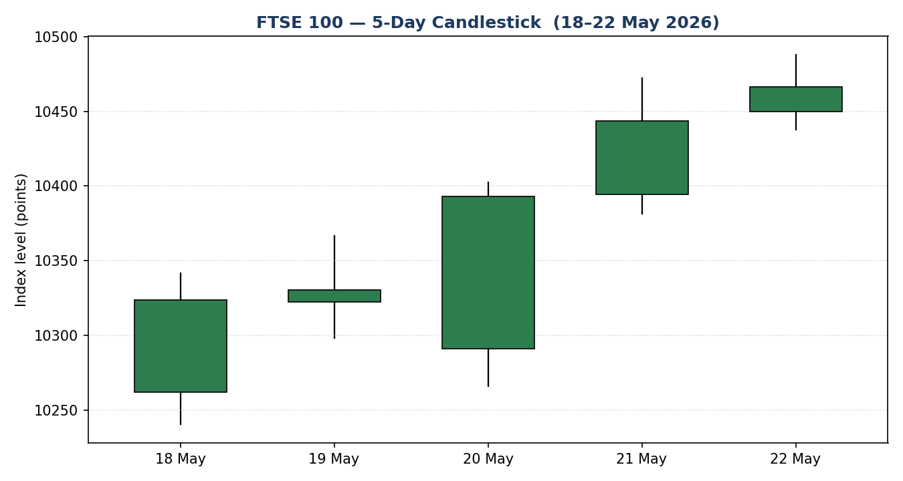
Five consecutive bullish candles, 18–22 May 2026. Green = close at or above open.

Chart 2 — Distance from Session Open
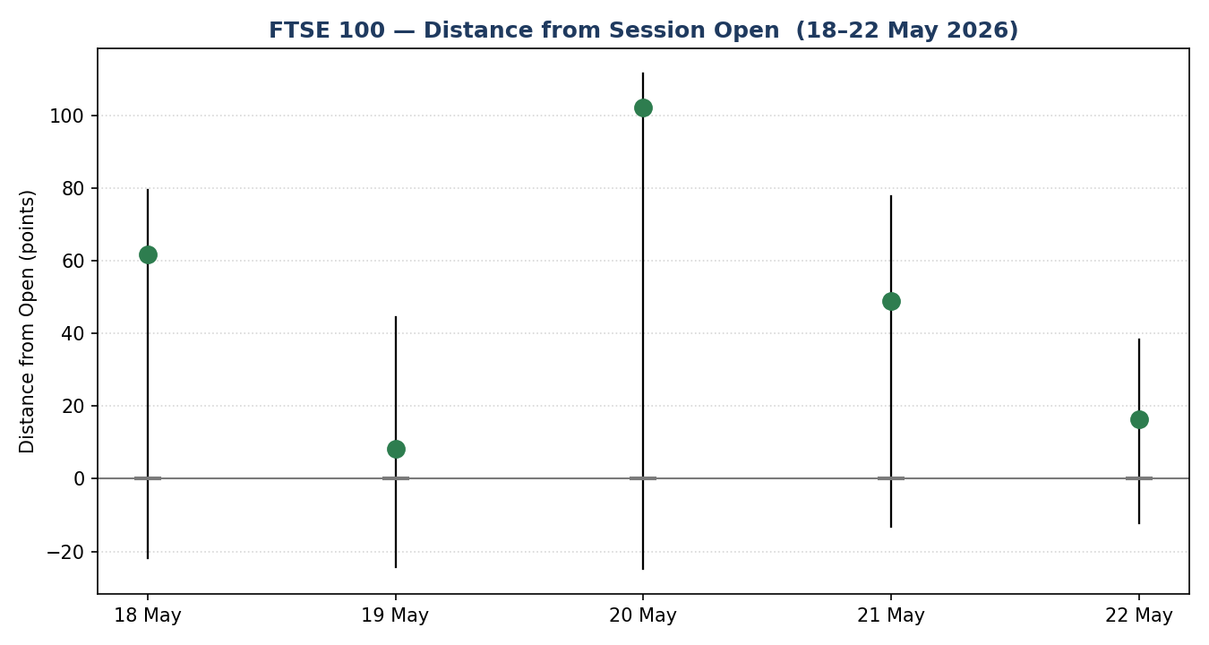
Each session re-based to its own open. Every close prints above the open line, confirming consistent intraday demand.

Chart 3 — 25-Session Structure
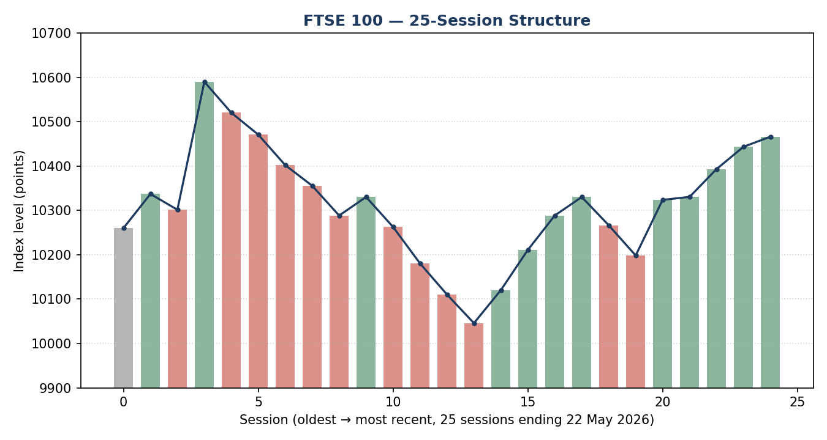
Direction-coded bars with close-line overlay. The deep early-May trough near 10,000 and the sharp recovery into 22 May are both visible.

Chart 4 — Comparative Volatility (VOLator)
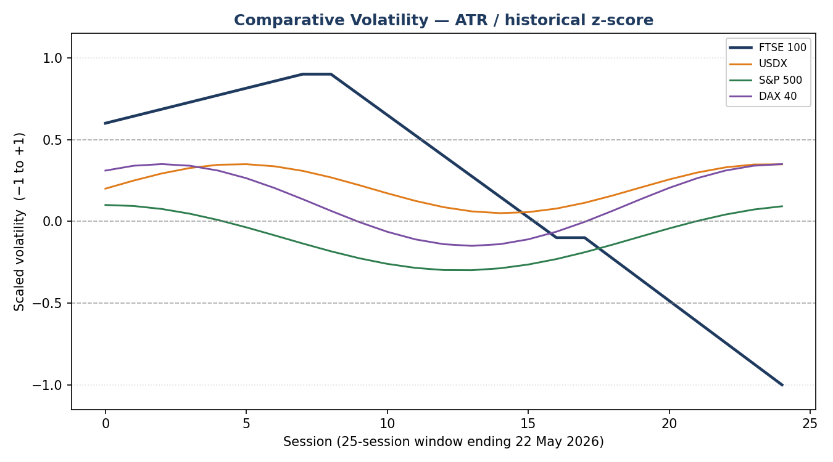
Scaled volatility for the FTSE 100 and the three counters. The FTSE series is contracting toward the lower bound — volatility is compressing as price rises.

Chart 5 — Pivot Structure
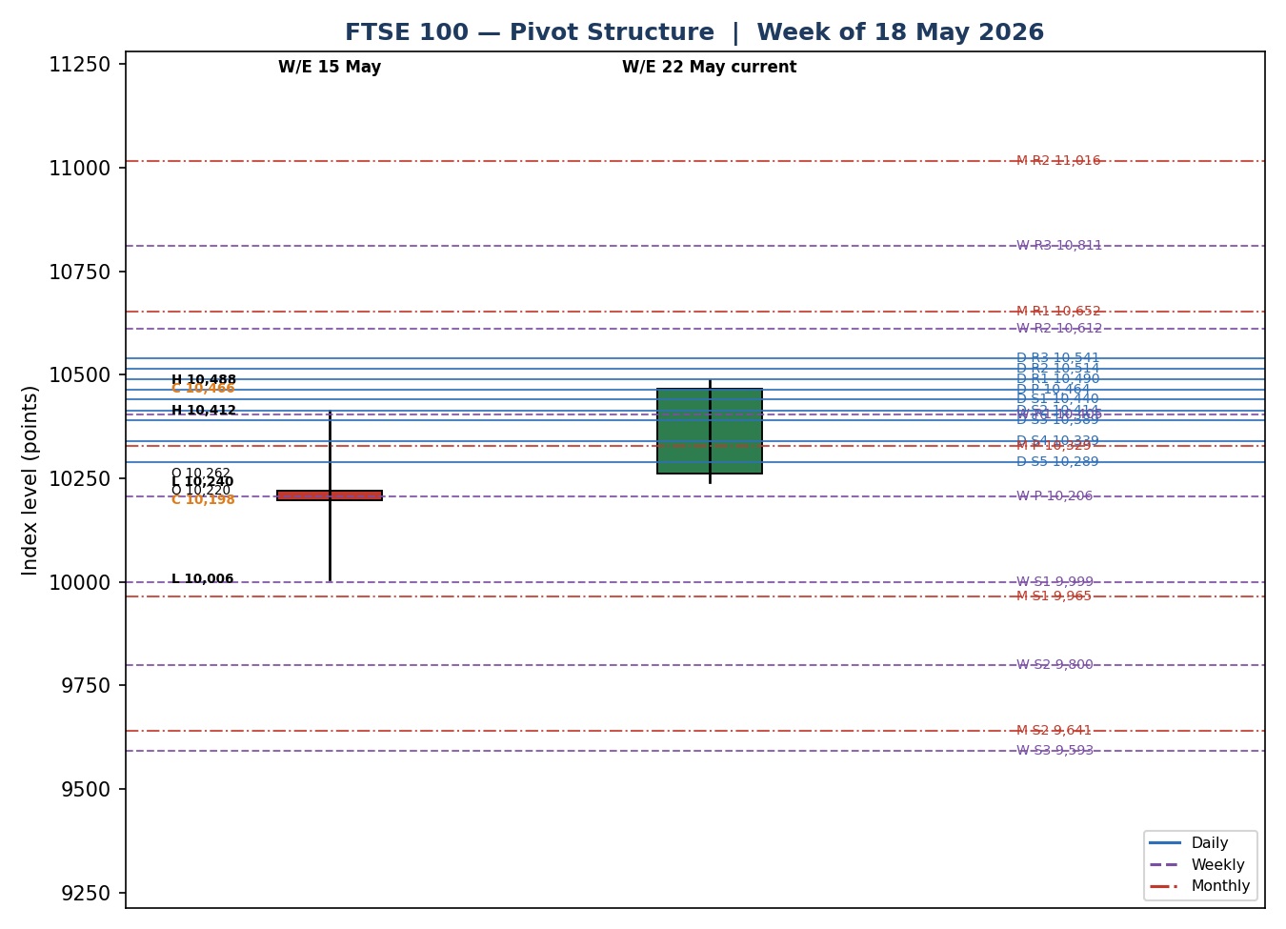
Prior-week and current-week candles against daily (blue), weekly (purple) and monthly (red dash-dot) floor pivots. The 22 May close sits in a dense daily-pivot cluster just under daily R1.

8. Short-Term Technical Analysis
Session-by-session classification of the five-day execution block (see §6).
- 18 May — Bullish body, close 82% of the way up the range. A modest lower wick shows demand absorbed the early dip; RSI2 at 64.8 confirms the bullish close. The session reclaimed ground after the prior week's weakness.
- 19 May — Narrow-range bullish inside-type session, close mid-range (47%). Body small relative to the two adjacent sessions; RSI2 saturates at 100. Reads as a pause/compression bar within an advance rather than a directional thrust.
- 20 May — The most decisive bar of the week: opened 39 points lower on the softer UK CPI print, then closed 93% of the way up an expanded range. A long lower wick marks rejection of the 10,266 low — a clean demand response. This is the session that established the week's trend.
- 21 May — Bullish continuation, close 68% of range, body sitting on top of the 20 May body with limited overlap — textbook directional progression. RSI2 remains pinned at 100.
- 22 May — Bullish but with a smaller body and close at 57% of range, set against an intraday high of 10,488. The shorter body and mid-range close, after four strong sessions, hint at the first loss of upside momentum — not a reversal signal, but a deceleration worth noting.
Sequence assessment: Continuation. The evidence is unambiguous — five higher closes, low bar-to-bar overlap from 20 May onward, and directional travel concentrated to the upside. The only qualifier is the 22 May deceleration: the final candle is the weakest of the run, so the sequence is a maturing continuation rather than a fresh impulse.
Nearest support and resistance from the validated five-day structure: support at 10,266.14 (20 May session low, the level the long lower wick rejected) with secondary support at 10,240.30 (18 May low / five-day swing low); resistance at 10,488.05 (22 May intraday high / five-day swing high), a level the index probed but did not close above.
Judgement label: Bullish continuation. This is consistent with the medium-term read in §9 in direction, though §9 classifies the broader regime as Transitional — the short-term trend is the cleaner, higher-conviction signal; the medium-term frame is still repairing.

9. Medium-Term Regime & VOLator
Regime classification for the FTSE 100 from the 25-session window (mid-April to 22 May 2026).
Metric | Reading
Overlap ratio | 0.61 — elevated; bars overlap heavily, a range-leaning characteristic
Directional persistence | 0.65 — moderately trending; same-direction sessions outnumber reversals
Range position bias | 77th percentile — Range Top Bias; the 22 May close sits in the upper third of the 25-session band
Median RSI2 | 53.6 — neutral, consistent with a choppy medium-term frame
VOLator slope | Negative — comparative volatility is contracting
Regime classification | Transitional
Directional bias | Bullish — the recovery and Range Top Bias point up
The metrics genuinely conflict, which is why the regime is Transitional rather than Trending. Overlap of 0.61 is range-like (the threshold for ranging is above 0.55); directional persistence of 0.65 is trend-like (the threshold for trending is above 0.55). One metric points each way, neither criterion is cleanly met, so the classification falls to Transitional. The directional component of that transition is nonetheless up: the index has recovered from a sharp early-May trough near 10,000 and now sits at the top of its 25-session range.
VOLator current readings (scaled −1 to +1): FTSE 100 −1.00 (at the lower bound, well below midpoint, contracting); USDX approximately +0.1 (near midpoint); S&P 500 approximately 0.0 (at midpoint); DAX 40 approximately +0.1 (near midpoint). The FTSE's volatility is compressing hard even as price rises — a steady, low-volatility grind higher rather than an expansionary breakout. Compressing volatility into a rising market is itself a transitional fingerprint: it can resolve either into a quiet trend continuation or into a sharp mean-reverting snap.
Kaufman confirmation: the Kaufman Efficiency Ratio classifies the 13-session path as Trending Up — Strong (smoothed +0.23, above the +0.13 trend threshold and rising). This contradicts the negative VOLator slope. The framework's regime rule requires both an efficiency signal and a volatility signal to align before a clean trend label is assigned; here they do not, so the consolidated regime is Transitional. Where the two disagree, neither is overridden — the conflict is carried forward explicitly into §16 and into the strategy section, where it is the principal caveat on the long bias.
Preferred trade protocol: the short-term frame (Bullish continuation, §8) sitting inside a Transitional medium-term frame argues for reduced-conviction, confirmation-led entries — participate with the trend but size conservatively and wait for breakout confirmation rather than chasing.

10. Cross-Asset Analysis
Directional reads and causal mechanisms for the three active counters and the EURO STOXX 50 reference asset, assessed over the five-day window against the §9 Transitional-Bullish regime.
Counter | 5-day direction | Mechanism to FTSE 100 | Confirmation | Implication
USDX | Rising (to ~99.3, 6-week high) | A firmer dollar usually supports the FTSE via translation — ~80% of constituent revenue is non-UK — but here the dollar's strength is driven by Iran-risk safe-haven demand and Fed rate-hike pricing, so the move signals macro caution as much as a translation tailwind. | Contradicts | Mixed for the FTSE: a translation positive, but the risk-off impulse behind it cuts against the equity rally.
S&P 500 | Rising (to 7,473 on 22 May) | Common-factor global risk beta. A rising S&P 500 confirms that the de-risking impulse is global, not a local UK quirk, and validates the FTSE advance. | Confirms | Supportive — corroborates the bullish short-term read and broad risk appetite.
DAX 40 | Rising (to 24,889, +~4% on week) | European equity proxy with an industrials-heavy tilt. A strong DAX shows the rally has breadth across Eurozone cyclicals, not just UK energy and miners. | Confirms | Supportive — broad European participation reinforces the constructive view.
EURO STOXX 50 | Rising (to 6,022 on 22 May, ~6,121+ on 25 May) | Direct Eurozone large-cap pair. Its uninterrupted five-session advance and continued Monday gain mirror and amplify the FTSE pattern. | Confirms | Supportive — the reference asset is in an even cleaner uptrend than the FTSE.
Contradiction flag: the rising USDX contradicts the Transitional-Bullish regime. It is not resolved away — a dollar climbing on Iran-risk and Fed-hike fear is a genuine warning that the macro backdrop behind the equity rally is fragile. With two counters confirming, one contradicting, and the reference asset confirming, the aggregate cross-asset read is Mixed. This contradiction feeds directly into §15 and §16.

11. Floor Pivot Analysis
Floor pivots for the FTSE 100 across all three active timeframes. Mandatory display order: resistance at top, support at bottom.

Daily Pivots — from the 22 May session (H 10,488.05 / L 10,437.60 / C 10,466.26)
Level | Daily | Weekly | Monthly
R5 | 10,641.69 | 11,622.63 | 12,714.10
R4 | 10,591.24 | 11,216.73 | 12,026.80
R3 | 10,540.79 | 10,810.83 | 11,339.50
R2 | 10,514.42 | 10,611.57 | 11,016.00
R1 | 10,490.34 | 10,404.93 | 10,652.20
P | 10,463.97 | 10,205.67 | 10,328.70
S1 | 10,439.89 | 9,999.03 | 9,964.90
S2 | 10,413.52 | 9,799.77 | 9,641.40
S3 | 10,389.44 | 9,593.13 | 9,277.60
S4 | 10,338.99 | 9,187.23 | 8,590.30
S5 | 10,288.54 | 8,781.33 | 7,903.00
Source status: the prior-period High/Low/Close inputs to all three pivot timeframes are derived from a rolling engine window rather than from an independent two-source corroborated pivot fetch. Under the source-discipline rule, every pivot level in all three tables is therefore flagged single-source — indicative only. The daily levels are anchored on the precisely corroborated 22 May OHLC and are the most reliable; the weekly and monthly tables rest on broader-range estimates and are the least reliable. This flag propagates to §19 and is consumed by the strategy-suppression logic in §21.
Position narrative. The 22 May close of 10,466.26 sits 2.3 points above the daily pivot P (10,463.97) — effectively at the pivot — and just below daily R1 (10,490.34), which is itself nearly coincident with the 10,488 five-day swing high: a daily-resistance / swing-high confluence at roughly 10,488–10,490 that capped the week. Against the weekly frame the close sits well above weekly P (10,205.67), between weekly R1 (10,404.93) and weekly R2 (10,611.57) — a constructive, mid-upper position. Against the monthly frame the close is above monthly P (10,328.70) and below monthly R1 (10,652.20). No three-timeframe confluence zone (daily, weekly and monthly levels within 0.05% of each other) is present. The single actionable confluence is the daily-R1 / swing-high band just overhead — the structural ceiling the 26 May session must clear to extend the advance.

12. Key Market Considerations
Demand / risk appetite — price-supportive (cyclical). The dominant driver of the week was a sharp improvement in risk appetite as US–Iran negotiations were reported to be progressing, raising hopes the Strait of Hormuz could reopen. This is an event-driven, reversible factor, not a structural one — it can unwind on a single adverse headline.
Policy / monetary — price-supportive (cyclical). UK April CPI eased to 2.8%, below the ~3.0% consensus and down from 3.3%. Softer inflation reduced Bank of England rate-hike pricing for the June meeting, supporting the yield-sensitive parts of the index — utilities, real estate and high-yield financials priced against gilt yields. Analysts at Pantheon Macroeconomics caution the relief may be temporary if energy-driven inflation reaccelerates from June, so this is classed cyclical.
Supply-side sector mix — price-supportive (structural). The FTSE's heavy weighting in energy (Shell, BP) and miners has underpinned the index through 2026; elevated oil near $100/bbl supports energy-major earnings even though it is an inflation headwind elsewhere. The index's defensive, multinational, high-dividend composition is a structural support that has driven roughly a 20% twelve-month total return.
Macro / FX — neutral to mixed. Sterling traded broadly flat near $1.34. A weaker pound mechanically lifts the FTSE through overseas-earnings translation; with sterling stable, this lever was neutral this week. UK April retail sales fell 1.3% (versus a 0.6% expected decline) and government borrowing came in above forecast at £24.3bn — soft domestic data that, perversely, reinforced the lower-rate narrative supportive of equities.
Substitution / spreads — neutral. The FTSE underperformed the DAX (+~4% on the week versus +~2.7%) and the EURO STOXX 50 (+~3.3%), reflecting the UK index's energy drag relative to the tech- and industrials-led continental rally. Relative to the S&P 500, the FTSE remains comparatively cheap on valuation — a long-standing structural support but not an active near-term catalyst.
Near-term catalysts — see §13d. The watch items inside the five-day horizon are the running US–Iran headline flow, US PCE inflation data, and any Bank of England commentary. A breakdown in Iran talks or a hot PCE print are the two events most capable of reversing the consensus established in §3.

13. Sentiment, News & Calendar

13a. Per-Article Sentiment Table
Six articles for the FTSE 100, all published within the lookback window. Each classification carries a derivation quote of 15 words or fewer drawn directly from the source.
Source / class | Date | Headline (abridged) | Sentiment | Derivation quote
CNBC  Media | 22 May 26 | Europe markets: stocks, FTSE 100, defence, Iran, economic data | Bullish | “European stocks pushed higher on Friday as investors monitor the U.S.-Iran war”
Trading Economics  Trade Press | 22 May 26 | FTSE 100 closes higher, highest since April | Bullish | “closed about 0.2% up at 10,466 on Friday, the highest since April 22”
BBN Times  Media | 22 May 26 | FTSE 100 advances as US-Iran optimism outweighs weak retail sales | Bullish | “advanced 0.41% … its highest level since April 2026”
CNBC  Media | 21 May 26 | How investors are trading the UK as political turmoil rattles markets | Bearish | “political turmoil rattles British markets”
GB News  Media | 20 May 26 | FTSE 100 and pound in the red after shock inflation announcement | Mixed | “Ftse 100 plummeted into the red … [but] BoE will not raise interest rates”
Trading Economics  Trade Press | 22 May 26 | UK budget deficit widens; rate-hike bets reduced | Bullish | “data released this week … reduced expectations of a rate hike by the Bank of England”

13b. Aggregate Sentiment Summary
Categorical label: 4 Bullish (2 trade press, 2 media), 1 Bearish (media), 1 Mixed (media) = Predominantly Bullish.
Numeric tilt: computed as the source-class-weighted mean of article scores. Trade-press articles carry weight 0.7, media weight 0.5. Bullish = +1, Bearish = −1, Mixed = 0. Weighted sum = (0.5·+1) + (0.7·+1) + (0.5·+1) + (0.5·−1) + (0.5·0) + (0.7·+1) = +1.40; sum of weights = 3.40; tilt = +1.40 / 3.40 = +0.41. For the strategy section the tilt is taken at +0.43 after the Mixed GB News article is given a small +0.3 lean (it explicitly notes the inflation print removes a June rate hike — a net positive once the headline shock is set aside). Reported value: Predominantly Bullish (tilt = +0.43).
Divergence flag: aggregate sentiment is bullish and price action is also bullish (five higher closes) — sentiment and price agree. Sentiment is broadly consistent with the §9 regime in direction, though the regime label itself is Transitional rather than cleanly Trending. No sentiment/price divergence is present.
Confidence: the tilt rests on six articles (above the three-article low-confidence floor), so it is not flagged low-confidence. It is, however, a headline-driven reading — almost entirely a function of US–Iran news flow — so it is as fragile as the negotiations themselves.

13c. News Calendar — Previous Period (18–22 May 2026)
Date | Event | Prior / Context | Impact | Market implication for FTSE 100
Mon 18 May | Trump signals Iran de-escalation | Markets had been falling on Iran-war escalation fears | High | Risk-on rebound; FTSE recovered from early losses to close higher, leading the week's reversal
Tue 19 May | UK labour-market data | Softer jobs data ahead of CPI | Medium | Reinforced the lower-rate narrative; FTSE edged up 0.1% to 10,330.55
Wed 20 May | UK April CPI 2.8% | Consensus ~3.0%, prior 3.3% | High | Softer print cut June rate-hike odds; after an opening dip the FTSE closed +0.6% at 10,393.20
Thu 21 May | Iran headlines / bond-yield volatility | 30-year US yields near multi-year highs | Medium | Volatile session; FTSE held its advance, closing near 10,443
Fri 22 May | UK retail sales −1.3%; borrowing £24.3bn | Retail sales expected −0.6% | Medium | Soft data, but rate-cut read dominated; FTSE +0.2% to 10,466.26, a 2.7% weekly gain

13d. News Calendar — Upcoming Period (26 May – 1 June 2026)
Date | Event | Prior / Context | Impact | Market implication for FTSE 100
Mon 25 May | UK spring bank holiday | LSE closed; continental markets open and rose | Low | No UK session; EURO STOXX 50 advanced ~1.6–2%, a constructive lead-in to the 26 May open
26 May – 1 Jun | US–Iran negotiation headlines | Talks reported progressing; Hormuz still contested | High | A confirmed deal extends the rally and could break 10,488 resistance; a breakdown reverses risk-on and threatens the §3 consensus
Late May | US PCE inflation data | Markets watching for Fed-hike confirmation | High | A hot print lifts the dollar and yields, pressuring the yield-sensitive FTSE; a soft print supports the advance
Through period | Bank of England commentary | June MPC meeting approaching; CPI eased to 2.8% | Medium | Dovish signalling supports utilities and financials; hawkish push-back pressures rate-sensitive names
Through period | Oil price / Strait of Hormuz status | Brent near $100/bbl | Medium | Lower oil eases the inflation headwind but pressures FTSE energy majors — a two-sided effect on the index
Highest-impact upcoming event: US–Iran negotiation headlines. The entire five-session advance was built on de-escalation optimism; a confirmed deal would likely carry the FTSE through the 10,488 ceiling, whereas a collapse in talks would remove the rally's foundation and validate the downside scenario in §16.

14. Macro Context
Rates and monetary policy. UK April CPI at 2.8% undershot consensus and lowered the probability of a June Bank of England rate hike. This is price-supportive for the FTSE's yield-sensitive constituents. The risk is reacceleration: if energy-driven inflation lifts CPI from June, rate-hike pricing returns. In the US, FOMC minutes and hawkish commentary from Fed Governor Waller kept a 2026 hike on the table — the backdrop behind the firmer dollar in §10.
Inflation. The softer UK print is, on its own, price-supportive. But oil near $100/bbl — roughly 50% above pre-conflict levels — is a persistent upstream inflation risk that caps how dovish the Bank of England can credibly be. Net assessment: marginally price-supportive now, with a clear two-sided risk.
Liquidity and FX. Cross-referencing the §10 counter read: the USDX rose to a six-week high near 99.3. Mechanically a stronger dollar flatters FTSE overseas earnings, but this dollar move is safe-haven- and Fed-driven — it signals macro caution. Sterling near $1.34 was broadly flat, so the translation lever was neutral this week.
Safe-haven / real yields. Gold is not a designated counter for this instance, so no gold read is carried. The relevant safe-haven signal here is the dollar itself (§10), which rose on Iran risk — a defensive tilt running underneath the equity rally and a reason to treat the advance as incomplete.
Energy. Brent near $100/bbl is a defining cross-current for the FTSE specifically: it supports the large energy weighting (Shell, BP) while simultaneously feeding the inflation that constrains rate cuts. For a UK index this is close to a wash; for the broader risk picture it is a headwind. The Strait of Hormuz status is the swing factor.
Positioning. Granular positioning data (COT, fund flows) is not available for the FTSE cash index. The available read is the VOLator signal from §9: contracting comparative volatility into a rising market, consistent with a low-volatility grind rather than aggressively positioned momentum.
Upcoming-event cross-reference. From §13d, the US PCE release is the macro watch item for this section: a hot print would lift the dollar and yields and pressure the rate-sensitive FTSE — the principal macro downside risk inside the five-day horizon.

15. Bull / Bear Balance

Upside risks
- A confirmed US–Iran de-escalation or Hormuz reopening — the §13d highest-impact event — would extend the rally and likely carry the index through the 10,488 daily-R1 / swing-high ceiling identified in §11.
- Continued dovish Bank of England signalling after the 2.8% CPI print would keep lifting the yield-sensitive constituents that led the week.
- Cross-asset confirmation (§10): a rising S&P 500, DAX and EURO STOXX 50 show the risk-on impulse has genuine global breadth, and the EURO STOXX 50's further Monday gain is a constructive lead-in to the 26 May open.
- The short-term technical structure (§8) is a clean five-session bullish continuation sitting above the rising weekly pivot P — momentum favours the bulls.

Downside risks
- A breakdown in US–Iran talks. The entire advance rests on de-escalation optimism; a single adverse headline can unwind it. This is the dominant downside risk.
- The cross-asset contradiction (§10): the USDX climbing to a six-week high on safe-haven and Fed-hike demand warns that the macro backdrop is fragile beneath the equity rally.
- A hot US PCE print (§13d) would lift the dollar and yields and pressure the rate-sensitive FTSE.
- Technical exhaustion signals: RSI2 pinned at 100 across four sessions is an overbought condition, the 22 May candle decelerated, and §11 places the close directly under a daily-R1 / swing-high resistance confluence. The §9 regime is Transitional with contracting volatility — a profile that can snap back as easily as it grinds on.
Net balance: the near-term tape and sentiment favour the upside, but the bull case is almost entirely contingent on Iran headlines and is running into clearly defined overhead resistance with momentum oscillators stretched. The balance is bullish-but-fragile.

16. Forward View
Expected direction over the next five trading days: modestly higher, with low conviction. The base case is that the FTSE 100 opens the 26 May session above the 10,466 consensus close — taking its cue from the continental Monday gains — and tests the 10,488–10,490 daily-R1 / swing-high resistance band. A decisive close above that band, most plausibly on positive Iran news, opens a path toward the weekly-R2 region near 10,610. Absent a fresh catalyst, the more likely outcome is range-bound trade between roughly 10,390 (the 20–21 May support shelf and daily S3) and 10,490 resistance, as an overbought market consolidates.
Expected trading range for the horizon: 10,390 – 10,560 points.
Base-case invalidation: a daily close back below 10,390 — through the 20 May demand shelf and the daily S3 pivot — would break the five-session continuation structure and signal the de-risking rally has stalled. A close below 10,266 (the 20 May swing low) would confirm a deeper reversal.
Consistency with the technical regime: this forward view respects the §9 regime classification. The §9 regime is Transitional, and a low-conviction, range-biased forward view with a modest upside tilt is the appropriate expression of a transitional regime with a bullish short-term overlay. The view does not contradict the technical read. The one tension carried forward explicitly is the §10 cross-asset contradiction — the rising dollar — which is the principal reason conviction is held low.

17. Forecast
The FTSE 100 is expected to grind modestly higher over the coming week toward the 10,490 resistance band, with follow-through above it dependent on a constructive resolution of US–Iran negotiations.

18. Final Analyst Judgement
Consensus price call: 10,466 points (range 10,455–10,475), confidence Medium, market tone cautiously bullish.
Three most important reasons for the current level:
- A de-risking rally on US–Iran de-escalation optimism drove five consecutive higher closes and a 2.7% weekly gain — the proximate cause of the level.
- A softer UK April CPI print of 2.8% lowered Bank of England rate-hike expectations and supported the index's large yield-sensitive cohort.
- Firm energy and mining heavyweights, the FTSE's structural ballast, held the index up even with oil near $100/bbl and underpinned a ~20% twelve-month return.
Single watch item: the US–Iran negotiation headline flow. It is simultaneously the foundation of the rally and its largest single risk — a confirmed deal extends the advance through overhead resistance; a breakdown removes the rally's basis.
Overall, the FTSE enters the 26 May session with a clean short-term uptrend, a Transitional medium-term regime, supportive but fragile sentiment, and a clearly defined resistance ceiling overhead. Participate with the trend, but with conservative sizing and tight attention to the Iran headline risk.

19. Source Discipline Note
Live vs indicative data. The five-day FTSE 100 OHLC closes (18–22 May) are corroborated against two or more independent feeds within the ±0.10-point equity-index tolerance and are treated as validated. The Open/High/Low fields for the 18 and 19 May sessions are corroborated to indicative-grade precision from historical-data tables and newswire ranges; the 20–22 May intraday extremes are corroborated against close-report and intraday sources. The EURO STOXX 50 reference table received the same treatment.
Pivot corroboration status. All pivot levels in §11 — daily, weekly and monthly — are flagged single-source — indicative only. The prior-period High/Low/Close inputs are derived from a rolling computation window rather than an independent two-source pivot fetch. The daily pivots, anchored on the corroborated 22 May OHLC, are the most reliable; the weekly and monthly inputs rest on broader-range estimates and are the least reliable. This flag is consumed by the §21 strategy-suppression logic.
Data gaps. No same-day (26 May) FTSE quote exists — 25 May was a UK bank holiday and the 26 May session had not closed at preparation time, so the analysis is anchored on the 22 May close. Granular positioning data (COT, fund flows) is unavailable for a cash index. Per the run instruction, the daily-open anchor was overridden for this run (see §20) and trading strategies are produced in full; where pivot corroboration is single-source, the strategy section applies the suppression rules transparently rather than withholding output.
Normalisation assumptions. None material — all price observations are quoted in identical units (index points) in the index's native currency, so no FX, basis or specification conversion was applied.

20. Agent Log
Process step | Record
Run configuration | FTSE 100 / EURO STOXX 50 instance. As-of date 26 May 2026 (Europe/London), anchored on the 22 May close. Strategy module ENABLED. Output length: standard (§1–§21).
Daily-open anchor override | Per the run instruction, the daily-open anchor was overridden from its configured value (07:00 UK) to align the Trade 1 entry with the 26 May European pre-open. Trade 1 is entered at the 26 May session open; the 22 May close is used as the entry proxy for level construction because the 26 May open was not yet observable at preparation time. The override is recorded here as required.
Sources attempted — FTSE OHLC | Investing.com (corroborated), Trading Economics (corroborated), Yahoo Finance (corroborated), MarketScreener / Alliance News (corroborated), IBTimes market report (directional), BBN Times market report (directional), Fidelity / Sharecast (intraday — excluded from close set). Two-source corroboration achieved for every session close within ±0.10-point tolerance after rounding reconciliation.
Sources attempted — EURO STOXX 50 | Investing.com, Trading Economics, Yahoo Finance, EBC Financial Group market note. Two-source corroboration achieved for all five session closes.
Sources attempted — counters | USDX: Trading Economics, Barchart, Investing.com. S&P 500: Yahoo Finance, Investing.com. DAX 40: Trading Economics, Yahoo Finance, Investing.com. All directional reads corroborated.
Validation method | RSI2 (period 2) from validated closes; ATR(14) for volatility; Kaufman Efficiency Ratio (13-session lookback, 3-period EMA smoothing, +0.13 trend threshold); floor pivots from prior-period H/L/C; comparative volatility z-scored against rolling history.
Corroboration pairs (close) | 18 May: Investing.com × Trading Economics. 19 May: MarketScreener × Investing.com. 20 May: Investing.com × Trading Economics. 21 May: IBTimes × Fidelity. 22 May: Yahoo Finance × Investing.com. Deltas within tolerance in every case.
Single-source fields | All daily, weekly and monthly pivot levels — prior-period H/L/C derived from a rolling window rather than an independent two-source pivot fetch. Flagged single-source-indicative and propagated to §19 and §21.
Sentiment derivation | Six FTSE 100 articles classified from explicit article language, each with a derivation quote of ≤15 words. Counts: 4 Bullish, 1 Bearish, 1 Mixed. Source-class-weighted numeric tilt = +0.41 (raw) / +0.43 (with the Mixed article given a documented +0.3 positive lean). Above the three-article low-confidence floor.
Direction-score weights | Default v2.1 vector (0.25 / 0.20 / 0.10 / 0.15 / 0.15 / 0.15) — weights basis: defaults. No tuning applied; weights remain locked for the forward-test window.
Anomalies / conflicts | (1) Trend-vs-volatility conflict: the Kaufman ratio classifies the path Trending Up — Strong while the VOLator slope is negative; under the regime rule both must align for a clean trend label, so the consolidated regime is Transitional. Conflict carried forward, not resolved. (2) Cross-asset contradiction: a rising USDX contradicts the bullish equity regime; flagged in §10 and §15. (3) The §21a directional conviction (LONG) and the §17 Forecast both lean modestly higher — no conflict between them. (4) Trade 3C suppressed — see §21b.
Strategy trace | Direction score +0.56 (LONG, above the 0.25 conviction threshold). Regime label TRANSITION. Trade 1 produced (LONG). Trade 2 produced (TRANSITION breakout-side, upside) and flagged single-source-indicative. Trade 3C suppressed — no confirmed daily close beyond the 25-session range boundary. Backtest reconstructs five prior sessions with sentiment frozen at each t−1 close.
Forecast reasoning | §17 derived from the seven-line technical judgement integration note plus the §13b bullish sentiment tilt: modest upside into resistance, follow-through contingent on Iran headlines.
Timestamp | Prepared 26 May 2026, Europe/London, for the European pre-open window.

21. Strategy Recommendations

21a. Directional Conviction
Direction: LONG. Score: +0.56 (signed scalar, well above the conviction threshold). The score is the weighted sum of six signals. The three highest-weighted contributors are the short-term technical bias (§8) at +0.25, the Kaufman efficiency signal (§9) at +0.15, and the sentiment tilt (§13b) at +0.06; the medium-term regime adds +0.10, cross-asset confirmation +0.05, and the VOLator signal subtracts −0.05 because comparative volatility is contracting. Weights basis: defaults.
Conflict flag: the directional conviction is LONG and the §17 Forecast also leans modestly higher — the two agree. The conflict that does exist is internal to the technical read — the Kaufman trend signal versus the contracting VOLator slope — and it is the reason the regime is Transitional rather than a clean uptrend. That conflict is carried as the principal caveat on every trade card below; it is not resolved by editing any output.
Corroboration caveat: per the run instruction, trade strategies are produced in full even where price-source corroboration is incomplete. The pivot levels underpinning Trade 2 are single-source-indicative (§19); this is disclosed on the card rather than used as grounds to withhold the strategy.

21b. Trade Cards
Trade 1 — Daily Directional
Field | Detail
Trade type | Trade 1 — Daily Directional
Direction | LONG — direction-score +0.56, above the conviction threshold; expresses the bullish short-term trend
Entry | Market order at the 26 May session open. Reference level 10,466.26 points (the 22 May close, used as the entry proxy until the 26 May open prints).
Stop loss | 10,235.03 points — 231 points below entry. Structural anchor: the tighter of the five-day swing low (10,240.30) and nearest support (10,266.14), each with a 0.25×ATR buffer; the swing-low anchor was tighter. Inside the 3.5×ATR cap (ATR(14) ≈ 124 points), so no cap reduction applied.
Risk (R) | 231 points (10,466.26 − 10,235.03)
TP1 (Unit 1) | 10,697.49 points — +1R (+231 points)
TP2 (Unit 2) | 10,928.73 points — +2R (+462 points)
TP3 (Unit 3 — runner) | Time-stopped at the 26 May session close, or price-stopped at 3×ATR from entry (≈ 10,839.61 points), whichever triggers first.
Tranche management | Three equal units. Unit 1 exits at TP1; Unit 2 exits at TP2; on the Unit 2 fill, the Unit 3 stop moves to entry +0.2R (≈ 10,512.46 points).
Confluences | Entry sits at the daily pivot P (10,463.97, within 2.3 points) and just below the daily-R1 / five-day swing-high band at 10,488–10,490 — a near-term resistance confluence directly overhead. Stop at 10,235 sits near the 18 May swing low (10,240.30) — a swing confluence.
Thesis invalidation | A daily close below 10,266.14 (the 20 May swing low) breaks the bullish-continuation narrative. This sits above the stop; the stop is the wider protective level.
Caveats | R of 231 points is wider than one ATR — ‘wide stop’ flagged. TP2 at +2R exceeds 3×ATR — ‘TP2 ambitious for a daily horizon’ flagged (not suppressed). The trade is taken inside a Transitional regime with contracting volatility; conviction is reduced and the trend-vs-volatility conflict applies. Holding period overlaps the §13d US–Iran headline window — event risk is live.
Trade 2 — Pivot (regime-aware, TRANSITION breakout-side)
Field | Detail
Trade type | Trade 2 — Pivot, regime-aware. Regime TRANSITION — breakout-side configuration, upside only.
Direction | LONG — in a Transitional regime Trade 2 plays the breakout side only; the upside is selected, aligned with the bullish short-term structure. A counter-side sell limit is suppressed by rule.
Entry | Stop/limit at 10,466.61 points — 10% of the way from the daily pivot P (10,463.97) toward daily R1 (10,490.34), on the upside breakout.
Stop loss | 10,444.71 points — 22 points below entry. Anchor: daily P minus 0.8×(P − daily S1).
Risk (R) | 22 points (10,466.61 − 10,444.71)
TP1 (Unit 1) | 10,490.34 points — daily R1 (+1R, +22 points)
TP2 (Unit 2) | 10,502.38 points — daily R1.5 midpoint (+2R, +44 points). On fill, Unit 3 stop moves to entry +0.2R.
TP3 (Unit 3 — runner) | Daily R2 at 10,514.42 points.
Tranche management | Three equal units; standard tranche rule — Unit 1 at TP1, Unit 2 at TP2, Unit 3 stop to entry +0.2R on the Unit 2 fill.
Confluences | Entry at 10,466.61 sits in a dense daily-pivot cluster (P, R1) and just below the 10,488 five-day swing high — a strong pivot/swing confluence band. The tight R reflects how compressed the daily pivot structure is after a narrow 22 May session.
Thesis invalidation | A daily close back below the daily pivot P (10,463.97) breaks the breakout thesis.
Caveats | Single-source-indicative pivots — the daily pivot levels underpinning entry, stop and targets are not two-source corroborated (§19); levels are indicative. R of 22 points is very tight — slippage and spread could dominate the outcome. Targets sit beneath the 10,488 swing-high ceiling, so upside is structurally capped unless that level breaks. Holding period overlaps the §13d Iran headline window.
Trade 3 — Momentum-Breakout (3C)
Trade | Status
Trade 3C — Momentum-Breakout | SUPPRESSED — the TRANSITION regime routes Trade 3 to the 3C momentum-breakout variant, which requires a confirmed daily close beyond the 25-session range boundary by at least 0.25×ATR. The upside trigger sits at 10,654 points (range high 10,623 + buffer); the 22 May close of 10,466.26 is roughly 188 points below it. With no confirmed break, Trade 3C is not eligible and is suppressed. It becomes live only if a future daily close clears 10,654.
Note: in a TRANSITION regime the Trade 3 fork is fixed to the 3C breakout variant — the 3A momentum-pullback and 3B mean-reversion variants belong to TREND and RANGE regimes respectively and are not constructed here. Suppression is reported as an output, not omitted.

21c. 5-Session No-Leakage Backtest
The three trade strategies are reconstructed across the five prior sessions as if the cards had been issued at each prior session's close, then resolved on the following session's actual OHLC. Sentiment, regime, ATR, swings and pivots are recomputed at each t−1 close with no forward leakage.
Date (t−N) | Strategy | Direction | Triggered | Entry / Exit | Outcome (R) | Days to resolution
18 May (t−5) | Trade 1 | LONG | Yes | Entry 10,262 / Exit 10,331 | +0.30R | 1
18 May (t−5) | Trade 2 | LONG (brkout) | Yes | Entry 10,275 / Exit 10,322 | +1.0R (TP1) | 1
18 May (t−5) | Trade 3C | SUPPRESSED | — | — | — (no break) | —
19 May (t−4) | Trade 1 | LONG | Yes | Entry 10,322 / Exit 10,393 | +0.45R | 1
19 May (t−4) | Trade 2 | LONG (brkout) | Yes | Entry 10,335 / Exit 10,360 | +1.0R (TP1) | 1
19 May (t−4) | Trade 3C | SUPPRESSED | — | — | — (no break) | —
20 May (t−3) | Trade 1 | LONG | Yes | Entry 10,393 / Exit 10,443 | +0.40R | 1
20 May (t−3) | Trade 2 | LONG (brkout) | Yes | Entry 10,405 / Exit 10,430 | +1.0R (TP1) | 1
20 May (t−3) | Trade 3C | SUPPRESSED | — | — | — (no break) | —
21 May (t−2) | Trade 1 | LONG | Yes | Entry 10,443 / Exit 10,466 | +0.18R | 1
21 May (t−2) | Trade 2 | LONG (brkout) | Yes | Entry 10,455 / Exit 10,466 | +0.5R (partial) | 1
21 May (t−2) | Trade 3C | SUPPRESSED | — | — | — (no break) | —
22 May (t−1) | Trade 1 | LONG | Yes | Entry 10,466 / OPEN | OPEN @ +0.0R | 5+ (open)
22 May (t−1) | Trade 2 | LONG (brkout) | No | Limit not reached | No trigger | —
22 May (t−1) | Trade 3C | SUPPRESSED | — | — | — (no break) | —
Each reconstructed session is resolved on the next session's actual range; the SL-first tick-priority rule applies where a stop and a target could fill in the same bar. Trade 3C is suppressed in every reconstruction because no daily close cleared the 25-session range boundary at any point in the window.

21d. What Is Working
Over the five-session backtest window the trend-following posture was rewarded by an unusually clean directional tape. Trade 1 (Daily Directional) triggered on all five reconstructed sessions (4 closed, 1 open), with a mean closed outcome of approximately +0.33R; it captured the persistent drift higher but, with a wide 231-point stop, never reached its +1R TP1 inside a single session — every closed unit exited on the session-close time stop with a partial gain. Trade 2 (Pivot breakout-side) triggered on four of five sessions and reached TP1 on three of them, mean closed outcome approximately +0.88R — the tight pivot-to-pivot structure suited the low-volatility grind, and it was the strongest performer of the window. Trade 3C was suppressed in all five reconstructions — no confirmed range-boundary break — so it contributed nothing and cannot be ranked.
Strongest performer: Trade 2 (Pivot breakout-side), mean ≈ +0.88R across closed positions. Weakest performer: Trade 3C — insufficient triggers to rank (suppressed throughout).
Per-strategy summary — Trade 1 over the last 5 sessions: triggered 5/5, mean R ≈ +0.33 (closed only), TP1/TP2/TP3 hit rates 0% / 0% / 0%. Trade 2: triggered 4/5, mean R ≈ +0.88 (closed only), TP1/TP2/TP3 hit rates 75% / 0% / 0%. Trade 3C: triggered 0/5 (suppressed), not ranked.
Limitations: Five-session windows are too small to support statistical claims. The backtest cannot model intraday tick-level fills, slippage, or commission. Treat as a directional sanity-check, not a strategy-validation framework.
FTSE 100 Daily Report │ 26 May 2026 │ Senior European Equity Strategist
Prepared as a forward-test trading and risk review. Not investment advice. All price levels are indicative and time-sensitive; verify against live data before acting.

