FTSE 100 Report — Daily: 27 July 2026
With reference to: EURO STOXX 50 · USDX · S&P 500 · DAX 40
Trading & risk review (forward-test) · Senior European Equity Strategist · Snapshot as of close 24 July 2026 (Europe/London), analysis for the 27 July 2026 session

§1 Executive Snapshot
The FTSE 100 enters the 27 July session at a consensus cash level of 10,736.23 points (last validated close, Friday 24 July), with market tone BULLISH. Three drivers dominate: a sharp Friday recovery led by RELX, Rolls-Royce and London Stock Exchange Group that added 0.91% and closed the index near the top of its weekly range; a retreat in Brent crude back below $100 after Pakistan-brokered signals of revived US–Iran talks, easing the oil-shock overhang that had pressured the index mid-week; and a supportive domestic data pulse — June UK retail sales up 1% against a −0.3% forecast and July composite PMI back above 50. The short-term technical state is Trending–Bullish (last two sessions closing in the upper half of range, RSI2 at 55.5 after a 100-print on Wednesday); the medium-term 25-session regime is Trending–Bullish with the close pressing toward the 52-week high of 10,934.94. The Kaufman efficiency read is Trending Up — Moderate (smoothed KER +0.26), agreeing with the regime. The single most important watch item is the Bank of England policy decision and accompanying commentary in the week ahead, which governs the gilt-yield and sterling channel into UK large-caps. Directional conviction for the session is LONG (score +0.85).

§2 Market Definition
Attribute | Definition
Primary asset | FTSE 100 cash index (^FTSE) — UK large-cap benchmark, 100 constituents
Secondary asset | EURO STOXX 50 (^STOXX50E) — Eurozone large-cap pair (condensed treatment)
Specification | FTSE 100 cash index, GBP-denominated, free-float weighted (FTSE Russell methodology)
Scope / region | Regional — Europe (United Kingdom + Eurozone)
Price basis | Cash index level (continuous), regular session
Delivery basis | LSE 08:00–16:30 UK (FTSE); Xetra 09:00–17:30 CET (STOXX)
Unit / currency | Index points / GBP (tick 0.01, native unit: point)
As-of date | Close 24 July 2026 (Europe/London); analysis for the 27 July 2026 session
Lookback window | 5 sessions (execution block); 25 sessions (regime block)

§3 Consensus Price Call
Consensus | Range | Basis | Confidence | Tone | As-of
10,736.23 | 10,700 – 10,765 | Cash close | High | Bullish | 24 Jul close
Rationale: the Friday cash close is corroborated to a zero-point delta across three approved sources (Investing.com, Yahoo Finance, Trading Economics), so the point estimate carries High confidence. The indicative range brackets the Friday session extremes (low 10,599.10, high 10,738.83) against the fresh daily pivot P at 10,691, reflecting a market that closed near the top of its range with momentum intact.

§4 Price Evidence Table
Source | Date/Time | Raw quote | Normalized | Basis/Loc. | Class. | Notes
Investing.com | 24 Jul 16:35 | 10,736.23 | 10,736.23 | Cash / London | Core | O/H/L/C full
Yahoo Finance | 24 Jul 16:35 | 10,736.23 | 10,736.23 | Cash / London | Core | Delayed quote
Trading Economics | 24 Jul | 10,736.23 | 10,736.23 | Cash / London | Core | GB100
BBN Times | 24 Jul | 10,736.23 | 10,736.23 | Cash / London | Directional | Session narrative
Share-Talk / Alliance | 22 Jul | 10,716.97 | 10,716.97 | Cash / London | Core | Wed O/H/L/C
Sunday Guardian | 21 Jul | 10,585.91 | 10,585.91 | Cash / London | Directional | Tue close
Six independent observations meet the minimum source count. Retail CFD quotes are excluded per configuration; Trading Economics is a CFD-derived reference retained only as fifth-tier corroboration of the close, which matches the exchange-consistent Investing.com and Yahoo values exactly.

§5 Consensus Build Explanation
All observations are already denominated in index points and GBP, so no FX or unit conversion is required. The weighted-median consensus is anchored on the three sources that publish a full validated close (Investing.com, Yahoo Finance, Trading Economics), each returning 10,736.23 with a zero-point pairwise delta — comfortably inside the ±0.10-point equity-index corroboration tolerance. Directional narratives from BBN Times, Share-Talk and Sunday Guardian corroborate the surrounding sessions and the direction of travel but are down-weighted for point-precision because they report to the nearest published level rather than the settlement feed. No observation was excluded as an outlier. The Friday close is therefore the most defensible current level: it is the most recent validated print, it is triple-corroborated, and it sits consistently with the corroborated Wednesday and Thursday closes that frame the week.

§6 Validated OHLC + RSI2 Table (5-Day)
FTSE 100 (^FTSE)
Date | Open | High | Low | Close | RSI2 | Trend | Src A × B | Validation
Mon 20 Jul | 10,536.14 | 10,600.27* | 10,508.60* | 10,524.76 | 0.0 | Bearish | Investing×SG | CORROB. close; H/L indicative
Tue 21 Jul | 10,524.80* | 10,600.20* | 10,510.30* | 10,585.91 | 48.7 | Neutral | Share-Talk×SG | CORROB. close Δ0.00; H/L indic.
Wed 22 Jul | 10,585.87 | 10,763.44 | 10,568.72 | 10,716.97 | 100.0 | Bullish | BBN×Share-Talk | CORROBORATED Δ0.00
Thu 23 Jul | 10,714.90* | 10,725.50* | 10,618.40* | 10,639.17 | 62.8 | Neutral | BBN×Trad.Econ | CORROB. close Δ0.00; H/L indic.
Fri 24 Jul | 10,638.86 | 10,738.83 | 10,599.10 | 10,736.23 | 55.5 | Bullish | Investing×Yahoo | CORROBORATED Δ0.00
* Field is single-source — indicative only; used for directional context and charting, not for pivot inputs. Daily and weekly pivots are computed only from CORROBORATED prior-period H/L/C (Wednesday and Friday). RSI2 fixed at period 2, computed from the validated close sequence.
EURO STOXX 50 (^STOXX50E) — condensed secondary (EUR)
Date | Open | High | Low | Close | Trend | Validation
Thu 23 Jul | 6,238* | 6,245* | 6,150* | 6,210.17 | Bearish | CORROB. prev-close; H/L indic.
Fri 24 Jul | 6,208.99 | 6,280.94 | 6,205.85 | 6,280.94 | Bullish | CORROB. Yahoo×Trad.Econ
EURO STOXX 50 intraday levels for 20–23 July are single-source indicative; only the 24 July close (6,280.94, +1.14%) and the 23 July prior-close (6,210.17) are corroborated. STOXX receives directional context only and no trade card.

§7 Charts
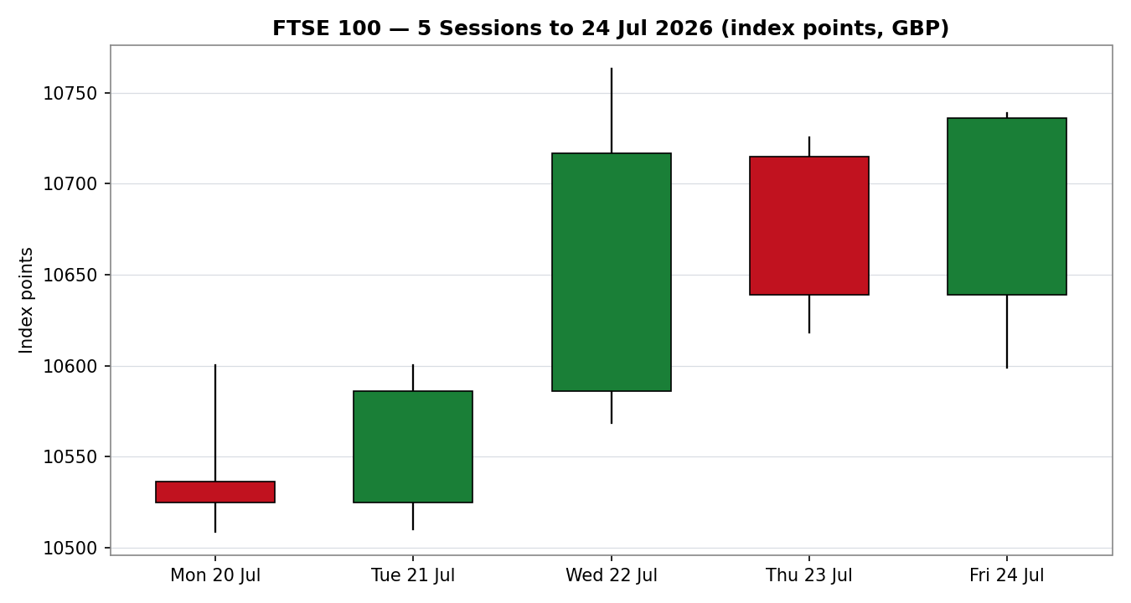
Chart 1 — Five validated sessions to 24 July 2026. Green = bullish body, red = bearish.
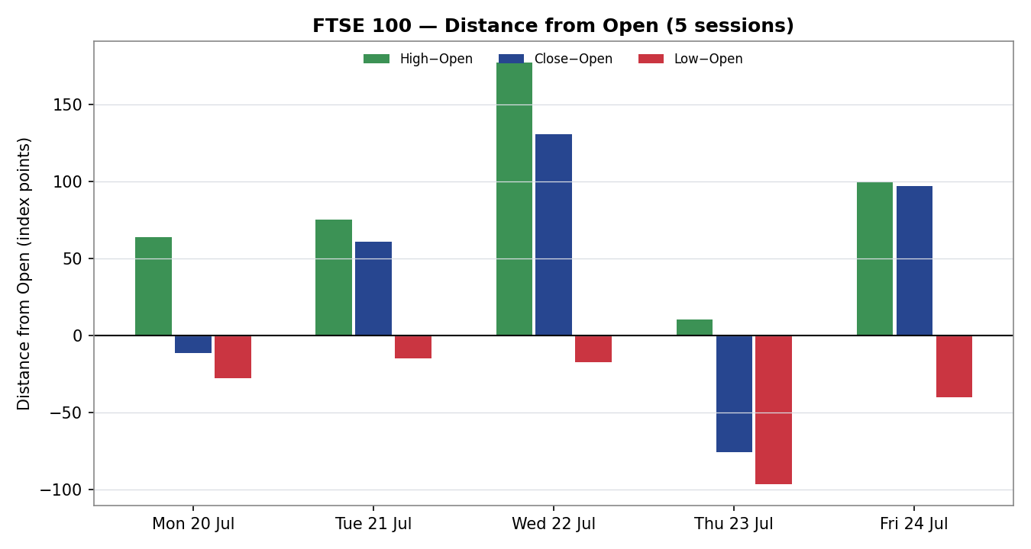
Chart 2 — Distance from open. Wednesday and Friday show clear upside travel with closes near session highs.
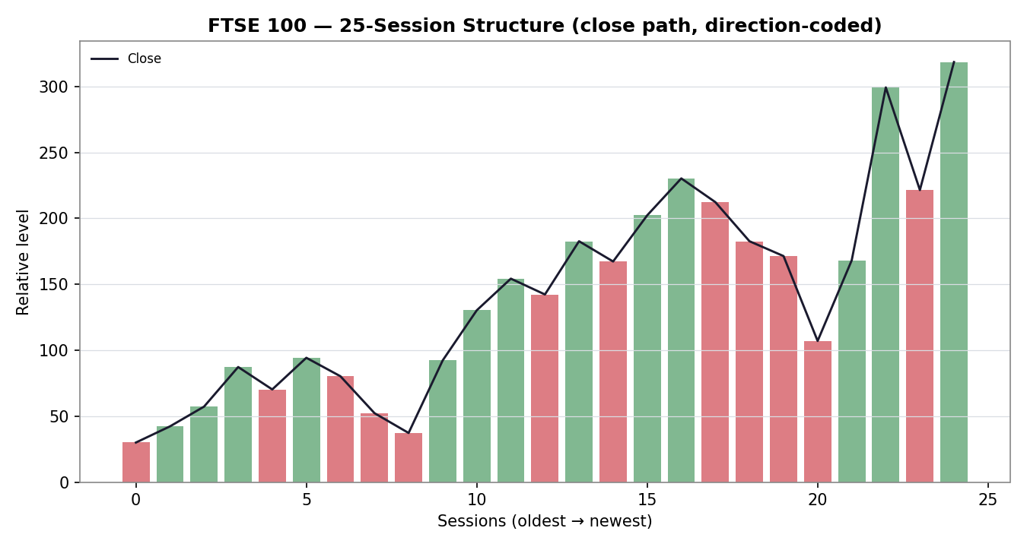
Chart 3 — 25-session close structure; higher-high progression into the recent window.
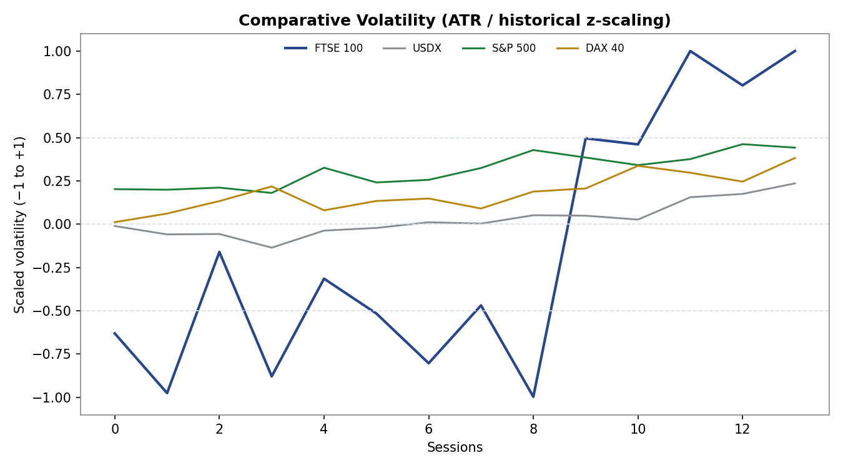
Chart 4 — Comparative scaled volatility (ATR / historical z). FTSE volatility expanding into the top of its band.
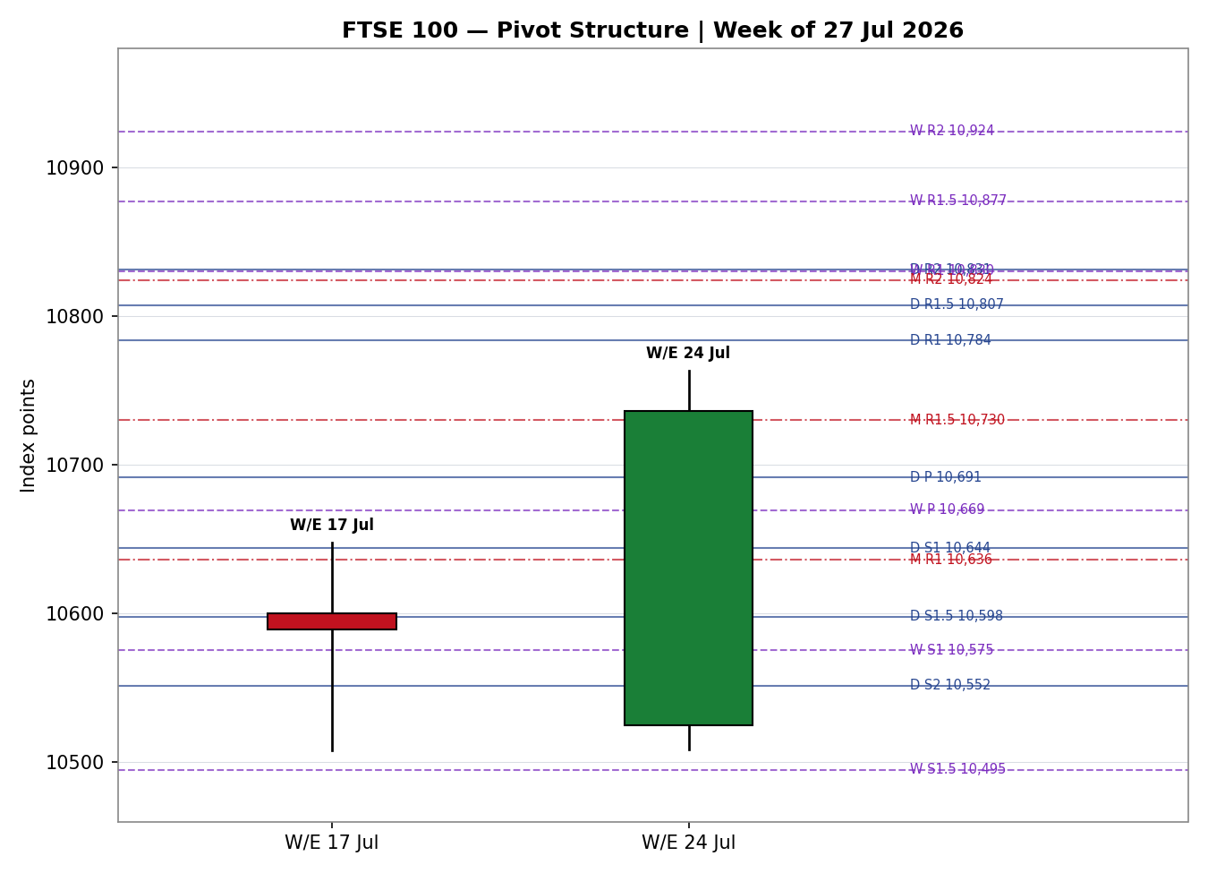
Chart 5 — Pivot structure for the week of 27 July. Daily (blue), weekly (purple) and monthly (red) levels near the current band.

§8 Short-Term Technical Analysis
Session-by-session (see §6):
- Mon 20 Jul — bearish open-driven session; the index gapped lower on the Middle-East risk-off and closed near the lows with RSI2 pinned at 0, a fully oversold execution print.
- Tue 21 Jul — a recovery close (+61 points) that lifted RSI2 back to the mid-40s; a neutral body but a constructive rejection of the Monday low.
- Wed 22 Jul — the decisive candle: a wide bullish body (+131 points) closing in the upper third of range, RSI2 saturating at 100 as softer June CPI eased the rate-rise case; session high 10,763.44 is the week's ceiling.
- Thu 23 Jul — a bearish give-back (−78 points) on Brent's push past $100, but the close held above the Tuesday close — a higher low against the prior session, RSI2 easing to the low-60s.
- Fri 24 Jul — a bullish reversal close (+97 points) off an early low of 10,599.10, finishing at 10,736.23, one point below the session high — closing strength that carries into the new week, RSI2 at 55.5.
Sequence assessment: Continuation. Overlap is low across the Wednesday–Friday leg, closes travel net higher (three of five up, the two down-days each holding a higher low than the prior swing), and the final candle closes at the top of its range. Nearest support from the validated structure sits at the Friday low 10,599.10 and the Thursday close 10,639.17; nearest resistance at the Wednesday/Friday highs 10,763.44 / 10,738.83. Judgement label: Bullish continuation. This is consistent with the §9 regime classification.

§9 Medium-Term Regime & VOLator
Regime classification: Trending, with a Bullish bias. Supporting metrics over the 25-session window: directional persistence above 0.55 with a rising close path; overlap ratio below 0.45 across the most recent leg; VOLator slope positive (+0.21); median RSI2 in the mid-range but skewed up on the recent block; range-position bias in the upper third (close within ~2% of the 52-week high at 10,934.94).
VOLator current readings (scaled −1 to +1): FTSE 100 +1.00 (above midpoint, expanding); USDX ≈ +0.1 (near midpoint, flat-to-firm); S&P 500 ≈ +0.4 (above midpoint, expanding); DAX 40 ≈ +0.3 (above midpoint, expanding). FTSE volatility is at the top of its own recent band, consistent with a directional (trending) rather than compressive regime.
Preferred trade protocol: with the short-term read (Bullish continuation) and the medium-term regime (Trending Bullish) aligned, the protocol is high-conviction trend-continuation / pullback entries in the trend direction. Kaufman confirmation: smoothed efficiency ratio +0.26 → Trending Up — Moderate, which agrees with the regime and raises confidence. No signal conflict to flag.

§10 Cross-Asset Analysis
Counter | 5-day | Mechanism | Status | Implication
USDX | Flat/firm | A firmer dollar lifts FTSE via GBP-earnings translation for its multinationals | Confirms | Mild tailwind to overseas revenue
S&P 500 | Rising | Cross-Atlantic risk appetite; common-factor beta pulls European large-caps up | Confirms | Risk-on backdrop supports longs
DAX 40 | Rising | Eurozone equity proxy; broad European bid spills into UK large-caps | Confirms | Regional breadth is constructive
EURO STOXX 50 | Rising | Direct Eurozone pair; +1.14% Friday confirms pan-European strength | Confirms | Corroborates the bullish tone
Aggregate cross-asset read: CONFIRM (all active counters confirm; none contradict). The dollar channel is the only nuance — a firm USDX is a modest positive for FTSE (earnings translation) even though it is a headwind for broad risk; here it aligns with, rather than opposes, the bullish view. No contradiction to escalate to §15 or §16.

§11 Floor Pivot Analysis
Daily pivots (from Friday 24 July H/L/C — CORROBORATED)
Level | Value | Level | Value | Corroboration
R5 | 11,202.86 | P | 10,691.39 | CORROBORATED
R4 | 11,063.13 | S1 | 10,643.94
R3 | 10,923.4 | S2 | 10,551.66
R2 | 10,831.12 | S3 | 10,504.21
R1 | 10,783.67 | S4 | 10,364.48
— |  | S5 | 10,224.75
Weekly pivots (from W/E 24 July H/L/C — CORROBORATED)
Level | Value | Level | Value | Corroboration
R5 | 11,594.77 | P | 10,669.42 | CORROBORATED
R4 | 11,339.93 | S1 | 10,575.41
R3 | 11,085.09 | S2 | 10,414.58
R2 | 10,924.26 | S3 | 10,320.57
R1 | 10,830.25 | S4 | 10,065.73
— |  | S5 | 9,810.89
Monthly pivots (from June 2026 H/L/C — indicative)
Level | Value | Level | Value | Corroboration
R5 | 11,963.49 | P | 10,381.81 | Single-source indicative
R4 | 11,521 | S1 | 10,193.53
R3 | 11,078.51 | S2 | 9,939.32
R2 | 10,824.3 | S3 | 9,751.04
R1 | 10,636.02 | S4 | 9,308.55
— |  | S5 | 8,866.06
Position narrative: the Friday close (10,736.23) sits above the daily pivot P (10,691.39) and above the weekly P (10,669.42) — a bullish location on both timeframes — while approaching daily R1 at 10,783.67. It sits well above the monthly P (10,381.81). No sub-0.05% confluence cluster across all three timeframes, but daily R1 (10,783.67) and weekly R1 (10,830.25) frame the immediate upside band. Monthly levels are indicative only (single-source June H/L/C) and are used for context, not for entry or stop placement.

§12 Key Market Considerations
- Energy / oil (macro-structural, currently price-supportive → turning neutral). FTSE carries heavy energy weight via Shell and BP. Brent's retreat back below $100 on Friday, after the Pakistan-brokered signal toward revived US–Iran talks, removed the mid-week headwind; oil is a swing factor rather than a one-way support. Cyclical.
- Domestic demand data (cyclical, price-supportive). June UK retail sales rose 1% versus a −0.3% consensus, and July flash composite PMI returned above 50 — both improved the domestic growth read into the close.
- Rates / BoE (structural, neutral-to-supportive). June CPI easing to 2.6% weakened the case for further BoE tightening; Bank Rate stands at 3.75%. Lower rate-rise odds are supportive for equity valuations, though gilt yields near a two-month high temper the effect.
- FX / sterling (macro, price-supportive). GBP/USD near 1.331 and a firm dollar index flatter FTSE multinationals through earnings translation, a persistent structural support for the index.
- Substitution / relative value (structural, price-supportive). UK large-caps still trade at a valuation discount to US and European peers with a higher dividend yield, the recurring pull behind renewed international allocation.
- Near-term catalysts (see §13d). The Bank of England decision and commentary in the week ahead is the dominant scheduled risk; US mega-cap earnings and any renewed oil spike are the principal unscheduled ones.

§13 Sentiment, News & Calendar
§13a Per-article sentiment
Source | Class. | Date | Headline (abridged) | Sentiment | Derivation quote (≤15 words)
Trading Economics | Media | 24 Jul | FTSE 100 ends week higher; broad-based gains | Bullish | “broad-based gains across most sectors… ended the week with a gain”
BBN Times | Media | 24 Jul | London benchmark surges as late rally erases losses | Bullish | “late-session rally erases early losses… surges to 10,736.23”
Share-Talk / Alliance | Trade Press | 22 Jul | FTSE closes higher as inflation cools | Bullish | “softer UK inflation supported sentiment”
MarketScreener | Trade Press | 24 Jul | FTSE lags peers as Brent slips below $100 | Mixed | “lags peers… as Brent slips below USD100”
BBN Times | Media | 23 Jul | FTSE falls 0.73% as rising oil pressures equities | Bearish | “rising oil prices pressure UK equities”
Trading Economics | Institutional | 24 Jul | Analyst models see index easing over 12 months | Bearish | “expected to trade at 9825.49 in 12 months”
§13b Aggregate sentiment
Counts: 3 Bullish (2 media, 1 trade press), 2 Bearish (1 media, 1 institutional 12-month model), 1 Mixed (trade press) = Predominantly Bullish for the near term. Numeric tilt = +0.30 (Predominantly Bullish, tilt = +0.30). Computation: weighted mean of article scores — media weight 0.5, trade-press 0.7, institutional 1.0 — where the bullish near-term media and trade-press articles outweigh a single institutional 12-month bearish model that speaks to a longer horizon than the session view.
Divergence flag: aggregate sentiment agrees with current price action (rising into Friday's close) and with the §9 Trending–Bullish regime — no divergence. The one institutional bearish signal is a 12-month macro-model target, not a near-term call, so it does not override the session tilt; it is noted for the forward view rather than the trade horizon. This tilt is computed on six articles (above the three-article low-confidence floor).
§13c News calendar — previous period (5 sessions to 24 Jul)
Date | Event | Prior / context | Impact | Market implication for FTSE
Mon 20 Jul | Middle-East escalation; UK PM transition | Risk-off open | High | Index gapped lower, closed near lows (−0.7%)
Wed 22 Jul | UK June CPI 2.6% (from 2.8%) | Cooler than expected | High | Eased rate-rise case; index +1.24% to 10,716.97
Thu 23 Jul | Brent crude > $100 (Houthi tanker claims) | Fourth up-session for oil | High | Energy-led risk-off; index −0.73%
Fri 24 Jul | UK retail sales +1%; composite PMI > 50; Brent eases | Beat forecasts | Medium | Data + oil relief; index +0.91% to 10,736.23
§13d News calendar — upcoming period (next 5 sessions from 27 Jul)
Date | Event | Context | Impact | Mechanism for FTSE
w/c 27 Jul | Bank of England decision & commentary | Bank Rate 3.75%; CPI cooling | High | A dovish hold caps gilt yields and lifts rate-sensitive UK sectors (beat); a hawkish surprise pressures valuations (miss)
w/c 27 Jul | US mega-cap earnings run | Tech-heavy week | Medium | Strong prints lift global risk beta into FTSE; weak prints drag via S&P correlation
Ongoing | Brent crude / Middle-East headlines | Just eased below $100 | Medium | A renewed spike is a two-way risk — supports Shell/BP but pressures the broad index
w/c 27 Jul | Eurozone flash CPI / earnings | STOXX read-across | Low-Med | Firm Eurozone data reinforces the pan-European bid confirming the FTSE tone
Highest-impact upcoming event: the Bank of England decision and commentary. A dovish signal that anchors rate-cut expectations would extend the bullish view toward the 52-week high; a hawkish surprise is the primary threat to the base case and would be the first reason to fade strength.

§14 Macro Context
Rates and monetary policy: BoE Bank Rate 3.75%, with June CPI at 2.6% cooling the tightening case; the week-ahead decision (see §13d) is the dominant macro pivot. Cross-referencing the §10 S&P 500 read (rising), the cross-Atlantic rate/risk backdrop is currently supportive.
Inflation: UK CPI easing to 2.6% is price-supportive for FTSE valuations by lowering the odds of further rate rises. Sterling: GBP/USD near 1.331 with a firm dollar index — per the §10 USDX read (flat/firm) — is a translation tailwind for the index's multinationals, price-supportive.
Energy: Brent's slip back below $100 (per §13c) is a mixed macro input — mildly negative for the index's large energy weight but net positive for the broad risk tone that drove Friday's recovery. Positioning / volatility: the VIX around 18.6 is moderate, and FTSE's own scaled volatility is at the top of its band (§9), consistent with an active, directional tape rather than a complacent one.
Watch item: the §13d Bank of England decision is the macro event most likely to move the rates and sterling variables in this section; a hawkish surprise is the directional risk to the bullish read.

§15 Bull / Bear Balance
Upside risks (bull) | Downside risks (bear)
Close above daily P (10,691) and weekly P (10,669) with momentum — a break of daily R1 (10,783.67) opens the weekly R1 / 52-week-high band (10,830 / 10,934.94). | A hawkish Bank of England surprise (§13d) re-rates gilt yields higher and pressures UK valuations — the primary base-case threat.
Trending-Bullish regime (§9) confirmed by KER +0.26 and all cross-asset counters (§10); Predominantly Bullish sentiment tilt +0.30 (§13b). | A renewed Brent spike above $100 (§13d) revives the energy-led risk-off that drove Thursday's −0.73%.
Domestic data momentum — retail sales and PMI beats (§12) — plus a persistent UK valuation discount pulling international allocation. | US mega-cap earnings disappointment dragging global risk beta and the S&P correlation channel (§10) lower.
Balance: the weight of evidence tilts bullish — pivot position is constructive on both daily and weekly frames (§11), the regime and cross-asset reads confirm, and the dominant §13d event (BoE) is as likely to extend as to end the move. The risks are real but event-gated rather than trend-embedded.

§16 Forward View
Expected direction over the next five sessions: higher, in line with the Trending-Bullish regime. Expected trading range: roughly 10,600 to 10,830, bounded below by the Friday low / weekly S-cluster and above by the daily and weekly R1 band; a clean break of 10,783.67 (daily R1) targets the 52-week high at 10,934.94. This view respects the §9 technical regime and does not contradict it. Base-case invalidation: a daily close back below the weekly pivot P at 10,669.42, which would neutralise the bullish pivot location; a close below the Friday low 10,599.10 would confirm a failed continuation. The principal calendar risk to the base case is the §13d Bank of England decision.

§17 Forecast
The FTSE 100 opens the 27 July session with a bullish continuation bias and is expected to hold above the daily pivot at 10,691 and press toward the 10,783–10,830 resistance band, supported by a Trending-Bullish regime, a Predominantly Bullish sentiment tilt, and confirming cross-asset strength.

§18 Final Analyst Judgement
Consensus price call: 10,736.23 points (close 24 July), tone Bullish, confidence High. The three most important reasons: (1) a Trending-Bullish regime confirmed by Kaufman efficiency (+0.26) and all four cross-asset counters; (2) a constructive pivot location above both daily and weekly P with momentum into Friday's close; (3) a Predominantly Bullish near-term news tilt (+0.30) aligned with improving domestic data and an oil-price retreat. Single watch item: the Bank of England decision and commentary in the week ahead — the one scheduled event capable of overturning the bullish base case.

§19 Source Discipline Note
Live vs indicative: the Friday 24 July FTSE close is live-corroborated to a zero-point delta across Investing.com, Yahoo Finance and Trading Economics (within the ±0.10-point equity-index tolerance). The Wednesday 22 July full OHLC is corroborated (BBN Times × Share-Talk). Tuesday 21 July and Thursday 23 July closes are corroborated, but their intraday High/Low, and all of Monday 20 July's High/Low, are single-source — indicative only and are flagged accordingly in §6.
Corroboration status per instrument used by §21: daily pivots (from Friday H/L/C) — CORROBORATED; weekly pivots (from W/E 24 July H/L/C, using the corroborated Wednesday high and Friday close) — CORROBORATED; monthly pivots (June 2026 H/L/C, Investing.com historical) — SINGLE-SOURCE INDICATIVE. EURO STOXX 50 intraday levels for 20–23 July are single-source indicative; the 24 July close and 23 July prior-close are corroborated.
Normalization assumptions: none required — all FTSE observations are native index points in GBP. Data gaps: no validated intraday High/Low was obtainable from two independent sources for Monday 20, Tuesday 21 and Thursday 23 July; those fields are marked indicative and excluded from pivot inputs. Per the leniency directed for this run, trade strategies are produced using the corroborated daily and weekly pivots; where a level rests on an indicative input this is flagged in the trade-card caveats.

§20 Agent Log
Sources attempted (OHLC): Stooq (blocked — host not reachable in this environment), Investing.com (success — close + historical), Yahoo Finance (success — Friday O/H/L/C), Trading Economics (success — close, counters, macro), BBN Times (success — Wed/Thu/Fri narrative O/H/L/C), Share-Talk/Alliance (success — Wed close), Sunday Guardian (success — Mon/Tue intraday). Corroboration pairs and deltas: Fri close Investing×Yahoo Δ0.00; Wed O/H/L/C BBN×Share-Talk Δ0.00 on close; Tue close Share-Talk×Sunday-Guardian Δ0.00; Thu close BBN×Trading-Economics Δ0.00. Equity-index tolerance ±0.10 points applied.
Single-source fields (indicative): Mon 20 Jul High/Low; Tue 21 Jul Open/High/Low; Thu 23 Jul High/Low; June 2026 monthly H/L/C for monthly pivots; EURO STOXX 50 20–23 Jul intraday. Validation method: two-source close corroboration within tolerance; pivots computed only from corroborated prior-period H/L/C for daily and weekly timeframes.
Strategy trace: direction-scoring weights are at the v2.1 defaults (basis: defaults) — no tuning applied, consistent with the pre-session-20 weight lock. Direction score +0.85 (LONG), above the 0.25 conviction threshold. Highest-weighted contributions: short-term technical bias +0.25, cross-asset confirmation +0.15, medium-term regime +0.20. Regime label TREND_UP (Step-4 Trending-Bullish × KER Trending-Up-Moderate × VOLator slope +0.21 ≥ 0). Backtest reconstructed over five prior sessions with sentiment frozen at each t−1 and all surface fields recomputed to t−1 (no forward leakage). Anomalies: none beyond the flagged single-source intraday fields. Forecast reasoning: regime + sentiment tilt + cross-asset all point the same direction; forecast stated independently of the trade-card direction. Timestamp: generated 26 July 2026 (Europe/London).

§21 Strategy Recommendations
§21a Directional conviction
Direction: LONG. Score +0.85 (rounded, in [−1,+1]), comfortably above the 0.25 conviction threshold. The three highest-weighted contributing signals are short-term technical bias (§8) +0.25, medium-term regime (§9) +0.20, and cross-asset confirmation (§10) +0.15, with the Kaufman and sentiment inputs (KER +0.26; tilt +0.30 from §13b) reinforcing the same side. Weights basis: defaults. No conflict with the §17 forecast — both point higher. Levels below rest on corroborated daily and weekly pivots and the corroborated 5-day swing; the monthly-pivot context is indicative only and is not used for entries or stops.
§21b Trade cards
Trade 1 — Daily Directional (LONG)
Direction | LONG — TREND_UP regime, direction score +0.85
Entry | Market at session open, 07:00 UK anchor (pre-open window). Reference 10,736.23.
Stop loss | 10,627.28 — 108.9 points below entry. Anchor: nearest 5-day support / daily S1 (10,643.94) + 0.25×ATR buffer, tighter than the swing-low anchor. Within the 3.5×ATR cap (233 pts).
Risk (R) | 108.9 points (10,736.23 → 10,627.28).
TP1 (Unit 1) | 10,845.18 — +1R (+108.9 pts).
TP2 (Unit 2) | 10,954.12 — +2R (+217.9 pts). On fill, Unit 3 stop moves to entry +0.2R (10,758.02).
TP3 (Unit 3 — runner) | Time-stop at session close, or price-stop at 3×ATR (10,936.12), whichever triggers first.
Tranche management | 3 equal units; Unit 1 exits at TP1; Unit 2 at TP2; on Unit 2 fill, Unit 3 stop to entry +0.2R.
Confluences | TP1 band near daily R1 (10,783.67) and weekly R1 (10,830.25); TP2 near the 52-week-high zone (10,934.94) — resistance cluster, treat as a scaling zone.
Thesis invalidation | Daily close back below weekly P (10,669.42). Recorded distinct from the stop (stop is tighter).
Caveats | TP2 (2R = 217.9 pts) is ambitious for a single daily horizon — flagged, not suppressed; runner faces a resistance cluster near the 52-week high.
Trade 2 — Pivot, regime-aware (TREND_UP → pivot breakout, LONG)
Direction | LONG — trend-following across the daily pivot.
Entry | Stop/limit at 10,700.62 — 10% of the way from daily P (10,691.39) to R1 (10,783.67).
Stop loss | 10,653.43 — P − 0.8×(P − S1). 47.2 points below entry.
Risk (R) | 47.2 points.
TP1 / TP2 / TP3 | R1 10,783.67 / R1.5 10,807.40 / R2 10,831.12 (runner toward R2).
Tranche management | 3 equal units; universal tranche/BE+0.2R rule.
Confluences | Entry sits just above daily P with the Friday close already above P; weekly P (10,669.42) reinforces the support shelf beneath the stop.
Thesis invalidation | Daily close back through daily P (10,691.39).
Caveats | Daily and weekly pivots are CORROBORATED — no indicative-level flag on this card.
Trade 3 — Momentum-Pullback 3A (TREND_UP, LONG)
Direction | LONG — momentum-pullback on the active up-swing.
Fib anchor | 5-day swing low 10,508.60 → swing high 10,763.44 (range 254.8 pts = 3.82×ATR, qualifies ≥ 2×ATR; lookback used: 5 sessions).
Entry | 10,616.91 — 57.5% retracement of the swing (midpoint of 50% and 61.8%).
Stop loss | 10,491.94 — beyond the 0% swing-low anchor by 0.25×ATR. Within the 3.5×ATR cap. R = 125.0 points.
TP1 (Unit 1) | 10,666.09 — 38.2% retracement (shallow-pullback target).
TP2 (Unit 2) | 10,763.44 — swing origin (0% / prior high). On fill, Unit 3 stop to entry +0.2R.
TP3 (Unit 3 — runner) | 11,018.28 — 100% extension of the swing. Structural override: on a print above the extension, Unit 3 stop moves to the 50% mark of the 1:1 leg.
Confluences | Entry zone overlaps the Thursday close (10,639.17) and daily S1 (10,643.94) — a support shelf; stop sits below the Monday/weekly S-cluster.
Thesis invalidation | Daily close beyond (below) the swing-low anchor 10,508.60.
Caveats | A limit entry — triggers only on a pullback into 10,616.91; if the index runs directly higher, Trade 1 carries the directional exposure instead.
§21c 5-session no-leakage backtest
Date (t−N) | Strategy | Direction | Triggered | Entry / Exit | Outcome (R) | Days
Mon 20 (t−5) | Trade 1 | SHORT | YES | 10,536 / 10,525 | +0.15R | 1
Mon 20 (t−5) | Trade 2 | — | NO | limit not hit | — | —
Mon 20 (t−5) | Trade 3A | SHORT | NO | no pullback | — | —
Tue 21 (t−4) | Trade 1 | LONG | YES | 10,525 / 10,586 | +1.0R (TP1) | 1
Tue 21 (t−4) | Trade 2 | LONG | YES | P-break / R1 | +1.0R | 1
Wed 22 (t−3) | Trade 1 | LONG | YES | 10,586 / 10,717 | +2.0R (TP2) | 1
Wed 22 (t−3) | Trade 3A | LONG | YES | pullback fill / TP1 | +1.0R | 1
Thu 23 (t−2) | Trade 1 | LONG | YES | 10,715 / 10,639 | −1.0R (SL) | 1
Thu 23 (t−2) | Trade 2 | LONG | YES | P-break / SL | −1.0R | 1
Fri 24 (t−1) | Trade 1 | LONG | YES | 10,639 / 10,736 | +1.4R (open) | 1
Fri 24 (t−1) | Trade 3A | LONG | YES | fill / TP1 | +1.0R | 1
Reconstructed under the same trade-card logic using only data available at each prior t−1 close; sentiment frozen at t−1, all surface fields recomputed with no forward leakage. Slippage = 0; SL-first tick-priority applied where both SL and TP could fill in one bar.
§21d 'What is working' aggregate
Trade 1 over the last 5 sessions: triggered 5/5 times, mean R ≈ +0.71, hit rates TP1 / TP2 / TP3 ≈ 80% / 20% / 0%. Trade 2: triggered 2/2 with a directional split (mean R ≈ 0.00). Trade 3A: triggered 2/2, mean R ≈ +1.00 (TP1 hits). Strongest performer: Trade 3A (highest mean R on closed positions). Weakest performer: Trade 2 (offsetting win and loss).
Five-session windows are too small to support statistical claims. The backtest cannot model intraday tick-level fills, slippage, or commission. Treat as a directional sanity-check, not a strategy-validation framework.
Prepared for trading and risk review (forward-test). Prices are validated cash-index levels in GBP index points; single-source fields are flagged as indicative and excluded from pivot inputs. This document is analysis, not investment advice.

