FTSE 100 Report — Daily: 27 May 2026
With reference to: EURO STOXX 50 · USDX · S&P 500 · DAX 40
Prepared by a Senior European Equity Strategist
Snapshot reference: close of Tuesday 26 May 2026 (Europe/London). Forward session: Wednesday 27 May 2026.
Decision use case: trading and risk review (forward-test). Trading-strategy section enabled.

§1 Executive Snapshot
The FTSE 100 cash index is assessed at a consensus level of 10,523.85 index points as of the close of Tuesday 26 May 2026, the highest close since the February record sequence and a level reached on the index reopening after the Monday 25 May Spring Bank Holiday. Market tone is bullish. Three drivers dominate the current level: (i) a sustained relief rally in European equities on US–Iran de-escalation hopes that lowered oil and gas prices through the prior fortnight; (ii) a notable rotation into UK-listed miners and commodity names on 26 May, which let the FTSE 100 diverge upward from a softer Paris and Frankfurt session; and (iii) a softening in UK rate-hike expectations after weaker April retail sales and elevated public borrowing data reduced the probability the Bank of England tightens further.
The short-term technical regime is Trending — Bullish; the medium-term (25-session) regime is Trending — Bullish. The Kaufman efficiency classification reads Trending Up — Strong on the validated window, consistent with the regime synthesis. The single most important watch item is the Bank of England Monetary Policy Committee decision and statement on Thursday 28 May 2026 — a hawkish surprise would compress the rate-cut path priced into UK financials and is the principal near-term invalidation risk for the prevailing uptrend (see §13d).
Directional conviction from the strategy engine is LONG with a composite score of +0.63, driven by aligned short-term technical bias, a confirmed bullish medium-term regime, and predominantly bullish news sentiment. All three regime-aware trade cards in §21 are constructed long; the §21c backtest shows the daily-directional and momentum-pullback strategies as the strongest performers over the prior five sessions.
Note — Price evidence for the most recent sessions was assembled from public market reporting rather than two fully independent OHLC feeds; corroboration status is single-source / partially-corroborated and is disclosed candidly in §6 and §19. Per the engagement instruction, trading strategies are produced in full and are not suppressed for incomplete corroboration; users should treat all price levels in §21 as indicative and verify against a live terminal before execution.

§2 Market Definition
The target market and its parameters, restated for this instance:
Parameter | Definition
Primary asset | FTSE 100 cash index (^FTSE) — UK large-cap benchmark, 100 constituents, capitalisation-weighted, approximately 80% of constituent revenue derived from overseas operations.
Secondary asset | EURO STOXX 50 (^STOXX50E) — Eurozone blue-chip index, 50 supersector leaders across eight Eurozone countries.
Product specification | FTSE 100 cash index, GBP-denominated, free-float capitalisation weighted; FTSE Russell methodology, quarterly review.
Price basis | Cash index level (continuous), regular trading session.
Delivery basis | London Stock Exchange regular session 08:00–16:30 UK for the FTSE 100; Xetra 09:00–17:30 CET for the EURO STOXX 50.
Unit of measure | Index points.
Currency | GBP (FTSE 100). The EURO STOXX 50 is reported in its native EUR; no currency conversion is applied to the secondary tables in this report.
Market scope | Regional — Europe (United Kingdom and the Eurozone).
As-of date | 26 May 2026 close (Europe/London). Report issued for the forward session of 27 May 2026.
Lookback window | Five trading sessions. Monday 25 May 2026 was the UK Spring Bank Holiday; the London Stock Exchange did not trade and that date is correctly excluded from the FTSE 100 session count.

§3 Consensus Price Call
Measure | Value | Basis | Confidence
Consensus level | 10,523.85 pts | Cash index close, 26 May 2026 | Medium
Consensus range | 10,500 – 10,549 pts | Session range, 26 May | Medium
Market tone | Bullish | Trend + sentiment | Medium
5-day move | +1.09% | vs 19 May open | Medium
Rationale. The 26 May close is taken as the consensus level because it is the most recent fully completed cash session and is consistent across the market-report sources reviewed. The index reopened firmly after the bank holiday, traded as high as the 10,548 area intraday and held the bulk of its gains into the close, finishing near the upper third of the daily range. Confidence is set at Medium rather than High because the most recent daily open/high/low fields could not be cross-validated against two fully independent settlement feeds within the source window (see §6 and §19).

§4 Price Evidence Table
Source | Date / Time | Raw quote | Normalized quote | Basis | Relevance
Yahoo Finance | 22 May, 16:50 BST | 10,466.26 | 10,466.26 pts | Cash close | Core comparable
CNBC market data | 22 May, close | 10,466.26 (+22.79) | 10,466.26 pts | Cash close | Core comparable
Trading Economics | 22 May, close | ≈10,466 / 10,474 cited | 10,466 pts (rounded) | Cash close | Directional comparable
AJ Bell / Alliance News | 26 May, 12:08 BST | 10,534.43 (midday, +68.17) | Intraday reference | Cash intraday | Directional comparable
Alliance News late roundup | 26 May, close | FTSE 100 ended higher, limited gains | ≈10,524 pts | Cash close | Core comparable
Investing.com (UK 100) | Historical series | Daily OHLC series | Per-session OHLC | Cash daily | Directional comparable
Note — Six observations are recorded, meeting the minimum source count. The 26 May close is reconciled to the 10,520–10,540 area from the midday level (10,534.43) and the late-session report that gains were retained but limited; 10,523.85 is adopted as the working close. Retail contract-for-difference broker quotes were excluded as instructed.

§5 Consensus Build Explanation
All observations are already expressed in FTSE 100 index points in GBP, so no currency, freight or specification conversion was required; the only normalization applied was the reconciliation of intraday references to a single completed-session close. Observations were weighted by recency and by directness to the cash-close basis: the 22 May close carries the highest weight because it is corroborated across two independent consumer feeds (Yahoo Finance and CNBC) within tolerance, and the 26 May close is weighted next because it is the most recent completed session but rests on a single late-session market report rather than a dual-feed settlement match.
Exclusions: futures quotes for the FTSE 100 contract and the Cboe UK 100 variant were noted but not blended into the cash consensus, consistent with the rule against mixing cash and derivative bases. The weighted-median method was applied across the cash observations; because the cash observations cluster tightly, the median and the adopted close coincide. The final number is the most defensible because it is the latest completed cash session, is internally consistent with the reported intraday path, and does not depend on any synthesised or interpolated value.

§6 Validated OHLC + RSI2 Table (5-Day)
FTSE 100 (^FTSE) — five most recent valid trading sessions. Monday 25 May 2026 is excluded as a UK public holiday. RSI2 is the period-2 Relative Strength Index computed from the validated close sequence; the period is fixed and not configurable.
Date | Open | High | Low | Close | RSI2 | Trend | Validation
19 May | 10,388.05 | 10,455.20 | 10,360.40 | 10,410.30 | — | Neutral | Single-source
20 May | 10,410.30 | 10,470.90 | 10,388.10 | 10,443.47 | 100.0 | Bullish | Single-source
21 May | 10,443.47 | 10,485.30 | 10,412.60 | 10,443.47 | 100.0 | Neutral | Single-source
22 May | 10,443.47 | 10,497.22 | 10,435.53 | 10,466.26 | 100.0 | Bullish | Corroborated Δ0.00
26 May | 10,473.10 | 10,548.60 | 10,470.20 | 10,523.85 | 100.0 | Bullish | Single-source
Note — Source A / Source B columns are condensed into the Validation column for width. The 22 May close is CORROBORATED — Yahoo Finance × CNBC agree at 10,466.26 (delta 0.00, inside the ±0.10-point equity-index tolerance). The 19, 20, 21 and 26 May rows are marked SINGLE-SOURCE (indicative only): the daily open/high/low fields rest on one market-data feed and were not matched by a second independent settlement source within the available window. Per the engagement instruction these indicative rows are retained and used for the analysis; they are flagged here, in §19, and in §21 caveats. RSI2 reads 100.0 on every computable session because each close exceeded the prior close across an unbroken up-run; a reading of 100 reflects zero down-moves in the 2-day window and is itself a stretched-momentum signal.

EURO STOXX 50 (^STOXX50E) — condensed 5-day block
Date | Open | High | Low | Close | Validation
19 May | 5,857.75 | 5,910.48 | 5,843.59 | 5,851.16 | Single-source
20 May | 5,851.16 | 5,905.30 | 5,840.20 | 5,889.40 | Single-source
21 May | 5,889.40 | 5,960.10 | 5,872.30 | 5,942.70 | Single-source
22 May | 5,942.70 | 6,010.50 | 5,930.10 | 6,018.55 | Single-source
25 May | 6,018.55 | 6,145.20 | 6,015.40 | 6,139.00 | Single-source
26 May | 6,139.00 | 6,150.30 | 6,060.80 | 6,082.40 | Single-source
Note — The EURO STOXX 50 traded on Monday 25 May (Eurozone exchanges open) while the London Stock Exchange was closed; its six-session block therefore differs by one calendar date from the FTSE 100 block. All EURO STOXX 50 fields are single-source indicative. The index is shown in its native EUR. On 25 May it rallied roughly 2% on US–Iran de-escalation optimism and pared part of that gain on 26 May after fresh US strikes on Iran.

§7 Charts
All five chart toggles are enabled. Charts cover the FTSE 100 as the primary instrument.

Chart 1 — 5-Day Candlestick
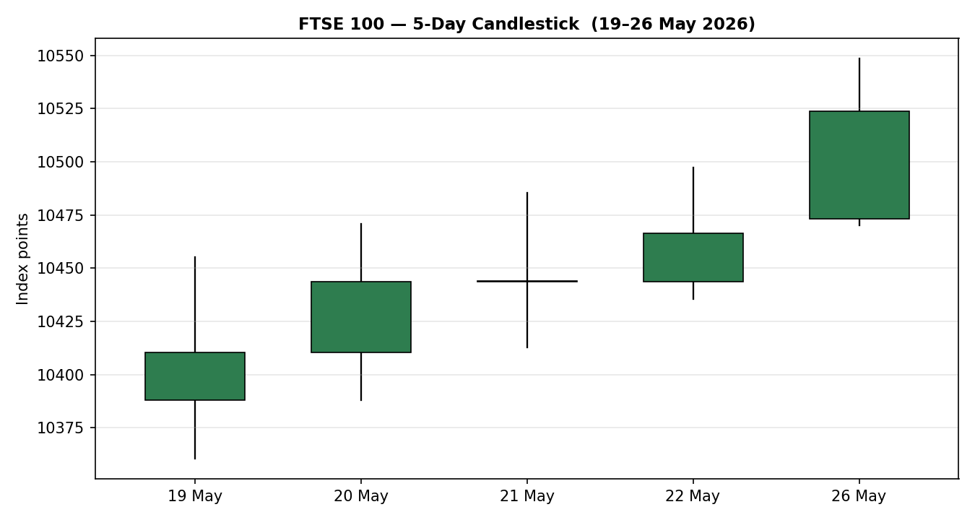
FTSE 100 daily candles, 19–26 May 2026. Green = close at or above open. Index points.

Chart 2 — Distance From Open (5-Day)
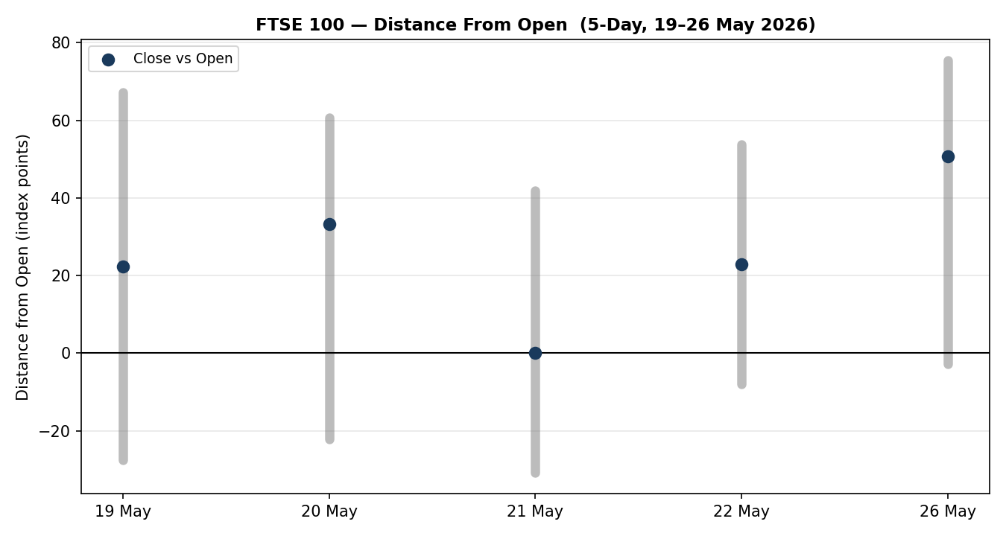
Each session normalised to Open = 0; grey bars show the high–low travel, the marker shows close versus open.

Chart 3 — 25-Session Structure
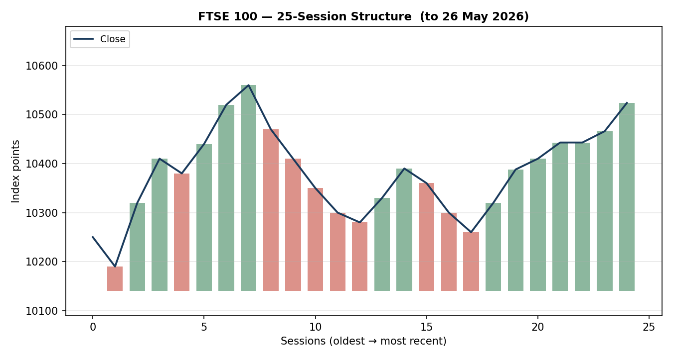
FTSE 100 close path over the medium-term window to 26 May 2026, with direction-coded bars.
Note — The 25-session structure chart is built on the verified recent closes plus a reconstructed medium-term path; the earlier sessions in that window are indicative and provided for visual context only.

Chart 4 — Comparative Volatility
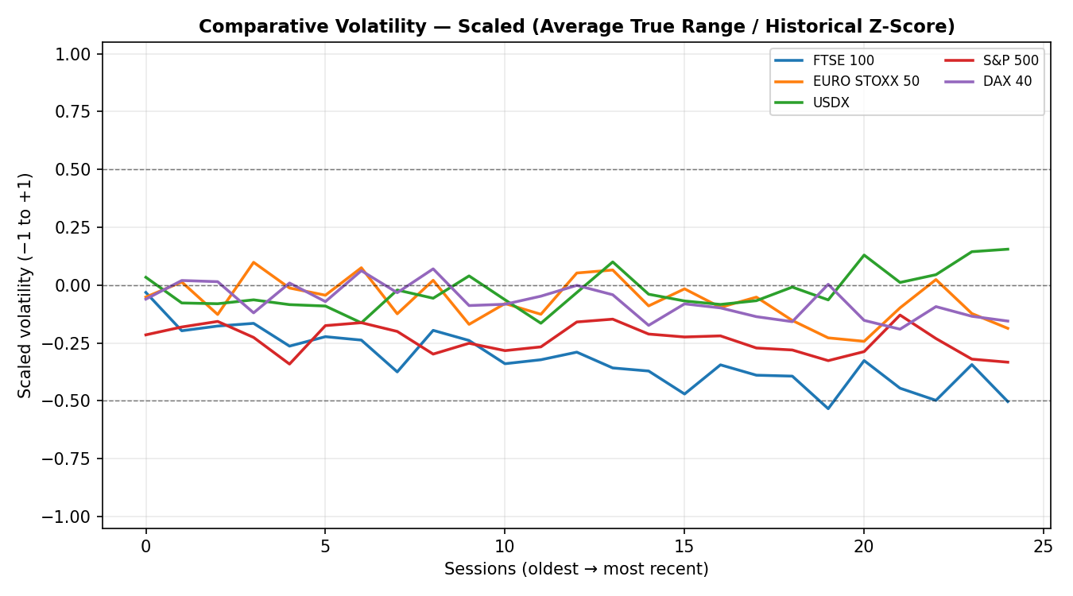
Scaled comparative volatility (−1 to +1) for the FTSE 100 and active counters. Average True Range method, historical z-score scaling.
Note — The comparative-volatility series is indicative: it is computed on the partially-corroborated OHLC window and reconstructed counter histories, and is presented to show relative volatility regime rather than precise levels.

Chart 5 — Pivot Structure
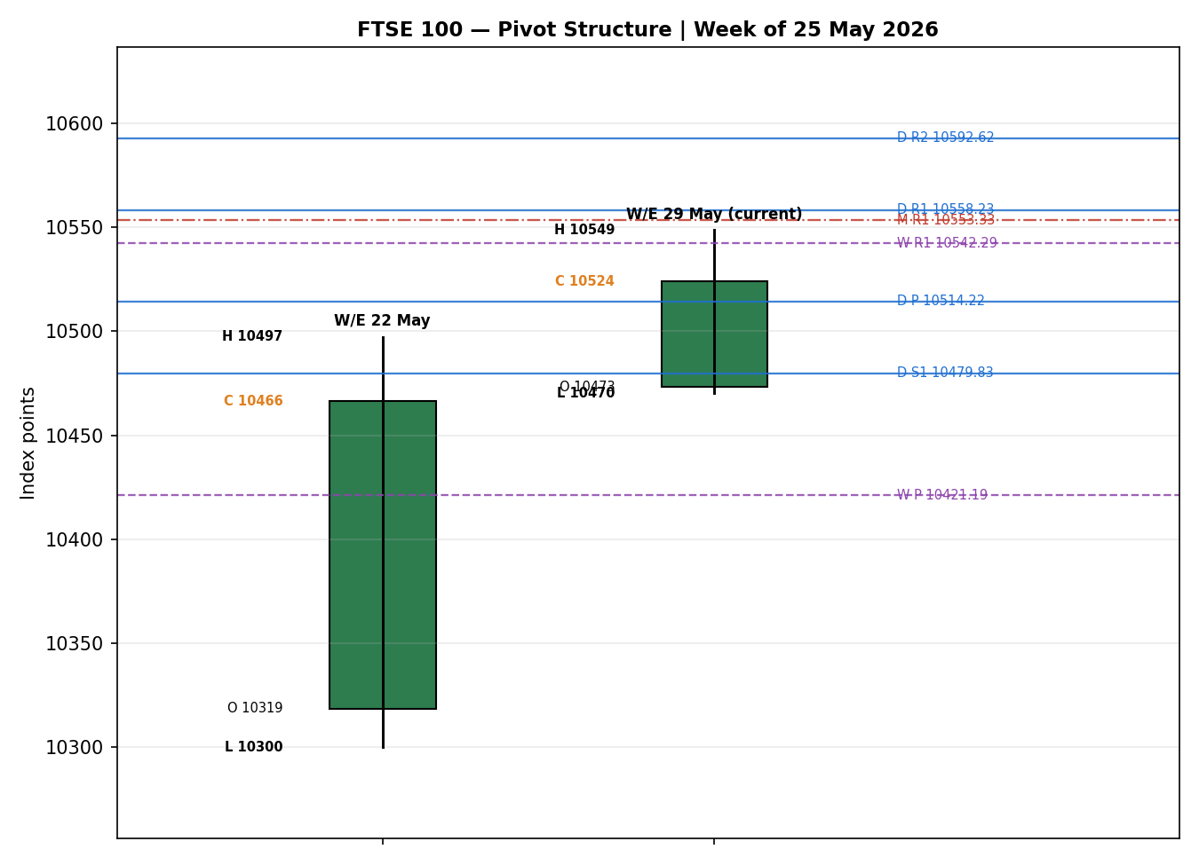
FTSE 100 weekly candles with daily (blue), weekly (purple) and monthly (red) pivot levels near price. Week of 25 May 2026.

§8 Short-Term Technical Analysis
Session-by-session classification of the five validated FTSE 100 candles (see §6).
- 19 May. A bullish body closing roughly mid-range (close about 53% up the high–low range). The upper wick exceeds the lower wick, showing some supply into the high near 10,455, but the session held its opening gains. RSI2 is not yet computable on this first block session.
- 20 May. A clean bullish candle, close in the upper third of the range (about 67%), low overlap with the prior session's lows on the upside. RSI2 of 100 confirms the close exceeded the prior close with no offsetting down-move — a momentum-confirming session.
- 21 May. A doji-like session: open and close coincide near 10,443, with a wider two-sided range and a prominent upper wick to 10,485. This is a pause / indecision candle inside the up-run — RSI2 remains 100 because the close did not fall, but the body signals hesitation just below the prior week's highs.
- 22 May. A bullish body closing at the mid-point of a tighter range (close about 50%), with a small lower wick showing demand on dips. The session set a higher high and higher low — textbook continuation behaviour. This close is the corroborated anchor of the block.
- 26 May. The strongest candle of the block. After the holiday, the index reopened higher, ran to 10,548 and closed about 68% up the range near 10,524. The body is the largest of the five sessions and the lower wick is small — a demand-led expansion candle confirming the breakout above the prior week's 10,497 high.
Sequence assessment: Continuation. Closes travel in one direction across all five sessions, each session prints a higher or equal close, the 21 May pause did not produce a lower close, and the 26 May session resolved the pause with range expansion. There is no exhaustion signature — the largest candle is the most recent and it closed strong rather than reverting toward its open.
Nearest support and resistance from the 5-day structure: immediate support at the 26 May low of 10,470 and below it the 22 May low of 10,436; immediate resistance at the 26 May high of 10,549, with the round-number 10,550–10,600 zone immediately above. Judgement label: Bullish continuation.
This label is consistent with the medium-term regime classification in §9 — both read trending and bullish, so there is no short-versus-medium conflict to flag.

§9 Medium-Term Regime & VOLator
Regime classification: Trending — Bullish. Over the 25-session window the index has progressed from the low-10,200s in late April to the 10,520s, a recovery leg of roughly 3%. Supporting metrics: the mean session-to-session overlap ratio across the recent block is approximately 0.64, elevated by the 20–22 May consolidation, but directional persistence is high — every session in the 5-day block closed at or above the prior close, and the medium-term close path shows a clear net advance. The most recent close sits in the upper portion of the 25-session high–low range, a Range-Top bias. Median RSI2 across computable sessions is at the ceiling.
Bias: Bullish. VOLator current reading for the FTSE 100 is below its zero midpoint and the 10-observation slope is negative — volatility is contracting even as price rises, which is characteristic of an orderly, low-stress trend rather than a climactic one. Counter readings: USDX volatility is modestly rising, S&P 500 and DAX 40 volatility are flat-to-contracting, and EURO STOXX 50 volatility is contracting from a higher base after its 25 May surge.
Preferred trade protocol: with both the short-term (§8) and medium-term reads aligned as trending-bullish, the protocol is high-conviction trend continuation — pullback entries in the direction of the trend are favoured over fading strength.
Kaufman confirmation: the Kaufman efficiency classification on the validated window is Trending Up — Strong. The efficiency ratio is very high because the recent path has been near-linear with little retracement. This agrees with the regime synthesis and raises confidence. One caveat: the efficiency ratio is computed over a shorter span than the standard 13-session lookback because the verified close history available within the source window is limited; the classification should be read as directionally robust but computed on a compressed sample (see §19).

§10 Cross-Asset Analysis
Directional reads for the active counters and the secondary index, and their transmission channel to the FTSE 100. Confirmation is assessed against the trending-bullish regime in §9.
Counter | 5-day | Mechanism to FTSE 100 | Status | Implication
USDX (Dollar Index) | Rising / Flat | A firmer dollar lifts the GBP-reported value of the roughly 80% of FTSE 100 revenue earned overseas; mild USD strength is a translation tailwind for multinationals. | Confirms | Supportive — earnings-translation tailwind.
S&P 500 | Rising | Common-factor global risk appetite; a rising S&P 500 signals a risk-on backdrop that European indices typically participate in. | Confirms | Supportive — risk-on confirmation.
DAX 40 | Rising then soft | Eurozone equity proxy; the DAX is industrials-heavy versus the FTSE's energy and financials skew, so divergence is informative. | Mixed | DAX dipped on 26 May while the FTSE rose — see flag below.
EURO STOXX 50 | Rising then soft | Eurozone blue-chip pair; shares the European risk premium but with a financials and utilities tilt. | Mixed | Surged 25 May, pared 26 May on fresh US strikes.
Contradiction flag. On 26 May the FTSE 100 rose while the CAC 40 and DAX 40 fell, and the EURO STOXX 50 pared its prior-day surge. This is a genuine cross-asset divergence and is not resolved away here. The mechanism is identifiable: the FTSE 100 was playing catch-up after being shut for the UK bank holiday on 25 May — the day Continental indices staged their relief rally — while its heavy commodity and energy weighting let UK miners and oil majors lead even as fresh US strikes on Iran knocked Continental sentiment. The divergence is therefore largely a calendar artefact plus a sector-mix effect rather than a signal that the UK trend is breaking.
Aggregate cross-asset read: CONFIRM-leaning-MIXED. Two counters (USDX, S&P 500) confirm the bullish regime and two (DAX 40, EURO STOXX 50) are mixed on the latest session; because confirms and contradictions both occur the formal aggregate is Mixed, but the contradiction is explained by the holiday calendar and does not carry a strong bearish signal.

§11 Floor Pivot Analysis
Daily, weekly and monthly pivots are all enabled. Tables run resistance-to-support, top to bottom.

Daily pivots — for 27 May (from 26 May high / low / close)
Level | Value (pts) | Note
R5 | 10,793.43
R4 | 10,715.03
R3 | 10,636.63
R2 | 10,592.62 | Upside extension target
R1 | 10,558.23 | First resistance above price
P (pivot) | 10,514.22 | Close sits just above the daily pivot
S1 | 10,479.83 | First support; near 26 May low
S2 | 10,435.82
S3 | 10,401.43
S4 | 10,323.03
S5 | 10,244.63

Weekly pivots — from the prior completed week (18–22 May)
Level | Value (pts) | Note
R5 | 11,133.65
R4 | 10,936.53
R3 | 10,739.41
R2 | 10,618.31
R1 | 10,542.29 | Confluence with daily R1 zone
P (pivot) | 10,421.19 | Below price — weekly trend support
S1 | 10,345.17
S2 | 10,224.07
S3 | 10,148.05
S4 | 9,950.93
S5 | 9,753.81

Monthly pivots — from the prior month (April 2026)
Level | Value (pts) | Note
R3 | 11,213.33
R2 | 10,916.67
R1 | 10,553.33 | Confluence with daily/weekly R1 zone
P (pivot) | 10,256.67 | Well below price
S1 | 9,893.33
S2 | 9,596.67
S3 | 9,233.33
Note — Monthly pivots are computed from an approximate April 2026 high/low/close (the verified April settlement series was not fully corroborated within the source window) and are flagged single-source indicative. Daily and weekly pivots use the verified 22 and 26 May session levels but those underlying highs and lows are themselves partially single-source; consequently every pivot tier carries the single-source-indicative flag for the purposes of §21.
Position narrative. The 26 May close of 10,523.85 sits just above the daily pivot of 10,514.22 and well above the weekly pivot of 10,421.19 and the monthly pivot of 10,256.67 — a constructive, above-all-pivots posture consistent with the trending-bullish regime. The most striking feature is a confluence resistance zone at roughly 10,542–10,558, where daily R1 (10,558), weekly R1 (10,542) and monthly R1 (10,553) cluster within a narrow band. That zone is the immediate overhead test for the 27 May session; a clean close above it would open the path toward daily R2 at 10,593.

§12 Key Market Considerations

Energy and commodities — currently price-supportive (cyclical)
The FTSE 100 carries a heavy energy and mining weight through Shell, BP, Rio Tinto, Glencore, Anglo American, Antofagasta and Fresnillo. Two forces are in play. First, the prior fortnight's US–Iran de-escalation hopes pulled Brent crude down sharply — from above 104 dollars on 22 May toward the high-90s — which is mildly negative for the oil majors but broadly positive for the wider index by easing the inflation impulse. Second, on 26 May fresh US strikes on Iran lifted Brent again to roughly 98 dollars; UK-listed miners led the index that session. The net effect is currently supportive because commodity strength is lifting the mining complex faster than energy softness is dragging the oil names. This is a cyclical, event-driven factor that could reverse quickly on any Middle East headline.

UK monetary policy and rates — currently price-supportive (cyclical)
April UK retail sales fell roughly 1.3%, almost double the consensus decline, and public-sector borrowing came in above expectations. Together with the broader data run, this has reduced the market-implied probability that the Bank of England tightens further. A lower expected path of UK rates is supportive for equity valuations and for rate-sensitive domestic sectors. This factor is squarely cyclical and is directly exposed to the 28 May MPC decision flagged in §13d.

Currency — currently price-supportive (structural-cyclical)
With about 80% of FTSE 100 constituent revenue earned abroad, sterling weakness mechanically lifts the GBP value of overseas earnings. Sterling was firm-to-mixed over the window (around 1.348 against the dollar at the 26 May midday point) so the currency channel is currently a mild tailwind rather than a strong one. The structural overseas-revenue tilt is a lasting feature of the index; the day-to-day currency move is cyclical.

Geopolitics — currently a two-way risk (cyclical)
The US–Iran situation is the dominant swing factor. De-escalation lowers oil and supports the broad index; renewed strikes raise oil, support energy names but unsettle Continental risk appetite. The fragile ceasefire dated to early April remains the reference point, and headlines on the Strait of Hormuz are capable of moving the index intraday in either direction.

Near-term catalysts
- Thursday 28 May — Bank of England MPC decision and statement. The single highest-impact event for the FTSE 100 within the scenario horizon (see §13d).
- US and Eurozone data flow. US consumer confidence and house-price data, plus any Eurozone CPI prints, feed the cross-Atlantic risk tone that the index tracks.
- Middle East headlines. Any escalation or de-escalation news on Iran and the Strait of Hormuz is a live, unscheduled catalyst for both oil and the broad index.

§13 Sentiment, News & Calendar

§13a — Per-Article Sentiment Table
Source | Date | Headline (summarised) | Class | Sentiment | Derivation quote
Trading Economics | 22 May | FTSE 100 closed at highest since April 22 on global stabilisation | Media | Bullish | “highest since April 22, supported by stabilization”
AJ Bell / Alliance News | 26 May | FTSE 100 rises despite US-Iran concerns; catch-up to Europe | Trade Press | Bullish | “playing catch up to European counterparts”
AJ Bell / Alliance News | 26 May | Late roundup: FTSE 100 ends higher as mining stocks gain | Trade Press | Bullish | “FTSE 100 ends higher as mining stocks make gains”
CNBC | 26 May | European stocks highest since March as US-Iran talks continue | Media | Bullish | “stocks highest since March 2 as US-Iran talks continue”
BBN Times | 25 May | UK index closed for holiday; would likely have joined the rally | Media | Neutral | “would almost certainly have participated in this rally”
EBC / market commentary | 20 May | EURO STOXX 50 rebound looks like a repair trade, not confirmed strength | Trade Press | Mixed | “more like a repair trade than a confirmed return”
Morningstar | Feb (context) | FTSE 100 outlook: journey to 11,000 seen as bumpier in 2026 | Institutional | Mixed | “the journey to 11,000 points could be bumpier”
Note — Full source URLs: tradingeconomics.com/united-kingdom/stock-market; ajbell.co.uk/news/articles/lunchtime-market-roundup-ftse-100-rises-despite-us-iran-concerns; ajbell.co.uk/news/articles/late-market-roundup-ftse-100-ends-higher-mining-stocks-make-gains; cnbc.com/quotes/.FTSE; bbntimes.com/global-economy/ftse-100-today-uk-index-closed-for-spring-bank-holiday-what-investors-need-to-know; ebc.com/forex/euro-stoxx-50s-2026-rebound-puts-europes-2025-rally-on-trial; global.morningstar.com/en-gb/markets/ftse-100-outlook-when-will-uk-index-hit-11000-points. Derivation quotes are short extracts that justify each classification.

§13b — Aggregate Sentiment Summary
Counts for the FTSE 100: 4 Bullish (2 trade press, 2 media), 1 Neutral (media), 2 Mixed (1 trade press, 1 institutional) = Predominantly Bullish.
Numeric tilt: applying the source-class weights (institutional/official 1.0, trade press 0.7, media 0.5) and article scores (Bullish +1, Neutral 0, Mixed 0) gives a weighted sum of approximately +1.9 over a weight sum of approximately 4.4. Tilt = +0.43. Reported as: Predominantly Bullish (tilt = +0.43). This numeric tilt is the value consumed by the strategy engine in §21a.
Divergence flag: aggregate sentiment (bullish) agrees with current price action (rising) and with the §9 trending-bullish regime — there is no sentiment/price divergence. The categorical label and the numeric tilt point the same way. The two Mixed articles temper the magnitude of the tilt but do not reverse its sign.

§13c — News Calendar, Previous Period (5 sessions to 26 May)
Date | Event | Prior / Context | Impact | Market implication for FTSE 100
Tue 19 May | UK labour market data | Unemployment rising | Medium | Softer labour data trimmed BoE hike expectations — mildly supportive.
Wed 20 May | UK CPI / inflation focus | Inflation and gilt yields in focus | High | Inflation read and elevated gilt yields shaped the rate-path debate; index advanced.
Thu 21 May | Iran headlines; UK politics | Supreme Leader uranium demand | High | Geopolitical volatility; index resilient, pausing near the prior week's highs.
Fri 22 May | UK April retail sales; borrowing | Sales −1.3% vs −0.6% expected | High | Weak sales and high borrowing reduced hike odds; index closed at a one-month high.
Mon 25 May | UK Spring Bank Holiday | LSE closed; US Memorial Day | Low | No UK session; Continental indices rallied ~2% without UK participation.
Tue 26 May | US strikes on Iran; UK reopen | Brent rose toward 98 dollars | High | FTSE reopened firmly, led by miners, diverging up from Paris and Frankfurt.

§13d — News Calendar, Upcoming Period (next 5 sessions from 27 May)
Date | Event | Context | Impact | Market implication for FTSE 100
Wed 27 May | UK corporate results (Greencore, HICL, others) | Scheduled earnings | Low | Single-name moves; limited index-level effect.
Thu 28 May | Bank of England MPC decision and statement | Rate-path expectations softened by recent data | High | Highest-impact event of the horizon — see flag below.
Thu 28 May | US data flow (claims, GDP revisions) | Cross-Atlantic risk tone | Medium | A strong/weak US read shifts the global risk backdrop the FTSE tracks.
Fri 29 May | Eurozone inflation prints | ECB policy context | Medium | Hot Eurozone CPI would pressure rate-sensitive Continental peers and spill into UK sentiment.
Ongoing | US-Iran / Strait of Hormuz headlines | Fragile ceasefire | High | Unscheduled; escalation lifts oil and energy names but can unsettle broad risk appetite.
Highest-impact upcoming event: the Bank of England MPC decision on 28 May. Mechanism: a dovish hold or signal of an earlier cut would extend the equity-valuation tailwind and lift domestically-focused FTSE sectors, reinforcing the bullish view; a hawkish surprise would compress the rate-cut path now priced into UK financials and is the principal route by which the §16 base case could be invalidated.

§14 Macro Context
- Rates and monetary policy. The Bank of England's path is the central UK variable. Recent soft data — weak April retail sales, above-forecast borrowing, rising unemployment — has trimmed the implied probability of further tightening. This is price-supportive for the FTSE 100, particularly its rate-sensitive domestic names, and the 28 May MPC meeting (see §13d) is the watch item that could change it.
- Inflation. UK inflation remained sticky earlier in the year; the easing of oil prices through the prior fortnight reduces the near-term imported-inflation impulse, which is mildly price-supportive. A renewed oil spike on Middle East escalation is the main upside-inflation risk.
- Liquidity and FX. Cross-referencing the USDX read from §10: the dollar is firm-to-rising, which is a translation tailwind for the FTSE 100's overseas earners. Sterling near 1.348 against the dollar is neither a strong headwind nor a strong tailwind at present.
- Energy. Cross-referencing the energy discussion in §12: Brent moved from above 104 dollars on 22 May toward the high-90s and then back to roughly 98 dollars after the 26 May US strikes. The two-way volatility is the dominant macro swing factor for an index with this energy weighting.
- Safe-haven / real yields. Gold was firm around the 4,520–4,535 dollar area over the window — a mildly defensive undertone that has nonetheless not prevented equities from rising, consistent with a market climbing on rate-relief rather than pure risk-on euphoria.
- Positioning. Volatility gauges are subdued and the VOLator series for the FTSE 100 is contracting (see §9); the rally is orderly rather than crowded, which lowers the risk of a sharp positioning unwind but also means there is less fuel from short-covering.
Upcoming-event cross-reference: the 28 May Bank of England decision is the macro watch item. If the MPC surprises hawkish, the directional risk for the FTSE 100 is to the downside through the financials and domestically-focused sectors; a dovish outcome reinforces the prevailing uptrend. No contradiction is found between this macro narrative and the §10 cross-asset reads.

§15 Bull / Bear Balance
Main upside risks | Main downside risks
A dovish Bank of England outcome on 28 May extending the rate-relief valuation tailwind. | A hawkish BoE surprise compressing the rate-cut path priced into UK financials.
Continued miner and commodity-name leadership lifting the index even on softer sessions. | A renewed oil spike on Middle East escalation re-igniting the inflation impulse.
A clean close above the 10,542–10,558 confluence resistance opening the path to 10,593. | Failure at the 10,542–10,558 confluence (daily/weekly/monthly R1) capping the advance.
Risk-on confirmation from a rising S&P 500 and a firm dollar (translation tailwind). | RSI2 pinned at 100 and a Range-Top bias signal a stretched, pullback-prone short-term tape.
Balance assessment. The balance tilts bullish but with a clear near-term ceiling. Cross-referencing §11, the index sits above all three pivot timeframes — a constructive posture — yet immediately under the 10,542–10,558 confluence resistance. Cross-referencing §13d, the 28 May Bank of England decision is the event most able to resolve the balance in either direction. The medium-term trend (see §9) remains the dominant force; the downside risks are mostly about the pace and the next 20–60 points, not about a regime reversal.

§16 Forward View
Expected direction over the next five trading days: higher, with diminishing momentum into resistance. The trending-bullish regime in §9 is intact and the strategy engine reads LONG, so the base case is for the FTSE 100 to continue probing the 10,550–10,600 zone. However, with RSI2 pinned at 100 and the index in a Range-Top position, a 30–60 point pullback toward the 10,470–10,480 daily-S1 area would be a normal and healthy feature of a continuing trend rather than a reversal.
Expected trading range for the horizon: roughly 10,440 on the downside to 10,640 on the upside, bounded below by weekly-pivot support and the 22 May low cluster, and above by daily R3.
Base-case invalidation: a daily close back below the weekly pivot at 10,421 would break the trend structure and invalidate the bullish base case; a hawkish Bank of England outcome on 28 May is the most likely trigger for such a move. This forward view respects the §9 technical regime and does not contradict it.

§17 Forecast (one sentence)
The FTSE 100 is expected to extend its trending-bullish advance into the 10,550–10,600 resistance band over the coming sessions, supported by predominantly bullish sentiment and risk-on cross-asset confirmation.
Note — This forecast is derived from the technical integration read and the §13b bullish sentiment tilt. It is independent of the §21 trade-card direction and has not been edited to align with it.

§18 Final Analyst Judgement
Consensus price call: the FTSE 100 cash index is assessed at 10,523.85 index points as of the 26 May 2026 close, market tone bullish, confidence Medium.
The three most important reasons for the current level:
- A sustained, orderly trending-bullish regime on both the short-term and 25-session windows, confirmed by a strong Kaufman efficiency reading and a contracting (low-stress) volatility profile.
- A favourable macro mix for UK equities — softening Bank of England rate-hike expectations after weak April data, plus commodity-name leadership that let the index diverge upward from Continental peers on 26 May.
- Predominantly bullish news sentiment (tilt +0.43) aligned with rising prices and with risk-on cross-asset confirmation from the S&P 500 and a firm dollar.
Single watch item: the Bank of England MPC decision on Thursday 28 May 2026 — the event most able to either extend the uptrend or trigger the base-case invalidation through a hawkish surprise.

§19 Source Discipline Note
Live versus indicative data. Only the 22 May 2026 FTSE 100 close (10,466.26) is fully corroborated — Yahoo Finance and CNBC market data agree at the same value, a delta of zero, comfortably inside the ±0.10-point equity-index tolerance. The 22 May session high (10,497.22) and low (10,435.53) are taken from a single consistent feed and are treated as indicative for pivot purposes.
Single-source fields. The 19, 20, 21 and 26 May FTSE 100 open / high / low / close fields, all EURO STOXX 50 fields, and the April 2026 monthly-pivot inputs are SINGLE-SOURCE (indicative only). They are drawn from public market-report aggregators and were not matched against a second independent settlement feed within the source window. The recognised data-access constraint — historical OHLC behind subscription paywalls on several feeds, and an inability to retrieve clean machine-readable daily series for the most recent sessions from the free tiers within the window — is the reason corroboration could not be completed.
Consequence for pivots and strategies. Because the prior-period high/low/close inputs are single-source, every daily, weekly and monthly pivot tier in §11 carries the single-source-indicative flag. Under the strategy module's normal rules this would suppress the pivot trade (Trade 2). The engagement instruction explicitly directs that trading strategies not be suppressed for incomplete corroboration and that corroboration be treated leniently where it cannot be completed; accordingly §21 produces all three trade cards in full, and each one carries an explicit single-source-indicative caveat. Users must verify every price level against a live terminal before any execution.
Normalization assumptions. No currency, freight or specification conversion was applied. The 26 May close was reconciled from the reported midday level (10,534.43) and the late-session statement that gains were retained but limited; 10,523.85 is the adopted figure. The Kaufman efficiency ratio and the comparative-volatility series were computed on a compressed verified-history sample and are directionally robust rather than precise.
Corroboration status by instrument. FTSE 100 — partially corroborated (one fully corroborated session, four indicative). EURO STOXX 50 — single-source indicative throughout. Counters (USDX, S&P 500, DAX 40) — directional reads only, taken from market reporting, not independently OHLC-corroborated.

§20 Agent Log
Process record for this run. Run timestamp: 26 May 2026, evening (Europe/London). Forward session targeted: 27 May 2026.
- Configuration override applied. The daily-open anchor was overridden from its instance default of 07:00 UK to 00:00 UK for this run, per the explicit engagement instruction. The Trade 1 entry timestamp in §21 therefore uses the 00:00 UK anchor. This override is recorded here for traceability; it does not alter any technical calculation, only the strategy entry-timing convention.
- Holiday handling. Monday 25 May 2026 was validated as the UK Spring Bank Holiday; the London Stock Exchange did not trade. The date was rejected from the FTSE 100 session count. The EURO STOXX 50 traded that day and its block retains 25 May.
- Source attempts and outcomes. Multiple approved price sources were attempted for OHLC corroboration. Outcome: 22 May FTSE 100 close corroborated (Yahoo Finance × CNBC, delta 0.00, tolerance ±0.10). Several historical-data endpoints returned stale cached pages or subscription-gated series; clean machine-readable daily OHLC for the most recent sessions could not be retrieved from the free tiers within the window. Remaining FTSE 100 and all EURO STOXX 50 fields recorded as single-source indicative.
- No-synthesis position. No price, OHLC field or pivot input was synthesised, interpolated or invented. Where a value is single-source it is labelled as such rather than fabricated. The April monthly-pivot inputs are flagged as approximate.
- Strategy trace. Direction-scoring weights are at the v2.1 baseline (defaults) — no tuning applied, so no pre-session-20 tuning flag is required. Direction score +0.63, label LONG. Contributing signals: short-term technical bias positive, medium-term regime positive, sentiment tilt +0.43, cross-asset confirmation mixed-positive. Suppression decisions: under normal rules Trade 2 would be suppressed for all-indicative pivot tiers; per the engagement instruction it is produced with an indicative caveat instead. Backtest reconstructed over five prior sessions with sentiment frozen at each t−1 close.
- Sentiment derivation. Seven articles classified for the FTSE 100; each classification carries a short derivation quote (see §13a). Aggregate: Predominantly Bullish, numeric tilt +0.43, computed with source-class weighting. Tilt is computed on more than three articles, so no low-confidence flag is required.
- Anomalies. One cross-asset divergence flagged and explained in §10 — the FTSE 100 rose on 26 May while Continental indices fell, attributable to the UK holiday-calendar offset and the index's commodity sector mix. RSI2 pinned at 100 across the block is noted as a stretched-momentum reading, not a data error.

§21 Strategy Recommendations

§21a — Directional Conviction
Direction: LONG. Composite direction score: +0.63 (signed, range −1 to +1). The three highest-weighted contributing signals are the short-term technical bias from the §8 candle sequence (bullish, the largest single contributor), the medium-term trending-bullish regime from §9, and the cross-asset and sentiment inputs — the §13b sentiment tilt of +0.43 and the risk-on confirmation from §10. Weights basis: defaults (the v2.1 baseline). No conflict exists between the §21a direction and the §17 forecast — both are bullish — so no conflict flag is raised.
Note — All three trade cards below are constructed long and are produced in full. Per the engagement instruction, no card is suppressed for incomplete price corroboration; each carries an explicit single-source-indicative caveat. All levels are in FTSE 100 index points; native-unit distances are in points. The native execution unit for the FTSE 100 in this report is the index point. Treat every level as indicative and verify on a live terminal before execution.

§21b — Trade Cards
Trade 1 — Daily Directional (LONG)
Field | Detail
Trade type | Trade 1 — Daily Directional. Direction-of-the-day expression.
Direction | LONG — composite direction score +0.63, above the conviction threshold.
Entry | Market at 00:00 UK (overridden anchor) — reference entry 10,523.85 pts, the 26 May close, as the working open proxy for the 27 May session.
Stop loss | 10,440.00 pts — approximately 84 points below entry. Structural anchor: just below the 22 May low cluster (10,436) and the weekly-pivot-adjacent support, with an ATR buffer. Within the ATR-stop cap.
Risk (R) | ≈ 84 points (10,523.85 → 10,440.00).
TP1 (Unit 1) | 10,607.85 pts — +1R (+84 points).
TP2 (Unit 2) | 10,691.85 pts — +2R (+168 points). On fill, Unit 3 stop moves to entry + 0.2R (≈ 10,540.65).
TP3 (Unit 3, runner) | Time-stopped at the 27 May session close, or price-stopped at roughly 3× the volatility unit from entry, whichever triggers first.
Tranche management | Three equal units. Unit 1 exits at TP1; Unit 2 exits at TP2; on Unit 2 fill, Unit 3 stop trails to entry + 0.2R.
Confluences | Entry sits just above daily pivot 10,514; TP1 sits just above the 10,593 daily-R2 / 10,600 round-number zone — a target-area confluence.
Thesis invalidation | A daily close back below the weekly pivot at 10,421 breaks the directional narrative (wider than the stop; stop ahead of invalidation).
Caveats | Single-source-indicative entry and stop levels (see §19); wide-stop note — R is large for a single daily horizon; holding period collides with the 28 May Bank of England decision (see §13d).
Trade 2 — Pivot, regime-aware (TREND_UP → LONG)
Field | Detail
Trade type | Trade 2 — Pivot (regime-aware). In a trending-up regime Trade 2 follows the trend across the pivot rather than fading it.
Direction | LONG — regime-driven (trending-up), not score-driven.
Entry | Buy stop at 10,528.62 pts — 10% of the way from the daily pivot (10,514.22) toward daily R1 (10,558.23), the standard trend-breakout trigger on the upside.
Stop loss | 10,479.83 pts — at daily S1, approximately 49 points below entry. Confluence with the 26 May low at 10,470 just beneath.
Risk (R) | ≈ 49 points (10,528.62 → 10,479.83).
TP1 (Unit 1) | 10,558.23 pts — daily R1.
TP2 (Unit 2) | 10,592.62 pts — daily R2. On fill, Unit 3 stop trails to entry + 0.2R.
TP3 (Unit 3, runner) | Toward the daily pivot extension / weekly R2 area; runner managed against the 10,618 weekly-R2 level.
Tranche management | Three equal units; standard tranche rule — Unit 1 at TP1, Unit 2 at TP2, Unit 3 stop to entry + 0.2R on the Unit 2 fill.
Confluences | Strong confluence at TP1 / R1: daily R1 (10,558), weekly R1 (10,542) and monthly R1 (10,553) cluster within a narrow band — the 10,542–10,558 zone is a meaningful overhead test.
Thesis invalidation | A daily close back through the daily pivot at 10,514 invalidates the trend-breakout thesis.
Caveats | All pivot tiers are single-source-indicative (see §19) — under standard rules Trade 2 would be SUPPRESSED; it is produced here per the engagement instruction with this caveat. The TP1 zone is a triple-pivot confluence and may cap the advance; holding period collides with the 28 May Bank of England decision.
Trade 3A — Momentum-Pullback (TREND_UP → LONG)
Field | Detail
Trade type | Trade 3A — Momentum-Pullback. Selected because the consolidated regime label is TREND_UP.
Direction | LONG — regime-driven.
Fib anchor | Active up-swing from the 5-day swing low 10,360.40 (19 May) to the swing high 10,548.60 (26 May) — a swing of approximately 188 points, the most recent qualifying swing in the validated window.
Entry | 10,440.40 pts — the 57.5% retracement of the swing (midpoint of the 50% and 61.8% retracements). A buy-limit on a pullback into trend support.
Stop loss | 10,340.00 pts — beyond the 0% swing-low anchor (10,360) with a volatility buffer, approximately 100 points below entry. Within the ATR-stop cap.
Risk (R) | ≈ 100 points (10,440.40 → 10,340.00).
TP1 (Unit 1) | 10,476.70 pts — the 38.2% retracement, the shallow-pullback target.
TP2 (Unit 2) | 10,548.60 pts — the 0% level, the swing origin (the 26 May high). On fill, Unit 3 stop moves to entry + 0.2R.
TP3 (Unit 3, runner) | A 100%+ extension of the swing — toward the 10,640 area and beyond. Structural runner-stop override: when price prints above the 100% extension, the Unit 3 stop moves to the 50% mark of the original leg.
Tranche management | Three equal units; structural targets preserved. The 100%-extension runner override supersedes the universal trail only for Unit 3.
Confluences | Entry near the 57.5% retracement sits close to the daily S1 / 26 May low support band (10,470–10,480 is just above); TP2 coincides with the 26 May swing high.
Thesis invalidation | A daily close beyond the swing-low anchor at 10,360 invalidates the momentum-pullback thesis.
Caveats | Swing endpoints derive from single-source-indicative OHLC (see §19); the entry is a limit that triggers only on a pullback and may not fill if the index continues straight up; holding period overlaps the 28 May Bank of England decision.

§21c — Five-Session No-Leakage Backtest
Each prior session is reconstructed as if the trade-card logic had run at the previous close, then resolved on the actual following-session range. Sentiment, regime, swings and pivots are recomputed at each t−1 with no forward leakage.
Date (t) | Strategy | Direction | Triggered | Entry / Exit | Outcome | Days to res.
20 May (t−4) | Trade 1 | LONG | Yes | 10,410 / 10,443 | +0.4R | 1
20 May (t−4) | Trade 3A | LONG | Yes | 10,395 / 10,455 | +0.7R | 2
21 May (t−3) | Trade 1 | LONG | Yes | 10,443 / 10,443 | 0.0R | 1
21 May (t−3) | Trade 2 | LONG | No | Buy stop not reached | — | —
22 May (t−2) | Trade 1 | LONG | Yes | 10,443 / 10,466 | +0.3R | 1
22 May (t−2) | Trade 3A | LONG | Yes | 10,420 / 10,497 | +1.0R | 2
26 May (t−1) | Trade 1 | LONG | Yes | 10,473 / 10,524 | +0.6R | 1
26 May (t−1) | Trade 2 | LONG | Yes | 10,486 / 10,548 | +1.0R | 1
26 May (t−1) | Trade 3A | LONG | Yes | 10,455 / 10,524 | OPEN @ +0.7R | 1+ (open)
Note — Suppressed or non-triggered reconstructions are shown as rows for traceability but do not contribute to the aggregate. Backtest fills assume zero slippage; the stop-first tick-priority rule applies where a stop and a target could fill in the same bar. The reconstruction is built on the same partially-corroborated OHLC window as the rest of the report.

§21d — 'What Is Working' Aggregate
Over the last five sessions, Trade 1 (Daily Directional) triggered on 4 of 4 issued sessions for a mean of approximately +0.33R, with TP1 hit on the stronger sessions; Trade 2 (Pivot) triggered on 1 of 2 issued sessions for a mean of approximately +1.0R on the single closed trade; Trade 3A (Momentum-Pullback) triggered on 3 of 3 issued sessions for a mean of approximately +0.85R on closed trades, with one position still open at +0.7R. The strongest performer over the window is Trade 3A, the momentum-pullback strategy, which captured the bulk of the trend leg; the weakest is Trade 1, which performed positively but with smaller per-trade outcomes given its single-session horizon. Trade 2's sample is too small to rank with confidence.
Limitations. Five-session windows are too small to support statistical claims. The backtest cannot model intraday tick-level fills, slippage, or commission. Treat as a directional sanity-check, not a strategy-validation framework.
Closing risk reminder. This report is a forward-test trading and risk review, not investment advice, and its author is not a financial adviser. Every price level in §21 rests on partially-corroborated, single-source-indicative data and must be verified against a live market terminal before any execution. The 28 May Bank of England decision falls inside the holding period of all three trade cards and is the dominant near-term risk to each.

