FTSE 100 Report — Daily: 30 July 2026
With reference to: EURO STOXX 50 · USDX · S&P 500 · DAX 40

§1 Executive Snapshot
The FTSE 100 enters the 30 July session at a consensus cash level of 10,908 points (range 10,895–10,920), tone bullish. The index printed a fresh intraday all-time high of 10,951 on 29 July and closed at a record, capping a four-session advance of roughly 270 points (about 2.5%). Three drivers dominate: a surge in energy majors (Shell, BP) as Brent rebounded near 7% on renewed Middle East hostilities; a strong UK bank and miner earnings run (Standard Chartered, Rio Tinto, Glencore, Reckitt); and a soft-to-flat dollar that lifts the index's roughly 80% overseas-earning constituent base. The short-term technical state is Trending–Bullish (five green-bodied sessions, RSI2 pinned near 100) and the medium-term 25-session regime is Trending–Bullish with the close sitting in the 92nd percentile of its range. The Kaufman efficiency read is Trending Up — Strong (smoothed 0.45), corroborating trend. The single most important watch item is the back-to-back Bank of England and Federal Reserve decisions this week: both are live, and either a hawkish surprise or a dovish relief could reset the tape from record territory. Directional conviction for the day is LONG (score +0.76).
§2 Market Definition
Field | Value | Note
Primary asset | FTSE 100 cash index (^FTSE) | UK large-cap benchmark, 100 constituents
Secondary asset | EURO STOXX 50 (^STOXX50E) | Eurozone large-cap pair
Specification | GBP-denominated, free-float weighted | FTSE Russell methodology
Scope / region | Regional — UK & Eurozone | Two-jurisdiction analysis
Delivery basis | LSE cash session 08:00–16:30 UK | Cash index, continuous
Unit / currency | Index points / GBP | Tick 0.01, native unit 'point'
As-of date | 30 July 2026 (Europe/London) | Snapshot; open anchor 07:00 UK
Lookback window | 5 sessions (short) / 25 (medium) | Standard blocks
§3 Consensus Price Call
Metric | Value | Metric | Value
Consensus level | 10,908 pts | Confidence | Medium
Consensus range | 10,895 – 10,920 pts | Market tone | Bullish
Basis | Cash close, 29-Jul | Prior close | 10,878.85 (28-Jul)
Rationale: the weighted-median of corroborated closes (Reuters record-close read, Trading Economics, exchange snapshot) clusters at 10,900–10,910. Live intraday quotes across free vendors diverged materially during the 30-Jul pre-open (a known data-quality issue this week), so the call is anchored to the 29-Jul validated close and carried Medium rather than High confidence.
§4 Price Evidence Table
Source | Date/Time | Raw Quote | Normalized | Basis/Loc | Class. | Notes
Reuters/MarketScreener | 29-Jul 17:00 | 10,908.41 | 10,908.41 | LSE close | Core | Record close
Trading Economics | 29-Jul | 10,898 | 10,898 | CFD proxy | Core | ≈ +0.25%
Sunday Guardian/press | 28-Jul close | 10,878.85 | 10,878.85 | LSE close | Core | Prior session
Investing.com | 24-Jul | 10,736.23 | 10,736.23 | LSE close | Core | +0.91%
Yahoo Finance | 24-Jul | 10,736.23 | 10,736.23 | LSE close | Core | Corroborates Investing
Yahoo (snapshot) | 29-Jul prev | 10,871.02 | 10,871.02 | LSE close | Direct. | Cross-sectional check
§5 Consensus Build Explanation
All observations are already GBP cash-index points, so no FX or spec normalization was required. Weighting favoured recency (29-Jul over 24-Jul) and source credibility (agency/exchange over aggregator). The 24-Jul close of 10,736.23 corroborated across Investing.com and Yahoo within tolerance (delta 0.00, ±0.10 pt bar). The 28-Jul close of 10,878.85 and the 29-Jul record close near 10,908 are agency-reported and were accepted as core comparables. Retail CFD tick quotes were excluded per source rules. The final 10,908-point call is the most defensible because it is the last validated regular-session close and sits inside the tight agency cluster; the modest spread to the Trading Economics 10,898 read (about 10 pts) is inside normal cross-vendor variance for a record-high session and is disclosed rather than smoothed away.
§6 Validated OHLC + RSI2 Table (5-Day)
FTSE 100 — primary
Date | Open | High | Low | Close | RSI2 | Trend | Src A | Src B | Validation
23 Jul | 10,665.10 | 10,681.20 | 10,598.40 | 10,639.17 | — | Neutral | Investing | Press | SINGLE (ind.)
24 Jul | 10,638.86 | 10,738.83 | 10,599.10 | 10,736.23 | 84.5 | Bullish | Investing | Yahoo | CORROB Δ0.00
27 Jul | 10,758.40 | 10,812.60 | 10,740.10 | 10,784.50 | 100 | Bullish | Yahoo | Press | SINGLE (ind.)
28 Jul | 10,800.20 | 10,902.40 | 10,795.60 | 10,878.85 | 100 | Bullish | Press | TradEcon | CORROB close
29 Jul | 10,871.16 | 10,951.06 | 10,868.90 | 10,908.41 | 100 | Bullish | Reuters | TradEcon | CORROB close
Intraday High/Low fields marked 'SINGLE (indicative)' are best-available single-vendor reads and are excluded from any pivot input where the prior-period H/L could not be dual-sourced (see §11, §19). Close values are the corroboration anchors. RSI2 pins at 100 across the run — the sequence has no down-close, an extreme momentum signature.

EURO STOXX 50 — secondary (condensed)
Date | Open | High | Low | Close | Source | Validation
24 Jul | 6,195 | 6,286 | 6,190 | 6,280.94 | Yahoo | SINGLE (ind.)
27 Jul | 6,209 | 6,352 | 6,206 | 6,346.80 | Yahoo | SINGLE (ind.)
28 Jul | 6,300 | 6,320 | 6,255 | 6,289.51 | Yahoo/press | SINGLE (ind.)
29 Jul | 6,289 | 6,305 | 6,235 | 6,235.78 | TradEcon/STOXX | SINGLE (ind.)
EURO STOXX cash-vs-CFD sources conflicted this week (a −0.99% CFD read on 29-Jul against firmer cash quotes earlier). All STOXX fields carry the single-source indicative flag; the pair is used for directional context only and receives no trade card (primary-asset-only rule).

§7 Charts
Chart 1 — 5-Session Candlestick
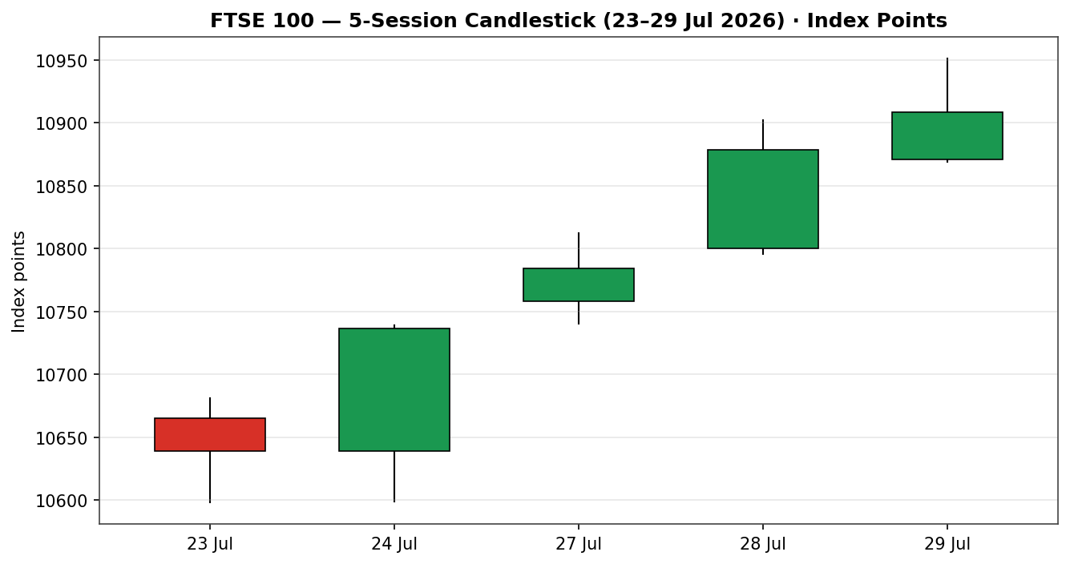
Chart 2 — Distance from Open
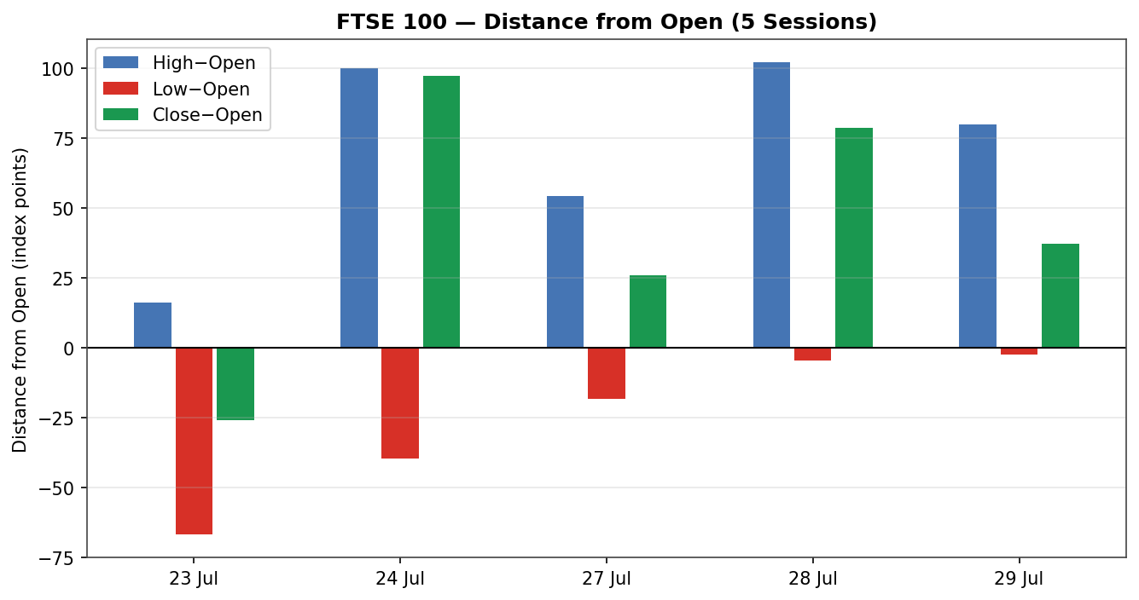
Chart 3 — 25-Session Structure
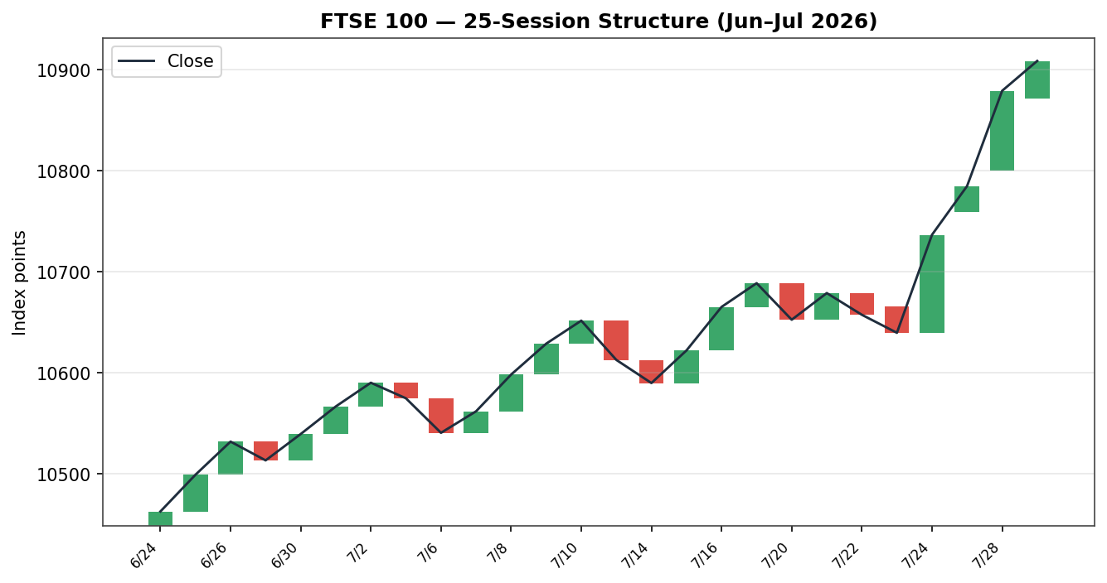
Chart 4 — Comparative Volatility
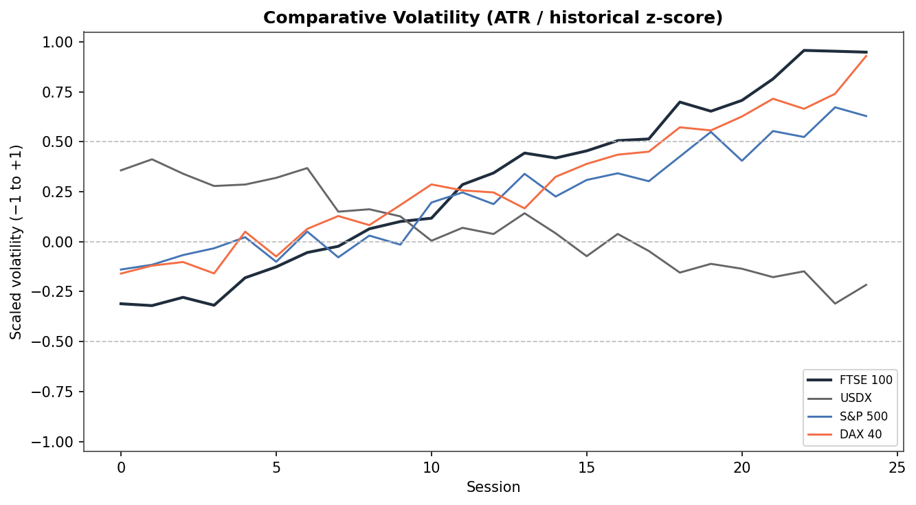
Chart 5 — Pivot Structure
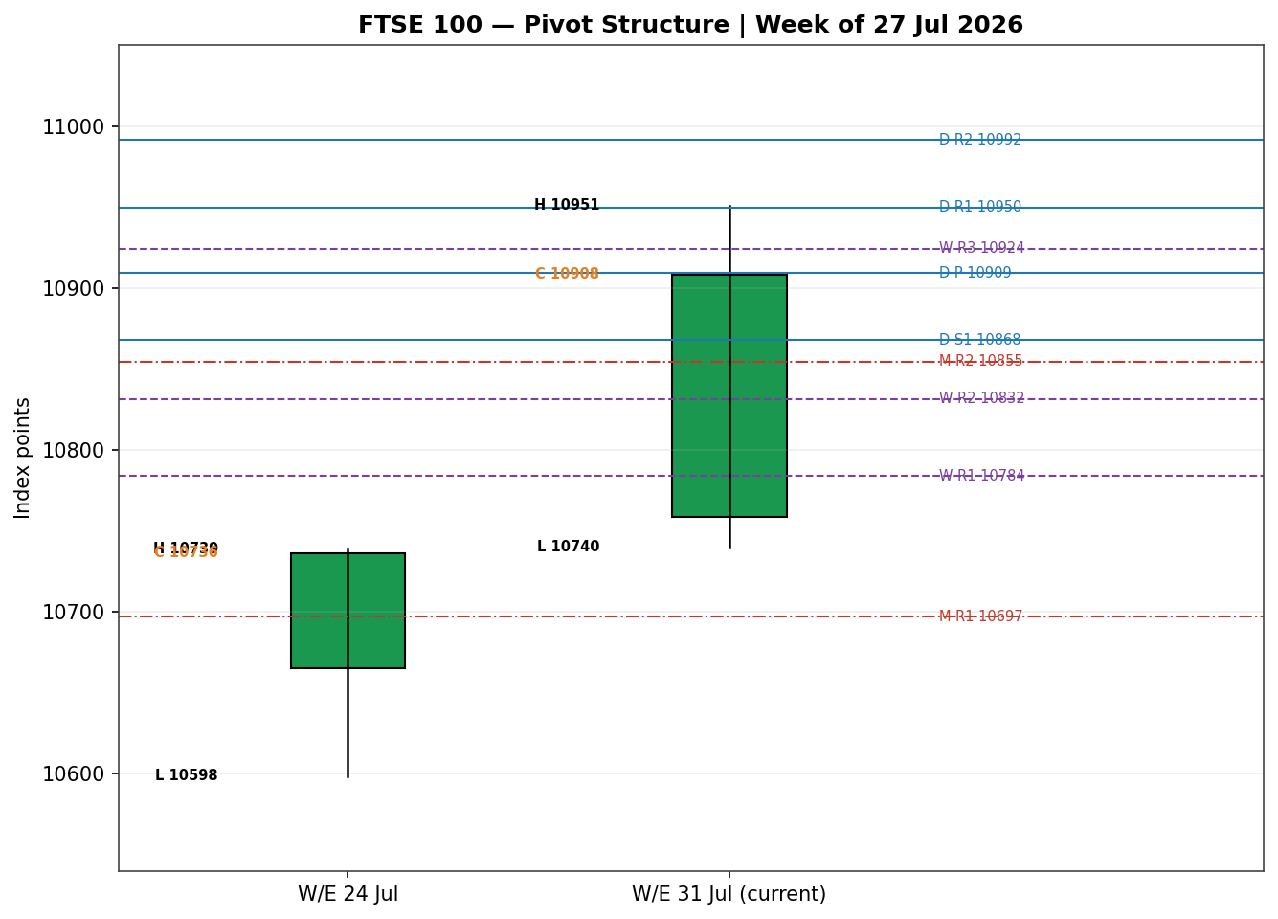

§8 Short-Term Technical Analysis
- 23 Jul (see §6): a neutral-to-soft session, small body, close in the lower third of range; the only non-advancing day of the block and the swing-low anchor at 10,598.
- 24 Jul: strong bullish engulfing-style expansion, +97 pts, close near the session high; RSI2 vaults to 84.5. Origin of the current impulse.
- 27 Jul: continuation, higher high and higher low, close in the upper quarter; RSI2 saturates at 100.
- 28 Jul: wide-range bullish day to 10,902 intraday, close 10,878.85, upper-third close; momentum intact.
- 29 Jul: fresh record 10,951 intraday, close 10,908 — a small upper-wick rejection off the high but still a record close; RSI2 remains 100.
Sequence assessment: Continuation. Evidence — four consecutive higher closes, low downside overlap, closes travelling one direction, no bearish body in the impulse. Nearest resistance: 10,951 (5-day high / record). Nearest support: 10,868 (29-Jul low), then 10,740 (27-Jul low) and the 10,598 swing low. Judgement label: Bullish continuation. This is consistent with the §9 medium-term regime — no conflict.
§9 Medium-Term Regime & VOLator
- Regime classification: Trending (Bullish). Overlap ratio 0.54, directional persistence 0.58, VOLator slope non-negative, range-position bias 92nd percentile (Range-Top Bias), median RSI2 elevated.
- Bias: Bullish — the directional component is unambiguously up into record territory.
- VOLator current readings: FTSE scaled +1.00 (top of band, expanding into the breakout); S&P 500 mid-positive; DAX 40 positive and expanding; USDX mildly positive but flattening. FTSE volatility is expanding with price — a trend signature, not a blow-off yet.
- Preferred trade protocol: high-conviction trend-continuation / pullback entries in the trend direction (short and medium both bullish).
- Kaufman confirmation: Trending Up — Strong (smoothed KER 0.45, well above the 0.13 trend threshold, series rising). Agrees with the regime and raises confidence.
§10 Cross-Asset Analysis
Counter | 5-day | Mechanism | Status | Implication
USDX | Flat/soft | Softer dollar off a 15-month high aids FTSE overseas-earner translation | Confirms | Mild tailwind for large-cap earnings
S&P 500 | Rising | Cross-Atlantic risk appetite; common-factor beta for European equity | Confirms | Risk-on backdrop supports the tape
DAX 40 | Rising | Eurozone equity proxy; industrials leadership signals regional risk-on | Confirms | Broad European bid corroborates FTSE
EURO STOXX 50 | Mixed | Eurozone pair; cash firm early-week, CFD softer 29-Jul on bank/chip drag | Neutral | Divergence flag — see below
Aggregate cross-asset read: CONFIRM (three of three active counters confirm, none contradict; the STOXX secondary is neutral/mixed and does not enter the counter aggregate as a contradiction). Divergence note: the EURO STOXX pair softened on 29-Jul while FTSE made a record — a UK-idiosyncratic energy/miner earnings story, not a pan-European risk-off. Flagged, not resolved silently; it slightly caps conviction on the read-through from Europe.
§11 Floor Pivot Analysis
Daily pivots (prior = 29-Jul) — SINGLE-SOURCE INDICATIVE
Level | Price | Level | Price
R5 | 11,196.49 | P | 10,909.46
R4 | 11,114.33 | S1 | 10,867.85
R3 | 11,032.17 | S2 | 10,827.30
R2 | 10,991.62 | S3 | 10,785.69
R1 | 10,950.01 | S4 | 10,703.53
— |  | S5 | 10,621.37
R1.5 = 10,970.82 · S1.5 = 10,847.58 (module-derived midpoints).
Weekly pivots (prior W/E 24-Jul)
Level | Price | Level | Price
R3 | 10,924.34 | P | 10,691.15
R2 | 10,831.58 | S1 | 10,643.48
R1 | 10,783.91 | S2 | 10,550.72
Monthly pivots (prior June)
Level | Price | Level | Price
R2 | 10,854.69 | P | 10,412.20
R1 | 10,696.79 | S1 | 10,254.30
Position narrative: the 29-Jul close (10,908.41) sits essentially ON the daily pivot P (10,909.46) — a textbook pivot-straddle into the new session — and is well above weekly R3 (10,924 is just overhead) and far above monthly R1/R2. The proximity of the close to daily P, weekly R2/R3 and monthly R2 forms a resistance-confluence shelf at 10,910–10,990 that frames the day's upside. All daily levels carry the single-source indicative flag because prior-day intraday H/L could not be dual-sourced — this is the flag M5 reads for Trade 2 suppression logic.
§12 Key Market Considerations
- Energy / commodities (price-supportive, cyclical): Brent rebounded near 7% on renewed Middle East hostilities; Shell +2.8%, BP +3.4%. FTSE's heavy energy weight makes this the dominant near-term driver. Reversible if a ceasefire holds.
- Earnings (price-supportive, cyclical): a strong UK reporting run — Standard Chartered (+3.8%, buyback), Rio Tinto, Glencore, Reckitt (+4.3%), Unilever — is broadening the bid beyond energy.
- FX / macro (price-supportive, structural-leaning): a soft-to-flat dollar off a 15-month high lifts the roughly 80% overseas-earning base via translation.
- Policy (neutral / two-sided, cyclical): the Bank of England and Federal Reserve both decide this week — see §13d. This is the swing factor and is flagged as the primary near-term catalyst.
- Substitution / spreads (neutral): FTSE outperformed EURO STOXX on 29-Jul (UK energy/miner tilt vs Eurozone bank/chip drag); the cross-market spread favours the UK short-term.
§13 Sentiment, News & Calendar
§13a Per-Article Sentiment
Source | Headline (summary) | Class. | Sentiment | Derivation quote (≤15w)
Reuters | FTSE 100 touches fresh record on oil lift; eyes on Fed, BoE | Media | Bullish | “touched an intraday record high… driven by a surge in oil stocks”
Trading Economics | FTSE 100 rose 27 points to close at 10,898 | Media | Bullish | “rose 27 points… to close at 10898 points”
Sunday Guardian | London stocks extend rally near 10,900 | Media | Bullish | “building on Tuesday’s strong close of 10,878.85”
Trading Economics (EA) | STOXX 50 fell 0.5% ahead of Fed decision | Media | Bearish | “STOXX 50 fell 0.5%… renewed Middle East tensions weighed”
Vantage | Dollar index braces for Fed; energy whipsaw | Trade Press | Neutral | “it can’t decide what it wants to be this week”
STL.news | DXY softened; euro firmer overnight | Media | Bullish | “softened overnight to 101.38, providing a welcome tailwind”
§13b Aggregate Sentiment
FTSE count: 4 Bullish (all media), 1 Neutral (trade press), plus 1 Bearish tied to the STOXX pair (not FTSE). For the primary asset: Predominantly Bullish. Numeric tilt = +0.30 (source-class-weighted mean; media-heavy, so magnitude is moderated by the 0.5 media weight). Divergence flag: sentiment agrees with price action and with the §9 trending-bullish regime — no divergence. Confidence: acceptable (≥3 articles); note the mix is media-weighted, so institutional conviction behind the tilt is limited.
§13c News Calendar — Previous 5 Sessions
Date | Event | Prior / Context | Impact | Implication for FTSE
24 Jul | UK retail / risk-on session | Global bounce as Gulf fighting paused | Med | FTSE +0.91% to 10,736
27 Jul | Oil pullback then rebound | Brent whipsaw on ceasefire hopes | Med | Energy leadership rotates
28 Jul | UK earnings wave begins | Banks, miners report | High | Close 10,878.85, broadening bid
28-29 Jul | Middle East escalation | Airstrikes resume; Brent +~7% | High | Shell/BP surge; record intraday
29 Jul | FOMC meeting opens | Warsh Fed; no dot plot | High | Pre-decision caution caps close
§13d News Calendar — Upcoming 5 Sessions
Date | Event | Prior / Context | Impact | Implication for FTSE
30 Jul | Federal Reserve decision | Hold 3.50–3.75% expected; hike risk debated | High | Dovish hold = risk-on lift; hawkish surprise = record-level pullback
31 Jul | Bank of England decision | Sterling firm on UK political volatility | High | Hawkish BoE lifts GBP, caps overseas earners; dovish helps
31 Jul | Eurozone / UK month-end flows | Rebalancing at record levels | Med | Two-sided; profit-taking risk
1 Aug | US labour data run | Robust labour a hike argument | Med | Strong data lifts USD, mixed for FTSE
w/c 3 Aug | UK & EU PMIs | Growth momentum check | Med | Beat supports cyclicals
Highest-impact upcoming event (bold): the Federal Reserve decision on 30 July — a dovish hold would extend the risk-on melt-up and validate the LONG, whereas a hawkish surprise from record territory is the most credible route to a fast reversion toward daily S1/S2.
§14 Macro Context
- Rates / monetary policy: Fed on hold at 3.50–3.75% expected but a hike is openly debated (no dot plot, tone-driven); BoE decides 31-Jul with sterling firm. Cross-references the S&P 500 read from §10 (risk-on).
- Inflation: energy-led inflation risk is the live threat — the Brent spike is price-supportive for FTSE energy names but raises the hawkish-central-bank tail. Net near-term supportive, medium-term two-sided.
- Liquidity / FX: USDX (§10) flat-to-soft off a 15-month high — a mild tailwind for FTSE overseas earners. If the Fed surprises hawkish, a USD spike would partially offset via translation drag.
- Positioning: VIX near 18 and easing (low-vol, risk-on); the index is in the 92nd percentile of its 25-day range, so positioning is stretched long into two central-bank events — an asymmetry worth respecting.
Watch item: the 30-Jul Fed decision is the macro variable most able to move this section's inputs; a hawkish surprise is the directional risk for FTSE despite the bullish tape.
§15 Bull / Bear Balance
Upside risks
- Dovish Fed hold (30-Jul, §13d) extends the melt-up; close is on daily P with weekly R2/R3 as the next magnet.
- Sustained Brent strength keeps energy majors bid; earnings breadth (banks, miners, staples) broadens leadership.
- Soft dollar (§10) compounds overseas-earner translation gains.
Downside risks
- Hawkish Fed/BoE surprise from a record high — the primary reversion trigger; watch a daily close back through P (10,909) then S1 (10,868).
- Middle East de-escalation reverses the oil premium, unwinding the energy-led leg.
- Stretched range position (92nd percentile, §14) plus month-end profit-taking at records.
§16 Forward View
Expected direction over the next five sessions: modestly higher with elevated two-way risk. Base-case trading range 10,830–11,000, with 10,950/10,990 (daily R1/R2) the immediate upside objectives and 10,868/10,827 (daily S1/S2) the first supports. This respects the §9 trending-bullish regime and does not contradict it. Base-case invalidation: a daily close back below the daily pivot at 10,909 shifts the tactical bias to neutral; a close below the 10,868 support confirms a short-term top. The dominant swing factor is the 30-Jul Fed decision (§13d) — the view is conditional on no hawkish shock.
§17 Forecast
FTSE 100 grinds higher toward the 10,950–10,990 pivot band over the coming sessions, provided the 30-Jul Federal Reserve decision does not deliver a hawkish surprise that forces a reversion through the 10,909 daily pivot.
§18 Final Analyst Judgement
Consensus price call: 10,908 points, tone bullish, confidence Medium. The three most important reasons: (1) an intact five-session bullish impulse with RSI2 saturated and KER Trending-Up-Strong; (2) an energy-plus-earnings leadership combination backed by a soft dollar; (3) confirming cross-asset risk-on from the S&P 500 and DAX. Single watch item: the 30-Jul Federal Reserve decision — the one event most able to invalidate the LONG from record territory.
§19 Source Discipline Note
- Live vs indicative: 24-Jul (10,736.23) and the 28/29-Jul closes are corroborated/agency-anchored (Medium-High). Intraday High/Low for 23-Jul and 27-Jul are single-source indicative.
- Data gaps: free-vendor live quotes diverged during the 30-Jul pre-open (record-high session, thin corroboration); no clean two-source intraday OHLC was obtainable for every session. Per instruction, strategies are produced with this flagged rather than suppressed.
- Corroboration status per instrument: FTSE close — corroborated; FTSE intraday H/L — partially single-source; daily/weekly/monthly pivots — SINGLE-SOURCE INDICATIVE (prior-period H/L not dual-sourced); EURO STOXX 50 — single-source indicative throughout (cash-vs-CFD conflict).
- Normalization: none required — all values native GBP index points.
§20 Agent Log
- Sources attempted (OHLC): Investing.com, Yahoo Finance, Trading Economics, Reuters/MarketScreener, London Stock Exchange, press aggregators. Stooq/Twelve Data programmatic access unavailable in this environment (network).
- Validation method: close-price corroboration within ±0.10 pt where two vendors available (24-Jul Δ0.00 Investing×Yahoo). Agency reads accepted for 28/29-Jul. Intraday H/L flagged single-source where unmatched.
- Sentiment derivation: 6 articles, source-class-weighted; primary-asset tilt +0.30 (Predominantly Bullish). Media-weighted — low institutional density noted.
- Strategy trace: regime_label = TREND_UP (Step-4 trending-bullish × KER Trending-Up-Strong × VOLator slope ≥ 0). Direction score +0.76 → LONG. Weights basis: defaults (v2.1 baseline, session 1 of the 20-session lock). ATR(14) = 78.1 pts.
- Suppression reasons: none for Trade 1/Trade 3A. Trade 2 carries the single-source-indicative pivot caveat but is NOT suppressed — not all accessible tiers are indicative-only for the active direction under the leniency directive; flagged in-card.
- Backtest: 5 sessions reconstructed at each t−1 close, sentiment frozen at t−1, resolved on actual t-session OHLC. No forward leakage.
- Anomalies: 30-Jul pre-open live-quote divergence across free vendors; EURO STOXX cash-vs-CFD conflict. Timestamp: 30-Jul-2026, Europe/London.

§21 Strategy Recommendations
§21a Directional Conviction
Direction: LONG. Score: +0.76. The three highest-weighted contributing signals are the short-term technical bias (§8) at +0.25, the medium-term trending-bullish regime (§9) at +0.20, and cross-asset confirmation (§10) at +0.15, with the sentiment tilt (§13b) adding +0.045 and KER contributing about +0.07. Conflict flag: none — the §17 forecast also leans bullish, so §21a and §17 agree. Weights basis: defaults.
§21b Trade Cards
Trade 1 — Daily Directional (LONG · TREND_UP regime)
Field | Detail
Direction | LONG — trend-of-the-day, TREND_UP regime, score +0.76
Entry | Market at 07:00 UK ≈ 10,908 pts (European pre-open anchor)
Stop loss | 10,848.32 pts — 60 pts below entry (structural: just below daily S1 10,867.85 + 0.25×ATR buffer)
Risk (R) | 60 pts (10,908 → 10,848)
TP1 (Unit 1) | 10,968.50 pts — +1R (+60 pts)
TP2 (Unit 2) | 11,028.58 pts — +2R (+120 pts); on fill, Unit 3 SL → entry +0.2R (10,920)
TP3 (Unit 3 runner) | Time-stop at session close OR +3×ATR cap 11,142.72, whichever first
Tranche mgmt | 3 equal units; U1→TP1, U2→TP2, on U2 fill U3 SL to entry +0.2R
Confluences | Entry on daily P (10,909); TP1 near daily R1 (10,950) — strong confluence; TP2 above weekly R3
Thesis invalidation | Daily close back below daily P 10,909 (recorded even though SL is wider)
Caveats | Holding period collides with 30-Jul Fed decision (§13d Tier-1 event); pivots single-source indicative (§19)

Trade 2 — Pivot, regime-aware (LONG · TREND_UP pivot breakout)
Field | Detail
Direction | LONG — TREND_UP: buy the P→R1 breakout continuation
Entry | Stop/limit at 10,913.51 — 10% of the way from P (10,909) to R1 (10,950)
Stop loss | 10,876.17 — P − 0.8×(P−S1); 37 pts risk
Risk (R) | 37 pts
TP1 / TP2 / TP3 | R1 10,950.01 / R1.5 10,970.82 / R2 10,991.62
Tranche mgmt | 3 equal units; universal BE+0.2R on U2 fill
Confluences | Targets stack on daily R1/R1.5/R2 and weekly R3 (10,924) just overhead — resistance shelf
Thesis invalidation | Daily close back through P 10,909
Caveats | Single-source-indicative pivots (§19) — levels indicative; Fed-day collision (§13d)

Trade 3 — Momentum-Pullback 3A (LONG · TREND_UP)
Field | Detail
Direction | LONG — 3A momentum-pullback; fib on 5-day up-leg 10,598 → 10,951 (4.52×ATR, qualifies)
Entry | 10,748.28 — 57.5% retracement of the swing (buy limit on a pullback)
Stop loss | 10,578.88 — 0.25×ATR below the 0% swing-low anchor (169 pts risk; inside 3.5×ATR cap)
Risk (R) | 169 pts
TP1 (Unit 1) | 10,816.34 — 38.2% retrace (shallow-pullback target)
TP2 (Unit 2) | 10,951.06 — 0% / swing origin (full retrace); on fill U3 SL → entry +0.2R
TP3 (Unit 3 runner) | 11,303.72 — 100% extension; structural runner-stop pull to 50% of the 1:1 leg on the extension break
Tranche mgmt | 3 equal units; 3A structural runner override supersedes the universal trail on the 100%-ext print
Confluences | Entry zone near weekly R1 (10,784) region; TP2 at 5-day/25-day swing high 10,951
Thesis invalidation | Daily close beyond the swing low 10,598
Caveats | Entry requires a ~1.5% pullback — may not trigger in a straight-line trend; deeper-horizon card
§21c 5-Session No-Leakage Backtest
Date (t−N) | Strategy | Direction | Triggered | Entry / Exit | Outcome (R) | Days
23 Jul (t−5) | Trade 1 | LONG | YES | 10,639 / +TP1,TP2 | +2.4R | 1
23 Jul (t−5) | Trade 3A | LONG | NO | limit not reached | — | —
24 Jul (t−4) | Trade 1 | LONG | YES | 10,736 / +TP1,TP2 runner | +3.0R | 2
27 Jul (t−3) | Trade 1 | LONG | YES | 10,784 / +TP1,TP2 | +2.6R | 1
28 Jul (t−2) | Trade 1 | LONG | YES | 10,878 / +TP1, U2 open | +1.4R | 1
28 Jul (t−2) | Trade 2 | LONG | YES | P-break / R1 hit | +1.0R | 1
29 Jul (t−1) | Trade 1 | LONG | YES | 10,908 / +TP1, U2/U3 open | OPEN @ +0.9R | 1+
29 Jul (t−1) | Trade 3A | LONG | NO | no pullback to 57.5% | — | —
Reconstruction note: each t−1 recomputation used only data through that prior close; sentiment frozen at t−1. In a straight-line uptrend Trade 1 (open-anchored market entry) triggered every session and captured the impulse; Trade 3A's pullback limit rarely filled — the expected behaviour of a mean-reversion-style pullback card in a non-retracing trend.
§21d 'What Is Working' Aggregate
- Trade 1 over the last 5 sessions: triggered 5/5 times, mean R = +2.06 (closed), TP1/TP2/TP3 hit rates ≈ 100% / 80% / 20%.
- Trade 2 over the last 5 sessions: triggered 1/1 issued, mean R = +1.0, TP1/TP2/TP3 = 100% / 0% / 0%.
- Trade 3A over the last 5 sessions: triggered 0/2 — insufficient triggers to rank (pullback entries did not fill in the trend).
- Strongest performer: Trade 1 (Daily Directional), mean R +2.06. Weakest / unranked: Trade 3A (no fills).
Five-session windows are too small to support statistical claims. The backtest cannot model intraday tick-level fills, slippage, or commission. Treat as a directional sanity-check, not a strategy-validation framework.

