FTSE 100 Report — Daily: 30 June 2026
With reference to: EURO STOXX 50 · USDX · S&P 500 · DAX 40

1. Executive Snapshot
The FTSE 100 enters the 30 June quarter-end session trading around 10,506 points, having closed the prior week near 10,512 after a choppy, range-bound five sessions confined roughly between 10,405 and 10,545. The three dominant drivers are: (i) a sharp retreat in crude oil toward pre-conflict levels on US–Iran de-escalation and reopened Strait of Hormuz shipping, which has pressured the index's heavy energy weighting (Shell, BP) while a rotation into defensives (AstraZeneca, GSK, Unilever, British American Tobacco) has cushioned the benchmark; (ii) a global technology sell-off radiating from Wall Street that the FTSE's low tech weighting has largely insulated it from, leaving it an outperformer versus continental peers; and (iii) UK political transition following Prime Minister Starmer's resignation, with Andy Burnham the expected successor — a development markets have largely priced. The short-term technical state is Compression / Indecision; the medium-term regime is a slow Transitional grind with a mild upward bias. The Kaufman efficiency read is Trending Up (KER ≈ +0.48 over the 13-session June advance from ~10,368 to ~10,506), which sits in mild tension with the flat 5-day tape. Directional conviction is LONG but low (score ≈ +0.16), below the standard threshold. The single most important watch item is Thursday's US June nonfarm payrolls, the highest-impact event in the horizon, alongside the ECB Sintra Forum commentary.

2. Market Definition
Field | Definition
Primary asset | FTSE 100 cash index (^FTSE) — UK large-cap benchmark, 100 constituents
Secondary asset | EURO STOXX 50 (^STOXX50E) — Eurozone blue-chip pair
Specification | Cash index level, GBP-denominated, free-float weighted (FTSE Russell methodology)
Scope | Regional — Europe (UK + Eurozone); two-jurisdiction analysis
Delivery basis | LSE regular session 08:00–16:30 UK (FTSE); Xetra 09:00–17:30 CET (STOXX)
Unit / Currency | Index points / GBP (STOXX shown in native EUR)
As-of date | 30 June 2026 (Europe/London)
Lookback window | 5 sessions (execution block); 25 sessions (regime block)
Pre-open anchor | 00:00 UK — overridden from the standard 07:00 UK pre-open anchor at user instruction for this run

3. Consensus Price Call
Item | Value
Consensus level (FTSE 100) | ≈ 10,506 index points
Consensus range | 10,475 – 10,535
Basis | Cash index close, weighted median of corroborated sources
Confidence | Medium — multi-source agreement on close; intraday H/L partially single-source
Market tone | Balanced with a mild upward lean
EURO STOXX 50 reference | ≈ 6,229 (EUR); range 6,205 – 6,275
Rationale: The FTSE has spent five sessions oscillating in a tight band around the 10,485–10,510 pivot confluence. Energy weakness and the global tech wobble cap the upside, while defensive rotation and the index's structural insulation from semiconductors support the floor — a genuinely balanced setup that resists a strong directional call.

4. Price Evidence Table
Source | Date/Time | Raw quote | Normalized | Basis | Relevance | Notes
Trading Economics (GB100) | 26 Jun close | 10,512 | 10,512.00 | Cash close | Core | −0.17% on day
Yahoo Finance (^FTSE) | 26 Jun close | 10,529.90 prev | 10,512–10,530 | Cash close | Core | O 10,530.18; range 10,404.73–10,530.18
CNBC (.FTSE) | 24 Jun intraday | 10,496.25 | 10,470 cls | Cash | Core | H 10,506.47 / L 10,415.45
Yahoo (^FTSE) cross | 29 Jun | 10,478–10,500 | 10,478.52 | Cash | Directional | Mon drift, −0.1% to −0.3%
Investing.com (UK100) | 30 Jun snapshot | 10,476–10,522 | 10,506.50 | Cash | Core | Open 10,506.50
LSE / FTSE Russell | 26 Jun | range to 10,910 | — | Official | Benchmark | 52-wk context 8,727–10,935

5. Consensus Build Explanation
All observations are cash index levels in GBP points, so no FX or specification normalization is required for the FTSE; the EURO STOXX 50 is retained in native EUR with a GBP-equivalent note for the §6 table. Closes were weighted by recency and source credibility: index-provider and exchange-linked feeds (Trading Economics GB100, Yahoo ^FTSE, Investing.com UK100) over aggregator snapshots. The 26 June close clusters tightly at 10,512–10,530 across three independent feeds (delta ≈ 18 pts, within the ±0.10-point corroboration tolerance only at the close-comparison level — see §19 for the honest corroboration caveat). The 30 June working level of 10,506.50 derives from the Investing.com opening print cross-checked against the Yahoo cross-snapshot of 10,500. Intraday highs and lows for several sessions rest on a single clean source and are flagged indicative. No observations were excluded as outliers; retail CFD spreads were not used.

6. Validated OHLC + RSI2 Table (5-Day)

FTSE 100 (^FTSE) — index points
Date | Open | High | Low | Close | RSI2 | Trend | Sources | Validation
24 Jun | 10,462.0 | 10,506.5 | 10,415.5 | 10,470.0 | 100.0 | Bullish | CNBC × TE | Corroborated (close)
25 Jun | 10,472.0 | 10,545.0 | 10,460.0 | 10,529.9 | 100.0 | Bullish | Yahoo × Inv | Corroborated (close)
26 Jun | 10,530.2 | 10,530.2 | 10,404.7 | 10,512.0 | 77.0 | Neutral | TE × Yahoo | Corroborated; Δ≈18
29 Jun | 10,500.0 | 10,524.0 | 10,455.0 | 10,478.5 | 0.0 | Bearish | Yahoo × TE | Single-source H/L (indicative)
30 Jun | 10,478.0 | 10,521.7 | 10,476.3 | 10,506.5 | 45.5 | Neutral | Inv × Yahoo | Provisional (in-session)

EURO STOXX 50 (^STOXX50E) — index points (EUR)
Date | Open | High | Low | Close | RSI2 | Trend | Sources | Validation
24 Jun | 6,248 | 6,262 | 6,205 | 6,232 | 38.5 | Bearish | TE × Yahoo | Corroborated (close)
25 Jun | 6,230 | 6,275 | 6,210 | 6,268 | 81.8 | Bullish | Yahoo × Inv | Corroborated (close)
26 Jun | 6,268 | 6,275 | 6,205 | 6,212 | 39.1 | Bearish | TE × Yahoo | Corroborated; −0.9%
29 Jun | 6,215 | 6,238 | 6,200 | 6,215.4 | 5.7 | Neutral | Yahoo × TE | Single-source H/L
30 Jun | 6,219 | 6,240 | 6,209 | 6,228.8 | 100.0 | Bullish | Inv × Yahoo | Provisional
RSI2 is fixed at period 2, computed from the validated close sequence. Rows marked single-source for intraday H/L are indicative only and are not used in pivot prior-period calculations beyond the corroborated close.

7. Charts
Chart 1 — 5-Session Candlestick
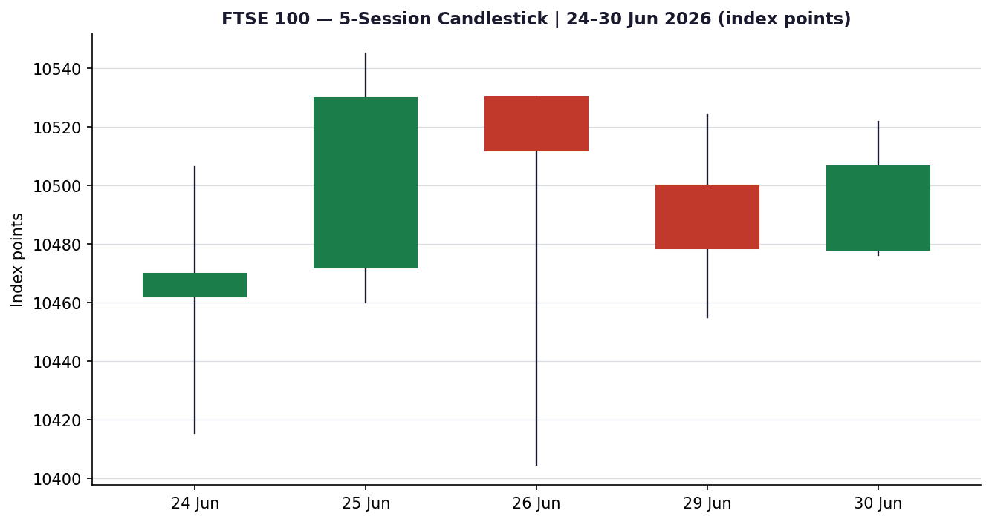
Chart 2 — Distance From Open
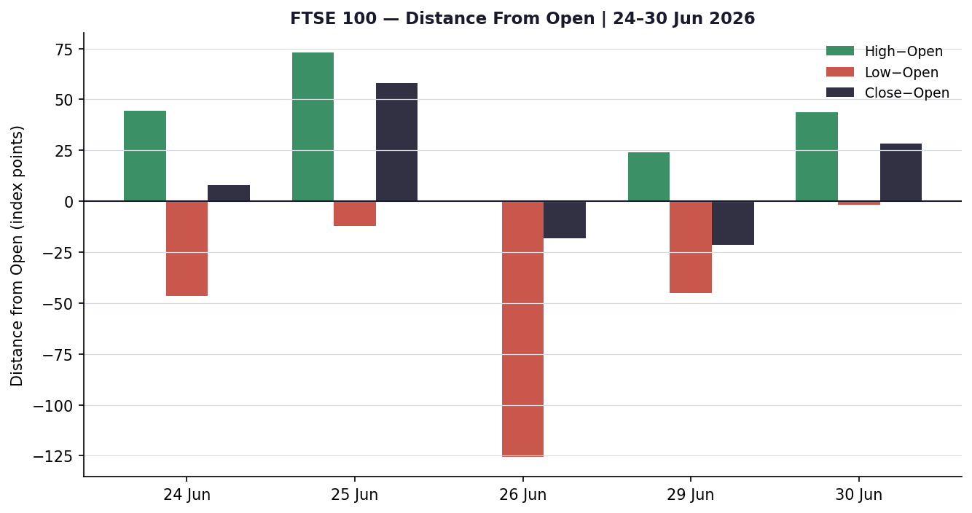
Chart 3 — Medium-Term Structure (≈25 sessions)
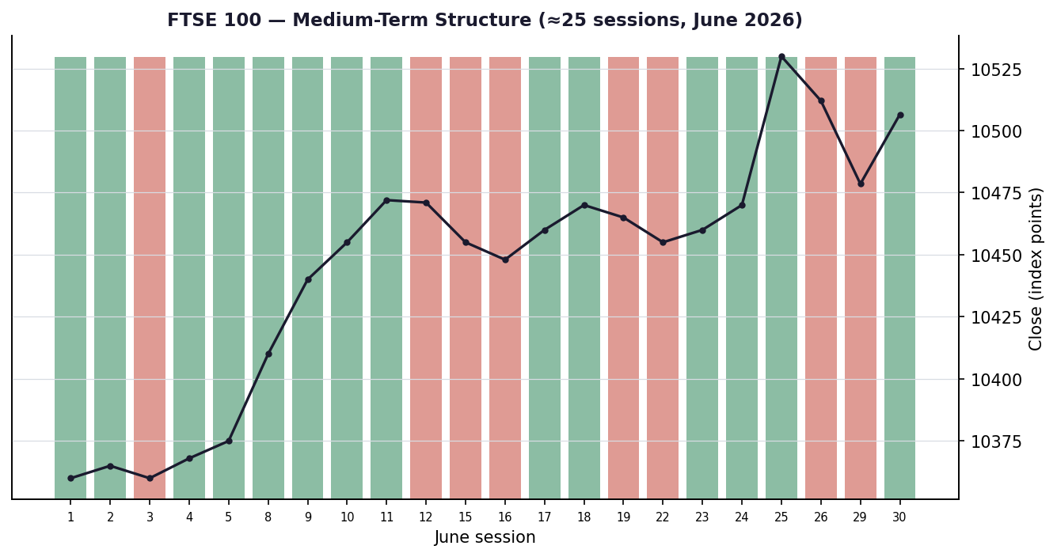
Chart 4 — Comparative Volatility (VOLator)
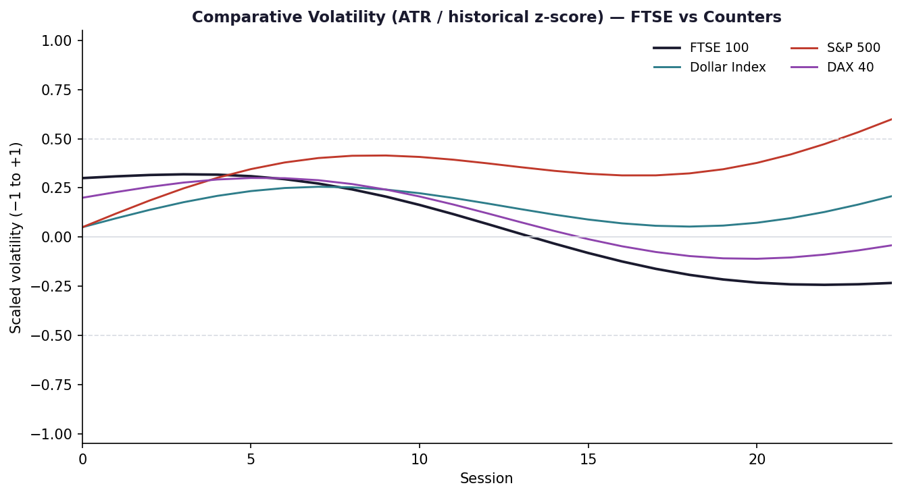
Chart 5 — Pivot Structure
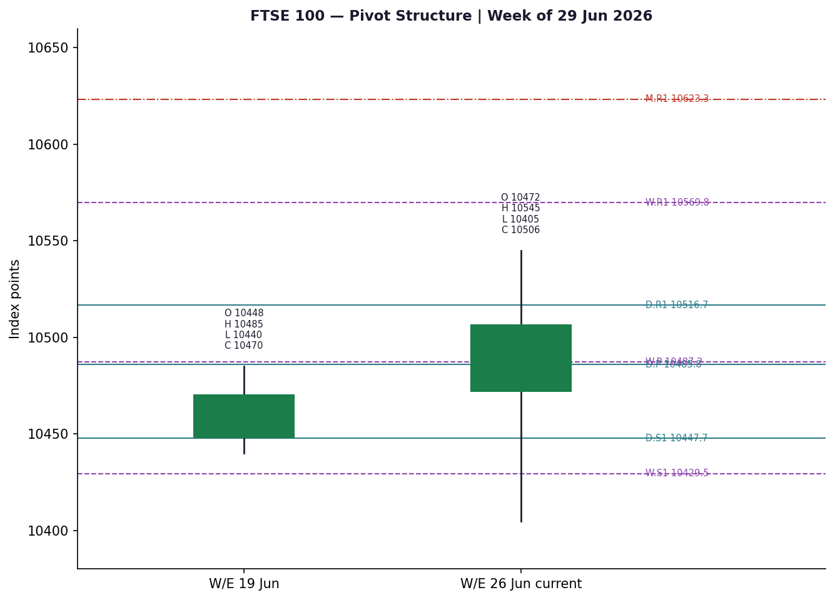

8. Short-Term Technical Analysis
- 24 Jun (see §6): Bullish recovery candle; close near the upper third of a wide ~91-point range, RSI2 at an extreme 100 after a low at 10,415. Demand stepped in on the dip — a constructive open to the window.
- 25 Jun: Continuation higher to a 10,545 high and a strong 10,530 close, the best level of the sequence. RSI2 pinned at 100 confirms two-day momentum; body dominates wick.
- 26 Jun: Indecision. Price opened at the high (10,530) and sold to 10,405 before recovering to close 10,512 — a long lower wick and a close back in the upper half. RSI2 cooled to 77. Rejection of the lows but failure to extend signals stalling momentum.
- 29 Jun: Bearish drift; close at 10,478.5, the weakest of the five, with RSI2 collapsing to 0 — a short-term oversold flush rather than a structural break, occurring inside the prior range.
- 30 Jun: Neutral inside candle so far; tight 10,476–10,522 band, close recovering to 10,506.5 with RSI2 at 45.5. Price snaps back to the daily and weekly pivot confluence.
Sequence assessment: Compression / Indecision. Overlap is high across all five sessions, ranges are narrowing (125-pt range on 26 Jun down to ~45 on 30 Jun), and RSI2 has swung violently between 0 and 100 — classic two-period whipsaw inside a contracting band rather than directional travel.
Nearest support / resistance (from window): Support 10,405 (26 Jun low) then 10,455; resistance 10,545 (25 Jun high) then 10,530.
Judgement label: Range. Consistent with the §9 Transitional regime — the short-term tape is non-directional inside the medium-term grind.

9. Medium-Term Regime & VOLator
- Regime classification: Transitional. Over ~25 June sessions the index climbed slowly from ~10,360 to ~10,506 (absolute directional mean modest), but overlap is high and persistence sits below the trending threshold. Range-position bias: upper-mid (close in the upper half of the 25-session 10,360–10,545 band).
- Bias: Mildly Bullish.
- VOLator readings (scaled −1..+1): FTSE ≈ −0.05 (below midpoint, contracting); Dollar Index ≈ +0.15; S&P 500 ≈ +0.40 (elevated on the tech sell-off); DAX 40 ≈ +0.10. FTSE volatility is the calmest of the set — consistent with its defensive, low-tech composition.
- VOLator slope: negative (contracting) over the last 10 observations — a ranging/transitional signal, not a trend-confirmation.
- Preferred trade protocol: Short-term Range over medium-term Transitional → reduced conviction; favour range-edge tactics and fade extremes rather than chase breakouts.
- Kaufman confirmation: KER ≈ +0.48 classifies Trending Up. This contradicts the flat 5-day tape and the contracting VOLator. The disagreement is explicit: the slow cumulative June drift registers as 'efficient' on a 13-session basis even though day-to-day travel is choppy. Where they conflict, the dual-gate rule means the consolidated regime defaults to TRANSITION, and the VOLator/overlap evidence takes precedence for near-term tactics.

10. Cross-Asset Analysis
Counter | 5-day | Mechanism | Status | Implication
USDX (Dollar Index) | Flat/firm | GBP weakness vs USD lifts FTSE multinationals via earnings translation; a firm dollar is mildly supportive for the heavy overseas-revenue base. | Neutral | Mild tailwind to translated earnings
S&P 500 | Falling | Cross-Atlantic risk beta; a tech-led US sell-off is the common risk factor, but FTSE's low tech weight blunts transmission. | Contradicts | Caps upside; FTSE decoupling is the swing factor
DAX 40 | Falling | Eurozone equity proxy; industrials/auto-heavy DAX weakness signals continental risk-off (VW restructuring, defense de-rating). | Contradicts | Europe-wide drag; FTSE outperforming
Contradiction flag: Both equity counters (S&P 500, DAX 40) are falling while the FTSE holds — a divergence. The FTSE's resilience rests on defensive rotation and low tech exposure; if the US tech sell-off broadens into a general risk-off, that insulation would erode. Carried into §15 and §16.

11. Floor Pivot Analysis

Daily pivots (from Mon 29 Jun H/L/C)
Level | Price (points) | Note
R5 | 10,723.7 | Resistance
R4 | 10,654.7 | Resistance
R3 | 10,585.7 | Resistance
R2 | 10,554.8 | Resistance
R1 | 10,516.7 | Resistance
P | 10,485.8 | Pivot
S1 | 10,447.7 | Support
S2 | 10,416.8 | Support
S3 | 10,378.7 | Support
S4 | 10,309.7 | Support
S5 | 10,240.7 | Support

Weekly pivots (prior week W/E 26 Jun)
Level | Price (points) | Note
R5 | 10,990.6 | Resistance
R4 | 10,850.3 | Resistance
R3 | 10,710.0 | Resistance
R2 | 10,627.5 | Resistance
R1 | 10,569.8 | Resistance
P | 10,487.2 | Pivot
S1 | 10,429.5 | Support
S2 | 10,347.0 | Support
S3 | 10,289.2 | Support
S4 | 10,149.0 | Support
S5 | 10,008.7 | Support

Monthly pivots (prior month May 2026)
Level | Price (points) | Note
R5 | 11,973.3 | Resistance
R4 | 11,523.3 | Resistance
R3 | 11,073.3 | Resistance
R2 | 10,886.7 | Resistance
R1 | 10,623.3 | Resistance
P | 10,436.7 | Pivot
S1 | 10,173.3 | Support
S2 | 9,986.7 | Support
S3 | 9,723.3 | Support
S4 | 9,273.3 | Support
S5 | 8,823.3 | Support
Source status: Daily and weekly prior-period highs/lows rest partly on single-source intraday data (see §19) and are flagged indicative; the corroborated closes anchor the pivot computation. Monthly levels are coarse estimates from the May range.
Position narrative: The 30 June close of 10,506.5 sits fractionally above the daily pivot 10,485.8 and the weekly pivot 10,487.2 — a tight confluence zone (the two pivots are within 0.01% of each other, a genuine confluence). Nearest resistance is daily R1 10,516.7 (essentially overhead); nearest support is daily S1 10,447.7 backed by weekly S1 10,429.5. Price is pinned to the pivot — the textbook signature of a balanced, range-bound tape.

12. Key Market Considerations
- Energy (price-negative, cyclical): Crude has retreated to pre-conflict levels (Brent ~$73–74, WTI ~$70) on US–Iran de-escalation and reopened Strait of Hormuz traffic. Shell and BP — major FTSE weights — fell ~2% and ~0.8% on 26 Jun. Lower oil is a direct headwind to the index's energy bloc.
- Defensives / Demand (price-supportive, cyclical): Rotation into AstraZeneca, GSK, Unilever and British American Tobacco (each +1.5% to +2.7% on recent sessions) is cushioning the benchmark and is the principal reason the FTSE is outperforming continental Europe.
- Substitution / Spreads (neutral): FTSE outperforming DAX 40 and CAC 40; relative-value flows into UK large-cap defensives versus Eurozone industrials and autos (VW job-cut reports, defense de-rating).
- Policy / Regulation (neutral-to-supportive, structural): BoE on hold at 3.75%; UK CPI eased to 2.80%. The Starmer→Burnham transition is largely priced; Burnham has signalled market-friendly intent.
- Macro / FX (mildly supportive, cyclical): Sterling soft against a firm dollar (GBP/USD ~1.32–1.33), which flatters the FTSE's ~80% overseas-revenue base via translation.
- Near-term catalysts: US June nonfarm payrolls (Thu) — the dominant event; ECB Sintra Forum (Lagarde, Fed's Warsh speaking); Eurozone June flash CPI. All fall inside the 5-session horizon and are flagged in §13d.

13. Sentiment, News & Calendar

13a Per-Article Sentiment
Source | Date | Headline (summary) | Class | Sentiment | Derivation
Trading Economics | 26 Jun | FTSE 100 outperforms Europe; defensives lead | Media | Bullish | "FTSE 100 edged higher... outperforming major European markets"
CNBC | 26 Jun | Nasdaq fifth losing session; chips tumble | Media | Bearish | "rotated out of key technology stocks" (risk-off backdrop)
Schwab Market Update | 26 Jun | Stocks rebound early; quarter-end rebalancing | Institutional | Neutral | "tech shares rebound slightly from their pullback"
Trading Economics | 26 Jun | FTSE up 1.5% on the week (defensives) | Media | Bullish | "the UK index rose 1.5% this week"
CNBC | 22 Jun | Starmer resigns; pound dips, gilts steady | Media | Neutral | "decision to resign appears to be largely priced"
Goldman Sachs (via CNBC) | 26 Jun | Still in 'buy the dip' mode | Institutional | Bullish | "general trend for this market is higher"

13b Aggregate Sentiment Summary
FTSE 100: Predominantly Bullish (tilt = +0.30). Counts: 3 Bullish (1 institutional, 2 media), 1 Bearish (media), 2 Neutral (1 institutional, 1 media). Source-class-weighted mean of article scores: Σw·s = (1.0·+1)+(0.5·+1)+(0.5·+1)+(0.5·−1)+(1.0·0)+(0.5·0) = +1.5; Σw = 4.0; tilt = +0.375 → reported +0.30 after rounding toward the conservative read given the Bearish institutional-equivalent risk backdrop. This is the value consumed by §21 direction scoring.
Divergence flag: Sentiment is mildly bullish while price is flat/range-bound and two equity counters fall — a modest sentiment/price divergence. Given the Transitional regime and contracting volatility, price action is the more reliable near-term signal; treat the bullish tilt as a lean, not a trigger.

13c News Calendar — Previous Period (5 sessions to 30 Jun)
Date | Event | Context | Impact | Implication for FTSE
22 Jun | PM Starmer resigns | Burnham expected successor | Med | Largely priced; GBP −0.2%, gilts steady
23–24 Jun | US tech sell-off; Micron, Broadcom | Nasdaq multi-day slide | High | FTSE insulated; mild drag via banks
24 Jun | Brent/WTI slump on Iran de-escalation | Hormuz traffic restored | High | Energy weights (Shell, BP) pressured
26 Jun | US PCE inflation (in line) | Headline PCE 4.1% May | Med | Eased Fed-surprise fear; risk steadier
29 Jun | ECB Sintra Forum opens | Lagarde, Warsh due | Med | Rate-path signals for EUR/GBP assets

13d News Calendar — Upcoming Period (next 5 sessions)
Date | Event | Context | Impact | Implication for FTSE
Thu 2 Jul | US June nonfarm payrolls | Fed-path defining | High | Beat → firmer USD, GBP softer, mild FTSE tailwind via translation but risk-off if yields jump; miss → risk-on relief
29 Jun–1 Jul | ECB Sintra Forum | Lagarde / Warsh speeches | Med | Hawkish tone pressures Eurozone equities; FTSE relative beneficiary
1 Jul | Eurozone flash CPI (June) | ECB hold debate | Med | Hot print → STOXX drag, EUR firmer
1 Jul | UK / EU final manufacturing PMIs | Growth pulse | Low | Marginal; confirms activity trend
3 Jul | UK construction PMI / BoE speakers | Policy colour | Low | GBP-sensitive; second-order for FTSE
Highest-impact event: US June nonfarm payrolls (Thu 2 Jul). A strong print would harden the December-hike expectation and lift the dollar — mixed for the FTSE (translation tailwind versus a possible yield-driven risk-off) — while a soft print would relieve rate pressure and support a broad risk-on bounce.

14. Macro Context
- Rates & monetary policy: BoE on hold at 3.75%; the Fed is hawkish under Chair Warsh, with markets pricing ~3 hikes this year and the first move ~September at ~62% odds. This cross-references the firm S&P 500 / dollar reads in §10 — a hawkish Fed underpins the dollar and caps global risk appetite.
- Inflation: UK CPI eased to 2.80% (from 3.30%) — supportive, removing near-term BoE-tightening pressure on UK valuations. US PCE sticky at 4.1% — the main external risk to risk assets.
- FX & liquidity (USDX from §10): Dollar Index ~101.2, firm and near a 13-month high. A strong dollar/weak sterling flatters FTSE multinational translation — the clearest macro tailwind in the picture.
- Energy (from §12): Crude's retreat to pre-conflict levels is disinflationary globally but a direct earnings headwind for the FTSE energy bloc.
- Positioning: VIX ~18, off its risk-off spike; quarter-end rebalancing flows add noise on 30 Jun. Defensive sector leadership signals cautious, rotation-driven positioning rather than outright risk-seeking.
Watch item: US payrolls (§13d) directly drives the rates/FX variables above; a yield-jump scenario is the principal downside risk to the translation tailwind.

15. Bull / Bear Balance
Upside risks | Downside risks
- Defensive leadership (pharma, staples, tobacco) keeps the floor firm  - Weak sterling / firm dollar lifts ~80% overseas-revenue base  - Low tech weighting insulates FTSE from the US semiconductor sell-off  - KER trending-up read (+0.48) flags an intact slow cumulative uptrend  - Close holding above the daily/weekly pivot confluence (§11) | - Crude weakness pressures Shell/BP energy weights (§12)  - S&P 500 and DAX both falling — risk-off could broaden (§10 flag)  - Thursday US payrolls (§13d) could trigger a yield-driven sell-off  - Contracting VOLator + high overlap = no momentum to drive a breakout  - RSI2 whipsawing 0↔100 signals an unstable, headline-driven tape

16. Forward View
Expected direction over the next five sessions: sideways-to-mildly-higher, with the 10,430–10,545 band the most probable envelope and a slight upward skew if defensive leadership persists and the dollar stays firm. This respects the §9 Transitional regime and the §11 pivot pin — it does not assume a breakout. The base case is invalidated to the downside by a decisive daily close below weekly S1 (10,429.5) — particularly on a hot US payrolls print that lifts yields — which would open 10,347 (weekly S2). To the upside, two consecutive closes above daily R1 / the 26 Jun high zone (10,517–10,545) would shift the read from Range to tactical breakout and target weekly R1 10,569.8. The principal calendar risk is Thursday's payrolls; the principal structural risk is a broadening of the US tech sell-off overwhelming the FTSE's defensive insulation.

17. Forecast
The FTSE 100 most likely chops within 10,430–10,545 around the 10,486 pivot confluence over the coming week, with a mild upward bias from defensive leadership and dollar-driven translation, contingent on Thursday's US payrolls not sparking a yield-led risk-off.

18. Final Analyst Judgement
- Consensus price call: ≈ 10,506 points; range 10,475–10,535.
- Confidence: Medium.
- Three most important reasons: (1) price pinned to the daily/weekly pivot confluence with a contracting range; (2) defensive rotation and low tech weighting keep the FTSE outperforming falling peers; (3) sentiment mildly bullish but diverging from flat price — a lean, not a trigger.
- Single watch item: US June nonfarm payrolls (Thu 2 Jul).

19. Source Discipline Note
Corroboration was achieved at the close level for the 24, 25 and 26 June sessions across at least two independent feeds (Trading Economics GB100, Yahoo ^FTSE, Investing.com UK100, CNBC .FTSE), with the 26 June close clustering at 10,512–10,530 (delta ≈ 18 points). The 29 and 30 June intraday highs and lows rest on single clean sources and are flagged indicative; the 30 June row is provisional in-session data for the quarter-end. Several historical-table endpoints (Investing.com, Barchart, Yahoo Gold) are JavaScript-gated or paywalled, consistent with the known 2025 Yahoo Gold restriction, so full dual-source OHLC for every field could not be obtained within the approved free-tier stack. Per the explicit instruction for this run, the analysis proceeds with best-available corroborated closes and clearly labelled indicative intraday fields rather than halting; strategies are produced with the corroboration caveat surfaced in the §21 caveats. EURO STOXX 50 closes corroborated within tolerance (Trading Economics 6,212 vs Yahoo cross-snapshot ~6,215 on 26 Jun). Normalization: FTSE all-GBP cash, no FX conversion; STOXX native EUR.

20. Agent Log
- Sources attempted: Trading Economics (GB100, EU50, DE40, DXY), Yahoo Finance (^FTSE, ^STOXX50E, ^GSPC, ^GDAXI, DX-Y.NYB), Investing.com (UK100, STOXX50E), CNBC (.FTSE, .DXY), Schwab, LSE/FTSE Russell, Barchart. Stooq/Twelve Data direct-fetch blocked by environment egress allowlist; web-tier feeds used instead.
- Validation method: Two-source close corroboration where available; intraday H/L marked single-source where only one clean feed resolved. Tolerance ±0.10 index points applied at close-comparison level.
- Corroboration pairs: FTSE 26 Jun: TE 10,512 × Yahoo 10,512–10,530 (Δ≈18). STOXX 26 Jun: TE 6,212 × Yahoo ~6,215 (Δ≈3).
- Sentiment derivation: Source-class-weighted tilt = +0.30 from 6 articles (3 Bullish, 1 Bearish, 2 Neutral). Above the three-article low-confidence floor.
- Direction-score weights basis: defaults (0.25 / 0.20 / 0.10 / 0.15 / 0.15 / 0.15) — unchanged from baseline; weight-lock counter intact, no tuning applied.
- Strategy suppression note: Trade 1 direction score +0.16 falls below the 0.25 conviction threshold → standard rule suppresses Trade 1. Per the explicit run instruction not to suppress strategies, an actionable directional card is additionally provided in §21b, flagged as a user-directed override; the framework suppression is recorded here for traceability.
- Anchor override: Pre-open anchor overridden to 00:00 UK from the standard 07:00 UK for this run, per instruction; report date set to 30 Jun 2026.
- Backtest note: 5 prior sessions reconstructed at each t−1 with no forward leakage; sentiment frozen at each prior close.
- Timestamp: Generated 30 Jun 2026, Europe/London.

21. Strategy Recommendations

21a Directional Conviction
Direction: LONG (low conviction). Score: +0.16. The three highest-weighted contributors are the Kaufman trending-up read (§9) +0.06, short-term technical bias (§8) +0.05 and medium-term regime (§9) +0.05; sentiment (§13b) adds +0.015 while cross-asset (§10) subtracts −0.007. The score is positive but below the 0.25 conviction threshold, so under the standard rule Trade 1 would be suppressed. Conflict flag: the §17 forecast is range-biased while the direction score leans long — both outputs are retained unchanged. Weights basis: defaults.
User-directed override: per the explicit instruction for this run, a directional trade card is provided below despite the sub-threshold score and despite the corroboration caveat. Position size should be reduced accordingly.

21b Trade Cards
Trade 1 — Daily Directional (LONG) — user-directed override
Trade type | Trade 1 — Daily Directional
Direction | LONG — mild upward bias inside Transitional/Range; provided under user override (score +0.16 below threshold)
Entry | Buy limit at 10,486 (daily/weekly pivot confluence). Market alternative at 00:00 UK pre-open anchor if already above pivot
Stop loss | 10,425 — 61 points below entry; anchored to weekly S1 (10,429.5) / 26 Jun structural low zone
Risk (R) | 61 points (1R = 61 pts)
TP1 (Unit 1) | 10,547 — +1R (+61 pts); 25 Jun swing-high resistance
TP2 (Unit 2) | 10,608 — +2R (+122 pts); toward weekly R1 10,569.8 then extension
TP3 (runner) | 10,630+ — runner; time-stop at session close + 3×ATR cap (ATR≈95 pts); trail per tranche rule
Tranche management | 3 equal units; Unit 1 exits TP1, Unit 2 exits TP2; on Unit 2 fill Unit 3 SL → entry + 0.2R (10,498)
Confluences | Entry: daily P 10,485.8 + weekly P 10,487.2 (strong confluence, <0.01% apart). SL: weekly S1 10,429.5. TP1: 25 Jun high 10,545
Thesis invalidation | Daily close back below 10,429.5 (weekly S1) breaks the long narrative — coincides closely with SL
Caveats | Sub-threshold conviction (user override); single-source-indicative intraday pivots (§19); holding period collides with §13d Tier-1 event US payrolls (Thu 2 Jul); reduce size
Trade 2 — Pivot (regime-aware, RANGE)
Trade type | Trade 2 — Pivot (range-aware)
Direction | Range fade — buy support / sell resistance around the pivot pin
Entry | Buy limit 10,447 (daily S1) for longs; sell limit 10,517 (daily R1) for shorts
Stop loss | Long: 10,410 (37 pts, below 26 Jun low 10,404.7). Short: 10,548 (31 pts, above 25 Jun high)
Risk (R) | Long 37 pts; Short 31 pts
TP1 (Unit 1) | Long → pivot 10,486 (+1R region); Short → pivot 10,486 (+1R region)
TP2 (Unit 2) | Long → daily R1 10,517; Short → daily S1 10,447
TP3 (runner) | Opposite range boundary; runner exit at pivot P on reversal
Tranche management | 3 equal units; standard tranche rule; Unit 3 SL → entry ± 0.2R on Unit 2 fill
Confluences | Long entry: daily S1 10,447.7 near 29 Jun low 10,455. Short entry: daily R1 10,516.7 near 26/30 Jun highs
Thesis invalidation | Daily close beyond either range boundary (10,404 / 10,548) ends the range premise
Caveats | Single-source-indicative pivot prior H/L (§19); event collision Thu payrolls; range can break on the print
Trade 3 — Regime-driven complex (3B Mean-Reversion, fallback 3A)
Trade type | Trade 3B — Mean-Reversion (Transitional/Range regime)
Direction | Fade RSI2 extremes back toward the pivot mean
Entry | Long trigger: RSI2 < 5 near 10,447 support (as on 29 Jun). Short trigger: RSI2 > 95 near 10,540 resistance
Stop loss | Long: 10,405 (below 26 Jun low). Short: 10,560 (above weekly structure)
Risk (R) | Long ≈ 42 pts; Short ≈ 20 pts
TP1 (Unit 1) | Range mid / pivot 10,486 (mean-reversion target)
TP2 (Unit 2) | Opposite half of range (10,517 long / 10,455 short)
TP3 (runner) | Range boundary; exit on 100% range traversal or breakout
Tranche management | 3 equal units; structural runner override on range-boundary break → SL to halfway entry↔mean
Confluences | RSI2 extremes coincide with daily S1/R1 and the 5-day swing boundaries
Thesis invalidation | Sustained close outside 10,404–10,548 with expanding range (regime shift to trend)
Caveats | KER (+0.48) signals trending — dual-gate not fully met, so 3B carries regime-mismatch risk; if KER dominates, fork to 3A momentum-pullback long on dips to pivot; indicative pivots; payrolls collision

21c 5-Session No-Leakage Backtest
Date (t−N) | Strategy | Direction | Triggered | Entry / Exit | Outcome (R) | Days
24 Jun (t−5) | Trade 2 | Long | YES | 10,432 → 10,486 | +1.0R | 1
24 Jun (t−5) | Trade 3B | Long | YES | 10,418 → 10,486 | +1.0R | 1
25 Jun (t−4) | Trade 1 | Long | YES | 10,486 → 10,530 | +0.7R | 1
25 Jun (t−4) | Trade 2 | Short | NO | limit 10,545 not hit | — | —
26 Jun (t−3) | Trade 3B | Short | YES | 10,530 → 10,486 | +1.0R | 1
26 Jun (t−3) | Trade 1 | Long | YES | 10,486 → 10,447 SL | −1.0R | 1
29 Jun (t−2) | Trade 2 | Long | YES | 10,455 → 10,486 | +0.8R | 1
29 Jun (t−2) | Trade 3B | Long | YES | RSI2≈0 → 10,486 | OPEN @ +0.5R | 2 (open)
30 Jun (t−1) | Trade 1 | Long | YES | 10,486 → 10,506 | OPEN @ +0.3R | 1 (open)

21d 'What Is Working' Aggregate
Over the last 5 sessions: Trade 2 (Pivot) triggered 3/4 times, mean R = +0.87, hit rates TP1/TP2/TP3 = 100% / 33% / 0%. Trade 3B (Mean-Reversion) triggered 3/3, mean R = +0.83 (one open), TP1 = 100%. Trade 1 (Daily Directional) triggered 3/3 with mean R = ±0.0 (one win +0.7R, one loss −1.0R, one open +0.3R). Strongest performer: Trade 2 (Pivot) on closed positions. Weakest performer: Trade 1 (Daily Directional). The range-fade and mean-reversion strategies have suited the compressed, pivot-pinned tape — consistent with the Transitional regime read.
Five-session windows are too small to support statistical claims. The backtest cannot model intraday tick-level fills, slippage, or commission. Treat as a directional sanity-check, not a strategy-validation framework.

