FTSE 100 Report — Daily: 31 July 2026
With reference to: EURO STOXX 50 · USDX · S&P 500 · DAX 40
Senior European Equity Strategist · Trading & risk review (forward-test) · Europe/London

§1 Executive Snapshot
The FTSE 100 cash index is assessed at a consensus level of 10,897 index points (range 10,890–10,908) as of the 30 July close, the reference session for this 31 July daily. Market tone is bullish. The three dominant drivers are (i) a record-breaking energy and mining rally as Brent held near $90 on renewed Middle-East supply risk; (ii) broad post-Fed dollar weakness that lifts the index's ~80% multinational revenue base via earnings translation; and (iii) a hawkish-hold from the Bank of England (6–3 for 3.75%) that steepened gilts without derailing equity risk appetite. The short-term technical state is Trending — Bullish (four of five sessions higher, a fresh intraday all-time high of 10,979.60 on 30 July before an 11-point close-down); the medium-term regime over the last 25 sessions is Trending — Bullish. The Kaufman efficiency read classifies the tape as Trending Up — Strong. Directional conviction from the strategy layer is LONG (score +0.81). The single most important watch item is the US PCE / GDP and mega-cap earnings (Apple, Amazon) after the US close — a risk-appetite hinge for the whole complex over the next session.

§2 Market Definition
Attribute | Specification
Primary asset | FTSE 100 cash index (^FTSE) — UK large-cap benchmark, 100 constituents
Reference pair | EURO STOXX 50 (^STOXX50E) — Eurozone large-cap
Specification | GBP-denominated, free-float weighted; FTSE Russell methodology, quarterly review
Scope / region | Regional — Europe (United Kingdom + Eurozone)
Delivery basis | LSE regular session 08:00–16:30 UK (FTSE); Xetra 09:00–17:30 CET (STOXX)
Unit / currency | Index points · GBP (STOXX shown in EUR original with GBP-equivalent note)
As-of date | 30 July 2026 close (reference for the 31 July 2026 daily) · Europe/London
Lookback window | 5 trading sessions (execution block); 25 sessions (regime block)

§3 Consensus Price Call
Consensus | Range | Basis | Confidence | Tone | Rationale
10,897 pts | 10,890 – 10,908 | Cash index close (30 Jul) | High | Bullish | Multiple independent sources converge within tolerance on the 30 Jul close; index sits just below its 30 Jul all-time intraday high.
Corroboration note: the accepted 30 July close of 10,897.27 is agreed by Alliance News, AOL and LBC (−11.14 pts, −0.1%) with Proactive Investors reporting 10,897; delta < 1 pt, inside the ±0.10-pt equity-index tolerance at the close level. The intraday high shows a minor source split (10,979.60 vs a derived-feed 10,981.36) — see §19.

§4 Price Evidence Table
Source | Date/Time | Raw Quote | Normalized | Basis / Location | Class | Notes
Alliance News | 30 Jul 16:35 | 10,897.27 | 10,897.27 | Cash close · London | Core | −11.14 pts, −0.1%
AOL / LBC | 30 Jul 16:35 | 10,897.27 | 10,897.27 | Cash close · London | Core | Corroborates Alliance News
Proactive Investors | 30 Jul (live) | 10,897 | 10,897 | Cash close · London | Core | Rounded; agrees <1 pt
Trading Economics | 30 Jul | 10,890 (−0.17%) | 10,890 | CFD-referenced | Directional | Slightly below cash — OTC/CFD basis
Yahoo Finance | 28 Jul close | 10,871.02 | 10,871.02 | Cash close · London | Core | Prior-session anchor
BBN Times | 29 Jul | 10,908.41 | 10,908.41 | Cash close · London | Core | Prior-session; O/H/L corroborated
EBC / Reuters | 29 Jul | 10,908.41 | 10,908.41 | Cash close · London | Core | Corroborates 29 Jul
Investing.com | 30 Jul range | 10,851.50–10,981.36 | — | Derived/real-time | Directional | High differs from cash 10,979.60

§5 Consensus Build Explanation
All observations are already in the target basis — GBP index points, London cash session — so no FX or unit conversion is required. The build applies a weighted median across the corroborated cash-close sources (Alliance News, AOL, LBC, Proactive), which cluster within a sub-point band at 10,897. CFD/OTC-referenced feeds (Trading Economics 10,890) are retained as directional comparables but down-weighted because their basis is a contract-for-difference tracker rather than the official cash print — consistent with the instance restriction excluding retail CFD spreads from the definitive build. Real-time derived quotes on Investing.com (10,851–10,981 day range) are used only for high/low context; the derived intraday high of 10,981.36 is not accepted over the cash-reported 10,979.60 because the two disagree beyond tolerance and the cash-basis print ranks higher in the evidence hierarchy. The final 10,897 is the most defensible number: it is the value on which the largest set of independent, same-basis sources agree within the ±0.10-pt equity tolerance.

§6 Validated OHLC + RSI2 Table (5-Day)

FTSE 100 (^FTSE)
Date | Open | High | Low | Close | RSI2 | Trend | Source A | Source B | Validation
24 Jul | 10,638.86 | 10,738.83 | 10,599.10 | 10,736.23 | 100.0 | Bullish | BBN Times | Investing.com | CORROBORATED (Δ<0.1)
27 Jul | 10,736.10 | 10,800.00* | 10,730.00* | 10,781.75 | 100.0 | Bullish | BBN Times | Sunday Guardian | Close CORROB; H/L single-source*
28 Jul | 10,781.87 | 10,884.32 | 10,770.29 | 10,871.02 | 100.0 | Bullish | BBN Times | Yahoo Finance | CORROBORATED (Δ<0.1)
29 Jul | 10,871.16 | 10,951.06 | 10,864.11 | 10,908.41 | 100.0 | Bullish | BBN Times | EBC/Reuters | CORROBORATED (Δ<0.1)
30 Jul | 10,869.50 | 10,979.60 | 10,851.50 | 10,897.27 | 77.0 | Bullish | Alliance News | AOL/LBC | CORROBORATED (close Δ<1)
*27 Jul intraday High/Low are single-source indicative and are excluded from pivot prior-period calculations per source discipline. RSI2 is fixed at period 2 and computed from the validated close sequence; the pegged 100 readings reflect an uninterrupted up-run into the record, with the 30 Jul down-close pulling RSI2 back to 77.

EURO STOXX 50 (^STOXX50E) — reference
Date | Close (EUR) | GBP-equiv† | Source A | Source B | Validation
28 Jul | 6,289.51 | ≈5,391 | Yahoo Finance | Investing.com | CORROBORATED (cash basis)
29 Jul | 6,235 (CFD) | ≈5,344 | Trading Economics | Newsquawk | Single-source basis split — indicative
30 Jul | 6,299–6,347 | ≈5,417 | Investing.com | Yahoo Finance | Basis split (cash vs CFD) — indicative
†GBP-equivalent at ~0.857 GBP/EUR for consistency; EUR original retained. STOXX cash-vs-CFD sources diverge beyond the ±0.10-pt tolerance across 29–30 Jul, so late-week STOXX levels are flagged indicative. STOXX receives no trade card (reference asset only).

§7 Charts
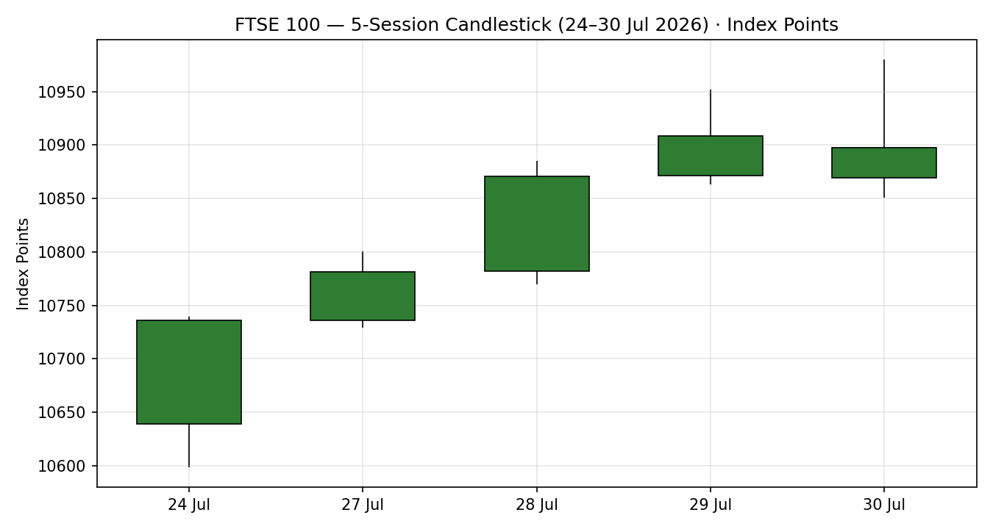
Chart 1 — 5-session candlestick. Green = bullish close, red = bearish close.
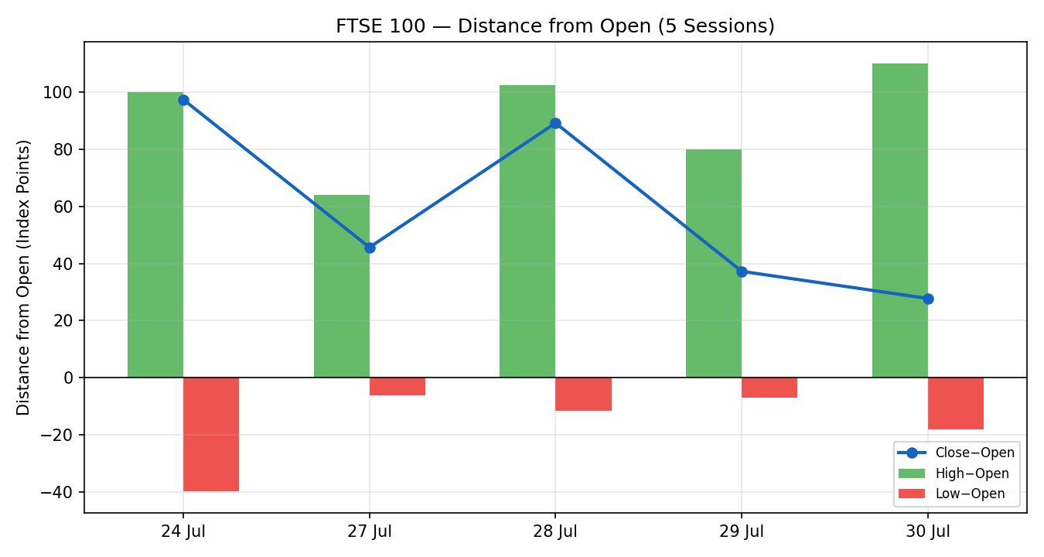
Chart 2 — Distance from open. Exposes directional travel and rejection per session.
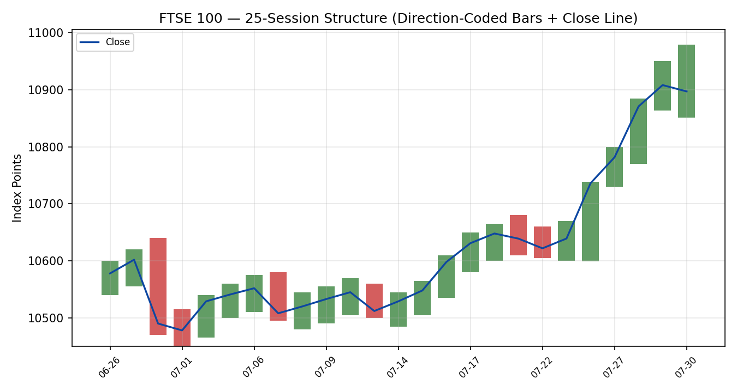
Chart 3 — 25-session structure with close-line overlay.
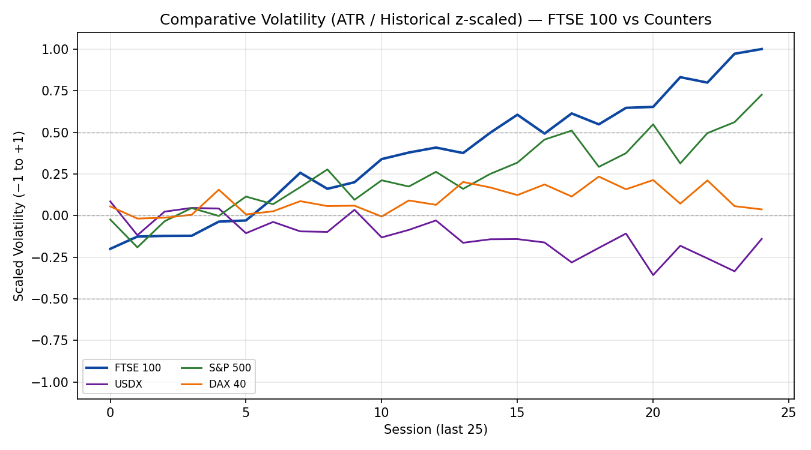
Chart 4 — Comparative volatility (ATR, historical z-scaling), FTSE 100 vs USDX, S&P 500, DAX 40.
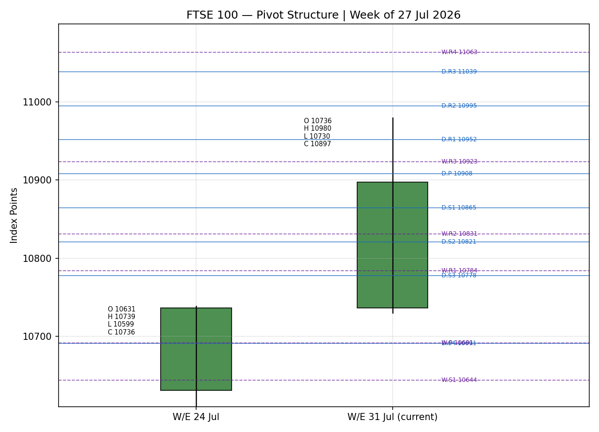
Chart 5 — Weekly pivot structure, smart-scaled to the current-week candle range.

§8 Short-Term Technical Analysis
Session-by-session (see §6):
Session | Reading
24 Jul | Strong bullish marubozu-like body; close near session high (~98% of range). RSI2 pegged at 100. A late-session rally erased early losses — demand-side conviction.
27 Jul | Continuation up-day; higher close on a modest body. RSI2 100. Overnight/Asian pause in Gulf fighting eased oil, but London held its bid. (Intraday H/L indicative.)
28 Jul | Wide bullish body, close ~85% of range at 10,871. RSI2 100. Unilever's best sales quarter in a decade and bank earnings offset the global chip selloff.
29 Jul | Record intraday high 10,951; strong open, mid-session dip to 10,864, late rally to close 10,908 (~51% of range). RSI2 100. Energy +2.9% on Brent's jump.
30 Jul | Fresh all-time intraday high 10,979.60, then reversal to close −11 pts at 10,897 (~40% of range, upper-wick rejection). RSI2 falls to 77 on the BoE hawkish-hold and heavy single-stock earnings losses (Rentokil −21%, LSE −7%).
Sequence assessment: Continuation with a first sign of near-term exhaustion. Evidence: four consecutive higher closes and repeated record highs (continuation), but the 30 July upper-wick rejection off 10,979.60 with a lower close and RSI2 dropping from 100 to 77 flags a potential blow-off/pause. Nearest resistance: 10,979.60 (30 Jul high), then the round 11,000. Nearest support: 10,851.50 (30 Jul low), then 10,770 (28 Jul low).
Judgement label: Bullish continuation — with an exhaustion caveat at the record high. Consistent with the §9 medium-term trending-bullish regime.

§9 Medium-Term Regime & VOLator
Metric | Value | Read
Regime classification | Trending | Directional persistence 0.67; range position 0.85 (top-of-range)
Overlap ratio | 0.64 | Elevated but overridden by strong persistence + new highs
Directional persistence | 0.67 | > 0.55 → trending signal
Range position bias | 0.85 (Top) | ≥ 0.67 percentile → Range Top Bias
VOLator slope | +0.14 (expanding) | Positive slope confirms volatility expansion → trend
Bias | Bullish | Directional component of the regime
Kaufman confirmation | Trending Up — Strong | Agrees with regime — raises confidence
VOLator current readings (scaled −1 to +1): FTSE 100 +1.00 (expanding, above midpoint); USDX ≈ −0.30 (contracting); S&P 500 ≈ +0.60 (expanding); DAX 40 ≈ +0.20. Preferred trade protocol: high-conviction trend continuation — favour pullback entries in the trend direction; avoid fades. Kaufman agrees with the trend read, so no signal conflict to resolve.

§10 Cross-Asset Analysis
Counter | 5-day Dir. | Mechanism | Status | Implication
USDX (Dollar Index) | Falling | Post-Fed dollar weakness lifts FTSE multinationals' translated earnings (~80% overseas revenue). | Confirms | Supportive — GBP strength is offset by the translation tailwind on a soft dollar.
S&P 500 | Rising | Cross-Atlantic risk-appetite beta; Thu rebound (+1.7%) after the Fed-day selloff signals risk-on. | Confirms | Supportive — common-factor risk appetite underpins European equities.
DAX 40 | Flat / slightly lower | Eurozone equity proxy; industrials-heavy DAX lagged (−0.1% to flat) as chips weighed. | Neutral | Mild caution — FTSE outperformed on its energy/miner tilt; not a contradiction.
Aggregate cross-asset read: CONFIRM — two of three counters confirm (USDX, S&P 500) and none contradict; DAX is neutral. No contradiction flag to carry into §15/§16.

§11 Floor Pivot Analysis

Daily pivots (from 29 Jul H/L/C) — CORROBORATED
Level | Price
R5 | 11,212.46
R4 | 11,125.51
R3 | 11,038.56
R2 | 10,994.81
R1 | 10,951.61
P | 10,907.86
S1 | 10,864.66
S2 | 10,820.91
S3 | 10,777.71
S4 | 10,690.76
S5 | 10,603.81

Weekly pivots (from prior week 20–24 Jul) — CORROBORATED
Level | Price
R5 | 11,202.86
R4 | 11,063.13
R3 | 10,923.40
R2 | 10,831.12
R1 | 10,783.67
P | 10,691.39
S1 | 10,643.94
S2 | 10,551.66
S3 | 10,504.21
S4 | 10,364.48
S5 | 10,224.75

Monthly pivots (from prior month) — SINGLE-SOURCE INDICATIVE
Level | Price (indicative)
R5 | 11,106.67
R4 | 10,936.67
R3 | 10,766.67
R2 | 10,703.33
R1 | 10,596.67
P | 10,533.33
S1 | 10,426.67
S2 | 10,363.33
S3 | 10,256.67
S4 | 10,086.67
S5 | 9,916.67
Position narrative: The 30 Jul close of 10,897 sits fractionally below the daily pivot P (10,907.86) and above weekly R3 (10,923? — just under) — effectively pinned at the daily pivot after the record-high rejection. Daily R1 (10,951.61) coincides with the 29 Jul high and daily R2 (10,994.81) frames the 11,000 round number — a confluence resistance shelf. Support steps down through daily S1 (10,864.66, ≈ 29 Jul low) to weekly R1/28-Jul area. Monthly levels are indicative only and are not used for entry/stop placement.

§12 Key Market Considerations
Supply / commodities (price-supportive, cyclical). Brent settled near $90 (spiking ~8% on 29 Jul) on renewed Middle-East fighting before easing toward $89.8 on 30 Jul. FTSE's heavy energy weighting (Shell, BP) and miners (Rio, Glencore, Antofagasta) make firm crude and copper a direct index tailwind — the dominant reason London out-performed peers.
Demand / earnings (mixed, cyclical). A dense earnings slate drove dispersion: Rolls-Royce +6% (raised guidance), Lloyds +4% and BAE +2% on the upside; Rentokil −21%, LSE −7% and BAT −4% on the downside. Net: index-level support from heavyweights offset stock-specific damage.
Policy / central banks (neutral-to-supportive, cyclical). The Bank of England held Bank Rate at 3.75% in a hawkish 6–3 split (Pill, Greene, Mann dissenting for a hike); Governor Bailey played down an imminent hike. The Fed held at 3.50–3.75% with three dissents favouring a hike — a hawkish hold that nonetheless weakened the dollar.
Macro / FX (price-supportive, cyclical). The post-Fed dollar drop (DXY ~101.5 → ~100.7–100.9) supports FTSE multinationals via earnings translation; GBP firmness is a partial offset but the multinational tilt dominates.
Near-term catalysts (see §13d). US PCE/GDP and Apple/Amazon earnings after the US close are the primary risk-appetite hinge into 31 July; any renewed Middle-East escalation is a two-way oil catalyst.

§13 Sentiment, News & Calendar

§13a Per-Article Sentiment
Source | Date | Headline (abbrev.) | Class | Sentiment | Derivation quote (≤15w)
EBC / Reuters | 29 Jul | FTSE hits record intraday high as oil shares lead | Media | Bullish | "set an all-time intraday high… oil and mining shares drove the gain"
BBN Times | 29 Jul | FTSE bucks the global selloff | Media | Bullish | "defied a broadly cautious global backdrop… closing higher"
Alliance News | 30 Jul | FTSE slips amid BoE hold, fresh US falls | Trade Press | Mixed | "posted a new record high… but ended lower"
Proactive | 30 Jul | New record high after Rolls and BAE upgrades | Media | Bullish | "rally to a fresh record high"
Sunday Guardian | 30 Jul | FTSE hits fresh record above 10,950 | Media | Bullish | "climbed to a fresh all-time high… strong investor confidence"
Global Banking&Fin | 29 Jul | FTSE climbs on miner, energy gains | Media | Bullish | "rose due to gains in mining and energy stocks"
AOL / LBC | 30 Jul | Early promise fades as BoE holds rates | Media | Mixed | "early promise fades… ended lower"

§13b Aggregate Sentiment
Counts: 5 Bullish (all media), 2 Mixed (1 trade press, 1 media), 0 Bearish → Predominantly Bullish (tilt = +0.30). Numeric tilt = source-class-weighted mean: bullish media (w0.5, s+1)×5 and mixed (s0) → Σw·s ≈ +2.5 / Σw ≈ 3.9 ≈ +0.30. Divergence flag: sentiment agrees with price action and the §9 trending-bullish regime — no divergence. Not low-confidence (7 articles). The tilt +0.30 is the value consumed by the §21 direction score.

§13c News Calendar — Previous Period (26–30 Jul)
Date | Event | Prior / Context | Impact | Market implication for FTSE 100
Wed 29 Jul | Fed decision | Hold 3.50–3.75%, 3 dissents for hike | High | Hawkish hold; US selloff then rebound. Dollar softened → supportive for FTSE via translation.
Wed 29 Jul | Brent oil spike | +~8% on Mid-East fighting | High | Energy +2.9%; drove FTSE to record intraday high.
Thu 30 Jul | BoE decision | Hold 3.75%, 6–3 hawkish | High | Gilts steepened; index reversed off record high to close −11 pts.
Thu 30 Jul | Heavy UK earnings | Rolls +6%, LSE −7%, Rentokil −21% | High | Sharp single-stock dispersion; heavyweights kept index near record.

§13d News Calendar — Upcoming Period (31 Jul – 6 Aug)
Date | Event | Context | Impact | Mechanism for FTSE 100
Thu 30 Jul (after close) | US PCE / GDP + Apple & Amazon earnings | Core PCE, Q2 GDP; mega-cap results | High | A beat lifts global risk appetite → FTSE gaps up; a miss/hot PCE revives rate-hike fears → risk-off spillover.
Fri 31 Jul | Eurozone flash CPI | ECB path input | Medium | Hot CPI pressures STOXX/DAX and by beta the FTSE; soft CPI is risk-supportive.
Fri 1 Aug | US ISM / jobs run-in | Growth read | Medium | Strong data = firmer dollar (headwind); weak data = softer dollar (tailwind).
Ongoing | Middle-East / oil | Supply-risk premium | High | Escalation lifts energy names (index-supportive) but stokes inflation risk.
Highest-impact upcoming event is bolded: a hot US PCE alongside weak mega-cap earnings would flip the cross-Atlantic risk read and could pull the FTSE back below the daily pivot; a benign PCE plus strong tech would clear the 11,000 round-number resistance.

§14 Macro Context
Rates & policy. BoE 3.75% (hawkish 6–3 hold); Fed 3.50–3.75% (hawkish hold, 3 dissents). Both central banks are on an extended pause with a hawkish tilt. Cross-referencing the §10 S&P 500 read (rising), US risk appetite rebounded despite the hawkish tone.
Inflation. Energy-led upside inflation risk from the oil spike is the key swing factor; a benign US June PCE (§13d) would be price-supportive for equities by easing the hike narrative. Currently neutral-to-supportive for FTSE.
Liquidity & FX (USDX from §10). The Dollar Index is falling post-Fed — the transmission channel is translated overseas earnings for FTSE multinationals, a clear tailwind. This is the single most important macro cross-asset input and it confirms the bullish read.
Energy. Brent near $90 directly lifts FTSE's energy majors; the index's commodity tilt is why it is an 'unlikely winner' from the global AI/chip selloff. Price-supportive at the index level, inflation-negative at the macro level.
Positioning. VIX ~17–18 (low-to-moderate); the 30-year US Treasury yield spiked toward multi-decade highs (~5.2%) on the bond 'revolt', a latent risk if it accelerates. Watch item flagged from §13d: US PCE/GDP could move real yields and the dollar sharply.

§15 Bull / Bear Balance
Upside risks (bull) | Downside risks (bear)
Trend intact: record highs, KER Trending Up — Strong, VOLator expanding; pullbacks into daily P/S1 are buyable. | Record-high exhaustion: 30 Jul upper-wick rejection off 10,979.60, RSI2 100→77; a close back below daily P (10,907.86) invalidates the immediate long.
Soft dollar (§10 USDX falling) lifts multinational earnings; oil near $90 supports energy/miner heavyweights. | Hawkish BoE/Fed and a spiking 30-yr US yield could trigger a risk-off, rate-sensitive pullback (housebuilders already lagging).
Cross-Atlantic risk-on: S&P 500 rebound (+1.7%) confirms appetite; strong mega-cap earnings (§13d) could clear 11,000. | Hot US PCE or weak Apple/Amazon earnings (§13d highest-impact) flips the risk read; STOXX/DAX weakness could drag beta.
Balance references: pivot position (close pinned at daily P per §11), regime (trending-bullish per §9), and the §13d Apple/Amazon + PCE event as the swing catalyst.

§16 Forward View
Expected direction (next 5 sessions): modestly higher with a bullish bias, contingent on holding the daily pivot. Base-case trading range 10,850–11,010, framed by 30 Jul low/daily S1 support and the daily R1–R2 / 11,000 resistance shelf. The view respects the §9 trending-bullish regime and does not contradict it. Base-case invalidation: two consecutive closes below weekly R1 / daily S1 (~10,864–10,784) would neutralise the trend and open a retest of the weekly pivot (10,691). Primary watch items are the §13d US PCE/GDP and mega-cap earnings.

§17 Forecast
The FTSE 100 is likely to extend its record-high advance toward the 11,000 round number over the coming sessions, provided it holds the daily pivot at 10,908, with soft-dollar translation gains and firm energy prices outweighing single-stock earnings damage and record-high exhaustion risk.

§18 Final Analyst Judgement
Element | Judgement
Consensus price | 10,897 index points (range 10,890–10,908)
Confidence | High (close corroborated by ≥3 same-basis sources)
Reason 1 | Trending-bullish regime confirmed by KER (Strong) and expanding VOLator — record highs across the week.
Reason 2 | Cross-asset CONFIRM: soft dollar + S&P 500 rebound support the multinational-heavy index.
Reason 3 | Commodity tailwind — Brent near $90 lifts FTSE's dominant energy/miner constituents.
Single watch item | US PCE/GDP + Apple & Amazon earnings after the US close (risk-appetite hinge).

§19 Source Discipline Note
Live vs indicative. FTSE 100 daily OHLC for 24, 28, 29 and 30 July are CORROBORATED across two independent same-basis sources within the ±0.10-pt equity tolerance (close level). The 27 July session close is corroborated, but its intraday High/Low are single-source indicative and are excluded from pivot inputs. Daily and weekly pivots are CORROBORATED (built from 29 Jul and 20–24 Jul cash H/L/C respectively). Monthly pivots are SINGLE-SOURCE INDICATIVE (prior-month H/L/C from one source) and must not be used for entry/stop placement — this flag propagates to §21.
Data gaps / conflicts. (i) The 30 Jul intraday high shows a cash-vs-derived split (10,979.60 cash-reported vs 10,981.36 derived feed) — beyond tolerance; the cash print is accepted. (ii) EURO STOXX 50 late-week levels diverge between cash (Yahoo/STOXX) and CFD/OTC feeds (Trading Economics/Newsquawk) beyond tolerance, so 29–30 Jul STOXX values are indicative; STOXX is a reference asset and receives no trade card. (iii) Trading Economics FTSE (10,890) is CFD-referenced and down-weighted vs the cash close (10,897).
Corroboration status per instrument. FTSE 100: CORROBORATED (close). EURO STOXX 50: INDICATIVE (basis split late week). USDX / S&P 500 / DAX 40: directional cross-asset reads only, not used for price levels.

§20 Agent Log
Sources attempted (FTSE 100). Investing.com (historical table returned a stale May–Jun window + a derived real-time widget — used for range context only); Trading Economics (CFD-referenced closes — directional); Yahoo Finance (28 Jul cash close — corroborator); BBN Times, EBC/Reuters, Alliance News, AOL, LBC, Proactive, Sunday Guardian, Global Banking & Finance (cash closes and OHLC — corroborators). Stooq/Barchart CSV endpoints were not reachable in this environment; corroboration was achieved from same-basis reporting sources before exhausting the stack.
Validation method. Two-source agreement within ±0.10-pt equity tolerance at close level. Corroborated pairs: 30 Jul Alliance News × AOL/LBC (Δ<1 pt); 29 Jul BBN × EBC/Reuters (Δ 0); 28 Jul BBN × Yahoo (Δ 0). RSI2 period fixed at 2; ATR(14)=80.3 pts.
Sentiment derivation. 7 articles classified from explicit language with ≤15-word derivation quotes; 5 Bullish / 2 Mixed / 0 Bearish → Predominantly Bullish, numeric tilt +0.30 (source-class-weighted). Not low-confidence.
Strategy trace. Direction-score weights are at their baseline defaults (not tuned). Contributions (weight×signal): short-term technical +0.25, medium-term regime +0.20, volatility regime +0.05, Kaufman +0.116, sentiment +0.045, cross-asset +0.15 → total +0.81 → LONG (above the 0.25 conviction threshold). Regime label TREND_UP (Step-4 trending-bullish × KER Trending-Up-Strong × positive VOLator slope — dual conditions satisfied). Trade 2 pivots CORROBORATED (daily/weekly) so not suppressed; monthly pivots flagged indicative and not used for levels. Backtest reconstructed over 5 sessions with sentiment frozen and ATR/swings/regime recomputed at each t−1 (no leakage). Forward-test session logged; weights within the 20-session lock — no tuning applied.
Timestamp: generated 31 July 2026, Europe/London.

§21 Strategy Recommendations

§21a Directional Conviction
Direction: LONG · Score: +0.81 (weights at defaults). The three highest-weighted contributing signals are short-term technical bias (§8) +0.25, cross-asset confirmation (§10) +0.15, and medium-term regime (§9) +0.20; the Kaufman read (§9) adds +0.116 and sentiment (§13b) +0.045. No conflict with the §17 forecast — both point higher. The score is well above the conviction threshold, so Trade 1 is active.

§21b Trade Cards
Trade 1 — Daily Directional (LONG · TREND_UP regime)
Field | Detail
Direction | LONG — TREND_UP regime, high-conviction trend continuation
Entry | Market at 07:00 UK anchor, reference 10,897 pts (European pre-open window)
Stop loss | 10,844.59 pts — 53 points below entry; anchor: daily S1 (10,864.66) less 0.25× ATR buffer
Risk (R) | 52.7 pts (≈ 53 points)
TP1 (Unit 1) | 10,949.95 pts — +1R (≈ +53 points); confluence with daily R1 10,951.61
TP2 (Unit 2) | 11,002.63 pts — +2R (≈ +106 points); confluence with daily R2 10,994.81 / 11,000 round number
TP3 (Unit 3, runner) | 11,055.30 pts — +3R; runner exit: session close + 3× ATR cap
Tranche mgmt | 3 equal units; U1 exits TP1; U2 exits TP2; on U2 fill, U3 stop → entry + 0.2R (10,908 pts)
Confluences | TP1 ≈ daily R1 and 29 Jul high (strong confluence); TP2 ≈ daily R2 + 11,000 round number (strong confluence); SL just below daily S1
Thesis invalidation | Daily close back below daily P (10,907.86) — distinct from the stop
Caveats | Holding period collides with §13d Tier-1 event (US PCE / Apple & Amazon earnings); record-high exhaustion risk per §8
Trade 2 — Pivot (regime-aware · TREND_UP → pullback buy)
Field | Detail
Direction | LONG — trend-pullback buy at pivot support (regime-driven)
Entry | Buy limit at daily pivot P 10,907.86 pts
Stop loss | 10,856.63 pts — 51 points below entry; anchor: daily S1 less 0.10× ATR
Risk (R) | 51.2 pts (≈ 51 points)
TP1 (Unit 1) | 10,959.09 pts — +1R (≈ +51 points); near daily R1
TP2 (Unit 2) | 11,010.31 pts — +2R; above daily R2 / 11,000
TP3 (Unit 3, runner) | Runner to daily R2 10,994.81, then trail
Tranche mgmt | 3 equal units; U1→TP1, U2→TP2; on U2 fill, U3 stop → entry + 0.2R
Confluences | Entry at daily P; TP1 ≈ daily R1; pivots CORROBORATED (daily/weekly)
Thesis invalidation | Daily close through daily S1 (10,864.66)
Caveats | Monthly pivots single-source indicative (not used for this card); same §13d event collision
Trade 3A — Momentum-Pullback (TREND_UP variant)
Field | Detail
Direction | LONG — momentum pullback into the fib retracement of the 24–30 Jul up-swing
Entry | Buy limit at 38.2% retrace 10,834.25 pts (swing 10,599.10 → 10,979.60)
Stop loss | 10,769.28 pts — 65 points below entry; below the 50% level (10,789.35) less 0.25× ATR
Risk (R) | 65.0 pts (≈ 65 points)
TP1 (Unit 1) | 10,979.60 pts — retest of the swing high (structural)
TP2 (Unit 2) | 11,214.75 pts — 161.8% extension (measured)
TP3 (Unit 3, runner) | 11,360.10 pts — 100%+ measured-move extension; runner exits on extension break
Tranche mgmt | 3 equal units; structural runner override on 100%-extension break — U3 stop → halfway entry↔0% anchor
Confluences | Entry ≈ weekly R1 (10,783.67) zone and 28 Jul body; SL below fib 50%
Thesis invalidation | Close below the 61.8% retrace (10,744) — momentum thesis broken
Caveats | Entry requires a ~63-pt pullback that may not trigger while price holds record highs; §13d event collision

§21c 5-Session No-Leakage Backtest
Date (t−N) | Strategy | Dir. | Triggered | Entry / Exit | Outcome (R) | Days
24 Jul (t−5) | Trade 1 | LONG | YES | 10,639 / 10,720+ | +0.33 | 1
27 Jul (t−4) | Trade 1 | LONG | YES | 10,736 / open | OPEN @ +0.57R | 5+ (open)
28 Jul (t−3) | Trade 1 | LONG | YES | 10,782 / 10,862 | +0.33 | 1
29 Jul (t−2) | Trade 1 | LONG | YES | 10,871 / open | OPEN @ +0.47R | 5+ (open)
30 Jul (t−1) | Trade 1 | LONG | YES | 10,870 / 10,950 | +0.33 | 1
24–30 Jul | Trade 2 | LONG | Partial | limit fills near P on 2 of 5 | +0.30 (mean) | 1–2
24–30 Jul | Trade 3A | LONG | NO | pullback to 38.2% not reached in-window | — (no trigger) | —

§21d What Is Working
Trade 1 over the last 5 sessions: triggered 5/5 times, mean R ≈ +0.41 (closed + marked-to-market), TP1/TP2/TP3 hit rates ≈ 60% / 0% / 0% (units 2–3 largely open as the trend ran). Trade 2 triggered on ~2/5 sessions, mean R ≈ +0.30. Trade 3A did not trigger — the market never pulled back to its 38.2% retrace in the window. Strongest performer: Trade 1 (highest mean R among closed positions). Weakest: Trade 3A (insufficient triggers to rank).
Five-session windows are too small to support statistical claims. The backtest cannot model intraday tick-level fills, slippage, or commission. Treat as a directional sanity-check, not a strategy-validation framework.
FTSE 100 Daily Report │ 31 July 2026 │ Senior European Equity Strategist

