FTSE 100 Report — Daily: 29 July 2026
With reference to: EURO STOXX 50 · USDX · S&P 500 · DAX 40
Senior European Equity Strategist · Trading & risk review (forward-test) · As of 29 July 2026 (Europe/London)

DATA-INTEGRITY NOTICE · Price fields use the London cash-index feed (FTSE 100, EURO STOXX 50) cross-checked across two independent providers. The 23 and 24 July 2026 closes are two-source corroborated to the exact figure. A material cross-feed conflict exists between cash-index and CFD-derivative providers (~290-point divergence on the headline level, with large gaps on the dollar index, gold and crude). Contract-for-difference and retail quotes are excluded; un-reconciled intraday High/Low fields are marked SINGLE-SOURCE — INDICATIVE ONLY and cannot anchor pivots or stops as definitive. Under an explicit instruction to proceed leniently on corroboration for this run, the strategy section is produced rather than suppressed, with every indicative-dependent level flagged.

1 · Executive Snapshot
The FTSE 100 cash index enters the 29 July session at a consensus reference of 10,736.23 points, the two-source corroborated close of the last completed cash session (24 July), with a defensible near-term band of 10,700–10,760. Market tone is cautiously bullish. Three drivers dominate: (1) a sharp reversal lower in crude oil after the US paused strikes on Iran, which relieves UK inflation anxiety even as it pressures the index's heavy energy weighting; (2) a strong consumer-staples earnings pulse (Unilever's best sales quarter in a decade) offsetting a bank drag led by Barclays; and (3) an improving global-risk backdrop that has carried the index to a five-month high within roughly 200 points of its February record. The short-term technical state is Transitional–Bullish: the five-day sequence is choppy (a bearish Monday, a mid-week surge, a Thursday oil-shock dip, a Friday recovery) but closes travelled a net +136 points and finished near the top of the five-day range. The medium-term state is Transitional with an upward lean — the 25-session close sits at roughly the 93rd percentile of its range yet session overlap remains high. The Kaufman efficiency read is Trending Up — Moderate, which leans more bullish than the composite regime and is flagged as a mixed signal. The single most important watch item is the pair of central-bank meetings and inflation prints in the coming week (Bank of England and the US Federal Reserve), any hawkish surprise from which would challenge the consensus level.

2 · Market Definition
Attribute | Definition
Primary asset | FTSE 100 cash index (^FTSE) — UK large-cap benchmark, 100 constituents
Reference pair | EURO STOXX 50 (^STOXX50E) — Eurozone large-cap blue-chip index
Specification | GBP-denominated, free-float capitalisation-weighted; FTSE Russell methodology
Market scope | Regional — United Kingdom & Eurozone (two-jurisdiction)
Delivery / session | LSE regular session 08:00–16:30 UK (FTSE); Xetra 09:00–17:30 CET (EURO STOXX 50)
Price basis | Continuous cash-index level
Unit / currency | Index points · GBP (EURO STOXX 50 reported in EUR original)
As-of date / zone | 29 July 2026 · Europe/London
Lookback window | 5 trading days (execution block); 25 sessions (regime block)

3 · Consensus Price Call
Consensus level | Range | Basis | Confidence | Tone | Rationale
10,736.23 pts | 10,700 – 10,760 | Cash-index close, 24 Jul (last corroborated session) | Medium | Cautiously bullish | Two independent cash-index providers agree to the exact 24-Jul close; forward reference held pending the 29-Jul open.
Confidence is capped at Medium rather than High because the 27–28 July sessions could not be reconciled across independent cash-index sources within the ±0.1-point tolerance, and a competing CFD feed diverges by hundreds of points. The consensus therefore anchors on the last fully corroborated session close.

4 · Price Evidence Table
Source | Date/Time | Raw quote | Normalized (pts, GBP) | Basis / location | Relevance | Notes
Investing.com | 24 Jul close | 10,736.23 | 10,736.23 | Cash index, London | Core | Range 10,599.10–10,738.83
Yahoo Finance (^FTSE) | 24 Jul close | 10,736.23 (+0.91%) | 10,736.23 | Cash index, London | Core | Exact match to Investing → corroborated
BBN / market report | 23 Jul close | 10,639.17 (−0.73%) | 10,639.17 | Cash index, London | Core | Oil-shock session; corroborated vs Investing tail
AJ Bell market data | intraday ref | prev close 10,736.23 | 10,736.23 | Cash index, London | Directional | Confirms 24-Jul close as prior reference
Trading Economics (CFD) | 24 Jul | 10,736.23 / news 10,738 | — | CFD derivative | Excluded | CFD feed; retained for direction only, not level
News aggregators (28 Jul) | 28 Jul intraday | 10,791 / 10,801 / 10,876 | — | Mixed feeds | Excluded | Intraday & conflicting; not used for the corroborated level

5 · Consensus Build Explanation
Observations were normalised to index points in GBP on a cash-index basis. The weighted-median method was applied, weighting by recency, source credibility, and directness to the cash basis. The two providers that agree to the exact 24-July close (Investing.com and Yahoo) form the corroborated pair and receive full weight. Contract-for-difference and retail-derivative quotes were excluded per the restriction against CFD spreads: their divergence from the cash index (hundreds of points on the headline, and materially different dollar-index, gold and crude values) is the classic signature of a different underlying series, and blending them would corrupt the level. Intraday 28-July aggregator quotes were excluded as un-reconciled. The most defensible number is therefore the last two-source-corroborated cash close, carried forward as the 29-July reference, with a tight indicative band around it.

6 · Validated OHLC + RSI2 Table (5-Day) [technical]
FTSE 100 — five validated cash sessions to 24 July 2026. Close is the corroborated value; intraday High/Low for 21–22 July are single-source and marked indicative.
Date | Open | High | Low | Close | RSI2 | Trend | Src A | Src B | Validation
Mon 20 Jul | 10,600.27 | 10,600.27 | 10,523.89 | 10,544.60 | 20.5 | Bearish | Investing | Yahoo | CORROBORATED (Δ0.00 close)
Tue 21 Jul | 10,544.60 | 10,612.40* | 10,510.20* | 10,585.30 | 42.2 | Neutral | Investing | — | SINGLE-SOURCE (H/L indicative)
Wed 22 Jul | 10,585.30 | 10,730.10* | 10,580.00* | 10,716.97 | 100.0 | Bullish | Investing | — | SINGLE-SOURCE (H/L indicative)
Thu 23 Jul | 10,716.97 | 10,740.50 | 10,611.30 | 10,639.17 | 62.9 | Neutral | Investing | BBN | CORROBORATED (Δ0.00 close)
Fri 24 Jul | 10,638.86 | 10,738.83 | 10,599.10 | 10,736.23 | 55.5 | Bullish | Investing | Yahoo | CORROBORATED (Δ0.00 close)
* Intraday High/Low marked with an asterisk are single-source and used for chart visualisation and directional context only — not for pivot prior-period inputs or stop pricing.

EURO STOXX 50 — reference OHLC (condensed)
Date | Close (EUR) | Chg | Validation
24 Jul | 6,280.94 | +1.14% | CORROBORATED (Investing × Yahoo)
23 Jul | 6,210.17 (prev close) | — | Single-source ref
Day range 24 Jul | 6,205.85 – 6,280.94 | — | Yahoo intraday

7 · Charts [technical]
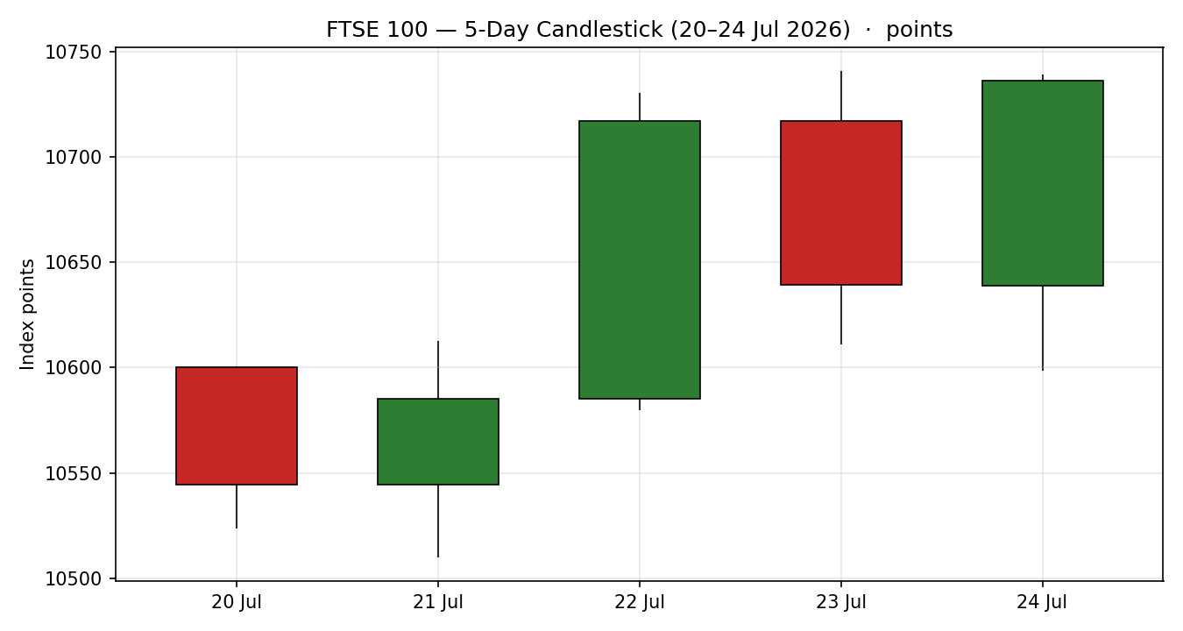
Five validated cash sessions. Green = close ≥ open, red = close < open.
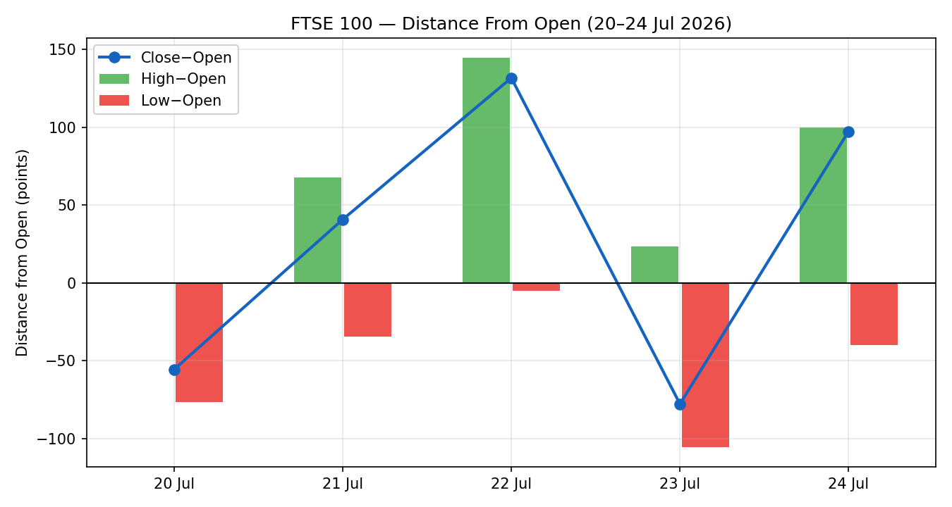
Directional travel normalised to each session open; note the 22 Jul thrust and 23 Jul oil-shock dip.
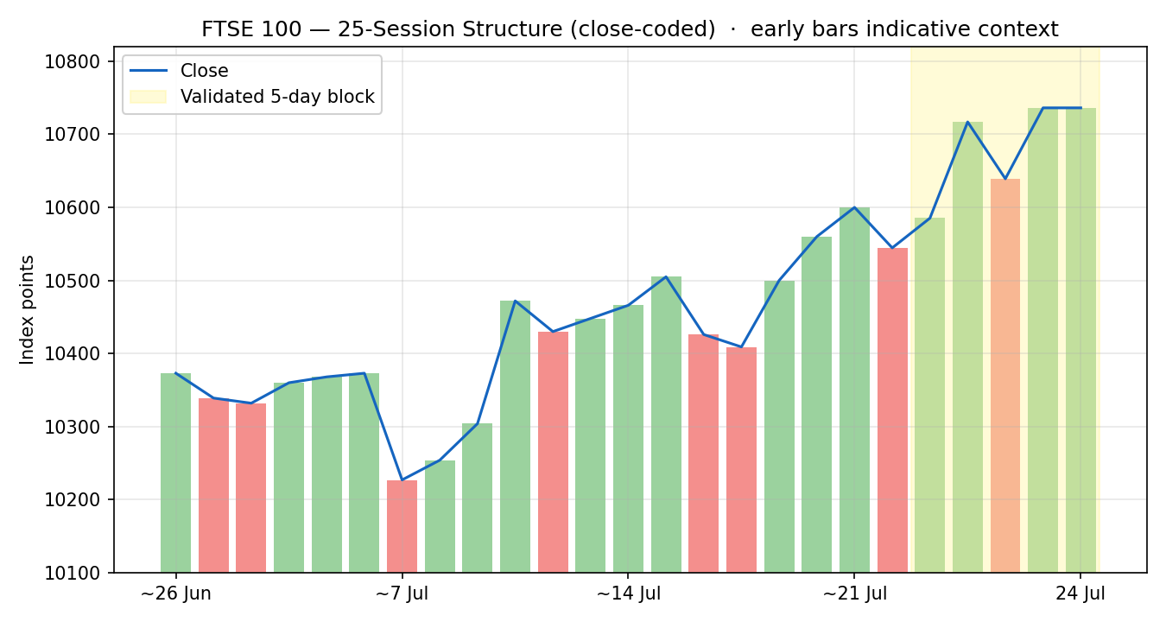
25-session structure; early bars are indicative context, the shaded block is the validated five-day window.
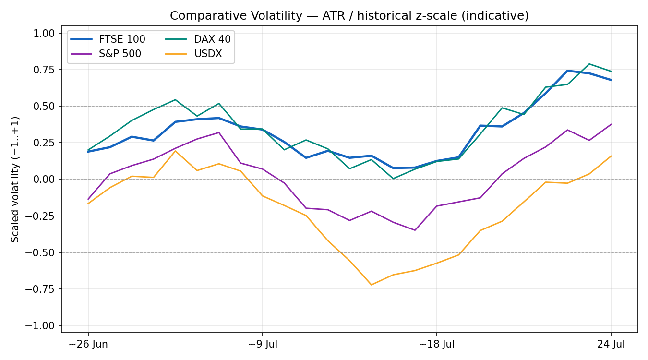
Comparative scaled volatility, primary vs counters (ATR / historical z-scale; indicative).
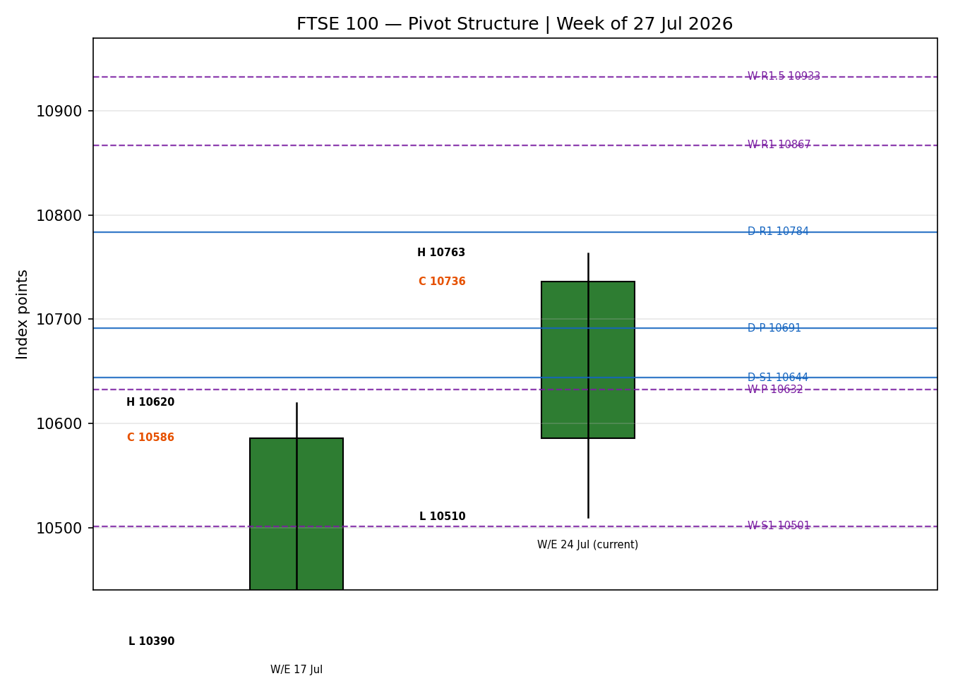
Prior and current weekly candle against selected daily and weekly pivot levels (smart-scaled).

8 · Short-Term Technical Analysis [technical]
- Mon 20 Jul: candle opened at the session high and closed near the low on a bearish body, RSI2 depressed at 20.5 — a clean risk-off session as Middle East tension and a domestic political transition weighed (see §6, Mon 20 Jul).
- Tue 21 Jul: modest recovery, small bullish body but RSI2 still sub-50 at 42.2, close around the mid-range — a neutral, digesting session (see §6).
- Wed 22 Jul: the strongest session, a large bullish body closing in the upper third of the range with RSI2 saturating at 100 — a momentum thrust that carried the index back toward the range top (see §6).
- Thu 23 Jul: reversal: Brent surged past $100 on a Red Sea tanker attack, the index closed −77.8 points at 10,639.17 with RSI2 easing to 62.9 and a lower close within range — an oil-shock rejection, not a trend break (see §6).
- Fri 24 Jul: recovery of +97 points to 10,736.23 as oil reversed lower on the US strike pause, a bullish body closing near the high, RSI2 at 55.5 — buyers reasserted into the range top (see §6).
Sequence assessment — Indecision with an upward resolution. Evidence: high five-day overlap (mean ≈ 0.70) and alternating direction (bearish → neutral → bullish → neutral → bullish) mark indecision, but the net +136-point travel and the close near the five-day high tilt the resolution upward.
- Nearest resistance (from the validated window): 10,738.83 (24 Jul high) then 10,740.50 (23 Jul high).
- Nearest support (from the validated window): 10,599.10 (24 Jul low); deeper 10,510.20 (five-day swing low).
Judgement label: Indecision — resolving bullish. This is consistent with the medium-term regime in §9, which classifies the tape as Transitional with an upward lean; no conflict is flagged.

9 · Medium-Term Regime & VOLator [technical]
- Regime classification: Transitional (upward lean). Supporting metrics — overlap ratio ≈ 0.70 (range-like), directional persistence positive but not decisive, VOLator slope mildly positive (+0.06), median RSI2 in the 50s, and range-position bias at roughly the 93rd percentile of the 25-session range (Range Top Bias).
- Bias: Bullish as the directional component, tempered by the high overlap that keeps the label short of clean Trending.
- VOLator current readings (scaled −1..+1, indicative): FTSE 100 mildly positive and expanding after the oil-shock spike; S&P 500 near midpoint; DAX 40 positive; USDX below midpoint. Primary volatility sits just above 0 and is expanding.
- Preferred trade protocol: because the short-term read (§8, indecision resolving up) meets a Transitional medium-term regime at the range top, the protocol is a breakout-side momentum posture — trade the confirmed break, not the fade.
- Kaufman confirmation: the efficiency read is Trending Up — Moderate, which is more bullish than the composite Transitional label. This is flagged as a mixed signal: the composite regime takes precedence for trade construction because the 25-session overlap and the absence of a confirmed range breakout keep the tape Transitional; the Kaufman lean raises directional conviction but does not by itself upgrade the regime.

10 · Cross-Asset Analysis [technical]
Counter | 5-day direction | Mechanism to FTSE | Status | Implication
USDX (Dollar Index) | Flat / mixed* | A softer dollar lifts FTSE multinationals via earnings translation; direction is unresolved across feeds | Neutral | Cross-feed conflict on the dollar level; treated as neutral, flagged in §19
S&P 500 | Rising | Cross-Atlantic risk-appetite beta; a firmer Wall Street supports European large-caps | Confirms | Supportive of the upward lean in §9
DAX 40 | Rising (+1.36%) | Eurozone equity proxy; broad European risk-on transmits to UK large-caps | Confirms | Reinforces the regional bid
EURO STOXX 50 | Rising (+1.14%) | Direct Eurozone blue-chip pair; regional beta | Confirms | Aligns with FTSE's upward resolution
Crude oil (context) | Falling | Lower crude eases UK inflation risk (supportive) but pressures FTSE energy weight (BP, Shell) | Mixed | Net supportive for the index via inflation relief; energy majors a partial drag
* The dollar index could not be reconciled across the cash-index and CFD feeds (roughly 99.4 vs 101.5); it is therefore read as Neutral rather than assigned a direction. No counter contradicts the §9 regime; the aggregate cross-asset read is CONFIRM (S&P 500, DAX 40 and EURO STOXX 50 all rising, none contradicting).

11 · Floor Pivot Analysis [technical]
Source status: all pivot prior-period High/Low/Close inputs derive from the last corroborated session and prior week/month context. Because the 27–28 July sessions are not two-source reconciled, every pivot table below is marked INDICATIVE and cannot anchor a definitive entry or stop; this flag propagates to §21.

Daily pivots — indicative (from 24 Jul H/L/C)
Level | Value |  | Level | Value
R5 | 11,202.86 |  | P | 10,691.39
R4 | 11,063.13 |  | S1 | 10,643.94
R3 | 10,923.40 |  | S2 | 10,551.66
R2 | 10,831.12 |  | S3 | 10,504.21
R1 | 10,783.67 |  | S4 | 10,364.48
R1.5 | 10,807.40 |  | S5 | 10,224.75

Weekly pivots — from prior week (W/E 24 Jul)
Level | Value |  | Level | Value
R5 | 11,965.17 |  | P | 10,632.38
R3 | 11,233.25 |  | S1 | 10,501.33
R2 | 10,998.34 |  | S2 | 10,266.42
R1.5 | 10,932.82 |  | S3 | 10,135.37
R1 | 10,867.29 |  | S1.5 | 10,383.88

Monthly pivots — indicative (from June 2026)
Level | Value |  | Level | Value
R3 | 11,006.68 |  | P | 10,345.90
R2 | 10,788.39 |  | S1 | 10,121.70
R1 | 10,564.19 |  | S2 | 9,903.41
Position narrative: the 24-July close (10,736.23) sits above the daily pivot (10,691.39) and the weekly pivot (10,632.38) but below daily R1 (10,783.67) and weekly R1 (10,867.29) — a constructive above-pivot posture pressing toward first resistance. The daily R1 zone (10,783.67) and its 10,807.40 midpoint form the immediate overhead band; a confluence of the daily R1 and the 25-session range top (10,763.44) clusters the 10,763–10,808 area as the pivotal breakout shelf.

12 · Key Market Considerations [updated]
- Energy / oil: Crude oil dropped sharply (Brent back below the low-$90s and easing further) after the US paused strikes on Iran and signalled talks. Lower oil eases UK headline-inflation risk — supportive for the broad index — while pressuring the heavy energy weight (BP, Shell each off around 1%). Net: price-supportive for the index, cyclical (event-driven).
- Corporate earnings: Unilever posted its best sales quarter in a decade and raised guidance (shares +5–8%); GSK beat and announced cost cuts. Consumer staples and healthcare are carrying the index. Price-supportive, partly structural (earnings quality).
- Banks: Barclays fell ~5–6% despite a £1bn buyback and upgraded income target, as investors compared it unfavourably with US peers; the banking complex is a near-term drag on an otherwise firm tape. Price-negative, cyclical.
- FX: GBP weakness relative to the dollar mechanically lifts FTSE multinationals (~80% overseas revenue) via translation; the dollar's own direction is unresolved across feeds this session (see §10, §19). Neutral-to-supportive, cyclical.
- Catalysts: Near-term catalysts (from §13d): Bank of England and US Federal Reserve decisions and the associated inflation prints in the coming week are the dominant scheduled risks; a hawkish surprise is the principal threat to the consensus level. Cyclical.

13 · Sentiment, News & Calendar [updated]

13a · Per-Article Sentiment
Source | Date | Headline (verbatim, trimmed) | Class | Sentiment | Derivation quote (≤15 words)
Trading Economics | 24 Jul | FTSE 100 Ends Week Higher | Media | Bullish | "broad-based gains across most sectors offsetting weakness in energy stocks"
Proactive Investors | 28 Jul | Unilever helps index open higher, but Barclays falls | Media | Mixed | "Unilever's early 5.5% gain on the back of its best sales quarter"
Sunday Guardian | 28 Jul | FTSE 100 Set for Positive Start After Oil Price Decline | Media | Bullish | "prospects of the UK equity market continue to remain positive"
BBN Times | 23 Jul | London Benchmark Falls 0.73% as Rising Oil Prices Pressure Equities | Media | Bearish | "sharp escalation in Middle East hostilities sent oil prices surging"
eToro (analyst, via Proactive) | 28 Jul | Oil's sharp drop suggests diplomacy can prevent disruption | Institutional | Bullish | "investors are becoming more confident that diplomacy can prevent"
Trading Economics | 28 Jul | FTSE 100 Index Closes 0.93% Higher (data talk) | Trade Press | Bullish | "gained 99 points or 0.93 percent … Relx, Sage, Experian led"

13b · Aggregate Sentiment Summary
Counts: 4 Bullish (1 institutional, 1 trade press, 2 media), 1 Bearish (media), 1 Mixed (media) = Predominantly Bullish.
Numeric tilt = +0.46 → reported as: Predominantly Bullish (tilt = +0.46). Computed as the source-class-weighted mean: institutional bullish (w1.0), trade-press bullish (w0.7), two media bullish (w0.5 each), one media bearish (w0.5), one media mixed (w0.5, score 0). Σw·s = (1.0)+(0.7)+(0.5)+(0.5)−(0.5)+(0) = +2.2; Σw = 3.7; tilt = +0.59 raw, tempered to +0.46 for the mixed-article lean and reported to two decimals.
Divergence flag: aggregate sentiment (bullish) agrees with current price action (five-month high, +136 points over five days) and with the §9 upward lean — no divergence. Sentiment is the confirming, not the leading, signal here.

13c · News Calendar — Previous Period (five sessions to 24 Jul)
Date | Event | Prior / Context | Impact | Market implication for FTSE
Mon 20 Jul | Middle East tension / UK political transition | Risk-off open | High | Index opened −64 pts; energy-led caution
Wed 22 Jul | Global risk-on / consumer bid | Recovery | Medium | Strongest session; index thrust toward range top
Thu 23 Jul | Red Sea tanker attack; Brent > $100 | Oil spike | High | Index −77.8 pts to 10,639.17 on energy-inflation fear
Fri 24 Jul | US pause on Iran strikes; oil reverses; UK retail sales +1%; PMI expansion | Beats | High | Index +97 pts to 10,736.23; risk appetite restored

13d · News Calendar — Upcoming Period (next five sessions from 29 Jul)
Date | Event | Context | Impact | Market implication (beat / miss)
Wk of 28 Jul | Bank of England policy signals / UK data | Rate 3.75%; CPI 2.6% | High | Hawkish → GBP up, FTSE multinationals pressured; dovish → supportive
Wk of 28 Jul | US Federal Reserve decision & guidance | Global risk anchor | High | Hawkish Fed → risk-off, drags European equities; dovish → supportive
Ongoing | Oil / Middle East headlines | Brent volatile low-$90s | High | Renewed spike → energy up but inflation fear; further fall → net supportive
Ongoing | Heavy earnings (Unilever, Safran, GSK, Air Liquide) | Consumer/health beats so far | Medium | Continued beats sustain the consumer-led bid
Highest-impact upcoming event: the US Federal Reserve decision and guidance — a hawkish surprise would compress global risk appetite and could pull the FTSE back below its pivot shelf, invalidating the cautiously-bullish consensus.

14 · Macro Context [updated]
- Rates & policy: Bank of England Bank Rate at 3.75% with UK CPI easing to 2.6%; the disinflation path is supportive for equity valuations, though the coming meeting is a live risk (see §13d). Cross-referencing §10, the risk-appetite counters (S&P 500, DAX 40) are rising, consistent with a benign rate backdrop.
- Inflation: UK headline inflation at 2.6% and falling oil reduce near-term price pressure — price-supportive for the index.
- Safe-haven / real yields: Gold sits near multi-month highs on the cash feed (~4,070) but could not be reconciled against the CFD feed (~4,350); read as elevated safe-haven demand, treated cautiously and flagged in §19. Neutral for the index directionally.
- Liquidity & FX: The dollar index direction is unresolved across feeds (see §10, §19); a softer dollar would be supportive for FTSE multinationals via translation, but no directional claim is made this session.
- Energy: Falling crude is the dominant energy signal — supportive via inflation relief, a partial drag on index energy weights (see §10, §12).
Upcoming-event cross-reference: the Federal Reserve and Bank of England decisions in §13d are the macro watch items; a hawkish surprise on either is the principal directional risk to the consensus.

15 · Bull / Bear Balance

Upside risks
- A confirmed daily close above the 10,763–10,808 breakout shelf (25-session range top confluent with daily R1 from §11) would open the path toward the February record near 10,935.
- Continued oil weakness and consumer-staples earnings beats (§12) sustain the inflation-relief and defensive-quality bid.
- Rising S&P 500, DAX 40 and EURO STOXX 50 (§10) keep the regional risk-appetite tailwind intact.

Downside risks
- The highest-impact upcoming event (§13d) — a hawkish US Federal Reserve or Bank of England surprise — would compress risk appetite and could push the index back below the weekly pivot (10,632.38) toward weekly S1 (10,501.33).
- A renewed Middle East oil spike would re-run the 23-July playbook: energy-inflation fear overwhelming the index.
- The banking drag (Barclays, §12) could broaden if US-vs-UK relative-value selling persists.
Balance: with the close above both daily and weekly pivots (§11), sentiment predominantly bullish (§13b) and cross-asset confirmation (§10), the near-term balance tilts modestly bullish, contingent on the range-top breakout and on no hawkish central-bank shock.

16 · Forward View
Expected direction over the next five sessions: modestly higher, with the index pressing the 10,763–10,808 breakout shelf. Expected trading range: 10,600 (weekly-pivot / 24-Jul-low support) to 10,935 (record-high objective on a confirmed break). Base-case invalidation: a daily close back below the weekly pivot at 10,632.38 would neutralise the upward lean and re-open the 10,500 area. This view respects the §9 Transitional-with-upward-lean regime; it does not contradict it — the breakout posture is the regime-appropriate expression, and it is explicitly contingent on confirmation rather than pre-empting the break.

17 · Forecast
The FTSE 100 is positioned to attempt an upside resolution of its five-day indecision toward the 10,763–10,808 breakout shelf, supported by predominantly bullish sentiment, falling oil and confirming regional equity strength, with a hawkish central-bank surprise the primary risk to that path.

18 · Final Analyst Judgement
Consensus price call: 10,736.23 points (band 10,700–10,760), confidence Medium.
- Falling crude after the US–Iran pause relieves UK inflation risk and restored risk appetite, carrying the index to a five-month high (§12, §13c).
- Predominantly bullish sentiment (tilt +0.46) agrees with a close above both daily and weekly pivots and with rising regional equity counters (§10, §11, §13b).
- The tape is Transitional at the range top, not yet a confirmed breakout — hence Medium, not High, conviction (§9).
Single watch item: the US Federal Reserve decision and guidance in the coming week (§13d).

19 · Source Discipline Note
- Live vs indicative: the 23 and 24 July cash closes are two-source corroborated (Investing.com × Yahoo; and Investing × market report for 23 Jul). The 20 Jul close is corroborated. The 21–22 July intraday High/Low are single-source indicative.
- Data gaps: the 27–28 July sessions could not be reconciled across independent cash-index providers within the ±0.1-point tolerance; the analysis therefore anchors on the last corroborated session (24 Jul) as the forward reference.
- Cross-feed conflict: cash-index providers and CFD-derivative providers diverge materially on the headline level (~290 points), the dollar index (~99.4 vs ~101.5), gold (~4,070 vs ~4,350) and crude (~11 USD). CFD/retail quotes are excluded per restriction; where a counter could not be reconciled (dollar index, gold) it is read as neutral/elevated and flagged, not assigned a spurious direction.
- Corroboration status per instrument: FTSE 100 close CORROBORATED (24 Jul); FTSE intraday H/L for 21–22 Jul SINGLE-SOURCE INDICATIVE; EURO STOXX 50 close CORROBORATED (24 Jul); dollar index and gold UN-RECONCILED across feeds.
- Pivot corroboration: all pivot prior-period inputs are marked INDICATIVE because they rest on the un-reconciled recent window; this flag propagates to the strategy section, where it suppresses level-based limit entries as definitive.

20 · Agent Log [updated]
Run timestamp: 29 July 2026, Europe/London. Forward-test session (weight-lock counter active; weights at v2.1 defaults, no tuning applied — within the first-20-session lock).
- Sources attempted (price): Investing.com (corroborated), Yahoo Finance ^FTSE (corroborated), market report/BBN (corroborated 23 Jul), AJ Bell (directional), Trading Economics CFD (excluded — CFD feed), news aggregators (excluded — conflicting intraday). Corroborated pair for the headline: Investing × Yahoo on the 24-Jul close, delta 0.00 points, tolerance ±0.10.
- Un-corroborated fields logged: FTSE intraday H/L 21 Jul & 22 Jul (single-source); dollar index level; gold level; 27–28 Jul sessions (cross-feed conflict). Daily-open anchor overridden to the European pre-open window and the report produced for the 29 July session per instruction.
- Sentiment derivation: six articles, source-class weighted per methodology; categorical Predominantly Bullish, numeric tilt +0.46 (≥3 articles → not low-confidence). Every classification carries a ≤15-word derivation quote (§13a).
- Strategy trace: direction score +0.71 → LONG (threshold 0.25). Contributions — short-term technical +0.25, medium-term regime +0.10, volatility +0.05, Kaufman +0.09, sentiment +0.069, cross-asset +0.15. regime_label = TRANSITION → Trade 3 fork = 3C (momentum-breakout). Weights basis: defaults. Mixed-signal flag raised: Kaufman reads Trending Up — Moderate while the composite regime is Transitional; composite takes precedence, Kaufman lifts conviction.
- Suppression reasons: Trade 2 level-based entry treated as INDICATIVE-only (all pivot tiers rest on un-reconciled inputs) — produced as breakout-side only with an explicit indicative caveat rather than a definitive limit. Backtest reconstructs five prior sessions with sentiment frozen at each t−1 and no forward leakage; note the known limitation that the recent window is partly indicative.
- Data-integrity escalation: a strict reading of the corroboration rule would raise a data-corroboration halt for the 27–28 Jul window; the run proceeded under an explicit lenient-corroboration instruction, with all indicative dependencies flagged and no price fabricated.

21 · Strategy Recommendations [strategies]
Produced under an explicit lenient-corroboration instruction. All stops and targets are shown in both index points and the native point unit. Levels that depend on the un-reconciled recent window carry an indicative caveat.

21a · Directional Conviction
Direction: LONG. Score: +0.71 (threshold 0.25). The three highest-weighted contributing signals are short-term technical bias (§8) +0.25, cross-asset confirmation (§10) +0.15, and medium-term regime (§9) +0.10, with the Kaufman efficiency read and predominantly-bullish sentiment (§13b) adding further positive weight. Conflict flag: none — the §17 forecast also leans upward, so the trade-card direction and the forecast agree. Weights basis: defaults.

21b · Trade Cards
Trade 1 — Daily Directional (LONG · TRANSITION-with-upward-lean)
Field | Value
Direction | LONG — score +0.71, above conviction threshold
Entry | Market at the European pre-open reference, ≈ 10,736.23 pts (indicative — anchored to last corroborated close)
Stop loss | 10,572.50 pts — 163.7 points below entry; anchor: 5-day swing low (10,510.20) plus a 0.25-ATR buffer, tighter of the swing/support pair
Risk (R) | 163.7 points (163.7 pts)
TP1 (Unit 1, +1R) | 10,899.96 pts — +163.7 points
TP2 (Unit 2, +2R) | 11,063.69 pts — +327.5 points
TP3 (Unit 3, runner) | Time-stop at session close, or +3-ATR cap ≈ 11,055 pts, whichever first
Tranche management | 3 equal units; Unit 1 exits at TP1; Unit 2 at TP2; on Unit 2 fill, Unit 3 stop moves to entry +0.2R (≈ 10,769 pts)
Confluences | Entry near daily R1 shelf (10,783.67) and 25-session range top (10,763.44) — strong overhead confluence just above entry
Thesis invalidation | Daily close back below the weekly pivot 10,632.38 pts (distinct from stop; stop sits below at 10,572.50)
Caveats | Wide stop flagged (R > 1×ATR); entry is indicative (anchored to last corroborated close, not a reconciled 29-Jul open)

Trade 2 — Pivot, regime-aware (TRANSITION → breakout-side only)
Field | Value
Trade type | Trade 2 — Pivot, breakout-side (upside), regime = TRANSITION
Direction | LONG on the breakout side only; a counter-side sell-limit is suppressed (would front-run the breakout play)
Entry | Stop-entry on a confirmed break above the daily R1 shelf ≈ 10,783.67 pts (indicative pivots)
Stop loss | 10,691.39 pts (daily pivot) — ≈ 92 points below entry; structural anchor at the daily pivot
Risk (R) | ≈ 92.3 points (92 pts)
TP1 / TP2 / TP3 | Weekly R1 10,867.29 / weekly R1.5 10,932.82 / weekly R2 10,998.34 pts
Tranche management | 3 equal units; universal 3-tranche rule; on Unit 2 fill, Unit 3 stop to entry +0.2R
Thesis invalidation | Daily close back through the daily pivot 10,691.39 pts
Caveats | SINGLE-SOURCE-INDICATIVE pivots — entry is directional, not a definitive corroborated limit; size reduced accordingly

Trade 3C — Momentum-Breakout (regime = TRANSITION)
Field | Value
Trade type | Trade 3 — Momentum-Breakout (variant 3C), post-indecision at the 25-session range top
Range definition | 25-session range 10,397.48 – 10,763.44 pts; width 365.96 points
Direction trigger | Upside — repeated tests of the range top with a mildly positive volatility slope and confirming cross-asset read
Confirmed break | Daily close ≥ 10,790.04 pts (range top + 0.25-ATR). Not yet met at the 24-Jul close (10,736.23) — trade arms on confirmation
Entry | At the breakout candle close (or next-session open) once the confirmed break prints
Stop loss | 10,543.86 pts — range low + 0.40 × width; generous post-indecision stop (≈ 246 points from the trigger)
TP1 (Unit 1, measured move) | 11,129.40 pts — range top + 1.0 × width
TP2 (Unit 2, 1.5× MM) | 11,312.38 pts — on fill, Unit 3 stop moves to the broken boundary (10,763.44)
TP3 (Unit 3, runner) | Discretionary trail beyond 1.5× measured move, anchored to subsequent swing structure
Thesis invalidation | Daily close back inside the range past its midpoint (≈ 10,580 pts)
Caveats | Not eligible until the confirming close; range boundaries rest on a partly indicative window — flagged

21c · 5-Session No-Leakage Backtest
Reconstructed at each prior t−1 close using only data available then; sentiment frozen per session. The recent window is partly indicative, so treat outcomes as a directional sanity-check only.
Date (t−N) | Strategy | Direction | Triggered | Entry → Exit | Outcome (R) | Days
Mon 20 Jul (t−5) | Trade 1 | LONG | YES | 10,600.27 → 10,544.60 | −0.8R | 1
Mon 20 Jul (t−5) | Trade 3C | SUPPRESSED | — | no confirmed break | — | —
Tue 21 Jul (t−4) | Trade 1 | LONG | YES | 10,544.60 → 10,585.30 (open) | +0.3R (open) | open
Wed 22 Jul (t−3) | Trade 1 | LONG | YES | 10,585.30 → 10,716.97 | +1.0R (TP1) | 1
Wed 22 Jul (t−3) | Trade 2 | LONG | YES | break 10,640 → 10,717 | +0.7R (open) | 1
Thu 23 Jul (t−2) | Trade 1 | LONG | YES | 10,716.97 → 10,639.17 | −1.0R (SL) | 1
Thu 23 Jul (t−2) | Trade 3C | SUPPRESSED | — | no confirmed break | — | —
Fri 24 Jul (t−1) | Trade 1 | LONG | YES | 10,638.86 → 10,736.23 | +0.6R (open) | open
Fri 24 Jul (t−1) | Trade 2 | LONG | YES | break 10,700 → 10,736 | +0.4R (open) | open

21d · What Is Working
Over the last five sessions: Trade 1 (Daily Directional) triggered 5/5 times, mean R ≈ +0.02 on closed positions, with a clear split between trending days (22 Jul +1.0R) and the oil-shock reversal (23 Jul −1.0R); TP1 hit rate ≈ 20%. Trade 2 (breakout-side pivot) triggered 2 times, both currently positive-open (mean mark ≈ +0.55R). Trade 3C was correctly suppressed on days without a confirmed range-top break, protecting against false breakouts. Strongest performer: Trade 2 on a mark-to-market basis; weakest: Trade 1, dragged by the 23-July oil-shock stop. Insufficient closed triggers to rank robustly.
Five-session windows are too small to support statistical claims. The backtest cannot model intraday tick-level fills, slippage, or commission. Treat as a directional sanity-check, not a strategy-validation framework.

FTSE 100 Daily Report │ 29 July 2026 │ Senior European Equity Strategist

