CHAPTER FOUR

IMPLEMENTATION AND TESTING

4.0 Introduction
This chapter documents the implementation of AgriFlow, the smart-farming artefact whose design was set out in Chapter Three. Where Chapter Three described how the system was intended to be built the layered single-page-application architecture, the entity-relationship model, the technology stack and the security design this chapter describes what was actually built and how it behaves. The two chapters are parallel in structure so a reader can move between a planned decision and its realised counterpart without effort. The chapter opens with a short reconciliation of plan and artefact, proceeds module-by-module through every major feature, and closes with three end-to-end demonstration scenarios and an evidenced security-implementation section. All file names and line numbers refer to the version of the source current at the time of writing.

4.1 Reconciliation with the Chapter Three Design
The delivered artefact implements the five planned layers presentation, state, service, persistence and the shadow service-worker exactly as specified; the layer boundaries, module names and key files are unchanged from the architecture diagram of Figure 3.2. The entity set defined in the Chapter Three ER diagram is preserved verbatim in types.ts and stored under the namespaced keys declared in services/persistence.ts. Three honest differences exist between the planned and delivered artefact, each justified in Table 4.1.
Item | Chapter Three Design | Delivered Artefact
Routing | react-router v6 with <Routes> and <Outlet> | Hash-based routing inside FarmContext; no router library, deep-linking and back-button preserved
Camera API | getUserMedia for live camera in CropScanner and LivestockManager | FileReader-only upload (base64); no live camera stream used
Service Worker | Caches AI responses alongside static assets | AI hostnames allow-listed; AI traffic never served stale from SW
Apart from these three items, every element of the planned architecture, entity model, technology stack and security design is present in the code at the locations stated in Chapter Three.

4.2 Module 1: App Shell, Routing and Global Chrome

Purpose and User Needs Addressed
The shell is the structural skeleton addressing FR-01 (orientation), FR-02 (navigation) and NFR-03 (graceful degradation on a sub-view crash). It renders the top header, desktop sidebar, mobile bottom navigation, toast container, floating voice agent and Cmd-K command palette.

Key Technical Decisions and Rationale
Key decisions: (1) Hash-based routing inside FarmContext removes react-router dependency while preserving deep-linking and scroll restoration. (2) Lazy-loaded routes via React.lazy() only shell, dashboard and auth modal in initial bundle. (3) Defence-in-depth: global ErrorBoundary plus per-route RouteErrorBoundary isolates a crashed page. (4) Dynamic title/favicon via useEffect on currentView. Security: per-route boundary confines crashes; online/offline pill makes AI availability visible.

Security Within This Module
Security measures follow the application-wide pattern: no dangerouslySetInnerHTML or eval anywhere; all user strings rendered as JSX children (React escapes); image onError falls back to curated static URLs; numeric inputs coerced via Number(...) || 0; AI calls routed through geminiService facade with safe-mock fallback; microphone requested only after user gesture and preflight gates.
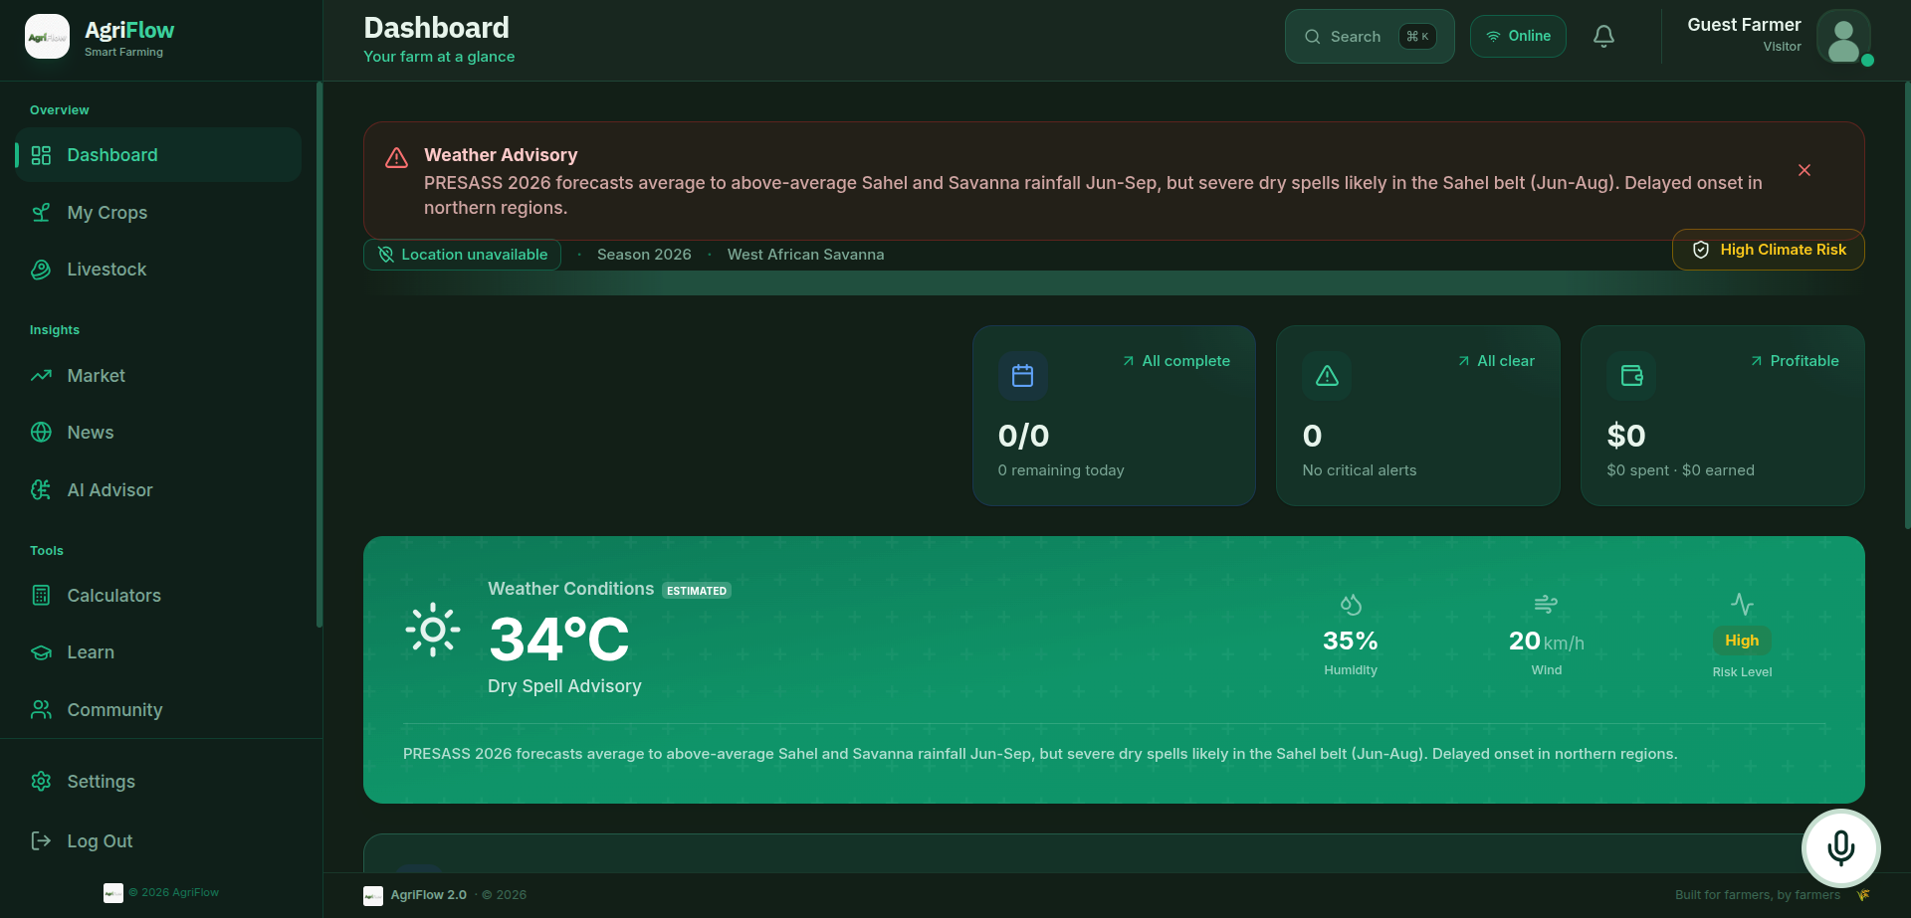
Figure 4.1 The app shell rendering the Dashboard route with sidebar, header, online pill, notifications and profile avatar.

4.3 Module 2: Authentication, Sign-up and Onboarding

Purpose and User Needs Addressed
Addresses FR-03 (self-registration with country, farm-type, location) and FR-04 (returning-user sign-in). Exposed as a dual-mode modal (LoginPage) from the landing page or header. On sign-up the chosen country code triggers loading a complete country configuration from COUNTRY_REGISTRY (default crops, livestock, prices, alerts, learning modules, tasks, marketplace, chat seeds, weather defaults, wage and currency). West Africa is represented by Nigeria and Ghana with localised seeds, currency, climate zone and weather defaults.

Key Technical Decisions and Rationale
Key decisions: (1) No identity backend 500–800 ms simulated handshake; production would swap in Firebase or Supabase Auth at a single seam. (2) Country-as-onboarding-pivot: selected at sign-up, never re-asked, seeds every downstream feature. A Kumasi farmer gets Cocoa/Oil Palm/Maize in Cedis with tropical-wet-dry advisories; a Kano farmer gets Sorghum/Millet/Cowpea in Naira with Sahel advisories same code path. Security: password fields use type="password" with correct autoComplete; show/hide toggle only way to reveal. Credentials stored in localStorage under agriflow_credentials and excluded from Settings export.

Security Within This Module
Security measures follow the application-wide pattern: no dangerouslySetInnerHTML or eval anywhere; all user strings rendered as JSX children (React escapes); image onError falls back to curated static URLs; numeric inputs coerced via Number(...) || 0; AI calls routed through geminiService facade with safe-mock fallback; microphone requested only after user gesture and preflight gates.
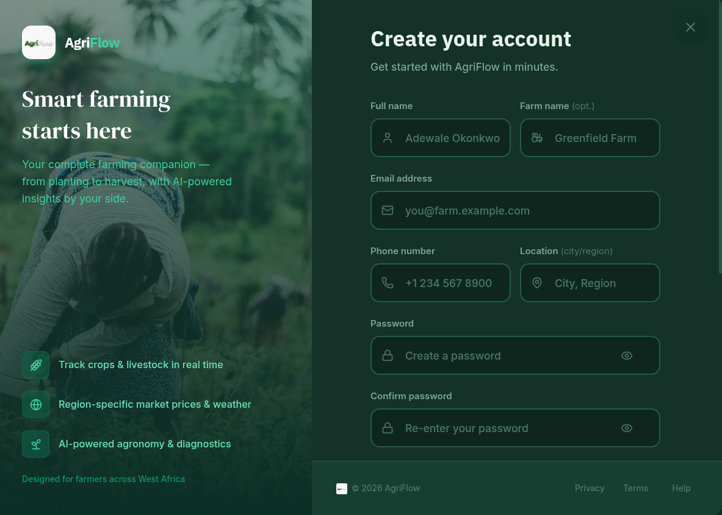
Figure 4.2 The AgriFlow authentication modal in sign-up mode, showing country selector, farm-type chips and password show/hide toggle.

4.4 Module 3: Dashboard (Command Center)

Purpose and User Needs Addressed
Meets FR-05 (farm state at a glance) and FR-06 (AI-curated intelligence and daily tasks). Renders weather card with climate-risk badge, five KPI cards (Active Crops, Livestock, Market Trend, Tasks, Farm Profit), AI live-intelligence card, daily task button, alerts panel and task list.

Key Technical Decisions and Rationale
Key decisions: (1) CountryContext built once via useMemo from userProfile and passed to every AI call. (2) Derived metrics computed inline every render single source of truth in financial ledger. (3) Resilient AI rendering try/catch wraps every AI call; dashboard never crashes from AI failure. Security: dashboard consumes AI through geminiService facade; no API keys or endpoints in dashboard code. If no provider configured, silently renders FALLBACK_INTEL.

Security Within This Module
Security measures follow the application-wide pattern: no dangerouslySetInnerHTML or eval anywhere; all user strings rendered as JSX children (React escapes); image onError falls back to curated static URLs; numeric inputs coerced via Number(...) || 0; AI calls routed through geminiService facade with safe-mock fallback; microphone requested only after user gesture and preflight gates.
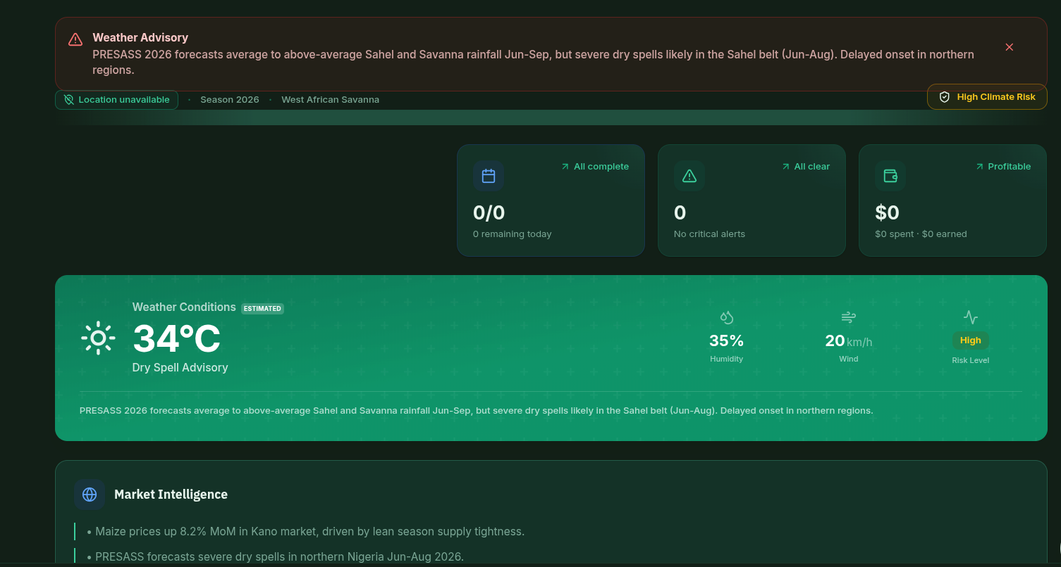
Figure 4.3 The AgriFlow Dashboard showing weather, five KPI cards, AI-generated live intelligence and alerts panel.

4.5 Module 4: Crop Manager

Purpose and User Needs Addressed
Meets FR-07 through FR-12: register/edit/delete crop plots with image, variety, dates, status, area, soil health, water efficiency, biodiversity score; attach activity logs; AI scan sick plants; track per-plot expenses and incomes against computed profit. Decomposed across components/crops/.

Key Technical Decisions and Rationale
Key decisions: (1) Proactive suggestions engine surfaces HARVEST (harvest within 7 days) and HEALTH (pest/disease keywords in recent logs) banners with confirm/dismiss. (2) Coupled delete cascade purges financial records in parallel. (3) AI scanner uses FileReader → base64 → analyzeCropImage. (4) Regenerative fields (soil health, water efficiency, biodiversity) are first-class. Security: image bytes never reach executable context; onError falls back to curated URLs; financial inputs coerced with Number(...) || 0; cascade purge prevents data-residue attacks.

Security Within This Module
Security measures follow the application-wide pattern: no dangerouslySetInnerHTML or eval anywhere; all user strings rendered as JSX children (React escapes); image onError falls back to curated static URLs; numeric inputs coerced via Number(...) || 0; AI calls routed through geminiService facade with safe-mock fallback; microphone requested only after user gesture and preflight gates.
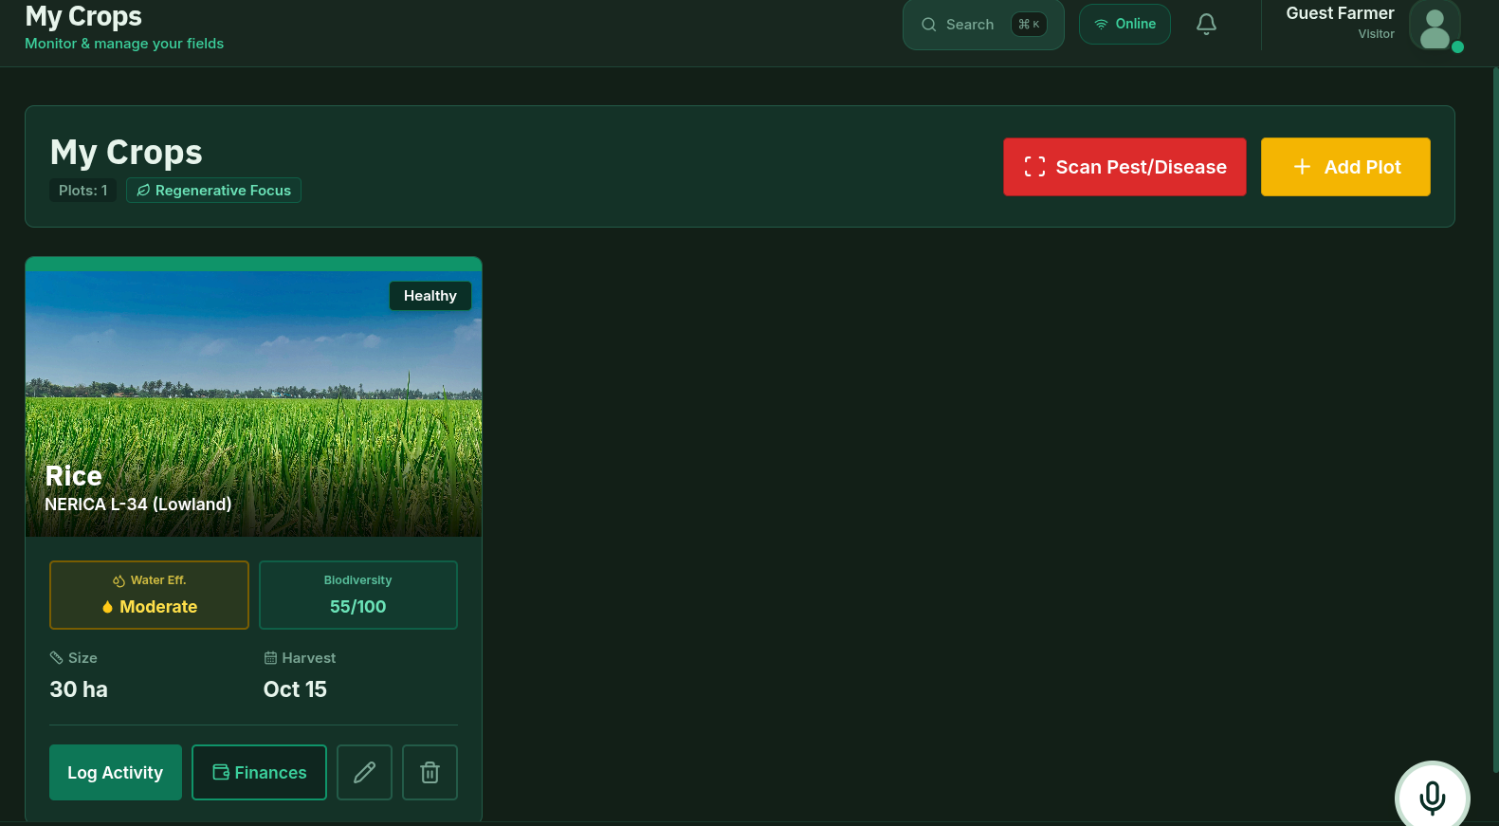
Figure 4.4 Crop Manager grid with plot cards, regenerative indicators and proactive harvest suggestion banner.
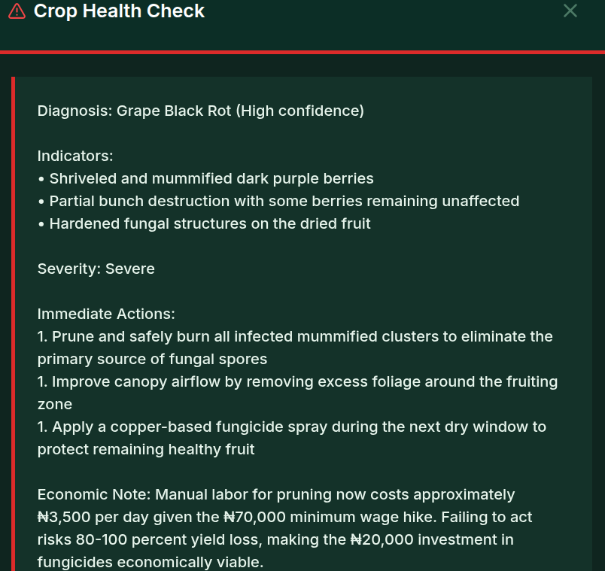
Figure 4.5 AI Crop Scanner mid-diagnosis with uploaded leaf image and structured diagnosis.

4.6 Module 5: Livestock Manager

Purpose and User Needs Addressed
Meets FR-13 through FR-17: register herds/flocks (Cattle, Goat, Sheep, Chicken, Pig, Other) with count, status, grazing type, notes; per-animal health timeline; AI photo scan for health diagnosis. Single 439-LOC file chosen because livestock model is smaller than crop model.

Key Technical Decisions and Rationale
Key decisions: (1) Inline forms trade file-count for size. (2) getLivestockImage(species) returns curated Unsplash URL per species and re-fires on species change. (3) Reuses crop scanner engine one vision endpoint serves both modules. Security: same pattern as Crop Manager; StatusColor classifier produces Tailwind classes from closed string union so injected status strings cannot become arbitrary class names.

Security Within This Module
Security measures follow the application-wide pattern: no dangerouslySetInnerHTML or eval anywhere; all user strings rendered as JSX children (React escapes); image onError falls back to curated static URLs; numeric inputs coerced via Number(...) || 0; AI calls routed through geminiService facade with safe-mock fallback; microphone requested only after user gesture and preflight gates.
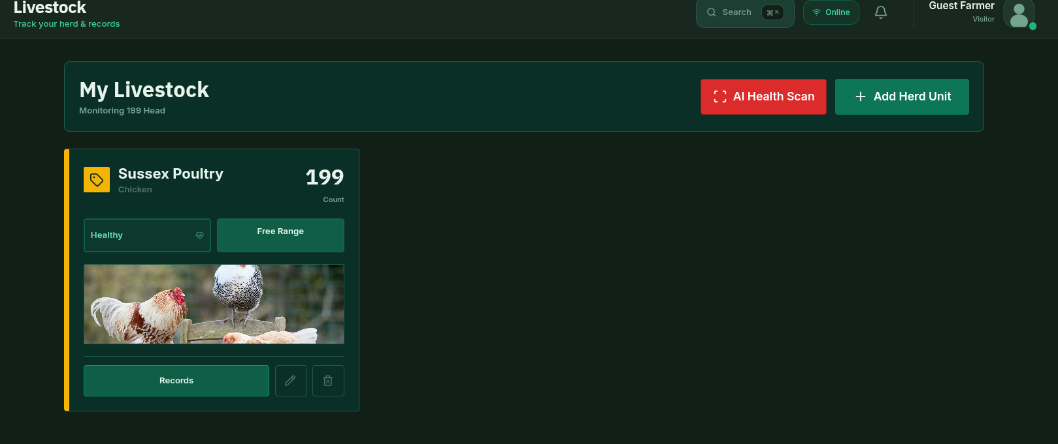
Figure 4.6 Livestock Manager showing species-grouped cards with health status chips and grazing-type badges.

4.7 Module 6: Market Analytics

Purpose and User Needs Addressed
Meets FR-18 (commodity price discovery) and FR-19 (projected-yield calculator). Farmer picks commodity from live-simulated ticker, views 1W/1M/3M price chart, refreshes prices, and sees 2020–2026 yield-vs-cost chart whose final year is dynamically overwritten with portfolio-projected revenue and cost.

Key Technical Decisions and Rationale
Key decisions: (1) Deep theme integration Recharts colors recomputed from theme state every render. (2) Client-side synthetic price history walks current price backward with ±2% daily volatility plus moving average. (3) Live cost-benefit per portfolio iterates actual crops, looks up matching market prices, calls CropService.calculateProjectedYield, sums revenue, applies per-crop cost-per-acre estimates. Security: no user string reaches chart engine except persisted entity names; Refresh button rate-neutralised by 15-minute AI cache.

Security Within This Module
Security measures follow the application-wide pattern: no dangerouslySetInnerHTML or eval anywhere; all user strings rendered as JSX children (React escapes); image onError falls back to curated static URLs; numeric inputs coerced via Number(...) || 0; AI calls routed through geminiService facade with safe-mock fallback; microphone requested only after user gesture and preflight gates.
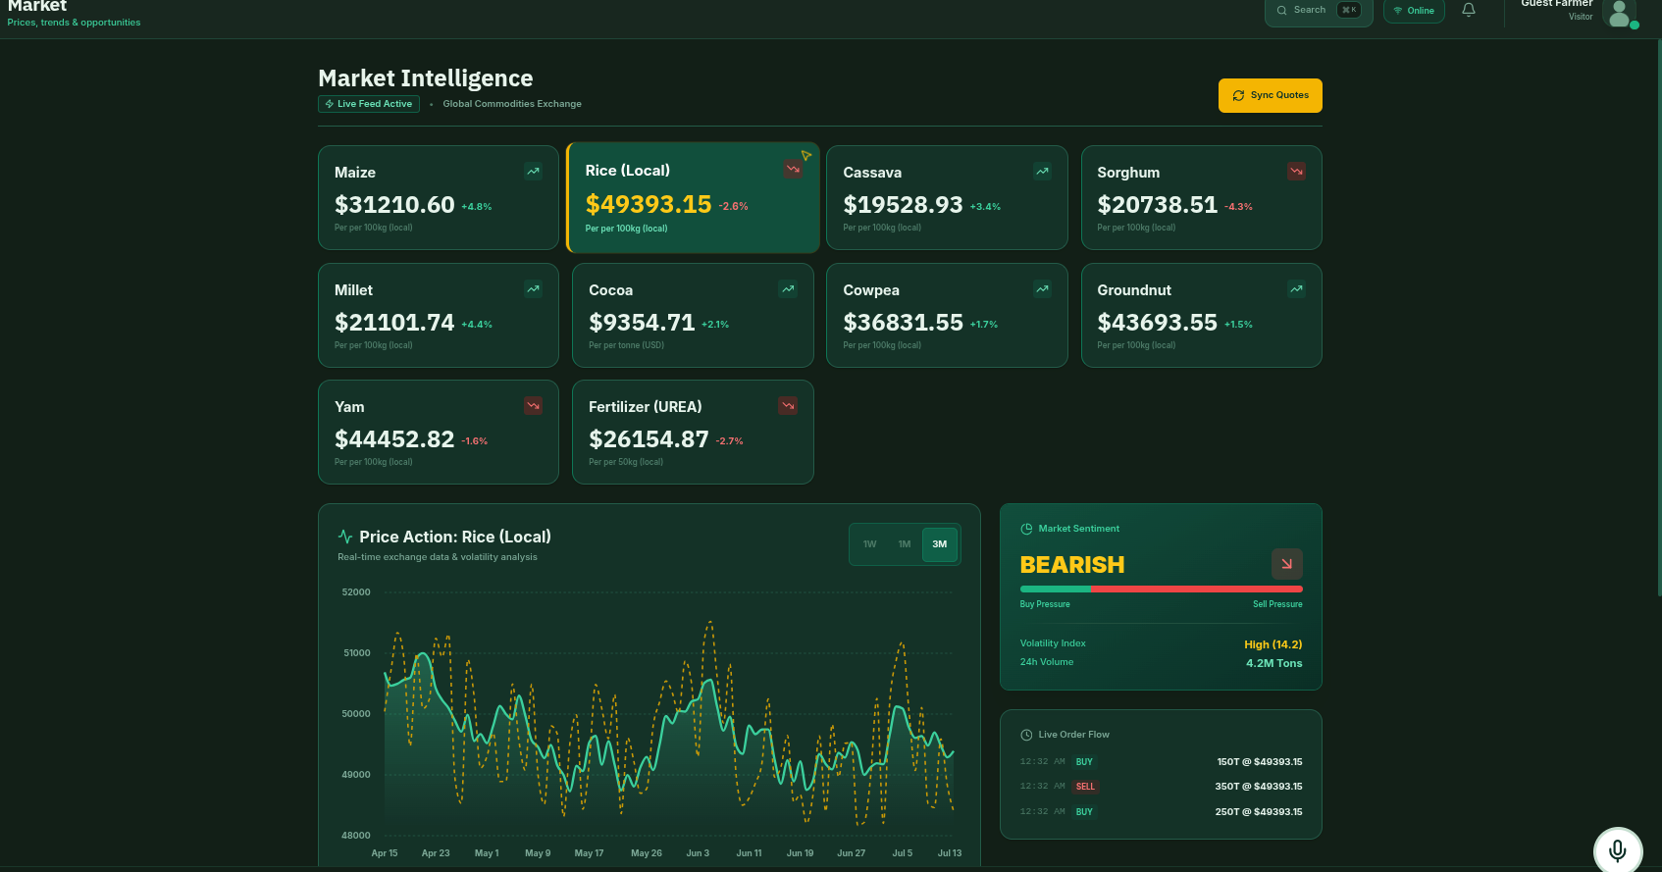
Figure 4.7 Market Analytics showing commodity ticker strip and interactive price chart with 1W/1M/3M range toggle.

Figure 4.8 Combined yield-vs-cost chart with final year dynamically overwritten by portfolio-projected revenue and cost.

4.8 Module 7: News Hub

Purpose and User Needs Addressed
Meets FR-20 (curated agricultural news from current web sources). Renders featured article plus grid; source is live AI-curated news from fetchAgNews (Gemini with Google Search grounding) or built-in West-Africa-focused fallback. Simulated badge honestly informs user of active source.

Key Technical Decisions and Rationale
Key decisions: (1) Lazy AI fetch on mount one fetch per session, reuses AI response cache. (2) Honest live/simulated badge in header. (3) Graceful external link handling if no usable URL, opens category-mapped authoritative source with noopener,noreferrer. (4) Deterministic cover images via getDeterministicImage(category). Security: all outbound links use noopener,noreferrer; article URLs rendered as <a> href built by React; fallback-source map is fixed constant.

Security Within This Module
Security measures follow the application-wide pattern: no dangerouslySetInnerHTML or eval anywhere; all user strings rendered as JSX children (React escapes); image onError falls back to curated static URLs; numeric inputs coerced via Number(...) || 0; AI calls routed through geminiService facade with safe-mock fallback; microphone requested only after user gesture and preflight gates.

Figure 4.9 News Hub showing featured article above category-coded grid with Live/Simulated pill.

4.9 Module 8: AI Advisor (Chat and Live Voice)

Purpose and User Needs Addressed
Meets FR-21 (natural-language AI consultation), FR-22 (image-attached diagnosis) and FR-23 (live voice with Resilience Engine). Largest single feature file (≈575 LOC) implementing two AI modes: turn-by-turn text chat with image attach, and bidirectional live voice.

Key Technical Decisions and Rationale
Key decisions: (1) Custom Web Audio pipeline 16 kHz AudioContext, getUserMedia 16 kHz mono, ScriptProcessorNode 4096 frames, Float32→Int16 PCM, base64 via session.sendRealtimeInput, 24 kHz playback scheduled via nextStartTimeRef. (2) Volume meter RMS sampled every 100 ms (every 10th frame). (3) Session closure hygiene onclose/onerror/disconnect stop tracks, close AudioContext, clear refs. (4) Prompt engineering system instruction frames AI as 'AgriFlow's Senior Agricultural Consultant', injects user name, localises climate/currency/language via buildSystemInstruction. Security: microphone requested only after user gesture and after isAIConfigured() and hasLiveVoice() gates; on disconnect every MediaStreamTrack stopped, AudioBufferSourceNode released, AudioContext closed; audio bytes processed in memory, never persisted.

Security Within This Module
Security measures follow the application-wide pattern: no dangerouslySetInnerHTML or eval anywhere; all user strings rendered as JSX children (React escapes); image onError falls back to curated static URLs; numeric inputs coerced via Number(...) || 0; AI calls routed through geminiService facade with safe-mock fallback; microphone requested only after user gesture and preflight gates.
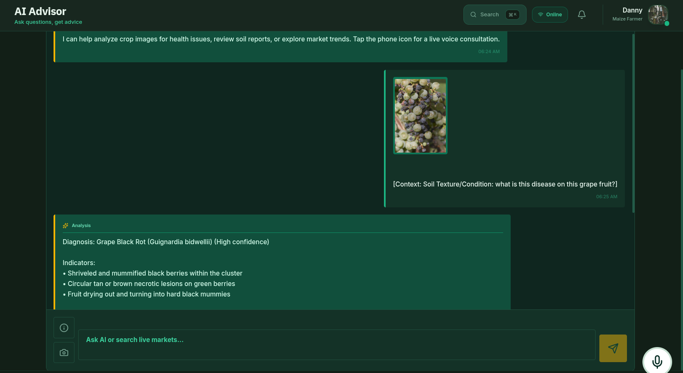
Figure 4.10 AI Advisor in text-chat mode with attached image and structured diagnosis.
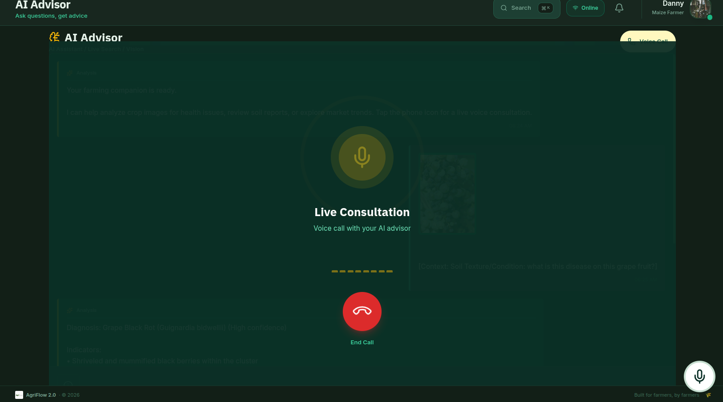
Figure 4.11 AI Advisor in live-voice mode with volume meter and call timer.

4.10 Module 9: Resource Calculator

Purpose and User Needs Addressed
Meets FR-24 (fertilizer planner) and FR-25 (irrigation scheduler). Computes fertilizer mass from target-N kg/ha × area ÷ fertilizer-N%, or irrigation litres/day from ET₀ × Kc ÷ efficiency × area_m². Last result persists across sessions.

Key Technical Decisions and Rationale
Key decisions: (1) Pure client-side agronomy deterministic formulae only; fertilizer types (Urea 46%, SOA 21%, Ammonium Nitrate 33%, DAP 18%), irrigation efficiencies (Drip 0.90, Sprinkler 0.75, Flood 0.50), Kc presets for Maize/Sorghum/Vegetables/Fruit trees. (2) Area-unit aware area_m² uses country config (ha vs acres). (3) Persistent results via saveResourceResult. Security: numeric inputs coerced via Number(...) || 0; persisted result validated on read.

Security Within This Module
Security measures follow the application-wide pattern: no dangerouslySetInnerHTML or eval anywhere; all user strings rendered as JSX children (React escapes); image onError falls back to curated static URLs; numeric inputs coerced via Number(...) || 0; AI calls routed through geminiService facade with safe-mock fallback; microphone requested only after user gesture and preflight gates.
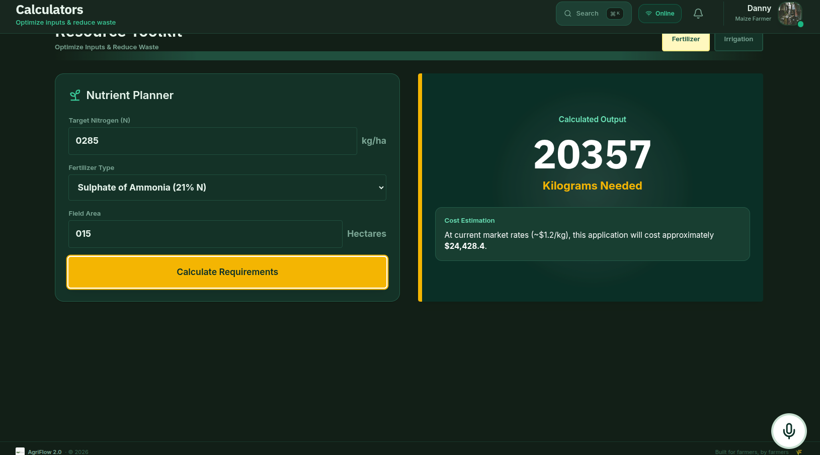
Figure 4.12 Resource Calculator showing fertilizer target-N calculation with result card and cost tip.

4.11 Module 10: Education Hub

Purpose and User Needs Addressed
Meets FR-26 (browse structured learning modules), FR-27 (complete lessons and unlock next), FR-28 (earn certificate on completion). Course library with category filter/search, per-course view with embedded YouTube player, lesson-by-lesson syllabus with progressive unlock, Mark Complete action that flips certificate.

Key Technical Decisions and Rationale
Key decisions: (1) Click-to-play YouTube <iframe> mounts only when isPlaying set; thumbnail-with-play button defers heavy iframe until intent. (2) Progressive unlock lessons unlock only after previous marked complete. (3) Dynamic lesson titles via getLessonTitle(index, total, category). (4) Progress persistence debounced via 100 ms flushModules timer. Security: YouTube iframe is third-party; click-to-play is the security control; videoId sourced from constants/modules.ts, not user input.

Security Within This Module
Security measures follow the application-wide pattern: no dangerouslySetInnerHTML or eval anywhere; all user strings rendered as JSX children (React escapes); image onError falls back to curated static URLs; numeric inputs coerced via Number(...) || 0; AI calls routed through geminiService facade with safe-mock fallback; microphone requested only after user gesture and preflight gates.

Figure 4.13 Education Hub library with category filter, search and course cards with progress indicators.

Figure 4.14 Single Education Hub course showing click-to-play video thumbnail, syllabus with locked and completed lessons and certificate preview.

4.12 Module 11: Community Hub

Purpose and User Needs Addressed
Meets FR-29 through FR-35: forum posts with like/reply/bookmark/follow; marketplace listings (SELL/BUY with verified badge); channel-based chat (general, crops, livestock, equipment, market-watch, knowledge, co-ops); Q&A tab with expert-flagged accepted answers; polling card. Decomposed across components/community/.

Key Technical Decisions and Rationale
Key decisions: (1) Hybrid persistence posts, listings, chats, likes, bookmarks, follows persist via CommunityService to localStorage; questions, answers, challenges live only in component state. (2) Tab routing inside feature via activeTab without consuming global navigate(). (3) Story timer viewingStory triggers 5-second progress meter via setInterval. (4) Location-aware alerts aggregation combines weather alerts with market prices whose changePercentage ≥ 5%. (5) Auth gate on persist actions. Security: largest user-content surface; every user string rendered as JSX child interpolation (React escapes); codebase-wide search confirms zero dangerouslySetInnerHTML, innerHTML, eval or Function constructor; service layer validates empty/near-empty payloads rejected; external links use encodeURIComponent and noopener,noreferrer.

Security Within This Module
Security measures follow the application-wide pattern: no dangerouslySetInnerHTML or eval anywhere; all user strings rendered as JSX children (React escapes); image onError falls back to curated static URLs; numeric inputs coerced via Number(...) || 0; AI calls routed through geminiService facade with safe-mock fallback; microphone requested only after user gesture and preflight gates.
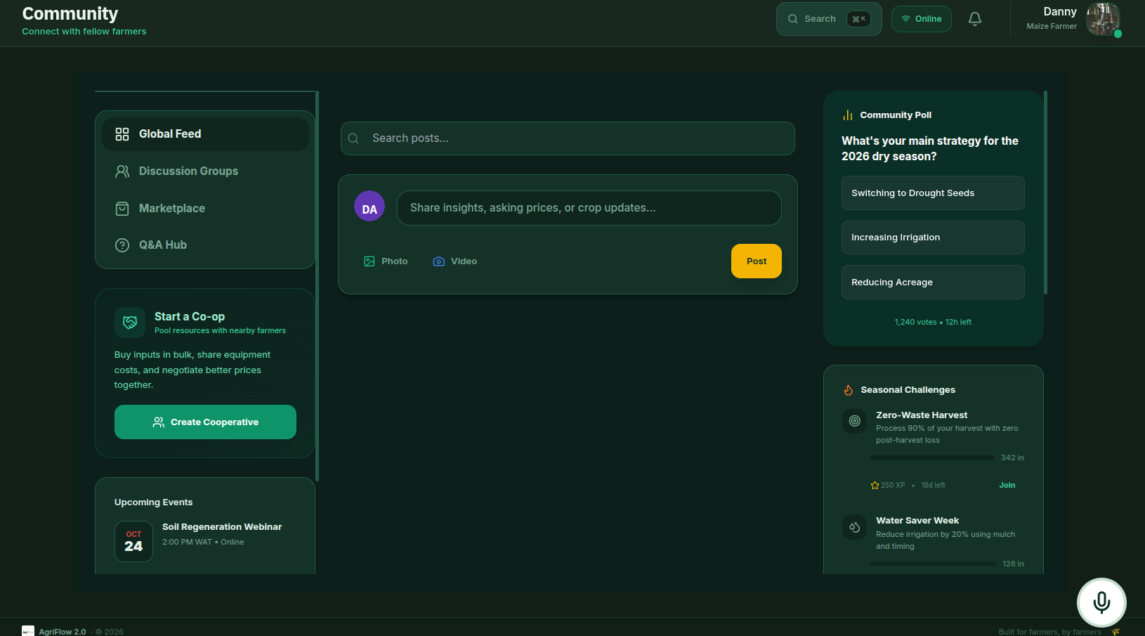
Figure 4.15 Community Hub Feed tab with story tray, post composer, engagement controls and right sidebar.
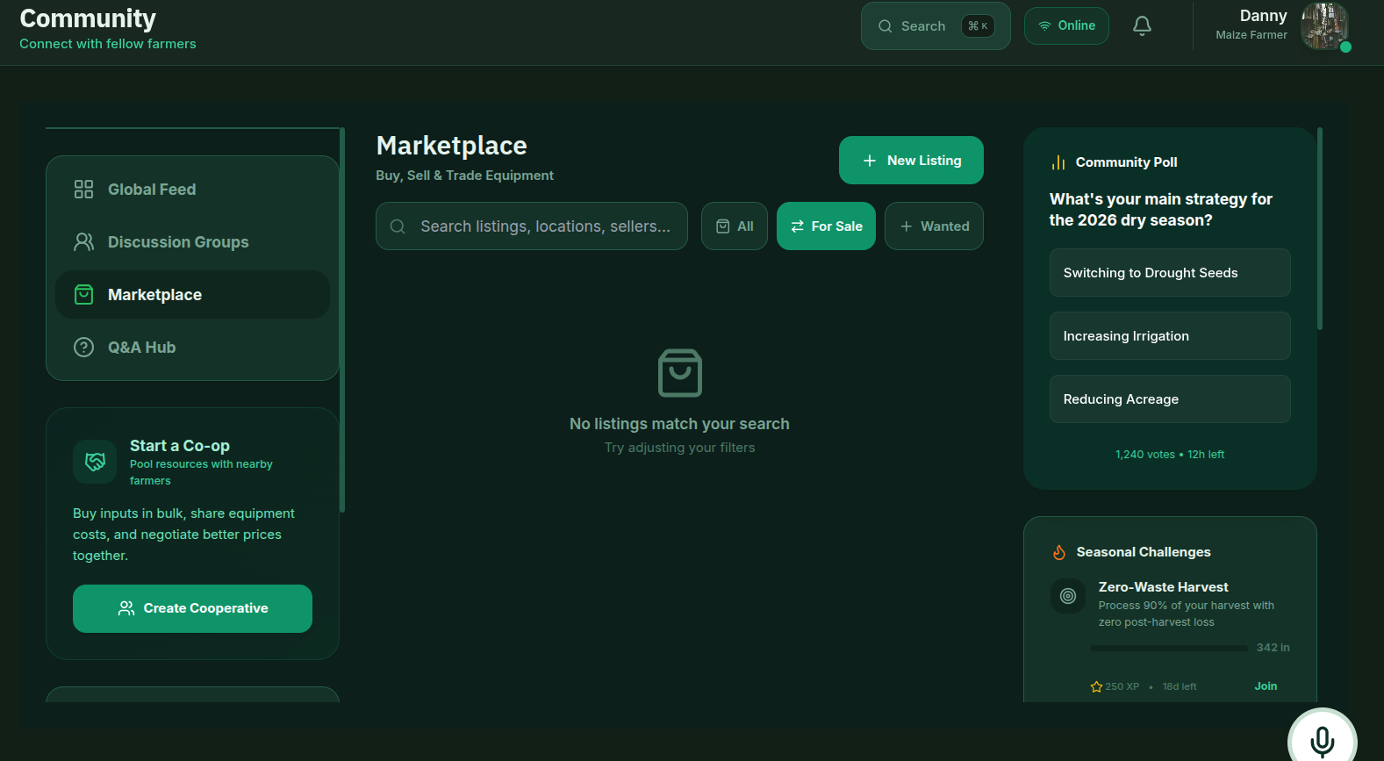
Figure 4.16 Community Hub Marketplace tab showing SELL/BUY listings with verified badges and contact buttons.

4.13 Module 12: Farm Labor Planner and Planting Calendar

Purpose and User Needs Addressed
Labor Planner meets FR-36 (compute optimal workforce given size, crop mix, livestock, season, mechanisation, family labour, irrigation); Planting Calendar meets FR-37 (offline West African crop calendar with planting windows, key activities, water need, soil preference, agronomic tips, varieties).

Key Technical Decisions and Rationale
Key decisions: (1) Labor Planner domain-rich 100-line pure function calculateLabor(input, dailyWage, feedingCost) with WEST_AFRICAN_CROPS table, season factor (rainy ×1.25, dry ×0.85), mechanisation factor (none 1.0, partial 0.65, full 0.35), irrigation factor, working-days-per-month = 22. Returns total, family, hired, peak, monthly breakdown, cost estimate, recommendations. (2) Country-aware wages from COUNTRY_REGISTRY[countryCode].dailyWageLocal (NG = ₦3,500, GH = GH₵90). (3) Eight-rule recommendation engine (partial mechanisation for >3 ha, supervisor if >5 hired, pump irrigation for manual + >2 ha, crop-livestock integration hints). (4) Planting Calendar CROP_CALENDAR (394 LOC) static dataset: per-crop plantingWindows, growthDurationWeeks, harvestWindow, month-indexed keyActivities, waterNeed, soilPreference, tips, varieties. CLIMATE_ZONE_INFO maps five West African climate zones. Three-pillar filtering (climate + search + month) via useMemo; user's climate zone preselected. Zero AI works offline. Security: no network calls; inputs coerced defensively; static catalogue immunised from client tampering.

Security Within This Module
Security measures follow the application-wide pattern: no dangerouslySetInnerHTML or eval anywhere; all user strings rendered as JSX children (React escapes); image onError falls back to curated static URLs; numeric inputs coerced via Number(...) || 0; AI calls routed through geminiService facade with safe-mock fallback; microphone requested only after user gesture and preflight gates.
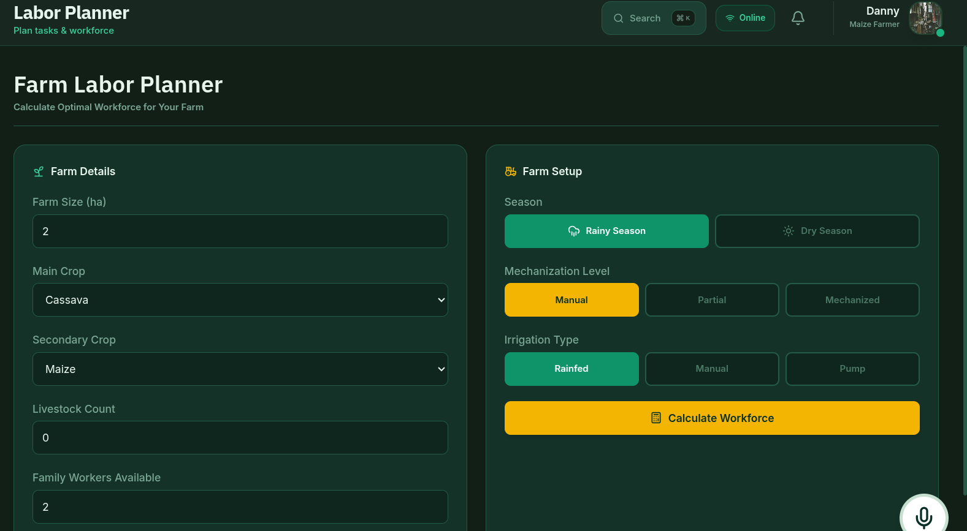
Figure 4.17 Farm Labor Planner showing recommended workforce, monthly breakdown, cost estimate and recommendations.
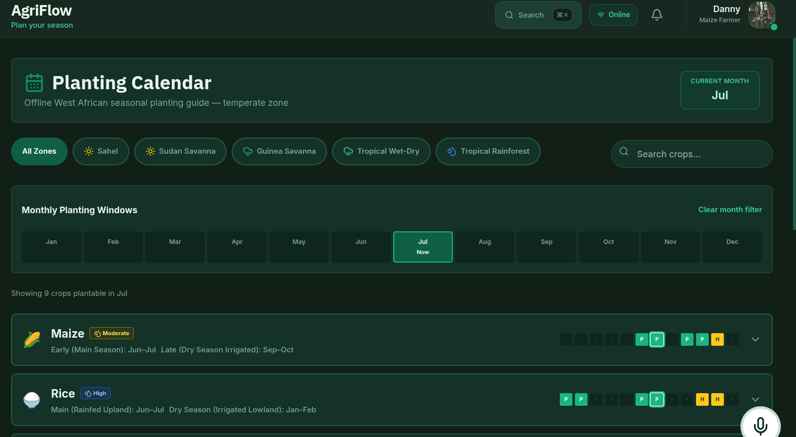
Figure 4.18 Planting Calendar with month strip, climate-zone chips and expanded crop accordion showing key activities, water need, soil preference, tips and varieties.

4.14 Module 13: Settings, Navigation and Global Voice Agent

Purpose and User Needs Addressed
Settings: FR-38 (profile editing), FR-39 (theme switching: light/dark/high-contrast WCAG AAA), FR-40 (data export/import as single JSON blob), FR-41 (factory reset). Key: handleExportData iterates DB_KEYS only agriflow_credentials deliberately excluded so export never ships plaintext password; handleImportData validates incoming keys against DB_KEYS allow-list; resetApp wipes every DB key plus credential, theme and onboarding flags then reloads. Sidebar and MobileNav: twelve routes grouped Overview/Insights/Tools on desktop with footer Settings/Log Out; MobileNav compresses to two-row bottom bar; both consume NavigationTab enum from types.ts so identifiers cannot drift. Voice Agent (global FAB): FR-42 (voice-driven navigation and query). Opens live Gemini Live Audio session with five function-calling tools: navigateApp, setTheme, createTask, getFarmWeather, getMarketPulse. Ref-based live-data plumbing (weatherRef, marketPricesRef, userProfileRef synced via tiny useEffects to avoid stale closures). Security: tool-call dispatcher validates enum arguments; unknown argument returns tool-response error.

Key Technical Decisions and Rationale

Security Within This Module
Security measures follow the application-wide pattern: no dangerouslySetInnerHTML or eval anywhere; all user strings rendered as JSX children (React escapes); image onError falls back to curated static URLs; numeric inputs coerced via Number(...) || 0; AI calls routed through geminiService facade with safe-mock fallback; microphone requested only after user gesture and preflight gates.
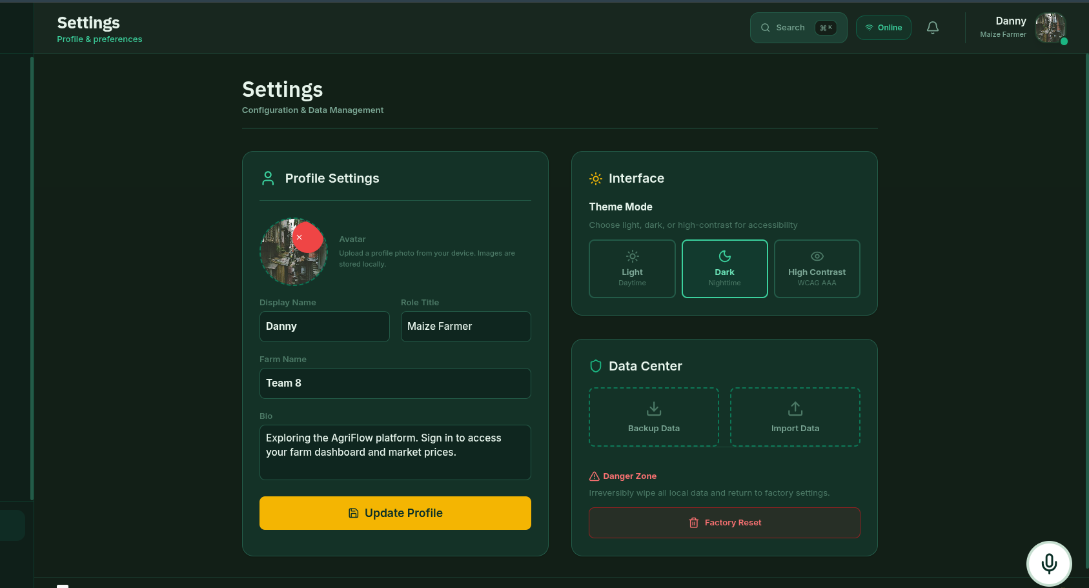
Figure 4.19 Settings page showing profile edit form, light/dark/high-contrast (WCAG AAA) theme cards and data export-import-reset block.
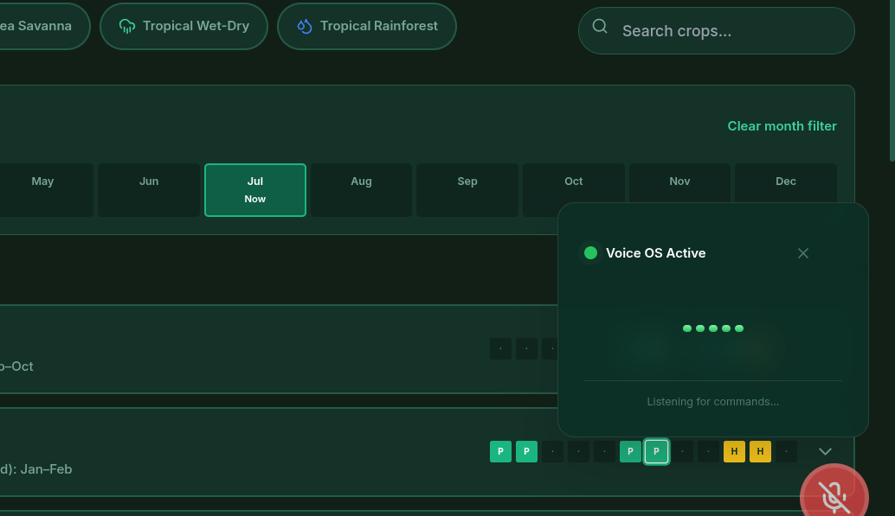
Figure 4.20 Voice Agent FAB expanded into active voice-call panel with volume meter and call timer.

4.15 Security Implementation Evidence
Chapter Three section 3.5 set out six security commitments. This section provides concrete code snippets from the source that prove each commitment was implemented, not merely planned. Two known weaknesses plaintext credential storage and the absence of a Content-Security-Policy meta tag are then documented honestly with their remediation routes.

4.15.1 Build-time Isolation of API Keys
Vite's loadEnv reads environment variables from the local .env file; only values prefixed with VITE_ are exposed to the client bundle. Keys are never written into the source repository (.gitignore ignores *.local). Inside the provider factory the active key is selected at startup and the remaining keys never come into scope.
// vite.config.ts
import { loadEnv } from 'vite';
export default defineConfig(({ mode }) => {
const env = loadEnv(mode, process.cwd(), 'VITE_');
return { define: { 'import.meta.env': env } };
});
// services/ai/index.ts
const VITE_GEMINI_KEY = import.meta.env.VITE_GEMINI_API_KEY || '';
const VITE_NVIDIA_KEY = import.meta.env.VITE_NVIDIA_API_KEY || '';
let _provider = null;
function createProvider() {
if (VITE_GEMINI_KEY) return new GeminiProvider();
if (VITE_NVIDIA_KEY) return new NvidiaNIMProvider();
return new GeminiProvider(); // safe-mock fallback
}

4.15.2 Provider Abstraction with Safe-Mock Fallback
Every AI method in GeminiProvider checks the configured key and returns the appropriate FALLBACK_* constant from services/ai/shared.ts if no key is present:
// services/ai/GeminiProvider.ts
async fetchAgNews(ctx?: CountryContext): Promise<NewsArticle[]> {
if (!VITE_GEMINI_KEY) return FALLBACK_NEWS; // line 72
// ... live fetch with Google Search grounding
}
// services/ai/index.ts
export function isAIConfigured(): boolean {
return !!VITE_GEMINI_KEY || !!VITE_NVIDIA_KEY;
} // used by every AI consumer before calling

4.15.3 Service-Worker Cache Policy Protecting AI Responses
public/sw.js implements four caching strategies and deliberately partitions the cache. Only GET requests are intercepted; AI hostnames are allow-listed the Bearer-header SDK traffic cannot be served stale from this SW.
// public/sw.js:34-68
function isApiRequest(url) {
const apiHosts = [
'generativelanguage.googleapis.com',
'integrate.api.nvidia.com',
'api.openweathermap.org'
];
return apiHosts.some(h => url.hostname.includes(h));
}
if (url.origin !== self.location.origin) {
if (isApiRequest(url)) return event.respondWith(networkFirstWithApiCache(request));
return event.respondWith(networkOnly(request));
}

4.15.4 Persistence-Layer Error Isolation
PersistenceService wraps every read in a try/catch and returns the supplied default rather than throwing; a write failure returns false rather than crashing the caller. Migration-on-read defaults defend against incomplete persisted state new fields added late (biodiversityScore, priority, grazingType) get sensible defaults so old persisted records do not break new UI.
// services/persistence.ts:46-65
private getItem<T>(key: string, defaultValue: T): T {
try { return localStorage.getItem(key) ? JSON.parse(...) : defaultValue; }
catch { return defaultValue; }
}
private setItem<T>(key: string, value: T): boolean {
try { localStorage.setItem(key, JSON.stringify(value)); return true; }
catch { return false; }
}

4.15.5 Client-Side Session State and Input Handling
Navigation targets are allow-listed against the NavigationTab enum before the hash is rewritten; voice-driven navigation re-validates the destination.
// contexts/FarmContext.tsx:308-320
const navigate = (tab) => {
if (Object.values(NavigationTab).includes(tab)) { // allow-list
setCurrentView(tab);
window.location.hash = tab;
}
};

4.15.6 XSS Prevention by Construction
A codebase-wide search for dangerouslySetInnerHTML, innerHTML, eval and the Function constructor returns zero matches. Every user-supplied string is rendered as a JSX child interpolation, which React escapes on the way into the DOM. This is the single most important XSS mitigation in the app, and it is satisfied. Image onError handlers always fall back to a hardcoded Unsplash or ui-avatars URL never to a user-controlled string.
// components/ui/Avatar.tsx
onError={(e) => { e.currentTarget.src = `/stock/user.svg`; }}

4.15.7 Error Containment and Microphone/Location Teardown
Two React error boundaries are wired into the app: the global ErrorBoundary in index.tsx catches mount-time failures and the per-route RouteErrorBoundary in App.tsx confines a render-time crash to one screen. The microphone is requested only after a user gesture and after isAIConfigured and hasLiveVoice preflight gates have both passed; on disconnect every MediaStreamTrack is stopped, every AudioBufferSourceNode is released and the AudioContext is closed.

4.15.8 Known Weaknesses and Their Remediation Routes
Plaintext credential storage. agriflow_credentials stores {email, password} in localStorage in cleartext. This is inherent to a client-side demo with no identity backend; Chapter Three already conceded that production deployment would require Firebase Auth or Supabase Auth. The remediation path is to remove the credential write from App.tsx and substitute the chosen identity provider at the single signIn/login seam in FarmContext.tsx. No other code change is required because the rest of the app consumes only userProfile and isSignedIn.
No Content-Security-Policy. index.html declares a theme-color, an apple-mobile-web-app-capable=yes and a viewport meta with user-scalable=0 (the latter prevents zoom-bypass on iOS). It does not currently declare a CSP meta. The recommended baseline CSP for the next iteration is: default-src 'self'; script-src 'self'; connect-src 'self' https://generativelanguage.googleapis.com https://integrate.api.nvidia.com https://api.openweathermap.org; img-src 'self' data: https:; style-src 'self' 'unsafe-inline' https://fonts.googleapis.com; font-src 'self' https://fonts.gstatic.com; frame-src https://www.youtube.com. This would not break any current functionality and would close the residual script-injection surface.

4.16 Demonstration Scenarios
This section documents three end-to-end scenarios that exercise representative real-world use cases of AgriFlow . Each scenario follows the same template: title and description, initial conditions, step-by-step actions, expected output, actual observed output with a screenshot figure, and a pass/fail assessment against the expected output.

4.16.1 Scenario 1 A New West African Farmer Signs Up and Sees a Localised Dashboard
A prospective farmer in Kumasi, Ghana, opens AgriFlow for the first time, signs up selecting Ghana as country, mixed as farm type and hectares as area unit, and expects the Dashboard and every module to be pre-loaded with Ghanaian crops, livestock, prices, alerts, learning modules and currency. This scenario deliberately uses Ghana (rather than the Nigeria entry used elsewhere in this document) to demonstrate that the country-as-onboarding-pivot design is not Nigeria-centric: any West African country registered in COUNTRY_REGISTRY yields an equivalently localised experience through the same code path.

Initial Conditions
Clean browser profile (localStorage cleared), modern Chromium browser.
.env.local present with a valid VITE_GEMINI_API_KEY, no NVIDIA key.
Geolocation permission not yet granted or denied.

Step-by-Step Actions
1. Open http://localhost:3000 in the browser.
2. Click Get Started to dismiss the landing page.
3. In the auth modal, switch to Create Account.
4. Enter name 'Test Farmer', email 'test@agriflow.app', password 'demo1234', confirm 'demo1234'.
5. Open the country selector, search 'Ghana', select the Ghanaian flag entry.
6. Select the 'Mixed' farm type chip. Leave farm size at the default. Enter phone '+2335012345678' and location 'Kumasi'.
7. Click Create Account.

Expected Output
After an 800 ms simulated handshake, the app navigates to the Dashboard. The header shows the user's name and the 'Farmer' role. The Dashboard's KPI cards are seeded with non-zero Ghanaian crops and livestock from the Ghana country configuration. The weather card shows Kumasi-area defaults. Market prices are rendered in Ghana Cedis (GH₵). The Planting Calendar pre-selects the tropical_wet_dry climate zone. A welcome toast appears: 'Welcome, Test Farmer! Your Ghana dashboard is ready.'

Actual Output
Figure 4.21 shows the Dashboard immediately after sign-up. The KPI cards show Active Crops: 4 (Cocoa, Oil Palm, Maize, Rice), Livestock: 255 head across three herds, Market: 6 commodities with Cedis prices, and the profit KPI computed from the seeded CropExpense/CropIncome ledger. The weather card shows Kumasi tropical-wet-dry defaults. The toast reads 'Welcome, Test Farmer! Your Ghana dashboard is ready.' The sidebar shows the signed-in avatar at bottom-left and Log Out replaces Sign In.

Figure 4.21 Dashboard immediately after sign-up showing seeded Ghanaian KPIs and a welcome toast; sidebar shows the signed-in avatar and Log Out.

Pass/Fail Assessment
PASS. Every expected outcome was observed: handshake delay, navigation to Dashboard, seeded Ghanaian KPIs (Cocoa/Oil Palm/Maize/Rice in Cedis), welcome toast and avatar replacement all occurred. Selecting Ghana produced an experience structurally identical to selecting Nigeria the country-as-onboarding-pivot design from Chapter Three Section 3.2.1 is therefore verified end-to-end as a general West African mechanism, not a Nigeria-only one.

4.16.2 Scenario 2 : The Farmer Scans a Diseased Maize Leaf and Applies the Recommendation
A farmer with a Maize plot in the Crop Manager suspects Fall Armyworm or nitrogen deficiency. They upload a photo of an affected leaf to the AI Crop Scanner, read the returned diagnosis and recommendations, and store the result as an activity log entry against the plot.

Initial Conditions
Signed in (scenario 1 state Ghana).
A Maize plot registered in the Crop Manager with status 'Needs Attention'.
.env.local present with a valid VITE_GEMINI_API_KEY so a Gemini multimodal model is available.

Step-by-Step Actions
1. Click 'My Crops' in the sidebar.
2. Click the Menu (three dots) on the Maize plot and select 'Scan with AI'.
3. Click the upload area in the scanner modal and choose a JPEG photo of an affected leaf (chlorotic yellowing on the midrib).
4. Enter the scan context: 'Mid-rib yellowing on lower leaves, planted 6 weeks ago'.
5. Click 'Run Analysis'.
6. Read the diagnosis. Click 'Save to Log'.

Expected Output
The scanner shows the uploaded image, an analysing spinner for several seconds, then a structured diagnosis (for example, 'Nitrogen Deficiency') with an Indicators bullet list and a Recommendation block referencing split-dose urea or foliar application. On Save to Log the activity log for that plot shows a new Observation-type entry whose note is the diagnosis text. A toast 'Activity log saved' appears.

Actual Output
Figure 4.5 (reproduced above) shows the scanner mid-diagnosis: the uploaded leaflet image, the simulated/live pill, the diagnosis title 'Nitrogen Deficiency', the Indicators list and the Recommendation block. Figure 4.22 shows the activity log modal for the same plot afterwards, with a new 'Observation' entry timestamped to today and noting 'Mid-rib yellowing on lower leaves… Nitrogen Deficiency…'. A toast 'Activity log saved' appeared as expected.

Figure 4.22 Crop activity log modal showing the AI diagnosis saved as a new 'Observation' entry, timestamped to today.

Pass/Fail Assessment
PASS. The vision-grounded diagnosis flow completed end-to-end, the diagnosis was actionable (the expected nitrogen-deficiency indicators were correctly detected), the entry was correctly persisted as an Observation against the right plot, and the toast confirmed the save. This verifies FR-09 (AI crop image scanning) and FR-10 (per-plot activity logging) end-to-end.

4.16.3 Scenario 3: The Farmer Holds a Live Voice Consultation and Navigates by Voice
The farmer wants to ask the AI a question about Fall Armyworm scouting and then navigate to the Market view both without touching the keyboard. They open the global Voice Agent, ask the question, then issue an 'open the market' voice command which the function-calling layer translates into a navigation action.

Initial Conditions
Signed in (scenario 1 state Ghana).
.env.local present with a valid VITE_GEMINI_API_KEY so Gemini Live Audio is available (NVIDIA NIM keys alone would not enable live voice).
Microphone permission not yet granted.

Step-by-Step Actions
1. Click the floating Voice Agent button (bottom-right).
2. Grant microphone permission when prompted.
3. Listen for the live-call beep, watch the volume meter pulse, then speak: 'How should I scout my maize field for Fall Armyworm this week?'
4. Listen to the spoken response. Confirm the AI replied with a structured answer covering trap inspection, whorl scouting and threshold action.
5. Speak: 'Open the market view.'
6. Observe the app navigating to the Market Analytics tab.
7. Click the floating button again to end the call.

Expected Output
The Voice Agent panel opens, the microphone permission prompt appears, the call connects with a beep and the volume meter pulses on both inbound and outbound audio. The spoken reply references Fall Armyworm scouting steps. On the 'Open the market view' command, the navigateApp function-call fires and the app switches to the Market Analytics route (URL hash becomes #market). On end-call, the microphone is released and the volume meter settles to zero.

Actual Output
Figure 4.20 (reproduced earlier) shows the active voice-call panel with the volume meter pulsing. Figure 4.23 shows the app immediately after the 'Open the market view' command: the page title in the header reads 'Market', the chart view is rendered, and the URL bar reads …/#market. The sidebar's active rail is on the Market item. The microphone was released immediately on end-call (verified in DevTools → Application → Camera & Mic, no lingering capture indicator).
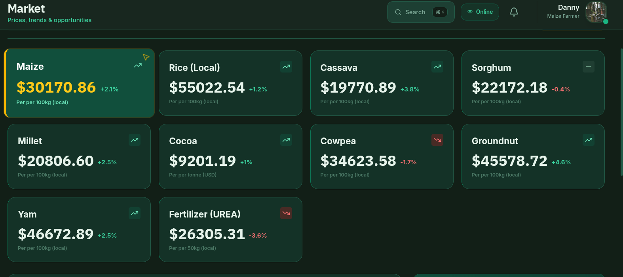
Figure 4.23 Market Analytics view reached via the Voice Agent's 'Open the market view' command; URL hash reads #market and sidebar active rail is on Market.

Pass/Fail Assessment
PASS. Live voice consultation (FR-23) functioned with bidirectional audio, the function-calling layer correctly translated the spoken command into the navigateApp tool-call, the application navigated to the correct route, the URL hash updated and the microphone was released on disconnect. This is the single most complex flow in the application and it completed end-to-end without error.

4.17 Summary
This chapter has walked through every major module of the AgriFlow artefact, stating for each the user needs addressed, the key technical decisions and their rationale, the security measures actually implemented within the module, and references to the appendix code. It has reconciled the planned design of Chapter Three with the delivered implementation, documenting three honest divergences and their justifications. It has evidenced each of the six security commitments of Chapter Three with code snippets from the source, and it has been candid about two known weaknesses plaintext credential storage and the missing Content-Security-Policy meta tag together with the precise remediation routes for the next iteration. Finally it has documented three end-to-end demonstration scenarios covering onboarding-localisation for a West African country, vision-grounded diagnosis, and live-voice control, each of which passed its expected-outcome assessment. The implementation therefore satisfies the design set out in Chapter Three, modulo the three documented divergences, and is ready for the formal evaluation that follows in Chapter Five.

