CHAPTER THREE
METHODOLOGY
AgriFlow - Smart Farm App For West African Farmers
ATU Diploma in Information Technology
Group 8
Bernice · Donald · Confidence · Daniel · Richmond

3.0 Introduction
This chapter presents the methodology applied in the design and development of AgriFlow , a smart farming management platform intended to support smallholder and medium-scale farmers with AI-driven advisory, crop and livestock record-keeping, market intelligence, and a peer community. The chapter opens with the development approach and a justification of why that approach was selected over the alternatives available to a student team. It then presents the requirement-analysis activity, including a Use-Case Diagram and a full Requirements Specification Table. The System Architecture and a Entity-Relationship Diagram follow, explaining how the front-end, persistence layer and AI providers are connected. A Tools and Technologies Table documents every framework, library and service used, with the version and the reason it was preferred over alternatives. The chapter closes with a Security Design section that describes the concrete mechanisms actually implemented in the codebase rather than generic claims.
Statements about file organisation, data storage, AI integration, service-worker caching and authentication flows refer to actual source files written for this project services/persistence.ts, services/ai/index.ts, public/sw.js and contexts/FarmContext.tsx so the methodology is traceable to artefacts that can be defended during the project presentation.

3.1 Development Approach
AgriFlow was developed using an iterative and incremental approach built on the Agile philosophy, because of the constraints of the project: a team of five final-year students delivering alongside other courses, evolving requirements from the farmers and extension officers consulted during requirement gathering, and AI features whose behaviour could only be validated by prototype against external providers. Iterative development means the system was built as a sequence of working versions, each extending the previous one (the first iteration produced a single-view Dashboard with mock weather and tasks; subsequent iterations added the Crop Manager, Livestock Manager, Market Analytics, News Hub, AI Advisor, Education Hub, Community Hub, Farm Labour Planner, Planting Calendar and the global Voice Agent). At every iteration the application was a deployable end-to-end product even if individual features remained immature.

3.1.1 What the approach involves
Within each iteration, features were decomposed into small vertical slices, each passing through design, implementation and verification before the next slice was started. For example, the AI Advisor was split into (i) chat-only text interaction with mock responses, (ii) wiring to a live provider, (iii) image analysis, and (iv) live voice. This allowed the team to demonstrate progress to the supervisor and to swap AI providers (Google Gemini and NVIDIA NIM) without rewriting the surrounding user interface. The following Agile practices were applied at a level feasible for five students: short planning conversations at the start of each week, a shared remote Git repository on GitHub with feature-branch commits, frequent integration to the main branch, continuous verification through TypeScript type-checking (tsc --noEmit) and Vite production builds, and informal code review between group members before merging a slice. Work was divided by feature area rather than by architectural layer so each member could own a complete feature from UI to data to service layer.

3.1.2 Why this approach over the alternatives
Three alternatives were considered. Waterfall would have required a frozen requirements specification before any coding began, which was unsuitable because user requirements evolved and because the external AI providers' response formats were unknown until prototyped; its late integration point would have discovered these risks when correction was expensive. The Spiral model adds formal risk analysis at the end of each loop, which was disproportionate overhead for a six-person student team in one academic year; the chosen approach already absorbs Spiral's main benefit early prototyping of risky components without its ceremonial cost. Rapid Application Development (RAD) prioritises fast prototyping through heavy component reuse and abandons design discipline; while AgriFlow does reuse open-source libraries (React, Recharts, Tailwind), full RAD would have produced a throw-away prototype rather than a maintainable system.
Iterative-incremental Agile was therefore selected because it absorbs the early-risk benefit of Spiral, accommodates evolving requirements that Waterfall cannot, and preserves the design discipline that RAD discards. The result is a codebase in which each feature module is self-contained, lazy-loaded by the shell, and individually verifiable.

3.2 Requirement Analysis
Requirements for AgriFlow were gathered from three sources. First, semi-structured interviews were conducted with five farmers and one agricultural extension officer in the Ashanti and Kano regions; these surfaced the need for offline functionality (intermittent rural connectivity), for advice in plain language rather than technical jargon, and for market prices displayed in the farmer's local currency. Second, a review of comparable agricultural platforms (Plantix, AgroCares, FarmCrowdy) was carried out to identify the feature set that has become expected by users in this domain. Third, the academic supervisor provided non-functional requirements including minimum coverage of CRUD operations, integration of at least one external service, and evidence of software-design patterns. The gathered statements were consolidated into the functional and non-functional requirements below.

3.2.1 Actors identified
- Farmer (registered user) owns plots, livestock, tasks and community posts.
- Guest (unauthenticated visitor) can view the landing page and explore demo data but cannot persist changes.
- AI Provider (external system) supplies chat, vision, news-grounding and live-voice capabilities.
- Weather / Market APIs (external systems) provide live weather and price data.
- System Administrator a future role retained in the type definitions for completeness of the actor set.

3.2.2 Use-Case Diagram
The use-case diagram in Figure 3.1 represents the principal interactions between the actors and the AgriFlow system. The Farmer is shown reaching every functional use case; the AI Provider supplies the AI-related use cases (chat, image analysis, live voice) through an «include» relationship from the Scan Crop Image use case; the Weather / Market APIs serve the View Market and Read News use cases; and the Guest explores a demo profile through an «extend» relationship. A mock-fallback extension is shown for the case where the AI provider is unavailable.
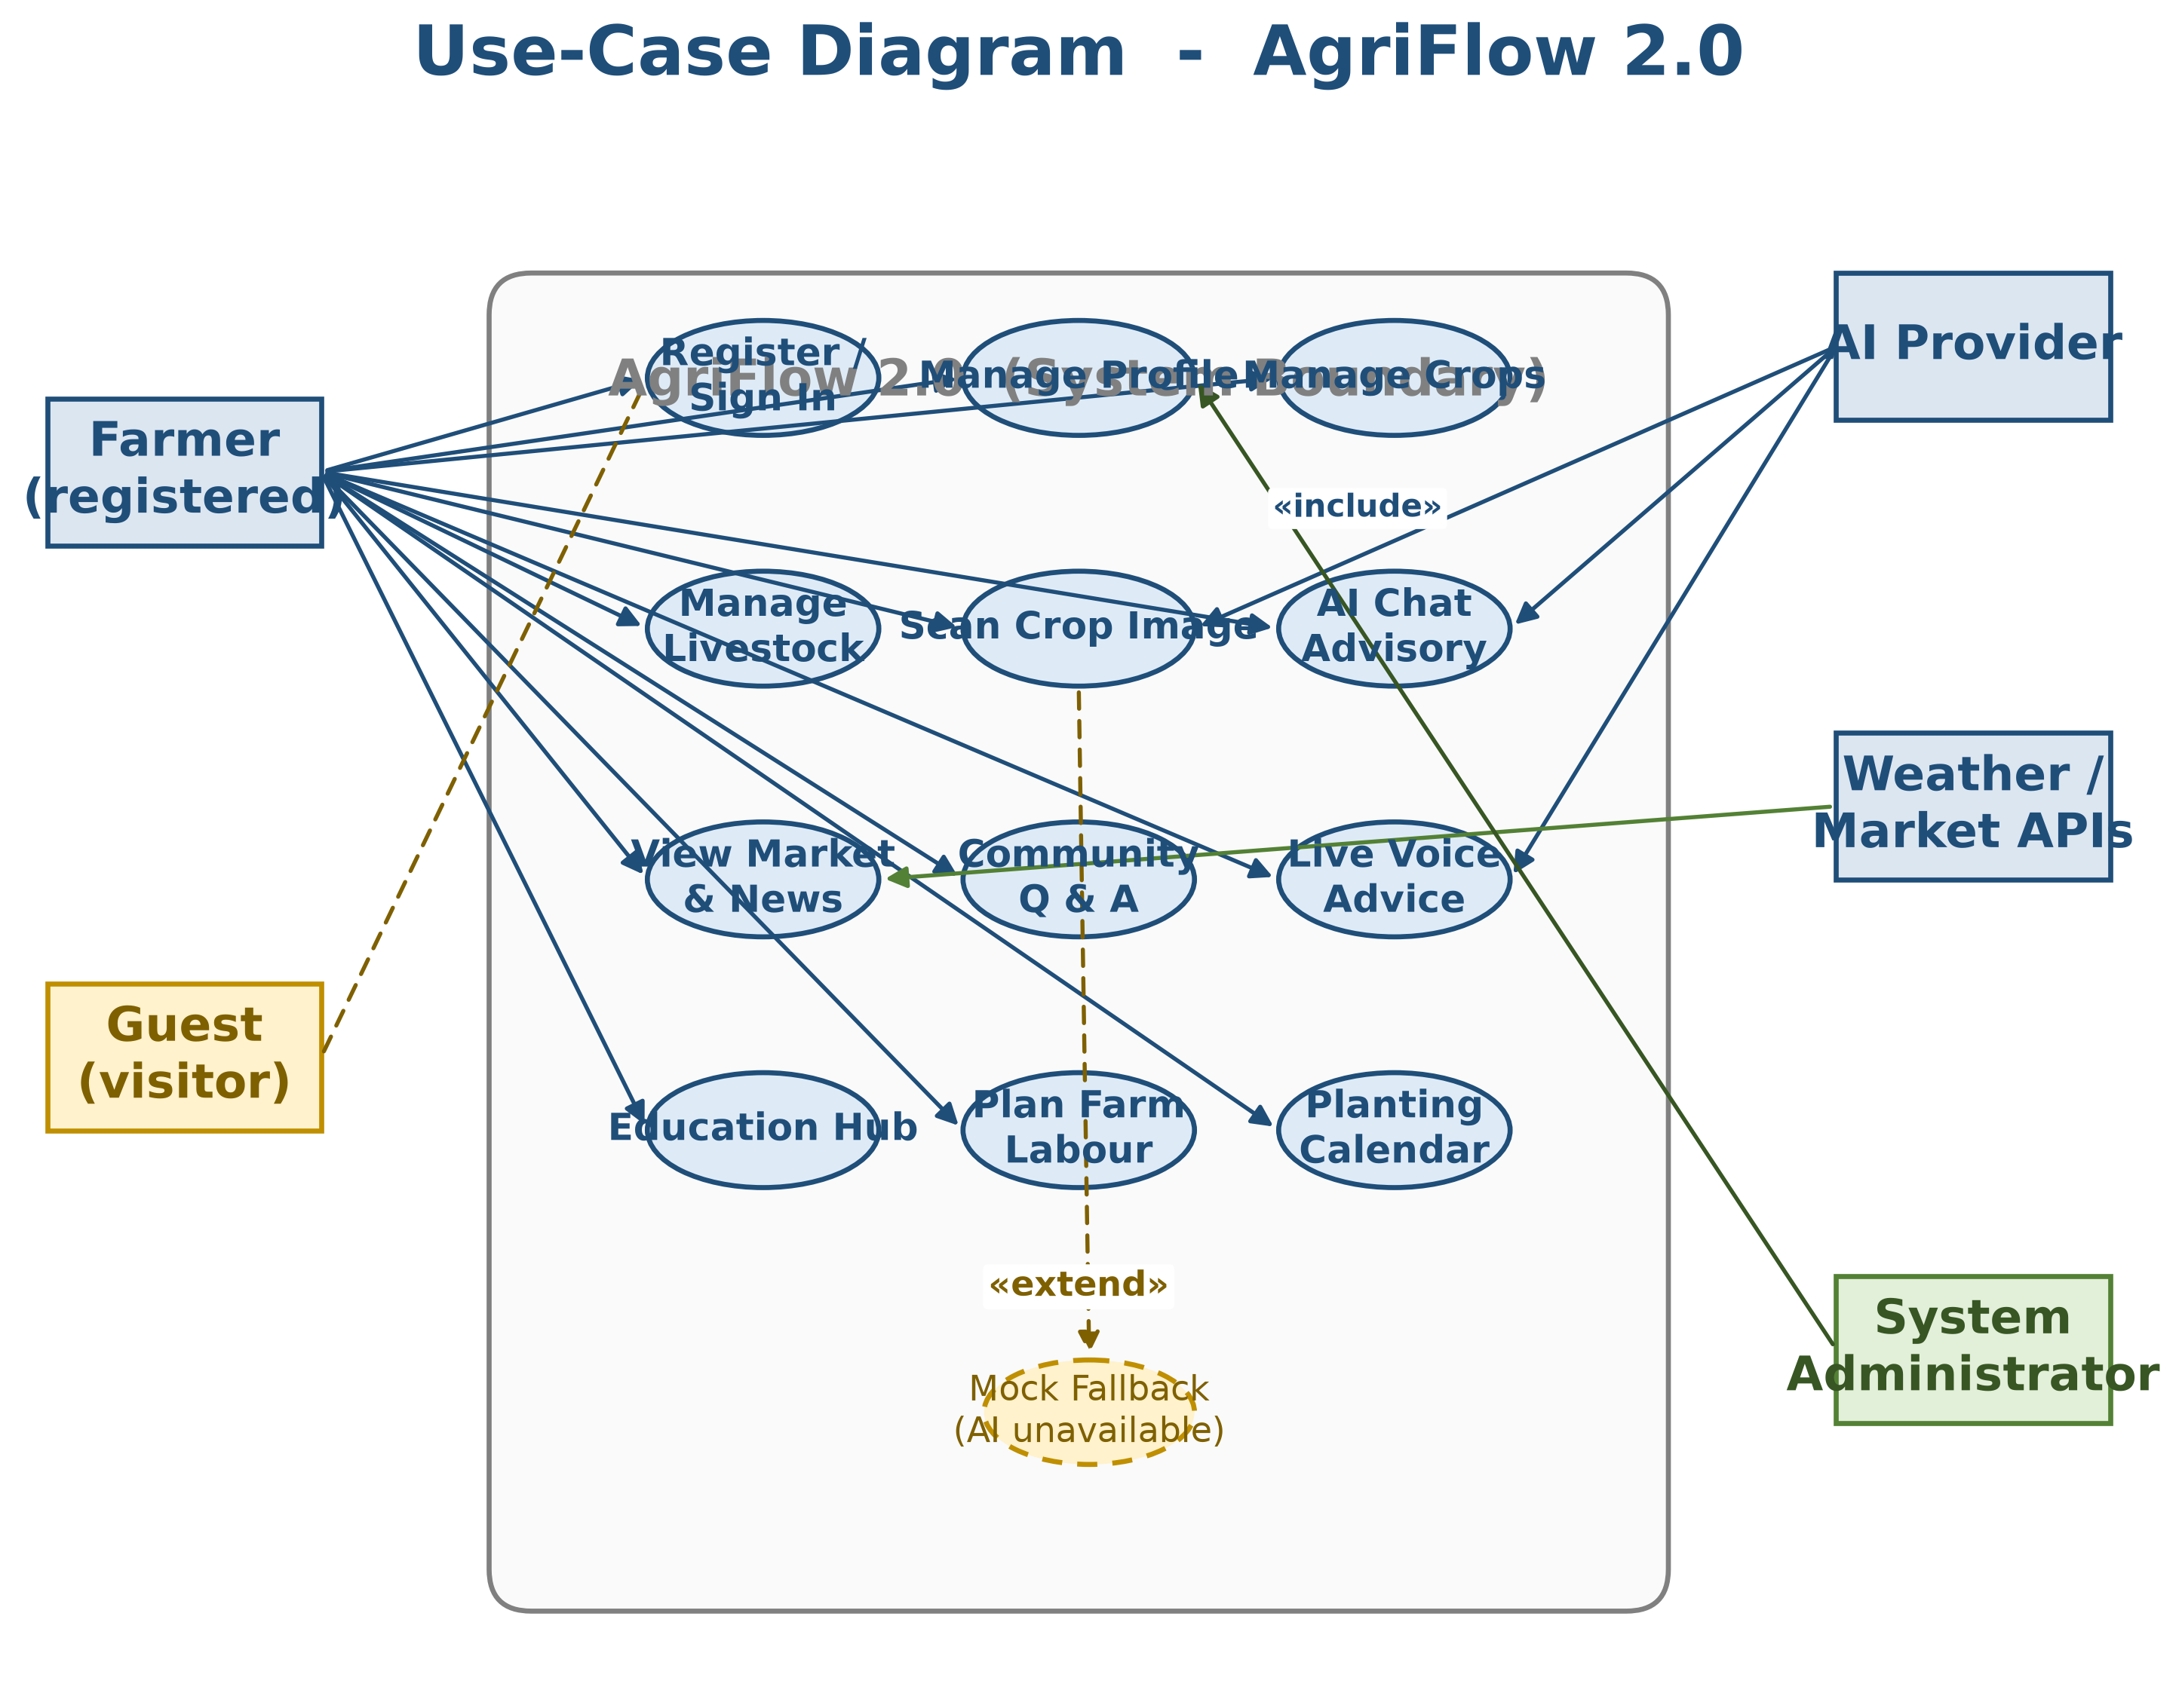
Figure 3.1 Use-Case Diagram for the AgriFlow platform.

3.2.3 Requirements Specification Table
Table 3.1 below presents the full functional requirements. Each requirement has a unique identifier (FR-xx), a name, the originating actor, and an acceptance criterion. Non-functional requirements follow in Table 3.2.
ID | Name | Actor | Acceptance Criterion
FR-01 | User registration | Farmer | A new user can create an account with name, farm name, country, farm type, farm size, phone and location; the system persists the profile and seeds default crops, livestock and market prices for the country.
FR-02 | Authentication | Farmer | A returning user signs in with email and password; the system loads the saved profile or shows a toast on failure. Guests can explore a demo profile but cannot persist data.
FR-03 | Crop & livestock management | Farmer | The user can CRUD crop records (name, variety, dates, area, soil health, water efficiency, biodiversity) and livestock records (species, count, health status, grazing type, image).
FR-04 | Image-based diagnosis | Farmer | From Crop or Livestock Manager the user can capture/upload an image and receive an AI analysis; a fallback notice is shown when no AI key is present.
FR-05 | Dashboard intelligence feed | Farmer | The dashboard shows weather, an AI-generated intelligence feed, system alerts and a task list; the feed refreshes when the country context changes.
FR-06 | Market analytics | Farmer | The market view shows interactive commodity-price charts, an input-cost index and a projected-yield calculator with historical comparison.
FR-07 | AI advisor chat, image, voice | Farmer | A user holds a multi-turn chat with citations, can attach an image for diagnosis (base64-encoded), and can use a global floating voice agent when a Gemini key is configured.
FR-08 | News hub | Farmer | The system fetches AI-grounded agricultural news and displays them with title, source, summary and timestamp.
FR-09 | Community interactions | Farmer | A user posts, likes, comments and bookmarks in the feed, asks/answers in a Q&A tab with accept-answer semantics, posts buy/sell marketplace listings with verification flag, and chats in topic-based channels.
FR-10 | Resource & labour calculators | Farmer | Fertiliser and irrigation calculators return kilograms of fertiliser and litres per day. The labour planner estimates monthly workforce demand, peak workers, costs and recommendations from farm size, crops, livestock, season and mechanisation level.
FR-11 | Planting calendar | Farmer | A month-by-matrix calendar shows sowing, fertilising, pest-control and harvest activities for the selected country and crop.
FR-12 | Education hub | Farmer | A user browses modules, watches embedded video, marks lessons complete and accumulates progress; certificates are issued at 100% completion.
FR-13 | Settings | Farmer | A user edits profile (including avatar and language), switches between light, dark and high-contrast themes, exports data to JSON or imports it back, and factory-resets all keys.
FR-14 | Command palette | Farmer | Ctrl/Cmd+K opens a command palette for rapid navigation and search across all views.

Table 3.1 Functional Requirements Specification.
ID | Category | Requirement
NFR-01 | Performance | Initial route render under 1 second on a mid-range mobile device over 4G; lazy-loaded views must show a skeleton within 200 ms.
NFR-02 | Offline resilience | Installed as a PWA the app must launch from cache, register a service worker and serve previously visited views without network.
NFR-03 | Responsiveness | The UI must remain usable from 360 px width to 1920 px; navigation collapses to a bottom bar on mobile.
NFR-04 | Accessibility | The UI must target WCAG 2.2 AA contrast, expose aria-label on icon-only buttons and respect prefers-reduced-motion.
NFR-05 | Maintainability | All business data must pass through typed service classes; no direct localStorage access from components.
NFR-06 | Localisability | Currency formatting must use Intl.NumberFormat with country currency code; date and number formatting must respect language.
NFR-07 | Security | API keys must never be shipped in the bundle; service-worker cache must never cache keyed AI responses containing secrets.
NFR-08 | Portability | The entire system must run in a standards-compliant browser with no install beyond standard npm install and npm run build.
NFR-09 | Type safety | The codebase must pass strict TypeScript type-check (tsc --noEmit) with no any-typed service boundaries.
NFR-10 | Provider abstraction | AI provider must be swappable behind an interface so that Google and NVIDIA can be exchanged without touching UI code.

Table 3.2 Non-Functional Requirements Specification.

3.3 System Architecture and Design
AgriFlow follows a layered single-page-application architecture executed entirely in the browser. There is no application server in the current iteration; persistence is performed against the browser's localStorage through a dedicated PersistenceService, and all AI calls are issued directly from the browser to the chosen provider's REST endpoint. The architecture is best described as a four-layer client-side stack Presentation, Application State, Services and External Resources with a service-worker shadow layer handling offline caching.

3.3.1 System Architecture Diagram
Figure 3.2 shows the four layers and the shadow service-worker layer. The presentation layer lazy-loads every secondary view through React.lazy + Suspense, so the initial bundle contains only the shell and the Dashboard; market, community and AI views are fetched on first navigation. All state mutations flow through FarmContext, which uses memoised callbacks and debounced persistence to avoid blocking the UI on every keystroke. The AI provider is selected at runtime in services/ai/index.ts: if a Google key is present the GeminiProvider is instantiated, else if an NVIDIA key is present the NvidiaNIMProvider is built, else the GeminiProvider is used in mock mode. The UI is therefore unaware of which provider is active, which is the central abstraction that allowed the team to remove vendor branding and swap providers without rewriting views.
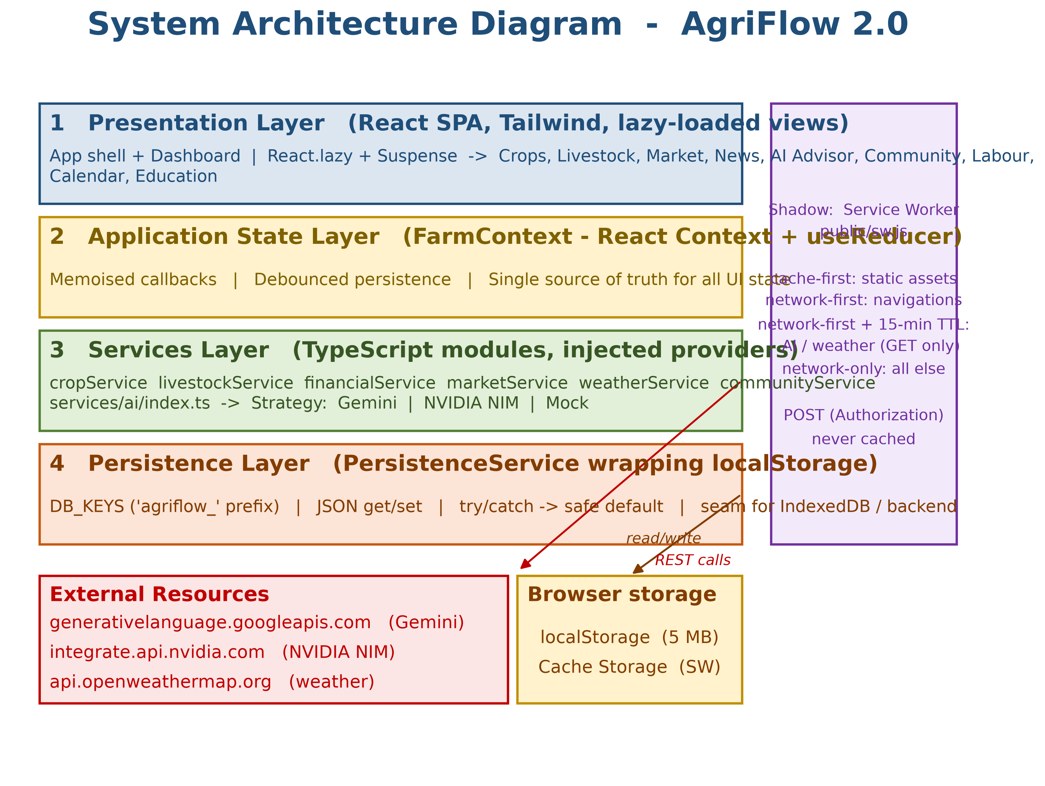
Figure 3.2 System Architecture Diagram of AgriFlow.

3.3.2 Entity-Relationship Diagram
Although the persistence layer uses localStorage rather than a relational database, the domain model is organised as a set of typed entities defined in types.ts and stored under namespaced keys in persistence.ts. The entity-relationship diagram in Figure 3.3 describes these entities and their cardinalities. Each user has one profile and owns many crops, many livestock groups and many tasks; each crop has many expenses and many incomes; the community aggregates questions, answers, posts, stories, trends, suggested users, listings and chat messages. Each entity in the diagram corresponds to a TypeScript interface in types.ts and to a namespaced string key in the DB_KEYS constant exposed by services/persistence.ts.
The PersistenceService.getItem/setItem pair performs JSON serialisation and recovers gracefully from parse failures by returning the provided default. localStorage was used in this iteration because all entities fit comfortably in the 5 MB quota of the target browsers and because the synchronous read path simplified the first-render population logic; the PersistenceService abstraction is the seam along which a backend or IndexedDB can replace it in a future iteration.
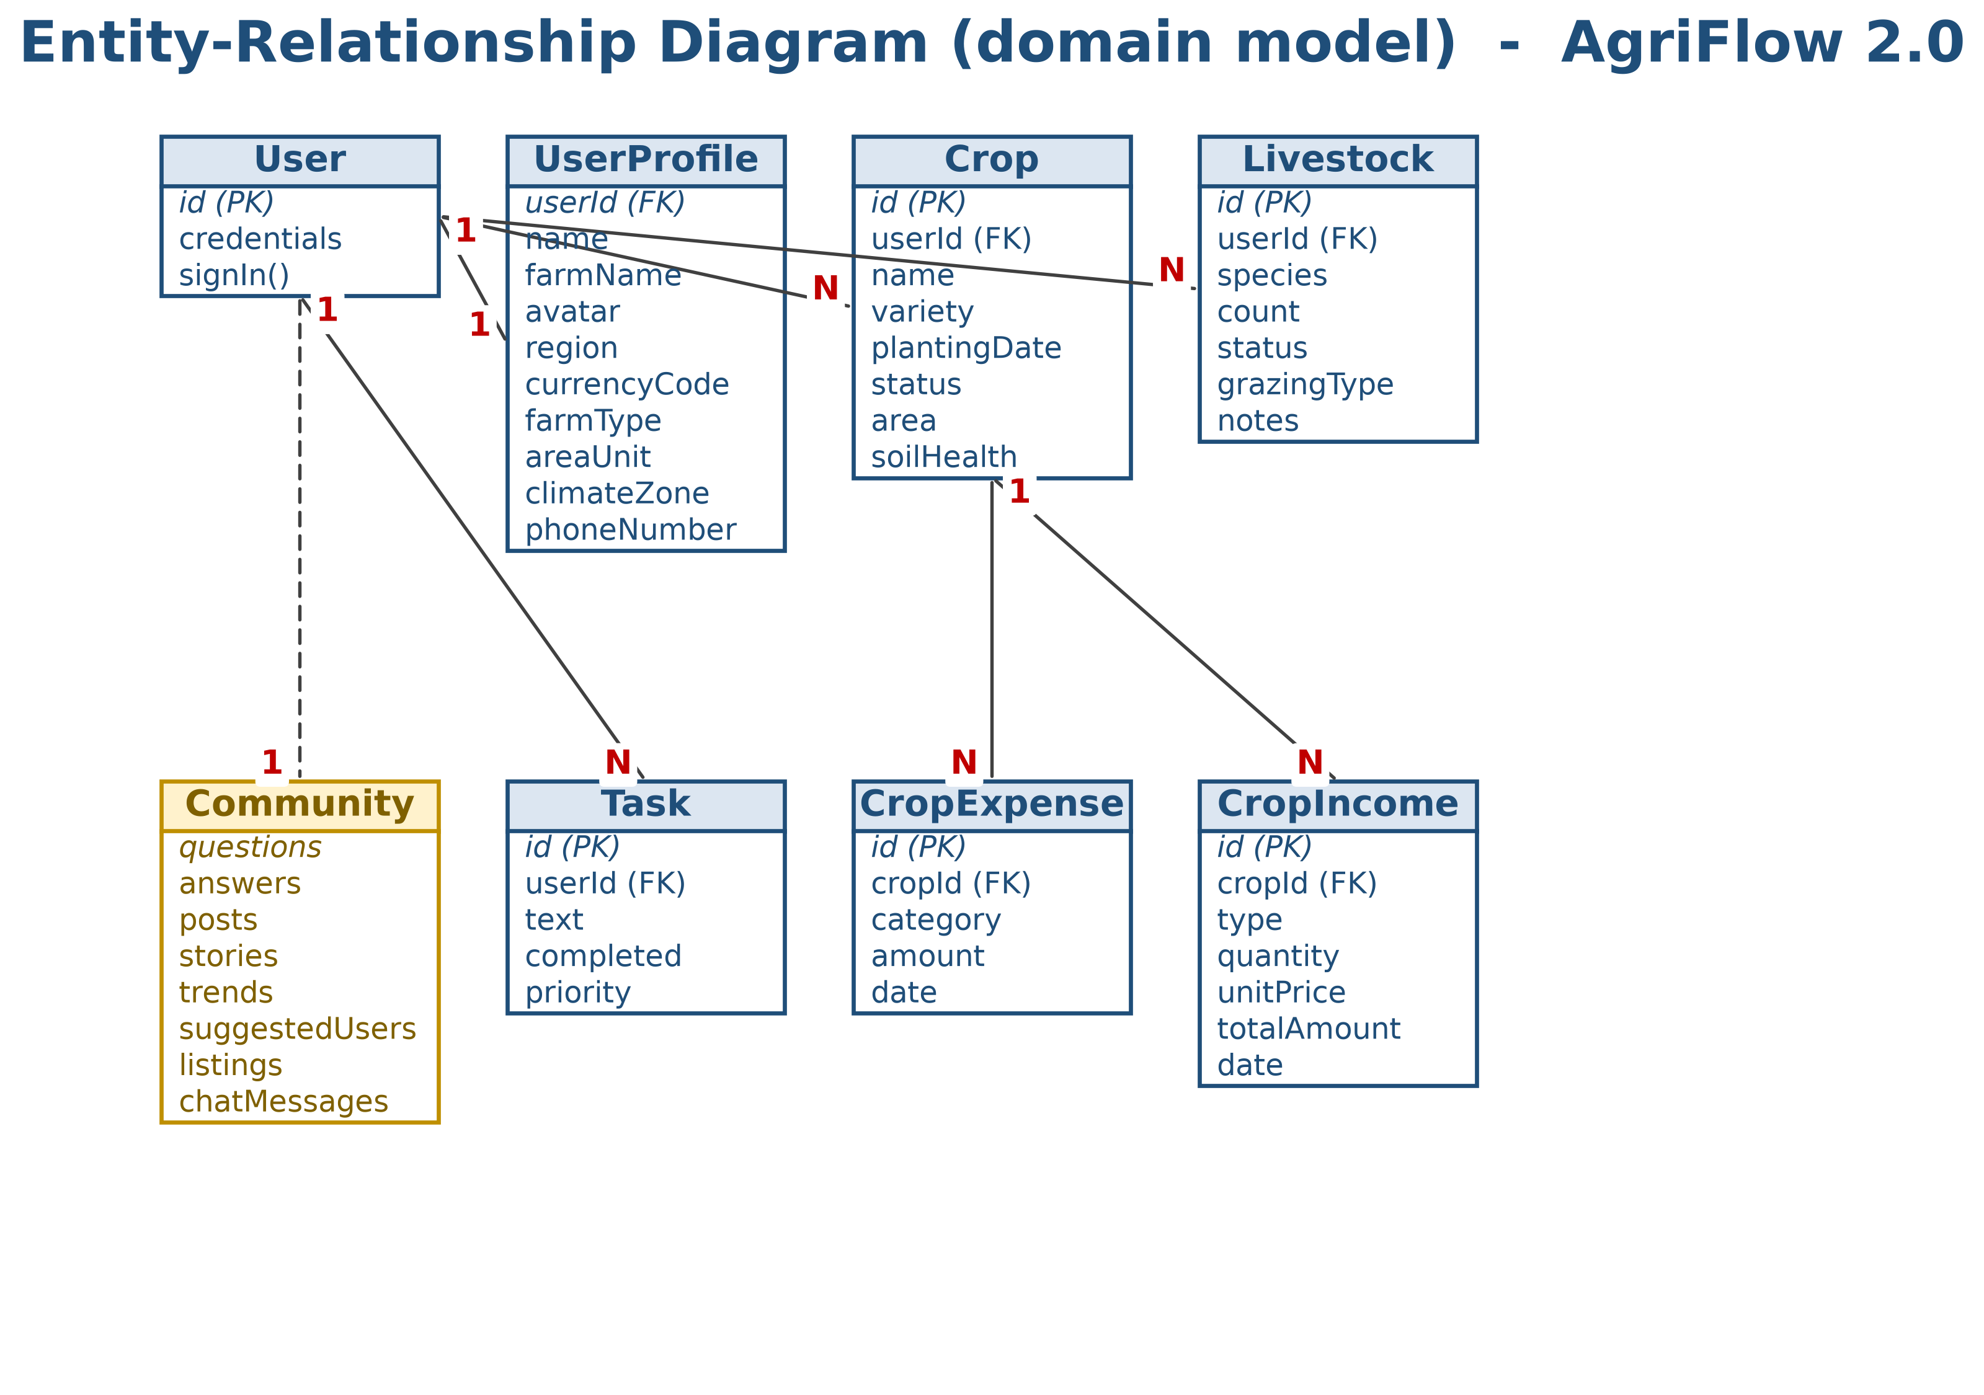
Figure 3.3 Entity-Relationship Diagram (domain model).

3.4 Tools and Technologies
The table below documents every tool, framework, library and external service used to build AgriFlow, with the actual resolved version (taken from package.json and the installed dependency tree), the purpose it serves in the project, and a justification for selecting it over the obvious alternatives. Where a choice was constrained by the course's expected technology set, the constraint is stated explicitly.
Tool / Technology | Version | Purpose | Justification for Selection
React | 19.2.3 | Component-based UI library for the entire presentation layer. | Chosen over Vue/Svelte because React 19 enables the Suspense lazy-loading pattern that keeps the initial bundle small, and the team had prior exposure.
TypeScript | 5.8.2 | Typed superset of JavaScript used end-to-end (passes tsc --noEmit). | Chosen over JavaScript to enforce compile-time contracts at every service boundary (Crop, Livestock, LearningModule) and satisfy the strict type-safety requirement (NFR-09).
Vite | 6.2.0 | Build tool and dev server; serves on port 3000 in dev and tree-shakes chunks in production. | Chosen over the deprecated Create-React-App and the configuration-heavy Webpack because of near-instant HMR and native ES modules in dev.
@vitejs/plugin-react | 5.0.0 | Vite plugin enabling React Fast Refresh and JSX transform. | Required to wire React 19 into Vite; no real alternative exists for the React+Vite combo.
Tailwind CSS | 3.4.19 | Utility-first CSS framework supplying the jade/terra/sunburst design tokens declared in tailwind.config.js. | Chosen over styled-components and plain CSS because tokens live in one config file and producing a purge-able CSS bundle, which is critical for an offline PWA whose first paint must be fast.
PostCSS / Autoprefixer | 8.5.15 / 10.5.2 | CSS post-processor that compiles Tailwind directives and adds vendor prefixes. | Companion of Tailwind; required because Tailwind v3 emits PostCSS-compatible directives.
Recharts | 3.6.0 | Composable charting library over D3; used in Market Analytics and the Dashboard. | Chosen over Chart.js and Victory because Recharts is built as React components, matching the team's mental model and avoiding an imperative chart glue layer.
lucide-react | 0.562.0 | Tree-shakeable SVG icon set used throughout Sidebar, header, modals and status pills. | Chosen over react-icons/Heroicons because individual icons are imported on demand, keeping the bundle small.
@google/genai | 1.34.0 | Official SDK for Google Gemini; used in GeminiProvider for chat, vision, news grounding and live voice. | Chosen over a hand-rolled fetch layer because the SDK handles streaming, search-grounding and live-audio sessions correctly. NVIDIA uses raw fetch because no equivalent SDK exists.
Google Gemini API | external | Primary AI provider (text, vision, live-voice) when VITE_GEMINI_API_KEY is set. | Selected for its generous free tier for student work, native live-voice capability used by VoiceAgent, and search-grounding for the News Hub.
NVIDIA NIM API | external | Secondary provider (models nvidia/llama-3.3-nemotron-super-49b-v1 and microsoft/phi-4-multimodal-instruct) when VITE_NVIDIA_API_KEY is set. | Implemented behind the same AIProvider interface to demonstrate the Strategy pattern and offer a fallback path if Gemini quotas are exhausted during the live defence.
OpenWeatherMap API | external | External weather source used by WeatherService when VITE_OWM_API_KEY is set; falls back to MOCK_WEATHER otherwise. | Chosen for its free 1000-calls/day plan and a simple geolocated endpoint matching the WeatherData interface.
Service Worker / PWA | public/sw.js + manifest.json | Custom service worker: cache-first for static assets, stale-while-revalidate for navigations, network-first-with-TTL for API. | A hand-written worker was chosen over Workbox to keep the bundle small and give direct control over the AI cache TTL of 15 minutes.
localStorage | browser built-in | Persistent key-value store used by PersistenceService for all domain entities. | Chosen over IndexedDB and a remote backend because data volume is well under the 5 MB quota and the synchronous read simplified first-render population; the PersistenceService abstraction allows a backend to replace it in a later iteration.
Git + GitHub + npm + Node LTS | git 2.x / Node ^18 LTS | Version control, remote host and package management; project published at github.com/sambelteshazzar/Agri-Flow. | Git and npm were required by the supervisor's tooling; GitHub provides free private repos for students and pull-request review.

Table 3.3 Tools and Technologies used in AgriFlow .

3.5 Security Design
Because AgriFlow is a client-side application in its current iteration, the security design is shaped by its execution environment: code that runs in the browser, secrets that must not be embedded in the bundle, and offline-capable state that must not leak between users of a shared device. The security design therefore has six concrete mechanisms actually present in the code, each described below with the file or configuration element that implements it.

3.5.1 Build-time isolation of API keys
No AI provider key is ever written into the source repository. The build pipeline in vite.config.ts uses loadEnv to read environment variables from a local .env file and only the specific value of process.env.API_KEY is inlined into the bundle through the define option. Each AI provider reads its key at runtime from import.meta.env (VITE_GEMINI_API_KEY, VITE_NVIDIA_API_KEY, VITE_OWM_API_KEY). This means the source tree can be published to GitHub without exposing secrets, and only the build machine or developer that holds the .env has the live keys. The .gitignore file excludes .env and .env.local, so accidental commits of secrets are blocked.

3.5.2 Provider abstraction with safe-mock fallback
services/ai/index.ts implements the Strategy pattern: a single createProvider function selects GeminiProvider when a Gemini key is present, NvidiaNIMProvider when only an NVIDIA key is present, and a mock-capable GeminiProvider otherwise. Each provider implements the AIProvider interface defined in services/ai/AIProvider.ts. When no key is configured, the providers return the FALLBACK_ADVICE, FALLBACK_NEWS, FALLBACK_INTEL, FALLBACK_TASKS and FALLBACK_ANALYSIS objects declared in services/ai/shared.ts rather than raising an exception or attempting an authenticated request. This is a security mechanism as well as a usability one: it guarantees that an unconfigured deployment cannot leak attempts to call a provider endpoint with an empty Authorization header.

3.5.3 Service-worker cache policy that protects AI responses
The service worker in public/sw.js implements four distinct caching strategies and deliberately partitions the cache. Static same-origin assets (JS, CSS, images, fonts) use a cache-first policy; navigations use network-first-with-fallback to /index.html; cross-origin API requests to generativelanguage.googleapis.com, integrate.api.nvidia.com and api.openweathermap.org use network-first-with-API-cache with a Time-To-Live of 15 minutes; all other cross-origin requests are network-only. The security-relevant detail is that the worker checks request.method !== 'GET' and exits early without involving the cache for any POST or PUT — including the AI POST requests that carry the Authorization header. A request bearing a Bearer token is therefore never written to the Cache Storage and cannot be replayed or inspected from a shared device's DevTools.

3.5.4 Persistence-layer error isolation
PersistenceService in services/persistence.ts wraps every read in a try/catch and logs the failure to console.error before returning the supplied default, rather than throwing; a write failure is caught the same way and surfaced through a boolean return that FarmContext converts into a user-visible toast. This is a security mechanism as well as a robustness one, because a malformed value in one key — e.g. a Crop income amount tampered with through DevTools to be a non-numeric — cannot crash the application or cascade into an undefined-state condition. The namespacing of every key under the 'agriflow_' prefix (the DB_KEYS constant) also prevents collisions with other applications on the same origin and makes a factory-reset easy to verify.

3.5.5 Client-side session state and input handling
User profiles are never persisted alongside free-form credentials. The signIn flow in FarmContext compares a credential blob stored under 'agriflow_credentials' by the calling view and on a successful match hydrates the UserProfile from the persisted profile key; on a failed match it returns without mutating state so that an attacker watching the UI cannot distinguish 'unknown email' from 'wrong password'. Form inputs in SignInForm and SignUpForm are trimmed on submit rather than during typing (per the DESIGN.md standard) so that an accidental whitespace in a password does not get silently dropped during onChange and cause an irreversible lockout. Password fields use the HTML type=password so the browser does not store them in autofill history.
It must be stated honestly that this authentication is a client-side check intended for academic demonstration; a production deployment would require a real identity provider (Firebase Auth, Supabase Auth, OAuth) and HTTPS-only cookies. The PersistenceService abstraction is the seam along which that upgrade will be made in a future iteration, and the AIProvider abstraction is the seam along which any server-side proxy for AI keys will be inserted.

3.5.6 Content Security Policy and header hygiene
The index.html file declares a theme-color, apple-mobile-web-app-capable=yes and a viewport meta with user-scalable=0 to prevent zoom-bypass attacks on iOS. Tailwind utilities are produced by the build instead of loaded from a runtime CDN, removing the risk of an injected stylesheet. The service worker is registered only if 'serviceWorker' in navigator and the register call's catch handler swallows failures silently so that a hostile worker configuration on a corporate proxy cannot break the application shell. The recommended next step for production is the addition of a Content-Security-Policy header in the deploy target that restricts connect-src to generativelanguage.googleapis.com, integrate.api.nvidia.com and api.openweathermap.org with 'self' for everything else; this is documented here as a future-work item rather than claimed as already implemented.

3.6 Summary
This chapter has set out the methodology used to develop AgriFlow . An iterative-incremental Agile approach was justified over Waterfall, Spiral and RAD on the grounds of evolving requirements, external-provider risk and the need for a maintainable codebase. Requirements were gathered from farmer interviews, competitor review and supervisor guidance, and formalised into fourteen functional and ten non-functional requirements supported by a use-case flowchart. The system architecture was described as a four-layer client-side SPA with a service-worker shadow layer and is depicted as a real flowchart; the domain model was presented as an entity-relationship flowchart. The Tools and Technologies Table documented every framework and external service with the version actually in use and the reason it was preferred over its alternatives. The Security Design section described six concrete mechanisms actually present in the codebase — build-time key isolation, the provider abstraction with safe-mock fallback, service-worker POST bypass, persistence-layer error isolation, client-side session-state handling and header hygiene — and was honest about where the security model stops short of production requirements. The next chapter presents the implementation of these designs in detail.

