LAWMANN LAUNDRY SERVICE
A proposal
Running your laundry business from your own phone

Prepared for: The owner, Lawmann Laundry Service
Location: University of Ghana, Legon
Prepared by: Daniel Sam
Contact: +233 596 257 218
Date: 26 September 2026

1. What I understand about your business
I am writing this from what you told me. Please read it and correct me where I am wrong. It costs you a minute now and saves us both a lot of trouble later.

How you work
- You collect laundry from students at hostels around Legon.
- You weigh each bag on the spot, at the hostel, before anything is washed, and price it from your own list.
- You take Mobile Money on your own number, 0556351853, which is MTN.
- You wash it yourself, in your own store.
- Students settle up when they collect.
One detail worth fixing down now.
Because the bag is weighed on campus before it is washed, that weighing moment is the agreed reference point. If a student ever says their bag was 12kg on Tuesday and comes back lighter, there is one agreed number to go back to. That is worth having in writing, and it costs nothing.

Where you collect
You mentioned collecting on campus, and I counted seventeen hostels from your list:
Group | Hostels
Private | Evandy · International Student Hostel · Ghana Hostels Ltd Flats Pentagon (Blocks A & B) · Vikings · Bani · TF Hostel · Aseda Annex A · Valco
UGEL and modern | Dr. Hilla Limann · Kwapong · Elizabeth Sey · Jean Nelson Aka
Traditional halls | Legon Hall (with Annex C / Graduate Hostel) · Mensah Sarbah · Akuafo · Volta · Commonwealth

TF Hostel alone is 960 beds. With the halls you listed, you are working with tens of thousands of students, not just the students in one building.

2. The problem you described
You told me that you cannot see your business properly without driving to the shop. In your own words, you want to know:
1. How much money came in today
2. How much people still owe you
3. How many people paid
4. Who paid half now and still owes the rest when they collect
5. How many people came in today, this week, this month
6. How your customers know their clothes are being washed, and when they are ready
All six of those are answered in this document. Section 5 shows you where.

3. The part you did not mention
You collect per kilogram.
Washing costs you money per kilogram too.
Nobody writes what came in next to what it cost you to run.
The gas. The power. The water. The detergent. Whoever washes and folds the pile. The fuel for the round. Nobody adds those up against the money that came in, because they are in four different places — a gas bill, a recharge, a barrel, and someone's pocket.
So today you can tell me what your students paid you. You cannot tell me what you actually made. That is not a criticism of you. It is arithmetic that has never had anywhere to live.
This app gives it somewhere to live. That is the most valuable part of everything in this document.

It is also the part that would change what you do. Your best-selling weight band is the one that looks thinnest on paper, and right now you have no way of knowing. If one of your bands is quietly costing you money, you would want to know that before the next term, not after it.

4. What you would have
One app. It works on the phone your collector already carries, on a tablet at the shop, and on your own phone or computer. You do not need to buy anything new.

Your collector, at the hostel
They open the app and the hostels for today are already on the screen. For each bag:
1. the student's phone number, their name, and their block or room.
2. the bag goes on the scale, they type the weight.
3. and the price fills in by itself. A 5kg bag shows GH¢93. They do not do any maths, and they cannot get it wrong.
4. your per-item prices are already in there too, for shirts, suits, duvets, sneakers and the rest.
5. they take the MoMo and photograph the confirmation message.
6. the bag is given a number. That number follows the bag the whole way, so nobody ever has to guess whose laundry is whose.
If the phone loses signal in a corridor, they can still record the bag and take cash. It saves on the phone and sends itself when the signal comes back.
And if a student wants to pay by MoMo, the app tells them so before the bag is weighed, not after. I know this matters, because your students pay the way you do, and the same person may not have signal in a corridor.

You, on your own phone, anywhere
- the real number, updated as people pay. Not an estimate.
- who still owes you, with names, phone numbers, amounts, and how long they have owed it. Oldest debt first, because that is the one you want collecting.
- how many people paid today.
- cash in the drawer, counted and compared against what should be there.
- your actual profit per kilogram, per week, per month.
- how many kilos came through this week, and what it cost you to wash them. Enter your gas and wage bills at the end of the week and the app works out your real cost per kilo — then shows you which of your bands actually makes money and which one costs you money.
- which bags are sitting unfinished, and which have been there too long.
- how many people came in today, this week, this month.
One thing worth saying about those last numbers.
Your business goes quiet in the holidays and gets very busy before exams. So the app compares this week with the same week last term, not just with last week. Otherwise in September it will tell you your business is dying, when what has actually happened is that everyone has gone home.

What your customers get
- a message when you accept their bag, telling them the weight, the price, and what is still owing.
- a message when it is ready.
- a message when their payment comes through.
- a page on their own phone where they can check their order without calling you or coming to ask.
They do not have to install anything. They open a link in the message.

5. Your questions, answered
What you asked | What you get
Track the business without driving to the shop | Everything in section 4, on your phone, at any hour
How much was made today | One correct number, updated as people pay
How much is left to be paid | A list of names and amounts, oldest debt first
How many people paid | The count, and who
Who paid half and owes the rest | Tracked per person. The balance follows the bag until they collect
How many came in, day, week, month | Counts, measured against the same time last term
How customers know it is ready | They are told automatically. You stop being the one being asked

6. Three things in your price list
I priced out your weight bands. I am not telling you what to change. I am asking you about three things.

6.1 Your 10–12kg band is your cheapest, so it is also your thinnest
Here is what each band works out at, if the bag is full. Your 10–12kg band is GH¢128 for up to 12kg, which is GH¢10.67 per kilo. A student with 12kg is paying 56% less per kilo than a student with 3kg.
Bag | You charge | That works out at | Breaks even at
3kg | GH¢73 | GH¢24.33 per kilo | 24.33
6kg | GH¢93 | GH¢15.50 per kilo | 15.50
9kg | GH¢103 | GH¢11.44 per kilo | 11.44
12kg | GH¢128 | GH¢10.67 per kilo — your cheapest | 10.67 ← tightest
15kg | GH¢190 | GH¢12.67 per kilo | 12.67

The last column is the number I care about. If it costs you more than GH¢10.67 to wash one kilo, then your best-selling band is losing you money and you would never know, because nobody is counting.
So I need one number from you. The honest one:
It costs me GH¢ ____________ per kilo to wash, all in.
All in means: gas · electricity · water · detergent and bleach · whoever washes and folds · fuel for the collection round · a share of the shop rent. If you are not sure, write down what you paid for gas, power, water, detergent and wages in one week, and how many kilos you washed in that week. I will do the dividing.

6.2 The jump from 12kg to 15kg is steep
From 10–12kg to 13–15kg the price goes from GH¢128 to GH¢190. That is GH¢62 more for 3kg of laundry, which is GH¢20.67 per kilo for those last 3kg. The 10–12kg band charges GH¢10.67 per kilo, so a student at 12kg pays about 19% less per kilo than a student at 15kg.
Two questions, and the first one matters more than the second:
- Is that deliberate? A full 15kg does take longer in the dryer, so the extra charge may be fair. Or the price may have been set years ago and never looked at since. I am not assuming it is wrong.
- And there is still no band above 15kg. A student doing laundry before exams will absolutely turn up with more than that, and right now there is no price for it.

6.3 Duvet
Your duvet line says “big / small” and both are GH¢70. Is the small one cheaper than GH¢70?
Duvet, small: GH¢ ____________

7. What I need from you before I start
1. What one kilo of laundry costs you to wash, all in. The blank in section 6.1. If you cannot put a number on it, give me your weekly gas, power, water, detergent and wages, plus how many kilos you washed that week.
2. Does anyone help you wash and fold? If so, are they on a salary or paid per kilo. This moves your cost per kilo more than gas does, so it is the second thing I need most.
3. A photograph of a MoMo confirmation message. Just so I know what one looks like when your students pay.
4. A few real orders. Three or four is enough. Weight, what you charged, what they actually paid. Your notebook or your WhatsApp is perfect. This is worth more to me than anything I could invent.

8. What changes in your routine
Two things, not one. The second one is the price of the first.
One. Weigh every bag, and write the weight down.
You already weigh at pickup, which is the reason this whole thing works. It just was not being written down. The only change is that it gets recorded, every time.
Why it has to be every bag, even the ones you price by item: if you charge GH¢30 for a suit and nobody weighed it, then there is no way for you or for me to know whether that suit cost you GH¢10 to wash or GH¢25. You would be guessing, and so would I.

Two. Enter your bills once a week.
Gas, power, water, detergent, and anyone's wages. Five numbers, once a week, from receipts you already have.
I want to be straight about why this one matters. Without it, the app can only tell you what money came in. With it, the app can tell you what you made. Those are different numbers, and only the second one tells you whether the business is worth running the way you are running it.

That is the whole change. Everything else is your business, run the way you already run it.

9. What this will not do
I would rather tell you now than disappoint you later.
- It will not wash anything. That does not change.
- It will not change your prices. It only shows you what your prices actually do to your profit.
- It will not collect MoMo for you automatically yet. You are on your own number, so for now the app records the payment and photographs your confirmation, and you still confirm it. That is a later step, once you are happy with this one.
- It will not replace your notebook in the first term.
Please keep your notebook for the first term.
Run the app alongside it. If the two ever disagree, the notebook wins and we fix the app. I would rather do that than throw away something that has already been working for you.

10. What it costs
It is two parts, and I want to be straight with you about which is which:
- To begin: one amount to build it.
- Then: a monthly amount to keep it running and supported, plus the messages we send to your customers.
The one cost I can put a real number on today is the messages to your customers. It is about two pesewas per message. If you do 20 bags a day and send 3 messages each, that is roughly GH¢36 for the whole month.
I am not going to quote you a build price in this document, because I have not built it yet and I do not want to give you a figure I cannot stand behind. Once we agree exactly what you want, I will quote it properly.
I would rather earn the monthly part than sell it to you at the start.
Which is why the next section matters more than the price.

11. How it would be built, and in what order
This is not a single big thing that appears all at once. It comes in steps, and each one is useful on its own.
Step | What it does | Why that order
1. The money | Weigh, price, record, take payment, and know who owes what | This is the foundation. Everything else is just reporting on top of it
2. The profit side | What it cost you to run, what you actually made, and which of your bands makes money | This is the part nobody has today, and it is what the business runs on
3. Your phone | Everything from steps 1 and 2, on your own screen | You can finally answer your six questions from anywhere
4. Your customers | Messages, and a way for them to settle a balance | Once the numbers behind it are right, not before
5. The paperwork | Clean tax records, so the GRA side is tidy | Needs real transaction history behind it
6. The hostels | The daily round across all seventeen | Most useful last, and only once the rest is solid

The order matters: money first, then profit, then everything else.
If we do it the other way round — a pretty screen first, arithmetic later — you would have a dashboard full of numbers you cannot trust. I have seen that go wrong.

12. What I ask of you
Show me yours working, before you pay me anything.
When the first version is ready, I will show you your own business in it — your hostels, your prices, your numbers. You look at it and tell me what is wrong.
If it does not answer your six questions, you do not take it, and you owe me nothing.

Agreement and contact
I have read this proposal and I would like to go ahead.
Role | Name | Date
Owner
Daniel Sam

Daniel Sam
+233 596 257 218
Available on WhatsApp as well as by phone.

Appendix · Your price list
This is the poster you showed me, the one this proposal was built from. I have reproduced it so we are both looking at the same document.
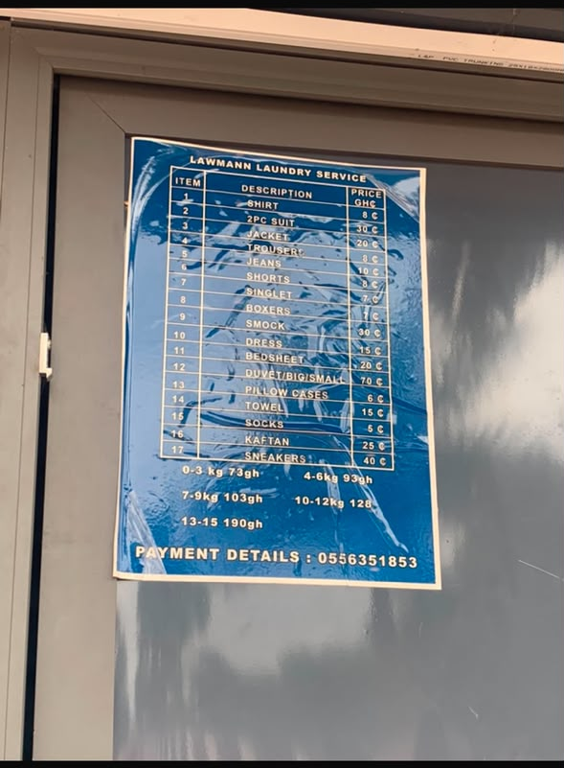

The same figures, typed out
So they can be corrected without handwriting on the poster.
Per item | GHS
Shirt | 8
Trouser | 8
Singlet | 7
Pillow case | 6
Socks | 5
Boxers | 6
Shorts | 8.50
Jeans | 10
Dress | 15
Towel | 15
Bedsheet | 20
Jacket | 20
Kaftan | 25
2-piece suit | 30
Smock | 30
Duvet (big / small) | 70
Sneakers | 40

By weight | Price | By weight | Price
0 – 3 kg | GH¢73 | 7 – 9 kg | GH¢103
4 – 6 kg | GH¢93 | 10 – 12 kg | GH¢128
 |  | 13 – 15 kg | GH¢190

Transcribed from the poster on 26 September 2026. One correction: the poster appears to read GH¢83 for 4–6kg, but you confirmed GH¢93, and GH¢93 is what I have used throughout. Please correct anything else I have read wrongly.

