CS 1632 – DELIVERABLE 4: Automated Web Testing

*Samuel Benek  
sambenek  
  
Scott Southerland  
immobilize*

[*https://github.com/sambenek/CS1632_Deliverable_4*](https://github.com/sambenek/CS1632_Deliverable_4)

**Summary**The purpose of this project was to get acquainted with the process of testing programs that involve an interface that is more than just text. Specifically we used Katalon, a Google Chrome extension that serves as a web testing framework. Katalon has the ability to record the actions you take in your browser and organize them into a test case. You can then run that test case to repeat those actions any time.   
  
The biggest challenge we faced in learning how to use Katalon was sifting through the wide array of assertions that can be made in a test case. We needed to make decisions about which observed behavior to check while also keeping in mind what Katalon is capable of looking at. Another challenge, while it is not specific to web testing, was making judgement calls on the requirements, which were a little vague. Looking for implicit requirements is uncertain business, but we feel confident in our decisions.

Our test plan has a total of 25 tests, 5 of which fail. The tests that failed are:

1. TEST – HOME DISPLAY
2. TEST – FACTORIAL LETTERS
3. TEST – FIBONACCI LETTERS
4. TEST – URL HELLO///
5. TEST – URL HELLO/##

These failed tests revealed defects in the web application, which are listed below.

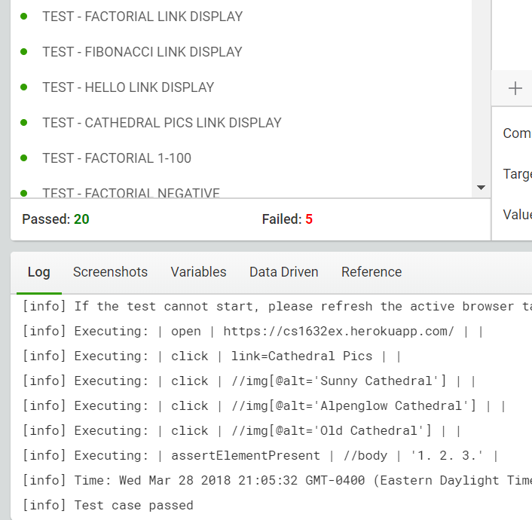

**Defects**

Summary: “THE WORLD IS YOUR OYSTER” is on the home page.Description: The home page includes the extraneous text “THE WORLD IS YOUR OYSTER”. The first requirement is very specific about what text should be present on the home page, right down to the presence of carriage returns. While it does not specifically state that no other text will be present, we consider that to be an implicit requirement and therefore this extra text is a defect.  
Reproduction Steps:

1. Navigate to <https://cs1632ex.herokuapp.com/> in browser.  
Expected Behavior: The text “Welcome, friend, to a land of pure calculation” and “Used for CS1632 Software Quality Assurance, taught by Bill Laboon” should be present, with or without carriage returns.  
Observed Behavior: The text “THE WORLD IS YOUR OYSTER” is also present, along with the expected text.  
  
Summary: Non-integer input on factorial page results in internal server error.  
Description: When any input that is not an integer, including both floating points and strings, is input on the factorial page, the result is an internal server error instead of 1.  
Reproduction Steps:

1. Navigate to <https://cs1632ex.herokuapp.com/> in browser.
2. Click “Factorial”.
3. Enter “hello” into text bar.
4. Observe results.

Expected Behavior: The text “Factorial of hello is 1!” should be displayed.  
Observed Behavior: Navigates to a page with only the text “Internal server error”.

Summary: Non-integer input on fibonacci page results in internal server error.  
Description: When any input that is not an integer, including both floating points and strings, is input on the fibonacci page, the result is an internal server error instead of 1.  
Reproduction Steps:

1. Navigate to <https://cs1632ex.herokuapp.com/> in browser.
2. Click “Fibonacci”.
3. Enter “hello” into text bar.
4. Observe results.

Expected Behavior: The text “Fibonacci of hello is 1!” should be displayed.  
Observed Behavior: Navigates to a page with only the text “Internal server error”.

Summary: Forward slashes and pound signs in the trailing text in the URL of the hello page results in default output.  
Description: The hello page should insert any trailing text in the URL into the text that is displayed on the page. However, if the text is a forward slash or pound sign, the result is the default text as if no text had been added to the URL.   
Reproduction Steps:

1. Navigate to <https://cs1632ex.herokuapp.com/> in browser.
2. Click “Hello”.
3. Add “///” to the end of the URL.
4. Press return.
5. Observe results

Expected Behavior: The text “Hello CS1632, from ///!” should be displayed.  
Observed Behavior: The text “Hello CS1632, from Prof. Laboon!” is displayed.

**Traceability Matrix**

HOMEPAGE-TEXT-REQ: TEST – HOME DISPLAY

FIVE-LINKS-REQ: TEST – HOME LINK, TEST - FACTORIAL LINK, TEST - FIBONACCI LINK, TEST - HELLO LINK, TEST - CATHY LINK, TEST - NONEXISTANT LINK, TEST - HOME LINK DISPLAY, TEST - FACTORIAL LINK DISPLAY, TEST - FIBONACCI LINK DISPLAY, TEST - HELLO LINK DISPLAY, TEST - CATHY LINK DISPLAY

FACTORIAL-VALID-INPUT-REQ: TEST – FACTORIAL 1-100

FIBONACCI-VALID-INPUT-REQ: TEST – FIBONACCI 1-100

FACTORIAL-FIBONACCI-INVALID-INPUT-REQ: TEST – FACTORIAL NEGATIVE, TEST – FACTORIAL ABOVE 100, TEST – FACTORIAL LETTERS, TEST – FIBONACCI NEGATIVE, TEST – FIBONACCI ABOVE 100, TEST – FIBONACCI LETTERS

HELLO-DEFAULT-TEXT-REQ: TEST – /HELLO DISPLAY NO INPUT

HELLO-INSERTED-TEXT-REQ: TEST – /HELLO DISPLAY MY INPUT, TEST – URL HELLO///, TEST – URL HELLO/##

CATHY-DISPLAY-REQ: TEST – CATHEDRAL DISPLAY