# ITC293: Assessment 4

Samuel Betts – 11727023

Contents

ITC293: Assessment 4 1

Interface Design, Navigation and Organisation 3

Preliminary Design 3

Interface Design 4

CSS Design Plan 4

Navigation Design 5

Navigation Map (Logical) 5

Storyboards 6

Homepage – index.html 6

About – sbetts_a4_about.html 7

Web Skills – sbetts_a4_web_skills.html 8

Resume – sbetts_a4_resume.html 9

Creative – sbetts_a4_creative.html 10

Creative – sbetts_a4_problem_solving.html 11

Technical – sbetts_a4_technical.html 12

Newsletter Sign Up Form – sbetts_a4_form.html 13

Organisation of Information 14

Navigation Map (Physical) 14

Technical Functionality in Terms of Web Development 15

Usage of CSS 15

HTML Form and JavaScript 15

Code Reusability and Readability 15

Validation 15

Testing Plan 15

Validations 16

File Sizes and Naming 17

Requirements Table 18

# Interface Design, Navigation and Organisation

## Preliminary Design

The purpose of the website is to provide a personal portfolio for the designer for a desired future employer to view. The type of employer is specified by my student id number, with my given employer type being Mining.

The target audience of the website would be a mining company looking to hire a web developer. The purpose and target of the website has remained the same for two previous iterations with changing requirements. This gives a solid foundation to alter the website based off of the new requirements.

The new requirements include having an index page, a resume page, four separate pages showcasing four different skills, with one of them being web development skills, and a newsletter sign up form that uses an external JavaScript file and the use of only external CSS.

The Preliminary Design of the webpage already includes some of these requirements, the index page, resume page, web skills page and external CSS. An about us page was also pre-existent, and I have decided to leave it in.

## Interface Design

### CSS Design Plan

**Header**

Includes a white background and black outline border, with the Website title and subtitle naming the current webpage. Padding and a margin from the edge of the webpage. Also includes the navigation bar.

**Navigation Bar**

Using CSS buttons, the current webpage is a blue button while the other pages are white.

**Body**

Blue background of the webpage.

**Main Article**

Main section of the webpage holding the content. To include padding and a margin from the edge of the webpage.

**Footer**

Footer on homepage only. Similar design to header but does not take up the as much of the width of the webpage as the header. Contains only the copyright notice.

### Newsletter Form Design

In order to make the form attractive, it also uses CSS.

Below is a screenshot of the final form design.

## Navigation Design

### Navigation Map (Logical)

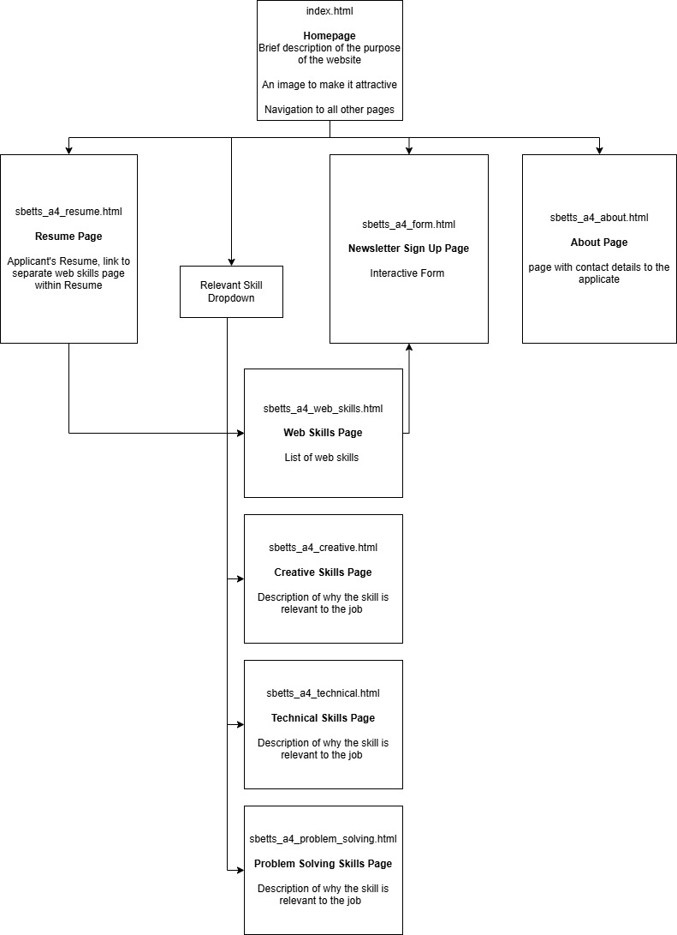

## Storyboards

### Homepage – index.html

|  |  |
| --- | --- |
| Description | Homepage |
| Content | Giving an introduction to the webpage and a brief description of each of the pages. Footer at the bottom of page with a copyright notice. |
| Interactions | Navigation links, current page highlighted blue using CSS buttons |
| Audio / Visual | Imagine floating to the left for appeal. |
| Navigation | CSS buttons with links to current and all other pages. |

### About – sbetts_a4_about.html

|  |  |
| --- | --- |
| Description | About |
| Content | Contact details of the applicant and a headshot of the applicant. |
| Interactions | Navigation links, current page highlighted blue using CSS buttons |
| Audio / Visual | Headshot of website creator / job applicant. |
| Navigation | CSS buttons with links to current and all other pages. |

### Web Skills – sbetts_a4_web_skills.html

|  |  |
| --- | --- |
| Description | Web Skills |
| Content | An unordered list of web skills the applicant contains. |
| Interactions | Navigation links, current page highlighted blue using CSS buttons  Internal Link to newsletter signup form |
| Audio / Visual | No audio or visual. |
| Navigation | CSS buttons with links to current and all other pages. |

### Resume – sbetts_a4_resume.html

|  |  |
| --- | --- |
| Description | Resume |
| Content | Resume of applicant, including ordered and unordered lists, as well as a table. Web Skills includes a link to the web skills page. |
| Interactions | Navigation links, current page highlighted blue using CSS buttons.  Link to web skills page within resume |
| Audio / Visual | No audio or visual. |
| Navigation | CSS buttons with links to current and all other pages. Link to web skills page within resume. |

### Creative – sbetts_a4_creative.html

|  |  |
| --- | --- |
| Description | Creative |
| Content | Paragraphs with a description of how the skill is relevant to the job listing. Image to the left. |
| Interactions | Navigation links, current page highlighted blue using CSS buttons. |
| Audio / Visual | Image to the left of page |
| Navigation | CSS buttons with links to current and all other pages. |

### Creative – sbetts_a4_problem_solving.html

|  |  |
| --- | --- |
| Description | Creative |
| Content | Paragraphs with a description of how the skill is relevant to the job listing. Image to the left. |
| Interactions | Navigation links, current page highlighted blue using CSS buttons. |
| Audio / Visual | Image to the left of page |
| Navigation | CSS buttons with links to current and all other pages. |

### Technical – sbetts_a4_technical.html

|  |  |
| --- | --- |
| Description | Creative |
| Content | Paragraphs with a description of how the skill is relevant to the job listing. Image to the left and right. |
| Interactions | Navigation links, current page highlighted blue using CSS buttons. |
| Audio / Visual | Image to the left of page |
| Navigation | CSS buttons with links to current and all other pages. |

### Newsletter Sign Up Form – sbetts_a4_form.html

|  |  |
| --- | --- |
| Description | Newsletter Sign Up Form |
| Content | Newsletter Signup form with three required text entries, radio buttons, tick boxes and an additional comments text entry. Submit and Reset buttons at the bottom of the form |
| Interactions | Navigation links, current page highlighted blue using CSS buttons.  HTML form using external JavaScript sheet  Alert when the page opens, and alert when requirements are not met. |
| Audio / Visual | No audio or visual |
| Navigation | CSS buttons with links to current and all other pages. |

## Organisation of Information

### Navigation Map (Physical)

# Technical Functionality in Terms of Web Development

## Usage of CSS

## HTML Form and JavaScript

## Code Reusability and Readability

## Validation

### Testing Plan

**HTML Validation:** Validate Files

* HTML - https://validator.w3.org/
* CSS - https://jigsaw.w3.org/css-validator/

**Webpage Content:** Ensure all content, text and images, are loading and displaying correctly

**Links Working:** Ensure all links are working and pointing to the correct sites

* Internal Links
* External Links

**Browser Compatibility:** Test multiple browsers including:

* Chrome
* Edge
* Firefox

Resize browser and ensure the look and feel of the page is maintained

### HTML Validations

Validation website used: https://validator.w3.org/

#### Index.html

#### Sbetts_a4_about.html

#### Sbetts_a4_creative.html

#### Sbetts_a4_form.html

#### Sbetts_a4_problem_solving.html

#### Sbetts_a4_resume.html

The initial validation did not pass. This was due to me having a list within a list. I ended up changing this to use headings rather than be a list. This was also consistent with the rest of the content within the resume.

Final validation below:

#### Sbetts_a4_technical.html

#### Sbetts_a4_web_skills.html

### CSS Validations

#### Portfolio.css

#### Print.css

## File Sizes and Naming

## Requirements Table

|  |  |  |
| --- | --- | --- |
|  |  |  |
|  |  |  |
|  |  |  |