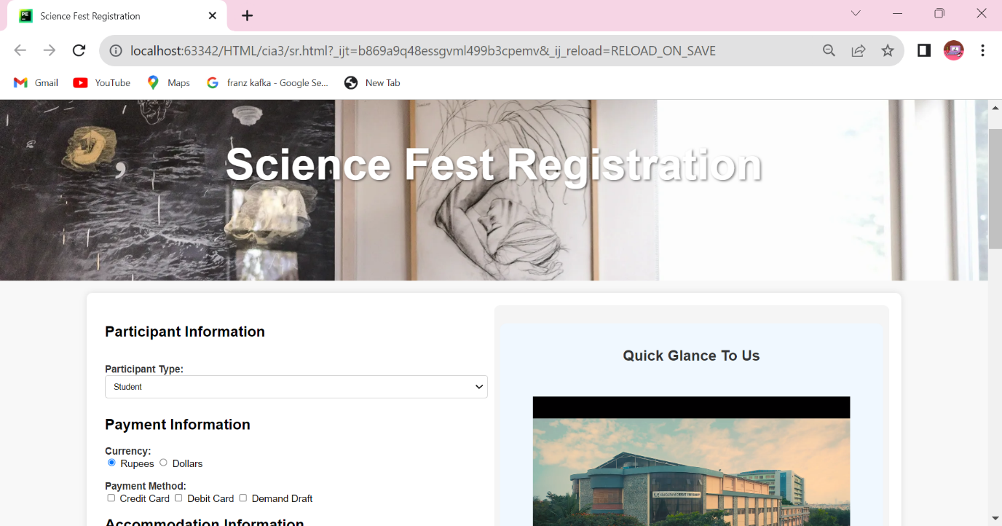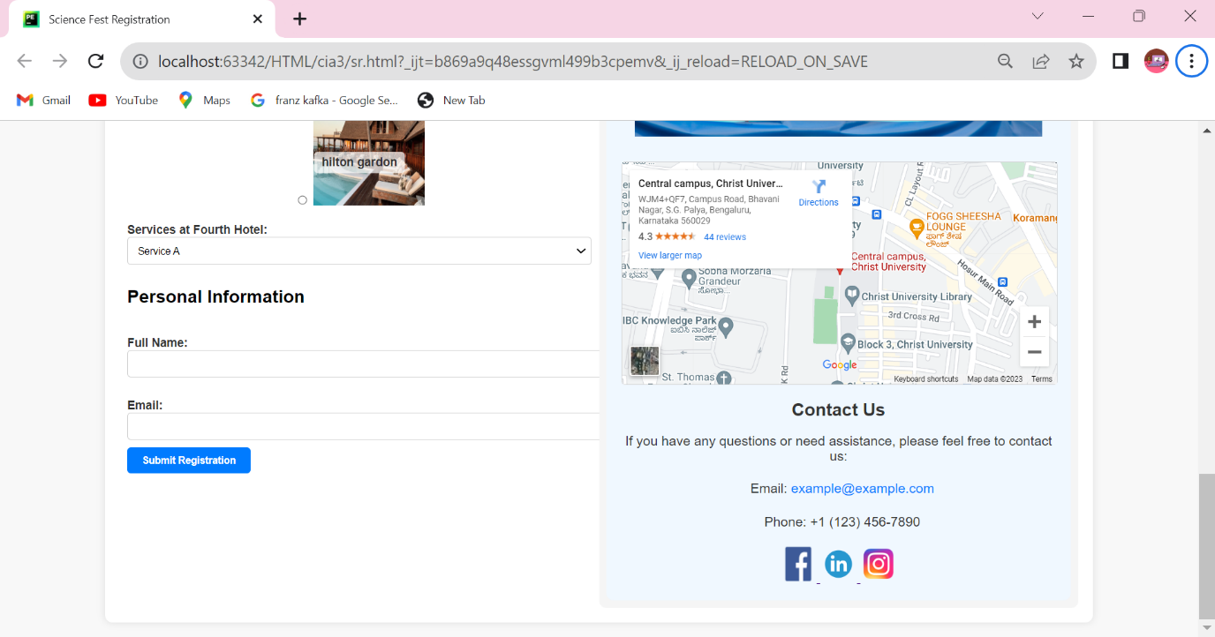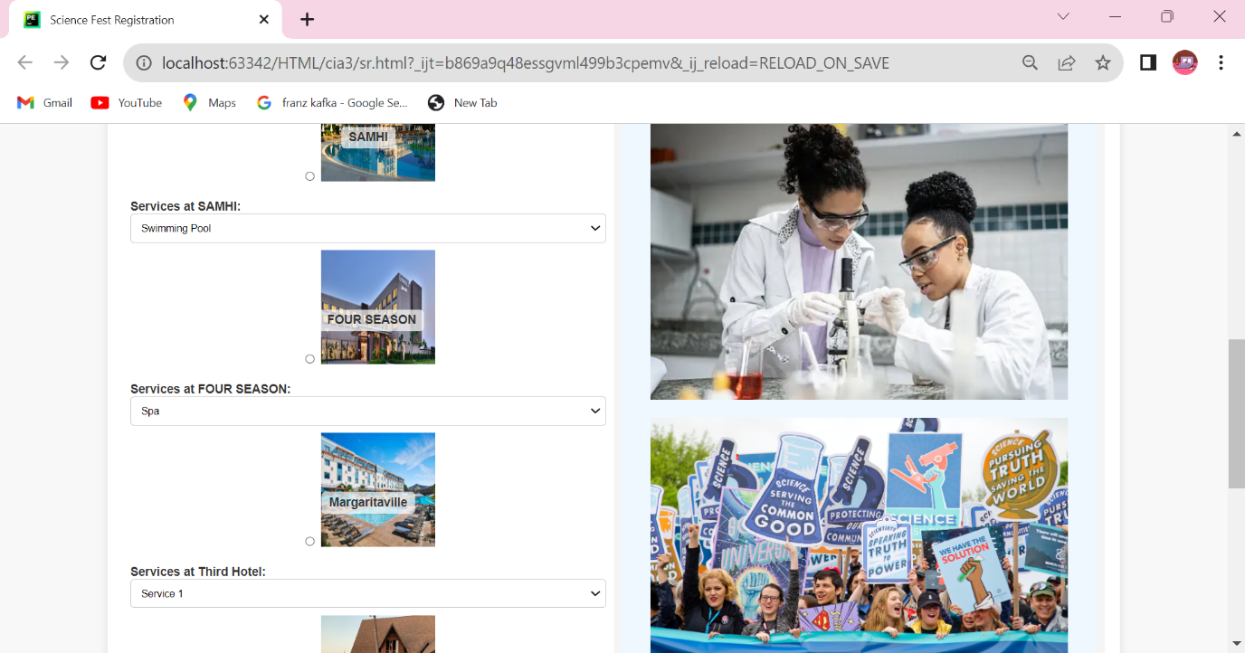

<!DOCTYPE html>  
<html lang="en">  
<head>  
 <meta charset="UTF-8">  
 <meta name="viewport" content="width=device-width, initial-scale=1.0">  
 <title>Science Fest Registration</title>  
 <style>  
 body {  
 font-family: Arial, sans-serif;  
 background-color: #f8f8f8;  
 margin: 0;  
 padding: 0;  
 display: flex;  
 flex-direction: column;  
 align-items: center;  
 }  
  
 .header {  
 background-image: url("1.webp"); /* Replace with your header image URL */  
 background-size: cover;  
 text-align: center;  
 padding: 100px 0;  
 color: #fff;  
 font-size: 36px;  
 text-shadow: 2px 2px 4px rgba(0, 0, 0, 0.5);  
 width: 100%;  
 }  
  
 .container {  
 background-color: #fff;  
 padding: 20px;  
 margin: 20px;  
 border-radius: 10px;  
 box-shadow: 0 0 10px rgba(0, 0, 0, 0.1);  
 width: 80%; /* Adjust the width as needed */  
 display: flex;  
 flex-wrap: wrap;  
 }  
  
 .left-column {  
 flex: 1;  
 padding: 10px;  
 }  
  
 .right-column {  
 flex: 1;  
 padding: 10px;  
 background-color: #f5f5f5;  
 border-radius: 10px;  
 }  
  
 /* Style the map */  
 .map {  
 width: 100%;  
 height: 300px;  
 border: 1px solid #ccc;  
 border-radius: 5px;  
 margin-top: 20px;  
 }  
  
 /* Style the Submit button */  
 input[type="submit"] {  
 background-color: #007bff;  
 color: #fff;  
 padding: 10px 20px;  
 border: none;  
 border-radius: 5px;  
 cursor: pointer;  
 font-weight: bold;  
 }  
  
 input[type="submit"]:hover {  
 background-color: #0056b3;  
 }  
  
 /* Style the form elements */  
 label {  
 display: block;  
 font-weight: bold;  
 color: #333;  
 }  
  
 input[type="text"],  
 input[type="email"],  
 select {  
 width: 100%;  
 padding: 10px;  
 border: 1px solid #ccc;  
 border-radius: 5px;  
 margin-bottom: 10px;  
 }  
  
 /* Style the contact section */  
 .contact-section {  
 text-align: center;  
 color: #333;  
 padding: 20px;  
 border-radius: 10px;  
 margin-top: 20px;  
 background-color: #F0F8FF;  
 }  
  
 /* Style the "Contact Us" header */  
 .contact-header {  
 font-size: 24px;  
 color: #333;  
 margin-bottom: 10px;  
 }  
  
 /* Style the Contact Info */  
 .contact-info {  
 font-size: 18px;  
 margin-bottom: 10px.  
 }  
  
 /* Style the Contact Info icons */  
 .contact-info i {  
 font-size: 24px;  
 margin-right: 10px;  
 }  
  
 /* Style the Contact Info links */  
 .contact-info a {  
 color: #007bff;  
 text-decoration: none;  
 transition: color 0.3s;  
 }  
  
 .contact-info a:hover {  
 color: #0056b3;  
 }  
  
 /* Style the Social Media Links */  
 .social-media {  
 margin-top: 20px;  
 }  
  
 /* Style the hotel name overlays */  
 .hotel-name-overlay {  
 position: absolute;  
 top: 60%; /* Adjust the vertical position */  
 left: 50%;  
 transform: translate(-50%, -50%);  
 background-color: rgba(255, 255, 255, 0.7);  
 padding: 5px 10px;  
 border-radius: 5px;  
 text-align: center; /* Center the text horizontally */  
 }  
  
 /* Style the hotel names */  
 .hotel-name {  
 font-weight: bold;  
 font-size: 16px;  
 color: #333;  
 }  
  
 /* Ensure hotel images are relative */  
 .hotel-container {  
 position: relative;  
 text-align: center; /* Center the text vertically */  
 }  
  
 /* Style for moving hotel selection bullet points down */  
 .hotel-container label {  
 margin-bottom: 20px;  
 }  
  
 /* Style the services section */  
 .services {  
 margin-top: 20px;  
 }  
  
 /* Style the services dropdown */  
 .services select {  
 width: 100%;  
 padding: 10px;  
 border: 1px solid #ccc;  
 border-radius: 5px;  
 margin-bottom: 10px;  
 }  
 /* Style for the two additional images */  
 .additional-images {  
 text-align: center;  
 margin-top: 20px;  
 }  
  
 .additional-images img {  
 max-width: 100%;  
 height: auto;  
 margin: 10px;  
 }  
 </style>  
</head>  
<body>  
 <div class="header">  
 <h1>Science Fest Registration</h1>  
 </div>  
 <div class="container">  
 <div class="left-column">  
 <form action="process_registration.php" method="post">  
 <!-- Participant Information -->  
 <div class="form-group">  
 <h2>Participant Information</h2>  
 <br>  
 <label for="participant_type">Participant Type:</label>  
 <select name="participant_type" id="participant_type">  
 <option value="student">Student</option>  
 <option value="faculty">Faculty Member</option>  
 <option value="professional">Professional</option>  
 <option value="company_rep">Company/Firm Representative</option>  
 </select>  
 </div>  
  
 <!-- Payment Information -->  
 <div class="form-group">  
 <h2>Payment Information</h2>  
 <label for="currency">Currency:</label>  
 <input type="radio" name="currency" value="rupees" checked> Rupees  
 <input type="radio" name="currency" value="dollars"> Dollars  
 <br><br>  
 <label for="payment_method">Payment Method:</label>  
 <input type="checkbox" name="payment_method[]" value="credit_card"> Credit Card  
 <input type="checkbox" name="payment_method[]" value="debit_card"> Debit Card  
 <input type="checkbox" name="payment_method[]" value="demand_draft"> Demand Draft  
 </div>  
  
 <!-- Accommodation Information -->  
 <div class="form-group">  
 <h2>Accommodation Information</h2>  
 <p>Select your preferred hotel:</p>  
  
 <!-- Hotel 1: SAMHI -->  
 <label class="hotel-container">  
 <input type="radio" name="hotel_selection" value="hotel1">  
 <img src="h1.jpg" alt="Hotel 1" style="width: 150px; height: 150px;">  
 <div class="hotel-name-overlay">  
 <span class="hotel-name">SAMHI</span>  
 </div>  
 </label>  
 <div class="services">  
 <label for="samhi_services">Services at SAMHI:</label>  
 <select name="samhi_services" id="samhi_services">  
 <option value="Swimming Pool">Swimming Pool</option>  
 <option value="Gym">Gym</option>  
 <option value="Free Wi-Fi">Free Wi-Fi</option>  
 <option value="Room Service">Room Service</option>  
 <option value="Restaurant">Restaurant</option>  
 <!-- Add more services as needed -->  
 </select>  
 </div>  
  
 <!-- Hotel 2: FOUR SEASON -->  
 <label class="hotel-container">  
 <input type="radio" name="hotel_selection" value="hotel2">  
 <img src="h2.webp" alt="Hotel 2" style="width: 150px; height: 150px;">  
 <div class="hotel-name-overlay">  
 <span class="hotel-name">&nbsp;&nbsp;FOUR SEASON</span>  
 </div>  
 </label>  
 <div class="services">  
 <label for="four_season_services">Services at FOUR SEASON:</label>  
 <select name="four_season_services" id="four_season_services">  
 <option value="Spa">Spa</option>  
 <option value="Conference Facilities">Conference Facilities</option>  
 <option value="Parking">Parking</option>  
 <option value="Bar/Lounge">Bar/Lounge</option>  
 <option value="24-hour Front Desk">24-hour Front Desk</option>  
 <!-- Add more services as needed -->  
 </select>  
 </div>  
  
 <!-- Hotel 3: Third Hotel -->  
 <label class="hotel-container">  
 <input type="radio" name="hotel_selection" value="hotel3">  
 <img src="h3.jpg" alt="Third Hotel" style="width: 150px; height: 150px;">  
 <div class="hotel-name-overlay">  
 <span class="hotel-name">Margaritaville</span>  
 </div>  
 </label>  
 <div class="services">  
 <label for="third_hotel_services">Services at Third Hotel:</label>  
 <select name="third_hotel_services" id="third_hotel_services">  
 <option value="Service 1">Service 1</option>  
 <option value="Service 2">Service 2</option>  
 <option value="Service 3">Service 3</option>  
 <!-- Add more services as needed -->  
 </select>  
 </div>  
  
 <!-- Hotel 4: Fourth Hotel -->  
 <label class="hotel-container">  
 <input type="radio" name="hotel_selection" value="hotel4">  
 <img src="h4.jpg" alt="Fourth Hotel" style="width: 150px; height: 150px;">  
 <div class="hotel-name-overlay">  
 <span class="hotel-name">hilton gardon</span>  
 </div>  
 </label>  
 <div class="services">  
 <label for="fourth_hotel_services">Services at Fourth Hotel:</label>  
 <select name="fourth_hotel_services" id="fourth_hotel_services">  
 <option value="Service A">Service A</option>  
 <option value="Service B">Service B</option>  
 <option value="Service C">Service C</option>  
 <!-- Add more services as needed -->  
 </select>  
 </div>  
 <!-- Add more hotel options with services as needed -->  
 </div>  
  
 <!-- Personal Information -->  
 <div class="form-group">  
 <h2>Personal Information</h2>  
 <br>  
 <label for="full_name">Full Name:</label>  
 <input type="text" name="full_name" id="full_name" required>  
 <br><br>  
 <label for="email">Email:</label>  
 <input type="email" name="email" id="email" required>  
 <!-- Add more personal information fields here -->  
 </div>  
  
 <!-- Submit Button -->  
 <div class="form-group">  
 <input type="submit" value="Submit Registration">  
 </div>  
 </form>  
 </div>  
  
 <!-- Contact Us Section -->  
 <div class="right-column">  
 <div class="contact-section">  
 <h2 class="contact-header">Quick Glance To Us</h2>  
  
 <br>  
 <video width="520" height="340" controls>  
 <source src="cp1.mp4" type="video/mp4">  
 Your browser does not support the video tag.  
 </video>  
 <div class="additional-images">  
 <!-- First Image -->  
 <img src="5.webp" width="550px" height="550px" alt="Image 1">  
 <br>  
 <!-- Second Image -->  
 <img src="6.jpg" width="550px" height="550px" alt="Image 2">  
 </div>  
 <div class="map">  
 <iframe src="https://www.google.com/maps/embed?pb=!1m18!1m12!1m3!1d3888.584519176046!2d77.60360070758557!3d12.934404087324872!2m3!1f0!2f0!3f0!3m2!1i1024!2i768!4f13.1!3m3!1m2!1s0x3bae15392f6ea2f9%3A0x851befe3b3f1d0b0!2sCentral%20campus%2C%20Christ%20University!5e0!3m2!1sen!2sin!4v1696069825615!5m2!1sen!2sin" width="100%" height="100%" style="border:0;" allowfullscreen="" loading="lazy" referrerpolicy="no-referrer-when-downgrade"></iframe>  
 </div>  
 <h2 class="contact-header">Contact Us</h2>  
 <p class="contact-info">If you have any questions or need assistance, please feel free to contact us:</p>  
 <p class="contact-info"><i class="fas fa-envelope"></i>Email: <a href="mailto:Science Fest_Registration_23@example.com">example@example.com</a></p>  
 <p class="contact-info"><i class="fas fa-phone"></i>Phone: +1 (123) 456-7890</p>  
  
 <!-- Social Media Links -->  
 <div class="social-media">  
 <a href="https://www.facebook.com/your-facebook-link" target="_blank">  
 <img src="facebook.png" width="50px" height="50px" alt="Facebook">  
 </a>  
 <a href="https://www.linkedin.com/login?fromSignIn=true&trk=guest_homepage-basic_nav-header-signin" target="_blank">  
 <img src="linkedin.png" width="50px" height="50px" alt="linkedin">  
 </a>  
 <a href="https://www.instagram.com/your-instagram-link" target="_blank">  
 <img src="instagram.png" width="50px" height="50px" alt="Instagram">  
 </a>  
 <!-- Add more social media links as needed -->  
 </div>  
 </div>  
 </div>  
 </div>  
</body>  
</html>