Sentiment Analysis Report

# Overview

This report summarizes sentiment analysis results from the file 'final_sentiment_analysis_with_labels.csv', which includes 63776 text entries. Sentiment labels were generated using VADER, TextBlob, and BERT scores. The final label is based on the average sentiment score.

# Sentiment Distribution

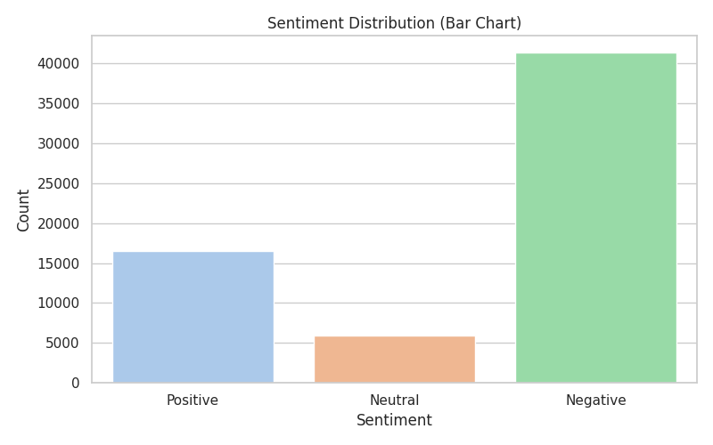

Bar chart showing the count of Positive, Neutral, and Negative sentiments.

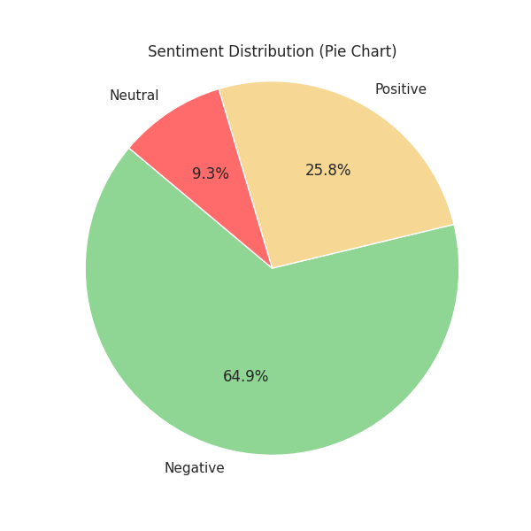

Pie chart showing sentiment proportions.

# Word Clouds

Word Cloud - Positive

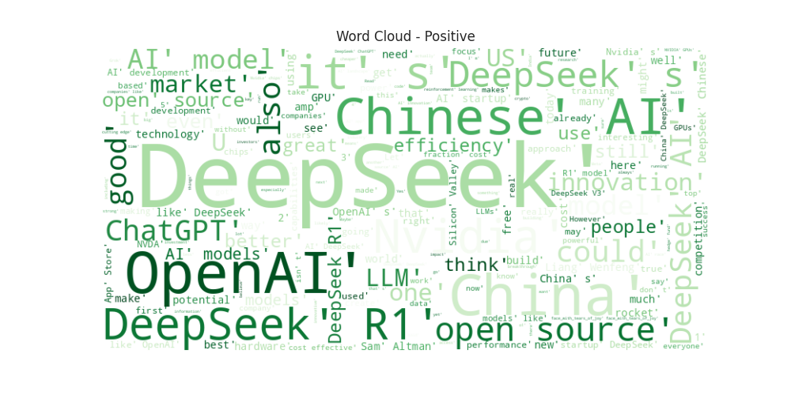

Word Cloud - Neutral

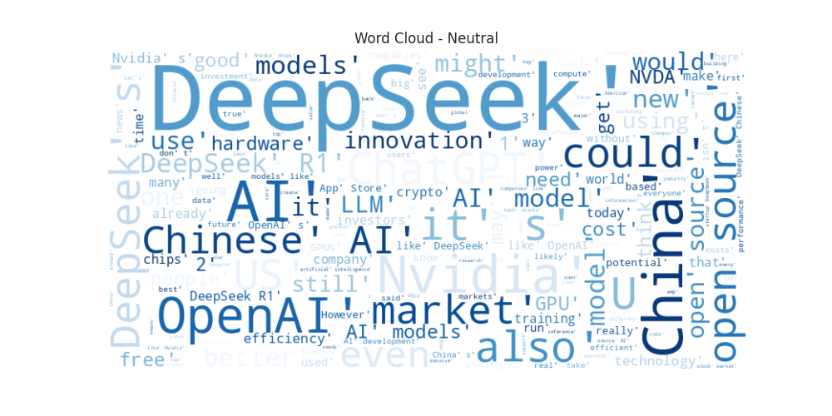

Word Cloud - Negative



# Key Observations

• Most of the texts were classified as Negative.

• Positive: 16484

• Neutral: 5918

• Negative: 41374

• The combination of three sentiment models ensures a more reliable classification.