Crowdstrike Installation Steps

**Step 1: Download windows-sensor-4.10.7304.exe file from the below link:**

<https://ibm.box.com/s/ug1kfi44hu7tu14ji8ort7aygjci720z>

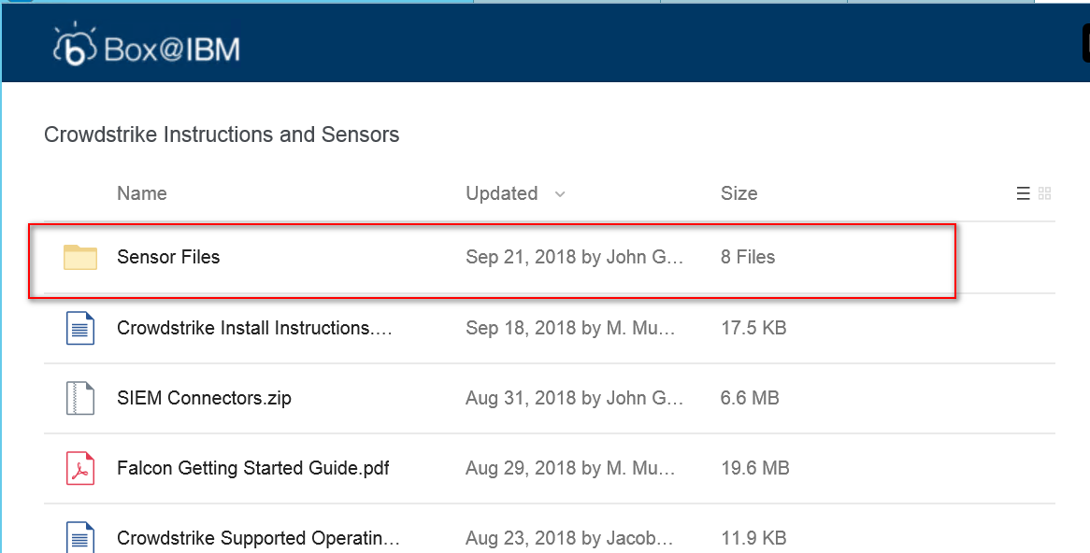

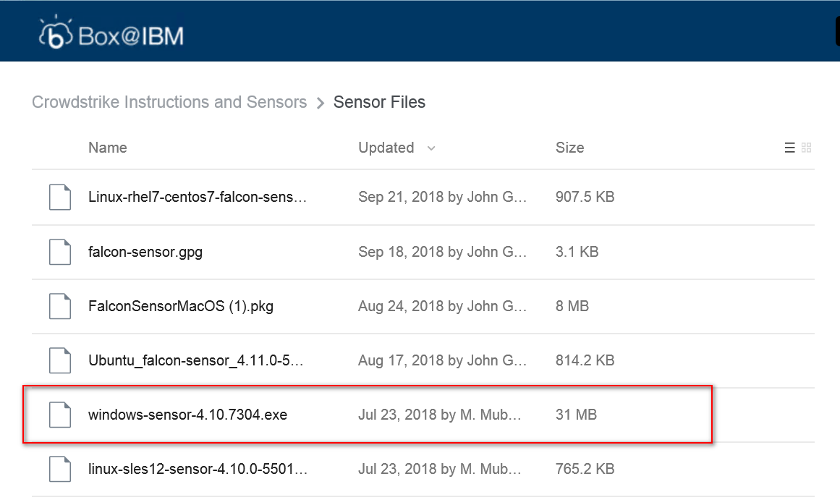

**Step 2: Install Sensor**

Accept the license agreement and enter the below Checksum code during installation

Customer ID (CID):

**20709802E00E4B4C9442CE5F8CA3E69D-9C**

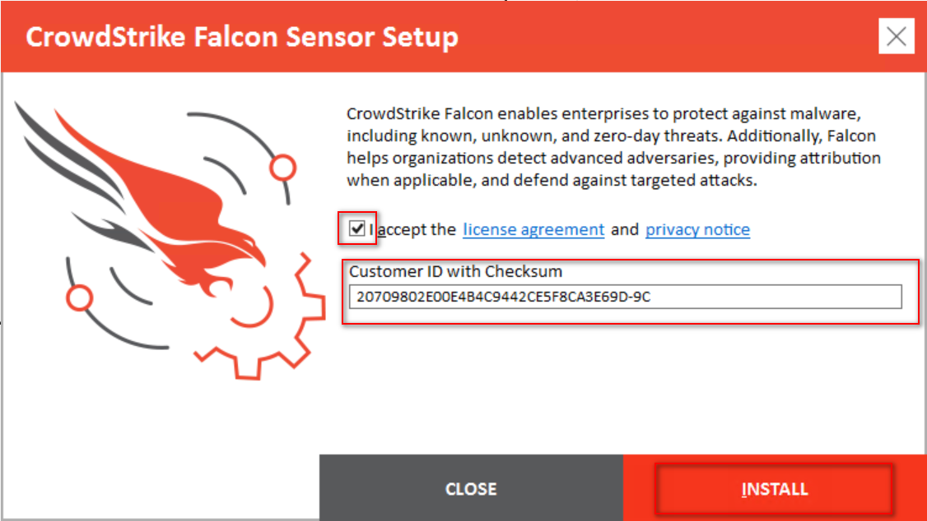

Click “Install” button

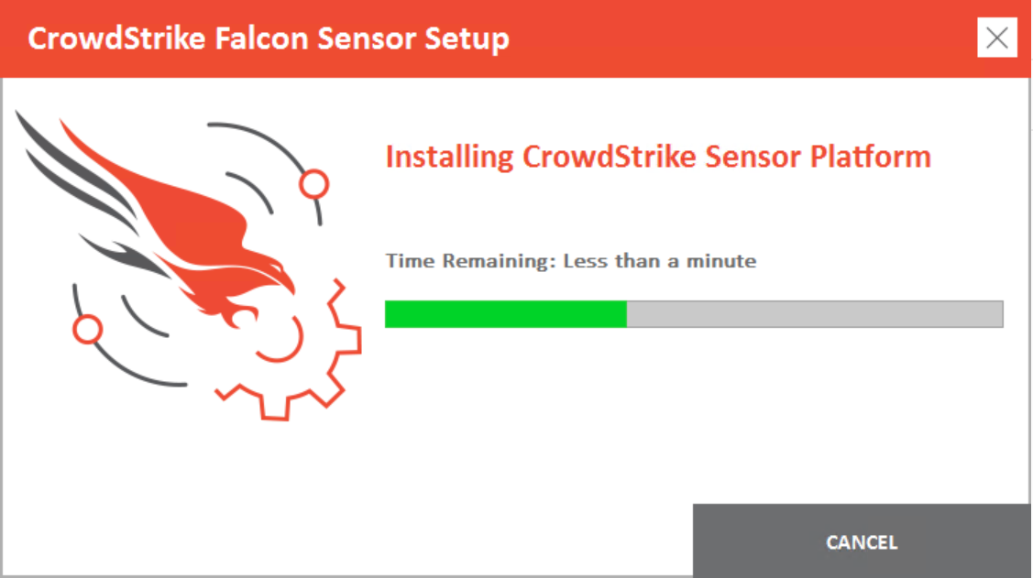

Wait for the installation to complete

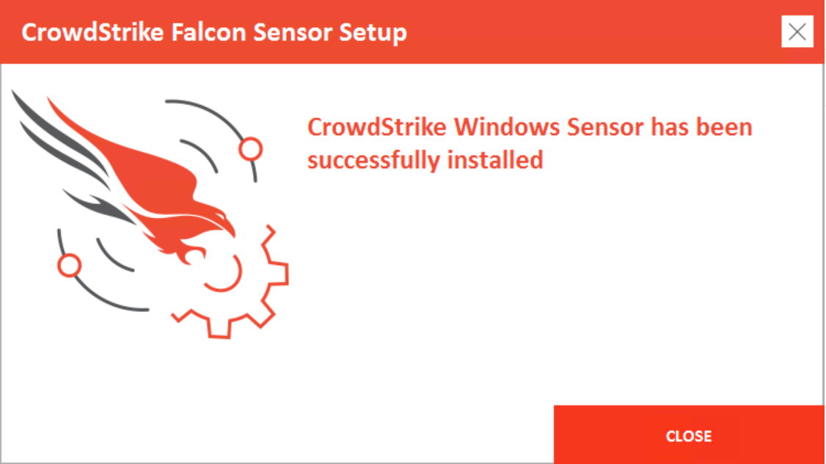

Click “Close” button

**Step 3: Verify the installation using the below command:**

Open administrator command prompt and run the below command:

**powershell.exe -command "[System.BitConverter]::ToString( ((Get-ItemProperty 'HKLM:\SYSTEM\CrowdStrike\{9b03c1d9-3138-44ed-9fae-d9f4c034b88d}\{16e0423f-7058-48c9-a204-725362b67639}\Default' -Name AG).AG)).ToLower() -replace '-',''"**

