Customer Churn Analysis Project
- Objective:
The objective of this project was to analyse customer churn behaviour in a telecom company and identify factors contributing to customer attrition. The analysis aimed to uncover patterns related to contract type, tenure, and monthly charges in order to provide actionable business recommendations.

- Tools Used:
• Excel
• SQL (Google BigQuery)
• Tableau

- Data Cleaning and Preparation:
The dataset was cleaned and prepared using Excel. Missing values and inconsistencies were checked before analysis. Calculated fields such as tenure groups and churn rate metrics were created for deeper analysis.

- Analysis Performed:
The following analyses were performed:
• Overall churn distribution
• Contract type vs churn analysis
• Tenure group analysis
• Monthly charges analysis
• High-risk customer identification using SQL
5) Key Insights:
Key Insights:
• Customers with month-to-month contracts showed the highest churn rate.
• Customers with shorter tenure were more likely to leave the service.
• Higher monthly charges were associated with increased churn probability.
• Long-term contract customers demonstrated significantly higher retention.

- Business Recommendations:
• Encourage customers to shift to long-term contracts through discounts and loyalty offers.
• Improve onboarding experience for new customers to reduce early churn.
• Introduce retention campaigns targeting high monthly charge customers.
• Monitor high-risk customers proactively using churn indicators.

Tableau Dashboard:
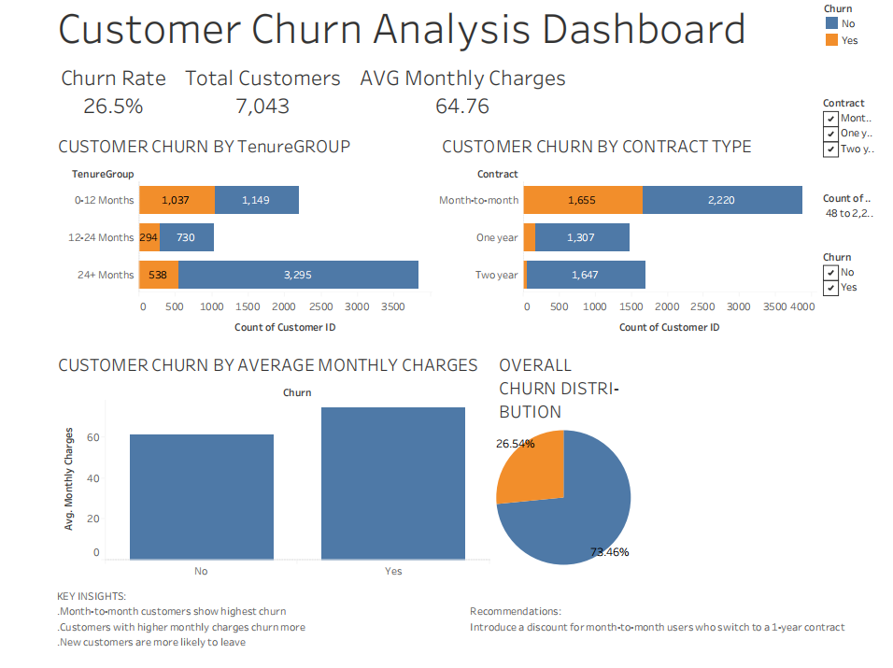

Excel Dashboard:

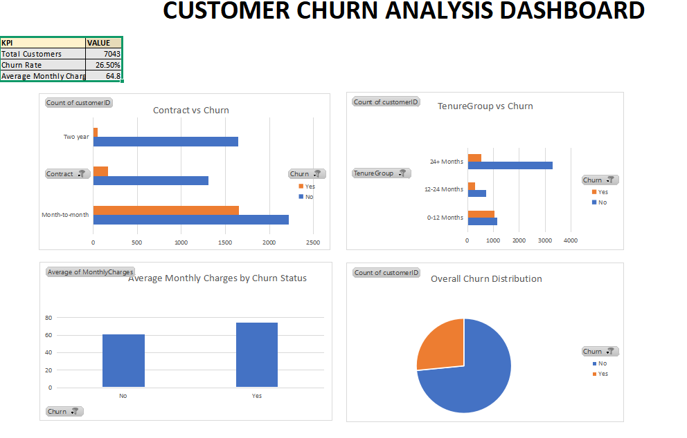
6)Conclusion:
This project demonstrated how data analysis tools such as Excel, SQL, and Tableau can be used together to identify customer churn patterns and support business decision-making through data-driven insights.

