DEPARTMENT OF



COMPUTER SCIENCE & ENGINEERING

**Experiment 4**

|  |  |
| --- | --- |
| **Student Name:** Sambhav Mahajan | **UID:** 23BCS11290 |
| **Branch:** B.E. C.S.E. | **Section/Group:** KRG-2B |
| **Semester: 5**th | **Date of Performance:** 8th September 2025 |
| **Subject Name:** ADBMS | **Subject Code:** 23CSP-333 |

1. **Aim:** To study the concepts of functional dependencies, candidate keys, prime and non-prime attributes, and normalization in relational databases, and to apply them to identify the highest normal form of a given relation.
2. **Objective:**

* To understand functional dependencies and their role in database design.
* To determine candidate keys for a given relation using closure method.
* To differentiate between prime and non-prime attributes.
* To analyze a relation schema and identify the highest normal form (1NF, 2NF, 3NF, BCNF) it satisfies.
* To learn how redundant functional dependencies can be removed.

DEPARTMENT OF

COMPUTER SCIENCE & ENGINEERING



1. **Questions and Answers**

Please turn over page

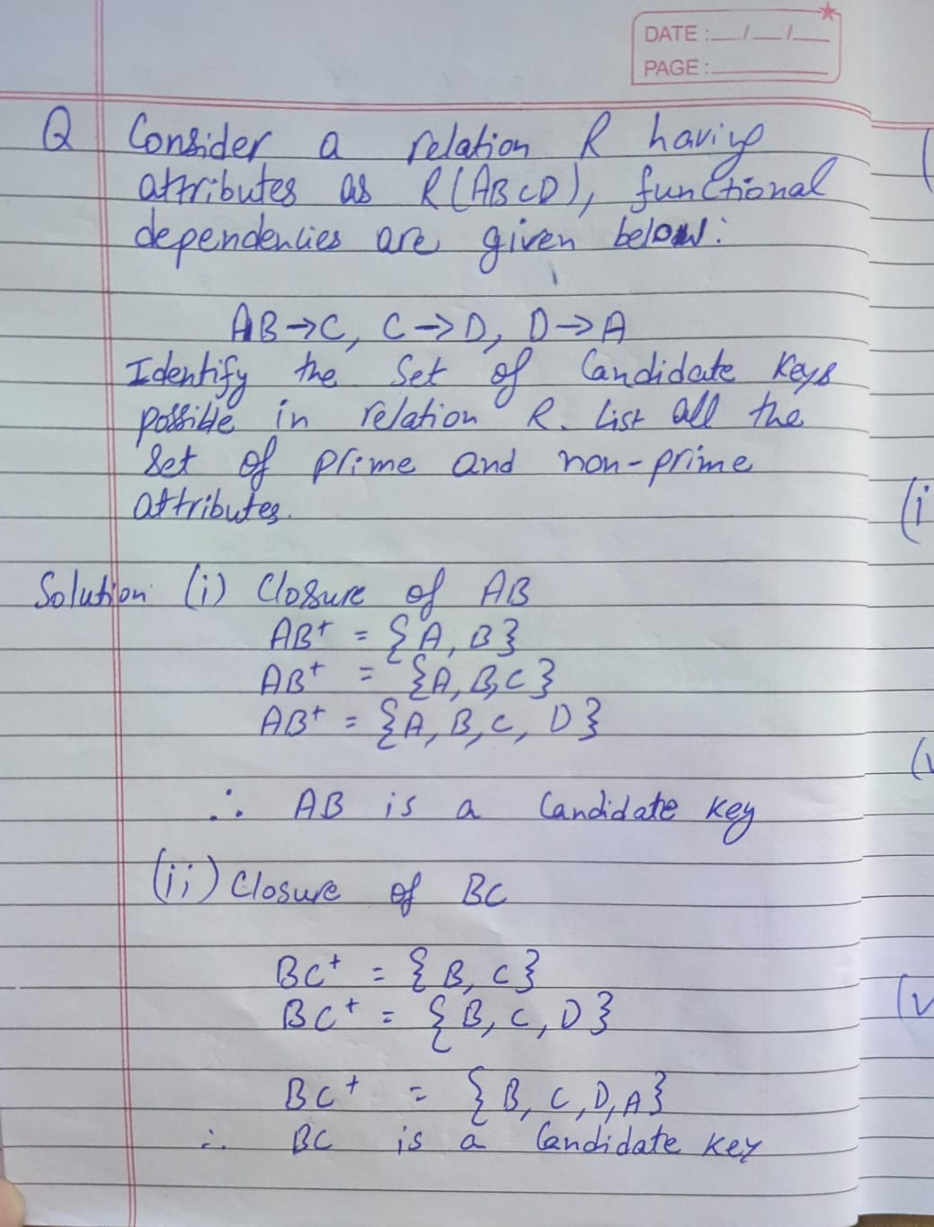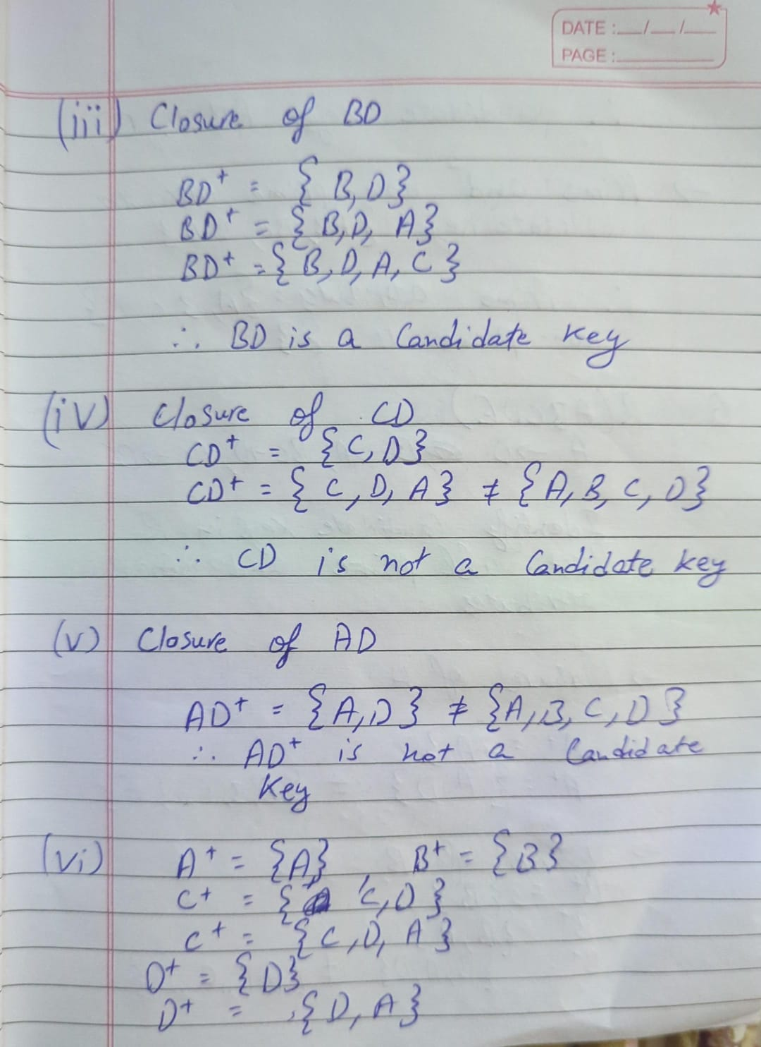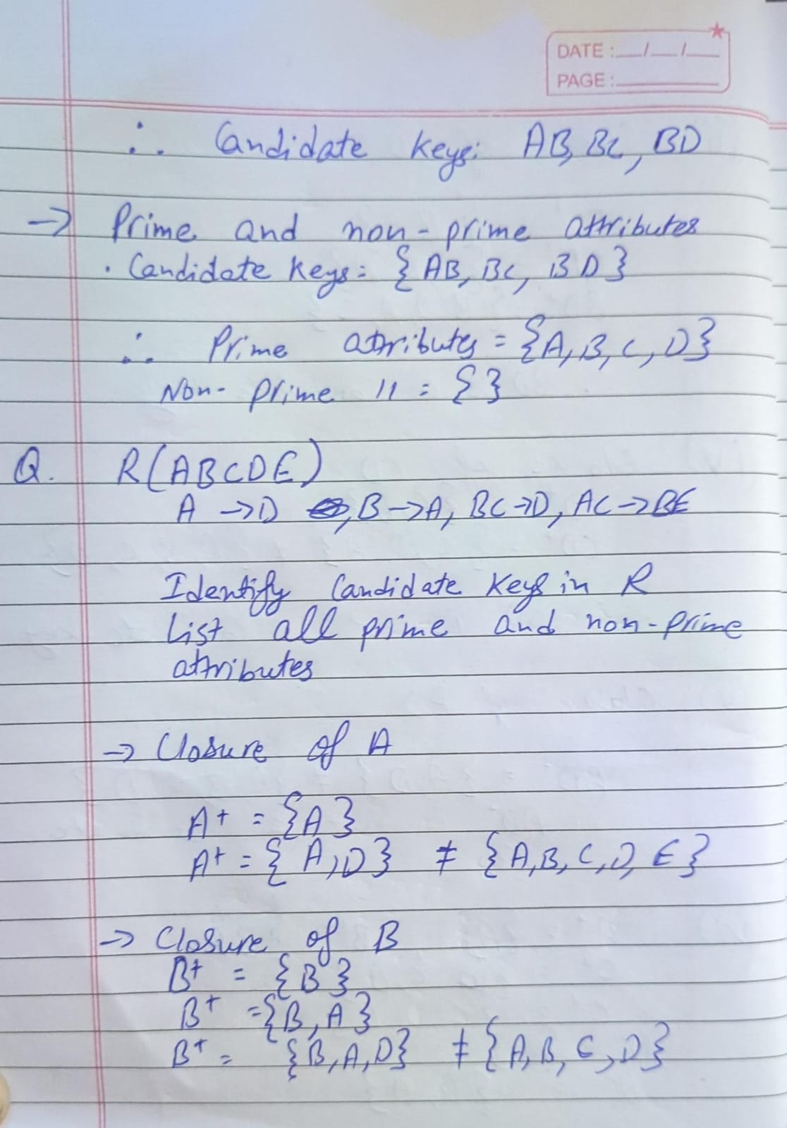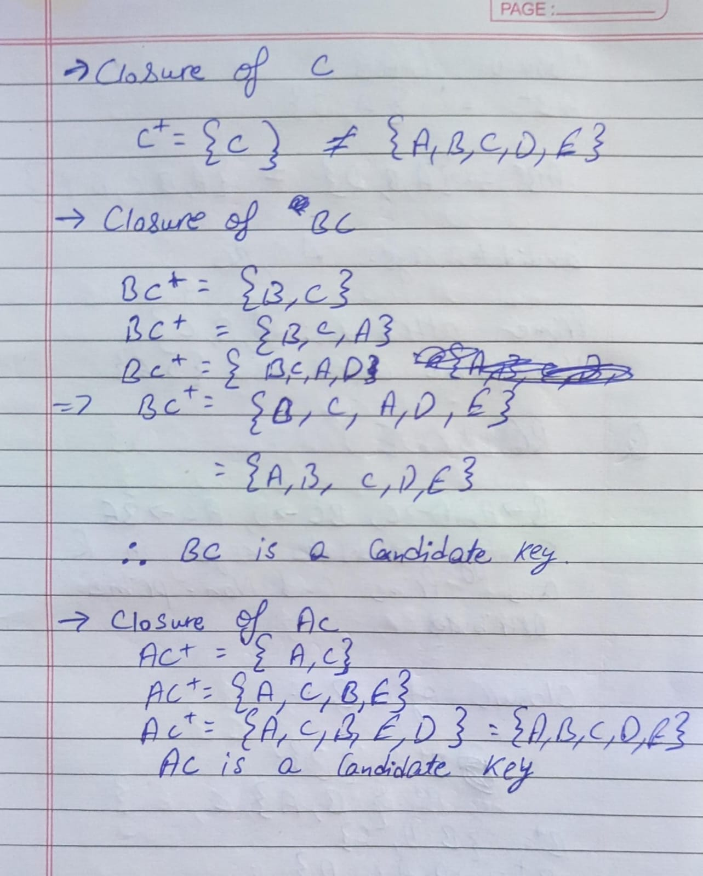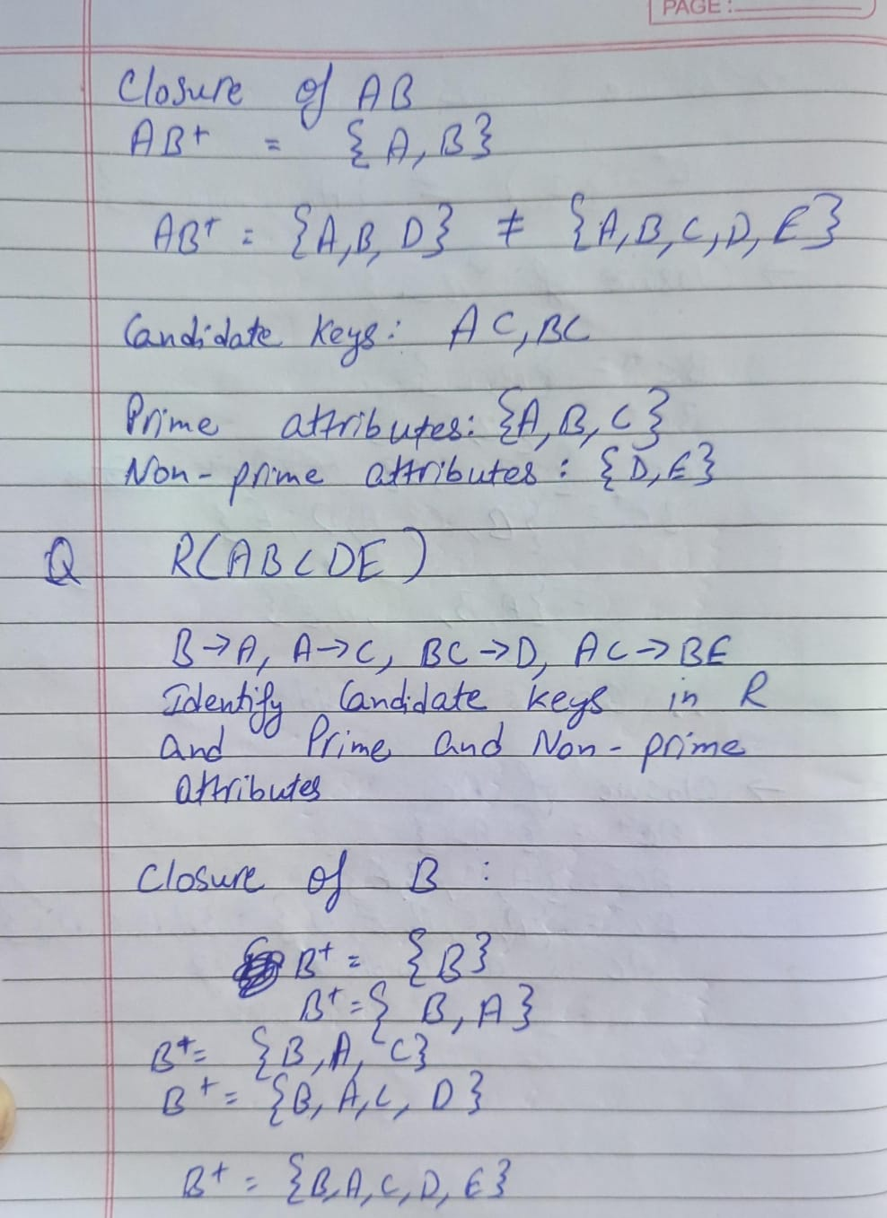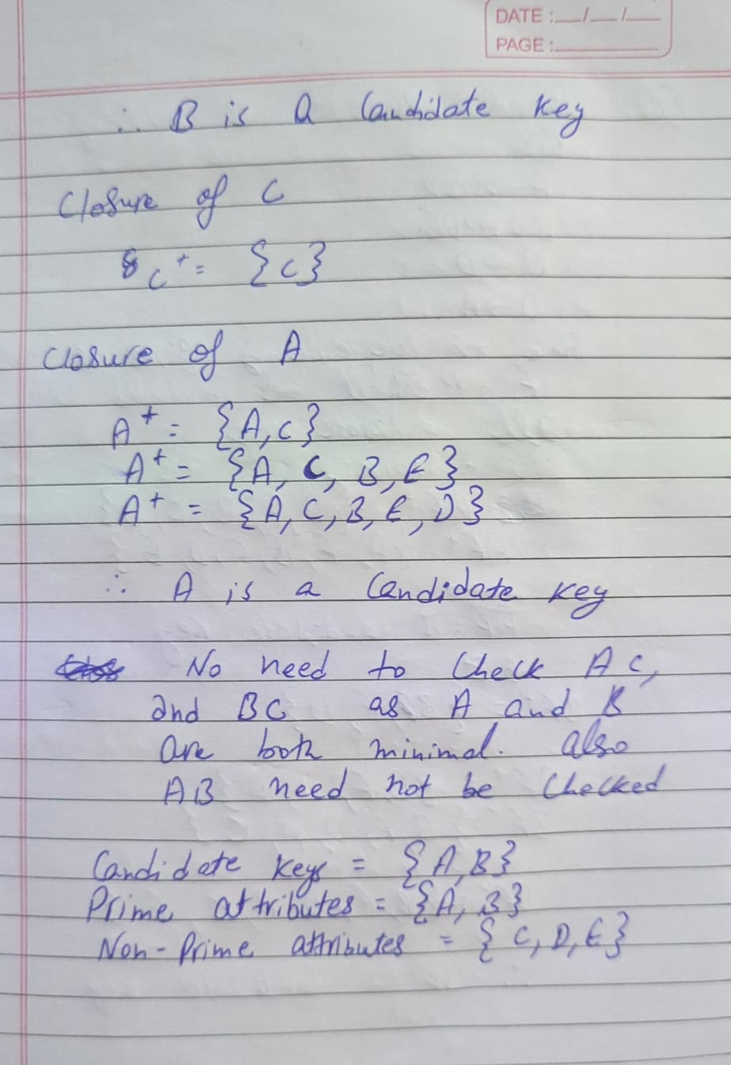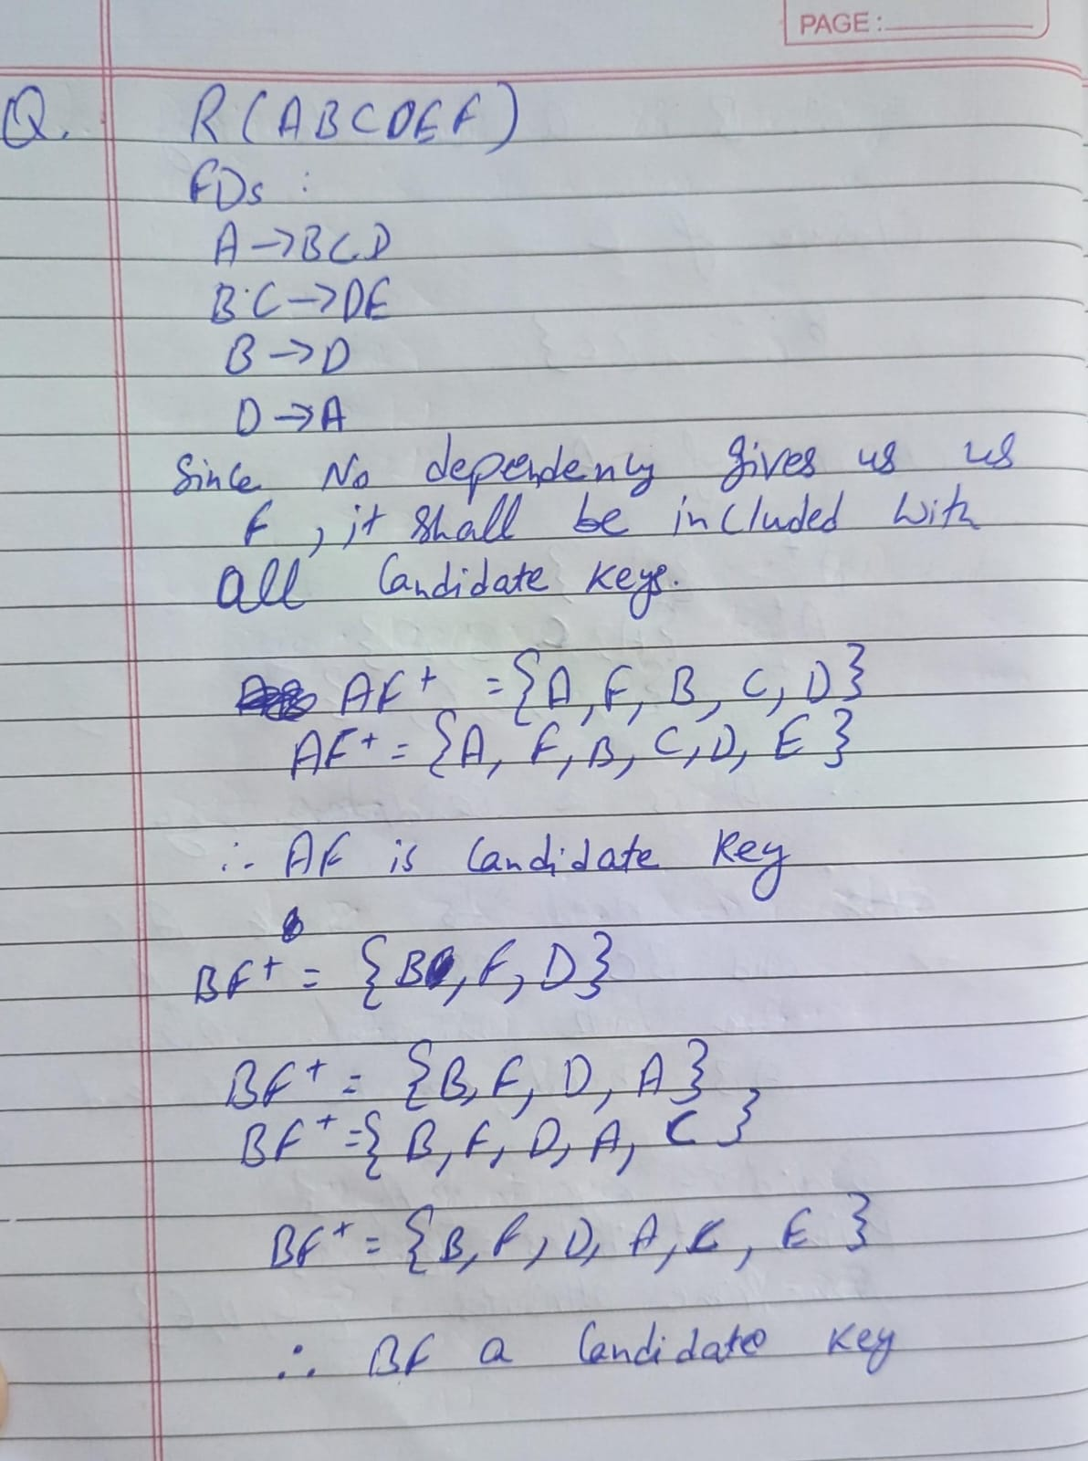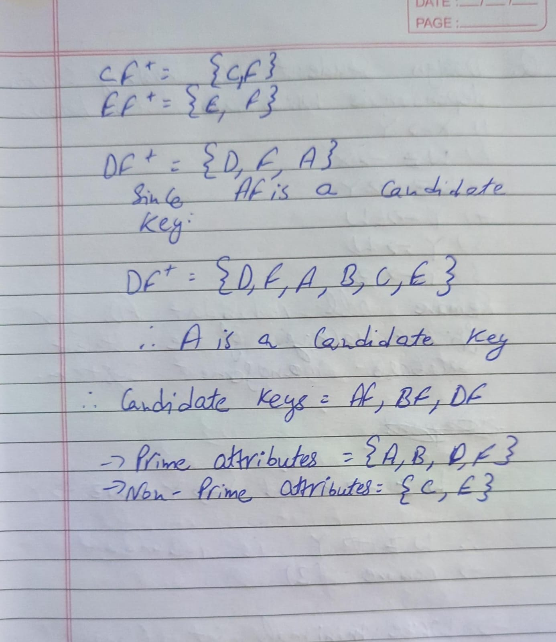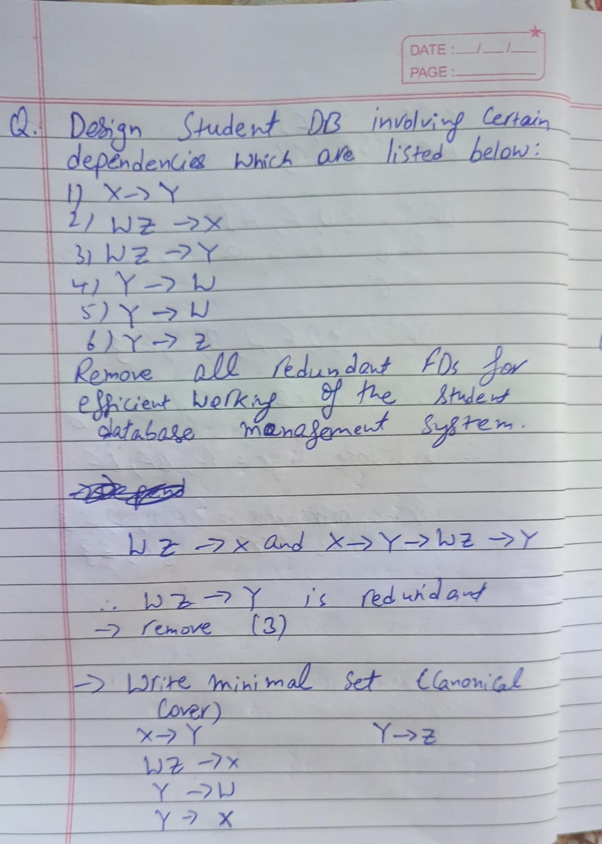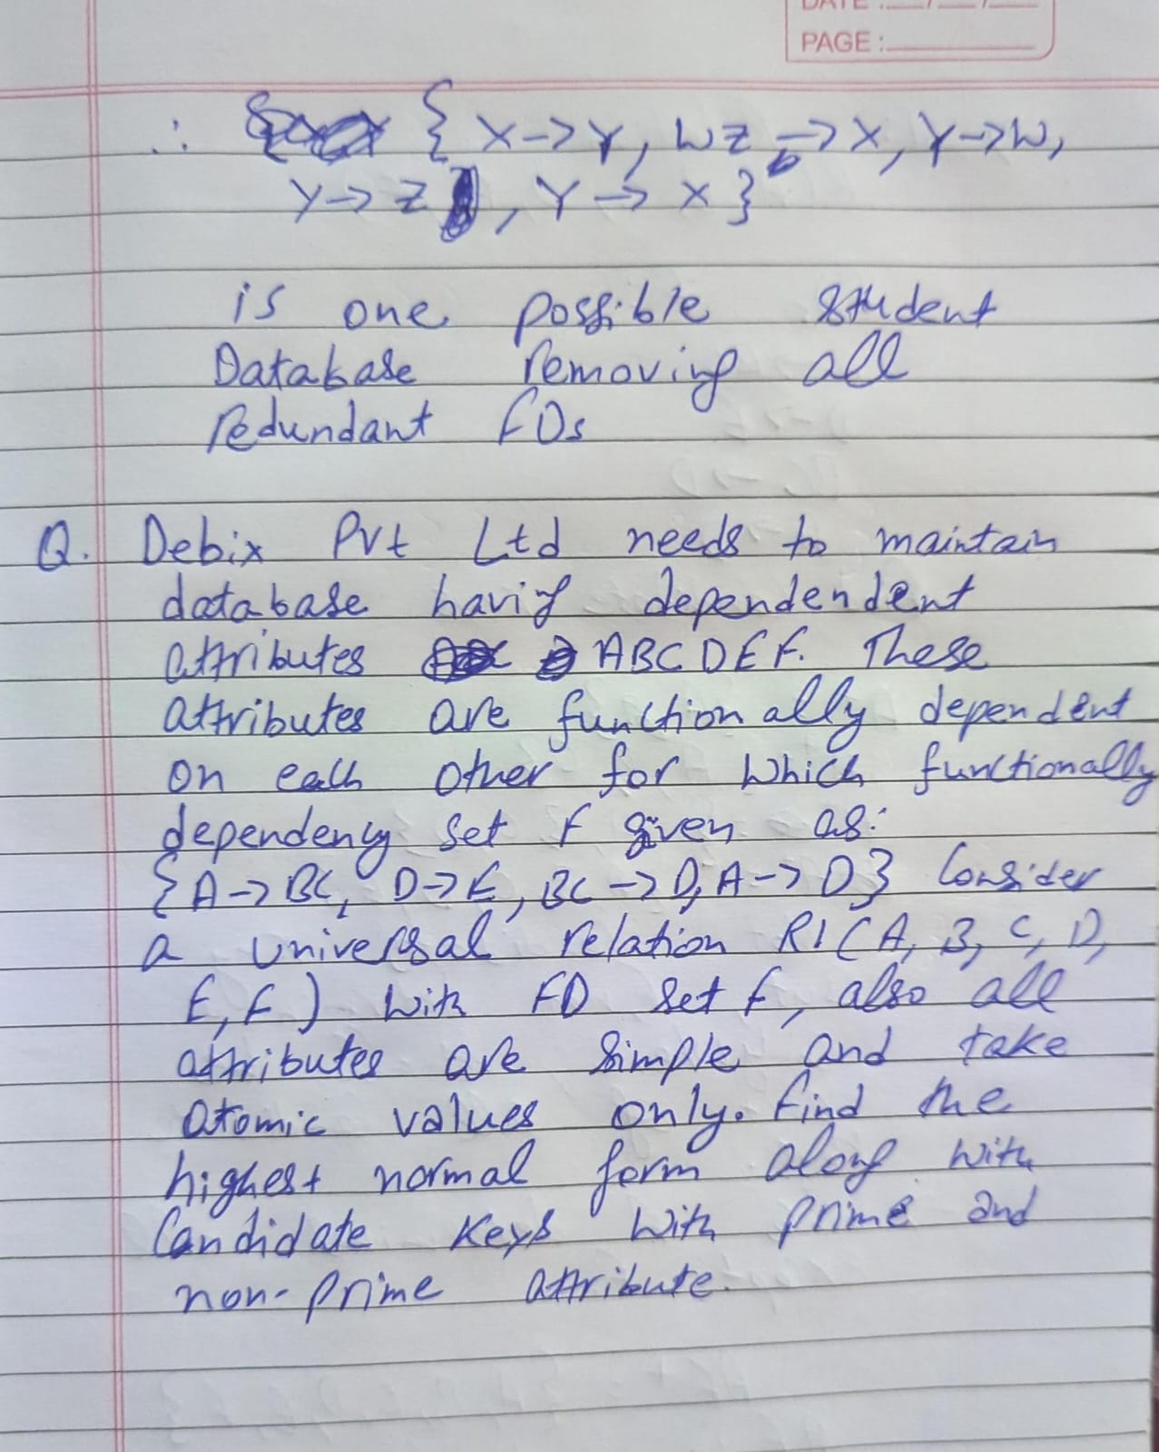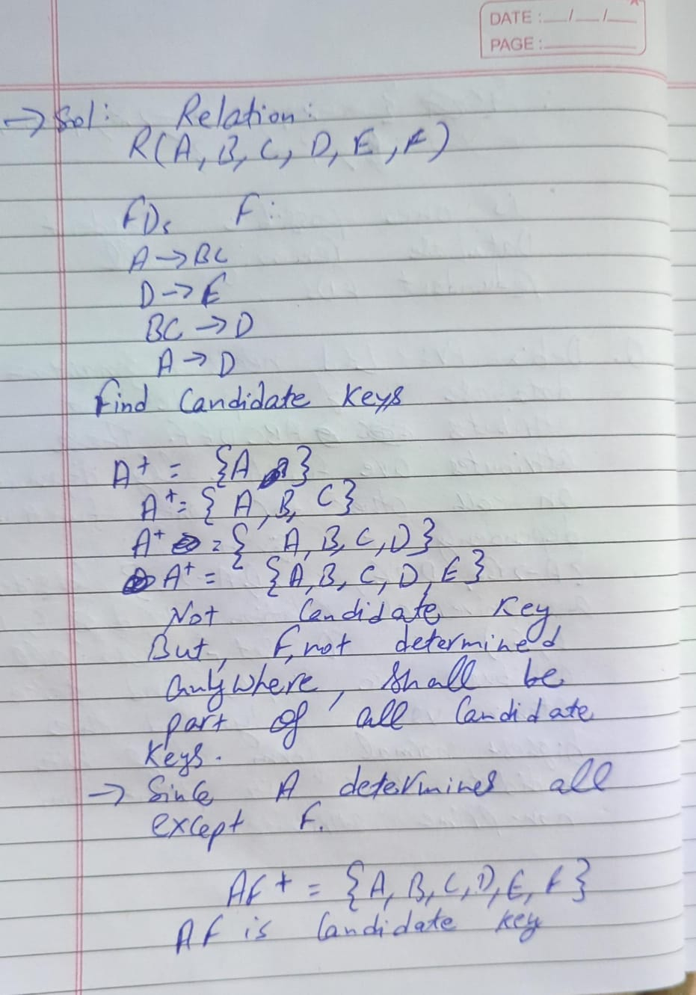

1. **Learning Outcomes:**

* Define and explain functional dependencies in relational schema.
* Find candidate keys and classify attributes into prime and non-prime.
* Detect partial, transitive, and trivial dependencies.
* Identify the highest normal form satisfied by a relation.
* Apply normalization techniques to design efficient and consistent database schemas.