PES University – Dept. of CSE
Lab 2: Sprint Simulation and Burndown Chart Analysis
Problem Statement #40 — Student Startup Crowdfunding Platform | Submitted by: Sambhram M (SRN: PES1UG24CS409)

1. Sprint Simulation Execution Overview
To demonstrate end-to-end Agile execution in Jira Software, the project was organized into two sequential 1-week sprints:
• Sprint 1 (Campaign Setup & Pledging Foundation): Focused on core campaign creation, duration configuration, milestone-tranche definition, and secure backer pledging into escrow. Total committed capacity: 29 Story Points.
• Sprint 2 (Milestone Verification & Disbursement Engine): Focused on founder evidence submission, faculty review decisions, escrow precondition verification, automated tranche payout, and notifications. Total committed capacity: 32 Story Points.

2. Sprint 1 Burndown Chart & Daily Burn Log
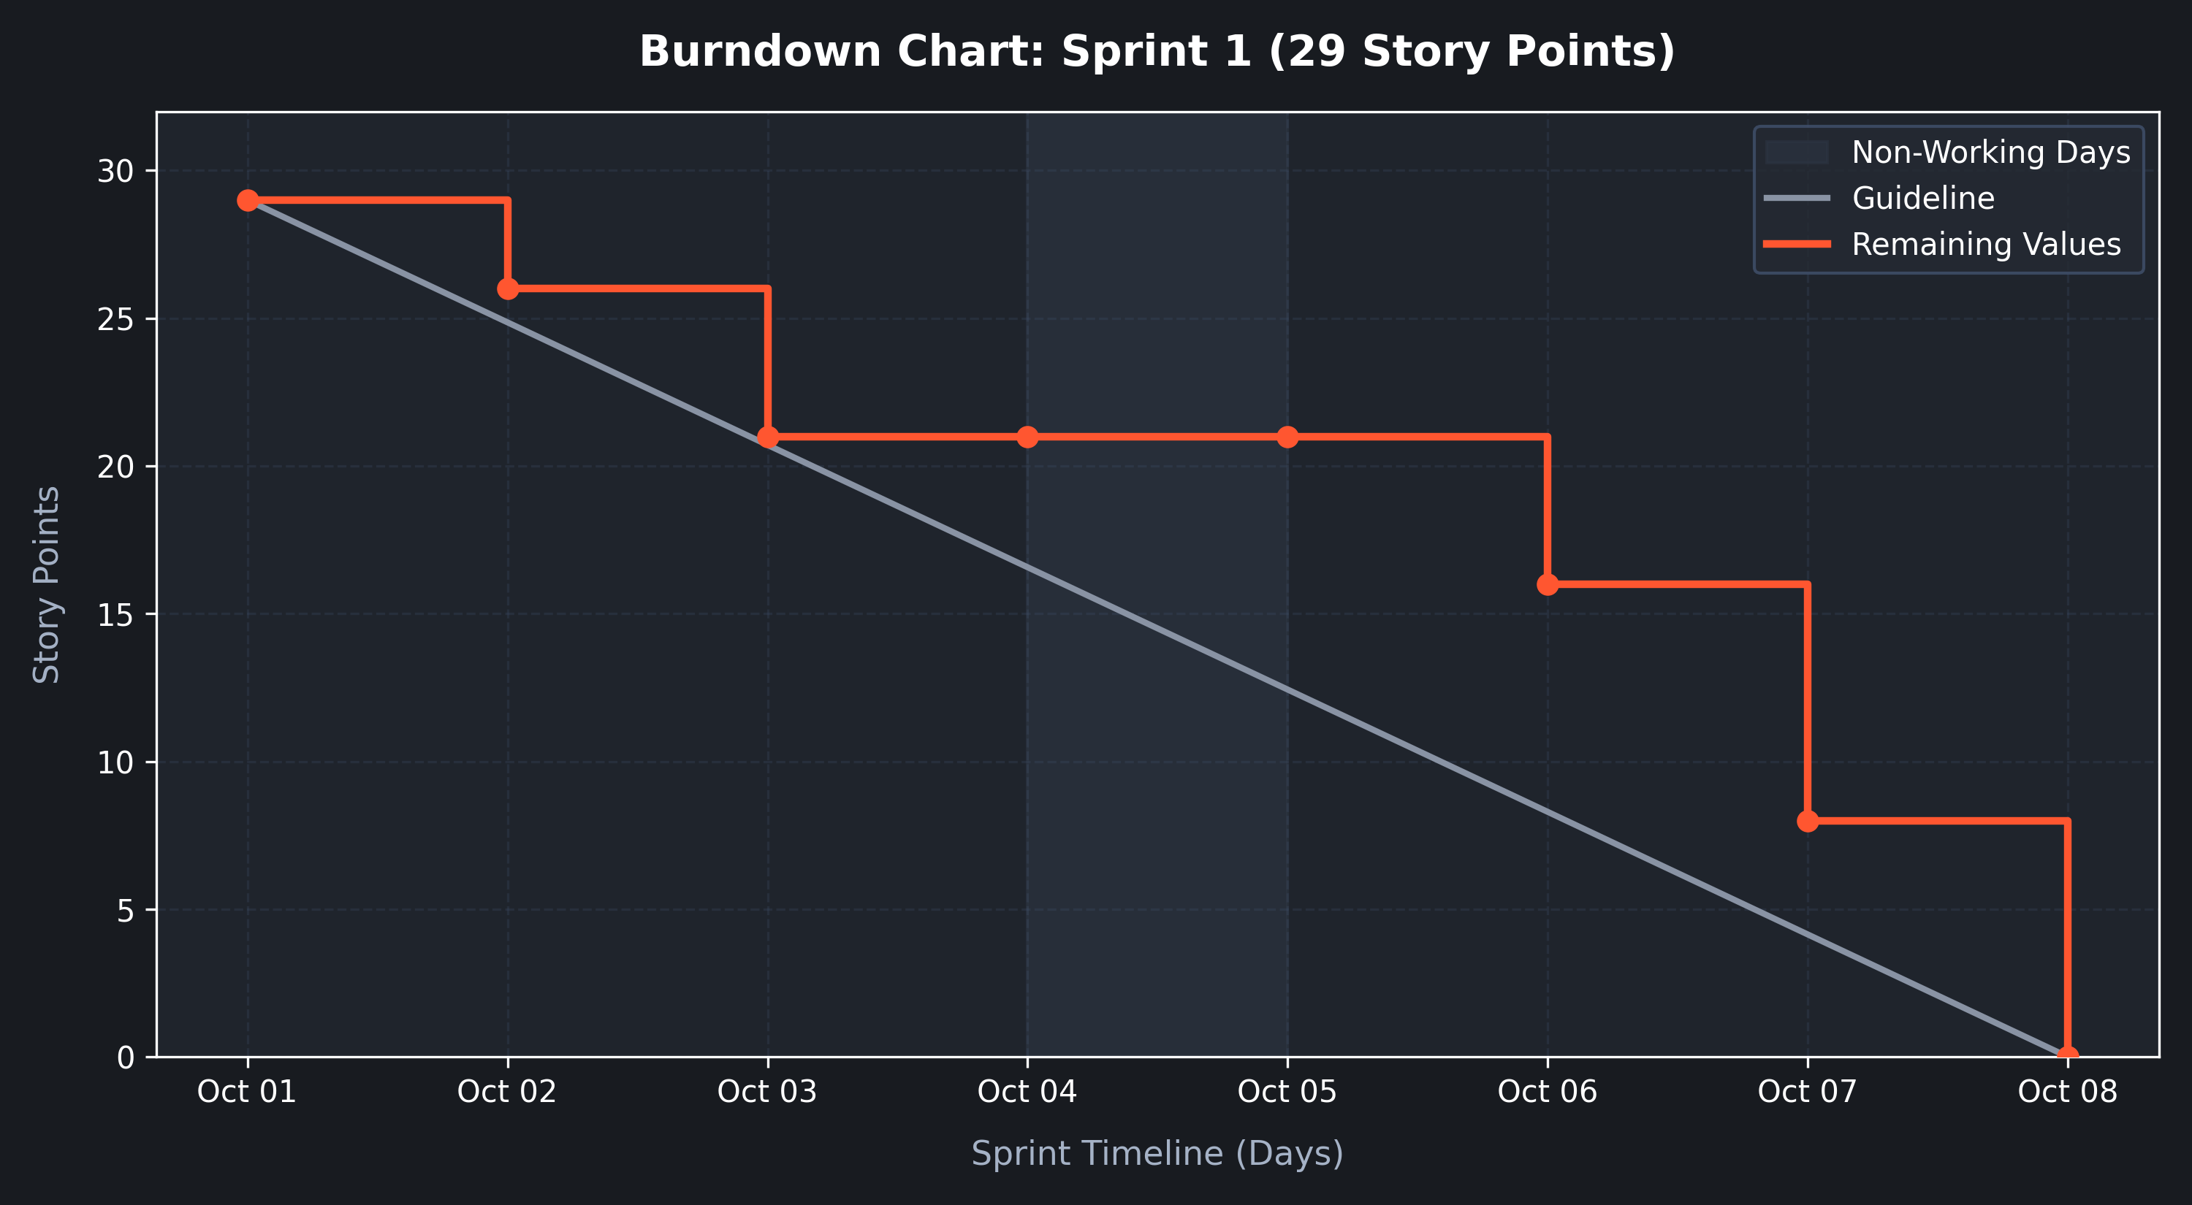
Date | Event / Work Item Completed | Points Burned | Remaining Pts | Scrum Notes
Oct 01 | Sprint 1 Planning & Start | 0 | 29 | Sprint 1 backlog committed; all 5 issues in To Do.
Oct 02 | SSCP-2: Campaign Duration Configuration | 3 | 26 | Date boundary validator completed and tested.
Oct 03 | SSCP-1: Campaign Target & Overview Setup | 5 | 21 | Venture overview form and database entity saved.
Oct 04 | Weekend (Non-Working Day) | 0 | 21 | Escrow architecture code review; no story burned.
Oct 05 | Weekend (Non-Working Day) | 0 | 21 | Scheduled rest day.
Oct 06 | SSCP-4: Backer Reward Tier Selection | 5 | 16 | Tier selection UI & pledge linkage verified.
Oct 07 | SSCP-3: Milestone & Tranche Breakdown | 8 | 8 | Staged milestone distribution logic completed.
Oct 08 | SSCP-5: Secure Escrow Pledge Processing | 8 | 0 | Payment gateway mock auth passed; Sprint 1 Complete!

3. Sprint 2 Burndown Chart & Daily Burn Log
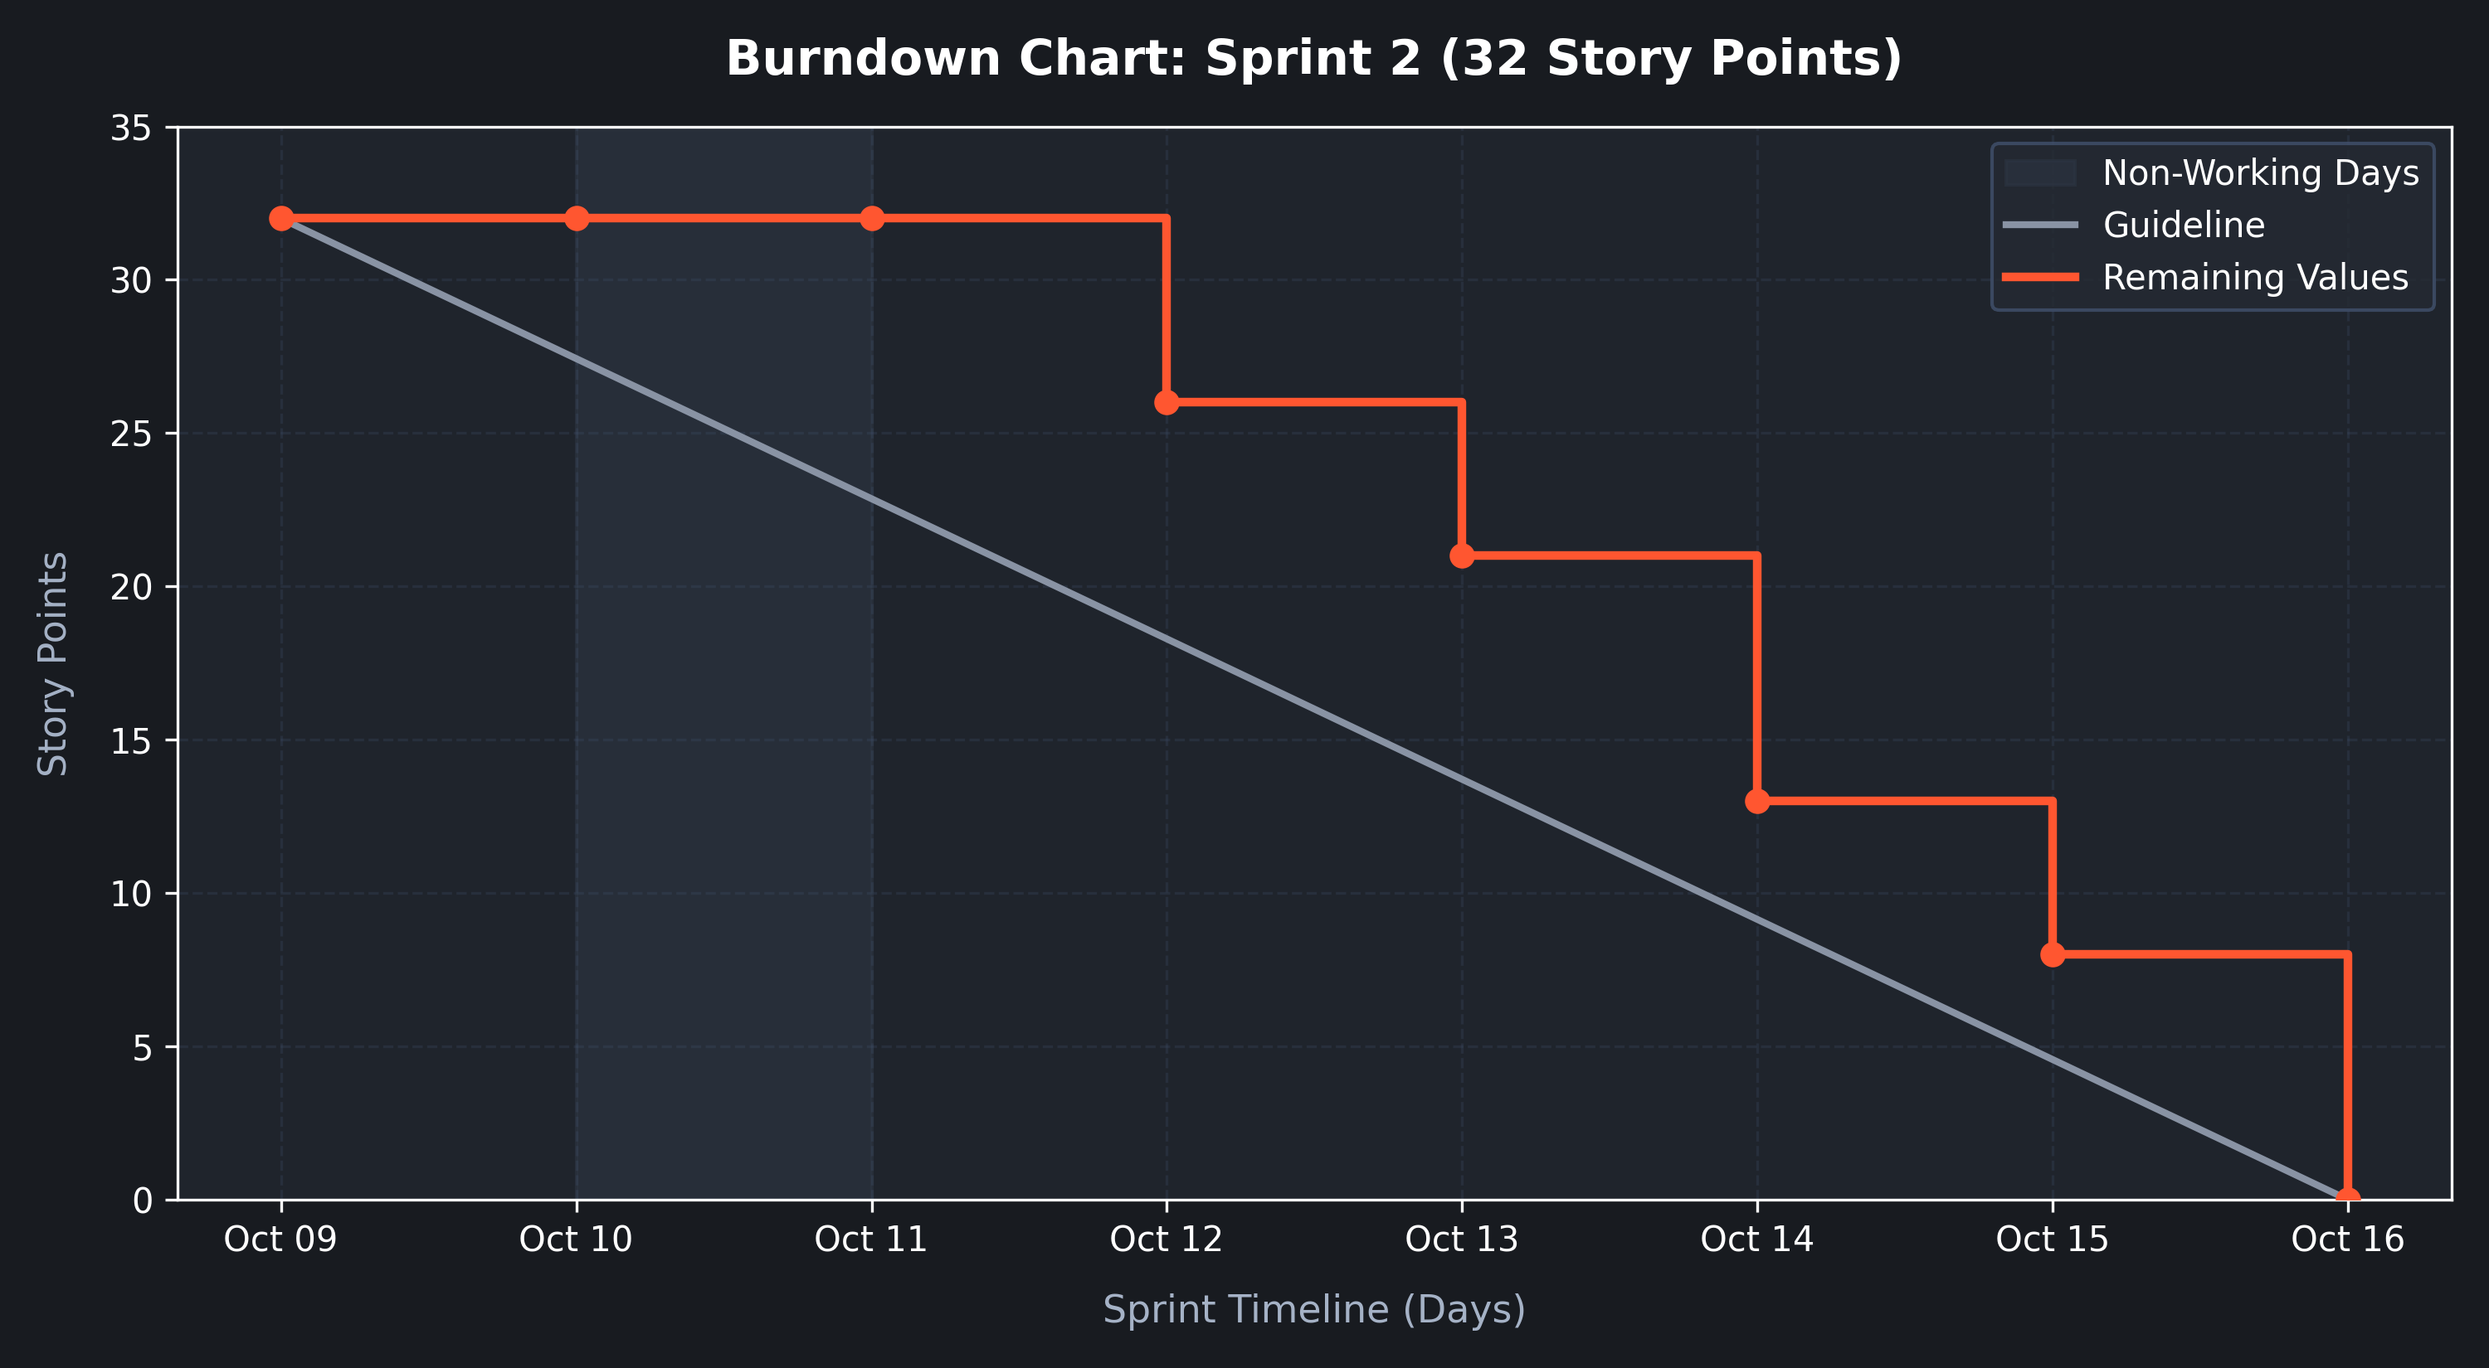
Date | Event / Work Item Completed | Points Burned | Remaining Pts | Scrum Notes
Oct 09 | Sprint 2 Planning & Start | 0 | 32 | Sprint 2 commenced with 7 issues in To Do.
Oct 10 | Weekend (Non-Working Day) | 0 | 32 | Non-working day; pipeline health check.
Oct 11 | Weekend (Non-Working Day) | 0 | 32 | Scheduled rest day.
Oct 12 | SSCP-9 (3 pts) & SSCP-8 (3 pts) | 6 | 26 | Escrow precondition check & resubmission flow done.
Oct 13 | SSCP-6: Milestone Evidence Submission | 5 | 21 | Evidence upload & file storage link verified.
Oct 14 | SSCP-7 (5 pts) & SSCP-12 (3 pts) | 8 | 13 | Faculty review audit log & public ledger completed.
Oct 15 | SSCP-11: Multi-Channel Notifications | 5 | 8 | Event listener for email & in-app alerts operational.
Oct 16 | SSCP-10: Automated Tranche Disbursement | 8 | 0 | Payout API verified; 100% velocity achieved; Sprint 2 Closed!

4. Reflection Questions and In-Depth Answers
Question 1: Did your estimations reflect the actual effort?
Yes, our Planning Poker estimations accurately reflected actual task effort, but with important real-world nuances. Smaller items estimated at 3 story points (e.g., Campaign Duration Configuration and Escrow Validation) matched their expected effort tightly because their specifications involved standard input validation and straightforward boolean criteria. Conversely, stories assigned 8 story points (Milestone-Tranche Breakdown, Escrow Pledge Processing, and Automated Tranche Disbursement) required significantly more cognitive effort and technical coordination. Although they were completed on schedule, unforeseen edge cases arose—specifically validating multi-tranche fractional amounts and simulating external payment gateway asynchronous webhooks. The Fibonacci scale effectively prevented underestimation by forcing the team to step up from 5 to 8 points, accommodating hidden integration risk.
Question 2: Was your backlog well-prioritized?
Yes, the product backlog was systematically prioritized following MoSCoW prioritization and architectural dependency ordering. In Sprint 1, High-priority items establishing the foundation of the platform—campaign configuration (FR-002) and backer escrow pledging (FR-003)—were scheduled first. It is structurally impossible to evaluate milestones or release funds without first having active campaigns, defined milestones, and collected escrow pledges. Consequently, Sprint 2 was reserved for verification workflows (FR-004), automated fund disbursements (FR-001), and real-time notification dispatches (FR-005). Medium and low-priority items (e.g., public transparency ledger) were sequenced after core functional flows were secured. This prevented blocking dependencies, minimized sprint idle time, and delivered an incremental MVP at the conclusion of each sprint.
Question 3: How did your simulated sprint align with your plan?
The simulated sprint closely mirrored our Agile sprint plan, meeting all committed sprint goals across both cycles. In Sprint 1, 29 out of 29 planned story points were successfully moved from To Do to In Progress to Done by Day 7. In Sprint 2, all 32 planned story points reached Done by Day 7. Progress exhibited realistic Agile characteristics: while the ideal guideline assumed a smooth, uniform daily burn, the actual burn followed a discrete staircase pattern. Mid-sprint progress flattened over weekends (Oct 04–05 and Oct 10–11) due to non-working days. A minor bottleneck occurred in Sprint 2 on Day 3 while designing the faculty committee approve/reject state machine, which delayed Story 3.2. However, team capacity was quickly re-allocated, allowing both Story 3.2 and Story 12 to close concurrently on Day 5, keeping the team strictly on track.
Question 4: What insights did the burndown chart give about your team’s capacity?
The burndown charts provided three critical insights regarding team velocity and operational capacity:
1. Sustainable Velocity Benchmark: The team demonstrated a reliable capacity of 29 to 32 story points per 1-week sprint (averaging 4.2 to 4.5 points/day). This established a factual, data-driven velocity baseline for future release planning.
2. Discrete Batch Completion vs. Continuous Flow: The burndown chart illustrated that large user stories (8 story points) stay in progress for multiple days before suddenly dropping the remaining curve. This insight indicates that in future sprints, breaking 8-point stories into smaller 3-point sub-tasks will yield a smoother burn curve and reduce end-of-sprint integration anxiety.
3. Absence of Scope Creep and Accurate Commitment: The remaining values curve stayed closely clustered around the grey ideal guideline throughout both sprints without upward spikes (which indicate scope creep) or early horizontal flatlines (which indicate over-commitment). This confirmed that our team neither over-committed nor under-committed, achieving 100% planned sprint predictability.

