**I FOCUS DATA**

**Srinivasa Sriharsha Goteti  
Director of I Focus Data**

(Personal Resume)

ADDRESS: 55453 Great America Parkway, Santa Clara, CA 95054

EMAIL: [contactus@ifocusdata.com](mailto:contactus@ifocusdata.com) | TELEPHONE: +1-438-527-0500

SrinivasaSriharsha.Goteti

Apt 354D Mayfield Avenue Valparaiso, IN |goteti.sriharsha@gmail.com |+1(480)603-6416

**OBJECTIVE:**Experienced software developer, team leader, subject matter expert is seeking to apply to the organization to increase organization abilities, performance management, business designing and deployment.  
  
**Education:  
Valparaiso University**, Valparaiso, IN, USA August ‘2016 to December ‘2017 Master of Information Technology

**Guru Nanak Engineering College**, Hyderabad, India October ‘2008 to May ‘2012   
Bachelor of Technology : Information Technology  
GPA: 3.5

**Work Experience:**

**IBM** United States September’2016 to September ‘2021  
 *Senior Project Management Manager*

* Established activities to collate contract and deployment details across A/NZ ELA clients
* Actively supported Deployment community to monitor and track sales opportunities through to deployment of software products

**Genpact** Hyderabad, India August’13 to June’16

*Process Developer*

* Developed, tested website coding and maintaining the websites and running without issues
* Led a team of 46 members in supporting customers in small business to excel.

**Cybrilla Technologies** Bangalore, India April’13 to July’13

*Web Developer*

* Developed Web Applications using Ruby on Rails, Ruby, Ajax, Python scripting language and using gems like bootstrap etc.
* Written Test cases and resolving the bugs

***A*WARDS AND RECOGNITION:**

* Selected to the Summer Summit 2013 of “IJCSIT” in Los Angeles(LA)for submitting

“International Paper” on the topic of “Web development and its extensions”.

* Actively involved with Social Organization “I-FOCUS”.

**Skills**Developing Websites | PHP| HTML | CSS | Project Management | RoR | Java Script |

Yours’s Sincerely,

Goteti. Srinivasa Sriharsha

**I FOCUS DATA**

(My Personal Mission, Vison, Value Statement)

ADDRESS: 55453 Great America Parkway, Santa Clara, CA 95054

EMAIL: [contactus@ifocusdata.com](mailto:contactus@ifocusdata.com) | TELEPHONE: +1-438-527-0500

**My Mission:**

My own statement of purpose is to put forth a concentrated effort, wholeheartedly, to all that I do. Whether it is an individual or work related objective, I need it to be clear to everybody around me that I am attempting my best. I feel that anything less is essentially an exercise in futility.

**Vision:**

"I believe that we are on the face of the earth to do great things and that's not changing. I am constantly focusing on improving myself. I believe in the simplicity. I believe in saying no to thousands of things, so that i can really focus on the few that are truly important and meaningful. I believe in excellence in whatever endeavour I take on.

**Value:**

I have the self-honesty to admit when I am wrong and the courage to change. And I think I will do extremely well with the vision and values I have.

**I FOCUS DATA**

(30 Second Speech)

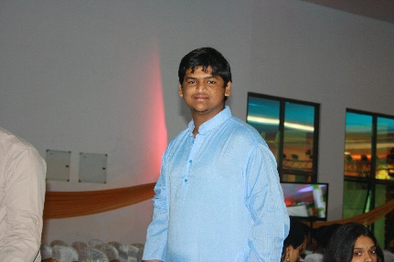 **30 Seconds Speech**

Hi I am Goteti, Graduated from GuruNanak Engineering College, India, and having 4 years of experience working with companies like Cybrilla, Genpact as a Tech Lead and Software Development. Currently, I am perusing my master in Information Technology from Valparaiso University, Indiana. Playing Drums and Doing charity towards education are my hobbies.

**I FOCUS DATA**

(60 Second Speech)

 **60 Second Speech**Thank you for providing time to a technically efficient leader, Hi, My name is Goteti from India, graduated from Guru Nanak Engineering College, Hyderabad, India. From there I gained **4** Years of experience in development, not only web and console applications but also in making short films. Being a Professional Drummer, always try to be on a tone of punctuality and discipline. In My Experience, led a team of 46 people and made myself comfortable towards managing skills, , now I would like to use that skills which I had learnt to make our company market out of it. I am currently perusing my master in information technology as a major from Valparaiso University. Use to do charity when I was in my home country towards education for poor.

**I FOCUS DATA**

(Company Profile)

ADDRESS: 55453 Great America Parkway, Santa Clara, CA 95054

EMAIL: [contactus@ifocusdata.com](mailto:contactus@ifocusdata.com) | TELEPHONE: +1-438-527-0500

**Business Administrative Contact Information:**

* NASDAQ Stock Exchange Ticker: IFOD.
* Primary Contact for Sales/Client services: 219-707-3352.
* Headquarters Address: 5453 Great America Parkway, Santa Clara, CA 95054.
* Postal Code: CA 95054.
* Country: United States
* Telephone: +1-438-527-0500
* Email Address: contactus@ifocusdata.com
* Parent Company: NA
* Subsidiaries, Associates: NA
* Year of Establishment: 2007
* Type of Organization: Private Organization
* Type of Business: Data Center
* Active Employees: 12,342
* Staff Turnover Rate: 98 Percentage
* In-house Working Language(s): English, French, Mandarin, Hindi, Mexican, Arabic
* General Inquiries: Email: [info@ifocusdata.com](mailto:info@ifocusdata.com), US & North America Sales: [us-sales@ifocusdata.com](mailto:us-sales@ifocusdata.com), Latin America Sales: [latam-sales@ifocusdata.com](mailto:latam-sales@ifocusdata.com), Europe, Middle East & Africa Sales: [emea-sales@ifocusdata.com](mailto:emea-sales@ifocusdata.com), Asia-Pacific Sales: apac-sales@ifocusdata.com

**Who We Are?**

Founded in the year 2007, I Focus Data managed to be a leading provider of innovative and customized data center solutions with site-specific colocation capabilities for businesses. I Focus Data is transforming the way companies leverage data center services that integrate current and next-generation technologies.

I Focus Data network of customizable, highly available, fully supported micro data centers combines the privacy and control of a private data center with the flexibility and cost efficiency of colocation. Through its team of experienced leaders and data-driven technology solutions for each customer, I Focus Data provides tangible results on data center needs.

**Can we help you?**

I Focus Data brings control and flexibility together in one solution instead of making them compete. A puzzle begs a solution, and this one has been challenging the data industry for a while: data centers are facing many competing pressures, from capital risk, power challenges, and regulations to the meteoric increase in data, to the continued virtualization of processing power. Until now, companies large and small had two choices: private data center or colocation in a large data center. Companies had to sacrifice control and security for flexibility and cost efficiency. And so, I Focus Data was born.

I Focus Data global wide network of fully-supported, scalable, private, demand driven data centers offer users and data center owners a complementary solution to geographically diversify assets, reduce risk of capital, and choose the location which best suits their business and customers. We stick to the following Mission, Vision, Values that were devised to enhance the customer experience.

***Mission:***

Our purpose is to deploy our diverse brand of extraordinary individuals and teams, to consistently transcend global market Data-Center necessities. With a global team, we can relate to anyone and everyone. Not only do we have specialized-skills, but we have skills that apply to different industries across the continents. Being diverse is a way of life, and we are better for it. We can relate to different countries, no matter if the industry is down in one, or up in the next. Simply put, a diverse workforce, equals a prepared one in our minds. And, we are prepared for any task, anywhere.

***Vision:***

I Focus Data wishes to become a pioneer in the Data Centre industry by meeting the needs of our customer base. Within the next 5-10 years (2021) we want to be a major player in Data Centre Innovation and by 2040 we want all data to be processed through us. We are always striving to improve, with a green by design standards we evaluate our efficiency and are quick to adopt to the techniques that are successful on a global scale. Despite gains in the reliability on technology, people guide the ship. We appeal to the masses because of our globally enhanced team, and when we incorporate that with our core values, our potential will consistently be a moving target.

***Values:***

Diversity is who we are, and we embody it. Our goal is to be consistently above the rest first and foremost by embracing honesty throughout our teams’ culture with each other and with clients. Despite gains in the reliability on technology, people guide the ship. We appeal to the masses because of our globally enhanced team, and when we incorporate that with our core values, our potential will consistently be a moving target.

Following are the values that I Focus Data is dedicated to:

* Dependability
* Craftsmanship
* Honesty
* Honor
* Concise Preparation
* Accomplishment
* Trustworthiness
* Civility
* Diversity
* Understanding
* Dependability
* Honesty

***Scope:***

I Focus will provide data storage via the cloud or other means to its customers, by operating and maintaining not only reliable, but environmental friendly data centers. Through our diverse team, we will analyze customer needs and implement a plan of action (POA) that will improve our customer’s day to day operations.

Process example:

* Find out from the customer what issues need to be addressed.
* Research and observe customer operations and get a grasp for how they operate.
* Study our findings and formulate a POA to address needs.
* Present findings to client and inform them of how plan will serve them and protect their privacy.
* Assign work to teams and or individuals based upon skills and experience.
* Implement plan that includes details on how we will maintain our work.
* Debrief with client to obtain valuable feedback on the service we provided.

**How We Can Help You?**

When you embark on a building project in this day and age—regardless of whether that project is big or small—you can find yourself burdened with an overwhelming sense of responsibility…

• Can I stay within budget and still get the quality of workmanship I need?

• Will my decision today have an impact on tomorrow?

• Am I achieving a healthy balance between energy efficiency and architectural style?

• Will my project bring kudos or criticism?

It doesn’t seem to matter how much progress we make, the demands to do more with less and to achieve the lowest possible carbon footprint are ever increasing. These pressures can make planning the simplest renovation a daunting task, let alone a full-scale building project.

I Focus Data started researching suitable alternatives to the (then) standard resources in response to our customer’s enquiries. We started researching innovations in the building and renovation arena and soon began expanding our products, services along with the customer base.

Following are the services that I Focus Data offers:

**Colocation:**

* Enterprise-Class
* Security and Compliance
* Low Cost

**Cloud:**

* Increased Performance
* Highly Secure
* Power and Flexibility

**Internet:**

* Highly Available
* Greater Flexibility
* Carrier Neutral

**Disaster Recovery:**

* Business Continuity
* Flexible Solutions
* Global wide Coverage

**Global Reach:**

I Focus Data offer services across the globe in 7 different locations. California as the headquarters, we were able to attract investors from various location i.e. Brazil, Cape town, Dublin, Beijing, Delhi, Australia.

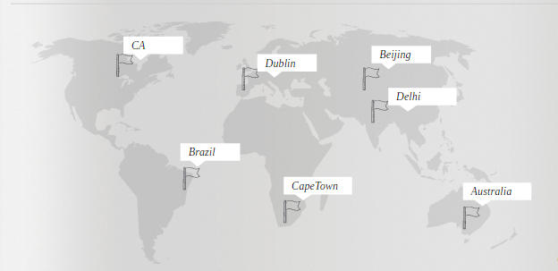

**Global Contact Information:**

|  |  |
| --- | --- |
| North America-Carlifonia | India-Delhi |
| 5453 Great America Parkway Santa Clara, CA 95054 Tel: +1-438-527-0500 R&D and Headquarters | Global Tech Park Tower A & B, 11th floor Marathahalli Outer Ring Road Devarabeesanahalli Village, Varthur Hobli, Delhi 560103 R&D Office |
| Ireland- Dublin | China-Beijing |
| 2 Georges Dock IFSC Dublin 1 Ireland | 15/F, China World Tower 3 1 Jianguomenwai Ave, Chaoyang District Beijing China 100004 |
| Australia-Melbourne | South Africa-Cape town |
| 600 Lorimer Street Port Melbourne  VIC  Australia 3207 | 5 Brewery Street, Isando,  Johannesburg  Gauteng |
| Brazil-Rio |  |
| R. Voluntarios da Patria  360 - Botafogo  Rio de Janeiro BR 22270-010 |  |

**Financial Information:**

Gross Annual Income for the last three years:

* Year 2013: 78 Million Dollars
* Year 2014: 1.7 Million Dollars
* Year 2015: 2.9 Million Dollars

With the innovations that I Focus Data is implementing and the customer satisfaction and trust it gained over the decade has helped it to achieve the above results.

**Partners:**

The service delivered by an organization is a function of not only the quality of the people and processes of that organization, but of their partners as well. I Focus Data aligns with like-minded data center partners who are focused on quality products and services, ethical operations, and a relentless focus on exceeding customer expectations.

I Focus Data believes strongly in partner collaboration and has developed one of the most admired partner ecosystems in the data center industry. Following are the list of partners who we do business with:

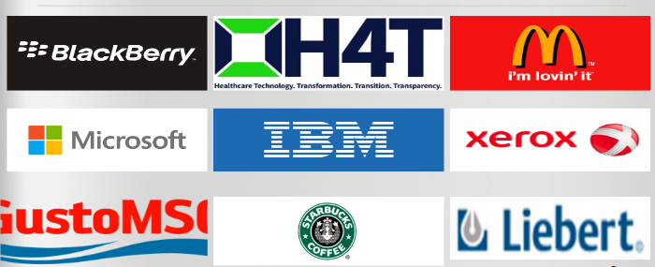

Our clients count on I Focus Data to provide a platform that allows them to meet their business needs both now and in the future. Our partners are an integral part of our premium customer service and performance and we dedicate significant resources to facilitate mutually beneficial relationships.

**Organization Chart:**

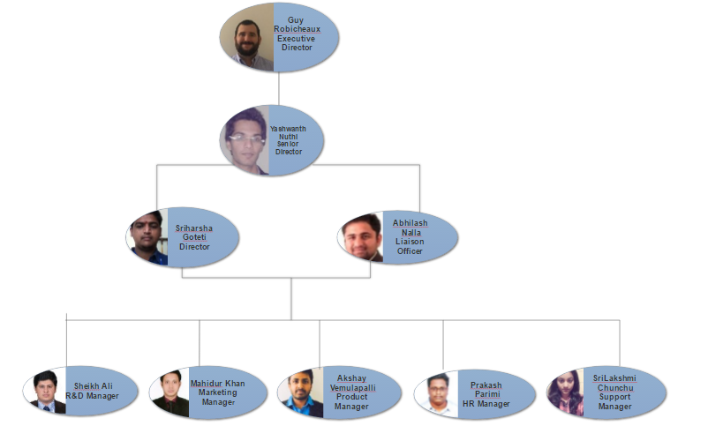

**Employee Breakdown:**

|  |  |  |  |
| --- | --- | --- | --- |
| Name | Job Title | Board | Remuneration |
| Peter Sedrak | President and Chief Executive Officer | Executive Board | 16,880,000USD |
| Guy M.Robicheaux | Executive Director | Non-Executive Board | 480,000USD |
| Yashwanth Gopi Nuthi | Senior Director | Non-Executive Board | 450,000USD |
| Abhilash Reddy Nalla | Liaison Officer | Non-Executive Board | 400,000USD |
| Srinivasa Sriharsha Goteti | Director | Senior Management | 350,000USD |
| Venkata Prakash Parimi | HR Manager | Senior Management | 350,000USD |
| Sheikh Ali Ahmed Faiz | Marketing Manager | Senior Management | 350,000USD |
| Mahidur R Khan | Sales Manager | Senior Management | 350,000USD |
| Akshay Kumar Vemulapalli | Product Manager | Senior Management | 350,000USD |
| Srilakshmi Chunchu | Customer Support Manager | Senior Management | 350,000USD |

**Contact List:**

|  |  |  |  |  |  |  |  |
| --- | --- | --- | --- | --- | --- | --- | --- |
| Name | Preferred Name | Language | Current Position | Preferred Method of contact | Latest Contact | Email Address | Phone Number |
| Pete Sedrak | Pete | Arabic,English,Egyptian (Coptic) | CEO | E-mail | 11:00 PM | pete.sedrak@valpo.edu | 219-663-6798 |
| Abhilash Reddy Nalla | Abhilash | English,Telugu,Hindi | Student | Email/Call | 10:00 PM | abhilashreddy.nalla@valpo.edu | 510-203-9653 |
| Akshay Kumar Vemulapalli | Akshay | English,Telugu | Student | Email | 10:00 PM | akshaykumar.vemulapalli@valpo.edu | 571-363-6304 |
| Guy M.Robicheaux | Guy | English | Student | Email | 11:00 PM | guy.robicheaux@valpo.edu | 337-321-2555 |
| Mahidur R Khan | Mahid | English, Bengali | Student | E-mail | 10.00 PM | mahidur.khan@valpo.edu | 773-754-6219 |
| Srilakshmi Chunchu | Siri | Telugu,English,kannada | Student | Email/Call | 10:00 PM | srilakshmi.chunchu@gmail.com | 361-474-3388 |
| Srinivasa Sriharsha Goteti | Goteti | Telugu,Hindi,English,tamil,kannada | Student | Email | 11:00 PM | srinivasasriharsha.goteti@valpo.edu | 480-603-6416 |
| Sheikh Ali Ahmed Faiz | Ali | Pushto, Urdu, English | Student | Email | 12:00 PM | sheikhaliahmed.faiz@valpo.edu | 586-265-3695 |
| Venkata Prakash Parimi | Prakash | English,Telugu | Student | Email | 10:00 PM | prakash.parimi@valpo.edu | 219-246-3463 |
| Yashwanth Gopi Nuthi | Yashwanth | English, Hindi, Telugu | Student | Email | 9.00 PM | yashwanthgopi.nuthi@valpo.edu | 219-707-3352 |

**Important Links:**

|  |  |
| --- | --- |
| Our Infrastructure | <https://www.ifocusdata.com/en/infrastructure> |
| Leave us a message | <https://www.ifocusdata.com/howarewedoing/> |
| Knowledge Base | <https://www.ifocusdata.com/kb/> |
| Video Library | <https://www.ifocusdata.com/en/company/news/video-library> |
| Events and Webinars | htps://www.ifocusdata.com/en/company/eventsandwebinars |
| Blogs | <https://www.ifocusdata.com/blogs/> |
| Testimonials | <https://www.ifocusdata.com/en/company/testimonals> |
| Careers | <https://www.ifocusdata.com/en/careers> |

**Business Solutions Through Data Centers**

**Final Report**

Prepared By: Sriharsha Goteti (Director: I Focus Data)

ADDRESS: 55453 Great America Parkway, Santa Clara, CA 95054

EMAIL: [contactus@ifocusdata.com](mailto:contactus@ifocusdata.com) | TELEPHONE: +1-438-527-0500

**Document Sign Off:** This document has been approved as the Final Report for the File Transfer Mechanism Risk Assessment and accurately reflects the current understanding of the project.

**Prepared by:**

**______________________________**

Sriharsha Goteti – I Focus Data Director

Date:1/12/2016

**Approved by:**

**______________________________**

Peter Sedrak – Master’s in Information Technology,

Date: 1/12/2016

Grace INC. CEO

**Executive Summary:**

I Focus Data business case has concluded that the overall net cost/benefit of a Project Spectra has produced tremendous results and is significantly exceeded the current projection. Initially, we were optimistic that the deployment phase would be valuable for successful strategy for the Spectra but due to the characteristics of product and the recommendations from the Grace Inc. study, this business case has identified a difference of $500K.

Technology investments are complex but difficult decisions were made within the strategic context of the I Focus Data. This business case process looked at many different options and consulted with other deployments within the management. The approach of this business case is comprehensive and looked beyond financial (quantifiable) estimates. It is important to note that the financial estimates are forecasts over a five-year term and are not guaranteed to occur. Hence, a risk assessment of the estimates was completed to account for potential future variability.

Although the data for business loss is collected in the field, there are no other characteristics that support the replacement of paper checklists to alleviate the situation.

**Introduction:**

The Grace Inc. systems were compromised along with the security systems and sensitive information went into wrong hands. Adding fuel to it, there was a pornographic image, videos floating around the organization’s workstations. In order to establish a bullet proof security system, Grace Inc. has reached out to I Focus Data. I Focus Data pioneer in providing the advanced security touches to the existing systems and building a robust system across the globe.

**Financial Costing Model:**

A good business plan should include far more than just a spreadsheet. Research and analysis should be undertaken to identify;

* Market potential
* Competitive landscape
* Regulatory issues
* Personnel requirements
* Capital expenses such as new equipment or machinery
* Inventory needed

This analysis is essential in order to determine cash resources required to meet objectives, profitability and return on investment. If done properly, the business plan becomes a dynamic tool that can be easily modified and updated as new information becomes available. This same tool becomes the foundation of securing debt and/or equity financing that may be needed to execute the plan.

**Financial Estimate:**

PPP Proxy: The PPP Proxy represents an estimate of the hypothetical, risk-adjusted whole-of-life cost of a public infrastructure project that is assumed for comparison purposes to be delivered by the private sector. The PPP Proxy will generally include risk-adjusted net present costs for capital delivery, lifecycle maintenance, the provision of ongoing operations / services, financing, and private sector value drivers. I Focus Data has a calculation of a PPP proxy model to estimate the potential service payments that would be required to meet construction, financing and lifecycle costs over the period of the operating term. Based upon the financial estimate technique PPP Proxy, I Focus Data was able to propose an original estimate of $11,000,000 million USD. Grace Inc. countered with a budget cut of 24% bringing the new budget $8,360,000 million USD.

**Requirements:**

* Environmentally Friendly (Solar power, daylight saving, eco space).
* LI FI (Evolving Technology).
* DCIM.
* High Advanced Tech (Google Fiber, IOT).
* Cooling System for Cloud or Data Center identified based on effective utilization.
* URL DOG (common on all packages) Certified dog with a trainer.

**Efficient Strategies for Grace Inc.:**

Data breach happened in Grace Inc. has served us an opportunity to enhance the security systems and provide bullet proof infrastructure to them. This opportunity paved a way to build trust and showcase our abilities to giants like Grace Inc. As a company we strive hard to meet the requirements of our client and is no same with Grace Inc. Following strategies should help achieve a successful relationship and also alleviate the smoke surrounded around Grace Inc.:

**Strategy 1:**

* Environmentally Friendly.
* WIFI (1.0 GHz/Sec).
* DCIM (Driving Energy).
* High Advanced Tech (Google Fiber).
* Cooling System (DX System).
* Data Center.
* URL DOG: Feature with scent-tracking dog.
* Locations: Europe.

**Strategy 2:**

* Environmentally Friendly.
* LI FI (1.6 GHz/sec).
* DCIM (Reduce downtime & increase bandwidth).
* High Advanced Tech (IOT).
* Cooling System (Non-DX System).
* Cloud Architecture.
* URL DOG: Feature with scent-tracking dog.
* Locations: United States of America.

**Strategy 3:**

* Environmentally Friendly.
* LI FI (0.8 GHz/sec).
* DCIM (Bandwidth consumption and energy evolving).
* High Advanced Tech (IOT).
* Cooling System (Non-DX System).
* Cloud & Data Center.
* URL DOG: Feature with scent-tracking dog.
* Locations: Asia.

Out of the above three strategies, I Focus Data recommend the second strategy as it suffice the needs of Grace Inc. and also its cost efficient for both the parties.

**Metrics Involved:**

* Schedule and Effort/Cost Variance
* Productivity: Resource Utilization
* Change requests to Scope of work
* Quality and Customer Satisfaction
* Gross Margin

**Risk assessment and Mitigations:**

A framework for benchmarking a future data center’s operational performance is essential for effective planning and decision making. Currently available criticality or tier methods do not provide defensible specifications for validating data center performance. An appropriate specification for data center criticality should provide unambiguous defensible language for the design and installation of a data center. Following techniques help I Focus Data analyze and compares existing tier methods, describes how to choose a criticality level, and proposes a defensible data center from threats. Maintaining a data center’s criticality is also discussed.

**SWOT**

* Strengths
* Weakness
* Opportunities
* Threats

**PEST**

* Political
* Economic
* Social
* Technological

**For more information: https://www.ifocusdata.com/riskassessment**

**Post project evaluation:**

Up on completion of every project, our team will do a project evaluation which emphasizes our opportunities for further projects and share the key takeaways for our organization betterment.

* Overall Project Assessment
* Scope Management
* Quality of Deliverables
* Key Accomplishments
* Lesson Learned
* Opportunities for Improvement
* Future Considerations
* Best Practices

Key Takeaways from Spectra are:

* Machine Learning to automate the operation activities
* LIFI Integration to reduce the environmental pollution
* Equivalency Coefficient for better infrastructure scaling
* Robotics Implementation for maintain efficient cooling systems

Thanks all for your cooperation in driving the Project **Spectra**

**Project Charter**

ADDRESS: 55453 Great America Parkway, Santa Clara, CA 95054

EMAIL: [contactus@ifocusdata.com](mailto:contactus@ifocusdata.com) | TELEPHONE: +1-438-527-0500

**Project Spectra**

# **Project charter Version: Final**

This document will explain the Spectra project for Grace Inc. that I Focus Data is performing as a subsidiary of Best Basket Inc.

**Table of Contents**

|  |  |
| --- | --- |
| Title | Page |
| Project Information | 3 |
| Project Description and Background | 4 |
| Challenges and Opportunities | 4 |
| Desired Project Impact | 5 |
| Project Measurable Organizational Value (MOV)And Project Scope | 6 |
| Scope Expectations | 7 |
| Project Requirement | 8 |
| Initial Requirements Budget | 9 |
| Revised Requirement Budget | 10 |
| Phase Breakdown and Budget | 11 |
| Phase Breakdown and Budget (Continued) | 12 |
| Vendor and Resource Provided | 13 |
| Date of Service Provided | 14 |
| Assumptions of Risk | 15 |
| Quality Management Plan | 15 |
| Change Management and Communication Plan | 16 |
| Project Administration and 2-way Communication Chart | 17 |
| Communication Plan Summary | 18 |
| Implementation and Closure | 18 |
| Signoff and Approvals | 19 |
| Glossary | 20 |
| Glossary (Continued) | 21 |

**Project Information**

**Project ID: Spectra**

**Stakeholders:**

**Peter Sedrak**

CEO Grace Incorporated

Phone: (219) 663-6798

Email: [pete.sedrak@valpo.edu](mailto:pete.sedrak@valpo.edu)

**Chakradhara (Chakri) V. Konduru**

CEO Best Basket Incorporated

(219) 916-9135

Email: [chakradhara.konduru@valpo.edu](mailto:chakradhara.konduru@valpo.edu)

**Guy Robicheaux**

Executive Director I Focus Data

Phone: (337) 321-2555

Email: [guy.robicheaux@valpo.edu](mailto:guy.robicheaux@valpo.edu)

**Project Description and Background**

**Project Description:**

To improve the following for Grace INC: security, storage, eco-friendly buildings, and highly robust systems and architecture.

**Background:**

Grace Inc. initially approached I Focus Data on 9/22/2016 about performing the Grace security initiative. Grace Inc. servers and systems were hacked effectively causing a security breach of their technology and sensitive information was stolen. Also, many system and servers were infiltrated with pornographic videos and images, subjecting Grace Inc. to spyware and malware.

**Challenges and Opportunities:**

As a result of the interview with Grace Inc. I Focus Data is presented with unique opportunity to improve an organization’s security integrity and its overall operational efficiency. We will be providing highly advanced technology for the Grace Inc. project, so it will be a continuous challenge to ensure we do not go over budget. It will also be important to make sure our technology will be top of the line for years to come and won’t be surpassed in the near future.

**Desired Project Impact**

The desired impact of this project is to not only increase the operational security of Grace Inc., but it is to also add value of the organization. Spectra should provide Grace Inc. with a return on its investment to the tune of increased profitability in all aspects of the company. The systems I Focus Data will provide will undoubtedly increase the efficiency of day to day operations within Grace Inc. Internally, the impact of Spectra will allow I Focus Data to brand itself as a top of the line IT Data company for years to come. A successful project will allow I Focus to increase its footprint within the industry, in addition to targeting bigger and more challenging projects in the future.

**Project Measurable Organizational Value (MOV)**

**And Project Scope**

**Project MOV**

I Focus Data will build Grace Inc. a data storage option that will improve security by 99.9% from the start to end of the project. Options will be via Data Center or a cloud that will include and efficient and environmentally friendly infrastructure, using high advanced technology within a year of project start date. This project will succeed if it provides Grace Inc. with a 99.9% security increase and conversely it will fail if it only improves security by 99.8%.

**Project Scope**

**Inside**

1. Secure Data
2. Storage options
3. Highly robust systems and technology
4. Architecture of the data systems
5. Efficient buildings

**Outside**

Grace Inc. approached I Focus Data through a stakeholder about installing an Equivalency Coefficient on each pc and server after the project contract was official. I Focus Data politely declined, and both companies have agreed to make this a priority in the next project they work on together.

**Scope Expectations**

**Exceed:**

This project will exceed expectations for Grace Inc., Best Basket, and I Focus Data, if it is complete within 1 years’ time, and beneath budget. It will also exceed the organizations’ expectations if 100% security can be provided by the services provided by I Focus Data and its vendors.

**Meet:**

Spectra will meet all organizations’ expectations if it is completed within the given timeframe of 1 year and if it is within the given budget of $8.36 Million USD. Spectra will also meet the expectations if it provides 99.9% to Grace Inc.

**Not Met:**

Spectra will fall short of the organizations’ expectations if it simply does the job of fulfilling the requirements laid out by Grace Inc. without improving or adding any organizational value to Grace as a company.

**Requirements**

The requirements for the Spectra project laid out by Grace Inc. are listed below. I Focus Data will oversee the contracting of outside vendors to provide the services and resources for Grace Inc.

1. Environmentally Friendly

2. LI FI

3. DCIM

4. High Advanced Tech (Google Fiber, IOT)

5. Cooling System

6. Cloud or Data Center

7. URL DOG

**Initial Requirement Budget**

The initial budget breakdown of the project by the 7 requirements is displayed in the figure below.

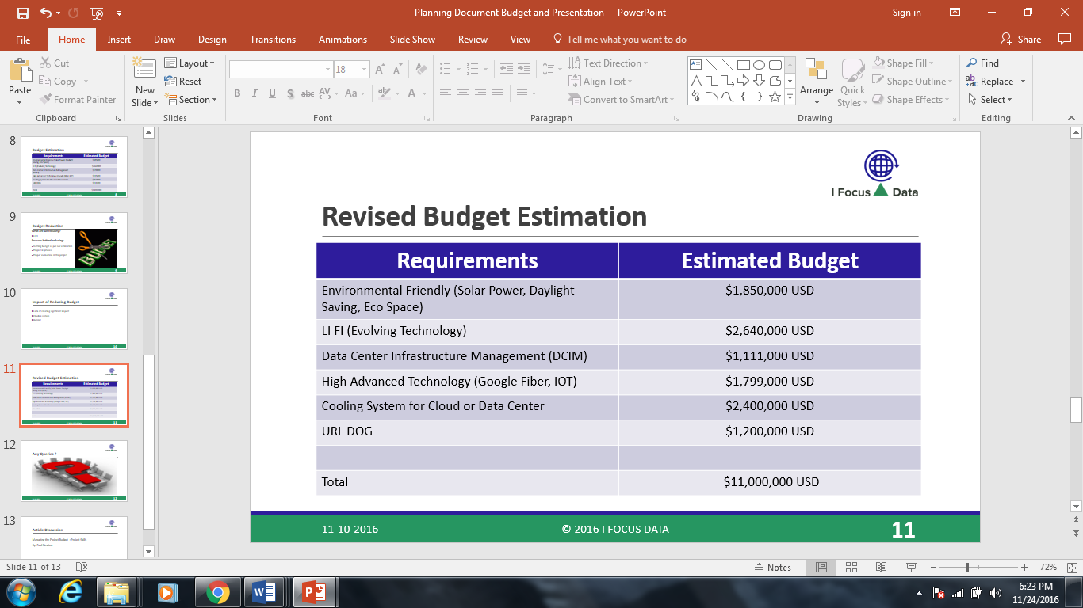

Figure 1.0

**Revised Requirement Budget**

Due to the unavailability of LIFI technologies and no vendors willing to provide service to our project, I Focus Data and Grace Inc. agreed to remove LIFI from the requirements. Instead I Focus will use and improve upon the WIFI networks in place. The subtraction of LIFI from the budget in turn reduced the cost to $8,360,000 million USD, or 24 % percent. Figure 2.0 explains the cut, as well as the budget before, and after.

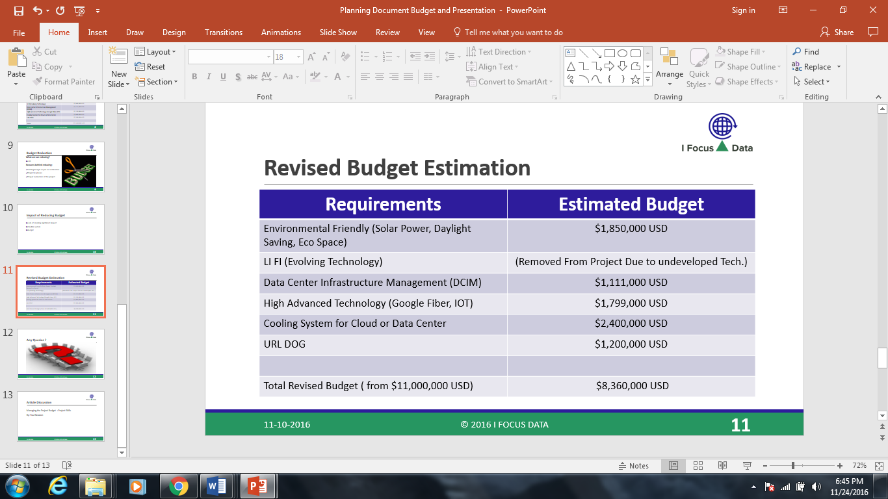

Figure 2.0

**Phase Breakdown and Budget**

**Phase I**

Phase I will consist of the Data Center/Cloud setup and the infrastructure management portion of the Spectra Project. Figure 3.0 breaks down the cost of each requirement in Phase I and the total cost of Phase I.

|  |  |  |
| --- | --- | --- |
| **Project Requirement** | **Phase of Project** | **Cost** |
| Cooling System and Data Center | Phase I | $ 2,400,000 Million USD |
| DCIM (Data Center Infrastructure Management) | Phase I | $ 1,111,000 Million USD |
|  |  |  |
| Total |  | $3,511,000 Million USD |

Figure 3.0

**Phase II**

Phase II will consist of the security and technology portion of the Spectra project. Figure 4.0 breaks down the cost of each requirement in Phase II and the total cost of Phase II.

|  |  |  |
| --- | --- | --- |
| **Project Requirement** | **Phase of Project** | **Cost** |
| High Advanced Technology | Phase II | $ 1,799,000 Million USD |
| URL Dog | Phase II | $ 1,200,000 Million USD |
|  |  |  |
| Total |  | $2,999,000 Million USD |

Figure 4.0

**Phase III**

Phase III will consist of the Environmental Friendly portion of the Spectra Project. Figure 5.0 breaks down the cost of each requirement in Phase III and the total cost of Phase III.

|  |  |  |
| --- | --- | --- |
| **Project Requirement** | **Phase of Project** | **Cost** |
| Environmental Friendly | Phase III | $1,850,000 Million USD |
|  |  |  |
| Total |  | $1,850,000 Million USD |

Figure 5.0

**Vendor and Resource Breakdown**

I Focus Data will contract the scope requirements of the Spectra project to various vendors. These vendors will perform services within the standards and specifications as required by Grace Inc., and I Focus Data. I Focus Data is contractually obligated to ensure that these standards and specifications are met. If anything is deemed out of spec, the scope of the project will be evaluated and changed until the standards and specifications promised are met.

|  |  |
| --- | --- |
| **Vendor** | **Resource Provided** |
| SUNPOWER by South Coast Solar | Solar Energy (Environmental Friendly) |
| IT Watch Dogs | URL Dog (Security) |
| Google Fiber | Google Fiber (High Advanced Technology) |
| Green House Data | Data Center/Cloud |
|  | Cooling System |
| Raritan | DCIM |
| PureLIFI | LIFI |

Figure 6.0

**Date of Service Provided**

The following is a tentative schedule of the services provided by I Focus Data to Grace Inc., through its vendors. The dates are subject to change due to the progress of the project. Each vendor has given an estimate of how long it would take for service to be provided. The Project Management Team will need to properly coordinate with each vendor to ensure the service can be provided efficiently without interfering with other aspects of the Spectra project.

|  |  |
| --- | --- |
| **Resource Provided** | **Date to be provided** |
| Solar Energy (Environmental Friendly) | September 2017 |
| URL Dog (Security) | April 2017 |
| Google Fiber (High Advanced Technology) | April 2017 |
| Data Center/Cloud | February 2017 |
| Cooling System | February 2017 |
| DCIM | February 2017 |
| LIFI | N/A (removed from project due to budget cuts) |

Figure 6.0

**Assumptions of Risks**

Throughout the course of doing a project this size, risks can occur. However, identifying risks ahead of time with a little foresight can help develop a plan to mitigate these risks. The management plan will be detailed later in the document. I Focus Data has identified the following to be the biggest risks to the Spectra project and its deliverable results.

* Rapidly developing technology out-dates the one being installed for Grace Inc.
* Falling outside of scope due to changes or requests by client and parent company.
* Going over budget due to various inspections and services that are provided by outside vendors.
* Other projects may be contracted by I Focus Data while Spectra is in progress. It will be I Focus Data’s responsibility to maintain 100% on the Spectra project no matter what other projects are going on.

**Quality Management Plan**

In addition to I Focus Data assigning personnel to monitoring the quality of the project, Grace Inc. has been invited to house a stakeholder onsite until the project is complete. This will increase communication with the client, in addition to internal communications within Best Basket and I Focus Data. Grace Inc. being on site will also place a heightened sense of awareness of sub-contractors who are on site performing services for the Spectra project.

**Change Management and Communication Plan**

To better manage any changes that may occur during the commencement of the Spectra project, I Focus Data proposes the following chain of hierarchy on any issues that occur during the installation of this project. I Focus Data has also proposed internally to the Best Basket board that all meetings regarding the status of the project include Guy Robicheaux, Yashwanth Gopi, Abhilash Reddy, or Harsha Goteti. The previously mentioned names are involved with the day to day operations of the Spectra project and involving them in the meetings shortens the distance pertinent information needs to travel in the even an issue arises.

In addition to the above, the following order will be the communication plan internally within I Focus.

* All managers will report to Harsha Goteti who is currently serving as Director.
* Harsha Goteti will report to Yashwanth Gopi who is currently Sr.Director.
* Yashwanth Gopi will report to Guy Robicheaux who is currently the Executive Director.

In the event of an emergency with personnel Abhilash Reddy should be consulted as he is the Liaison Officer at I Focus Data. Abhilash Reddy will also be prepared to fill in should any of the other directors be unavailable. Regardless, he will be briefed and updated, so he can be prepared to fill any need the project should have.

**Project Administration and 2 Way Communication**

**Grace Inc.**

**Best Basket Stakeholders**

**I Focus Data**

**Director**

**Liaison Officer**

**Sr. Director**

**Dept. Managers**

Figure 7.0

**Communication Plan Summary**

Grace Inc. will communicate to the project shareholders within corporate first. After corporate digests the information and they send it down the ladder, it will then go to the I Focus Executive Director. After the information is within I Focus Data, the Executive Director will assign tasks to the Sr. Director, Director, and Liaison Officer. Finally, the latter positions will communicate and further assign tasks to the department managers and their teams where appropriate.

**Implementation and Closure**

As the project is nearing completion, I Focus Data will conduct a closeout survey a maximum of 3 weeks of project completion with the client. Once it is confirmed that all deliverables and milestones have been met, I Focus Data will then close the project. The post-project survey will gauge overall satisfaction of the work I Focus Data has provided. This will also help I Focus Data grow and improve its brand as it continues to perform major projects in the IT industry.

**Signoff and Approvals**

**Client Approval**

Client Title and Print Sign Date

**Corporate Approval**

Corporate Title and Print Sign Date

**I Focus Data Approval**

I Focus Data Title and Print Sign Date

**Glossary**

**Acceptance Criteria:** those criteria, including performance requirements and essential conditions that must be met before the project deliverables are accepted.

**Communications Management Plan:** a document that describes the communications needs for a project. It describes:

* how, when, and in what form project information will be distributed
* who will receive the information and the kinds they will receive.
* who is responsible for preparing the information

**Deliverable:** any measurable, tangible, verifiable outcome, result, or item that must be produced to complete a project milestone.

**Project:** a temporary and one-time undertaking that has the following five characteristics:

* is a one-time event
* creates unique products or services
* has time and cost constraints
* is completed against certain specifications (requirements)
* has a defined start and end date
* consumes resources (e.g., money, people, material, and equipment)

**Project Requirement:** a function or condition that must be met by a product, system, or service as specified in the project plans and contracts.

**Project Scope:** defines the boundaries of the project. The scope describes what will be delivered where, when, and how. It describes the services, functions, systems, solutions, or tangible products for which the sponsor will take delivery. The scope should include:

* the major objectives that the project is expected to accomplish
* the key time, financial, technical, and legal constraints
* the significant assumptions

**Project Team:** a group of people working together on a common goal, the accomplishment of a successful project. Typically, a project team consists of a project manager and one or more subject matter experts divided into three to twelve core and extended team members.

**Risk Management:** a structured approach to managing project uncertainty through a sequence of activities including risk identification and assessment. Project team members develop strategies to manage and mitigate risks based upon the probability of the risk occurring and the impact to the project if the risk event occurs.

**Stakeholder:** any person or group that is affected by the execution and success or failure of a project. This includes team members, resource owners, end users, and operational owners of the project outcomes. A project's sponsor is the most important stakeholder.

**Task:** an action necessary to achieve a project milestone. The work involved to achieve a task is further broken out into activities.

**Work Breakdown Structure (WBS):** a project management tool used to divide the total project scope into manageable pieces of work. It is typically presented as an outline or a tree diagram. The higher levels of a WBS describe deliverables and planned outcomes, and the lowest level of the WBS describe the tasks required to complete the deliverables and outcomes. The work breakdown structure is used to create the work schedule.

**Work Schedule:** a project document that describes the milestones, tasks, activities, deliverables, and related information that are significant to the project. These key elements of a project work schedule must be completed on-time and on-budget for a project to be successful and therefore require monitoring by the project manager and stakeholders. The status of the project work schedule is reported in the project status report.

**Glossary Source:**

<https://technology.berkeley.edu/tpo/glossary>

# PROJECT SPECTRA PLANNING

Creation Date: 11/25/2016 Version: Final

ADDRESS: 55453 Great America Parkway, Santa Clara, CA 95054

EMAIL: [contactus@ifocusdata.com](mailto:contactus@ifocusdata.com) | TELEPHONE: +1-438-527-0500

**Project Planning:**

Project Name: Spectra

Date: November 25th, 2016

Plan Release #: Final

Project Executive Director: Guy Robicheaux

**Sign off and Approvals**

## Client Approval

Client Title and Print Sign Date

## Corporate Approval

Corporate Title and Print Sign Date

### I Focus Data Approval

I Focus Data Title and Print Sign Date

**Purpose of Plan:**

The Project Spectra Plan will provide a definition of the project, including the project’s goals and objectives. Additionally, the Plan will serve as an agreement between the following parties: Project Sponsor, Project Manager, Project Team, and other personnel associated with and/or affected by the project.

**The Project Plan defines the following:**

* Project purpose
* Business and project goals and objectives
* Scope and expectations
* Roles and responsibilities
* Assumptions and constraints
* Project management approach
* Ground rules for the project
* Project timeline

**Background Information:**

Grace Inc. initially approached I Focus Data on 9/22/2016 about performing the Grace security initiative. Grace Inc. servers and systems were hacked effectively causing a security breach of their technology and sensitive information was stolen. Also, many system and servers were infiltrated with pornographic videos and images, subjecting Grace Inc. to spyware and malware.

**Project Approach:**

This section outlines the way I Focus Data will roll out the project, including the highest-level milestones.

Phases:

|  |  |
| --- | --- |
| Phase I: | Secure agreement with client |
| Phase II: | Install Equipment |
| Phase III: | Install/Test Software |
| Phase IV: | Conduct Hardware/Software Testing |
| Phase V: | Conduct Training |
| Phase VI: | Implementation and Reporting |

**Goals and Objectives:**

Business Goals and Objectives

The business goals and objectives for this project will focus on implementing following goals that:

* Improve safety and security.
* Facilitates coordination and information sharing both internal and external to the participating organizations.
* Enhances the ability and effectiveness of staff to perform their jobs.
* Facilitates coordinated crime prevention and reduction.
* Provides high levels of data security.
* Provides an open, flexible, reliable technology base for the future.
* Facilitates the electronic capture of data at its source.
* Is easy to use.
* Eliminate redundant data entry throughout the organization.

**Risk Assessment:**

The initial **Risk Assessment** (following page) attempts to identify, characterize, prioritize, and document a mitigation approach relative to those risks which can be identified prior to the start of the project.

The **Risk Assessment** will be continuously monitored and updated throughout the life of the project, with monthly assessments included in the status report (see **Communications Plan**) and open to amendment by the Project Manager.

Because mitigation approaches must be agreed upon by project leadership (based on the assessed impact of the risk, the project’s ability to accept the risk, and the feasibility of mitigating the risk), it is necessary to allocate time into each Steering Committee meeting, dedicated to identifying new risks and discussing mitigation strategies.

The Project Manager will convey amendments and recommended contingencies to the Steering Committee monthly, or more frequently, as conditions may warrant.

**Initial Project Risk Assessment:**

|  |  |  |  |
| --- | --- | --- | --- |
| **Risk** | **Risk Level L/M/H** | **Likelihood of Event** | **Mitigation Strategy** |
| **Project Size** |  |  |  |
| Person Hours | **H:** Over 20,000 | **Certainty** | Assigned Project Manager, engaged consultant,  comprehensive project  management approach and communications plan |
| Estimated Project Schedule | **H:** Over 12 months | **Certainty** | Created comprehensive project timeline with frequent baseline  reviews |
| Team Size at Peak | **H:** Over 15 members | **Certainty** | Comprehensive communications plan, frequent meetings, tight project management oversight |
| Number of Interfaces to Existing Systems Affected | **H:** Over 3 | **Certainty** | Develop interface control document immediately |
| **Project Definition** |  |  |  |
| Narrow Knowledge Level of  Users | **M:** Knowledgeable of user area only | **Likely** | Assigned Project Manager(s) to assess global implications |
| Available documentation clouds establishment of  baseline | **M:** More than 75% complete/current | **Likely** | Balance of information to be gathered by consultant |
| Project Scope Creep | **L:** Scope generally defined, subject to revision | **Unlikely** | Scope initially defined in project plan, reviewed monthly by three groups (Project Manager and  Steering Committee) to prevent undetected scope creep |
| Consultant Project Deliverables unclear | **L:** Well defined | **Unlikely** | Included in project plan, subject to amendment |
| Vendor Project Deliverables | **M:** Estimated, not clearly defined | **Somewhat likely** | Included in project plan, subject to amendment |
| Cost Estimates Unrealistic | **L**: Thoroughly predicted by industry experts  using proven practices to 15% margin of error | **Unlikely** | Included in project plan, subject to amendment as new details  regarding project scope are  revealed |
| Timeline Estimates Unrealistic | **M:** Timeline assumes no derailment | **Somewhat likely** | Timeline reviewed monthly by three groups (Project Manager and Steering Committee) to  prevent undetected timeline departures |
| Number of Team Members  Unknowledgeable of Business | **L**: Team well versed in business operations impacted by technology | **Unlikely** | Project Manager and consultant to identify knowledge gaps and provide training, as necessary |
| **Project Leadership** |  |  |  |
| Steering Committee existence | **L:** Identified and enthusiastic | **Unlikely** | Frequently seek feedback to ensure continued support |
| Absence of Commitment  Level/Attitude of Management | **L:** Understands value & supports project | **Unlikely** | Frequently seek feedback to ensure continued support |
| **Risk** | **Risk Level L/M/H** | **Likelihood of Event** | **Mitigation Strategy** |
| Absence of Commitment Level/Attitude of Users | **L:** Understands value & supports project | **Unlikely** | Frequently seek feedback to ensure continued support |
| Absence of Mid-  Management Commitment | **L:** Most understand value & support project | **Unlikely** | Frequently seek feedback to ensure continued support |
| **Project Staffing** |  |  |  |
| Project Team Availability | **M:** Distributed team makes availability questionable | **Somewhat likely** | Continuous review of project momentum by all levels.  Consultant to identify any impacts caused by unavailability. If  necessary, increase commitment by participants to full time status |
| Physical Location of Team prevents effective management | **M:** Team is dispersed among several sites | **Likely** | Use of Intranet project website, comprehensive Communications Plan |
| Project Team’s Shared  Work Experience creates poor working relationship | **M:** Some have worked together before | **Somewhat likely** | Comprehensive Communications  Plan |
| Weak User Participation on Project Team | **L:** Users are part-time team members | **Unlikely** | User Group Participants coordinated by full time employee |
| **Project Management** |  |  |  |
| Procurement  Methodology Used foreign to team | **L:** Procurement  Methodology familiar to team | **Unlikely** | N/A |
| Change Management Procedures undefined | **L:** Well-defined | **Unlikely** | N/A |
| Quality Management Procedures unclear | **L:** Well-defined and accepted | **Unlikely** | N/A |
| **Software Vendor** |  |  |  |
| Number of Times Team  Has Done Prior Work with  Vendor Creates Foreign Relationship | **H:** Never | **Certainty** | A comprehensive vendor evaluation and selection process  (incorporated into Project Plan) will be employed to predict and define the relationship between the department and the vendor |
| Team’s Lack of Knowledge of Package | **M:** Conceptual understanding | **Somewhat likely** | Comprehensive vendor evaluation and selection process incorporated into Project Plan will assist the  team in better understanding the package offering(s) |
| Poor Functional Match of  Package to Initial System Requirements | **L:** Minimal customization required | **Unlikely** | Although a package has not yet been selected, the Consultant has compared the initial requirements with available functionality and  determined that a functional match  to the initial requirements is very likely. Vendor selection will be  based, in part, on how well the proposed application matches defined functional specifications. |

**Assumptions:**

**Project Assumptions:**

The following assumptions were made in preparing the Project Plan:

* Employees are willing to change business operations to take advantage of the functionality offered by the new technology.
* Management will ensure that project team members are available as needed to complete project tasks and objectives.
* The Steering Committee will participate in the timely execution of the Project Plan (i.e., timely approval cycles and meeting when required).
* Failure to identify changes to draft deliverables within the time specified in the project timeline will result in project delays.
* Project team members will adhere to the Communications Plan.
* Mid and upper management will foster support and “buy-in” of project goals and objectives.
* The City will ensure the existence of a technological infrastructure that can support the new technology.
* All project participants will abide by the guidelines identified within this plan.
* The Project Plan may change as new information and issues are revealed.

**Constraints:**

**Project Constraints**:

The following represent known project constraints:

* Project funding sources are limited, with no contingency.
* Due to the nature of law enforcement, resource availability is inconsistent.

**Critical Project Barriers:**

Unlike risks, critical project barriers are insurmountable issues that can be destructive to a project’s initiative. In this project, the following are possible critical barriers:

* Removal of project funding
* Natural disasters or acts of war

Should any of these events occur, the Project Plan would become invalid.

**Project Management Approach:**

**Project Timeline:** 12 Months

**Project Roles and Responsibilities:**

|  |  |  |  |
| --- | --- | --- | --- |
| **Role** |  | **Responsibilities** | **Participant(s)** |
| Project  Sponsor | ▪  ▪  ▪ | Ultimate decision-maker and tie-breaker  Provide project oversight and guidance  Review/approve some project elements | **Peter Sedrak**  CEO Grace Inc. |
| Steering Committee | ▪  ▪  ▪  ▪  ▪ | Commits department resources.  Approves major funding and resource allocation strategies, and significant changes to funding/resource allocation  Resolves conflicts and issues  Provides direction to the Project Manager Review project deliverables | **Guy Robicheaux**  Executive Director I Focus Data |
| Project  Manager | ▪  ▪  ▪  ▪  ▪  ▪  ▪  ▪  ▪ | Manages project in accordance to the project plan  Serves as liaison to the Steering Committee  Receive guidance from Steering Committee  Supervises consultants  Supervise vendor(s)  Provide overall project direction  Direct/lead team members toward project objectives  Handle problem resolution  Manages the project budget | **Srinivasa Sriharsha Goteti**  Director I Focus Data |
| Project Participants | ▪  ▪  ▪  ▪  ▪  ▪  ▪  ▪  ▪  ▪ | Understand the user needs and business processes of their area  Act as consumer advocate in representing their area  Communicate project goals, status and progress throughout the project to personnel in their area  Review and approve project deliverables  Creates or helps create work products  Coordinates participation of work groups, individuals, and stakeholders  Provide knowledge and recommendations  Helps identify and remove project barriers  Assure quality of products that will meet the project goals and objectives | **I Focus Data** |

**Issue Management:**

The information contained within the Project Plan will likely change as the project progresses. While change is both certain and required, it is important to note that any changes to the Project Plan will impact at least one of three critical success factors: Available Time, Available Resources (Financial, Personnel), or Project Quality. The decision by which to make modifications to the Project Plan (including project scope and resources) should be coordinated using the following process:

|  |  |
| --- | --- |
| **Step 1:** As soon as a change which impacts project scope, schedule, | |
|  | staffing or spending is identified, the Project Manager will document the issue. |
| **Step 2:** | The Project Manager will review the change and determine the associated impact to the project and will forward the issue, along with a recommendation, to the Steering Committee for review and decision. |
| **Step 3:** | Upon receipt, the Steering Committee should reach a consensus opinion on whether to approve, reject or modify the request based upon the information contained within the project website, the  Project Manager’s recommendation, and their own judgment. Should the Steering Committee be unable to reach consensus on the approval or denial of a change, the issue will be forwarded to the Project Sponsor, with a written summation of the issue, for ultimate resolution. |
| **Step 4:** | If required under the decision matrix or due to a lack of consensus, the Project Sponsor shall review the issue(s) and render a final decision on the approval or denial of a change. |
| **Step 5:** | Following an approval or denial (by the Steering Committee or Project Sponsor), the Project Manager will notify the original requestor of the action taken. There is no appeal process. |

**Communications Plan:**

Disseminating knowledge about the project is essential to the project’s success. Project participants desire knowledge of what the status of the project is and how they are affected. Furthermore, they are anxious to participate. The more that people are educated about the progress of the project and how it will help them in the future, the more they are likely to participate and benefit.

This plan provides a framework for informing, involving, and obtaining buy-in from all participants throughout the duration of the project.

**Audience:** This communication plan is for the following audiences:

* Project Sponsor
* Steering Committee
* Project Manager
* User Group Participants  Subject Matter Experts

**Communications Methodology:**

The communications methodology utilizes three directions for effective communication:

**Top-Down:** It is absolutely crucial that all participants in this project sense the executive support and guidance for this effort. The executive leadership of the organization needs to speak with a unified, enthusiastic voice about the project and what it holds for everyone involved. This will be 'hands-on' change management, if it is to be successful. Not only will the executives need to speak directly to all levels of the organization, they will also need to listen directly to all levels of the organization, as well.

The transition from the project management practices of today to the practices envisioned for tomorrow will be driven by a sure and convinced leadership focused on a vision and guided by clearly defined, strategic, measurable goals.

**Bottom-Up:** To ensure the buy-in and confidence of the personnel involved in bringing the proposed changes to reality, it will be important to communicate the way in which the solutions were created. If the perception in the organization is that only the Steering Committee created the proposed changes, resistance is likely to occur. However, if it is understood that all participants were consulted, acceptance seems more promising.

**Middle-Out:** Full support at all levels, where the changes will have to be implemented, is important to sustainable improvement. At this level (as with all levels), there must be an effort to find and communicate the specific benefits of the changes. People need a personal stake in the success of the project management practices.

**Communications Outreach:**

The following is a list of communication events that are established for this project:

**Monthly Status Reports:** The Project Manager shall provide monthly written status reports to the Steering Committee. The reports shall include the following information tracked against the Project Plan:

* Summary of tasks completed in previous month
* Summary of tasks scheduled for completion in the next month
* Summary of issue status and resolutions

**Monthly Steering Committee Meeting:** These status meetings are held at least once per month and are coordinated by the Project Manager. Every member of the Steering Committee participates in the meeting. The Project Manager sends the status report to each member of the team prior to the meeting time so everyone can review it in advance.

**Bi-Monthly Project Team Status Meeting:** These status meetings are held every other month. Every member of the Project Team will be invited to participate in the meeting. Project Manager sends the status report to each member of the team prior to the meeting so everyone can review it in advance.

**Website Use:** User Group Participants and Subject Matter Experts may be updated monthly at the discretion of the Project Manager. Information will be posted to the project’s website.

SWOT ANALYSIS:

Creation Date: 11/25/2016 Version: Final

ADDRESS: 55453 Great America Parkway, Santa Clara, CA 95054

EMAIL: [contactus@ifocusdata.com](mailto:contactus@ifocusdata.com) | TELEPHONE: +1-438-527-0500

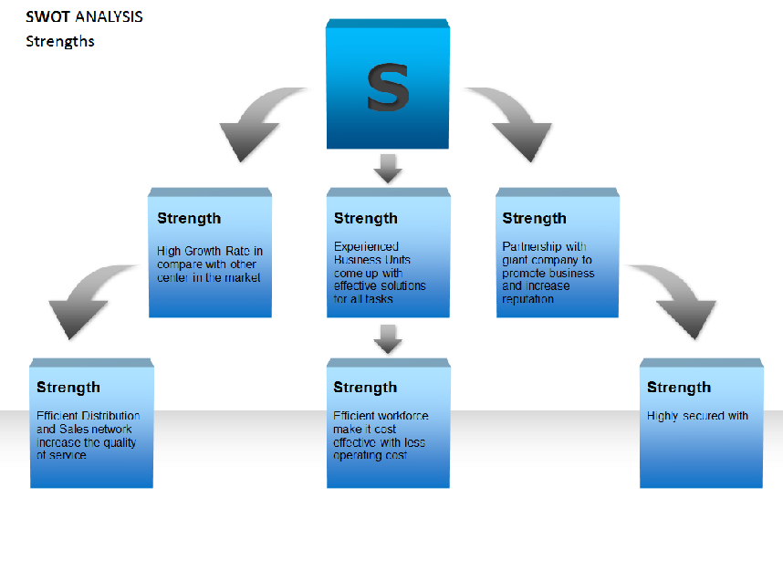

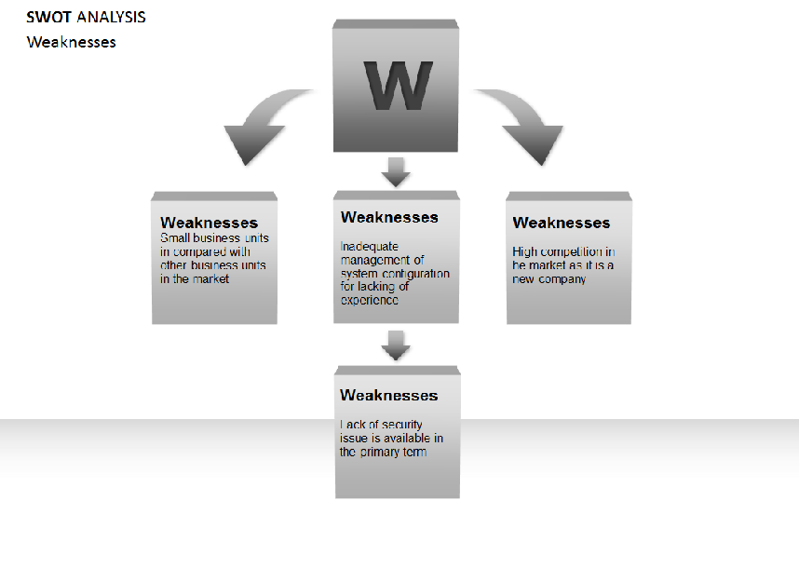

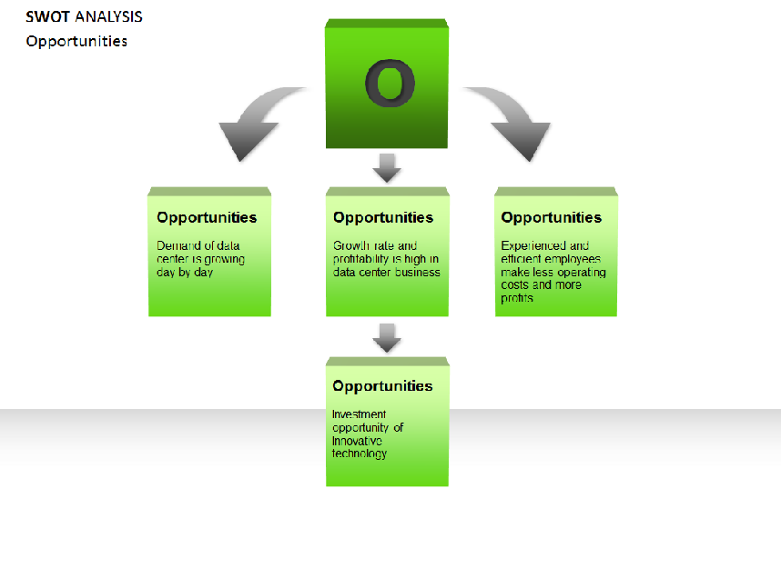

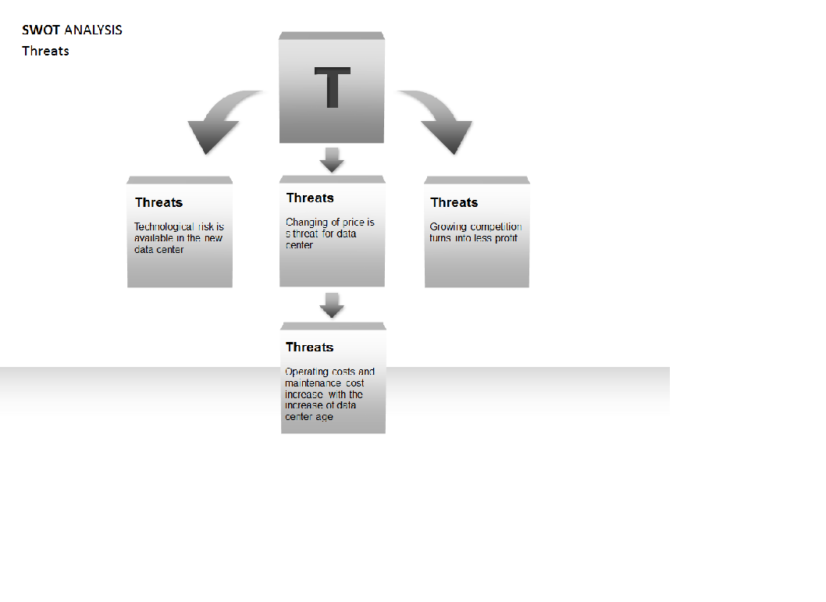

# PROJECT CLOSE OUT

Creation Date: 12/01/2016 Version: Final

ADDRESS: 55453 Great America Parkway, Santa Clara, CA 95054

EMAIL: [contactus@ifocusdata.com](mailto:contactus@ifocusdata.com) | TELEPHONE: +1-438-527-0500

# Project Close-Out

# Version <2.0>

# <12/01/2016>

##### VERSION HISTORY

Grace Inc., with help of Best Basket, subsidiary with I Focus Data has designed a system for the organization security of content and brought its project for **Project Close Out**, up to the final point of approval, was controlled and tracked.

Here is the tabular description of the version of our project status moved in status which ensured for success and gain highest revenue for the organization for Grace Inc., and satisfying the requirements of security of content from pornographic identification and maintaining content distribution for safe content.

|  |  |  |  |  |  |
| --- | --- | --- | --- | --- | --- |
| **Version #** | **Implemented**  **By** | **Revision**  **Date** | **Approved**  **By** | **Approval**  **Date** | **Reason** |
| 1.0 | <Guy> | <12/01/16> | <Peter Sedrak> | <10/27/16> | <more additional information added to the document.> |
| 2.0 | <Goteti Sriharsha> | Final | <Peter Sedrak> | <12/01/16> | Final Close out Document after implementing changes |

# General Project Information

[Enter high-level general project information. Expand this section to include more information if needed for the project.]

|  |  |
| --- | --- |
|  | **Description** |
| **Project Name** | [Spectra] |
| **Project Description** | [Developing a Secure Data Center for Grace Inc with 7 Technical Requirements] |
| **Project Manager** | [Peter Sedrak] |
| **Project Sponsor** | [Peter Sedrak] |
| **General Comments** | [Customer based Data Center with high level environmental friendly organization] |

|  |  |  |  |  |
| --- | --- | --- | --- | --- |
|  | **Baseline** | **Actual** | **Variance** | **% Variance** |
| **Start Date** | [08/25/2016] | [08/25/2016] | [000 days] | [00.0%] |
| **Finish Date** | [12/01/2016] | [01/12/2016] | [000 days] | [00.0%] |
| **Budget** | [$11,000,000.00s] | [$10,630,000.00s] | [$430,00.00s] | [8.0%] |

# Management Effectiveness

Grace Inc., is a customer centered data centered which was been well certified and identified in public view, and made a effective presence in terms of data center, and management had maintain great leadership qualities in terms of maintaining this kind of highly technical efficient data center, parallelly making great contribution to environment as a environment friendly data center which is spread all around the world in all major cities to reach small business customer with help of Best Basket as a client to the organization and a subsidiary as I Focus Data.

# Lessons Learned

Being a customer centered company business is been developed and need to be improvised as on daily updates to provide best customer relations, and also to have a best data center, we need to have latest updates been done, and in order to have all requirements, we had made subsidiary products example for url dog, there was a technical instrument laced as because of url dog need to be certified by government, and maintaince cost becomes high, so it need to be balanced with other products , there said to be couple of lessons, but end of the day maintain high technical efficient data center with environmental friendly and maintaining data security is the key factor for the Grace Inc., which would improve customer relations and generate high revenue to the organization.

# Administrative Closure

project administrative closure activities such as procedures to transfer the project products or services to production and/or operations; stakeholder approval for all deliverables; confirmation that the project has met all sponsors, clients, and other stakeholder’s requirements; verification that all deliverables have been provided and accepted; validation that completion and exit criteria have been met; regulatory compliance items.

# Contract Closure

Best Basket and Grace Inc., collaborately provided 7 requirements which are been well established, and are installed in specified elapsed time to ensure project promise and maintaining project deliverables deadlines

# Information Distribution & Archive

Project Close out of Grace Inc., defines and describes of satisfying organization and allowing the deliverables to be full filled, and

|  |
| --- |
| **Requirements** |
| Environmental Friendly |
| [LiFi] |
| DCIM |
| High Advanced Technology (IOT, Google Fiber) |
| Cooling System |
| Url Dog |
| Cloud/Data Center |

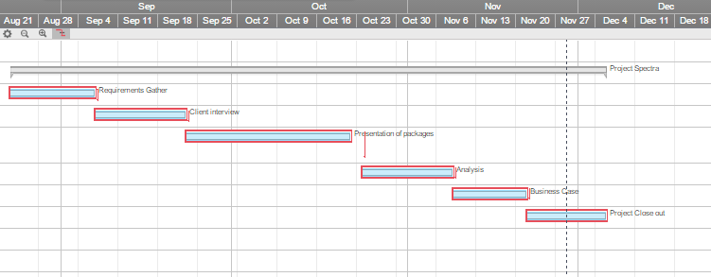

Fig: Gantt Chart

# Appendix A: Project Close-Out Approval

The undersigned acknowledge they have reviewed the **Project Close-Out Form** and agree with the approach it presents. Changes to this **Project Close-Out Form** will be coordinated with and approved by the undersigned or their designated representatives.

[List the individuals whose signatures are required. Examples of such individuals are Project Sponsor, Business Steward, Technical Steward and Project Manager. Add additional signature lines as necessary.]

|  |  |  |  |
| --- | --- | --- | --- |
| Signature: |  | Date: |  |
| Print Name: |  |  |  |
| Title: |  |  |  |
| Role: |  |  |  |

|  |  |  |  |
| --- | --- | --- | --- |
| Signature: |  | Date: |  |
| Print Name: |  |  |  |
| Title: |  |  |  |
| Role: |  |  |  |

|  |  |  |  |
| --- | --- | --- | --- |
| Signature: |  | Date: |  |
| Print Name: |  |  |  |
| Title: |  |  |  |
| Role: |  |  |  |

# Appendix B: References

The following table summarizes the documents referenced in this document.

|  |  |  |
| --- | --- | --- |
| **Document Name and Version** | **Description** | **Location** |
| **Environment Friendly (1.0)** | **To be well Efficient Environment Friendly organization.** | **All around of the branches of data branches which are in major cities** |
| **LIFI (2.0)** | **New technology in terms in terms data transfer** | **All around of the branches of data branches which are in major cities** |
| **DCIM(1.0)** | **High Level Data Center Management for effective functionality** | **All around of the branches of data branches which are in major cities** |
| **High Advanced (IOT, Google Fiber)(1.0)** | **New versioned data centered with all elements on latest versions** | **All around of the branches of data branches which are in major cities** |
| **Cooling System(1.0)** | **Re-utlization of water** | **All around of the branches of data branches which are in major cities** |
| **Url Dog(2.0)** | **Technical instrument which works similar as a Dog operates in a data center** | **All around of the branches of data branches which are in major cities** |

Thank you all for having review of the document.

# Resumes of I Focus Data Group Members

ADDRESS: 55453 Great America Parkway, Santa Clara, CA 95054

EMAIL: [contactus@ifocusdata.com](mailto:contactus@ifocusdata.com) | TELEPHONE: +1-438-527-0500

**Abhilash Reddy Nalla**

**Mobile: +1 612 615 6595**

**Email:** [**abhilashreddy.nalla@valpo.edu**](mailto:abhilashreddy.nalla@valpo.edu)

|  |
| --- |
| **Objective** |

To obtain a challenging software position with expertise in implementing Web and Database applications using Java and new Bigdata technologies and also with an ability to learn latest technologies in challenging environment.

|  |
| --- |
| **Professional Summary** |

* Experienced in development, implementation and maintenance of Web Applications in cloud (AWS, Azure).
* Created and implemented benchmark workloads for internal R&D use.
* Performance measurement, analysis, and tuning using Cloud computing and EC2.
* MarkLogic Server design and implementation work, including XML Data Modelling, XQuery and XSLT.
* Expertise in developing web based applications using Core Java, J2EE and REST APIs.
* Successfully composed 2000 lines of high quality code with no issues during deployment.
* Developed approximately 50 JUnit and TestNg test cases
* Developed Database Architecture, Design and Data Models.
* Experienced in N-Tier architecture and utilized Business model mapping layer and Presentation layer using Spring MVC.
* Knowledge on SQL and No-SQL database like MarkLogic, OpenTSDB and Mongo DB in writing SQL queries and XPath expressions.
* Executed, Deployed 55 million $ project successfully by leading a team of six.
* Proficiency in web design, frontend/backend development and ETL tools.
* Expertise knowledge on Object Oriented concepts and Java Development Frameworks.
* Excellent analytical, problem solving skills and highly motivated to deliver quality solutions

|  |
| --- |
| **Technical Skills** |

**Technologies :** Spring Core/MVC3, Log4J, Bootstrap, Rest Services, Hibernate, JDBC

EasyRec, Revive Ad Server, Drupal 7.

**Programming languages :** Core Java, JQuery, XQuery, XSLT, XML, AngularJS JavaScript, CSS3, JSON.

**Databases :** MySQL, MS SQL Server, MarkLogic, Mongo DB, openTSDB.

**Web Servers :** Apache Web Server, Tomcat, Jetty Server.

**Development tools** :Eclipse Kepler/Luna, Net Beans.

**Operating Systems** : Windows Server, Red hat Linux

|  |  |
| --- | --- |
| **Educational Qualification** | |
| Master of Science Information Technology | |

**Professional Experience**

|  |
| --- |
| **Valparaiso University – Web Administrator April 2016 – Till Date** |

**Responsibilities:**

* Experience in planning and delivering software platforms used across multiple products and organizational units.
* Deep expertise and hands on experience with Web Applications and programming languages such as Java, Spring, Hibernate, oracle, HTML, CSS, JavaScript, JQuery and API's.
* Deep functional knowledge or hands on design experience with Web Services (REST, SOAP, etc.).

|  |
| --- |
| **Cognizant Technology Solutions – Programmer Analyst** |

**Campaign Management July 2014 – Dec 2014**

**Responsibilities:**

* Developed several Java services to perform CRUD operations on underlying business objects.
* Analyzed and validated the business model in Spring MVC by performing consistency check, validating logical source tables.
* Developed customized reports and graphs as per End user requirement.
* Prepared Data Modelling design documents and Test Cases.
* Built a new custom Test class using LOG4J for checking various inputs.
* Worked on various POCs for Ad Insertion on campaign videos through Easy Rec and Revive ad server.
* Involved in data modelling design for OpenTSDB for generating graphs of campaign users.
* Developed and customized the coding of mapping between OpenTSDB and Analytics charts.
* Involved in testing the uses cases and generate reports.
* Extensively used front-end technologies like Bootstrap, Angular JS, HTML5 and CSS3 to give a rich front-end look for the End user.
* Used SQL tools like PhpMyAdmin to run SQL queries and validate the data in database.
* Coordinated activities towards meeting project timelines.

# **R&D Project: Proof of Concept on MarkLogic Jan 2015 – May 2015**

**Responsibilities:**

* Attended meetings with Subject Matter Experts (SME), Business Analysts and End-Users in gathering and analyzing the Business Requirements.
* Developed several XSLT-based utilities for generating Java source code from XML representations.
* Developed customized reports and graphs as per End user requirement.
* Prepared Data Modelling design documents and Test Cases.
* Built a new custom Test class using LOG4J for checking various inputs.
* Involved in data modelling design for MarkLogic for transformations based on Input files.
* Developed and customized the coding of mapping between MarkLogic and Rest Services.
* Involved in testing the uses cases and generate reports.
* Extensively used front-end technologies like Bootstrap, Angular JS, HTML5 and CSS3 to give a rich front-end look for the End user.
* Developed a JDBC-based API, including the necessary SQL, to access underlying DB2 database for the Partners project.
* Created search for mobile app from scratch using Mark logic search: search API.
* Handled MarkLogic related production issues and automated data loading process.

**Client: UKTV - London May 2015 – Dec 2015**

**Responsibilities:**

* Responsible for design, implementation, and deployment of professional service projects.
* Experienced in Service Oriented Architecture (SOA) and building REST and SOAP web services using MarkLogic and Java.
* Worked closely with customer developers, IT staff, and business users to model real-world problems, design solutions, implement working systems, and deploy them.
* Designed and implemented XML schemas, XQuery APIs, Java APIs, business logic, and XHTML/XML/JavaScript user interfaces.
* Worked with product development to integrate customer requirements into MarkLogic Server.
* Taught XML, XPath, XQuery, and MarkLogic Server courses for external developers and IT staff, and for new employees.
* Developed and enhanced training materials as needed.
* Provided tutorials and open-source code projects for the Mark Logic developer site
* Mentored new employees in the consulting and support groups.

|  |
| --- |
| **DCS Labs - Software Developer** |

**E–Commerce Inventory Management Jan 2013 – April 2014**

* Deep expertise and hands on experience with Web Applications and programming languages such as Java, Spring, Hibernate, Oracle, HTML, CSS, JavaScript, JQuery and API's.
* Deep functional knowledge or hands on design experience with Web Services (REST, SOAP, etc.) is needed to be successful in this position.
* Experience in planning and delivering software platforms used across multiple products and organizational units.
* Develop frameworks for websites based on approved design, ensure it works as expected.
* Establish guidelines and procedures for project changes.
* Working knowledge of JAVA/J2EE development, Struts, spring, AJAX, and JBoss.
* Expertise on Eclipse IDE, Junit, ANT, Maven, CVS, and SVN.
* Working knowledge of server side development using servlets, XML/XSD, Web services.
* Maintain cutting edge knowledge of current and emerging technologies, industry trends and standards

**Greater Chicago Area Abhilash Reddy Nalla**

**AKSHAY KUMAR VEMULAPALLI**

1809 Chicago St

Valparaiso 46383 Mobile: 571 363 6304

IN, United States Email Id: akshaykumar.vemulapalli@valpo.edu

**Objective**

Good at networking skills, management skills and communication skills by which I can bring new concepts to the company which can help increase the company both in technical field and management field.

**AREAS OF INTEREST**

* Networking.
* Wireless communication.
* Troubleshooting.

**Skills & Abilities**

**software skills**

Programming Languages : C, C++, JAVA, AUTO CAD

Software packages : MS Office

Operating Systems : Windows, LINUX, IOS

Network Technologies :

**interpersonal skills**

* Ability to rapidly build relationship and set up trust.
* Confident and determined.
* Calm and cool.

**Experience**

Worked as a Network Support Technician at Google, Chicago, IL, US for 5 years. I led a 50 Million Dollar project on ‘Internet for All’ which was a huge success. My role was to be responsible for staying on top of the plants to make sure they are moving along with the project, answering technical questions and walking them through processes, reporting results back to the lead and project manager.

**Project(Bachelors)**

Title : Fabrication of Smart Robot for Library.

Hardware : Sensors, Micro Controller, Motors.

**Internship**

Company : Placebo Gears and Transmissions, Hyderabad

Project Title : MANUFACTURING OF HELICAL AND BEVEL GEARS

Duration : 1 month

**Education**

**Graduation Valparaiso University, Valparaiso, IN May 2017**

* Major: Information technology (Computing Track)
* GPA: 3.56 / 4

**under graduation JNT UNIVERSITY MAY 2015**

* Major: Mechanical Engineering

GPA: 7.75 / 10

**Extra-curricular activities**

* Interested in Social activities & conducted few charity works like donating food and clothes to the needless in my home town.
* Paper Presentation in ACUMEN'15, Vasavi College, Hyderabad.
* Participated in Pre Eureka Business Plan Workshop, IIT Bombay.

**LANGUAGES KNOWN**

English, Hindi, Telugu.

356 Garfield Ave, Apt No. 02, Valparaiso, IN - 46383

C: +1-586-265-3695

E: sheikhaliahmed.faiz@valpo.edu

**OBJECTIVE**

Experience Data Science professional with strong machine learning skills in a multitude of applications is seeking an opportunity to join an organization where I can utilize my potentials and enhance database designing, big data analytics and software project management.

**EXPERIENCE**

**Landmark Resources, Pakistan**  **August 2014 – August 2015**

**Data Scientist**

Core Responsibilities:

* Actively lead Requirement Analysis, Data Modelling, Software Design, Java EE Development and implemented backend replication environment
* Tool Reliability Analysis: Using big data approach to transform and analyze log files and bringing in insights of failure correlation and mechanism. (Data Size: over 1 TB)
* Down Hole Environment Analysis: Using data cleaning, noise reduction and statistics analysis to bring understanding and insights of down hole drilling environment. (Data size: over 200GB)
* Developed new intellectual property for LMKR; primarily using signal processing and machine learning algorithms to solve geophysical problems

**TECHNICAL SKILLS**

* Data mining
* Modeling and simulation
* Statistical and machine learning
* Research and development using R.
* **Software:** Matlab, Python, Java, and C#

**SKILL SUMMARY**

* Strong Work Ethics
* Team Leadership
* Good Communication Skills
* Project Management & Team Work

**ACADEMIC QUALIFICATION**

**Valparaiso University, IN, United States of America May 2016 – August 2017 (Expected)**

**Masters of Science (M.S.) – Information Technology - Computing**

Cumulative GPA: 4.00  
**Bahria University, Pakistan** **February 2011 - March 2015  
Bachelors of Science (B.S.) – Geophysics**

Cumulative GPA: 3.47

**Guy M. Robicheaux**

2230 Chicago Street Apt: 102

Valparaiso, IN 46383

Phone: 337-321-2555

E-mail: guy.robicheaux@gmail.com

**Objective:** Experienced operations professional with 3 years of experience in; operations supervision, computers, and management. By providing my experience and willingness to learn, I will help a company improve its efficiency, structure, and profitability.

**Skills:**

* Experienced in fiber optic splicing, termination, and testing using OTDRs and fusion splicers
* Programmed and operated proprietary software to increase oil-well stability and profitability
* On-site experience coordinating and supervising customer specific installations and multimillion dollar projects
* Ability to manage tasks in a high pressure and unpredictable environment, such as critical step fiber splicing and testing by minimizing lost rig time and preventing millions in lost costs
* Experienced in a high-pressure and results driven multimillion-dollar industrial field

**Work Experience:**

**Baker Hughes Incorporated**

**Intelligent Production Systems Operations Specialist** Broussard, LA. Oct. 2014– Nov. 2015

* Performed role as lead on-site supervisor of teams on installations of oil-well monitoring systems worth 2 million dollars by implementing organization, structure and efficiency
* Uploaded pressure and temperature data and job progress reports onto home-base server and portable storage to help determine flow of oil to increase well
* Documented 12 installation’s sequence of events for 8 clients to inform them of job progress
* Maintained client inventory totaling 1 million USD through proper storage location and label documentation

**Weatherford International**

**Optimization Field Engineer/Supervisor** Broussard, LA. May 2012 - August 2014

* Coordinated installations of up to 10 million dollars in total combined costs
* Provided reports for 5 separate clients during and post system installation
* Monitored optical gauges in 15 oil-wells during RIH and post installation perforating
* Performed pre-job fiber tracing, testing, and simulation of gauge data to maintain product integrity and functionality for 5 or more clients
* Provided clients with outstanding service by providing P/T Data storage, progress reporting, and fiber optic splicing, terminating, and testing

**Education:**

* M.S. Computer and Information Technology Expected: Dec. 2017

Valparaiso University

* B.S. Industrial Technology, College of Engineering December 2011

University of Louisiana at Lafayette

**MAHIDUR RAHMAN KHAN**

**Address**: 203 Sturdy Rd, Apt#34, Valparaiso, IN-46383

**E-mail**: [mahidur.rahman.khan@gmail.com](mailto:mahidur.rahman.khan@gmail.com)

**Telephone**: +1 773-754-6219

**OBJECTIVE**

Extremely passionate to work in a fast paced, highly motivating position where I can assist others involve myself in challenging business analyst roles and expand my skills & knowledge. As I have a 5 years of experiences of business analyst in the top organization so it will be helpful for me to work responsibly and help my organization in its mission and goal achievement process.

**PROFESSIONAL ACCOMPLISHMENT**

**Company: Global Technologies**

**Position:** Business Analyst (August 2016 to present)

**Department:** Information Technology

**Job Responsibilities:**

* Defining, Prioritizing, communicating and fostering shared understanding of project objectives and scope.
* Working as a liaison among stakeholders to elicit, analyze, communicate, validate and document requirements for changes to business processes, policies and information systems.
* Collaborating with stakeholders to elicit, prioritize, validate, and document testable, developer-ready business requirements
* Creating both low fidelity and professional quality project artifacts such as requirement plans, business requirement documents, visual models (e.g., context diagrams, process maps, use cases, mind maps), traceability matrices, and others as appropriate
* Serving as a critical resource and liaison between subject matter experts and technologists throughout the project lifecycle.
* Identifying and communicating risks and issues as well as solutions.

**Company: MGH GROUP**

**Position:** Trainee Executive (December 2014 to August 2015)

**Department:** Marketing (Yang Ming Shipping Line)

**Job Responsibilities:**

* Worked as a Customer Relationship Manager which involves liaising directly with clients as well as suppliers.
* Worked within Shipping and Logistics and ensuring each shipment generates the maximum contribution to the company by keeping constant focus on meeting the required service level at the lowest possible cost.
* Communicated with customers by telephone or in person in order to provide information about products and services, to take orders or cancel accounts, or to obtain details of complaints.

**Company: Banglalink Digital Communications Limited**

**Position:** Intern (May 2014 to August 2014)

**Department:** Marketing (International Roaming Unit)

**Job Responsibilites:**

* Involved in developing the strategy, roadmap and conducting regular market research to maintain high technological and market value level in comparison to world leading International & Roaming Services offerings.
* Working withvarious departments and Communicate with potential vendors, technology providers and partners to establish strong and reliable roaming services.

**TECHNICAL SKILL**

* **Pragramming Languages:** C, C++, HTML, R, PYTHON, JAVA, CSS
* **Operating Systems:** Windows (98, 2000, XP, 8, 10)
* **Packages:** Proficient in MS-Office (2010, 2013,2016), SPSS, Adobe Photoshop, etc.

**MAJOR ACADEMIC WORKS**

* Developed a **website** under final project in Internet & Web Technologies in January-2016.
* Edited many **web pages** in Internet & Web Technologies Assignments.
* Worked on projects Density based traffic control system and RF based spy robot.

**EXPERIENCES AND EXTRA CURRICULAR ACTIVITIES**

* **Campus Ambassador [January 2014 – April 2014]**

***Teach for Bangladesh***

(Responsible for recruiting brilliant and talented fellows from North South University who will be teaching the underprivileged children, thus ensuring proper and excellent  
education for all children)

* **Senior Team Member [March 2011 – July 2012]**

***Young Entrepreneurs Society (NSU YES)***

(Responsible for organizing different competitions and events like AD-Maker BD, ITBPC, NMCI, Annual Club Carnival and bringing corporate sponsorship by convincing them for various programs in North South University)

* Represented North South University at South Asian Youth Convention (SAYC) 2012 organized by FBCCI and SAARC CCI.
* Attended Social Business Forum 2012 at North South University organized by Yunus Centre.
* Volunteered in National Career Fair, Admission Test organized by North South University.

**EDUCATIONAL QUALIFICATIONS**

**Masters in Information Technology 2016**

**Valparaiso University**, Indiana, USA

**CGPA :3.85** on a scale of **4.00**

**Bachelors of Business Administration (BBA) 2014**

**North South University**, Dhaka, Bangladesh

**Major 1 : Marketing**

**Major 2 : Finance &Accounting**

**CGPA : 3.23** on a scale of **4.00**

Venkata Prakash. P

404Glendale Blvd,Apt 3C,Valparaiso,IN 46383

prakash.parimi@valpo.edu

219-246-3463

**Objective:**

To pursue a challenging career and reach new peaks in an organization where one can have source of Strength and dedication, and leading to organizational growth

**Academic** **Qualifications**

**Valparaiso** **University**, Valparaiso, IN, USA December 2017

Master’s in Information Technology & Computing

**Jawaharlal** **Nehru** **Technological** **University** Kakinada India April 2014

Bachelor of Technology

**Professional** **Summary**:

**KRG** **TECHNOLOGIES** **Chennai**, Jan 15 To Nov 15

**IT** **Recruiter**

**Roles & Responsibilities:**

•Categorized Project requirements and specifications for various business processes and source according to company policies and Expectations. Involved in full recruitment life cycle

•Filtered through and reviewed completed candidate profile/resume and evaluated applicant’s work history, education and training, job skills, desired salary/hourly rate, and personal qualifications against open requirements.

•Worked in the recruiting department to recruit IT and Operations professionals

•Clients included Disney, Symphony Telecca, KForce, HCL, Aspire Systems etc.

•Attended daily and weekly meetings to report status of recruitment processes

**YOCHANA IT Solutions, Hyderabad,** Jul 14 to Dec 14

**Technical Recruiter.**

**Roles & Responsibilities:**

•Work according to Client requirements and specifications for various business processes and source candidate to meet required client expectations

•Clear Understanding of full recruitment life cycle

• Working experience on different job portals like tech-fetch, monster, dice.

•Worked in the recruiting department to recruit IT professionals

•Clients included Morgan Stanley, TD Ameritrade, UBS, etc.

•Explained position requirements to candidates and negotiated salaries befitting of candidate experience

**Co-Curricular**

* Attended the Workshop on “Robotics” Conducted at AU Vishakhapatnam. (November 2011)
* Internship at “ONGC” Tatipaka During March 2013 to May 2013
* Conducted mini projects like shadow Alarm, Smoke Detector and gave seminars on Bluetooth technologies, Virtual Reality.
* Organized events at school and college level and volunteered many events like Annual Meets. Freshers Party
* Participated in various chess competitions at school level.

**Declaration**

I hereby declare that the information furnished above is true to the best of my knowledge.

Place: Valparaiso, IN Yours sincerely,

Date: 08/07/2016 Venkata Prakash. P

**DR SRILAKSHMI CHUNCHU**

207 sturdy rd, apt 10, Valparaiso, 46383.

Cell: +1 361-474-3388, email: [srilakshmi.chunchu@valpo.edu](mailto:srilakshmi.chunchu@valpo.edu)

**Objective**

To work in a challenging and stimulating environment with an opportunity to use my skills and experience and to enrich my knowledge that improves my experience. To be a factor towards the achievement of organizational goals by applying my education and professional skills with an outstanding approach to customer service and excellent written and verbal communication skills.

**Highlights**

**Medical terminology**

**Operating Systems**: Windows family, Mac family, Linux.

**Computer Programming languages:** Core Java, UNIX, LINUX.

**Database**: Database management- MySQL, Oracle.

**Other Software’s:** MSOffice, Advanced MS Excel, Library Office, Putty, NetBeansIDE8.1

**Experience**

* Have done one year Internship program at Global Hospital in various departments like General Medicine, Neurology, Nephrology, Psychology, Gastroenterology at Bangalore, Karnataka, India.
* Did project on Infectious diseases in Paediatrics and General Medicine over a period of six months at Rural Tertiary Care Hospital to find the outcomes of Drug Interactions, Adverse Drug Reactions, side effects of drugs and the economic burden of Antibiotics.
* **POSTER PRESENTATIONS:**
* **ABS-P210**- STUDY ON INFECTIOUS DISEASE PATTERN IN A PEDIATRIC DEPARTMENT OF A RURAL TERTIARY CARE HOSPITAL at ISPOR.( International society for Pharmacoeconomics and outcomes research) in Manipal University of pharmaceutical sciences.
* **ABS-P075-**STUDY ON INFECTIOUS DISEASES PATTERN IN HOSPITALIZED RURAL TERTIARY CARE TEACHING HOSPITAL at ISPOR .( International society for Pharmacoeconomics and outcomes research) in Manipal University of pharmaceutical sciences.
* **CONFERENCES:**
* Participated in the one day national symposium on recent trends in pharmacy education held on November 29th 2010.
* Participated at “3rd international conference and exhibition on Biowaivers, Biologies and Biosimilars” held on October 27th -29th, 2014 in Hyderabad international convention centre, India.
* Participated in the pharmacy practice module, advanced learning series-2 held on January 29th to 31st, 2015.

**EDUCATION**

* Doctor of pharmacy (PHARM D)

Rajiv Gandhi university of Health Sciences, India.

* MSIT-Computing Track (continuing)

Valparaiso University, Indiana, USA.

**N.YASHWANTH GOPI**

E-Mail: yashwanthgopi@gmail.com

Contact No.: 219-707-3352

***Goal oriented professional*** *who undertakes complex assignments, meets tight deadlines and delivers superior performance. I possess practical knowledge of cutting edge technologies and utilize them to achieve company goals*

**PROFILE SUMMARY**

* A dynamic professional with 7 years of experience as **Information Security Analyst, Business Operations Analyst**, **Resolution Expert** with **Rolls-Royce**, **Accenture, Dell International Services.**
* Maintained the Rolls-Royce’s security system of the North America region and helped in enhancing the it across USA by implementing an automated bulletproof monitoring, counter attack tools.
* Reported major bugs across the top social networking sites which helped save 150 million user data.
* Got listed as Hall of famer in LinkedIn, Oracle, IBM, Facebook, Yahoo and was the runner up in Google’s Pwn2Own 2017 competition.
* Managed digital marketing campaigns worth millions of dollars for **Google** premium clients, achieving Return of Investment (ROI).
* Experience strategizing frontline support and DFP Services Relationship Managers (SRMs).

**PROFESSIONAL EXPERIENCE**

**Jan’17-Apr’21             Rolls-Royce, Virginia as Information Security Analyst**

**Role:**

* Established system controls by developing framework for controls and levels of access; recommended improvements.
* Ensured authorized credential access by investigating improper access; revoking access; reporting violations; monitoring information requests by new programming; recommending improvements.
* Established computer and terminal physical security by developing standards, policies, and procedures; coordinating with facilities security.
* Safeguarded computer files by performing regular backups; developing procedures for source code management and disaster preparedness.
* Accomplished information systems and organization mission by completing related results as needed.
* Provided inputs into tactical security initiatives and assisted in maintaining Information Protection policies, standards, and technical baselines.
* Provided security knowledge to teams of technical specialists working on integrating centralized or networked systems to offer enhanced levels of information security.

**Jul’14-July’16              Accenture, Hyderabad as Business Delivery** **Process Associate**

**Role**:

·         Mentored clients in troubleshooting issues on products such as DART, DFP, Mobile, Video or web page tagging. This helped them increase the ROI of millions of dollars on the campaigns.

·         Analysed & reported discrepancies, inventory forecasting & sales assistance and effective client communication through E-Mails; managing all trafficking issues and assisting in resolving them.

·         Designed, built and maintained social media presence for the company and its clients (Google) measured and reported performance of all digital marketing campaigns which has increased the morale of the team to solve complex queries for the clients..

·         Lead as quality consultant and mentored analysts, clients and management associated with regulatory standards. QA framework that I've developed has gained the interest of the top level management and they incorporated it in other processes.

·         Participated in improving and developing quality practices in product development organization.

**Aug’13-May’14                           Dell International Services as Client Technical Support Associate**

**Role:**

·         Handled calls and provided level 1 Technical support to end users

·         Looked after Microsoft Outlook, Outlook Express, Windows Live mail configuration, backup, troubleshooting

·         Installed and configured of network printers, scanners and its basic level of troubleshooting

·         Assisted end users with third party software and hardware issues and resolved problems in inbound calls and outbound calls

**HIGHLIGHTS**

·         Hall of famer for LinkedIn, Oracle, IBM, Facebook, Yahoo

·         Runner up of Google’s Pwn2Own competition for the year 2017

·         Received the Stellar performer award for the year 2015

·         Bagged the Centurion Award for Jan’15, Mar’15

·         Bestowed with Numer Uno award for being the Most Productive Employee

·         Cross trained on ad servers like DFP, Ad Exchange, PubMatic

·         Mentored a team of 18 ensuring the deliverables are met

·         Assisted training team on automating the content and delivered sessions

·         Worked on creating a repository and SOP for complex queries that helped onshore teams of Google

**SKILL SET**

Proficient in ASP.NET | .NET | HTML | PHP | LoadRunner | Metasploit | Nessus | Burp Suite | Kali Linux | Perl | Python | Bash and concepts like Social Engineering, Penetration Testing, SQL Injection, URL poisoning, Systems Forensics

**EDUCATION**

* Valparaiso University, Valparaiso, IN, USA                                                        **Dec’ 17**

(Master’s in Information Technology & Computing)

·         Bharat Institute of Engineering and Technology                                                                                              **May’13**

(Bachelor's in Information Technology)





**Product: URL DOG (Digital Sensors):**

Prepared for: **I FOCUS DATA**

Prepared by: **Goteti. Srinivasa Sriharsha**

27 October 2016



Product Over view + Deliverables

**Vendor Details**

**Vendor Name:** Geist

**Hours of operation:** Sales: 8am to 5pm CST, Support 9am to 5pm CST

**Product Brief**

**Project:** Url Dog

**Description:** URL DOG is a feature which is said to be a new feature in information technology datacenter which helps in identifying pornographic content in hard drive, SD Disk, data center, which would help in maintaining good and safe content. This is been implemented in very limited regions, under restrictions of police, where recently it was been implemented by Indiana police of it’s working.   
**Cost Range:** $199 per piece of product

**Deliverables:** IT Watch Dogs 1400 (http://www.geistglobal.com/sites/all/files/site/10014401_watchdog_1400_watchdog_1400_p_3.pdf).



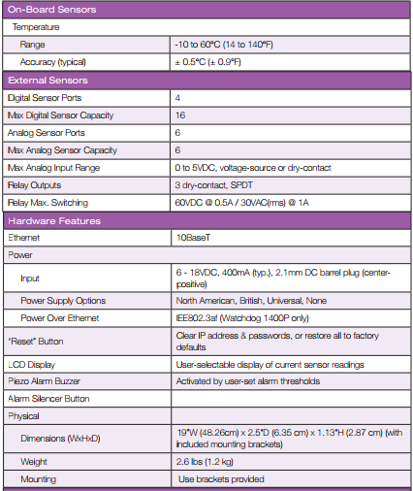



Contact Information

**Company Details:**

|  |  |
| --- | --- |
| **Item** | **Detail** |
| Name | **Geist , Inc.** |
| Address | 1777 Yolande Avenue Lincoln, NE, USA |
| Phone | 512-257-1462 |
| Email | sdomant@geistglobal.com |
| Website | http://www.geistglobal.com/ |

**Project Contact**

At any time during the project, you can get in touch with Shelley

|  |  |
| --- | --- |
| **Item** | **Detail** |
| Contact Name | Shelley |
| Phone | 512-257-1462 |
| Email | sdomant@geistglobal.com |

**Product Compatibility:**Product warranty: 1 year (best usage on the way it is utilized and it’s environment)  
Support: Support timings are been mentioned above which would be given product technical expert who is well trained.  
Physical Specifications: (http://www.geistglobal.com/sites/all/files/site/10014401_watchdog_1400_watchdog_1400_p_3.pdf)  
Specification about the product is been in above link, also more specific help in the website for detailed description.

**Web Interface: Alarms Page**  
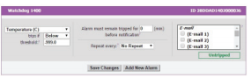

**Manual Installation**:   
Product need to be installed by our own technical team, for each piece to be installed it would take 15 minute to install.   
  
**Shipping Date**: 24/10/2016  
  
**Arrival Date**: 26/10/2016 (2 business working days)  
  
Regards,   
Sriharsha Goteti (Director of IFocus Data)

**Referrence:**http://www.geistglobal.com/sites/all/files/site/10014401_watchdog_1400_watchdog_1400_p_3.pdf

## Thanking mail: Thanking mail from IFocus Data

|  |  |  |  |  |
| --- | --- | --- | --- | --- |
| |  | | --- | | Srinivasa Sriharsha Goteti <srinivasasriharsha.goteti@valpo.edu> | | Oct 24  https://mail.google.com/mail/u/0/images/cleardot.gif |  | **https://mail.google.com/mail/u/0/images/cleardot.gif**  **https://mail.google.com/mail/u/0/images/cleardot.gif** |
| |  | | --- | | to sdomant  https://mail.google.com/mail/u/0/images/cleardot.gif | | | |

Hello Selley,  
  
  
Thank you very much for providing information regarding url dog,(Watch Dog)  , I would really appreciate your patience of answering all my questions. It was a great pleasure taking with you .I would get back to you once  get a approximate information from my technical team, where the requirement should satisfy my organization needs and values.

https://ssl.gstatic.com/ui/v1/icons/mail/images/cleardot.gif

--

Regards,  
Sriharsha Goteti

 14 Goals of my life :

1. Complete My Master’s with a great grade and GPA from Valparaiso University. (Academic) December ‘2017
2. Work on a Research Project on cloud computing from Valparaiso University and make it useful to the students for student’s education. (Academic) December ‘2016
3. With my hard earned money would like to construct a house for my mom and dad in the place named as Kakinada in India where house should be in between if farms by December ‘2025. (Long term personnel Goal)
4. Would like to settle myself with my family in United States of America with an own Apartment as a Permanent Registrant of USA. (Personnel Goal) December ‘2020
5. Ambition to secure a job in Microsoft in United States of America. (Professional Goal) December ‘2024
6. Setup a Music firm, and encourage young talent to learn Music by December ‘2028
7. Setup an Education Center where students who love education but poor in income, and help them in preparing for SAT to have them secure a basic degree in USA.
8. In reference to Environment, create a small place and adjoin them with Plants for environment protection
9. Establish Determination, Devotion, Dedication towards opening a food center at my home for poor people, whenever it might the door of my home should be open for food because I know the value of food and its wastage.
10. Excel myself in technical stream, and should continue my technical acumen.
11. Un expected plan as to peruse Masters in Management Field in United States of America after gaining an experience of 4 years from Reputed IT Company. (Academic)
12. Select a Life partner after having love each other and inform at home regarding marriage. (Personnel)
13. At least one time in life, need to climb Mount Everest.
14. Play for a Music Band in United States of America as a Jazz Drummer.

https://ssl.gstatic.com/ui/v1/icons/mail/images/cleardot.gif

**Personal MOV:**  
  
  
I would like to see myself as a Senior Software Engineer settled in USA in coming 5 years , and for which my scope and vision would help in guiding and keep me always in path.

Strategic:   
  
Pursue my master in information technology from Valparaiso University and apply for job opportunities, as a direct person . However, if possible join as intern with an organization which it best benefits me to grow and gain in my life, and make ourself gain in USA. This should be made by January 2018 as a permanent employee, and while making as an intern then it should be done by august 2017. After becoming a permanent employee to one of the top most MNC, and make myself to gain experience in Software Field and see myself as a senior Software Employee, and also by January 2019, I should hold a H1B Status on my passport for USA.

Plan1 :   
Pursue my master from Valparaiso University by December ‘2017, and then Carry H1B status to gain my growth to one of the software Company as a Senior Software Engineer in span of 3 years .  
  
Plan2 :   
Pursue my master from Valparaiso University by August ‘2017, do an internship from a company in USA, and slowly by January ‘2018 become a Permanent Employee in the company and apply for a H1B and continue to Growth as a Senior Software Engineer.  
  
Plan3 :

Work Hard to achieve your goals with vision and scope, with a good and great determination we can achieve it if we treat that this is your life and your living for yourself.

**Personal Scope:**Overview:  
  
Plan 1: Pursue my M.S. Information Technology from Valparaiso University and complete my graduation by December 2017. Also, I would like to secure a job in January 2018 at one of the top Multi-National Companies (MNC) in USA. (Exceeding Expectations)

Plan 2: Pursue my M.S. Information Technology from Valparaiso University and complete my graduation by December 2017. And, I would like to secure a job in USA. (met expectations)

Plan 3: Accomplishing my goals in a specified time frame. And, giving myself and my parents a sense of fulfillment and satisfaction, by accomplishing these goals. Once my confidence, commitment, dedication, devotion and determination are in place there is nothing in the world which I cannot do. I would not like to plan for negative in my area of travel.

Scope by Ways of SWOT ANALYSIS:

Strength:

Having been in practice with drums since my child hood and I’m passionate towards it. I have performed

numerous times in my home country, and it was always in front of crowds. This doesn’t apply to just my

personal –life. With anything I do, I’m very passionate and dedicated. I will work hard on anything until I

accomplish the desired results.

Passionate, driven, confident, committed.

Weakness:

Not experienced in American culture, due to lack of exposure.

Opportunity:

Performing in Our University itself.

Threat:

Getting approval, Clearance for my performance.

Quality Measurement:

I would like to perform a musical program in our university within first semester.

High Quality Statement -Planning to do my program for Diwali celebrations.

Low Quality Statement– Doing a program in our university by end of my Graduation.

Thank you note for all:

Thank you for viewing my Personal Binder.

It was a great pleasure working with you all as a team, my pleasure to write a thank you note keeping all your help and work in remembrance.  
  
 Prof. Peter Sedrak. (CEO OF Grace Inc.,)

Chakri (CEO OF Best Basket) & Team of Best Basket.  
Guy (Executive Director of I Focus Data) & Team of I Focus Data