

**Company Profile**

ADDRESS: 55453 Great America Parkway, Santa Clara, CA 95054

EMAIL: [contactus@ifocusdata.com](mailto:contactus@ifocusdata.com) | TELEPHONE: +1-438-527-0500

**Table of Content:**

1. Business Administration Contact Information ------------------------------------------- 3
2. Who We Are? ---------------------------------------------------------------------------- 4
3. Can We Help You? ----------------------------------------------------------------------- 4
   1. Mission ------------------------------------------------------------------------------- 5
   2. Vision --------------------------------------------------------------------------------- 5
   3. Value --------------------------------------------------------------------------------- 5
   4. Scope -------------------------------------------------------------------------------- 6
4. How Can We Help You? ----------------------------------------------------------------- 7
5. Global Reach ----------------------------------------------------------------------------- 9
6. Global Contact Information ------------------------------------------------------------- 10
7. Financial Information ------------------------------------------------------------------- 10
8. Partners --------------------------------------------------------------------------------- 11
9. Organization Structure ----------------------------------------------------------------- 12
10. Employee Breakdown ------------------------------------------------------------------ 13
11. Contact List ----------------------------------------------------------------------------- 14
12. Important Links ------------------------------------------------------------------------- 15

**Business Administrative Contact Information:**

* NASDAQ Stock Exchange Ticker: IFOD.
* Primary Contact for Sales/Client services: 219-707-3352.
* Headquarters Address: 5453 Great America Parkway, Santa Clara, CA 95054.
* Postal Code: CA 95054.
* Country: United States
* Telephone: +1-438-527-0500
* Email Address: contactus@ifocusdata.com
* Parent Company: NA
* Subsidiaries, Associates: NA
* Year of Establishment: 2007
* Type of Organization: Private Organization
* Type of Business: Data Center
* Active Employees: 12,342
* Staff Turnover Rate: 98 Percentage
* In-house Working Language(s): English, French, Mandarin, Hindi, Mexican, Arabic
* General Inquiries: Email: [info@ifocusdata.com](mailto:info@ifocusdata.com), US & North America Sales: [us-sales@ifocusdata.com](mailto:us-sales@ifocusdata.com), Latin America Sales: [latam-sales@ifocusdata.com](mailto:latam-sales@ifocusdata.com), Europe, Middle East & Africa Sales: [emea-sales@ifocusdata.com](mailto:emea-sales@ifocusdata.com), Asia-Pacific Sales: apac-sales@ifocusdata.com

**Who We Are?**

Founded in the year 2007, I Focus Data managed to be a leading provider of innovative and customized data center solutions with site-specific colocation capabilities for businesses. I Focus Data is transforming the way companies leverage data center services that integrate current and next-generation technologies.

I Focus Data network of customizable, highly available, fully supported micro data centers combines the privacy and control of a private data center with the flexibility and cost efficiency of colocation. Through its team of experienced leaders and data-driven technology solutions for each customer, I Focus Data provides tangible results on data center needs.

**Can we help you?**

I Focus Data brings control and flexibility together in one solution instead of making them compete. A puzzle begs a solution, and this one has been challenging the data industry for a while: data centers are facing many competing pressures, from capital risk, power challenges, and regulations to the meteoric increase in data, to the continued virtualization of processing power. Until now, companies large and small had two choices: private data center or colocation in a large data center. Companies had to sacrifice control and security for flexibility and cost efficiency. And so, I Focus Data was born.

I Focus Data global wide network of fully-supported, scalable, private, demand driven data centers offer users and data center owners a complementary solution to geographically diversify assets, reduce risk of capital, and choose the location which best suits their business and customers. We stick to the following Mission, Vision, Values that were devised to enhance the customer experience.

***Mission:***

Our purpose is to deploy our diverse brand of extraordinary individuals and teams, to consistently transcend global market Data-Center necessities. With a global team, we can relate to anyone and everyone. Not only do we have specialized-skills, but we have skills that apply to different industries across the continents. Being diverse is a way of life, and we are better for it. We can relate to different countries, no matter if the industry is down in one, or up in the next. Simply put, a diverse workforce, equals a prepared one in our minds. And, we are prepared for any task, anywhere.

***Vision:***

I Focus Data wishes to become a pioneer in the Data Centre industry by meeting the needs of our customer base. Within the next 5-10 years (2021) we want to be a major player in Data Centre Innovation and by 2040 we want all data to be processed through us. We are always striving to improve, with a green by design standards we evaluate our efficiency and are quick to adopt to the techniques that are successful on a global scale. Despite gains in the reliability on technology, people guide the ship. We appeal to the masses because of our globally enhanced team, and when we incorporate that with our core values, our potential will consistently be a moving target.

***Values:***

Diversity is who we are, and we embody it. Our goal is to be consistently above the rest first and foremost by embracing honesty throughout our teams’ culture with each other and with clients. Despite gains in the reliability on technology, people guide the ship. We appeal to the masses because of our globally enhanced team, and when we incorporate that with our core values, our potential will consistently be a moving target.

Following are the values that I Focus Data is dedicated to:

* Dependability
* Craftsmanship
* Honesty
* Honor
* Concise Preparation
* Accomplishment
* Trustworthiness
* Civility
* Diversity
* Understanding
* Dependability
* Honesty

***Scope:***

I Focus will provide data storage via the cloud or other means to its customers, by operating and maintaining not only reliable, but environmental friendly data centers. Through our diverse team, we will analyze customer needs and implement a plan of action (POA) that will improve our customer’s day to day operations.

Process example:

* Find out from the customer what issues need to be addressed.
* Research and observe customer operations and get a grasp for how they operate.
* Study our findings and formulate a POA to address needs.
* Present findings to client and inform them of how plan will serve them and protect their privacy.
* Assign work to teams and or individuals based upon skills and experience.
* Implement plan that includes details on how we will maintain our work.
* Debrief with client to obtain valuable feedback on the service we provided.

**How We Can Help You?**

When you embark on a building project in this day and age—regardless of whether that project is big or small—you can find yourself burdened with an overwhelming sense of responsibility…

• Can I stay within budget and still get the quality of workmanship I need?

• Will my decision today have an impact on tomorrow?

• Am I achieving a healthy balance between energy efficiency and architectural style?

• Will my project bring kudos or criticism?

It doesn’t seem to matter how much progress we make, the demands to do more with less and to achieve the lowest possible carbon footprint are ever increasing. These pressures can make planning the simplest renovation a daunting task, let alone a full-scale building project.

I Focus Data started researching suitable alternatives to the (then) standard resources in response to our customer’s enquiries. We started researching innovations in the building and renovation arena and soon began expanding our products, services along with the customer base.

Following are the services that I Focus Data offers:

**Colocation:**

* Enterprise-Class
* Security and Compliance
* Low Cost

**Cloud:**

* Increased Performance
* Highly Secure
* Power and Flexibility

**Internet:**

* Highly Available
* Greater Flexibility
* Carrier Neutral

**Disaster Recovery:**

* Business Continuity
* Flexible Solutions
* Global wide Coverage

**Global Reach:**

I Focus Data offer services across the globe in 7 different locations. California as the headquarters, we were able to attract investors from various location i.e. Brazil, Cape town, Dublin, Beijing, Delhi, Australia.

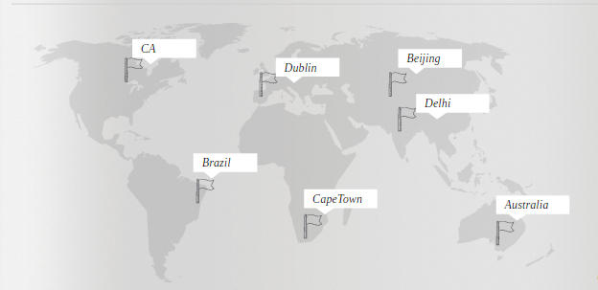

**Global Contact Information:**

|  |  |
| --- | --- |
| North America-Carlifonia | India-Delhi |
| 5453 Great America Parkway Santa Clara, CA 95054 Tel: +1-438-527-0500 R&D and Headquarters | Global Tech Park Tower A & B, 11th floor Marathahalli Outer Ring Road Devarabeesanahalli Village, Varthur Hobli, Delhi 560103 R&D Office |
| Ireland- Dublin | China-Beijing |
| 2 Georges Dock IFSC Dublin 1 Ireland | 15/F, China World Tower 3 1 Jianguomenwai Ave, Chaoyang District Beijing China 100004 |
| Australia-Melbourne | South Africa-Cape town |
| 600 Lorimer Street Port Melbourne  VIC  Australia 3207 | 5 Brewery Street, Isando,  Johannesburg  Gauteng |
| Brazil-Rio |  |
| R. Voluntarios da Patria  360 - Botafogo  Rio de Janeiro BR 22270-010 |  |

**Financial Information:**

Gross Annual Income for the last three years:

* Year 2013: 78 Million Dollars
* Year 2014: 1.7 Million Dollars
* Year 2015: 2.9 Million Dollars

With the innovations that I Focus Data is implementing and the customer satisfaction and trust it gained over the decade has helped it to achieve the above results.

**Partners:**

The service delivered by an organization is a function of not only the quality of the people and processes of that organization, but of their partners as well. I Focus Data aligns with like-minded data center partners who are focused on quality products and services, ethical operations, and a relentless focus on exceeding customer expectations.

I Focus Data believes strongly in partner collaboration and has developed one of the most admired partner ecosystems in the data center industry. Following are the list of partners who we do business with:

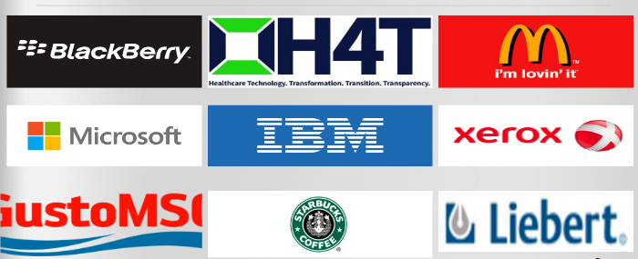

Our clients count on I Focus Data to provide a platform that allows them to meet their business needs both now and in the future. Our partners are an integral part of our premium customer service and performance and we dedicate significant resources to facilitate mutually beneficial relationships.

**Organization Chart:**

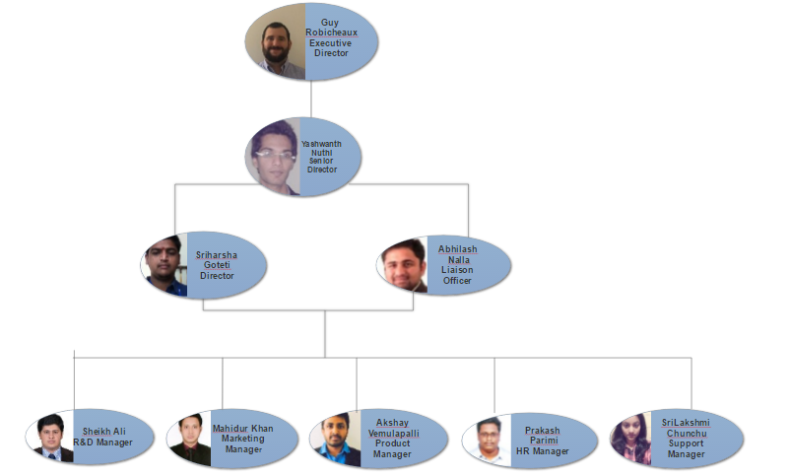

**Employee Breakdown:**

|  |  |  |  |
| --- | --- | --- | --- |
| Name | Job Title | Board | Remuneration |
| Peter Sedrak | President and Chief Executive Officer | Executive Board | 16,880,000USD |
| Guy M.Robicheaux | Executive Director | Non-Executive Board | 480,000USD |
| Yashwanth Gopi Nuthi | Senior Director | Non-Executive Board | 450,000USD |
| Abhilash Reddy Nalla | Liaison Officer | Non-Executive Board | 400,000USD |
| Srinivasa Sriharsha Goteti | Director | Senior Management | 350,000USD |
| Venkata Prakash Parimi | HR Manager | Senior Management | 350,000USD |
| Sheikh Ali Ahmed Faiz | Marketing Manager | Senior Management | 350,000USD |
| Mahidur R Khan | Sales Manager | Senior Management | 350,000USD |
| Akshay Kumar Vemulapalli | Product Manager | Senior Management | 350,000USD |
| Srilakshmi Chunchu | Customer Support Manager | Senior Management | 350,000USD |

**Contact List:**

|  |  |  |  |  |  |  |  |
| --- | --- | --- | --- | --- | --- | --- | --- |
| Name | Preferred Name | Language | Current Position | Preferred Method of contact | Latest Contact | Email Address | Phone Number |
| Pete Sedrak | Pete | Arabic,English,Egyptian (Coptic) | CEO | E-mail | 11:00 PM | pete.sedrak@valpo.edu | 219-663-6798 |
| Abhilash Reddy Nalla | Abhilash | English,Telugu,Hindi | Student | Email/Call | 10:00 PM | abhilashreddy.nalla@valpo.edu | 510-203-9653 |
| Akshay Kumar Vemulapalli | Akshay | English,Telugu | Student | Email | 10:00 PM | akshaykumar.vemulapalli@valpo.edu | 571-363-6304 |
| Guy M.Robicheaux | Guy | English | Student | Email | 11:00 PM | guy.robicheaux@valpo.edu | 337-321-2555 |
| Mahidur R Khan | Mahid | English, Bengali | Student | E-mail | 10.00 PM | mahidur.khan@valpo.edu | 773-754-6219 |
| Srilakshmi Chunchu | Siri | Telugu,English,kannada | Student | Email/Call | 10:00 PM | srilakshmi.chunchu@gmail.com | 361-474-3388 |
| Srinivasa Sriharsha Goteti | Goteti | Telugu,Hindi,English,tamil,kannada | Student | Email | 11:00 PM | srinivasasriharsha.goteti@valpo.edu | 480-603-6416 |
| Sheikh Ali Ahmed Faiz | Ali | Pushto, Urdu, English | Student | Email | 12:00 PM | sheikhaliahmed.faiz@valpo.edu | 586-265-3695 |
| Venkata Prakash Parimi | Prakash | English,Telugu | Student | Email | 10:00 PM | prakash.parimi@valpo.edu | 219-246-3463 |
| Yashwanth Gopi Nuthi | Yashwanth | English, Hindi, Telugu | Student | Email | 9.00 PM | yashwanthgopi.nuthi@valpo.edu | 219-707-3352 |

**Important Links:**

|  |  |
| --- | --- |
| Our Infrastructure | <https://www.ifocusdata.com/en/infrastructure> |
| Leave us a message | <https://www.ifocusdata.com/howarewedoing/> |
| Knowledge Base | <https://www.ifocusdata.com/kb/> |
| Video Library | <https://www.ifocusdata.com/en/company/news/video-library> |
| Events and Webinars | htps://www.ifocusdata.com/en/company/eventsandwebinars |
| Blogs | <https://www.ifocusdata.com/blogs/> |
| Testimonials | <https://www.ifocusdata.com/en/company/testimonals> |
| Careers | <https://www.ifocusdata.com/en/careers> |