**Project Charter**

ADDRESS: 55453 Great America Parkway, Santa Clara, CA 95054

EMAIL: [contactus@ifocusdata.com](mailto:contactus@ifocusdata.com) | TELEPHONE: +1-438-527-0500

**Project Spectra**

# **Project charter Version: Final**

This document will explain the Spectra project for Grace Inc. that I Focus Data is performing as a subsidiary of Best Basket Inc.



**Table of Contents**

|  |  |
| --- | --- |
| Title | Page |
| Project Information | 3 |
| Project Description and Background | 4 |
| Challenges and Opportunities | 4 |
| Desired Project Impact | 5 |
| Project Measurable Organizational Value (MOV)And Project Scope | 6 |
| Scope Expectations | 7 |
| Project Requirement | 8 |
| Initial Requirements Budget | 9 |
| Revised Requirement Budget | 10 |
| Phase Breakdown and Budget | 11 |
| Phase Breakdown and Budget (Continued) | 12 |
| Vendor and Resource Provided | 13 |
| Date of Service Provided | 14 |
| Assumptions of Risk | 15 |
| Quality Management Plan | 15 |
| Change Management and Communication Plan | 16 |
| Project Administration and 2-way Communication Chart | 17 |
| Communication Plan Summary | 18 |
| Implementation and Closure | 18 |
| Signoff and Approvals | 19 |
| Glossary | 20 |
| Glossary (Continued) | 21 |

**Project Information**

**Project ID: Spectra**

**Stakeholders:**

**Peter Sedrak**

CEO Grace Incorporated

Phone: (219) 663-6798

Email: [pete.sedrak@valpo.edu](mailto:pete.sedrak@valpo.edu)

**Chakradhara (Chakri) V. Konduru**

CEO Best Basket Incorporated

(219) 916-9135

Email: [chakradhara.konduru@valpo.edu](mailto:chakradhara.konduru@valpo.edu)

**Guy Robicheaux**

Executive Director I Focus Data

Phone: (337) 321-2555

Email: [guy.robicheaux@valpo.edu](mailto:guy.robicheaux@valpo.edu)

**Project Description and Background**

**Project Description:**

To improve the following for Grace INC: security, storage, eco-friendly buildings, and highly robust systems and architecture.

**Background:**

Grace Inc. initially approached I Focus Data on 9/22/2016 about performing the Grace security initiative. Grace Inc. servers and systems were hacked effectively causing a security breach of their technology and sensitive information was stolen. Also, many system and servers were infiltrated with pornographic videos and images, subjecting Grace Inc. to spyware and malware.

**Challenges and Opportunities:**

As a result of the interview with Grace Inc. I Focus Data is presented with unique opportunity to improve an organization’s security integrity and its overall operational efficiency. We will be providing highly advanced technology for the Grace Inc. project, so it will be a continuous challenge to ensure we do not go over budget. It will also be important to make sure our technology will be top of the line for years to come and won’t be surpassed in the near future.

**Desired Project Impact**

The desired impact of this project is to not only increase the operational security of Grace Inc., but it is to also add value of the organization. Spectra should provide Grace Inc. with a return on its investment to the tune of increased profitability in all aspects of the company. The systems I Focus Data will provide will undoubtedly increase the efficiency of day to day operations within Grace Inc. Internally, the impact of Spectra will allow I Focus Data to brand itself as a top of the line IT Data company for years to come. A successful project will allow I Focus to increase its footprint within the industry, in addition to targeting bigger and more challenging projects in the future.

**Project Measurable Organizational Value (MOV)**

**And Project Scope**

**Project MOV**

I Focus Data will build Grace Inc. a data storage option that will improve security by 99.9% from the start to end of the project. Options will be via Data Center or a cloud that will include and efficient and environmentally friendly infrastructure, using high advanced technology within a year of project start date. This project will succeed if it provides Grace Inc. with a 99.9% security increase and conversely it will fail if it only improves security by 99.8%.

**Project Scope**

**Inside**

1. Secure Data
2. Storage options
3. Highly robust systems and technology
4. Architecture of the data systems
5. Efficient buildings

**Outside**

Grace Inc. approached I Focus Data through a stakeholder about installing an Equivalency Coefficient on each pc and server after the project contract was official. I Focus Data politely declined, and both companies have agreed to make this a priority in the next project they work on together.

**Scope Expectations**

**Exceed:**

This project will exceed expectations for Grace Inc., Best Basket, and I Focus Data, if it is complete within 1 years’ time, and beneath budget. It will also exceed the organizations’ expectations if 100% security can be provided by the services provided by I Focus Data and its vendors.

**Meet:**

Spectra will meet all organizations’ expectations if it is completed within the given timeframe of 1 year and if it is within the given budget of $8.36 Million USD. Spectra will also meet the expectations if it provides 99.9% to Grace Inc.

**Not Met:**

Spectra will fall short of the organizations’ expectations if it simply does the job of fulfilling the requirements laid out by Grace Inc. without improving or adding any organizational value to Grace as a company.

**Requirements**

The requirements for the Spectra project laid out by Grace Inc. are listed below. I Focus Data will oversee the contracting of outside vendors to provide the services and resources for Grace Inc.

1. Environmentally Friendly

2. LI FI

3. DCIM

4. High Advanced Tech (Google Fiber, IOT)

5. Cooling System

6. Cloud or Data Center

7. URL DOG

**Initial Requirement Budget**

The initial budget breakdown of the project by the 7 requirements is displayed in the figure below.

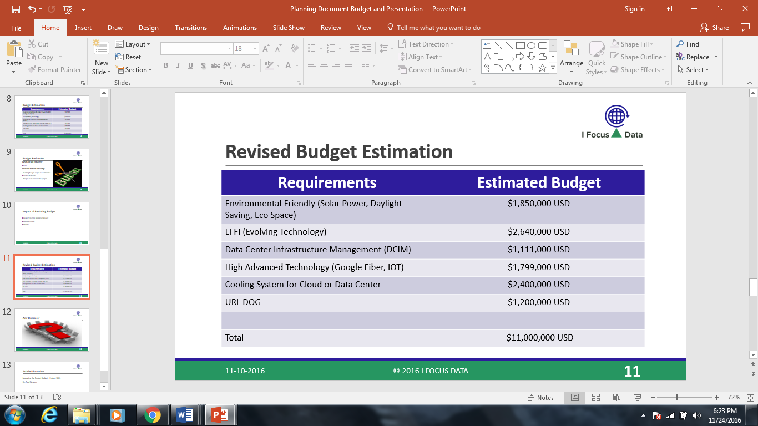

Figure 1.0

**Revised Requirement Budget**

Due to the unavailability of LIFI technologies and no vendors willing to provide service to our project, I Focus Data and Grace Inc. agreed to remove LIFI from the requirements. Instead I Focus will use and improve upon the WIFI networks in place. The subtraction of LIFI from the budget in turn reduced the cost to $8,360,000 million USD, or 24 % percent. Figure 2.0 explains the cut, as well as the budget before, and after.

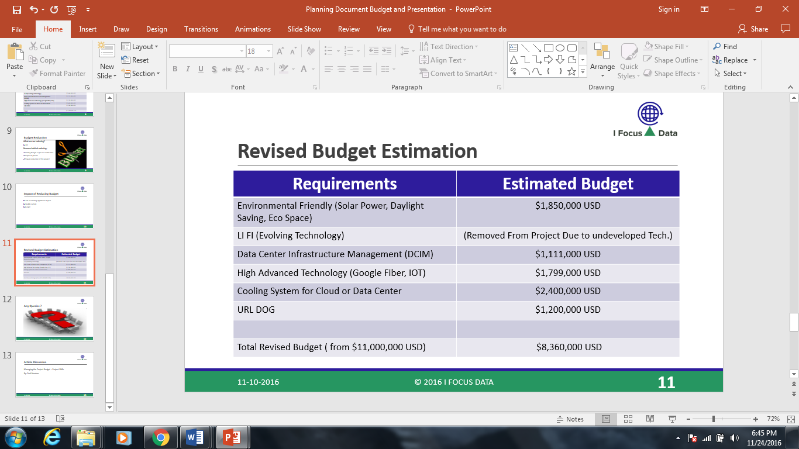

Figure 2.0

**Phase Breakdown and Budget**

**Phase I**

Phase I will consist of the Data Center/Cloud setup and the infrastructure management portion of the Spectra Project. Figure 3.0 breaks down the cost of each requirement in Phase I and the total cost of Phase I.

|  |  |  |
| --- | --- | --- |
| **Project Requirement** | **Phase of Project** | **Cost** |
| Cooling System and Data Center | Phase I | $ 2,400,000 Million USD |
| DCIM (Data Center Infrastructure Management) | Phase I | $ 1,111,000 Million USD |
|  |  |  |
| Total |  | $3,511,000 Million USD |

Figure 3.0

**Phase II**

Phase II will consist of the security and technology portion of the Spectra project. Figure 4.0 breaks down the cost of each requirement in Phase II and the total cost of Phase II.

|  |  |  |
| --- | --- | --- |
| **Project Requirement** | **Phase of Project** | **Cost** |
| High Advanced Technology | Phase II | $ 1,799,000 Million USD |
| URL Dog | Phase II | $ 1,200,000 Million USD |
|  |  |  |
| Total |  | $2,999,000 Million USD |

Figure 4.0

**Phase III**

Phase III will consist of the Environmental Friendly portion of the Spectra Project. Figure 5.0 breaks down the cost of each requirement in Phase III and the total cost of Phase III.

|  |  |  |
| --- | --- | --- |
| **Project Requirement** | **Phase of Project** | **Cost** |
| Environmental Friendly | Phase III | $1,850,000 Million USD |
|  |  |  |
| Total |  | $1,850,000 Million USD |

Figure 5.0

**Vendor and Resource Breakdown**

I Focus Data will contract the scope requirements of the Spectra project to various vendors. These vendors will perform services within the standards and specifications as required by Grace Inc., and I Focus Data. I Focus Data is contractually obligated to ensure that these standards and specifications are met. If anything is deemed out of spec, the scope of the project will be evaluated and changed until the standards and specifications promised are met.

|  |  |
| --- | --- |
| **Vendor** | **Resource Provided** |
| SUNPOWER by South Coast Solar | Solar Energy (Environmental Friendly) |
| IT Watch Dogs | URL Dog (Security) |
| Google Fiber | Google Fiber (High Advanced Technology) |
| Green House Data | Data Center/Cloud |
|  | Cooling System |
| Raritan | DCIM |
| PureLIFI | LIFI |

Figure 6.0

**Date of Service Provided**

The following is a tentative schedule of the services provided by I Focus Data to Grace Inc., through its vendors. The dates are subject to change due to the progress of the project. Each vendor has given an estimate of how long it would take for service to be provided. The Project Management Team will need to properly coordinate with each vendor to ensure the service can be provided efficiently without interfering with other aspects of the Spectra project.

|  |  |
| --- | --- |
| **Resource Provided** | **Date to be provided** |
| Solar Energy (Environmental Friendly) | September 2017 |
| URL Dog (Security) | April 2017 |
| Google Fiber (High Advanced Technology) | April 2017 |
| Data Center/Cloud | February 2017 |
| Cooling System | February 2017 |
| DCIM | February 2017 |
| LIFI | N/A (removed from project due to budget cuts) |

Figure 6.0

**Assumptions of Risks**

Throughout the course of doing a project this size, risks can occur. However, identifying risks ahead of time with a little foresight can help develop a plan to mitigate these risks. The management plan will be detailed later in the document. I Focus Data has identified the following to be the biggest risks to the Spectra project and its deliverable results.

* Rapidly developing technology out-dates the one being installed for Grace Inc.
* Falling outside of scope due to changes or requests by client and parent company.
* Going over budget due to various inspections and services that are provided by outside vendors.
* Other projects may be contracted by I Focus Data while Spectra is in progress. It will be I Focus Data’s responsibility to maintain 100% on the Spectra project no matter what other projects are going on.

**Quality Management Plan**

In addition to I Focus Data assigning personnel to monitoring the quality of the project, Grace Inc. has been invited to house a stakeholder onsite until the project is complete. This will increase communication with the client, in addition to internal communications within Best Basket and I Focus Data. Grace Inc. being on site will also place a heightened sense of awareness of sub-contractors who are on site performing services for the Spectra project.

**Change Management and Communication Plan**

To better manage any changes that may occur during the commencement of the Spectra project, I Focus Data proposes the following chain of hierarchy on any issues that occur during the installation of this project. I Focus Data has also proposed internally to the Best Basket board that all meetings regarding the status of the project include Guy Robicheaux, Yashwanth Gopi, Abhilash Reddy, or Harsha Goteti. The previously mentioned names are involved with the day to day operations of the Spectra project and involving them in the meetings shortens the distance pertinent information needs to travel in the even an issue arises.

In addition to the above, the following order will be the communication plan internally within I Focus.

* All managers will report to Harsha Goteti who is currently serving as Director.
* Harsha Goteti will report to Yashwanth Gopi who is currently Sr.Director.
* Yashwanth Gopi will report to Guy Robicheaux who is currently the Executive Director.

In the event of an emergency with personnel Abhilash Reddy should be consulted as he is the Liaison Officer at I Focus Data. Abhilash Reddy will also be prepared to fill in should any of the other directors be unavailable. Regardless, he will be briefed and updated, so he can be prepared to fill any need the project should have.

**Project Administration and 2 Way Communication**

**Grace Inc.**

**Best Basket Stakeholders**

**I Focus Data**

**Director**

**Liaison Officer**

**Sr. Director**

**Dept. Managers**

Figure 7.0

**Communication Plan Summary**

Grace Inc. will communicate to the project shareholders within corporate first. After corporate digests the information and they send it down the ladder, it will then go to the I Focus Executive Director. After the information is within I Focus Data, the Executive Director will assign tasks to the Sr. Director, Director, and Liaison Officer. Finally, the latter positions will communicate and further assign tasks to the department managers and their teams where appropriate.

**Implementation and Closure**

As the project is nearing completion, I Focus Data will conduct a closeout survey a maximum of 3 weeks of project completion with the client. Once it is confirmed that all deliverables and milestones have been met, I Focus Data will then close the project. The post-project survey will gauge overall satisfaction of the work I Focus Data has provided. This will also help I Focus Data grow and improve its brand as it continues to perform major projects in the IT industry.

**Signoff and Approvals**

**Client Approval**

Client Title and Print Sign Date

**Corporate Approval**

Corporate Title and Print Sign Date

**I Focus Data Approval**

I Focus Data Title and Print Sign Date

**Glossary**

**Acceptance Criteria:** those criteria, including performance requirements and essential conditions that must be met before the project deliverables are accepted.

**Communications Management Plan:** a document that describes the communications needs for a project. It describes:

* how, when, and in what form project information will be distributed
* who will receive the information and the kinds they will receive.
* who is responsible for preparing the information

**Deliverable:** any measurable, tangible, verifiable outcome, result, or item that must be produced to complete a project milestone.

**Project:** a temporary and one-time undertaking that has the following five characteristics:

* is a one-time event
* creates unique products or services
* has time and cost constraints
* is completed against certain specifications (requirements)
* has a defined start and end date
* consumes resources (e.g., money, people, material, and equipment)

**Project Requirement:** a function or condition that must be met by a product, system, or service as specified in the project plans and contracts.

**Project Scope:** defines the boundaries of the project. The scope describes what will be delivered where, when, and how. It describes the services, functions, systems, solutions, or tangible products for which the sponsor will take delivery. The scope should include:

* the major objectives that the project is expected to accomplish
* the key time, financial, technical, and legal constraints
* the significant assumptions

**Project Team:** a group of people working together on a common goal, the accomplishment of a successful project. Typically, a project team consists of a project manager and one or more subject matter experts divided into three to twelve core and extended team members.

**Risk Management:** a structured approach to managing project uncertainty through a sequence of activities including risk identification and assessment. Project team members develop strategies to manage and mitigate risks based upon the probability of the risk occurring and the impact to the project if the risk event occurs.

**Stakeholder:** any person or group that is affected by the execution and success or failure of a project. This includes team members, resource owners, end users, and operational owners of the project outcomes. A project's sponsor is the most important stakeholder.

**Task:** an action necessary to achieve a project milestone. The work involved to achieve a task is further broken out into activities.

**Work Breakdown Structure (WBS):** a project management tool used to divide the total project scope into manageable pieces of work. It is typically presented as an outline or a tree diagram. The higher levels of a WBS describe deliverables and planned outcomes, and the lowest level of the WBS describe the tasks required to complete the deliverables and outcomes. The work breakdown structure is used to create the work schedule.

**Work Schedule:** a project document that describes the milestones, tasks, activities, deliverables, and related information that are significant to the project. These key elements of a project work schedule must be completed on-time and on-budget for a project to be successful and therefore require monitoring by the project manager and stakeholders. The status of the project work schedule is reported in the project status report.

**Glossary Source:**

<https://technology.berkeley.edu/tpo/glossary>