



**Product: URL DOG (Digital Sensors):**

Prepared for: **I FOCUS DATA**

Prepared by: **Goteti. Srinivasa Sriharsha**

27 October 2016



Product Over view + Deliverables

**Vendor Details**

**Vendor Name:** Geist

**Hours of operation:** Sales: 8am to 5pm CST, Support 9am to 5pm CST

**Product Brief**

**Project:** Url Dog

**Description:** URL DOG is a feature which is said to be a new feature in information technology datacenter which helps in identifying pornographic content in hard drive, SD Disk, data center, which would help in maintaining good and safe content. This is been implemented in very limited regions, under restrictions of police, where recently it was been implemented by Indiana police of it’s working.   
**Cost Range:** $199 per piece of product

**Deliverables:** IT Watch Dogs 1400 (http://www.geistglobal.com/sites/all/files/site/10014401_watchdog_1400_watchdog_1400_p_3.pdf).



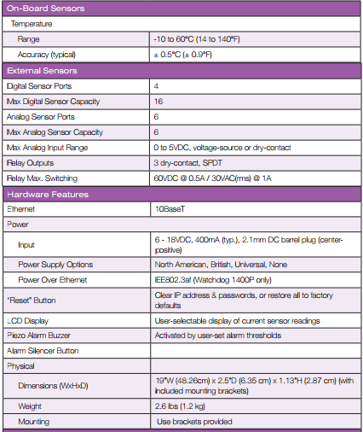



Contact Information

**Company Details:**

|  |  |
| --- | --- |
| **Item** | **Detail** |
| Name | **Geist , Inc.** |
| Address | 1777 Yolande Avenue Lincoln, NE, USA |
| Phone | 512-257-1462 |
| Email | sdomant@geistglobal.com |
| Website | http://www.geistglobal.com/ |

**Project Contact**

At any time during the project, you can get in touch with Shelley

|  |  |
| --- | --- |
| **Item** | **Detail** |
| Contact Name | Shelley |
| Phone | 512-257-1462 |
| Email | sdomant@geistglobal.com |

**Product Compatibility:**Product warranty: 1 year (best usage on the way it is utilized and it’s environment)  
Support: Support timings are been mentioned above which would be given product technical expert who is well trained.  
Physical Specifications: (http://www.geistglobal.com/sites/all/files/site/10014401_watchdog_1400_watchdog_1400_p_3.pdf)  
Specification about the product is been in above link, also more specific help in the website for detailed description.

**Web Interface: Alarms Page**  
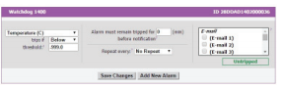

**Manual Installation**:   
Product need to be installed by our own technical team, for each piece to be installed it would take 15 minute to install.   
  
**Shipping Date**: 24/10/2016  
  
**Arrival Date**: 26/10/2016 (2 business working days)  
  
Regards,   
Sriharsha Goteti (Director of IFocus Data)

**Referrence:**http://www.geistglobal.com/sites/all/files/site/10014401_watchdog_1400_watchdog_1400_p_3.pdf