PORTFOLIO CONSTRUCTION
Prototype Report
What it does now and what comes next
Prepared for Sam & Pat | 09 August 2026
A transparent research and paper-portfolio prototype. It does not connect to a broker, place trades or promise returns.

Executive summary
The tool researches companies in the S&P 500 and Nasdaq-100, checks the quality of the evidence, then builds a 15-company proposed portfolio. Each holding links to a full research report. A separate Current portfolio view highlights price, thesis, audit and allocation changes for review. It never trades automatically.
Area | What is working now | Status
Research universe | 517 companies across the S&P 500 and Nasdaq-100; 192 have current saved research. | Active
Portfolio | 15 holdings, no cash, a 50% sector limit and a passed risk check. | Working
Decision rating | A true 0-100 score. It keeps the differences between companies and includes a small uncertainty deduction, so it never gives a false 100/100 certainty score. | Working
Monitoring | 15 positions checked; 11 unchanged and 4 allocation changes flagged for review. Price alone is not a sell signal. | Working
S&P 500 benchmark | The starting observation is saved. A one-month comparison starts after 30 days of records. | Building history
Status is based on the latest saved prototype run and is not an investment recommendation.
What the tool does today
- Looks at financials, valuation, business quality, management, competitors, earnings, catalysts, news, market signals and the wider economy.
- Checks the evidence and challenges the investment case before a company can be included.
- Avoids duplicate company exposure, limits concentration and gives different companies different weights based on return potential, evidence, risk and volatility.
- Lets you click a ticker for the investment case, risks, suggested holding period, valuation, catalysts, bot research and audit findings.
- Creates monitoring checks using refreshed fundamentals, valuation, technical signals, catalysts, thesis challenge and audit results. Price is shown as context, not as a fixed sell rule. All changes remain prompts for a person to review.

Latest proposed portfolio
This is the latest saved allocation. It is not a performance forecast.
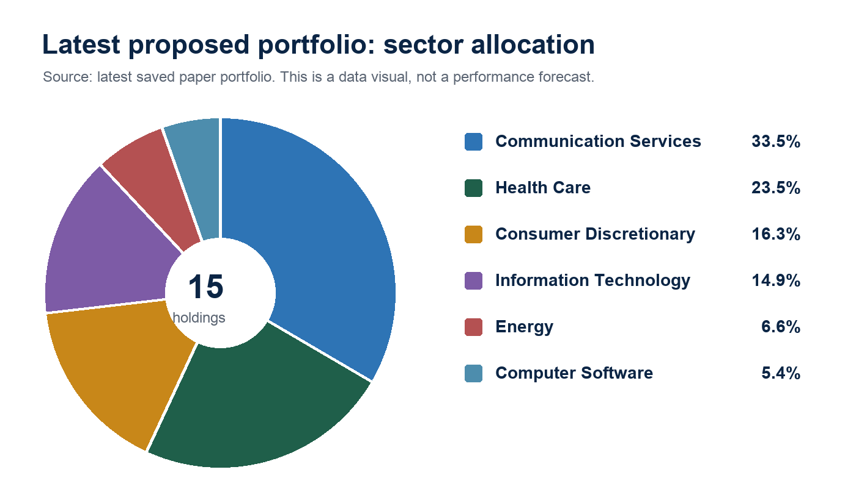
The model estimates 77.7% price upside over about 5 years (roughly 12.2% a year in the model). This is an estimate, not a promise.
Company | Allocation | Decision rating | Portfolio decision
News Corp (Class B) (NWS) | 9.4% | 85/100 | SELECTED
Accenture (ACN) | 7.2% | 82/100 | SELECTED
Atlassian (TEAM) | 5.4% | 82/100 | SELECTED
Bristol Myers Squibb (BMY) | 9.1% | 82/100 | SELECTED
Fox Corporation (Class A) (FOXA) | 6.8% | 82/100 | SELECTED
APA Corporation (APA) | 6.6% | 80/100 | SELECTED
Centene Corporation (CNC) | 6.5% | 80/100 | SELECTED
Adobe Inc. (ADBE) | 7.7% | 80/100 | SELECTED
TKO Group Holdings (TKO) | 6.8% | 79/100 | SELECTED
Cigna (CI) | 7.9% | 79/100 | SELECTED
Airbnb (ABNB) | 6.1% | 74/100 | SELECTED
Trade Desk (The) (TTD) | 4.9% | 73/100 | SELECTED
Booking Holdings (BKNG) | 5.2% | 71/100 | SELECTED
AT&T (T) | 5.5% | 71/100 | SELECTED
Expedia Group (EXPE) | 4.9% | 69/100 | SELECTED

Research sources and decision controls
Company filings are the main source of financial facts. Other sources add useful checks, but they do not overrule the audit process.
- SEC filings: the main source for reported revenue, cash flow, debt, shares and other company financial facts.
- Yahoo Finance/yfinance: current and historic market prices used for market context, volatility and technical analysis.
- Financial Modeling Prep: a separate check on reported statements, analyst estimates, rating snapshots and analyst price-target consensus.
- Massive: historic market data and company news, used to strengthen price context and identify relevant events.
- FRED: official US macroeconomic series such as interest rates, inflation and growth, used to assess the macro and discount-rate backdrop.
- Alpha Vantage: an additional independent income-statement source used as a cross-check when available.
- Data quality: the system shows missing or conflicting data instead of making up values. News is filtered so irrelevant headlines do not influence a company decision.
Portfolio safeguard policy
The prototype stays fully invested, but it does not treat every researched company as suitable. A failed audit, a broken thesis, weak valuation quality, duplicate exposure, too much sector concentration or a failed risk check can block or reduce a holding.
The decision rating combines the investment case, evidence quality, estimated return, valuation reliability, risk, thesis, technical context and the breadth of sources. It uses the full 0-100 scale and keeps the differences between companies. A small uncertainty deduction means it never gives a false 100/100 certainty score. It is not a prediction that a share price will rise.
S&P 500 comparison and current portfolio
The S&P 500 is the benchmark. Once the system has 30 days of saved checks, the website will compare the portfolio's past-month return with the S&P 500 over the same period. Until then, it says there is not enough data.
The performance chart will use real dated checks, not estimated past results. The latest check records 4 allocation changes for review, but the system has not changed the portfolio itself. A change is triggered by refreshed research evidence, not by an automatic 12% or 20% price rule.

What else needs actioning
- Run scheduled full research refreshes for current holdings so the monitoring view uses up-to-date fundamentals, valuation, technical analysis, catalysts, sentiment, thesis challenge and audit results.
- Add a proper catalyst probability model for events such as approvals, trials, contracts, product launches, acquisitions and regulatory decisions, using source-backed probabilities rather than headline sentiment alone.
- Improve technical analysis with stronger trend, momentum, volume, support/resistance and relative-strength measures, all compared against the wider market and sector.
- Expand fundamental analysis across several reporting periods: revenue growth, margins, free cash flow, debt, returns on capital, share dilution and guidance changes.
- Build sector and industry comparison models so each company is judged against direct competitors, not only against its own history.
- Add earnings-call, management-guidance and filing-change extraction, with clear links to the evidence that changed a view.
- Make macro analysis more specific: interest-rate, inflation, growth, credit and sector sensitivity should affect valuation assumptions and position sizes where relevant.
- Add portfolio-level correlation, factor and liquidity analysis so diversification is based on economic exposure, not only company names and sectors.
- Replace generic exit rules with a research-led exit framework: thesis break, valuation change, evidence failure, catalyst completion, deteriorating fundamentals or deteriorating technical context.
- Keep a complete decision log: what was known at the time, why a holding was chosen, what changed later and whether the decision was right.
- Build point-in-time historical datasets and backtests, including realistic transaction costs, turnover, delisted companies and out-of-sample testing.
- Build a longer paper record and compare it with the S&P 500 over 1, 3, 6 and 12 months before claiming an edge.
- Use paper outcomes to calibrate the scoring model. The learning bot should improve weights only from recorded evidence and later results, never hindsight.
- Add operational controls: source-health checks, stale-data warnings, error monitoring, reproducible research snapshots and manual approval for every portfolio change.
- Consider live trading only after strong paper results, independent review, clear risk limits, trading-cost analysis, broker controls and your explicit approval.

