Calling Cards Strategy Paired End V2

**Forward primer (One of the following):**

**OM-PB-ACG:**

AATGATACGGCGACCACCGAGATCTACACTCTTTCCCTACACGACGCTCTTCCGATCTACGTTTACGCAGACTATCTTTCTAG

**OM-PB-CTA:**

AATGATACGGCGACCACCGAGATCTACACTCTTTCCCTACACGACGCTCTTCCGATCTCTATTTACGCAGACTATCTTTCTAG

**OM-PB-GAT:**

AATGATACGGCGACCACCGAGATCTACACTCTTTCCCTACACGACGCTCTTCCGATCTGATTTTACGCAGACTATCTTTCTAG

**OM-PB-TGC:**

AATGATACGGCGACCACCGAGATCTACACTCTTTCCCTACACGACGCTCTTCCGATCTTGCTTTACGCAGACTATCTTTCTAG

**OM-PB-TAG:**

AATGATACGGCGACCACCGAGATCTACACTCTTTCCCTACACGACGCTCTTCCGATCTTAGTTTACGCAGACTATCTTTCTAG

**OM-PB-ATC:**

AATGATACGGCGACCACCGAGATCTACACTCTTTCCCTACACGACGCTCTTCCGATCTATCTTTACGCAGACTATCTTTCTAG

**OM-PB-CGT:**

AATGATACGGCGACCACCGAGATCTACACTCTTTCCCTACACGACGCTCTTCCGATCTCGTTTTACGCAGACTATCTTTCTAG

**OM-PB-GCA:**

AATGATACGGCGACCACCGAGATCTACACTCTTTCCCTACACGACGCTCTTCCGATCTGCATTTACGCAGACTATCTTTCTAG

**Reverse Primer: OM8951:**

CAAGCAGAAGACGGCATACGAGATCTTGTTATAGATAGCTTATCGCGATC

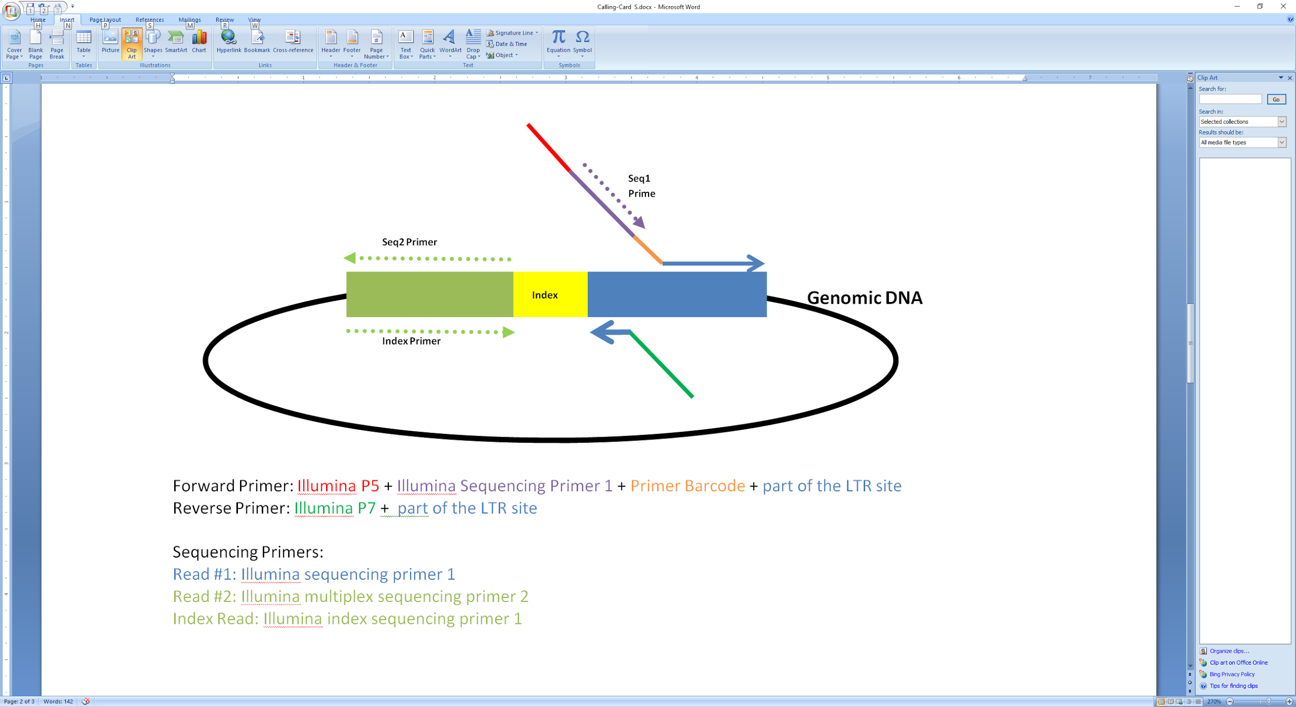

Read1:

PCR Barcode(3bp) + LTR seq(TTTACGCAGACTATCTTTCTAGGG) + TTAA + GenomicDNA or (TCTAGCTGCATCAGGATCATATCGT)

PCR Barcode (5bp) + LTR(32bp: GCGTCAATTTTACGCAGACTATCTTTCTAGGG) + TTAA + GenomeDNA or (TCTAGCTGCATCAGGATCATATCGT)

R2: cutter + genome_seq

Iread: Index