**Hybrid Travel Recommendation System: Integrating Collaborative and Content-Based Filtering Techniques**

*A Project Report submitted by*

**Sambit Mohanty**

**M22AI622**

*in partial fulfilment of the requirements for the award of the degree of*

**Master of Technology**

**in**

**Data and Computational Science**



**Indian Institute of Technology Jodhpur**

**School of Artificial Intelligence and Data Science**

*January 2024*

**Declaration**

I hereby declare that the work presented in this Project Report titled Hybrid Travel Recommendation System: Integrating Collaborative and Content-Based Filtering Techniques -Master of Technology in Data and Computational Science submitted to the Indian Institute of Technology Jodhpur in partial fulfilment of the requirements for the award of the degree of Master of Technology in Data and Computational Science submitted., is a bonafide record of the research work carried out under the supervision ofProfessor Dr. Sandeep Kumar Yadav.The contents of this Project Report in full or in parts, have not been submitted to, and will not be submitted by me to, any other Institute or University in India or abroad for the award of any degree or diploma.



**Signature**

*Mr. Sambit Mohanty*

M22AI622

**CERTIFICATE**

This is to certify that the Project Report titled Hybrid Travel Recommendation System: Integrating Collaborative and Content-Based Filtering Techniques, submitted by Mr. Sambit Mohanty (M22AI622) to the Indian Institute of Technology Jodhpur for the award of the degree of Master of Technology in Data and Computational Science is a bonafide record of the research work done by him under my supervision. To the best of my knowledge, the contents of this report, in full or in parts, have not been submitted to any other Institute or University for the award of any degree or diploma.

**Signature**

Dr. Sandeep Kumar Yadav

Department of Electrical Engineering

Indian Institute of Technology Jodhpur

Karwar, 342037, India

**ABSTRACT**

Within the sphere of contemporary travel, personalisation is an essential component in increasing the user experience and ensuring that the customer is satisfied. The goal of this project is to develop a novel hybrid recommendation algorithm that is specifically designed for the travel industry. This algorithm combines the benefits of collaborative filtering approaches with content-based filtering techniques. The suggested algorithm generates personalised travel recommendations by taking into account not only the preferences of the user but also their previous interactions and the content characteristics of the destinations they visit. We have demonstrated that our technique is superior in terms of suggestion accuracy and coverage by conducting comprehensive experiments and evaluations on real-world datasets. This approach addresses the intrinsic challenges that are associated with the travel industry, which include limited data and various consumer preferences. The results of this study not only help to the development of a reliable recommendation system for travellers, but they also pave the way for additional developments in hybrid algorithmic designs across a variety of different fields.

**Keywords:** Content-based filtering algorithm, Collaborative filtering-based algorithm, Utility matrix,

Sparse Density, Cosine Similarity.

**TABLE OF CONTENTS**

INTRODUCTION ................................................................................................................................. 6

LITERATURE SURVEY ...................................................................................................................... 8

2.1 DeepFake Detection by Analyzing Convolutional Traces [1] ....................................................... 8

2.2DeepFake Image Detection[2] .................................................................................................... 10

2.3 Deepfakes Creation and Detection Using Deep Learning[5]. ............................................... 12

2.4 Exploring Depth Information for Face Manipulation Detection [3] .......................................... 14

MODELS AND ALGORITHMS ........................................................................................................ 16

3.1 Dataset Gathering .......................................................................................................................

3.2 Dataset preparation ..................................................................................................................... 3.3 Model Creation ...........................................................................................................................

3.4Experiments ................................................................................................................................ 18 RESULTS AND FUTURE SCOPE ..................................................................................................... 19

CONCLUSION .................................................................................................................................... 22 REFERENCES .................................................................................................................................... 23

**CHAPTER-1**

# INTRODUCTION

In recent years, the field of recommendation systems has undergone tremendous developments. These advancements have been driven by the ever-increasing desire for personalised user experiences across a variety of disciplines. These kinds of technical advancements have the potential to be of tremendous advantage to the travel industry, which is a significant industry that feeds on user-centric solutions. A deeper connection between travellers and their locations can be fostered through the capacity to recommend destinations, lodgings, and activities that are personalised to individual tastes. This not only improves the user experience but also serves to enrich the user experience.

Collaborative filtering, rooted in the idea of leveraging user interactions and preferences, offers insights into patterns and trends by examining user-item interactions. However, it often faces challenges in situations where user data is sparse or when new items are introduced into the system. On the other hand, content-based filtering, which focuses on the intrinsic attributes of items and user profiles, provides recommendations based on similarity metrics. Yet, it may overlook serendipitous recommendations or fail to capture evolving user preferences over time.

Recognizing these challenges, this research introduces a hybrid travel-based recommendation algorithm that synergistically combines both collaborative and content-based filtering approaches. By harnessing the complementary strengths of these methodologies, the proposed algorithm aims to provide users with a more comprehensive and accurate set of travel recommendations. This introduction sets the stage for a deeper exploration of the hybrid algorithm, its design principles, implementation details, and the potential impact on enhancing the travel planning and booking experience for users worldwide.

.

**CHAPTER-2**

# LITERATURE SURVEY

## 2.1 A systematic review and research perspective on recommender systems [1]

**Deepjyoti Roy et al. (2022)** classified the recommender systems into 3 categories namely Content-based recommender system, Collaborative filtering-based recommender system and optimization-based recommender system. However, the scope of our research is limited to content-based and collaborative filtering-based algorithms only. Further Categorization is done in figure 1.

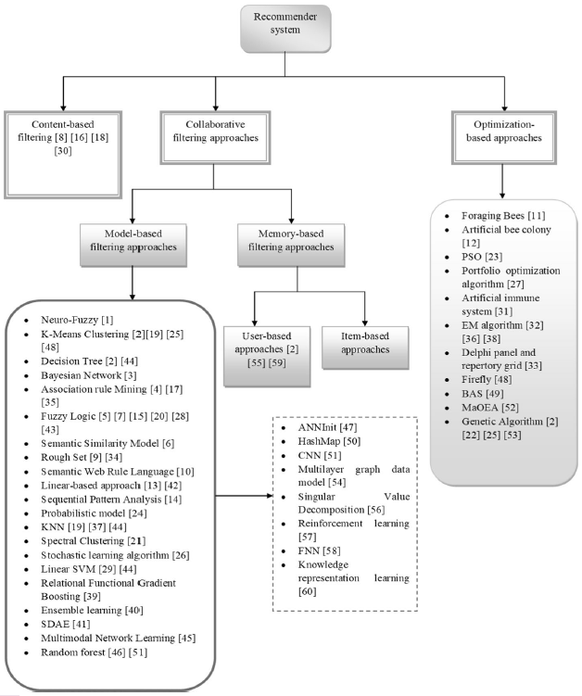

*Figure 1: Categorisation of Recommender Systems*

In our research, for model-based approaches we have covered K-Means Clustering, KNN, Singular Value Decomposition (SVD), Normal Predictor (based on normal distribution) and some other matrix factorization algorithms.

**2.2 Netflix Recommendation System based on TF-IDF and Cosine Similarity Algorithms [2]**

**Mohamed Chiny et al. (2022)** implemented a recommender system using TF-IDF and cosine similarity, often used in Natural Language Processing (NLP). TF-IDF stands for Term Frequency – Inverse Document frequency. Term frequency is the ratio of number of times a term appears in a document to that of total number of terms in the document. Inverse Document frequency is the logarithm of the ratio of the total number of documents to the number of documents containing the term. Fig 2 shows the formula.

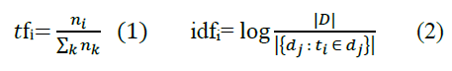

*Figure 2: Formula for TF and IDF*

TF-IDF score is the product of TF and IDF value. Cosine similarity is the angle between the 2 movie vector where each vector has TF-IDF has component.



*Figure 3: Cosine Similarity Formula*

**2.3 Model-based Approach for Collaborative Filtering [3]**

**Minh-Phung Thi Do et al. (2010)** explained Collaborative Filtering as a technique where user’s choices on items are predicted based on the choices of other users. To do that we need a rating matrix (also known as utility matrix)where rows represent the users, column represents the items (destinations in our case) and intersection of these two represents the rating. Collaborative Filtering is divided into Memory Based approach and model based approach.

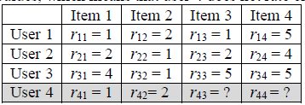

*Figure 4: Structure of a Utility Matrix*

Memory based approach uses cosine similarity between the user vectors in order to predict their closeness. Closure the value of cosine similarity to zero, the more similar the 2 user vectors are.

Model based approach uses machine learning models to predict the user behaviour. In this paper, the models explained are clustering model, classification model, latent class model, Markov Decision based model and Matrix Factorization based model. In our research we have used Clustering and Matrix Factorization based model.

**2.4 Movies recommendation system using collaborative filtering and k-means [4]**

**Phongsavanh Phorasim et al. (2017)** implemented K-Means clustering in movies recommendation system. Centroid in this case is considered as the user rating vector and updation of the centroid takes place based on the users added to the Cluster. The addition of the user to the cluster depends upon the Euclidean distance between the user and cluster centroid.

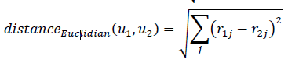

*Figure 5: Formulae for Euclidean Distance*

**2.5 Improved Ranking Based Collaborative Filtering Using SVD and Borda Algorithm [5]**

**Muhammad Iqbal Ardiansyah et al. (2019)** proposed a method based on Single Value Decomposition (SVD).

In SVD, the utility matrix is formulated as product of three matrices i.e

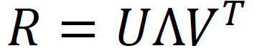

Where R is the utility matrix, U is the user matrix, V is the item matrix and Λ is a diagonal matrix where entries in the diagonal represent the eigen value of R. Both U and V are orthonormal matrices.

To predict the rating of a user U on an item i , the formula is give by:

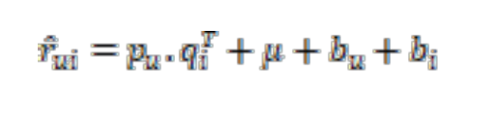

where  is predicted rating,  is the user vector where  U, is the transposed item vector where  V,  is the average rating of all items,  are biased used to minimize the prediction error.

**2.6** **Surprise Documentation [6]**

**Surprise** is an easy-to-use python library used for recommendation system. It has the **prediction_algorithms** package from where we can use in-built method for basic algorithms like Normal Predictor, Baseline etc, KNN algorithms and Matrix Factorisation methods like SVD, SVDpp, NMF etc. The **Dataset module** is used to convert the utilty matrix into a dataset of schema (user_id, item_id, rating). The **accuracy** module has performance metrics like mae, rmse etc which can be used for performance analysis.

**CHAPTER-3**

# IMPLEMENTATION OF EXISTING ALGORITHMS

**3.1 Content-Based Filtering**

**Dataset:** City.csv from Kaggle.

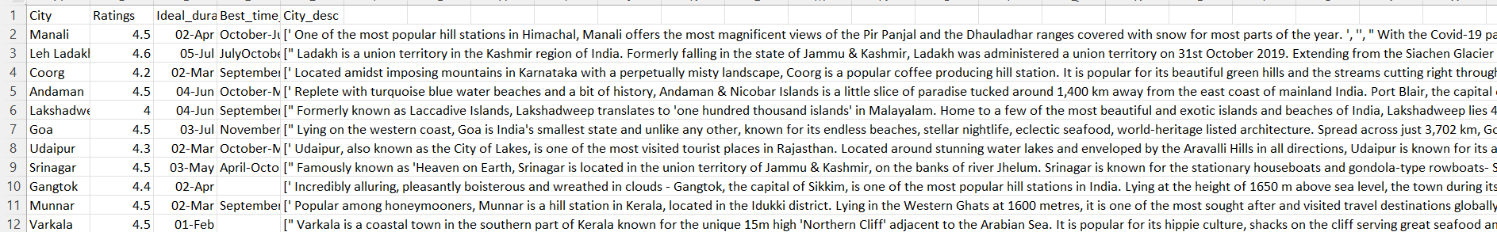

*Figure 6: City.csv dataset*

**Dataset preprocessing**

Ratings, Ideal_duration, Best_time_to_visit columns are dropped from the dataset.

**Implementation steps**

* *TfidfVectorizer* method is used to create a matrix with columns as keywords in the document and rows would be the same as that of initial dataset.
* The initial challenge is numerical terms would also be considered as a keyword as they are in the form of string in the document.
* So, we had to remove these numerical terms using regular expression for alphabet characters as token pattern.
* The *fit_transform* method would be used to calculate the TF-IDF score of each keyword in each row of the dataset. A sample tf-idf matrix is shown in figure 7.
* 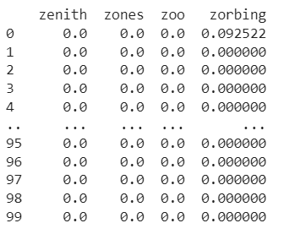

*Figure 7: TF-IDF Matrix sample*

* Cosine similarity is calculated which would give us the similarity score of the cities.
* *recommend_destination* method would return top 5 cities based on the input city. The sorting in this method would be based on the similarity score of the input city with the remaining cities of dataset in the descending order.
* Higher the similarity score, more is the similarity between the cities.

**3.2 Collaborative-Filtering based Algorithm**

**Dataset Creation:**

* Utility matrix is created by generating the ratings using custom algorithm.
* Rows consist of user where user_id is of format ‘user_{index_of_row-1}’. Number of Users are considered as 5000.
* Column consists of the cities which are retrieved from the **‘City.csv’** file.
* Intersection of rows and columns is the rating given by user in that row to the City in that column.
* All the ratings are initialised to zero.
* Integer values in the range of [1,5] are assigned randomly based upon the spare density.
* For eg: If sparse density is 0.1, which means only 10% of in the utility matrix is non zero.
* After matrix generation, it is stored in .csv file. Naming convention of file is given by **‘Utility_Matix_{no of users}_{sparse density}.csv’**.
* Sparse density is increased by 0.1 and the above steps are repeated till the sparse density value is 1.

**3.2.1 Memory based Algorithm**

* For user based collaborative filtering, cosine similarity score is calculated between the users. The more closure the similarity score to zero, the more similar the users are.
* Similarly for item based collaborative filtering, cosine similarity score is calculated between the items (Cities in our case).

**3.2.2 Model Based Algorithm**

**SVD**

* After reading utility matrix, the dataframe is converted into **Surprise Dataset (**defined in the **Surprise** Library of python).

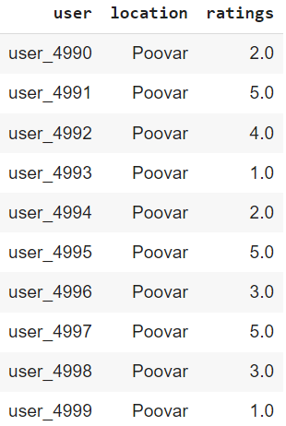

*Figure 8: Structure of a Surprise Dataset*

* Dataset is divided into trainset and testset (80:20).
* After training the data, predictions were made on testset and these predictions we used to calculate performance metrics like rmse and mae.
* Finally, 5 fold cross validation is performed to generate avg rsme and avg mae
* The above process is repeated for all the files that were generated in Dataset creation step.
* Performance of SVD model with different sparse density is compared by plotting avg rsme and avg mae against the sparse density.

Other models like NMF (similar to SVD with non-negative predictions), Normal Predictor, BaseLine, KNN etc are trained and performance comparison is done with SVD.

**CHAPTER-4**

# IMPLEMENTATION OF HYBRID ALGORITHM

**Dataset used:** ‘City.csv’, ‘Utility_Matrix_5000_0.3.csv’

Hybrid algorithm is implemented by combining both Content-based and Collaborative-based filtering algorithm. It leverages on strengths of both approaches in order to enhance the performance and relevance of travel recommendations. Currently we have implemented a draft version of the hybrid algorithm in which there’s still scope of improvement of performance metrices and relevant recommendation.

**Steps**:

* Initially, we’ll be implementing Content based Algorithm on the **‘City.csv’** dataset. This would give us a set of Cities based on the similarity of TF-IDF scores.
* 20 Cities are retrieved including the city which is given as input to the algorithm.
* Before implementing collaborative filtering, only the columns with column heading same as that of 20 cities retrieved in previous step are fetched from **‘Utility_Matrix_5000_0.3.csv’** dataset.
* Some rows were also eliminated based on the logic that the users who have like the input city should be in the final DataFrame i.e rating > 3 given by the users for the input city.
* So collaborative filtering would be applied on a matrix (dataframe) whose dimensions are m x n where

m (no of users) < 5000 and n (no of cities) = 20

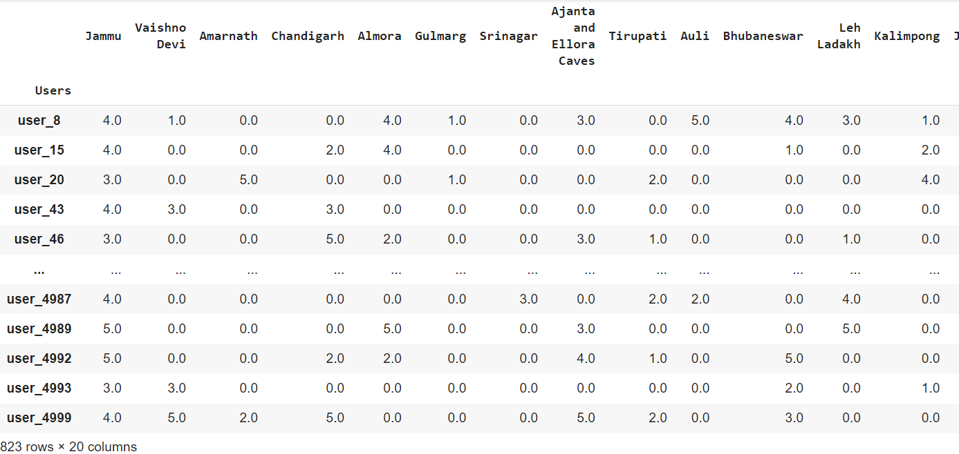

*Figure 8: Structure of a Final DataFrame (input City = Jammu)*

* SVD model is preferred for training the data. The process of splitting the data, converting to surprise dataset, cross validation and performance metrics calculation remains the same as that of the one explained under **“SVD”** section.
* To get the recommendations, user_id is taken as input.
* Cities that are not visited by the user are recommended and are sorted based on the ratings predicted by the model .

**CHAPTER-5**

# RESULTS

**5.1 Results of Content-Based Filtering.**

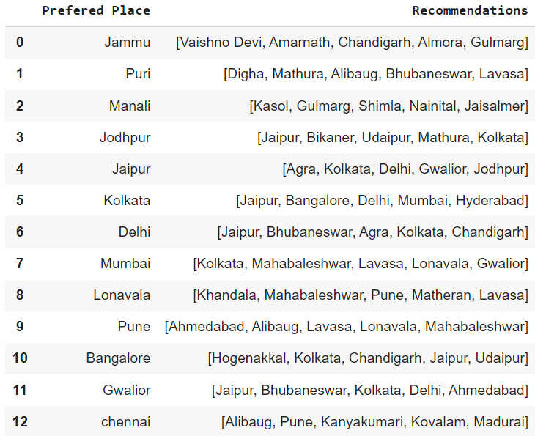

**5.2 Comparison of performance of SVD with different sparse density of dataset.**

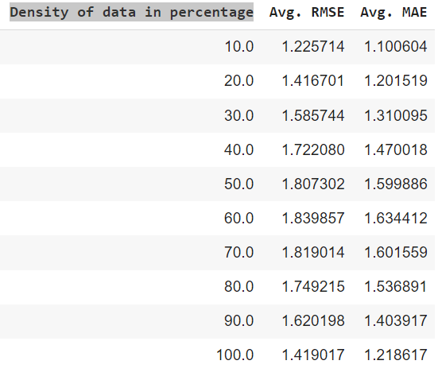

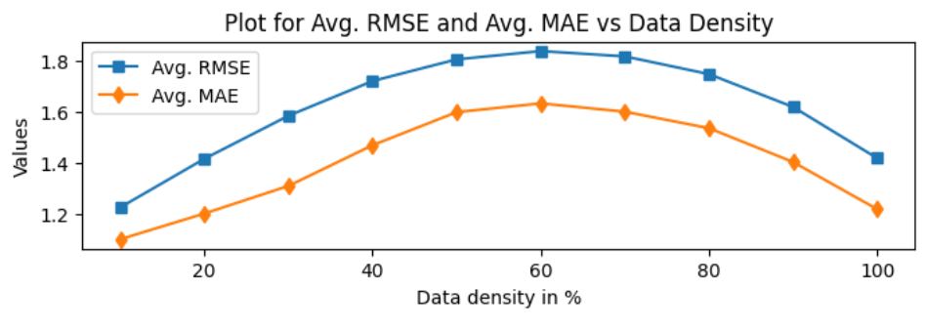

*Figure 9: Performance metrics Comparison*

**5.3 Comparison of performance of SVD with other models.**

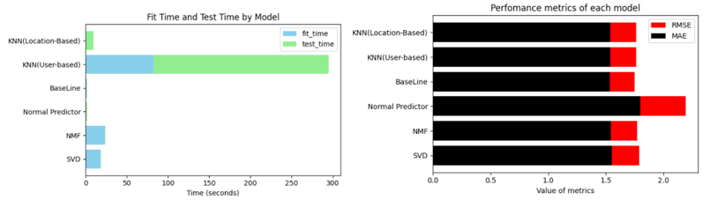

*Figure 10: Performance metrics Comparison of different models*

**5.4 Impact of number of users on SVD model.**

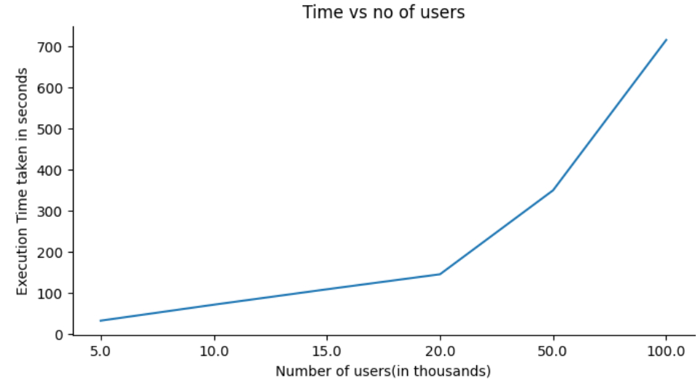

**5.5 Results of Hybrid approach**

Input location: Jammu, Input User id = user_20

RMSE: 1.7096

MAE: 1.4868

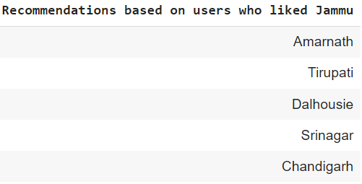

Input location: Chennai, Input user = user_23

RMSE: 1.7062

MAE: 1.4840

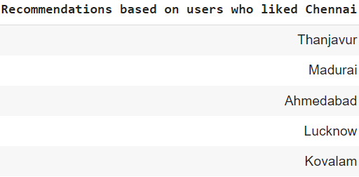

Input Location: Tirupati

Input user = user_31 Input user = user_31

RMSE: 1.7231 RMSE: 1.7176

MAE: 1.5009 MAE: 1.4951

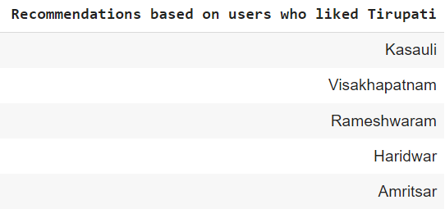 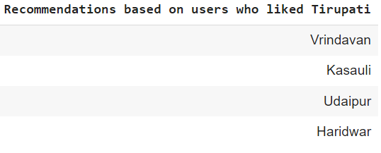

**CHAPTER-6**

**CONCLUSION AND FUTURE WORK**

We have presented a comprehensive study and development of a hybrid travel recommendation algorithm in this research paper. The purpose of this algorithm is to improve the personalisation and effectiveness of travel recommendations. The proposed algorithm takes advantage of the strengths of multiple recommendation techniques to provide a comprehensive and user-centric approach to travel planning and exploration. This is accomplished by integrating collaborative filtering, content-based filtering, and contextual information.

The scope of future work is opened to all the 3 algorithms. For content-based, we can implement reinforcement learning in order add the cities which are not present in the ‘City.csv’ dataset. For Collaborative filtering, models other than svd can be used which may give us better performance. This can also include deep learning models. Hybrid implementation is still work in progress in our current research. The scope of work in hybrid implementation would be focusing on more relevant outputs.

**REFERENCES**

1. A systematic review and research perspective on recommender systems (Luca Guarnera et al.)

[2] Netflix Recommendation System based on TF-IDF and Cosine Similarity Algorithms

(Mohamed Chiny et al. (2022)).

[3] Model-based Approach for Collaborative Filtering (Minh-Phung Thi Do et al. (2010)).

[4] Movies recommendation system using collaborative filtering and k-means (Phongsavanh Phorasim et al. (2017))

[5] Improved Ranking Based Collaborative Filtering Using SVD and Borda Algorithm

Muhammad Iqbal Ardiansyah et al. (2019).

[6] Surprise Documentation (https://surprise.readthedocs.io/en/stable/)