**HACK-O-UPLIFT**

**2021**

**TEAM NAME: TEAM MAVERICKS**

**Sambit Kumar Tripathy**

**Ritulagna Tripathy**

**Abhips Raj Sahoo**

**Ayush Singh**

**PROJECT THEME : FIN-TECH**

**PROBLEM STATEMENT**

As we all know, open banking refers to open APIs that facilitate third-party developers to develop applications and services around the financial institution. This new-built technology is expanding at an exponential rate in the financial market. Nowadays, customers are switching to online banking since offline processes tend to become hectic and time-consuming. But one of the notable issues that bother people and financial firms is the security of data while retaining customer transparency. This issue affects the advancement of digitizing financial services.

Further, some of the prevalent open banking software we know are limited to money transactions and bill payments. So, clients use separate applications for different targets, which makes their online banking experience troublesome. Also, the customers barely find any applicable rewards or offers provided by their respective banks or service providers. So, open banking systems should constantly monitor customer insights, which can be rewarding for both client and service providers.

Overall, this problem statement asks us to find a way to ensure: Faster innovation in the field of open banking, personalized offers for clients and detailed monitoring of customer insights.

**SOLUTION’S IMPLEMENTED**

**Making every financial dealing completely online and user-friendly:**

Conventional method used to be hectic and time consuming. Also, it was quite difficult for the user to gather all information related to various financial deals. Though online methods make it faster and smoother, the user needs to be self-reliant which can make them a bit hesitant before taking any financial decisions.

So, through our services the client can enjoy:

1. Varieties of deals over a single platform like opening accounts, money transactions, loans, consultancy, insurance services, investments etc. which makes it very convenient for them.
2. In case of any doubts, they can go through the video graphics or can seek expert's advice.

**Constant tracking of customer actions:**

In conventional method it was quite difficult for clients to keep a proper track of profit margin and expenditures.

So, we are providing customers:

* With insights on their transactions and graphs to show their daily, weekly or monthly expenses so as to provide them an organized information and help them to to put a check on their expenses.
* Data on the profits they had made in their past transactions.
* Insights on the profits they can make by doing certain investments.

**Experts' advice before any deal and live customer support:**

Clients can get spoilt for choices after going through so many investment and loan options, insurance policies etc. So, through our app we will:

* Highlight the key points i.e., profits, interest rate etc. about every deals so that they can compare and choose the preferrable one.
* Help them interact with financial experts with 24x7 customer support before making any important financial decisions. This will help the customers to draw optimal conclusions.
* Constantly update them about the stats of their financial deals.

**Personalized offers based on location and interests:**

We will notify our customers about the discounts and offers available on their respective financial providers by:

* Adding location markers on those specific stores.
* Sending notifications to the customer regarding the offers applicable on various e-commerce stores.

By including this feature, we are increasing engagement of the financial firms and adding extra benefits to the customer, which will increase their faith towards the bank.

**Constant monitoring of customer insights:**

We will conduct regular surveys to gather information on the interests and background of the customer to provide them with personalized offers, along with improving our own services.

Generally, users get rewards which are not helpful for them, leading to dissatisfaction. So we are adding this feature which will let us know about the user’s interest and the rewards provided to them will be based on it.

**Providing high level security**

Present issue in the current open banking structure is security, due to which many financial services aren’t being digitized.

As service providers, we will assure both the bank and customers that utmost privacy shall be maintained. Even we, as mediators, are not taking away any data that should remain confidential between the two parties. We will not retain any user information in our database.

**IMPACT METRICS**

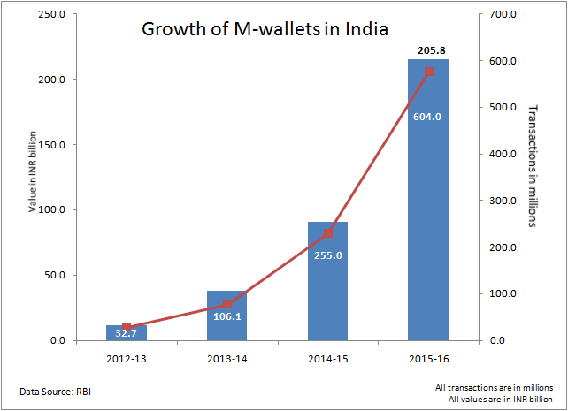

As we can see in the graph, with each passing year the number of peoples preferring mobile banking is rising exponentially.

So, we are here with our solution model that have a set of good and catchy features tends to attract more customers. Also, the addition of step-by-step instructions and expert's financial advice makes it more enchanting.

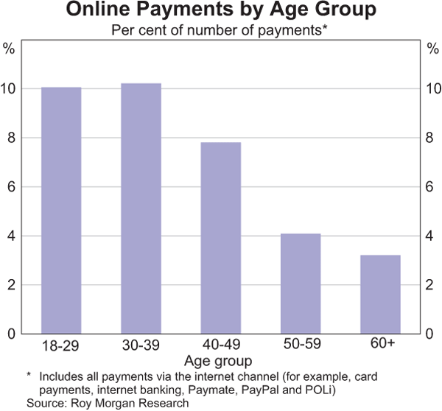

We are monitoring the percentage of mobile banking users based on their age groups, which generates a decreasing graph. So major issue is that the interface of these apps is quite complex for elderly individuals.

So, we came up with innovations like instruction video and experts consultancy that will make it more feasible for them to use.

**EXTENT OF SCALABILITY/USABILITY**

In the present world scenario, the number of internet users is booming, and everyone wants to have all their work to be done online. And the present open banking applications can’t fulfil all the demands at a single platform.

So here we came up with a solution that can fulfil the client side demands with varieties of amazing features. The application has a very user-friendly interface and is available for all. It includes instruction videos that will help the user to figure out how to use the app; we have included a chat bot for 24x7 customer support, and we are also providing expert consultancy to help the users.

**UI EXPLAINED**

**Sign-Up & Login**

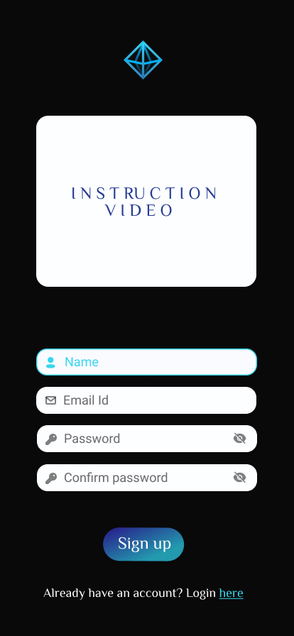 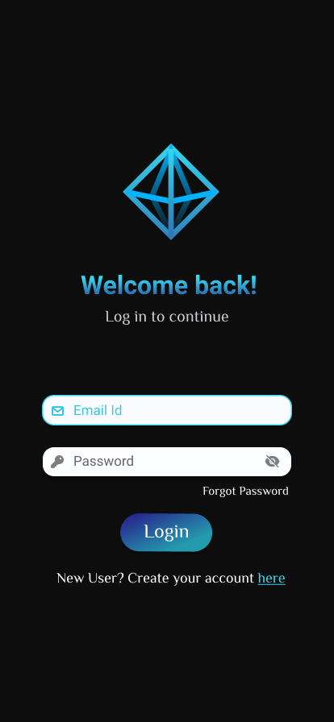

To ensure the credential authenticity we will be offering **Fingerprint Lock** along with **Alpha-Numeric password** access to our clients.

To make the signup process smoother we will be providing **Instruction videos** for our new clients.

**Home Page**

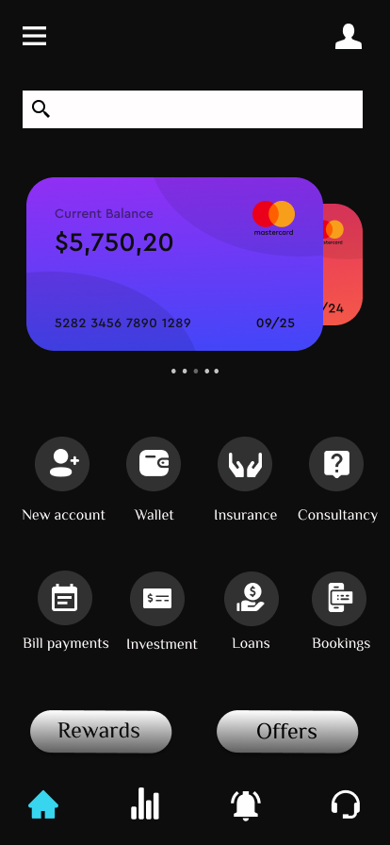

It will function as the centre stage for all the choices that are being provided to the user as it’s the sole means for the user to access those features.

It consists of :

Card Switch, opening new bank accounts, Wallet for payments, applying for insurance, seeking expert advice, applying for loans, investing your money, making bill payments, ticket bookings, checking the rewards earned, offers available.

It also has a search bar if in case any user has difficulty to find something.

At the bottom there are 4 tabs that will be present on all the pages: Homepage, Stats, Customer Support & Settings respectively.

**Offers Page**

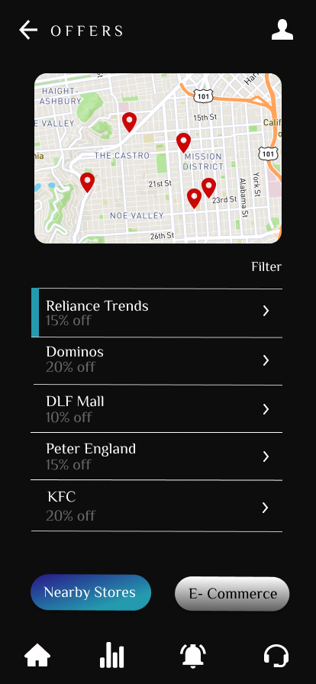 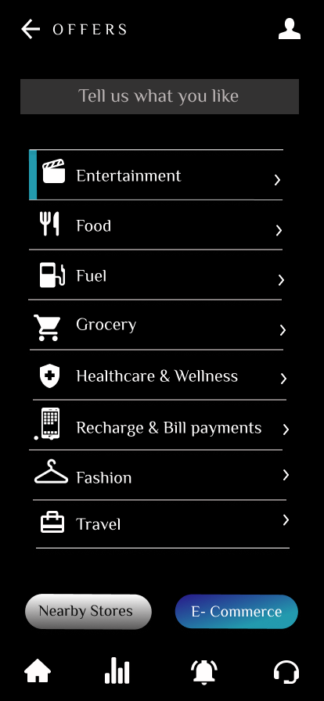

**We will be presenting various offers from different categories like Entertainment, Food.**

**We will be notifying you about offers available in the nearby stores through the map.**

**We will be classifying offers between nearby stores and online e-commerce stores.**

**Rewards & Stats Page**

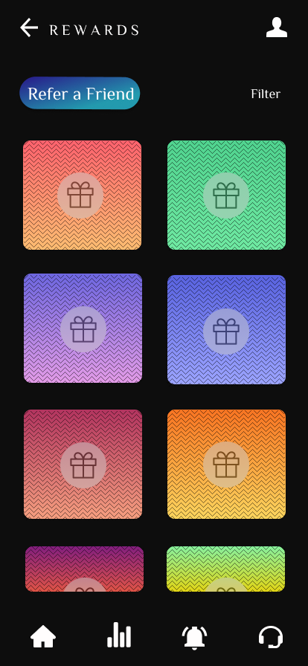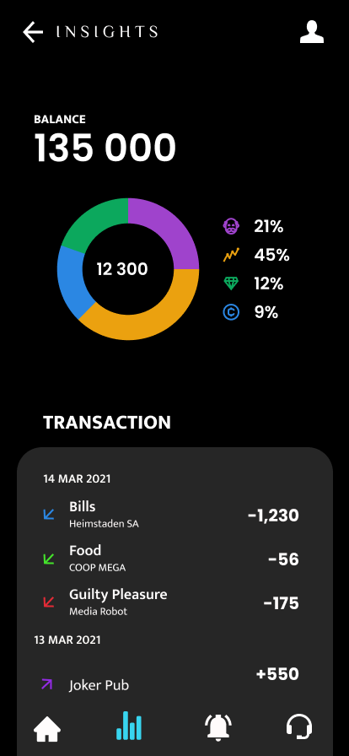

**The pie chart will let you know about your spending, investments and saving, with the feature of comparing it to the previous months expenditure.**

**You can get all your transaction history stored in a systematic form for better convenience.**

**All the rewards earned in the past transaction can be accessed here and with the filter option, they can choose to view rewards according to their desired** criteria.

**Customer Support Page**

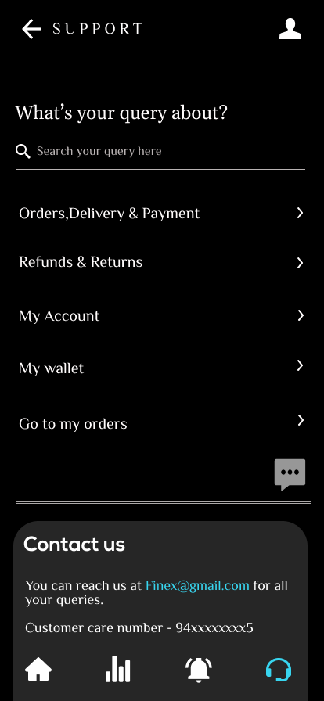

The customer support page will consist of the **FAQ (Frequently Asked Question)** section to brief most asked questions.

It has a feature to enter your query, if it is not present in FAQ section, which will be attended by a chat bot that will be live 24x7. We are also providing email-ids and contact numbers in case the query isn’t resolved.

**TECHNOLOGY STACKS USED**

1. Android Studio : We will be using android studio to convert our idea to practically usable solution. It will accelerate our development and help us build the highest-quality apps for Android devices.
2. Kotlin : We will be using Kotlin because of its easy and clean code structure that reduces chances of bugs.
3. IBM Watson : We will be using IBM Watson to regulate a chat bot that will be used for 24x7 customer support.
4. Machine Learning : We will be using machine learning to create a profit prediction model. It will help the user to make proper investments.
5. Google Maps API : We will be using google maps API to provide users information about the offers in the nearby stores.

  

|  |  |  |
| --- | --- | --- |
| ANDROID STUDIO | KOTLIN | IBM WATSON |

 

|  |  |
| --- | --- |
| MACHINE LEARNING | GOOGLE MAPS API |

**SOCIAL IMPACT/NOVELTY**

You can access your account at any time of the day and are no longer confined to conventional business hours Faster and more efficient. Traditional banking can be a relatively slow process, especially if you encounter long lines at the teller windows or must delay transactions because the bank has already closed.

If you have the internet there is no problem with the user accessing, there bank from inside their own home.

This application has many features and services available for example you can apply for credit cards, manage investments, get loans and insurances, buy tickets, and pay bills through the internet.

**FUTURE SCOPE**



Digitization of all financial services and providing customers extra benefits regarding their finance will improve customer engagement.



Providing step-by-step instructions will make our clients less hesitant about taking financial decisions and attract more customers.



Further expansion of our firm by designing a website or desktop application. There is always a scope of improvement in technology which can make all the processes even faster and more secured.