Model Evaluation & Explainability Report

1. Key Data Quality Findings
Genre normalization (84 to 41): The dataset was merged from Netflix and Disney, which use different naming conventions (e.g., 'Dramas' vs 'Drama', 'Action & Adventure' vs 'Action-Adventure'). We built a manual mapping to merge these duplicates.
Rating/duration swap: 3 rows had their rating and duration columns swapped (identified during EDA).
Country trailing commas: 5 entries had trailing commas creating empty strings after splitting.
Director/Cast analysis: We found 104 directors and 118 actors with strong genre consistency, but decided not to include them as features because director has 30% missing data and cast signal is largely redundant with the country feature.

3. Evaluation Metrics
All models were tuned using GridSearchCV with 3-fold cross-validation on the training set.
Model | F1 Micro | F1 Macro | F1 Weighted | Precision Micro | Recall Micro | AUC Micro | AUC Macro
Logistic Regression | 0.6344 | 0.4979 | 0.6455 | 0.5548 | 0.7405 | 0.9671 | 0.943
Linear SVM | 0.6413 | 0.4907 | 0.6468 | 0.5727 | 0.7285 | 0.9658 | 0.9398
XGBoost | 0.6266 | 0.4206 | 0.5961 | 0.7627 | 0.5317 | 0.9651 | 0.9316

Key insight: F1 Micro is ~0.63 (moderate) while AUC Micro is ~0.97 . This gap means the models learned strong patterns but the fixed 0.5 decision threshold is suboptimal for rare genres. Per-genre threshold tuning would improve F1 without retraining.

4. Comparison Plots

Tuned Models: F1 & AUC Comparison
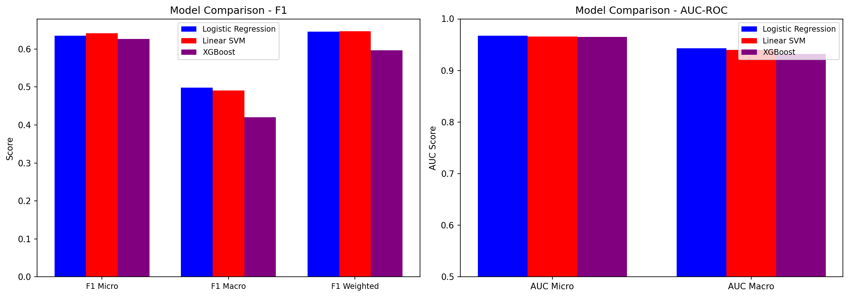
Per-Genre F1 Score (Top 20 Genres)
Linear SVM (red) leads on most genres. All models perform well on common genres (International Movies, Drama) but struggle with rarer ones.
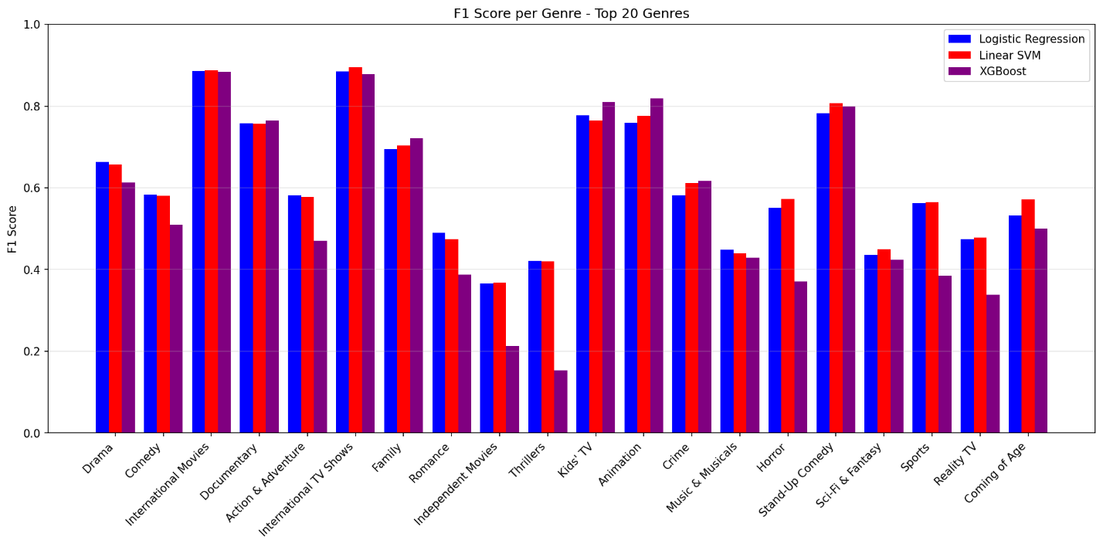

Per-Genre AUC-ROC (Top 20 Genres)
AUC scores are consistently high (0.85+) across all genres and models, confirming the models rank genres correctly.
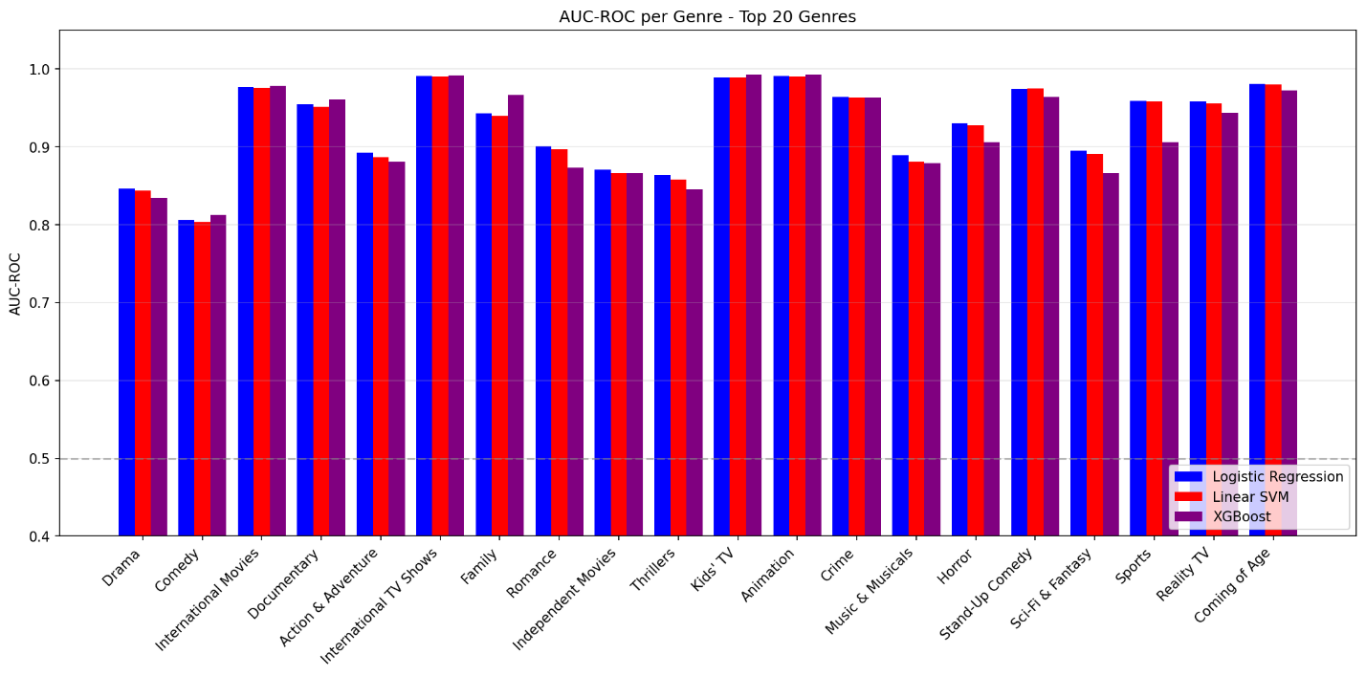

5. Explainability Visuals
Top Features by Genre (Logistic Regression Coefficients)
Linear model coefficients show which words most strongly predict each genre. The model learned intuitive patterns: Horror is predicted by 'horror', 'supernatural', 'ghost', 'zombie'; Romance by 'love', 'romance', 'couple', 'wedding'; Stand-Up Comedy by 'comedian', 'stand', 'comic', 'special'.
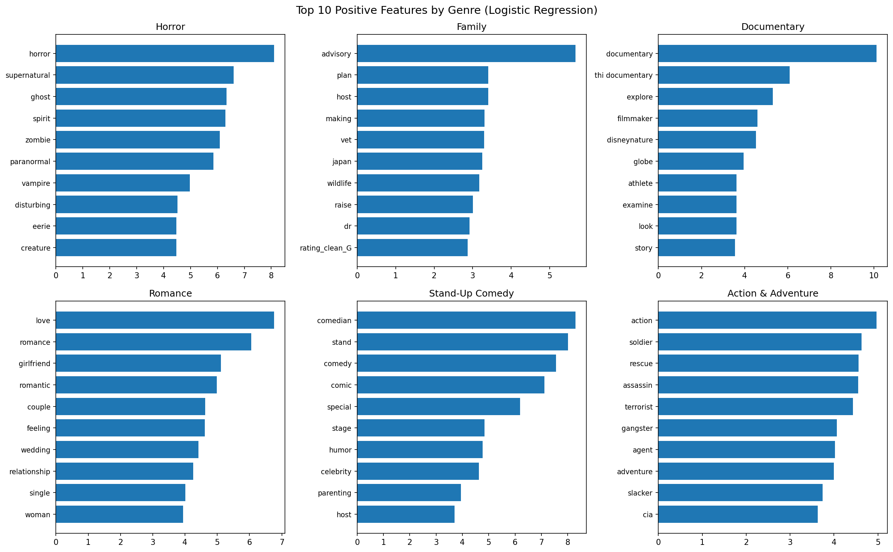
XGBoost Global Feature Importance
XGBoost relies more on structural features (type, platform, release_year) for initial splits, then uses text features for fine-grained genre discrimination.
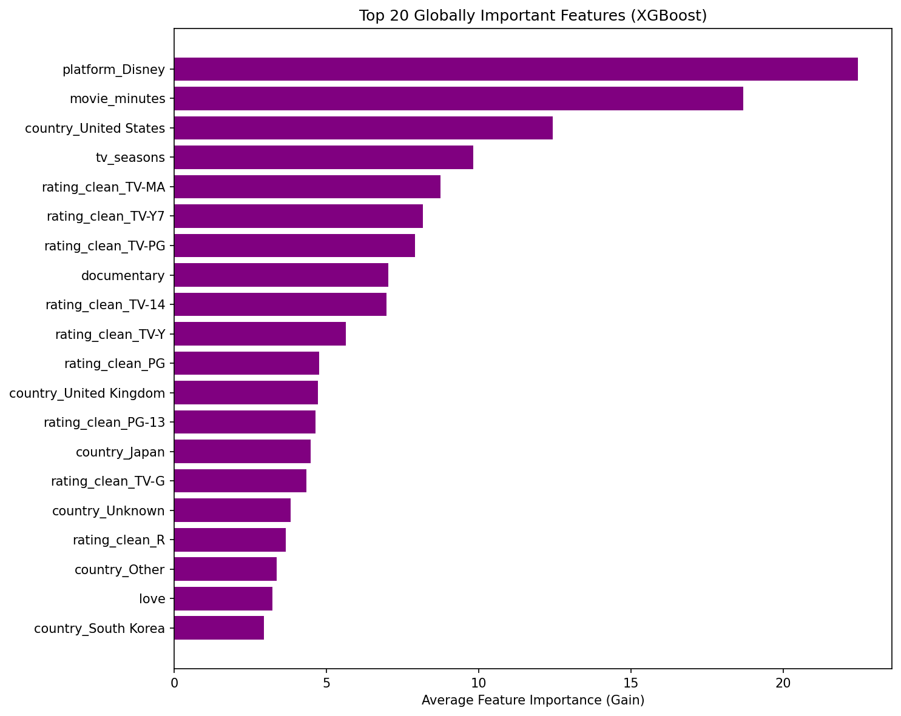

Linear SVM Global Feature Importance
Linear SVM learned nearly identical genre-predictive patterns as Logistic Regression (horror/zombie/ghost for Horror; love/romance/wedding for Romance), confirming both linear models found the same signal
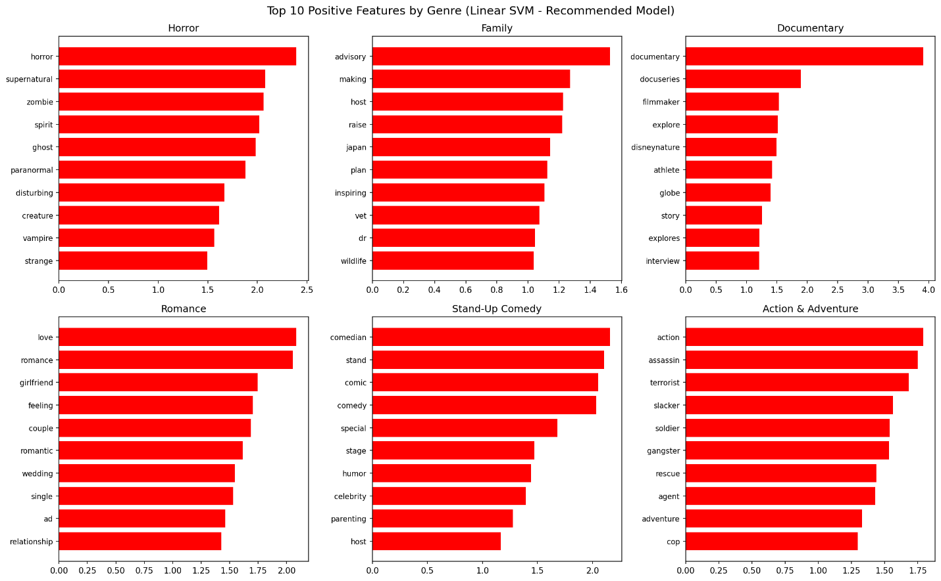

Cross-Model Feature Importance (LR vs XGBoost vs SVM)
All three models agree that platform (Disney/Netflix), content rating, and key genre words like "documentary" and "love" are the most important features - while XGBoost uniquely relies heavily on movie_minutes for its tree splits, reflecting how tree models prefer numeric features over sparse text.
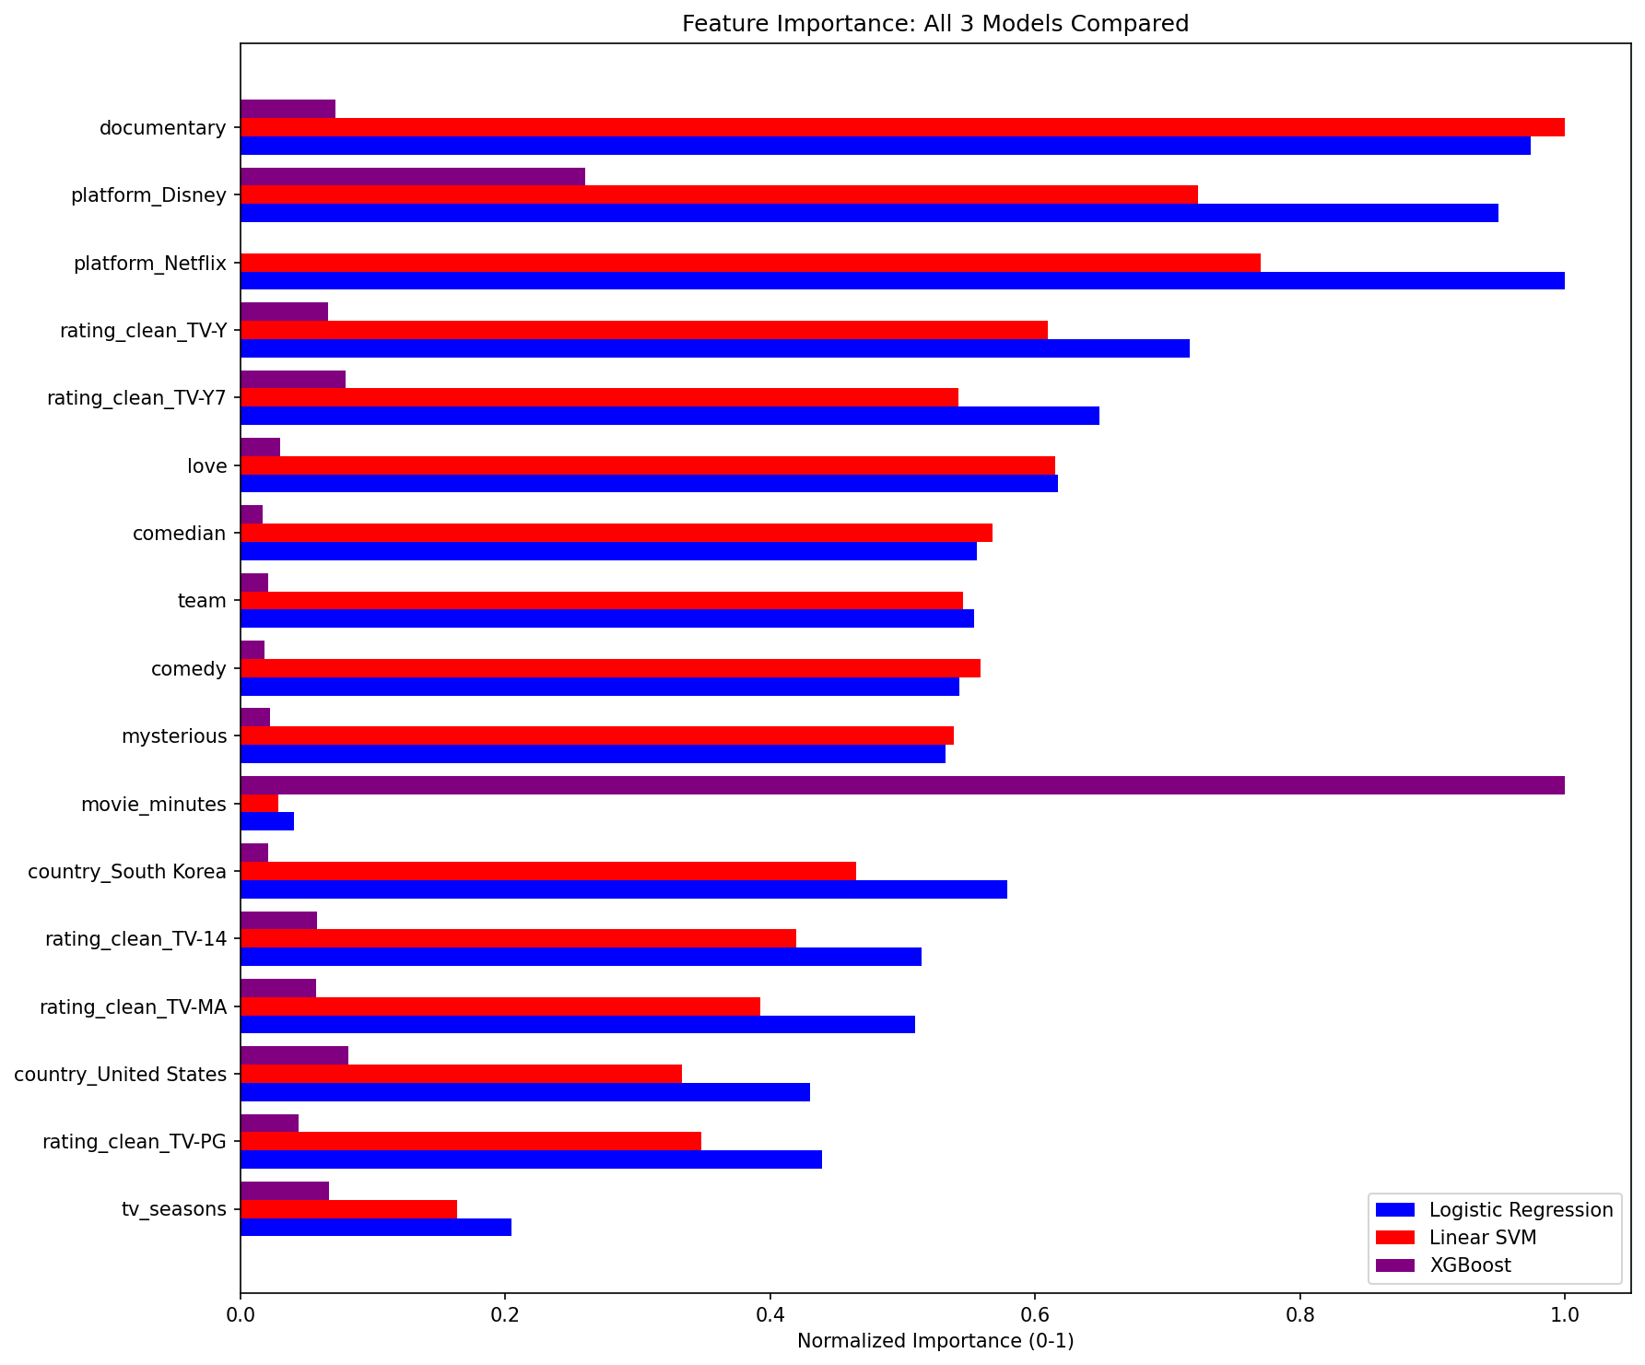

6. Model Recommendation
Recommended model: Linear SVM
Linear SVM is recommended because it achieves the best F1 Micro score (0.6386), trains the fastest among tuned models, and provides clear per-feature weights for interpretability. It outperforms Logistic Regression on the primary metric while maintaining comparable AUC scores.

