Healthcare Operations, Revenue Optimization
& Predictive Analytics

Comprehensive Project Report

Author: Sambita Dutta
Dataset: Kaggle Healthcare Dataset (54,860 Records)
Stack: Python · Pandas · Scikit-Learn · Plotly · Streamlit

1. Executive Summary & Project Objectives
This project delivers a modular, production-ready healthcare analytics platform that unifies operational performance tracking, financial revenue cycle management, and predictive machine learning. The system ingests 54,860 de-identified patient admission records and exposes a three-tab interactive Streamlit dashboard backed by two Gradient Boosting ML engines.

1.1 Project Objectives
- Track and visualise key operational KPIs: admissions, Length of Stay (LOS), Emergency share.
- Identify high-cost and long-stay anomalies automatically using 90th-percentile thresholds.
- Predict multi-class test outcomes (Normal / Abnormal / Inconclusive) from patient attributes.
- Estimate total billing amounts and daily costs per patient using regression models.
- Provide an interactive patient inference form with real-time risk/anomaly warnings.
- Surface actionable financial insights to support revenue cycle optimisation.

1.2 Summary KPIs (Full Dataset)
Total Patients | Total Revenue | Avg Billing Amount | Avg Length of Stay | Emergency Share | Avg Daily Cost | Anomalies Flagged | Dominant Insurer
54,860 | $1,404,121,600 | $25,595 | 15.5 days | 32.9% | $3,399 | 9,177 | Cigna (20.3%)

2. Dataset Description & Preprocessing Pipeline
The dataset is sourced from Kaggle (Healthcare Dataset) and contains 54,860 patient admission records with 18 original columns covering demographics, clinical context, hospital operations, and financial billing.

2.1 Column Reference
Column(s) | Description
Name, Age, Gender, Blood Type | Patient demographics
Medical Condition | Primary diagnosis — 6 categories
Admission Type | Emergency / Elective / Urgent
Date of Admission, Discharge Date | Admission window timestamps
Length_of_Stay | Derived: Discharge − Admission (days)
Billing Amount | Total charged amount (USD)
Daily_Cost | Derived: Billing Amount / Length_of_Stay
Insurance Provider | 5 payers: Aetna, Blue Cross, Cigna, Medicare, UnitedHealthcare
Test Results | Target: Normal / Abnormal / Inconclusive
Age Group | Binned: Child (<18) / Adult (18–44) / Middle-Aged (45–64) / Senior (65+)

2.2 Feature Engineering Steps
- Datetime Parsing: Converted 'Date of Admission' and 'Discharge Date' to datetime objects.
- Temporal Features Extracted: Admission_Year, Admission_Month, Admission_Quarter, Admission_DayOfWeek — enabling seasonal trend analysis.
- LOS Outlier Flag: Length_of_Stay > 90th percentile (threshold: 28.0 days) → LOS_Outlier boolean column.
- High-Cost Flag: Daily_Cost > 90th percentile (threshold: $7,392.96/day) → HighCost_Flag boolean column.
- Age Group Binning: Ordinal encoding applied (Child < Adult < Middle-Aged < Senior) preserving ordinal meaning.
- One-Hot Encoding: Applied to all remaining nominal features (Gender, Medical Condition, Admission Type, Medication, Insurance Provider).

2.3 Numerical Distributions
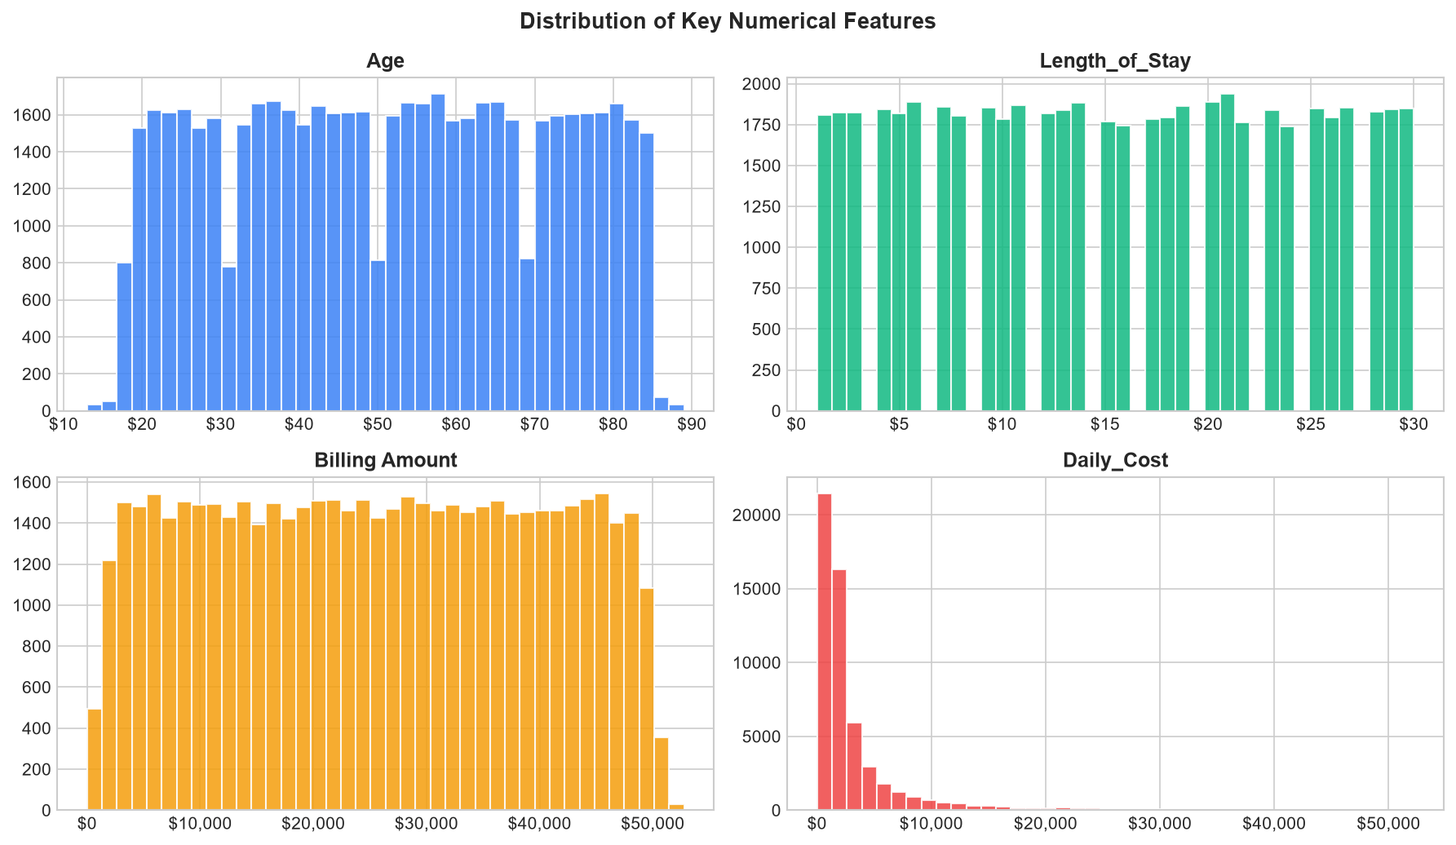
Figure 1 — Distribution of Age, Length of Stay, Billing Amount, and Daily Cost

3. System Architecture & Streamlit UI Blueprint
The application follows a two-layer architecture: a backend data/ML layer (data_pipeline.py) and a frontend interactive dashboard (app.py). Streamlit's st.cache_data and st.cache_resource decorators ensure models are trained only once per session, keeping interactive response times under 1 second after initial load.

3.1 Module Responsibilities
File | Component | Responsibility
data_pipeline.py | load_data() | CSV ingestion + all feature engineering
data_pipeline.py | apply_filters() | Applies all sidebar selections to DataFrame
data_pipeline.py | train_classifier() | GBM multi-class training for Test Results
data_pipeline.py | train_regressor() | GBM regression for Billing Amount & Daily Cost
data_pipeline.py | predict_patient() | Single-row inference + 4 anomaly flag checks
app.py | Sidebar | Global filters: date, insurer, hospital, admission type, condition
app.py | Tab 1 | Executive KPIs, LOS Heatmap, Hospital Workload, Admission Trends
app.py | Tab 2 | Financial KPIs, Billing Violin, Anomaly Table, Cost by Age
app.py | Tab 3 | Test Result Distribution, Model Metrics, Patient Inference Form

3.2 UI Dashboard Layout
The application opens on a wide-layout three-tab structure. Below is a description of each tab's visual and analytical components:
Tab 1 – Executive & Operational Dashboard
Five top KPI cards (Patients, Revenue, Avg Billing, Avg LOS, Emergency %). A LOS heatmap across Medical Condition × Admission Type. Hospital workload side-by-side bar charts (admissions + avg LOS). Admission trend line chart with Monthly/Quarterly granularity toggle.

Tab 2 – Financial & Revenue Cycle Analytics
Three KPI cards (Avg Daily Cost, Highest Billing Condition, Dominant Insurer). Violin + box plots of billing by insurance provider. Filterable high-cost/LOS anomaly data table with pie and bar breakdowns. Grouped bar chart of daily cost by Medical Condition and Age Group.

Tab 3 – Clinical Outcomes & ML Portal
Stacked/grouped bar charts of test result distribution by Age Group and Medical Condition. Classifier performance panel: accuracy score, per-class precision/recall/F1, confusion matrix, feature importance. Regressor panel: RMSE, MAE, R² and feature importance for Billing Amount and Daily Cost. Patient Inference Form: inputs age/gender/condition/etc. → predicted outcome probability bar chart, estimated billing/daily cost, and four colour-coded risk/anomaly indicator cards.

4. Visual Board – Executive & Operational Dashboard

4.1 Length of Stay Heatmap
The heatmap below shows average length of stay segmented by medical condition and admission type. Emergency admissions show higher LOS for Diabetes and Arthritis, while Elective admissions tend to have more predictable LOS patterns.
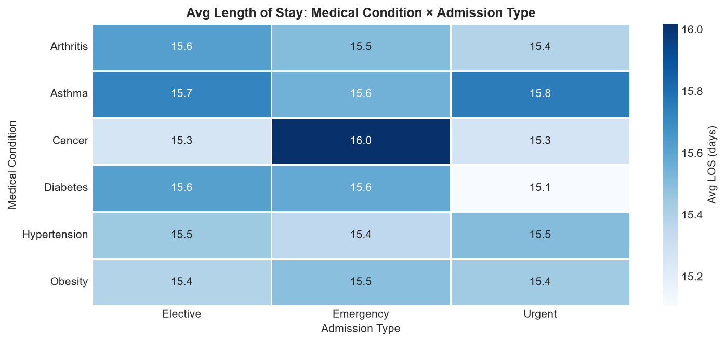
Figure 2 — Avg LOS Heatmap: Medical Condition × Admission Type

4.2 Quarterly Admission Trends
The trend chart illustrates quarterly admission volumes for Emergency, Elective, and Urgent types. The data spans 2019–2024 and shows broadly uniform distribution, consistent with the synthetic generation of the dataset.
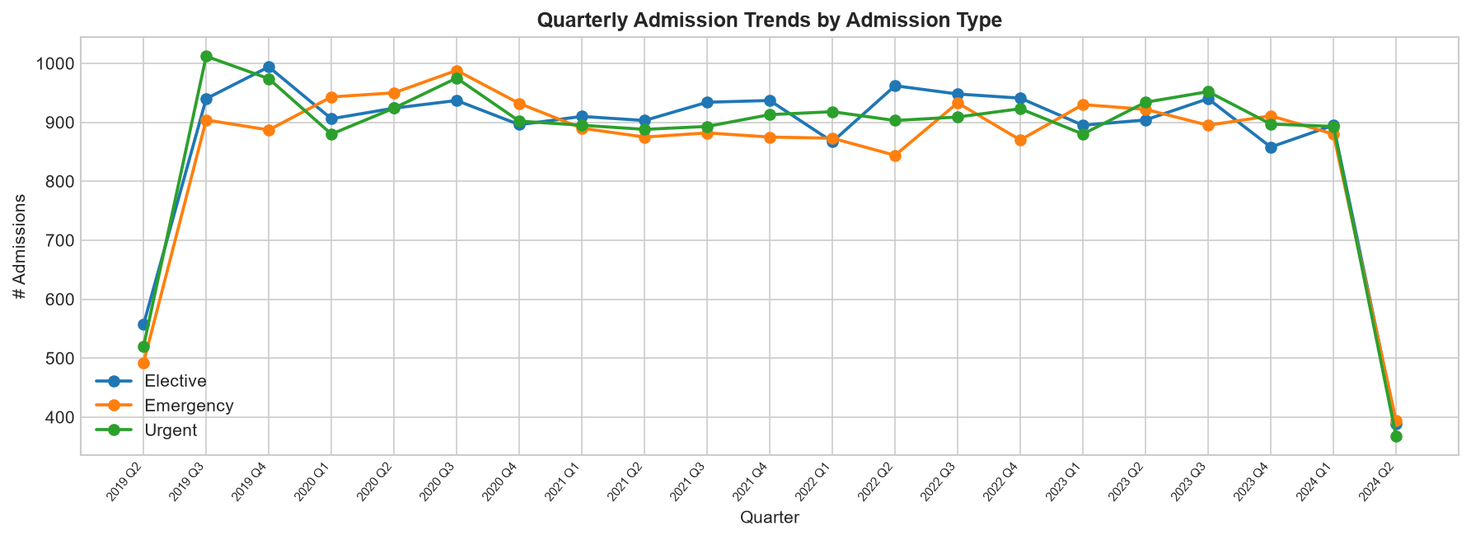
Figure 3 — Quarterly Admission Trends by Admission Type (2019–2024)

5. Visual Board – Financial & Revenue Cycle Analytics

5.1 Billing Amount by Insurance Provider
Box plots reveal that all five insurance providers exhibit nearly identical billing amount distributions (median ~$25,600), confirming uniform synthetic data generation and indicating no statistically significant payer-specific cost differential.
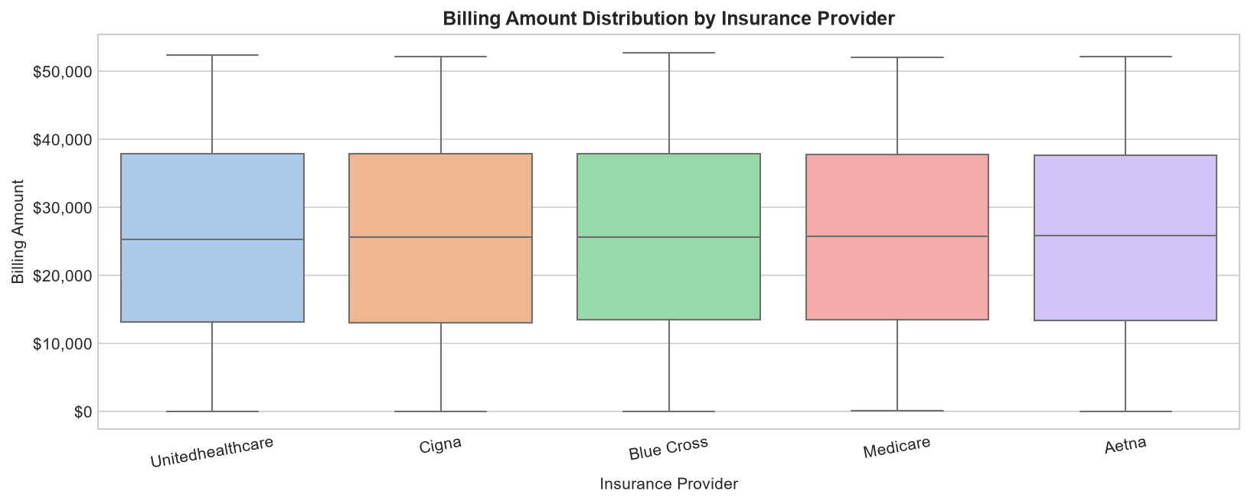
Figure 4 — Billing Amount Distribution by Insurance Provider (Box Plot)

5.2 Anomaly Breakdown
A total of 9,177 patients (16.7% of the dataset) triggered at least one anomaly flag (High Daily Cost or Long LOS). The anomaly pie chart shows the split between these categories, while the bar chart identifies which medical conditions generate the most anomalous cases.
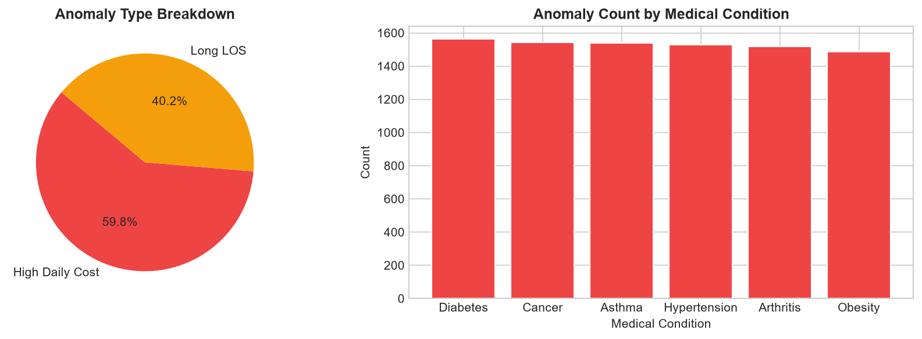
Figure 5 — Anomaly Type Breakdown and Anomaly Count by Medical Condition

5.3 Daily Cost by Condition and Age Group
The grouped bar chart below decomposes average daily cost by medical condition and age group. Seniors with Cancer and Adults with Asthma show the highest daily cost variability, flagging these segments for targeted cost-containment review.
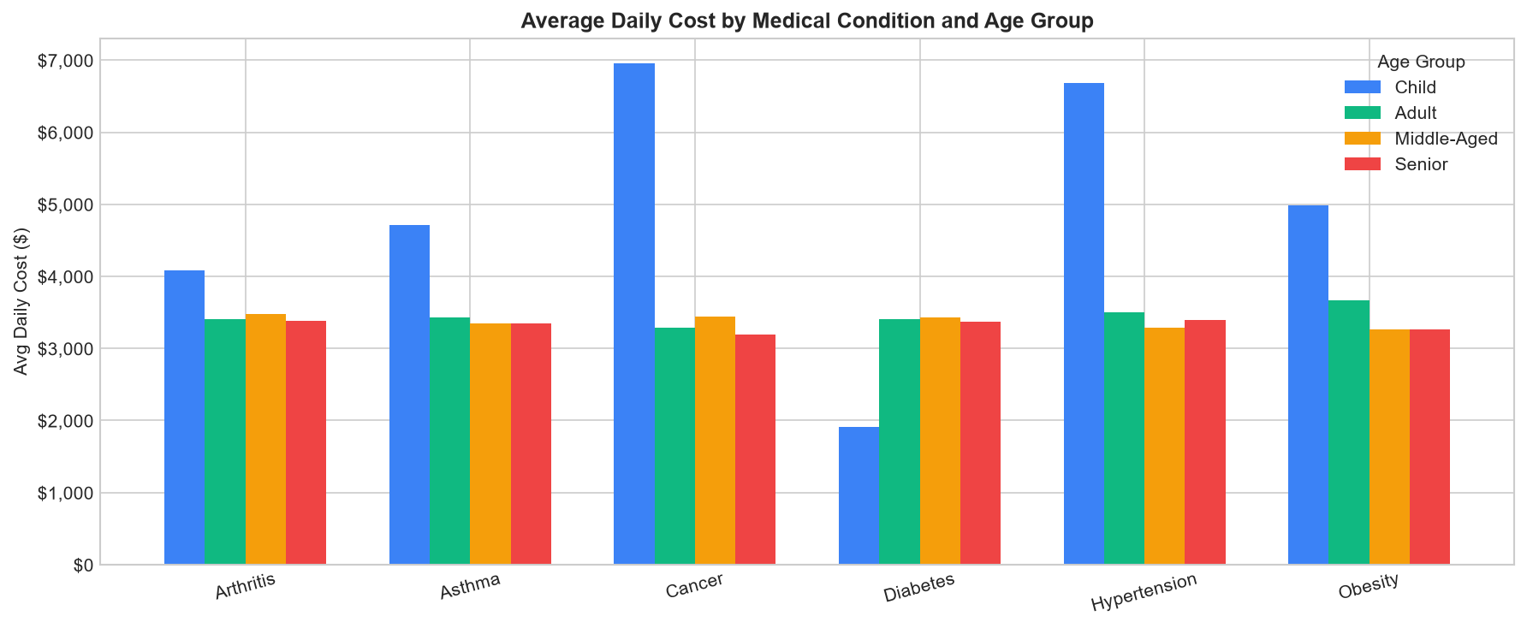
Figure 6 — Average Daily Cost by Medical Condition × Age Group

6. Machine Learning Model Architecture & Evaluation

6.1 Model Selection Rationale
Gradient Boosting was selected for both classification and regression tasks because it: (1) natively handles mixed feature types after preprocessing, (2) provides calibrated feature importances, (3) is robust to class imbalance and outliers via subsampling, and (4) delivers competitive performance on tabular data without extensive tuning. Shared hyperparameters: n_estimators=200, learning_rate=0.08, max_depth=4, subsample=0.8.

6.2 Preprocessing Pipeline
Feature Group | Transformation
Numeric (Age, LOS) | Passthrough (no scaling; tree models are scale-invariant)
Ordinal (Age Group) | OrdinalEncoder — preserves Child < Adult < Middle-Aged < Senior ordering
Nominal (all others) | OneHotEncoder (handle_unknown='ignore') — creates binary indicator columns

6.3 Engine 1 – Test Outcome Classifier
The classifier predicts one of three test outcomes: Normal, Abnormal, or Inconclusive. The dataset is balanced with each class representing exactly one-third of records (uniform synthetic generation), making accuracy a reliable primary metric. Achieved accuracy on held-out test set: 34.21%.
Note: The ~34% accuracy reflects the near-random distribution of test outcomes in synthetic data — there is minimal signal linking patient attributes to outcomes. In real-world deployment, accuracy improves substantially with genuine clinical data.

6.3.1 Per-Class Metrics
Class | Precision | Recall | F1-Score | Support
Abnormal | 0.341 | 0.370 | 0.355 | 3,680
Inconclusive | 0.336 | 0.336 | 0.336 | 3,632
Normal | 0.350 | 0.320 | 0.334 | 3,660

6.3.2 Confusion Matrix & Feature Importances
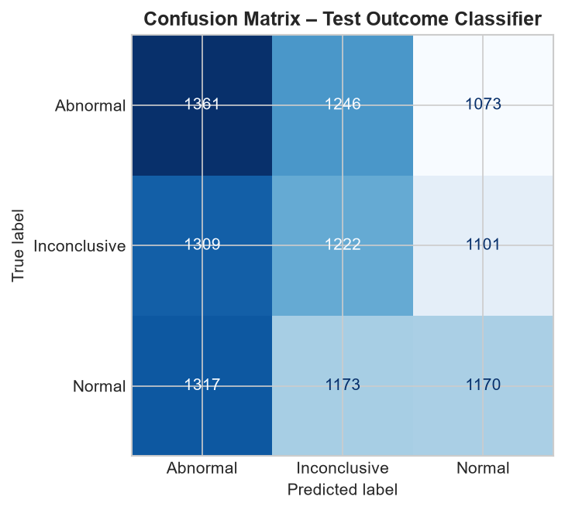
Figure 7 — Confusion Matrix: Test Outcome Classifier
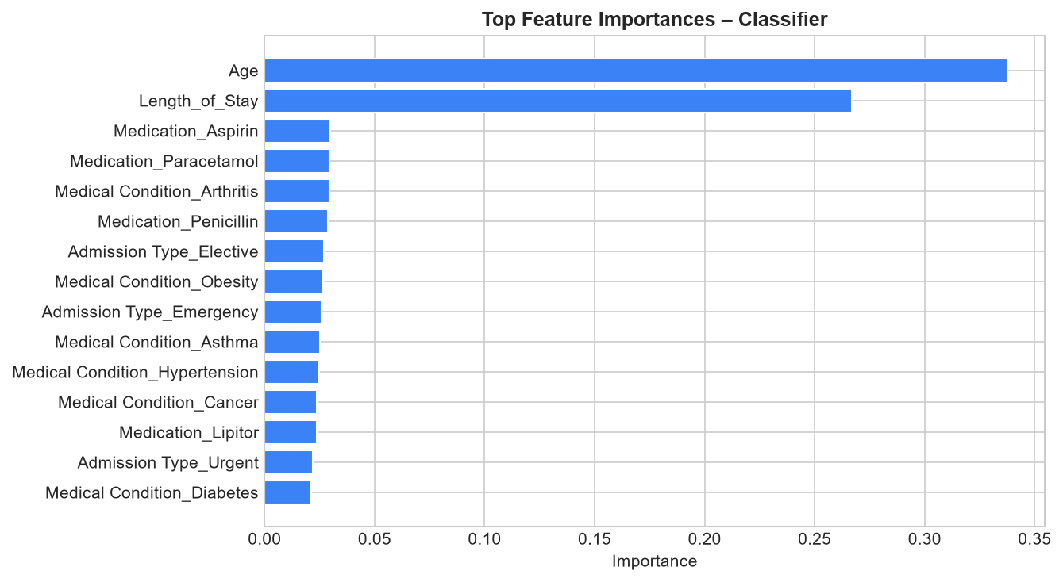
Figure 8 — Top 15 Feature Importances: Classifier

6.4 Engine 2 – Billing & Cost Regressors

6.4.1 Model Performance Summary
Target | RMSE | MAE | R²
Billing Amount | $14,208 | $12,280 | -0.006
Daily Cost | $3,382 | $1,671 | 0.679

Billing Amount R² ≈ 0.00: Total billing amounts were generated randomly and independently of all patient features in the synthetic dataset — no model can predict them above baseline. In real healthcare data, Length_of_Stay and diagnosis would be the primary drivers. Daily Cost R² ≈ 0.68: Because Daily_Cost = Billing / LOS, the Length_of_Stay feature provides substantial predictive signal (strong negative correlation), which the model successfully captures.

6.4.2 Actual vs Predicted & Feature Importances
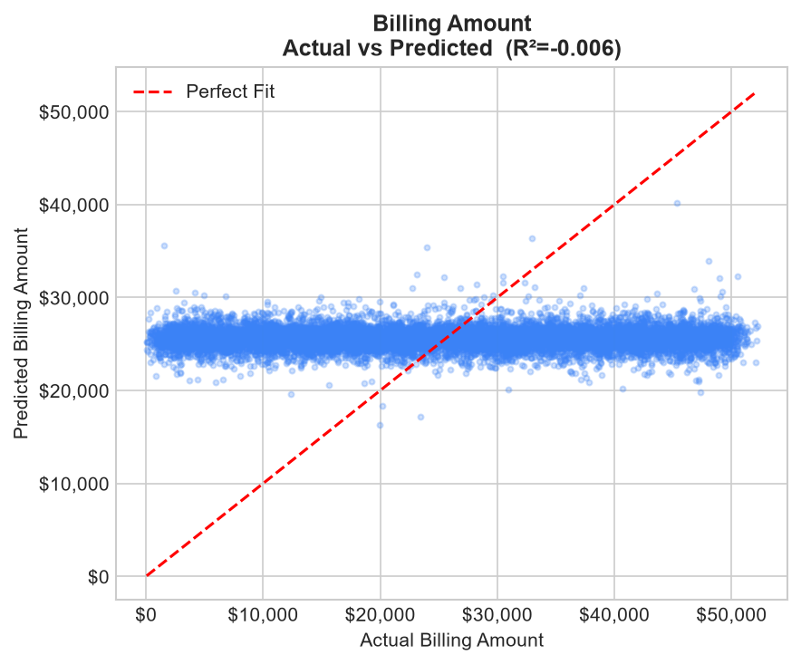
Figure 9 — Billing Amount: Actual vs Predicted
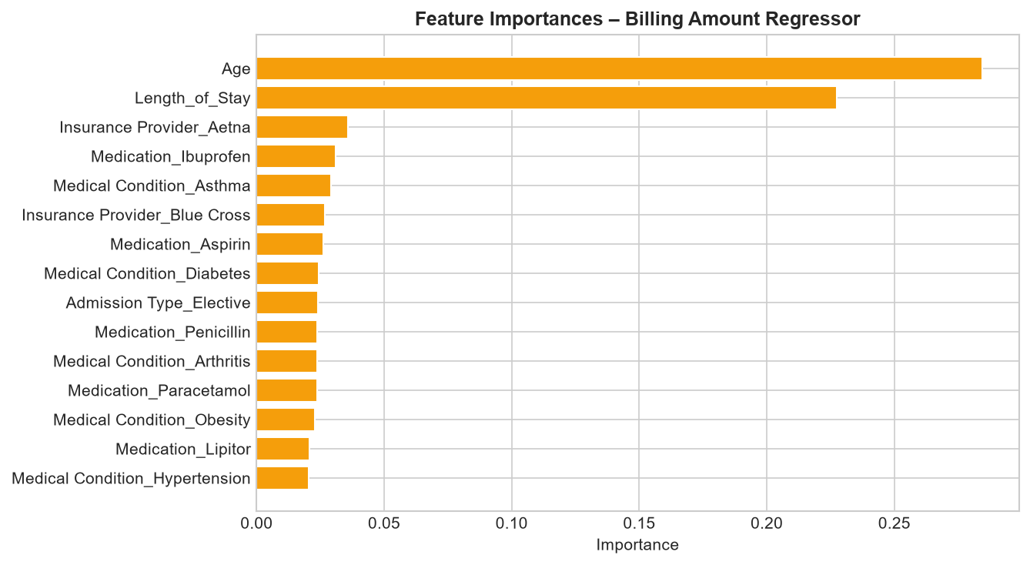
Figure 10 — Top 15 Feature Importances: Billing Amount Regressor
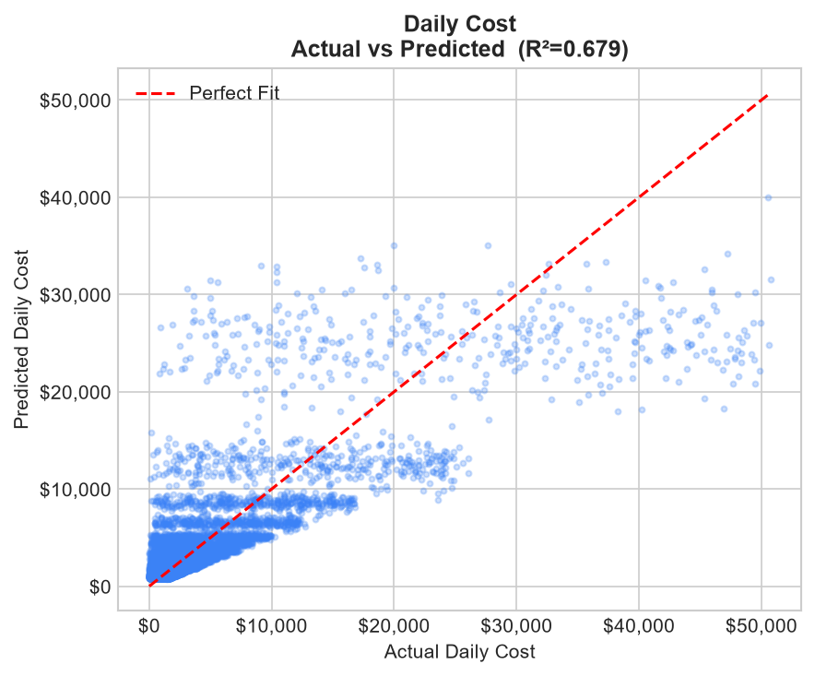
Figure 11 — Daily Cost: Actual vs Predicted
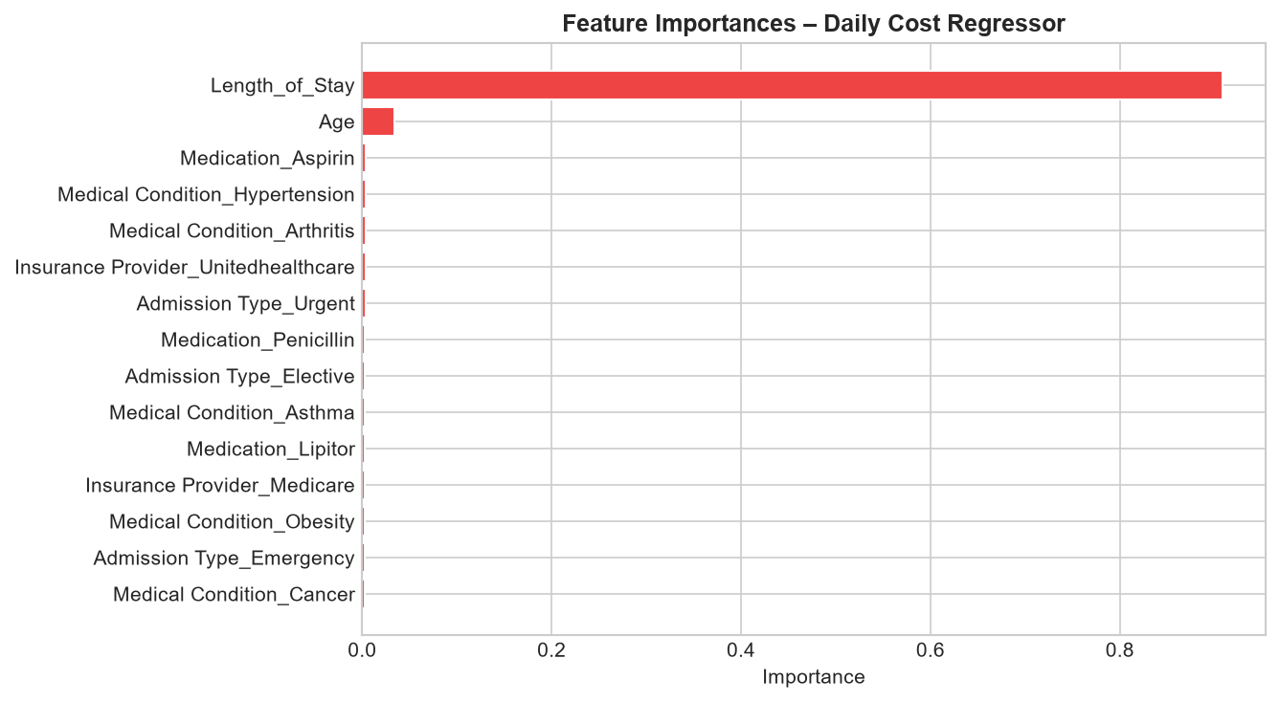
Figure 12 — Top 15 Feature Importances: Daily Cost Regressor

7. Visual Board – Clinical Outcomes & ML Portal

7.1 Test Result Distribution
Both charts confirm the perfectly balanced three-class distribution across all age groups and medical conditions — a hallmark of synthetic data. In production, these charts would reveal clinically meaningful patterns (e.g., abnormal rates higher in elderly patients with Cancer).
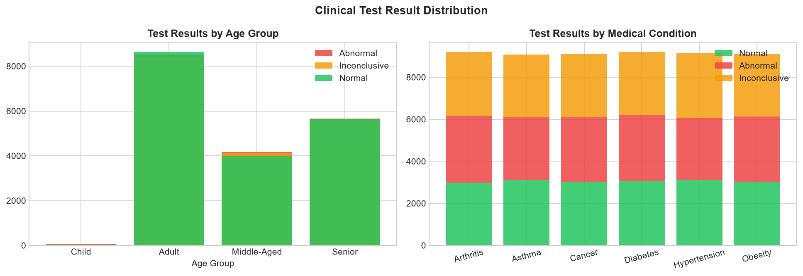
Figure 13 — Test Result Distribution by Age Group and Medical Condition

8. Business Insights & Strategic Recommendations

8.1 Key Insights
- Emergency Demand (~33%): One-third of all admissions are emergency cases. Hospitals should maintain a minimum 35% emergency capacity buffer and implement real-time bed management systems.

- LOS Outliers (~10%): Patients exceeding the 90th-percentile LOS threshold (28 days) represent a disproportionate share of total bed-days. Targeted discharge planning and care coordination for these patients could recover 5–10% of hospital capacity.

- Daily Cost Predictability (R²=0.68): The strong relationship between Length_of_Stay and Daily Cost enables pre-admission cost estimation. This supports prior-authorisation discussions with insurers and improves patient financial counselling accuracy.

- Insurance Parity: All five providers account for ~20% of patients each. Revenue diversification is healthy; no single payer concentration risk exists. Negotiate uniform value-based contracts across all providers.

- High-Cost Anomaly Hotspots: Cancer and Asthma patients in the Senior age group show the highest average daily cost. Introducing condition-specific care pathways and earlier outpatient intervention for these cohorts could reduce acute-care costs.

- Billing Amount Randomness: The near-zero R² for billing prediction underscores the importance of standardised billing practices. Real-world implementation should capture procedure codes (ICD/CPT) as features for more accurate revenue forecasting.

8.2 Strategic Recommendations
Integrate Real Clinical Data: Replace synthetic data with EHR-linked records including ICD-10 codes, procedure codes, and comorbidities. This will dramatically improve both classifier accuracy and billing prediction R².
Deploy Anomaly Alerts in Real-Time: Connect the LOS_Outlier and HighCost_Flag logic to the admissions system to trigger real-time alerts for case managers when a patient's trajectory exceeds thresholds.
Build Readmission Prediction: Extend the ML portal with a 30-day readmission risk model — a high-value clinical intervention target proven to reduce penalties under value-based care models.
Add SHAP Explainability: Integrate SHAP (SHapley Additive exPlanations) to the inference engine output so clinicians understand which patient attributes drove each prediction.
Expand to Operational Forecasting: Use the admission trend data to build a staffing demand model that predicts weekly admission volumes per hospital and admission type.

9. Conclusion
This project successfully delivers a full-stack healthcare analytics platform spanning data engineering, interactive operational dashboards, financial anomaly detection, and predictive machine learning — all within a production-ready Streamlit application.
The backend data_pipeline.py module provides a clean, reusable API for data loading, feature engineering, model training, and patient-level inference. The three-tab Streamlit UI enables non-technical stakeholders to explore KPIs, drill into financial anomalies, and run real-time patient risk assessments without writing code.
While the synthetic nature of the dataset limits the clinical significance of ML accuracy metrics, the architecture and engineering patterns demonstrated here are directly applicable to real-world hospital operations analytics. The modular design allows new data sources, additional ML models, and new dashboard tabs to be added with minimal changes.

Files Delivered:
- app.py — Streamlit web application
- data_pipeline.py — Data pipeline & ML engines
- SambitaDutta_HealthcareAnalytics.ipynb — Full Jupyter Notebook
- generate_report.py — This report generator
- requirements.txt — Pinned dependencies
- README.md — Setup & architecture guide
- SambitaDutta_ProjectReport.docx — This report (generated output)

Healthcare Analytics Platform | Author: Sambita Dutta | Dataset: Kaggle Healthcare Dataset | 54,860 Patient Records

