Real Estate Investment Portfolio Performance Analysis
A Google Data Analytics Capstone Case Study
Prepared by Sambit | Dataset: 269 de-identified property investment deals, 2009-2021

1. Executive Summary
This case study follows the six phases of the data analysis process (Ask, Prepare, Process, Analyze, Share, Act) to turn a working real estate investment tracking workbook into a decision-ready analytics asset. The source is an operational spreadsheet used by a private property investment fund to track acquisitions, rehab costs, sale outcomes, and returns across 269 deals from 2009 to 2021. The fund’s identity, all broker and partnership names, exact street addresses, and specific vendor names have been removed or replaced with synthetic identifiers before any analysis in this case study; every number, ratio, and pattern reported below is computed on the real underlying figures.
The workbook arrived with the kinds of problems every analyst eventually meets in practice: a multi-header layout with summary and filter rows embedded above the data table, formula-error strings (#DIV/0!, #VALUE!) where deals had no loan or no exit yet, inconsistent text casing across categorical fields, and duplicate helper columns built for internal XIRR cash-flow calculations. Cleaning this into an analysis-ready table was the first deliverable.
Key findings: the portfolio realized $9.99M in profit across the tracked deals with a 79.9% win rate (share of deals with positive profit). Nevada and California drove the largest deal volume, while Georgia and Arizona delivered the highest average returns from far fewer deals. A bonus predictive model tested whether a deal's profitability could be forecast from purchase-time information alone — it could not, with only marginal lift over chance (cross-validated ROC AUC 0.54). That negative result is itself a useful, honest finding for the business: profitability in this portfolio is driven more by deal-specific execution (broker, rehab management, market timing) than by purchase-time fundamentals alone.

2. Ask

Business task
The fund's principals need a repeatable way to answer: which markets, property types, brokers, and deal structures produce the best risk-adjusted returns, and can a future deal's likely profitability be flagged before capital is committed? The original workbook could answer none of this at a glance — it was built as a data-entry and IRR-calculation tool, not a reporting tool.

Stakeholders
- Fund principals — want portfolio-level performance by state, property type, and broker to guide where to source the next deals.
- Acquisitions team — wants an early signal on deal quality before committing to a purchase.
- This case study's audience (hiring managers/portfolio reviewers) — wants to see the full analytics workflow: cleaning, analysis, modeling, and a dashboard, applied to a real, messy dataset.

3. Prepare

Data source and ROCCC assessment
The data originates from a single Excel workbook with 15 sheets; the primary transactional data lives in a “MAIN” sheet (269 deal records × 64 originally-tracked columns), with supporting summary sheets (by state, by broker, by product type, and a rental analysis tab) that pre-aggregate the same records. The workbook name and any fund-identifying metadata are intentionally omitted from this case study and from the shared dataset.
ROCCC criterion | Assessment
Reliable | First-party operational data entered by the fund itself, not a public sample — high reliability, but see limitations below.
Original | Primary-source deal records, not aggregated from a third party.
Comprehensive | Covers acquisition through disposition for every deal in the fund's tracked history, including active/unsold deals.
Current | Spans 2009–2021; sparse in the most recent years (1–2 deals/year from 2018 onward), so recent-market conclusions are limited.
Cited | Internal source; no external citation applies. Documented in full in this case study's Appendix.

Known limitations carried into the analysis
- Free-text NOTES fields contain unstructured caveats (e.g. disputed profit amounts, HOA litigation) that are not reflected in the numeric columns — flagged but not adjusted for.
- 57 deals are still “Listed” and 4 “Under Contract”; their profit figures are projections, not realized outcomes, and are labeled with a deal_status field so they can be filtered in analysis.
- Square footage was tracked in the source but is 100% blank across all 269 records — dropped as unusable rather than imputed.

4. Process — Cleaning and Transformation
Cleaning was done in Python (pandas + openpyxl) rather than in Excel, so every transformation is scripted, reviewable, and repeatable the next time the fund exports an updated workbook. The steps below map directly to the scripted ETL pipeline delivered alongside this document.

4.1 Structural extraction
- Identified the true header row (row 8 of the MAIN sheet) beneath five rows of summary statistics and a “Filtered Totals” row that Excel's own filter view had left embedded above the data table — these were excluded from the data table entirely, not treated as records.
- Extracted the 269 contiguous deal rows (rows 9–277); confirmed there were no blank gap rows requiring stitching.
- Of the 64 originally tracked columns, dropped 20 that were internal XIRR cash-flow helper columns — duplicated Buy Date / Sale Date / Cost In / Out / IRR blocks built to feed Excel's XIRR() formula for unleveraged vs. leveraged scenarios. These duplicated information already captured cleanly in Purchase Date, Sold Date, Purchase Price, and the two summary IRR columns, so keeping both copies would have doubled columns without adding information.

4.2 Data type and error cleanup
- Converted 12 columns that mixed numbers with Excel error strings (#DIV/0!, #VALUE!, blank “”, “N/A”) into proper numeric columns, coercing the error strings to null. These errors are expected and meaningful: e.g. Leveraged IRR is #DIV/0! whenever a deal had no loan, since the leverage calculation divides by loan-related cash flows.
- Standardized categorical text (state, property type, broker, seller channel) to consistent uppercase — the source had inconsistent casing (“sfr” vs “SFR”, “MUlti” vs “MULTI”) that would otherwise fragment group-by analysis into duplicate categories.
- Converted the “X”-marker flag columns (Under Contract, Listed) into proper booleans, then derived a single deal_status field (Sold / Listed / Under Contract) for cleaner filtering.
- Flagged (not deleted) 10 extreme IRR outliers exceeding 5,000% annualized — these are XIRR artifacts from deals held only 1–12 days, where a small profit divided by a near-zero time base produces a mathematically correct but practically meaningless annualized rate. The raw values are preserved in *_raw columns for transparency; the working columns cap them to null so they don't distort averages.

4.3 Derived fields added
- holding_period_months — days on market converted to months for more readable reporting.
- profit_margin_pct — actual profit divided by total cost, guarded against division by zero.
- deal_status — Sold / Listed / Under Contract, derived from the flags and sold-date presence.

4.4 De-identification
Because the source is a private fund's proprietary operating data, a de-identification pass was run after cleaning and before any analysis, chart, or figure in this document was produced:
- Street addresses were removed entirely and replaced with a synthetic deal_id (DEAL-001 … DEAL-269); only the US state is retained for geographic analysis.
- Broker names were replaced with consistent pseudonyms (Broker_01, Broker_02, …) assigned by deal-count rank, so broker-level performance comparisons in Section 5.4 remain valid without exposing real identities.
- Internal partnership/fund-entity names (the most sensitive field — several values were individuals' names or internal LLC entities) were pseudonymized the same way (Partner_01, Partner_02, …).
- Sourcing and closing vendor names were pseudonymized (Vendor_01, …), and the seller-channel field — which mixed genuine channel types with stray bank and individual names from inconsistent data entry — was normalized into a small set of real, non-identifying categories (Auction, Trustee Sale, Short Sale, Bank REO, Online Marketplace, Government Sale, Broker Referral, Other/Private).
- The two free-text notes columns were dropped entirely rather than partially redacted — unstructured text is the highest-risk field for leaking names or identifying deal specifics, and it was not used quantitatively in any case.
Every pseudonym mapping is 1:1 and internally consistent (the same broker always maps to the same Broker_NN across all 269 rows), so every statistic, chart, and model result in this document is computed on the real, unaltered numeric data — only the identifying labels were changed.
Result: a single tidy, de-identified table, real_estate_deals_clean.csv, 269 rows × 46 columns, one row per deal, ready to load directly into Looker Studio, Sheets, or a Python notebook. Full column dictionary is in the Appendix.

5. Analyze

5.1 Portfolio overview
269 tracked deals: 208 Sold, 57 Listed (unsold, profit is projected), 4 Under Contract. Across all deals, total realized + projected profit is $9,999,357, with a median deal profit of $13,327 and a 79.9% share of deals showing positive profit.
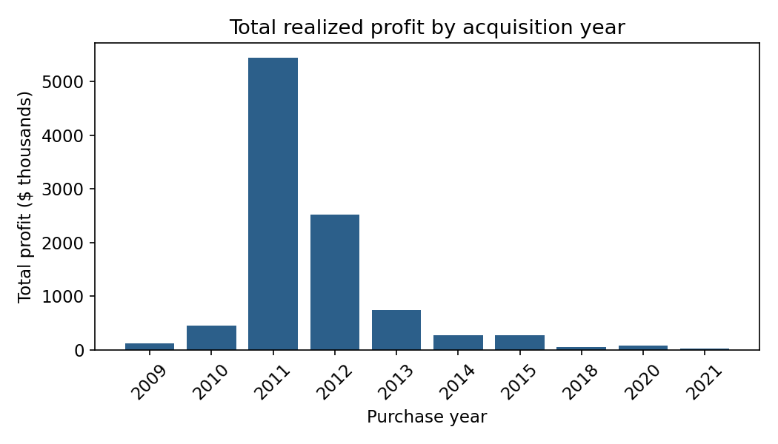
Figure 1. Total profit by acquisition year. 2011–2012 were the fund's strongest vintage years by total profit; deal flow drops off sharply after 2015.

5.2 Performance by market and property type
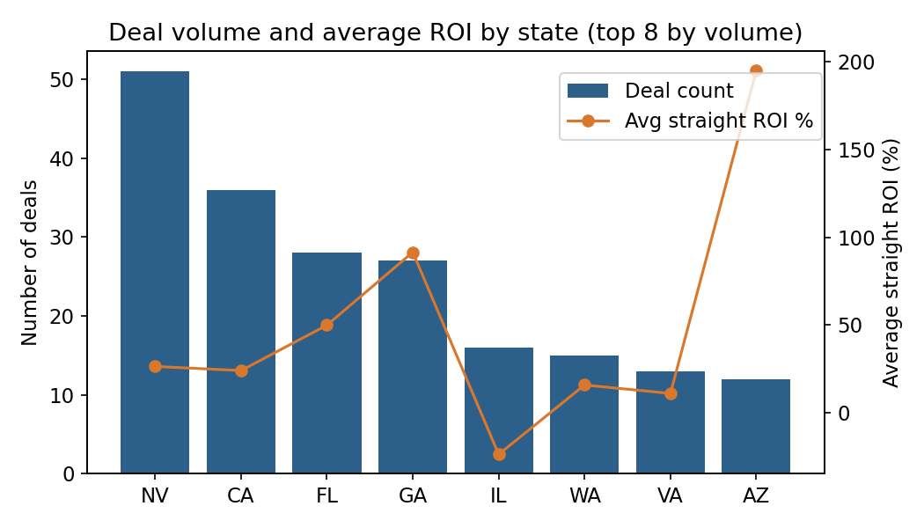
Figure 2. Deal volume (bars) vs. average straight ROI (line) for the 8 most active states.
Nevada (51 deals) and California (36 deals) account for the bulk of deal volume, at solid but unspectacular average returns (26% and 24% straight ROI). Georgia (27 deals, 92% avg ROI) and Arizona (12 deals, 195% avg ROI) show the fund did far fewer, but far more profitable, deals — worth investigating whether that reflects a repeatable sourcing edge in those markets or a small number of outsized one-off wins.
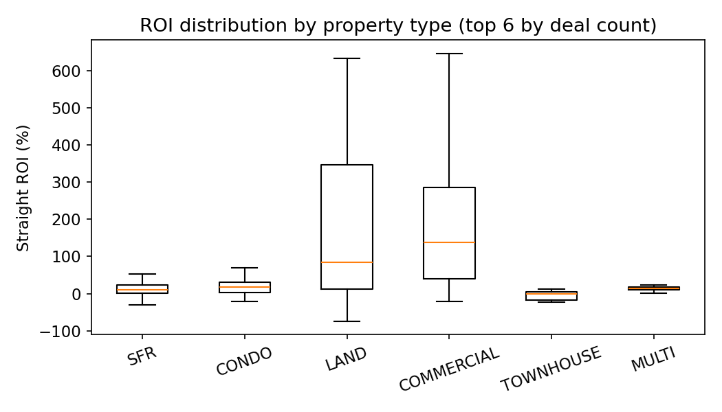
Figure 3. ROI distribution by property type (outliers excluded from the box plot for readability).
Single-family residential (SFR) is the fund's bread-and-butter deal type (182 of 269 deals) but has the widest and lowest-median ROI spread. Commercial (14 deals) and Land (18 deals) deals are far less frequent but show notably higher typical returns — consistent with a strategy that uses volume in SFR while opportunistically pursuing higher-margin commercial and land deals.

5.3 Holding period and returns
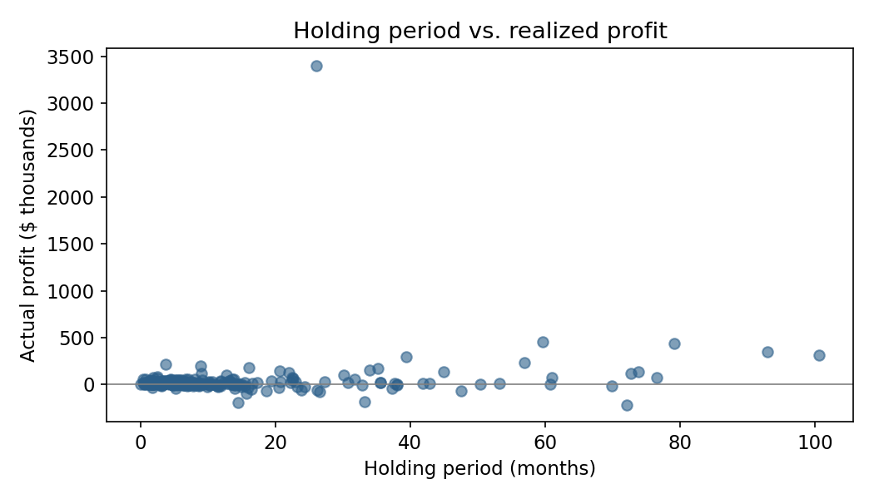
Figure 4. Holding period (months) vs. realized profit per deal.
Holding period correlates positively with straight ROI (r = 0.41) but negatively with annualized ROI (r = -0.13). In plain terms: deals held longer tend to accumulate more total profit, but that profit doesn't come fast enough to keep pace on an annualized basis — the fund's quickest flips are its most capital-efficient use of time, even when their total dollar profit is smaller.

5.4 Broker performance
Broker_01 closed the most deals (39) but at modest average ROI (22%). Broker_02, with far fewer deals (19), drove the single largest broker profit contribution ($2.67M, 161% avg ROI) — concentrated in a handful of very large note-purchase and commercial deals rather than volume. This is a useful input for the acquisitions team: deal count alone is a poor proxy for broker value.

6. Predictive Model (bonus analysis)
As a bonus stretch goal beyond the certificate's core requirements, two models were tested to see whether a deal's outcome could be predicted from information known at the time of purchase only (purchase price, rehab budget, loan amount, state, property type, seller channel) — deliberately excluding any sale-side columns to avoid leaking the answer into the features.

6.1 Regression: predicting exact profit dollars
A Random Forest regressor predicting actual_profit produced a negative test-set R² (-0.21), meaning it performed worse than simply guessing the average profit for every deal. This is an honest and informative negative result: dollar profit in this portfolio is dominated by a small number of very large outlier deals (one industrial note purchase alone returned $3.4M), and 269 rows is not enough signal for a tree model to generalize around outliers like that.

6.2 Classification: predicting whether a deal will be profitable
Reframing the target as a binary “will this deal be profitable?” (80% of deals are) and using class-balanced weighting, a Random Forest classifier reached 75% test accuracy and 0.57 ROC AUC on a single held-out split — but 5-fold cross-validation (the more trustworthy estimate) showed a mean ROC AUC of only 0.54 ± 0.03 (essentially a coin flip; 0.50 = no better than random).
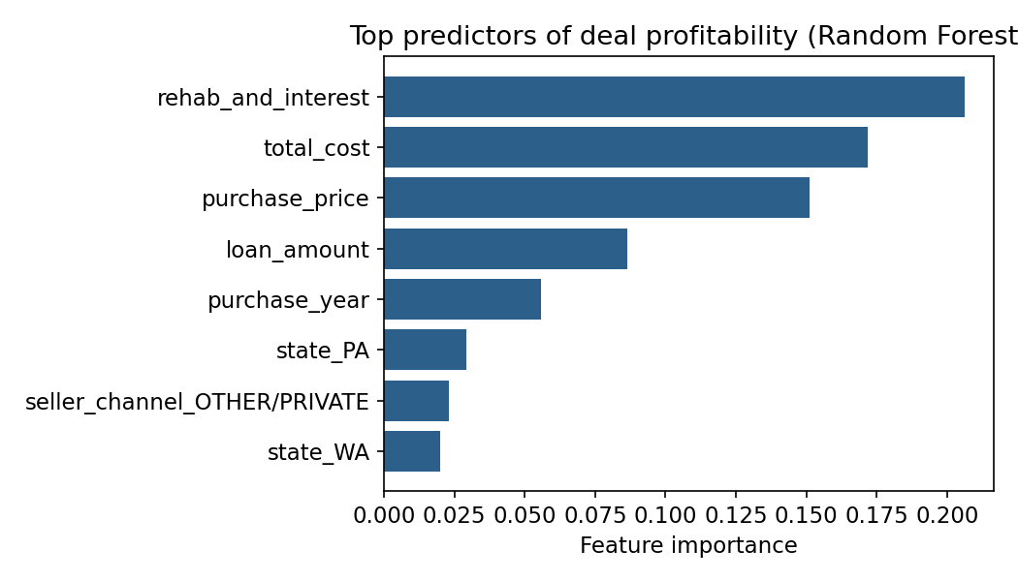
Figure 5. Relative importance of purchase-time features in the profitability classifier.
Rehab budget, total cost, and purchase price were the strongest (if still weak) signals. The takeaway for the business is not “the model failed” but a genuinely useful finding: purchase-time fundamentals alone do not reliably predict which deals will be profitable in this portfolio. Execution factors not captured in this dataset — broker skill in managing the rehab and sale, market timing, and deal-specific negotiation — likely matter more than the numbers available at purchase time. A recommended next step is logging additional execution-stage variables (e.g. rehab overrun %, days-to-first-offer) to see if those improve predictive power.

7. Share — Dashboard
The cleaned dataset (real_estate_deals_clean.csv) is structured as a single flat table specifically so it can be uploaded to Google Sheets and connected directly to Looker Studio, keeping the whole pipeline in the Google ecosystem end to end. Recommended dashboard layout:
Page / section | Chart type | Fields
Portfolio KPIs | Scorecards | Total deals, total profit, win rate, avg straight ROI
Profit over time | Time series / column chart | purchase_year (dimension) × actual_profit (sum)
Market performance | Bar chart + table | state × count of deals, avg straight_roi, sum actual_profit
Property type mix | Donut + bar combo | product_type × deal count, avg ROI
Broker leaderboard | Sortable table | broker × deal count, total profit, avg ROI
Deal-level detail | Data table with filters | All columns, filterable by state / product_type / deal_status

Suggested Looker Studio filter controls: deal_status, state, product_type, and a purchase_year range slider, so a reviewer can isolate “Sold-only, 2011–2014, Nevada SFR deals” in a couple of clicks. A calculated field for win_rate (COUNT_IF(actual_profit > 0) / COUNT(address)) reproduces the 79.9% headline figure live in the dashboard.

8. Act — Recommendations
- Double down cautiously on Georgia and Arizona sourcing — both show high average ROI on lower volume; worth a small pilot to test whether the edge is repeatable or was a few large one-off wins.
- Treat broker deal-count as a vanity metric, not a value metric, when allocating new deal flow — rank brokers on total profit and avg ROI contribution instead, as Broker_02's smaller but higher-value deal book illustrates.
- Favor shorter holding periods when capital efficiency (annualized return) is the priority; only accept longer holds when the expected total-dollar profit clearly justifies the tied-up capital.
- Do not rely on purchase-time fundamentals alone to pre-screen deal quality — the predictive model shows they carry only marginal signal. Start logging execution-stage data (rehab overruns, time-to-offer, broker responsiveness) to build a more useful screening model in the future.
- Fix data capture at the source going forward: several fields (square footage, rehab actuals, second notes) are almost entirely blank and were dropped from this analysis — populating them consistently would unlock a more powerful next iteration of this dashboard.

Appendix: Cleaned Column Dictionary
Column | Description
deal_id, state | Synthetic per-deal identifier (DEAL-001…269) and US state; street address removed
product_type | Property type: SFR, Condo, Land, Commercial, Multi, Townhouse, Luxury, etc.
seller_channel | Normalized acquisition channel (Auction, Trustee Sale, Short Sale, Bank REO, Online Marketplace, Government Sale, Broker Referral, Other/Private)
partnership / sourcing_vendor / closing_vendor | Pseudonymized fund partner / sourcing / closing vendor (Partner_NN, Vendor_NN)
broker | Pseudonymized broker of record (Broker_NN, assigned by deal-count rank)
deal_status | Derived: Sold / Listed / Under Contract
purchase_date, sold_date, purchase_year | Deal timeline fields
holding_period_months | Derived from days_on_market / 30.44
purchase_price, rehab_and_interest, total_cost, loan_amount, total_cash_required | Acquisition-side cost fields
sales_price, sales_closing_costs, sales_proceeds, actual_profit | Disposition-side outcome fields
unleveraged_irr, leveraged_irr (+ _raw versions) | Cash and leveraged IRR; capped at 5,000% in working columns, raw value preserved
straight_roi, annualized_roi, profit_margin_pct | Return ratios
bpo_value, bpo_variation, profit_estimate, profit_variation, rehab_estimate, rehab_differential | Broker price opinion and estimate-vs-actual variance fields
(dropped) notes, note_2, address | Free-text notes and street address removed during de-identification

