Samuel Boye and Temesgen Gadore
Professor Dawn Duerre
CSS335 Programming Language Paradigms
30 April 2026

Banking DSL Final Project

Overview
The Banking DSL (Domain-Specific Language) is a custom programming language built in Python that simulates basic banking operations. The language allows users to deposit funds, withdraw funds, check balances, and create new accounts through a simple command-based interface. The project was built using a full compiler pipeline: a Lexer, Parser, Abstract Syntax Tree (AST), and Interpreter, modeled after the Calc language developed in Lessons 11 and 12.

Team Contributions
The following outlines which team member wrote each class, module, and function:

Samuel Boye:
- bank_account.py — BankAccount class (all fields, getters, setters, deposit, withdraw, check_balance)
- token.py — Token class and all token type constants
- lexer.py — Lexer class and tokenization logic
- banking.ebnf — EBNF grammar for the Banking DSL

Temesgen Gadore:
- parser.py — Parser class and all parse methods
- ast_node.py — ASTNode class
- interpreter.py — Interpreter class and all execute methods
- spec_testing.py — All unit tests using Python unittest module

banking.py — Main program, menu loop, and process_input pipeline written collaboratively.

Language Design — Banking EBNF Grammar
The Banking DSL grammar was written in EBNF (Extended Backus-Naur Form) following the style used in class. The grammar file is named banking.ebnf. The grammar defines the following:

- program — a sequence of zero or more statements
- statement — one of: deposit, withdraw, balance, create, or exit
- account_id — two letters followed by six digits (e.g. SB123456)
- amount — an integer or float value
- first_name / last_name — one or more letters

The EBNF grammar is as follows:
digit = "0" | "1" | "2" | "3" | "4"
| "5" | "6" | "7" | "8" | "9" ;

letter = "a" | "b" | ... | "z" | "A" | ... | "Z" ;

integer = digit, { digit } ;
float = digit, { digit }, ".", digit, { digit } ;
amount = float | integer ;

account_id = letter, letter, digit, digit, digit,
digit, digit, digit ;

deposit_stmt = "deposit", account_id, amount ;
withdraw_stmt = "withdraw", account_id, amount ;
balance_stmt = "balance", account_id ;
create_stmt = "create", first_name, last_name, amount ;
exit_stmt = "exit" | "quit" | "end" ;

statement = deposit_stmt | withdraw_stmt | balance_stmt
| create_stmt | exit_stmt ;

program = { statement } ;

Code Structure and Design
The project is organized into separate modules, one per class. The main entry point is banking.py. Below is a description of each file:

bank_account.py
Contains the BankAccount class. Stores private fields for first name, last name, account number, and balance. The account number is auto-generated using the first letter of the first and last name followed by six random digits. Includes getters and setters for all fields, and methods for deposit, withdraw, and check_balance.

token.py
Contains the Token class. Defines token type constants (DEPOSIT, WITHDRAW, BALANCE, CREATE, EXIT, ACCOUNT_ID, AMOUNT, NAME, EOF, UNKNOWN) and stores a type/value pair for each token produced by the Lexer.

lexer.py
Contains the Lexer class. Takes a raw input string and splits it into words. Each word is classified into its correct Token type using regular expressions. Keywords are matched case-insensitively. Returns a list of Token objects ending with an EOF token.

ast_node.py
Contains the ASTNode class. Each node stores a type, an optional value, and a list of child nodes. Node types mirror the DSL statement types: PROGRAM, DEPOSIT, WITHDRAW, BALANCE, CREATE, and EXIT.

parser.py
Contains the Parser class. Takes the token list from the Lexer and builds an Abstract Syntax Tree. Each parse method handles one statement type and produces a corresponding ASTNode with appropriate children. Includes bounds checking to prevent crashes on incomplete input.

interpreter.py
Contains the Interpreter class. Walks the AST produced by the Parser and executes each node against the list of BankAccount objects. Routes each node type to its corresponding execute method.

banking.py
The main entry point. Initializes 9 pre-created BankAccount objects, displays them to the user, and runs the main menu loop. Each line of user input is passed through the full pipeline: Lexer, Parser, AST, Interpreter.

spec_testing.py
Contains the DSL specification tests using Python's unittest module. Provides a menu to run all tests or individual tests. Tests cover deposit, withdraw, balance, create account, account number format, and invalid input handling.

Pre-Created Accounts
The following 9 accounts are created at program startup. Account numbers are randomly generated each run using the first letters of the first and last name followed by 6 digits. Below is a sample output from a program run (these do not match the actual precreated accounts just the names are the same):
--- Pre-Created Accounts ---
Name: Samuel Boye | Account #: SB473189 | Balance: $1500.00
Name: Temesgen Gadore | Account #: TG901260 | Balance: $1800.00
Name: John Doe | Account #: JD412642 | Balance: $2000.00
Name: Jane Smith | Account #: JS405346 | Balance: $800.00
Name: Alice Johnson | Account #: AJ837222 | Balance: $3200.00
Name: Bob Williams | Account #: BW868120 | Balance: $500.00
Name: Clara Brown | Account #: CB620851 | Balance: $1200.00
Name: David Jones | Account #: DJ948007 | Balance: $4500.00
Name: Eva Garcia | Account #: EG134588 | Balance: $950.00
----------------------------

Note: Account numbers are randomly generated each run. Use the account numbers displayed at startup when testing deposit, withdraw, and balance commands.

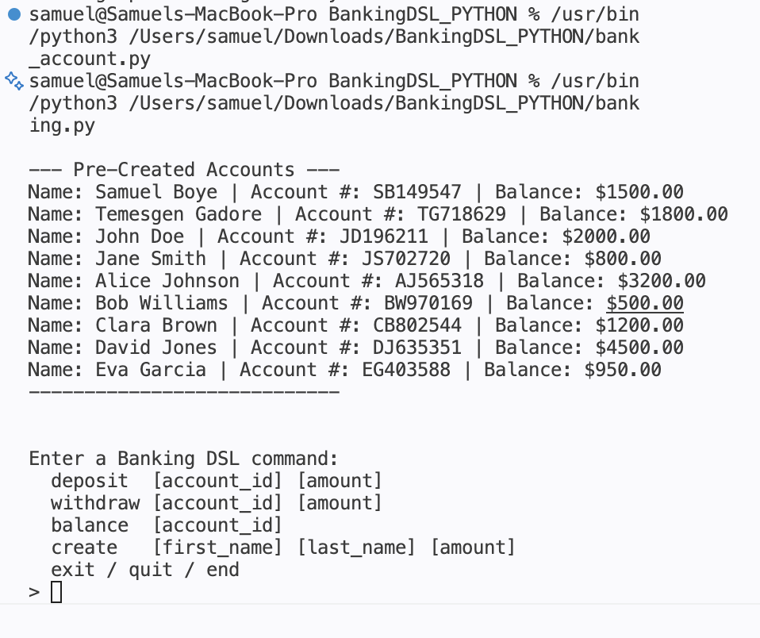

How to Run the Code
The following instructions assume Python 3.9 or later is installed and all project files are in the same folder.
Run the main Banking program:
python3 banking.py

Run the DSL specification tests:
python3 spec_testing.py

The program will display pre-created accounts and prompt for a Banking DSL command. To show lexer and parser output, the program prints tokens and the AST before showing the result for every command entered.

Example commands to test:
deposit:
Depositing 190 into precreated account for Samuel Boye which had a balance of 1500

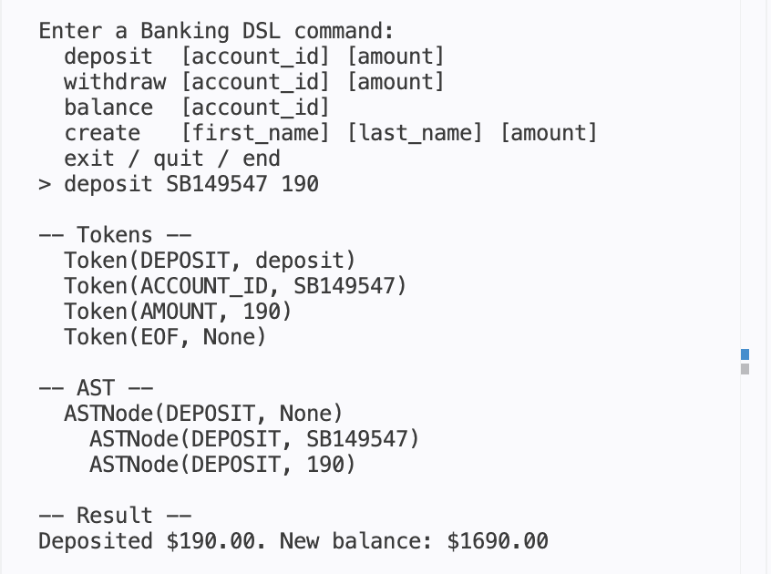
withdraw:
Withdrawing 90 from Samuel Boye bank account which had a balance of 1690
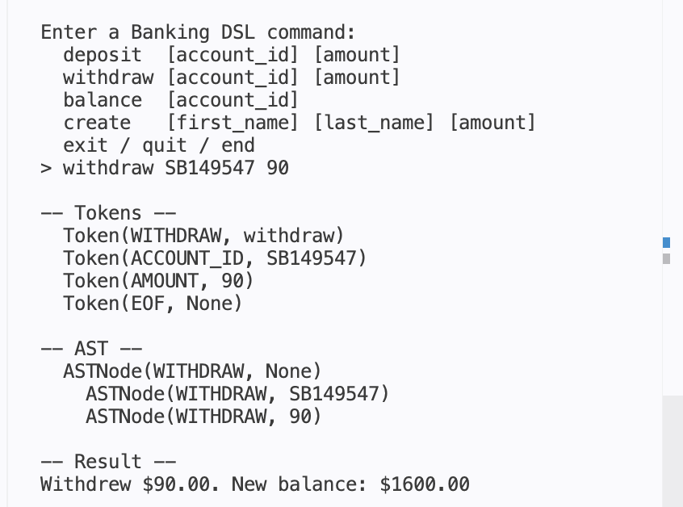

balance:
Balance for the pre created Samuel Boye account
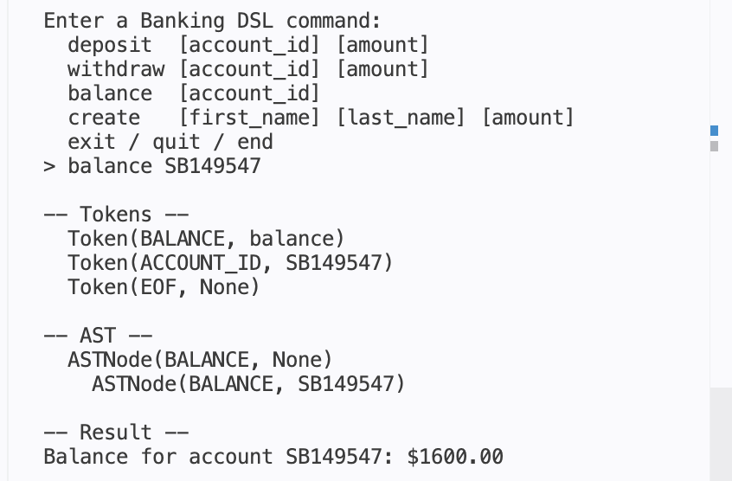
create:
Creating a new bank account for LeBron James
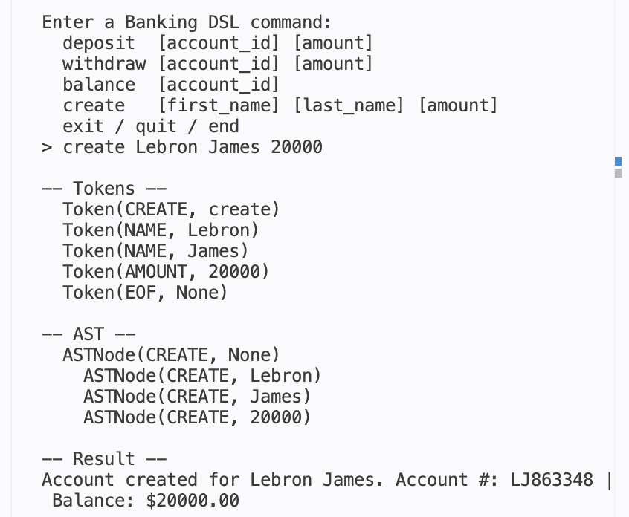

Specification Testing Screenshots
The following screenshots show spec_testing.py running all tests.

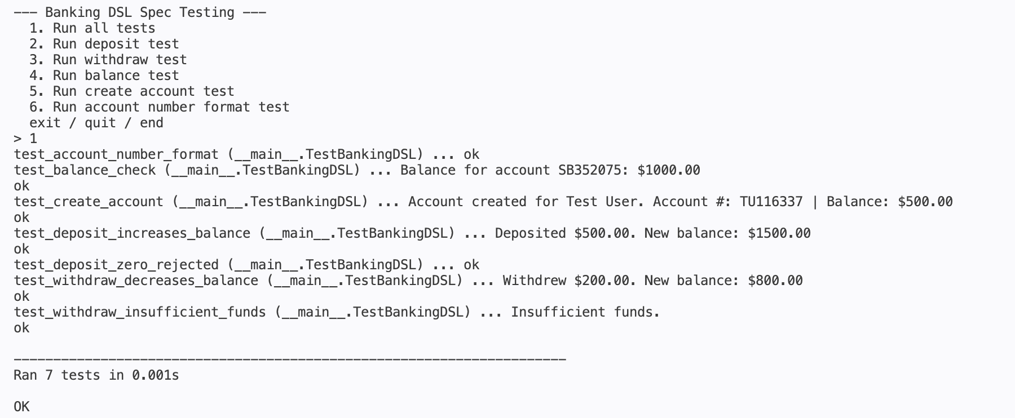

Program Hierarchy / Flow
The following diagram shows the flow of a user command through the Banking DSL pipeline:

User Input (string)
|
v
Lexer
(token.py, lexer.py)
|
v
List of Tokens
|
v
Parser
(parser.py, ast_node.py)
|
v
Abstract Syntax Tree (AST)
|
v
Interpreter
(interpreter.py)
|
v
BankAccount Operations
(bank_account.py)
|
v
Output printed to screen

Works Cited
Duerre, Dawn. CSS335 Programming Language Paradigms Course Materials. Concordia University St. Paul, Spring 2026.

Van Rossum, Guido, et al. Python 3 Documentation. Python Software Foundation, 2026, docs.python.org.

"Extended Backus-Naur Form." Wikipedia, Wikimedia Foundation, 2026, en.wikipedia.org/wiki/Extended_Backus%E2%80%93Naur_form.

