Department of Computer Technology

Vision of the Department
To be a well-known centre for pursuing computer education through innovative pedagogy, value-based education and industry
collaboration.

Mission of the Department
To establish learning ambience for ushering in computer engineering professionals in core and multidisciplinary area by developing Problem- solving skills through emerging technologies.

Session 2025-2026


Mission:
Means to achieve

Vision

Vision:

Dream

of

where

you

want.

Program Educational Objectives of the program (PEO): (broad statements that describe the professional and career accomplishments)
PEO1 | Preparation | P: Preparation | Pep-CL abbreviation pronounce as Pep-si-lL easy to recall
PEO2 | Core Competence | E: Environment  (Learning Environment) | Pep-CL abbreviation pronounce as Pep-si-lL easy to recall
PEO3 | Breadth | P: Professionalism | Pep-CL abbreviation pronounce as Pep-si-lL easy to recall
PEO4 | Professionalism | C: Core Competence | Pep-CL abbreviation pronounce as Pep-si-lL easy to recall
PEO5 | Learning  Environment | L: Breadth (Learning in diverse areas) | Pep-CL abbreviation pronounce as Pep-si-lL easy to recall

Program Outcomes (PO): (statements that describe what a student should be able to do and know by the end of a program)
Keywords of POs:

Engineering knowledge, Problem analysis, Design/development of solutions, Conduct Investigations of Complex Problems, Engineering Tool Usage, The Engineer and The World, Ethics, Individual and Collaborative Team work, Communication, Project Management and Finance, Life-Long Learning
PSO Keywords: Cutting edge technologies, Research
“I am an engineer, and I know how to apply engineering knowledge to investigate, analyse and design solutions to complex problems using tools for entire world following all ethics in a collaborative way with proper management skills throughout my life.” to contribute to the development of cutting-edge technologies and Research.

Integrity: I will adhere to the Laboratory Code of Conduct and ethics in its entirety.

Name and Signature of Student and Date
(Signature and Date in Handwritten)


Sambodhit Chavhan

Department of Computer Technology

Vision of the Department
To be a well-known centre for pursuing computer education through innovative pedagogy, value-based education and industry
collaboration.

Mission of the Department
To establish learning ambience for ushering in computer engineering professionals in core and multidisciplinary area by developing Problem- solving skills through emerging technologies.

Session | 2025-26 (ODD) | Course Name | Computer vision Lab
Semester | 5 | Course Code | CT
Roll No | 70 | Name of Student | Sambodhit Chavhan

Practical Number | 7
Course Outcome | Upon successful completion of the course the students will be able to  - Apply image enhancement and smoothing techniques to improve image quality for further analysis.  - Extract meaningful features from images using descriptors such as HOG and SIFT.  - Implement and evaluate modern object detection methods including YOLO and R-CNN.  - Analyze and develop solutions for motion estimation, object recognition, and facial expression recognition using classical and learning-based methods.
Aim | Implement motion estimation using optical flow technique.
Problem Definition | To estimate and visualize motion in a video sequence by calculating the movement of objects between consecutive frames using the optical flow technique.
Theory (100 words) | - Optical Flow:  Optical flow is a technique to estimate the apparent motion of pixels in an image sequence based on intensity changes. It represents motion as a vector field, where each vector shows the direction and magnitude of movement.  - Types of Optical Flow:  - Dense Optical Flow: Computes motion vectors for all pixels (e.g., Farneback method).  - Sparse Optical Flow: Computes motion for selected feature points (e.g., Lucas-Kanade method).
Procedure and Execution  (100 Words) | Algorithm:  - Input: Video stream or video file.  - Read the first frame and convert it to grayscale.  - Initialize an empty image to accumulate motion lines (optional for trails).  - For each subsequent frame:  - Convert the frame to grayscale.  - Compute dense optical flow between previous and current frame.  - Compute motion magnitude and direction.  - Threshold motion magnitude to detect significant motion.  - Draw motion lines in regions exceeding the threshold.

4.6 Overlay motion lines on the original frame.
4.7 Update the previous frame.
- Display the result.
- Repeat until the video ends or exit is triggered.
- Release resources and close all windows.

Code:

import cv2
import numpy as np

cap = cv2.VideoCapture('op.mp4')

if not cap.isOpened():
print("Error: Cannot open video") exit()

ret, first_frame = cap.read() if not ret: print("Error: Cannot read first frame") exit()

prev_gray = cv2.cvtColor(first_frame, cv2.COLOR_BGR2GRAY) step = 16 scale = 3 while True:
ret, frame = cap.read() if not ret: break

gray = cv2.cvtColor(frame, cv2.COLOR_BGR2GRAY)

flow = cv2.calcOpticalFlowFarneback(prev_gray, gray, None,
0.5, 3, 15, 3, 5, 1.2, 0)
mag, ang = cv2.cartToPolar(flow[..., 0], flow[..., 1])

mag_norm = cv2.normalize(mag, None, 0, 255,
cv2.NORM_MINMAX)
mag_color = cv2.applyColorMap(mag_norm.astype(np.uint8), cv2.COLORMAP_JET)

overlay = cv2.addWeighted(frame, 0.7, mag_color, 0.3, 0)

for y in range(0, frame.shape[0], step): for x in range(0, frame.shape[1], step):
fx, fy = flow[y, x] if np.hypot(fx, fy) > 1: # draw only significant motion cv2.arrowedLine(overlay,
(x, y),

(int(x + scale*fx), int(y + scale*fy)), color=(255, 255, 255),
thickness=1, tipLength=0.3)

cv2.imshow('Enhanced Motion Estimation', overlay) prev_gray = gray

if cv2.waitKey(30) & 0xFF == 27: break

cap.release() cv2.destroyAllWindows()

Output:
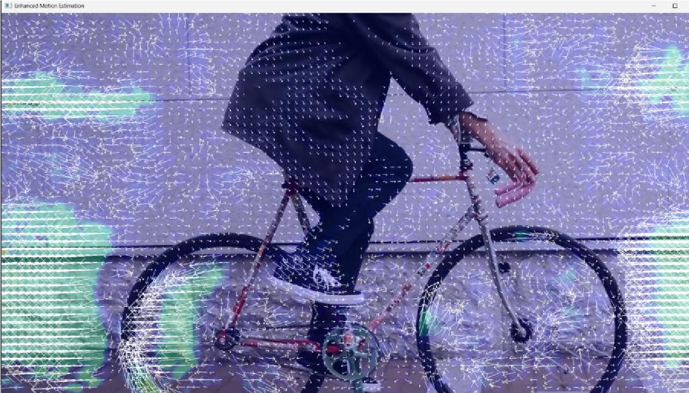1)VS CODE

Output Analysis | Occlusion occurs in computer vision when one object in a scene blocks or hides another object, either partially or fully, from the camera’s view. It leads to loss of visual information, making motion estimation or tracking difficult in the occluded regions. Handling occlusion often requires prediction, interpolation, or tracking of multiple features to maintain accurate analysis, such as when a

Yeshwantrao Chavan College of Engineering
(An Autonomous Institution affiliated to Rashtrasant Tukadoji Maharaj Nagpur University)
Hingna Road, Wanadongri, Nagpur - 441 110
NAAC A++
Ph.: 07104-237919, 234623, 329249, 329250 Fax: 07104-232376, Website: www.ycce.edu
 | person walks behind an obstacle that temporarily hides them from view.
Link of student Github profile where lab assignment has | https://github.com/sambodhit-chavhan/CV-

Yeshwantrao Chavan College of Engineering
(An Autonomous Institution affiliated to Rashtrasant Tukadoji Maharaj Nagpur University)
Hingna Road, Wanadongri, Nagpur - 441 110
NAAC A++
Ph.: 07104-237919, 234623, 329249, 329250 Fax: 07104-232376, Website: www.ycce.edu

Department of Computer Technology

Vision of the Department
To be a well-known centre for pursuing computer education through innovative pedagogy, value-based education and industry

collaboration.

Mission of the Department
To establish learning ambience for ushering in computer engineering professionals in core and multidisciplinary area by developing Problem- solving skills through emerging technologies.

been uploaded
Conclusion | Occlusion occurs when an object in a scene blocks another object from the camera’s view, making the hidden object partially or fully invisible.
Plag Report  (Similarity index <  12%) | 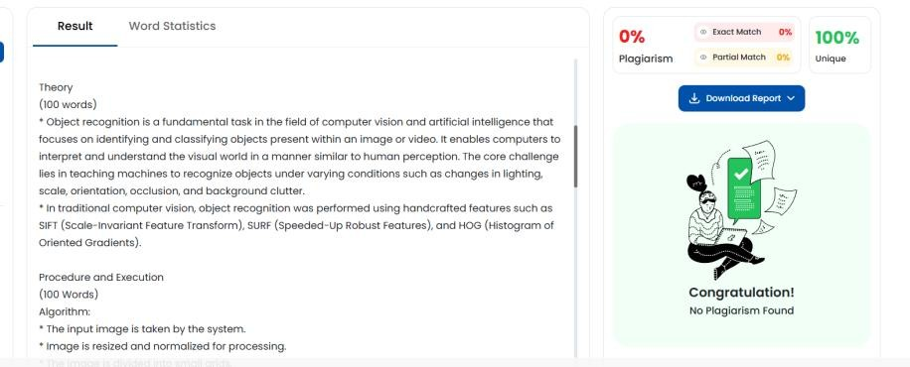
Date | 05/11/2025

