Nagar Yuwak Shikshan Sanstha’s


Yeshwantrao Chavan College of Engineering
(An Autonomous Institution affiliated to Rashtrasant Tukadoji Maharaj Nagpur
University) Hingna Road, Wanadongri, Nagpur - 441 110
NAAC A++
Ph.: 07104-237919, 234623, 329249, 329250 Fax: 07104-232376, Website:
www.ycce.edu Department of Computer Technology
Vision of the Department
To be a well-known centre for pursuing computer education through innovative pedagogy, value-based education and industry collaboration. Mission of the Department
To establish learning ambience for ushering in computer engineering professionals in core and multidisciplinary area by developing Problem solving skills through emerging technologies.
Session | 2025-26 (ODD) | Course Name | JAVA:FSD Lab
Semester | 5 | Course Code | 23CT1506
Roll No | 70 | Name of Student | Sambodhit Chavhan

- Problem definition : Banks need a simple system to manage customer accounts, perform transactions, and display account details. Many small institutions or beginners learning software development require a basic banking application that performs essential operations such as creating an account, depositing money, withdrawing money, and checking balances.

- Input
BankProject.java

import javax.swing.*; import java.awt.*; import java.awt.event.ActionEvent; import java.awt.event.ActionListener; import java.text.DecimalFormat; import java.util.HashMap; import java.util.Map;

/**
- BankProject
- This class contains the Account Model, the BankManager Logic, and the Swing UI (BankUI).
- It simulates a simple bank system allowing account creation, deposit, withdrawal, and balance inquiry.
*/

// =========================================================================
// 1. Account Model Class
// =========================================================================
class Account { private final String accountNumber; private final String accountHolderName; private double balance;

public Account(String accountNumber, String accountHolderName, double initialDeposit) { this.accountNumber = accountNumber; this.accountHolderName = accountHolderName; this.balance = initialDeposit;
}

public String getAccountNumber() { return accountNumber;
}

public String getAccountHolderName() { return accountHolderName;
}

public double getBalance() { return balance;
}

public void deposit(double amount) { if (amount > 0) { this.balance += amount;
}
}

public boolean withdraw(double amount) { if (amount > 0 && this.balance >= amount) { this.balance -= amount; return true;
}
return false;
}

@Override public String toString() {
// Used for displaying the account in the combo boxes return accountNumber + " (" + accountHolderName + ")";
}
}

// =========================================================================
// 2. BankManager Logic Class
// ========================================================================= class BankManager { private final Map<String, Account> accounts;
public BankManager() { this.accounts = new HashMap<>();
}
public boolean addAccount(String number, String name, double initialDeposit) { if (accounts.containsKey(number)) { return false; // Account already exists
}
Account newAccount = new Account(number, name, initialDeposit); accounts.put(number, newAccount);
return true;
}

public Account getAccount(String accountNumber) { return accounts.get(accountNumber);
}

public boolean deposit(String accountNumber, double amount) { Account account = getAccount(accountNumber); if (account != null && amount > 0) { account.deposit(amount); return true;
}
return false;
}

public boolean withdraw(String accountNumber, double amount) { Account account = getAccount(accountNumber);
if (account != null) { return account.withdraw(amount);
}
return false; // Account not found
}
public double getBalance(String accountNumber) {
Account account = getAccount(accountNumber); return account != null ? account.getBalance() : -1; // -1 to indicate error/not found
}
public Account[] getAllAccounts() { return accounts.values().toArray(new Account[0]);
}
}

// =========================================================================
// 3. Main Application Class (UI Setup and Event Handling)
// ========================================================================= public class BankProject extends JFrame {

private final BankManager bankManager; private final DecimalFormat currencyFormat = new DecimalFormat("¤#,##0.00");

// UI Components for common use across tabs - now separated for each panel private JComboBox<Account> depositAccountSelector; private JComboBox<Account> withdrawAccountSelector; private JComboBox<Account> viewBalanceAccountSelector; private JLabel balanceDisplayLabel;

public BankProject() { super("Simple Bank Management System"); this.bankManager = new BankManager();
// Basic Frame Setup setDefaultCloseOperation(JFrame.EXIT_ON_CLOSE); setSize(600, 450); setLocationRelativeTo(null); // Center the window setLayout(new BorderLayout());
// Use a JTabbedPane to organize the different functions JTabbedPane tabbedPane = new JTabbedPane(); tabbedPane.setFont(new Font("SansSerif", Font.BOLD, 14));

// Create and add individual function panels tabbedPane.addTab("Add Account", createAddAccountPanel()); tabbedPane.addTab("Deposit", createTransactionPanel("Deposit")); tabbedPane.addTab("Withdraw", createTransactionPanel("Withdraw")); tabbedPane.addTab("View Balance", createViewBalancePanel());

add(tabbedPane, BorderLayout.CENTER);

// Pre-populate with a test account bankManager.addAccount("1001", "Alice Johnson", 500.00); bankManager.addAccount("1002", "Bob Smith", 1250.75);

// Initial setup for all account selectors updateAccountSelector();

// Make the frame visible setVisible(true);
}

/**
- Helper method to show messages to the user using JOptionPane.
*/ private void showMessage(String title, String message, int messageType) {
JOptionPane.showMessageDialog(this, message, title, messageType);
}
/**
- Updates the JComboBox models across all tabs whenever a new account is added.
*/ private void updateAccountSelector() {
Account[] accounts = bankManager.getAllAccounts();

// Helper to update a single selector java.util.function.Consumer<JComboBox<Account>> updateSelector = selector -> {
if (selector != null) { selector.removeAllItems(); for (Account acc : accounts) { selector.addItem(acc);
}
}
};

// Update all three selector instances updateSelector.accept(depositAccountSelector); updateSelector.accept(withdrawAccountSelector); updateSelector.accept(viewBalanceAccountSelector);
}

// =========================================================================
// Panel 1: Add Account
// ========================================================================= private JPanel createAddAccountPanel() { JPanel panel = new JPanel(new GridBagLayout()); panel.setBorder(BorderFactory.createEmptyBorder(20, 20, 20, 20));
GridBagConstraints gbc = new GridBagConstraints(); gbc.insets = new Insets(10, 10, 10, 10);
gbc.fill = GridBagConstraints.HORIZONTAL;
// Labels
JLabel nameLabel = new JLabel("Account Holder Name:");
JLabel numberLabel = new JLabel("Account Number (Unique):");
JLabel depositLabel = new JLabel("Initial Deposit Amount (>= 0):");

// Text Fields
JTextField nameField = new JTextField(15);
JTextField numberField = new JTextField(15);
JTextField depositField = new JTextField(15);

// Add components to the panel gbc.gridx = 0; gbc.gridy = 0; panel.add(nameLabel, gbc); gbc.gridx = 1; gbc.gridy = 0; panel.add(nameField, gbc);

gbc.gridx = 0; gbc.gridy = 1; panel.add(numberLabel, gbc); gbc.gridx = 1; gbc.gridy = 1; panel.add(numberField, gbc);

gbc.gridx = 0; gbc.gridy = 2; panel.add(depositLabel, gbc); gbc.gridx = 1; gbc.gridy = 2; panel.add(depositField, gbc);

// Button
JButton addButton = new JButton("Create New Account"); addButton.setFont(new Font("SansSerif", Font.BOLD, 14)); gbc.gridx = 0; gbc.gridy = 3; gbc.gridwidth = 2; panel.add(addButton, gbc);
// Action Listener for Add Account Button addButton.addActionListener(e -> {
String name = nameField.getText().trim();
String number = numberField.getText().trim(); String depositStr = depositField.getText().trim();
if (name.isEmpty() || number.isEmpty() || depositStr.isEmpty()) { showMessage("Input Error", "All fields must be filled out.", JOptionPane.ERROR_MESSAGE);
return;
}
try {
double initialDeposit = Double.parseDouble(depositStr);
if (initialDeposit < 0) {
showMessage("Input Error", "Initial deposit must be zero or positive.", JOptionPane.ERROR_MESSAGE);
return;
}

if (bankManager.addAccount(number, name, initialDeposit)) {
showMessage("Success", "Account " + number + " for " + name + " created successfully!", JOptionPane.INFORMATION_MESSAGE);
// Clear fields nameField.setText(""); numberField.setText(""); depositField.setText("");
// Update account list across all panels updateAccountSelector();
} else {
showMessage("Creation Failed", "Account number already exists.", JOptionPane.ERROR_MESSAGE);
}
} catch (NumberFormatException ex) {
showMessage("Input Error", "Initial deposit must be a valid number.", JOptionPane.ERROR_MESSAGE);
}
});
return panel;
}

// =========================================================================
// Panel 2 & 3: Deposit and Withdraw (Transaction Panels)
// =========================================================================
private JPanel createTransactionPanel(String type) { JPanel panel = new JPanel(new GridBagLayout()); panel.setBorder(BorderFactory.createEmptyBorder(20, 20, 20, 20)); GridBagConstraints gbc = new GridBagConstraints(); gbc.insets = new Insets(10, 10, 10, 10); gbc.fill = GridBagConstraints.HORIZONTAL;

// Determine which specific selector field to use for this panel
JComboBox<Account> currentSelector;

if (type.equals("Deposit")) { if (depositAccountSelector == null) { depositAccountSelector = new JComboBox<>(); depositAccountSelector.setFont(new Font("SansSerif", Font.PLAIN, 12));
}
currentSelector = depositAccountSelector;
} else { // Withdraw if (withdrawAccountSelector == null) { withdrawAccountSelector = new JComboBox<>(); withdrawAccountSelector.setFont(new Font("SansSerif", Font.PLAIN, 12));
}
currentSelector = withdrawAccountSelector;
}
// Account Selector
JLabel accountLabel = new JLabel("Select Account:");

// Amount Field
JLabel amountLabel = new JLabel(type + " Amount:");
JTextField amountField = new JTextField(15);

// Button
JButton transactionButton = new JButton(type); transactionButton.setFont(new Font("SansSerif", Font.BOLD, 14));

// Layout components gbc.gridx = 0; gbc.gridy = 0; panel.add(accountLabel, gbc); gbc.gridx = 1; gbc.gridy = 0; panel.add(currentSelector, gbc); // Added the selector here

gbc.gridx = 0; gbc.gridy = 1; panel.add(amountLabel, gbc); gbc.gridx = 1; gbc.gridy = 1; panel.add(amountField, gbc);

gbc.gridx = 0; gbc.gridy = 2; gbc.gridwidth = 2; panel.add(transactionButton, gbc);

// Action Listener for Transaction Button transactionButton.addActionListener(e -> {
Account selectedAccount = (Account) currentSelector.getSelectedItem(); String amountStr = amountField.getText().trim();

if (selectedAccount == null) { showMessage("Error", "Please add an account first.", JOptionPane.ERROR_MESSAGE);
return;
}
if (amountStr.isEmpty()) { showMessage("Input Error", "Please enter an amount.", JOptionPane.ERROR_MESSAGE);
return;
}
try {
double amount = Double.parseDouble(amountStr);
if (amount <= 0) {
showMessage("Input Error", "Amount must be positive.", JOptionPane.ERROR_MESSAGE);
return;
}

String accountNumber = selectedAccount.getAccountNumber(); boolean success = false;

if (type.equals("Deposit")) { success = bankManager.deposit(accountNumber, amount);
if (success) {
showMessage("Deposit Successful", currencyFormat.format(amount) + " deposited to account " + accountNumber + ".\nNew Balance: " +
currencyFormat.format(bankManager.getBalance(accountNumber)), JOptionPane.INFORMATION_MESSAGE);
}
} else if (type.equals("Withdraw")) { success = bankManager.withdraw(accountNumber, amount);
if (success) {
showMessage("Withdrawal Successful", currencyFormat.format(amount) + " withdrawn from account " + accountNumber + ".\nNew Balance: " +
currencyFormat.format(bankManager.getBalance(accountNumber)), JOptionPane.INFORMATION_MESSAGE);
} else {
showMessage("Transaction Failed", "Insufficient funds or invalid amount for
withdrawal.", JOptionPane.WARNING_MESSAGE);
}
}

// Clear the amount field amountField.setText("");

} catch (NumberFormatException ex) {
showMessage("Input Error", "Amount must be a valid number.", JOptionPane.ERROR_MESSAGE);
}
});

return panel;
}

// =========================================================================
// Panel 4: View Balance
// =========================================================================
private JPanel createViewBalancePanel() { JPanel panel = new JPanel(new GridBagLayout()); panel.setBorder(BorderFactory.createEmptyBorder(20, 20, 20, 20)); GridBagConstraints gbc = new GridBagConstraints(); gbc.insets = new Insets(10, 10, 10, 10); gbc.fill = GridBagConstraints.HORIZONTAL;

// Account Selector (Specific to View Balance tab) JLabel accountLabel = new JLabel("Select Account:"); if (viewBalanceAccountSelector == null) { viewBalanceAccountSelector = new JComboBox<>(); viewBalanceAccountSelector.setFont(new Font("SansSerif", Font.PLAIN, 12)); }

// Balance Display Label balanceDisplayLabel = new JLabel("Select an account to view its balance."); balanceDisplayLabel.setFont(new Font("SansSerif", Font.BOLD, 16)); balanceDisplayLabel.setForeground(Color.BLUE.darker());

// Button to trigger the balance check
JButton checkBalanceButton = new JButton("Check Balance"); checkBalanceButton.setFont(new Font("SansSerif", Font.BOLD, 14));

// Layout components gbc.gridx = 0; gbc.gridy = 0; panel.add(accountLabel, gbc); gbc.gridx = 1; gbc.gridy = 0; panel.add(viewBalanceAccountSelector, gbc);

gbc.gridx = 0; gbc.gridy = 1; gbc.gridwidth = 2; panel.add(checkBalanceButton, gbc);

gbc.gridy = 2; panel.add(balanceDisplayLabel, gbc);

// Action Listener for Check Balance Button checkBalanceButton.addActionListener(e -> {
Account selectedAccount = (Account) viewBalanceAccountSelector.getSelectedItem(); if (selectedAccount == null) { balanceDisplayLabel.setText("No accounts available.");
return;
}

String accountNumber = selectedAccount.getAccountNumber(); double balance = bankManager.getBalance(accountNumber);
if (balance != -1) {
balanceDisplayLabel.setText("Current Balance for " + accountNumber + ": " + currencyFormat.format(balance));
} else {
balanceDisplayLabel.setText("Error: Account not found.");
}
});

return panel;
}

/**
* Main method to start the application.
*/
public static void main(String[] args) {
// Schedule a job for the event-dispatching thread:
// creating and showing this application's GUI.
SwingUtilities.invokeLater(BankProject::new);
}
}

3.output

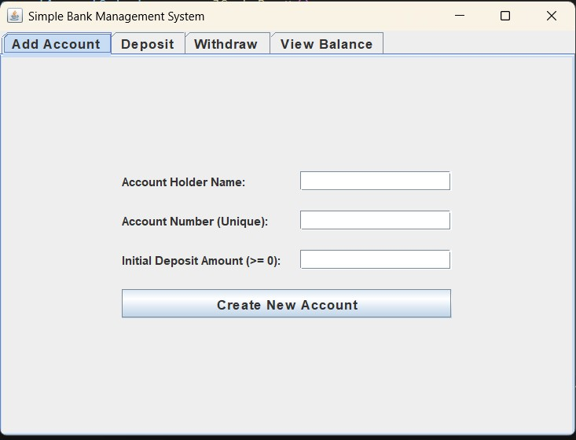

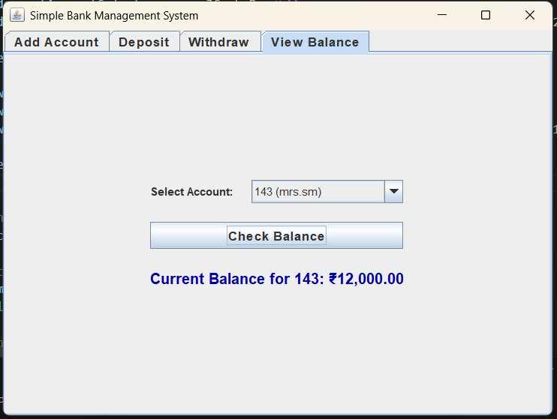

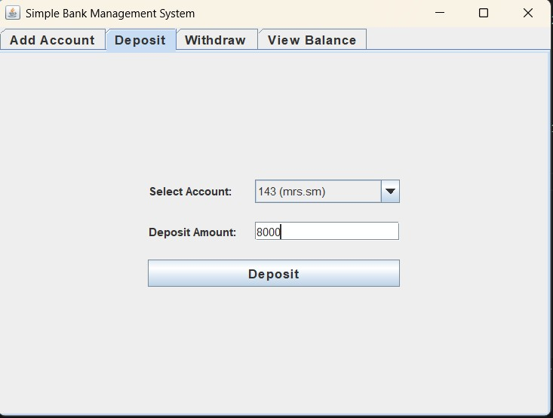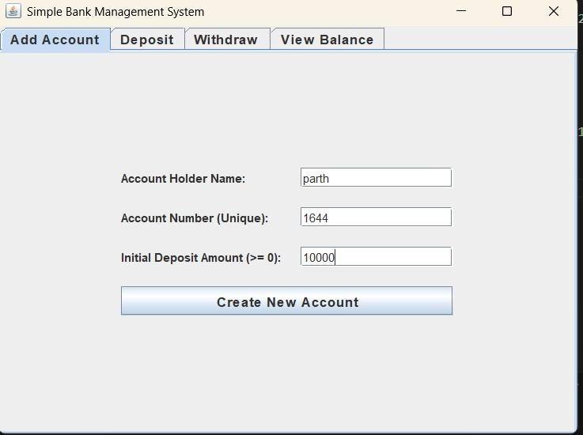

4. Github link : https://github.com/parth1644/Java_lab/tree/main/BasicBankProject

