Nagar Yuwak Shikshan Sanstha’s


Yeshwantrao Chavan College of Engineering
(An Autonomous Institution affiliated to Rashtrasant Tukadoji Maharaj Nagpur
University) Hingna Road, Wanadongri, Nagpur - 441 110
NAAC A++
Ph.: 07104-237919, 234623, 329249, 329250 Fax: 07104-232376, Website:
www.ycce.edu Department of Computer Technology
Vision of the Department
To be a well-known centre for pursuing computer education through innovative pedagogy, value-based education and industry collaboration. Mission of the Department
To establish learning ambience for ushering in computer engineering professionals in core and multidisciplinary area by developing Problem solving skills through emerging technologies.
Session | 2025-26 (ODD) | Course Name | JAVA:FSD Lab
Semester | 5 | Course Code | 23CT1506
Roll No | 70 | Name of Student | Sambodhit Chavhan

- Problem definition : People often struggle to manage tasks efficiently due to lack of organization. Without a proper system, important tasks are forgotten, deadlines are missed, and productivity decreases. To solve this, users need a simple, easy-to-use application that allows them to record, update, and track daily tasks.
The goal of this project is to develop a To-Do List Application that helps users manage their tasks in an organized manner. The application should allow users to create, view, edit, and delete tasks, ensuring better personal productivity.

- Input

Task.java public class Task { private String description; private boolean isComplete;

/**
  - Constructor for a new Task.
  - New tasks are initialized as incomplete (isComplete = false).
  - * @param description The textual description of the task.
*/ public Task(String description) { this.description = description; this.isComplete = false;
}

// --- Getters ---

public String getDescription() { return description;
}

public boolean isComplete() { return isComplete;
}

// --- Setters ---

public void setDescription(String description) { this.description = description;
}

/**
- Sets the completion status of the task.
- * @param isComplete The new status (true for complete, false for incomplete).
*/
public void setComplete(boolean isComplete) { this.isComplete = isComplete;
}

// --- Formatting for Display ---
/**
- Overrides the default toString method to provide a formatted display * that includes the status of the task.
- * @return A formatted string like "[ ] Buy milk" or "[X] Buy milk".
*/
@Override public String toString() {
// Use [X] for complete and [ ] for incomplete tasks String status = isComplete ? "[X]" : "[ ]"; return status + " " + description;
}
}

ToDoGuiApp.java import javax.swing.*; import java.awt.*; import java.awt.event.ActionEvent; import java.awt.event.ActionListener; import java.util.List;

public class ToDoGuiApp {

private ToDoList todoList; private JFrame frame; private DefaultListModel<String> listModel; // Model for the JList data private JList<String> taskJList; private JTextField taskInput;

public ToDoGuiApp() {
// Initialize the core logic manager
this.todoList = new ToDoList();

// Initialize GUI components frame = new JFrame("Swing To-Do List Application"); listModel = new DefaultListModel<>(); taskJList = new JList<>(listModel); taskInput = new JTextField(25); // Set preferred column size
}

private void createAndShowGUI() {
// --- Frame Setup --- frame.setDefaultCloseOperation(JFrame.EXIT_ON_CLOSE); frame.setSize(600, 450); frame.setLayout(new BorderLayout(10, 10)); // Outer layout

// --- 1. Input Panel (North) ---
JPanel inputPanel = new JPanel(new FlowLayout(FlowLayout.CENTER, 10, 10)); JButton addButton = new JButton("Add Task"); inputPanel.add(new JLabel("New Task:")); inputPanel.add(taskInput); inputPanel.add(addButton); frame.add(inputPanel, BorderLayout.NORTH);

// --- 2. Task List Display (Center) --- taskJList.setSelectionMode(ListSelectionModel.SINGLE_SELECTION);
// Use a JScrollPane for scrollability when the list grows JScrollPane scrollPane = new JScrollPane(taskJList); frame.add(scrollPane, BorderLayout.CENTER);

// --- 3. Action Buttons Panel (South) ---
JPanel actionPanel = new JPanel(new FlowLayout(FlowLayout.CENTER, 20, 10)); JButton markCompleteButton = new JButton("Mark Complete");
JButton deleteButton = new JButton("Delete Task");

actionPanel.add(markCompleteButton); actionPanel.add(deleteButton); frame.add(actionPanel, BorderLayout.SOUTH);

// --- Event Handling (Action Listeners) ---

// 1. Add Task Action
ActionListener addTaskAction = e -> {
String description = taskInput.getText().trim(); if (!description.isEmpty()) { todoList.addTask(description); updateTaskListDisplay(); // Refresh the JList taskInput.setText(""); // Clear input field
} else {
JOptionPane.showMessageDialog(frame, "Task description cannot be empty.", "Input Error",
JOptionPane.WARNING_MESSAGE);
}
};
addButton.addActionListener(addTaskAction); taskInput.addActionListener(addTaskAction); // Allow pressing Enter in the text field

// 2. Mark Complete Action markCompleteButton.addActionListener(e -> { int selectedIndex = taskJList.getSelectedIndex(); if (selectedIndex != -1) {
// JList index is 0-based; ToDoList methods expect 1-based index if (todoList.markTaskComplete(selectedIndex + 1)) { updateTaskListDisplay();
}
} else {
JOptionPane.showMessageDialog(frame, "Please select a task to mark as complete.", "Selection Required", JOptionPane.WARNING_MESSAGE);
}
});

// 3. Delete Task Action deleteButton.addActionListener(e -> { int selectedIndex = taskJList.getSelectedIndex(); if (selectedIndex != -1) {
// JList index is 0-based; ToDoList methods expect 1-based index if (todoList.deleteTask(selectedIndex + 1)) { updateTaskListDisplay();
}
} else {
JOptionPane.showMessageDialog(frame, "Please select a task to delete.", "Selection Required", JOptionPane.WARNING_MESSAGE);
}
});

frame.setLocationRelativeTo(null); // Center the window frame.setVisible(true);
}

/**
- Reads the current list of Tasks from the ToDoList manager
- and updates the JList component to reflect the state.
*/
private void updateTaskListDisplay() { listModel.clear();
// Use the getTasks() method added to ToDoList.java
for (Task task : todoList.getTasks()) {
// Task.toString() provides the formatted string like "[X] Buy milk" listModel.addElement(task.toString());
}
}

// --- Main Method --- public static void main(String[] args) {
// Java Swing applications must run on the Event Dispatch Thread (EDT)
SwingUtilities.invokeLater(() -> { ToDoGuiApp app = new ToDoGuiApp(); app.createAndShowGUI();
});
}}
ToDoList.java

import java.util.ArrayList; import java.util.List;

public class ToDoList { private List<Task> tasks;

public ToDoList() { this.tasks = new ArrayList<>();
}

// --- Core Logic Methods ---

/** Adds a new task to the list. */ public void addTask(String description) { tasks.add(new Task(description));
// Note: Console print statements are generally removed in a pure GUI app,
// but we'll keep them here for debugging/console verification.
System.out.println("✅ Task added: " + description);
}
/** Displays all tasks with their index (1-based). (Used for debugging/console fallback) */ public void viewTasks() { if (tasks.isEmpty()) {
System.out.println("🤷 The to-do list is empty!");
return;
}

System.out.println("\n--- Your To-Do List ---"); for (int i = 0; i < tasks.size(); i++) {
System.out.println((i + 1) + ". " + tasks.get(i));
}
System.out.println("-----------------------\n");
}
/** * Marks a task as complete using a 1-based index (user input).
* @return true if successful, false otherwise.
*/
public boolean markTaskComplete(int index) {
// Convert 1-based index (user input) to 0-based index (ArrayList) int arrayIndex = index - 1;

if (arrayIndex >= 0 && arrayIndex < tasks.size()) { tasks.get(arrayIndex).setComplete(true);
System.out.println("🎉 Task " + index + " marked as complete.");
return true;
} else {
return false;
}
}
/** * Deletes a task using a 1-based index (user input).
* @return true if successful, false otherwise.
*/
public boolean deleteTask(int index) {
// Convert 1-based index (user input) to 0-based index (ArrayList) int arrayIndex = index - 1;

if (arrayIndex >= 0 && arrayIndex < tasks.size()) {
Task removedTask = tasks.remove(arrayIndex);
System.out.println("🗑 Task deleted: " + removedTask.getDescription());
return true; } else { return false;
}
}

// --- GUI Integration Method (NEW) ---

/** * Returns the internal list of tasks. This is essential for the
* ToDoGuiApp (the View) to render the current state of the list.
*/
public List<Task> getTasks() { return tasks;
}
}

3.output
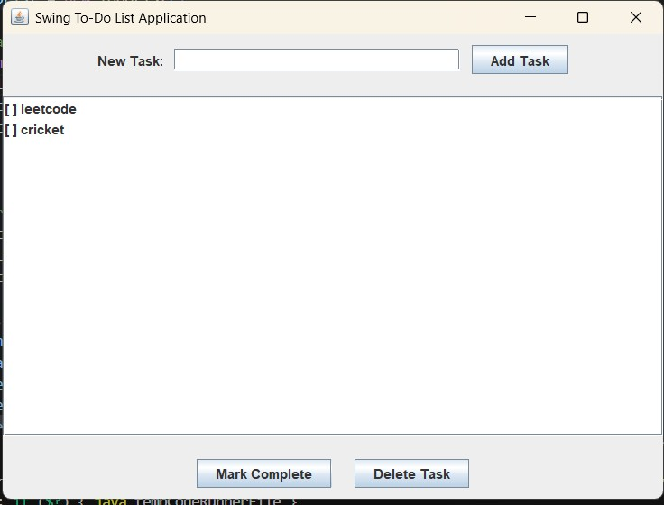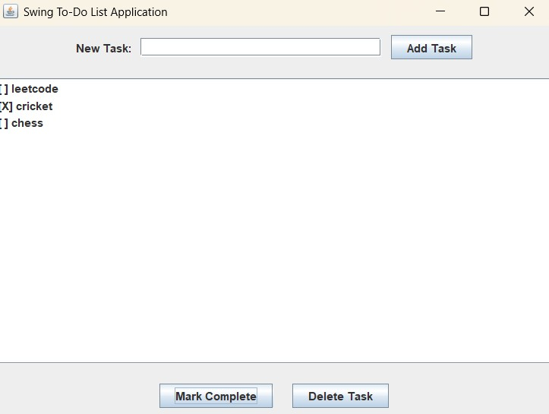
4. Github link : https://github.com/parth1644/Java_lab/tree/main/ToDoListProject/java-app/src

