CSCI3302 HW0

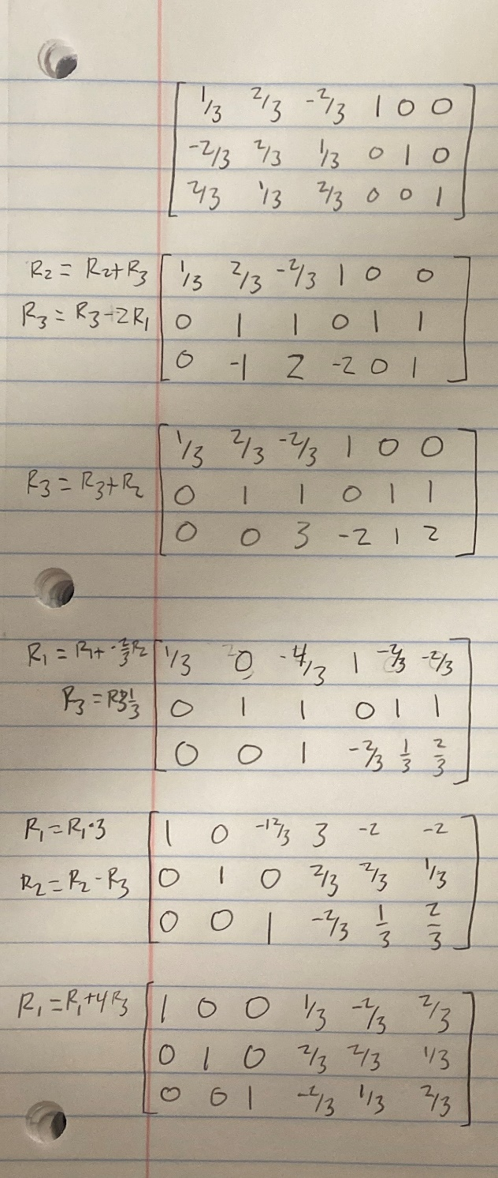Samuel Boehle

1

To find the inverse I put an identity matrix next to the matrix and used row operations to move the identity matrix to the left. The result is my answer. I included handwritten matrices in this problem since I was told I was allowed to on piazza.

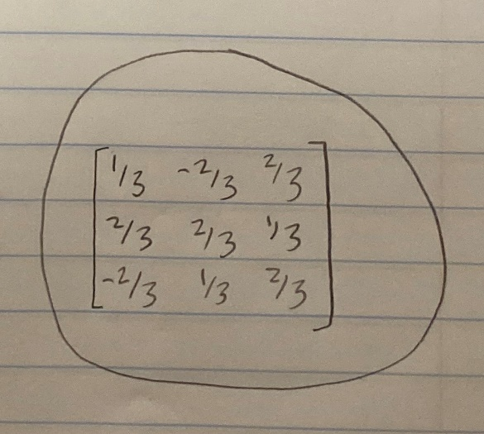Answer:

2

$$θ=\cos^{-1}{\frac{v∙w}{\left|\left|v\right|\right|\left|\left|w\right|\right|}}$$

$$u∙v=3*4-3*3-1*3=0$$

$$\left|\left|v\right|\right|=\sqrt{3^{2}+3^{2}+{-1}^{2}}=\sqrt{19}$$

$$\left|\left|w\right|\right|=\sqrt{4^{2}+{-3}^{2}+3^{2}}=\sqrt{34}$$

$$θ=\cos^{-1}{\frac{0}{\sqrt{19}\sqrt{34}}=\frac{π}{2}}$$