Enrico Blackwell - [enbl2915@colorado.edu](mailto:enbl2915@colorado.edu)

Samuel Boehle - [sabo3897@colorado.edu](mailto:sabo3897@colorado.edu)

John Chabin - [joch3302@colorado.edu](mailto:joch3302@colorado.edu)

We have completed mapping and localization. For mapping we are using manual control for now and using the lidar code from our previous labs. For localization we are using the robots GPS. We have just started computer vision. We will use the RRT code from the homework, all that is left to do for navigation is implement the code. For manipulation we have been able to get the hand to move.

Screenshot of mapping result:

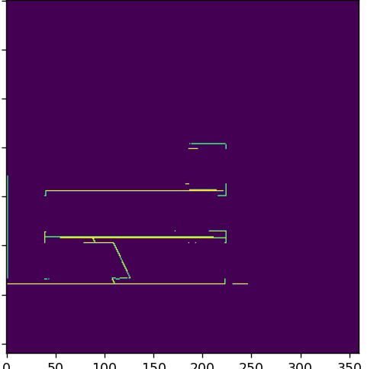

Screenshot of snippet of RRT code

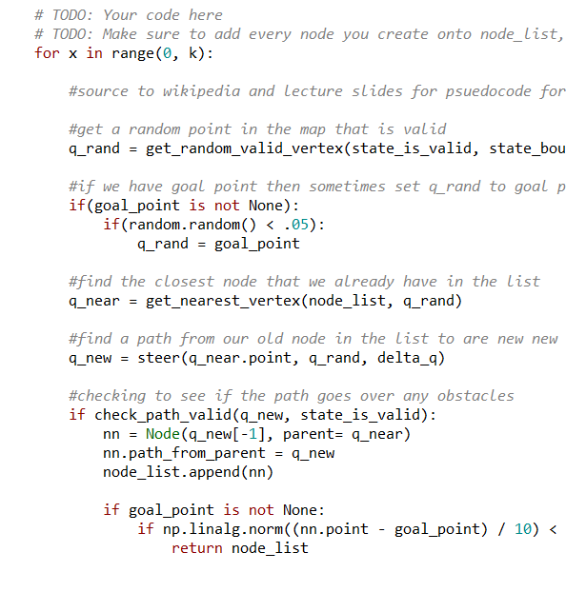

Going forward I think that we need to focus on getting the computer vision and the manipulator working as these are the things we are most of unsure of working with.