Table Structure Example:
Let’s assume we have the following two tables:

1. employees table:
CREATE TABLE employees (
employee_id INT PRIMARY KEY,
first_name VARCHAR(50),
last_name VARCHAR(50),
hire_date DATE,
department_id INT,
salary DECIMAL(10, 2)
);

2. departments table:
CREATE TABLE departments (
department_id INT PRIMARY KEY,
department_name VARCHAR(100)
);

INSERT INTO departments (department_id, department_name)

VALUES

(1, 'Sales'),

(2, 'Marketing'),

(3, 'Engineering'),

(4, 'HR'),

(5, 'Finance');

INSERT INTO employees (employee_id, first_name, last_name, hire_date, department_id, salary) VALUES

(1, 'John', 'Doe', '2015-06-23', 1, 55000.00),

(2, 'Jane', 'Smith', '2018-02-10', 2, 62000.00),

(3, 'Samuel', 'Adams', '2012-11-04', 3, 90000.00),

(4, 'Emily', 'Clark', '2020-03-15', 1, 45000.00),

(5, 'Daniel', 'Harris', '2016-07-19', 4, 49000.00),

(6, 'Rachel', 'Baker', '2019-10-01', 3, 95000.00),

(7, 'Paul', 'Jones', '2017-09-13', 2, 55000.00),

(8, 'Sophia', 'Taylor', '2014-12-21', 5, 73000.00),

(9, 'Michael', 'Lee', '2011-08-14', 4, 47000.00),

(10, 'Olivia', 'King', '2022-01-30', 3, 98000.00);
- To concat the first_name and last_name of employees into a single column named full_name.
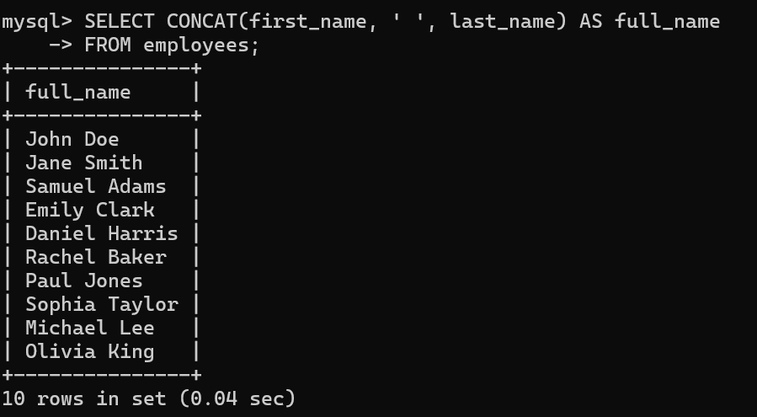
- Query that retrieves the first and last names of employees, as well as their department names by using a subquery inside the SELECT statement.

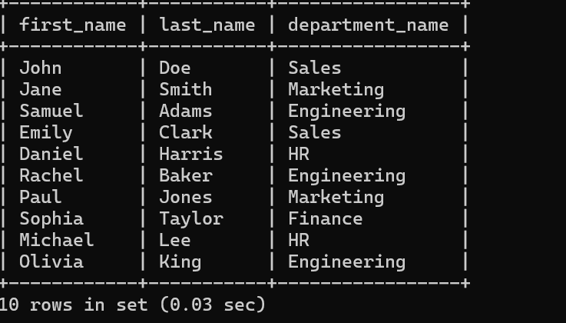
- Query counts the number of employees in each department.

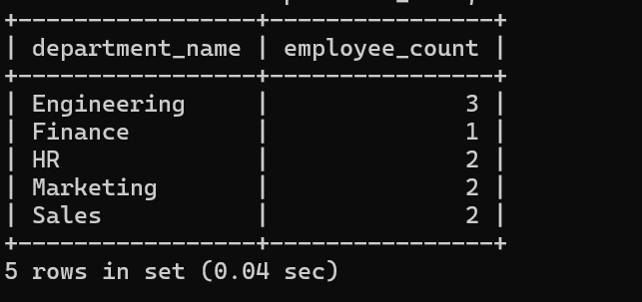
- Query to lists all departments and counts the number of employees in each department .

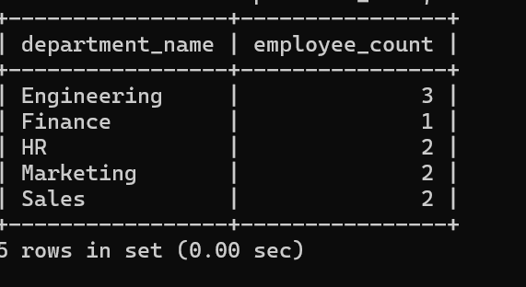

- To find employees with salary greater than average salary of their department

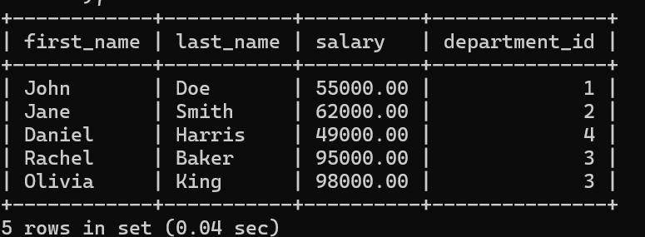
- To get all employee names in each department.

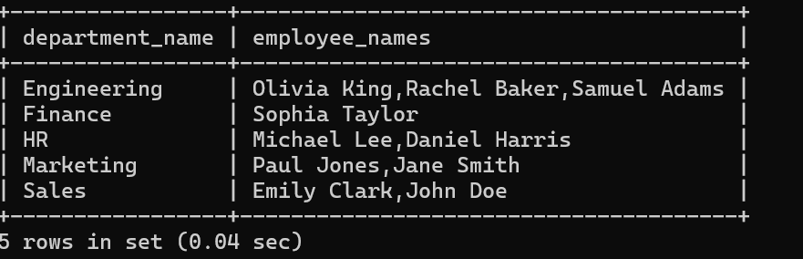
- Subquery to find the employee with the highest salary in each department.

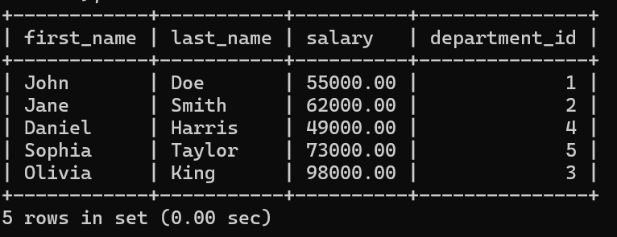

- Group employees by hire year and calculate the total salary for each year

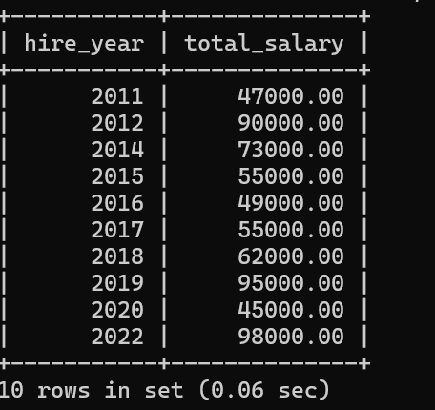
- Group departments and count the number of employees in each department

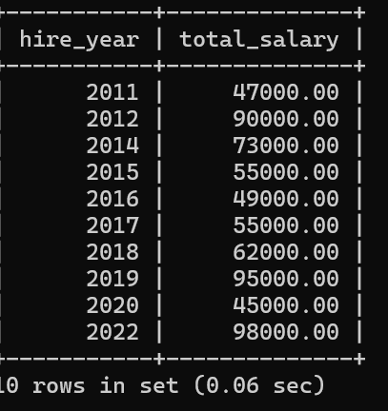
- Find the highest salary in each department

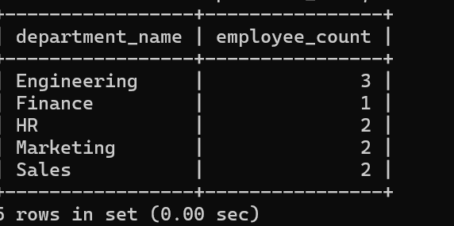

- Group employees by department and show the average salary in each department.

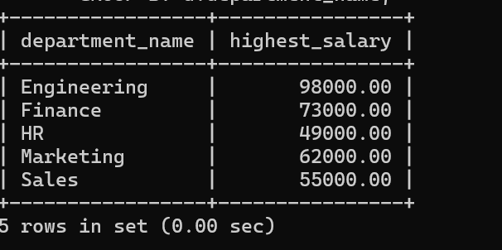
- Find departments with more than 5 employees

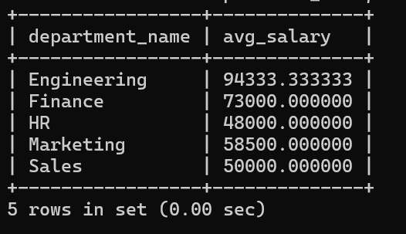

- List departments where the average salary is greater than 50,000.

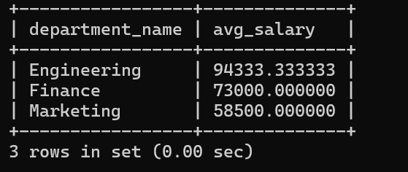

- List employees who earn more than 60,000 and belong to a department with more than 3 employees.


- Show departments where there is more than one employee with a salary over 100,000.


- Delete an employee with a specific employee_id (e.g., 5)
- Delete employees who have a salary lower than 30,000

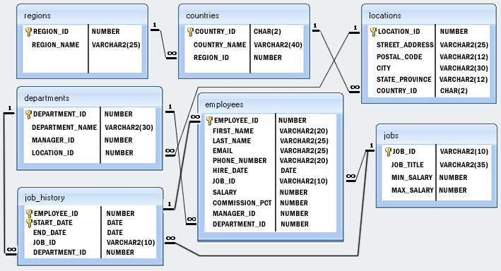

MySQL Update Table exercises
- Write a SQL statement to change the email column of employees table with 'not available' for all employees.
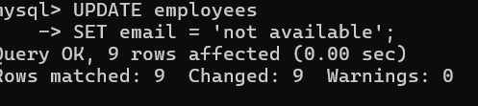

- Write a SQL statement to change the email and commission_pct column of employees table with 'not available' and 0.10 for all employees.
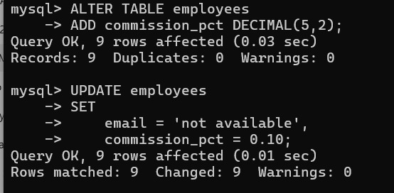

- Write a SQL statement to change the email and commission_pct column of employees table with 'not available' and 0.10 for those employees whose department_id is 110.
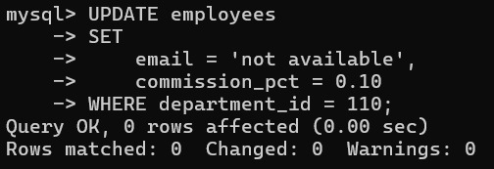

- Write a SQL statement to change the email column of employees table with 'not available' for those employees whose department_id is 80 and gets a commission is less than .20%
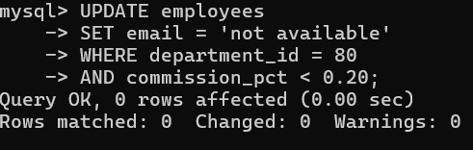

- Write a SQL statement to change the email column of employees table with 'not available' for those employees who belongs to the 'Accouning' department.
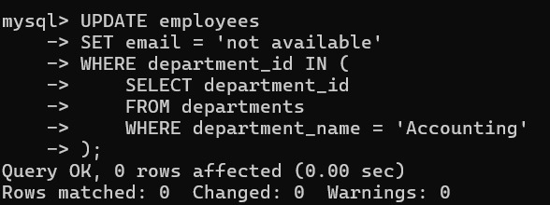

- Write a SQL statement to change salary of employee to 8000 whose ID is 105, if the existing salary is less than 5000.
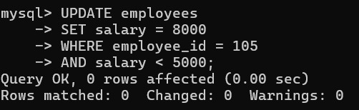

7. Write a SQL statement to change job ID of employee which ID is 118, to SH_CLERK if the employee belongs to department, which ID is 30 and the existing job ID does not start with SH.
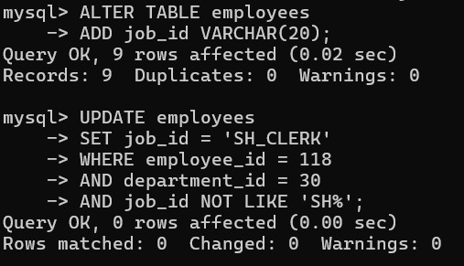

MySQL Alter Table exercises

- Write a SQL statement to rename the table countries to country_new.


- Write a SQL statement to add a column region_id to the table locations.

- Write a SQL statement to add a columns ID as the first column of the table locations.


- Write a SQL statement to add a column region_id after state_province to the table locations.


- Write a SQL statement change the data type of the column country_id to integer in the table locations.


- Write a SQL statement to drop the column city from the table locations.


- Write a SQL statement to change the name of the column state_province to state, keeping the data type and size same.


8. Write a SQL statement to add a primary key for the columns location_id in the locations table.
Here is the sample table employees.
Sample table: employees
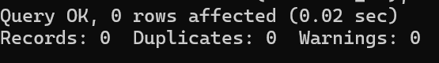

- Write a SQL statement to add a primary key for a combination of columns location_id and country_id.


- Write a SQL statement to drop the existing primary from the table locations on a combination of columns location_id and country_id.
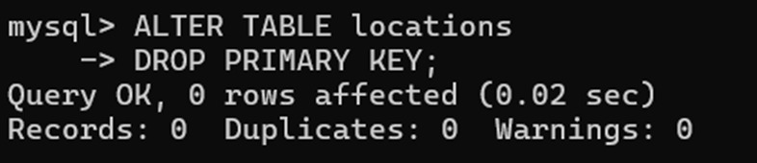

Basic SELECT Statement Exercises

Sample table: employees

1. Write a query to display the names (first_name, last_name) using alias name “First Name", "Last Name"

2. Write a query to get unique department ID from employee table.

3. Write a query to get all employee details from the employee table order by first name, descending.

4. Write a query to get the names (first_name, last_name), salary, PF of all the employees (PF is calculated as 12% of salary).

5. Write a query to get the employee ID, names (first_name, last_name), salary in ascending order of salary.

6. Write a query to get the total salaries payable to employees.

7. Write a query to get the maximum and minimum salary from employees table.

8. Write a query to get the average salary and number of employees in the employees table.

9. Write a query to get the number of employees working with the company.

10. Write a query to get the number of jobs available in the employees table.

MySQL Aggregate Functions and Group by- Exercises

Sample table: employees

1. Write a query to list the number of jobs available in the employees table.

2. Write a query to get the total salaries payable to employees.

3. Write a query to get the minimum salary from employees table.

4. Write a query to get the maximum salary of an employee working as a Programmer.

5. Write a query to get the average salary and number of employees working the department 90.

6. Write a query to get the highest, lowest, sum, and average salary of all employees.

7. Write a query to get the number of employees with the same job.

MySQL Restricting and Sorting Data – Exercises

Sample table: employees

1. Write a query to display the names (first_name, last_name) and salary for all employees whose salary is not in the range 10,000 through 15,000.

2. Write a query to display the names (first_name, last_name) and department ID of all employees in departments 30 or 100 in ascending alphabetical order by department ID.

3. Write a query to display the names (first_name, last_name) and salary for all employees whose salary is not in the range 10,000 through 15,000 and are in department 30 or 100.

4. Write a query to display the names (first_name, last_name) and hire date for all employees who were hired in 1987.

5. Write a query to display the first_name of all employees who have both "b" and "c" in their first name.

6. Write a query to display the last name, job, and salary for all employees whose job is that of a Programmer or a Shipping Clerk, and whose salary is not equal to 4,500, 10,000, or 15,000.

7. Write a query to display the last names of employees whose names have exactly 6 characters.

8. Write a query to display the last names of employees having 'e' as the third character.

9. Write a query to display the jobs/designations available in the employees table.

10. Write a query to display the names (first_name, last_name), salary and PF (15% of salary) of all employees.

11. Write a query to select all record from employees where last name in 'BLAKE', 'SCOTT', 'KING' and 'FORD'.

MySQL Sub Queries Exercises

1. Write a query to find the names (first_name, last_name) and the salaries of the employees who have a higher salary than the employee whose last_name='Bull'.

2. Write a query to find the names (first_name, last_name) of all employees who works in the IT department.

3. Write a query to find the names (first_name, last_name) of the employees who have a manager and work for a department based in the United States.
Hint : Write single-row and multiple-row subqueries
Sample table: employees
Sample table: departments
Sample table: locations

4. Write a query to find the names (first_name, last_name) of the employees who are managers.

5. Write a query to find the names (first_name, last_name), the salary of the employees whose salary is greater than the average salary.

6. Write a query to find the names (first_name, last_name), the salary of the employees whose salary is equal to the minimum salary for their job grade.
Sample table: employees
Sample table: jobs

7. Write a query to find the names (first_name, last_name), the salary of the employees who earn more than the average salary and who works in any of the IT departments.
Sample table: employees
Sample table: departments

8. Write a query to find the names (first_name, last_name), the salary of the employees who earn more than Mr. Bell.
Sample table: employees
Sample table: departments

9. Write a query to find the names (first_name, last_name), the salary of the employees who earn the same salary as the minimum salary for all departments.
Sample table: employees
Sample table: departments

10. Write a query to find the names (first_name, last_name), the salary of the employees whose salary greater than the average salary of all departments.
Sample table: employees

11. Write a query to find the names (first_name, last_name) and salary of the employees who earn a salary that is higher than the salary of all the Shipping Clerk (JOB_ID = 'SH_CLERK'). Sort the results of the salary of the lowest to highest.
Sample table: employees

12. Write a query to find the names (first_name, last_name) of the employees who are not supervisors.
Sample table: employees

13. Write a query to display the employee ID, first name, last names, and department names of all employees.
Sample table: employees
Sample table: departments

14. Write a query to display the employee ID, first name, last names, salary of all employees whose salary is above average for their departments.
Sample table: employees
Sample table: departments

15. Write a query to fetch even numbered records from employees table.
Sample table: employees

16. Write a query to find the 5th maximum salary in the employees table.
Sample table: employees

17. Write a query to find the 4th minimum salary in the employees table.
Sample table: employees

18. Write a query to select last 10 records from a table.
Sample table: employees

19. Write a query to list department number, name for all the departments in which there are no employees in the department.
Sample table: employees
Sample table: departments

20. Write a query to get 3 maximum salaries.

21. Write a query to get 3 minimum salaries.

22. Write a query to get nth max salaries of employees.

MySQL Sub Queries Solutions

1
SELECT FIRST_NAME, LAST_NAME, SALARY
FROM employees
WHERE SALARY > (SELECT salary FROM employees WHERE last_name = 'Bull');
2
SELECT first_name, last_name
FROM employees
WHERE department_id
IN (SELECT department_id FROM departments WHERE department_name='IT');
3
SELECT first_name, last_name
FROM employees
WHERE manager_id IN(select employee_id FROM employees WHERE department_id
IN (SELECT department_id FROM departments WHERE location_id
IN (select location_id from locations where country_id='US')));
4
SELECT first_name, last_name
FROM employees
WHERE (employee_id IN (SELECT manager_id FROM employees));
5
SELECT first_name, last_name, salary
FROM employees
WHERE salary > (SELECT AVG(salary) FROM employees);
6
SELECT first_name, last_name, salary
FROM employees
WHERE employees.salary = (SELECT min_salary FROM jobs
WHERE employees.job_id = jobs.job_id);
7
SELECT first_name, last_name, salary
FROM employees
WHERE department_id IN (SELECT department_id FROM departments
WHERE department_name LIKE 'IT%') AND salary > (SELECT avg(salary) FROM employees);
8
SELECT first_name, last_name, salary
FROM employees
WHERE salary >
(SELECT salary FROM employees WHERE last_name = 'Bell') ORDER BY first_name;

9
SELECT *
FROM employees
WHERE salary = (SELECT MIN(salary) FROM employees);
10
SELECT *
FROM employees
WHERE salary >
ALL(SELECT avg(salary)
FROM employees GROUP BY department_id);
11.
SELECT first_name,last_name, job_id, salary
FROM employees
WHERE salary >
ALL (SELECT salary FROM employees WHERE job_id = 'SH_CLERK')
ORDER BY salary ;
12.
SELECT b.first_name,b.last_name
FROM employees b
WHERE NOT EXISTS
(SELECT 'X' FROM employees a WHERE a.manager_id = b.employee_id);
13
SELECT employee_id, first_name, last_name,
(SELECT department_name FROM departments d
WHERE e.department_id = d.department_id) department
FROM employees e ORDER BY department;
14
SELECT employee_id, first_name
FROM employees
AS A WHERE salary >
( SELECT AVG(salary) FROM employees WHERE department_id = A.department_id);
15
SET @i = 0;
SELECT i, employee_id
FROM (SELECT @i := @i + 1 AS i, employee_id FROM employees)
a WHERE MOD(a.i, 2) = 0;

16
SELECT DISTINCT salary
FROM employees e1
WHERE 5 = (SELECT COUNT(DISTINCT salary)
FROM employees e2
WHERE e2.salary >= e1.salary);

17
SELECT DISTINCT salary
FROM employees e1
WHERE 4 = (SELECT COUNT(DISTINCT salary)
FROM employees e2 WHERE e2.salary <= e1.salary);
18
SELECT * FROM
(SELECT * FROM employees
ORDER BY employee_id DESC LIMIT 10)
sub ORDER BY employee_id ASC;
19
SELECT *
FROM departments
WHERE department_id
NOT IN (select department_id FROM employees);
20
SELECT DISTINCT salary
FROM employees a
WHERE 3 >= (SELECT COUNT(DISTINCT salary)
FROM employees b
WHERE b.salary <= a.salary) ORDER BY a.salary DESC;
21
SELECT DISTINCT salary
FROM employees a
WHERE 3 >= (SELECT COUNT(DISTINCT salary)
FROM employees b WHERE b.salary >= a.salary)
ORDER BY a.salary DESC;
22
SELECT * FROM employees emp1 WHERE (1) = (SELECT COUNT(DISTINCT(emp2.salary)) FROM employees emp2 WHERE emp2.salary > emp1.salary);

MySQL JOINS – Exercises

1. Write a query to find the addresses (location_id, street_address, city, state_province, country_name) of all the departments.
Hint : Use NATURAL JOIN.
Sample table : locations
Sample table : countries

2. Write a query to find the names (first_name, last name), department ID and name of all the employees.
Sample table : employees
Sample table : departments

3. Find the names (first_name, last_name), job, department number, and department name of the employees who work in London.
Sample table : departments
Sample table : locations

4. Write a query to find the employee id, name (last_name) along with their manager_id, manager name (last_name).
Sample table : employees

5. Find the names (first_name, last_name) and hire date of the employees who were hired after 'Jones'.
Sample table : employees

6. Write a query to get the department name and number of employees in the department.
Sample table : employees
Sample table : departments

7. Find the employee ID, job title, number of days between ending date and starting date for all jobs in department 90 from job history.
Sample table : employees

8. Write a query to display the department ID, department name and manager first name.
Sample table : employees
Sample table : departments

9. Write a query to display the department name, manager name, and city.
Sample table : employees
Sample table : departments
Sample table : locations

10. Write a query to display the job title and average salary of employees.
Sample table : employees

11. Display job title, employee name, and the difference between salary of the employee and minimum salary for the job.
Sample table : employees

12. Write a query to display the job history that were done by any employee who is currently drawing more than 10000 of salary.
Sample table : employees
Sample table : Job_history

13. Write a query to display department name, name (first_name, last_name), hire date, salary of the manager for all managers whose experience is more than 15 years.
Sample table : employees
Sample table : departments

Joins Exercises Solutions

1
SELECT location_id, street_address, city, state_province, country_name
FROM locations
NATURAL JOIN countries;
2
SELECT first_name, last_name, department_id, department_name
FROM employees
JOIN
departments
USING (department_id);
3
SELECT e.first_name, e.last_name, e.job_id, e.department_id, d.department_name
FROM employees e
JOIN
departments d ON (e.department_id = d.department_id)
JOIN
locations l ON (d.location_id = l.location_id)
WHERE LOWER(l.city) = 'London';
4
SELECT e.employee_id 'Emp_Id', e.last_name 'Employee', m.employee_id 'Mgr_Id', m.last_name 'Manager'
FROM employees e
join employees m
ON (e.manager_id = m.employee_id);
5
SELECT e.first_name, e.last_name, e.hire_date
FROM employees e
JOIN
employees davies
ON (davies.last_name = 'Jones')
WHERE davies.hire_date < e.hire_date;

6.
SELECT department_name AS 'Department Name',
COUNT(*) AS 'No of Employees'
FROM departments
INNER JOIN employees
ON employees.department_id = departments.department_id
GROUP BY departments.department_id, department_name
ORDER BY department_name;

7
SELECT employee_id, job_title, end_date-start_date Days FROM job_history
NATURAL JOIN jobs
WHERE department_id=90;
8
SELECT d.department_id, d.department_name, e.manager_id, e.first_name
FROM departments d
INNER JOIN employees e
ON (d.manager_id = e.employee_id);
9
SELECT d.department_name, e.first_name, l.city
FROM departments d
JOIN employees e
ON (d.manager_id = e.employee_id)
JOIN locations l USING (location_id);
10
SELECT job_title, AVG(salary)
FROM employees
NATURAL JOIN jobs
GROUP BY job_title;
11
SELECT job_title, first_name, salary-min_salary 'Salary - Min_Salary'
FROM employees
NATURAL JOIN jobs;
12
SELECT jh.* FROM job_history jh
JOIN employees e
ON (jh.employee_id = e.employee_id)
WHERE salary > 10000;
13.
SELECT first_name, last_name, hire_date, salary,
(DATEDIFF(now(), hire_date))/365 Experience
FROM departments d JOIN employees e
ON (d.manager_id = e.employee_id)
WHERE (DATEDIFF(now(), hire_date))/365>15;

MySQL Northwind database, Products table – Exercises

1. Write a query to get Product name and quantity/unit.

2. Write a query to get current Product list (Product ID and name).

3. Write a query to get discontinued Product list (Product ID and name).

4. Write a query to get most expense and least expensive Product list (name and unit price).

5. Write a query to get Product list (id, name, unit price) where current products cost less than $20.

6. Write a query to get Product list (id, name, unit price) where products cost between $15 and $25.

7. Write a query to get Product list (name, unit price) of above average price.

8. Write a query to get Product list (name, unit price) of ten most expensive products.

9. Write a query to count current and discontinued products.

10. Write a query to get Product list (name, units on order , units in stock) of stock is less than the quantity on order.

... More
Structure of 'northwind' database :
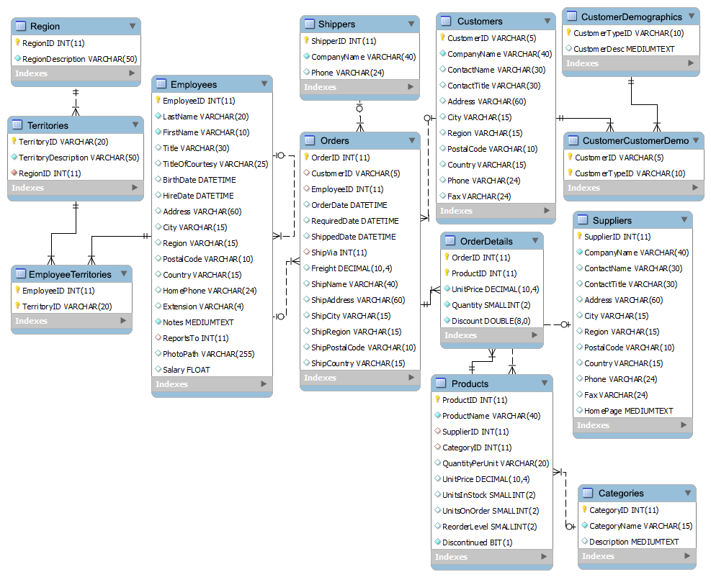

MySQL Northwind database, Products table – Solution

1
SELECT ProductName, QuantityPerUnit
FROM Products;
2
SELECT ProductID, ProductName
FROM Products
WHERE Discontinued = "False"
ORDER BY ProductName;
3
SELECT ProductID, ProductName
FROM Products
WHERE Discontinued = "True"
ORDER BY ProductName;
4
SELECT ProductName, UnitPrice
FROM Products
ORDER BY UnitPrice DESC;
5
SELECT ProductID, ProductName, UnitPrice
FROM Products
WHERE (((UnitPrice)<20) AND ((Discontinued)=False))
ORDER BY UnitPrice DESC;
6
SELECT ProductName, UnitPrice
FROM Products
WHERE (((UnitPrice)>=15 And (UnitPrice)<=25)
AND ((Products.Discontinued)=False))
ORDER BY Products.UnitPrice DESC;
7
SELECT DISTINCT ProductName, UnitPrice
FROM Products
WHERE UnitPrice > (SELECT avg(UnitPrice) FROM Products)
ORDER BY UnitPrice;
8
SELECT DISTINCT ProductName as Twenty_Most_Expensive_Products, UnitPrice
FROM Products AS a
WHERE 20 >= (SELECT COUNT(DISTINCT UnitPrice)
FROM Products AS b
WHERE b.UnitPrice >= a.UnitPrice)
ORDER BY UnitPrice desc;
9
SELECT Count(ProductName)
FROM Products
GROUP BY Discontinued;
10.
SELECT ProductName, UnitsOnOrder , UnitsInStock
FROM Products
WHERE (((Discontinued)=False) AND ((UnitsInStock)<UnitsOnOrder));

