Turtle Shell Chess
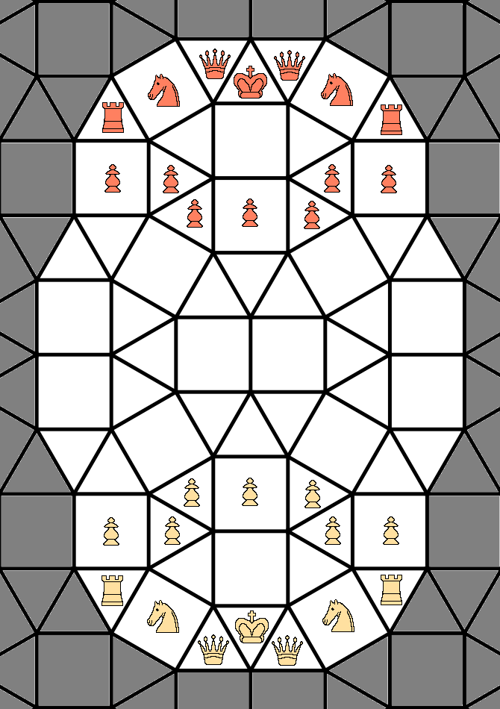
Version 1.11 2022-05-27
Introduction
Since 1994, I have wanted to create a playable Chess variant using this particular tessellation, a tiling that the Wikpedia calls a 33344-33434 tiling.

When I was trying to come up with a Chess variant with this tiling back then, my then roommate said my board looked like a “Turtle Shell”, which is why this variant is called “Turtle Shell Chess”.

It took me 28 years, but I have finally formalized the rules for “Turtle Shell Chess”.

The board
This Chess variant is played on a board using a tiling which combines squares and triangles. Pieces are placed and moved inside of the squares and triangles. The places where pieces may go are called cells; there are 64 cells in Turtle Shell Chess.

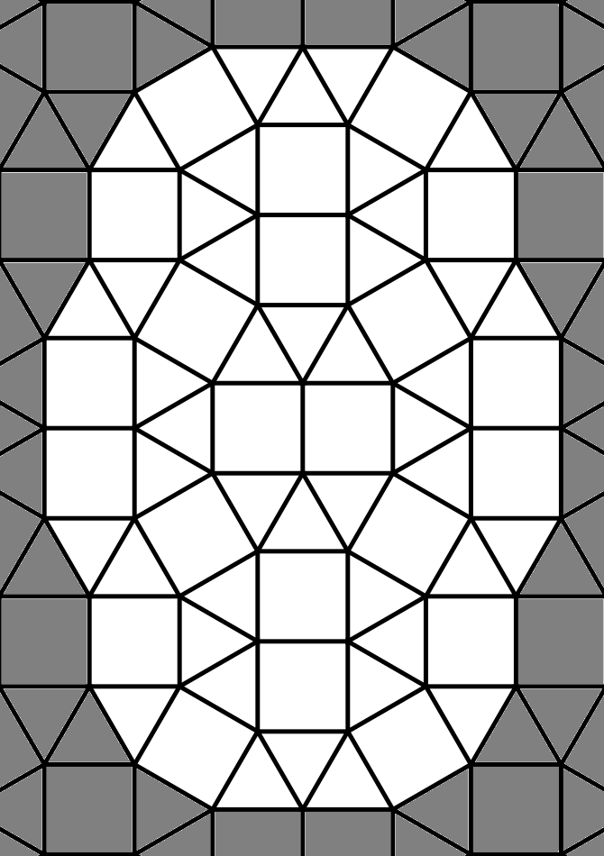
Naming the cells
A modified form of algebraic notation is using to give each cell on the board a unique designation, as follows:
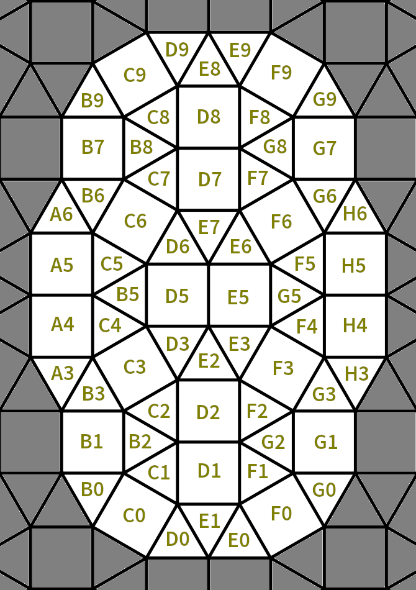
Rows
The board has 10 rows in it. Because of the nature of the tiling, some cells are in more than one row. Rooks can move left and right along rows.

Files
The board has six files. As with rows, some cells are in more than one file. Rooks can move up and down files, and pawns can move as well as capture one square towards the opponent’s endzone on a given file.

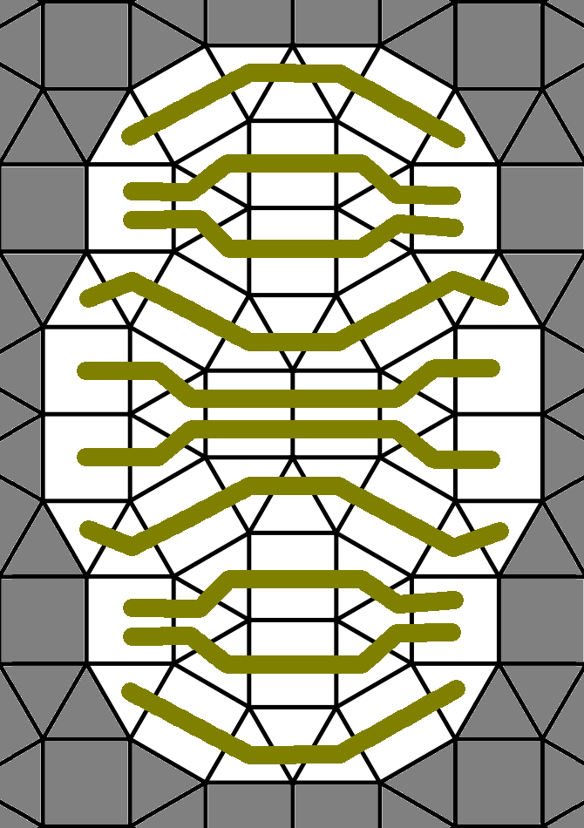  Rows in Turtle Shell Chess | 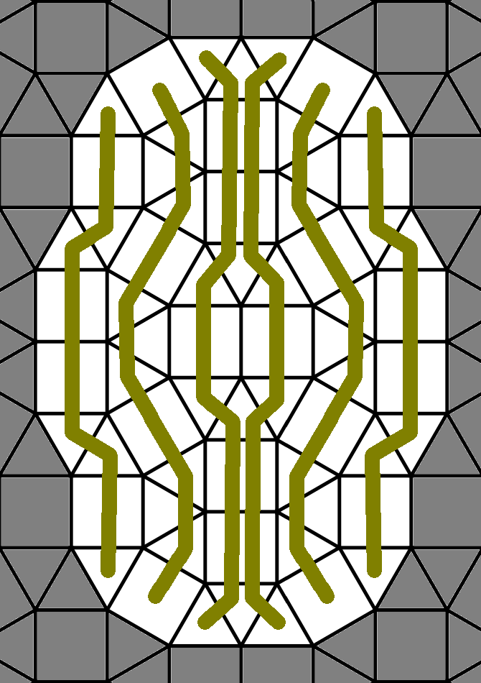  Files in Turtle Shell Chess
Promotion zones
Any pawn placed in the opponent’s promotion zone may be promoted to a rook. A pawn not in the opponent’s endzone is not required to promote; promotion is mandatory once in the endzone. There is no limit on the number of promoted pawns allowed on the board.

In the image below, white pawns may promote in the yellow cells, and black pawns may promote in the red cells.

End zones
Any pawn placed in the opponent’s end zone is required to promote to a rook. If a player is able to place his king in the opponent’s end zone, they immediately win the game.

In the image below, white pawns must promote on the yellow cells, and a white king on any of the yellow cells is victory for white. Likewise, black pawns must promote on the red cells, and a black king on any of the red cells is victory for black.

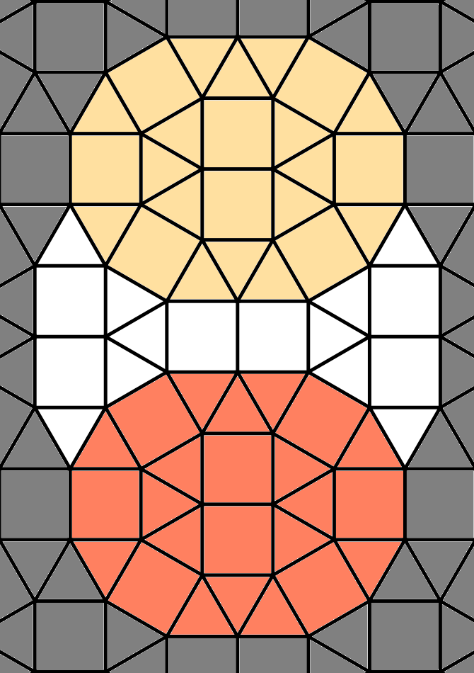 Turtle Shell Chess promotion zones | 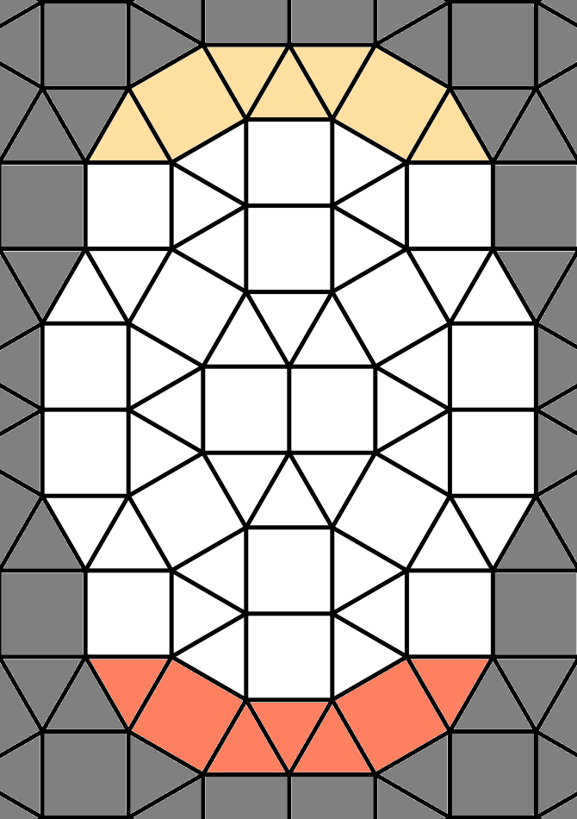Turtle Shell Chess end zones
Movement and capture
Each piece is Turtle shell chess has a given movement to it. If a piece moves to a square occupied by an opponent’s piece, the opponent’s piece in question is removed from the board; this is called capture.

The rook
A rook may move any number of cells along a row or file until it is blocked by a piece of the same color. If there is an enemy piece on the rook’s path, the rook may capture that piece, but the rook may not continue moving after capturing.

A rook must make an entire single move along the same row or file. For example, a rook on D0 may move to D3 (which is on the same file) but may not move to E3, because moving to E3 is only possible from D0 if the rook changes the file they are on during the move.

The guard
The guard may move or capture to any cell it shares an edge with. If a cell is a triangle, a guard may move or capture to any of the up to three adjacent cells. If the cell is a square, a guard may move or capture to any of the up to four adjacent cells.
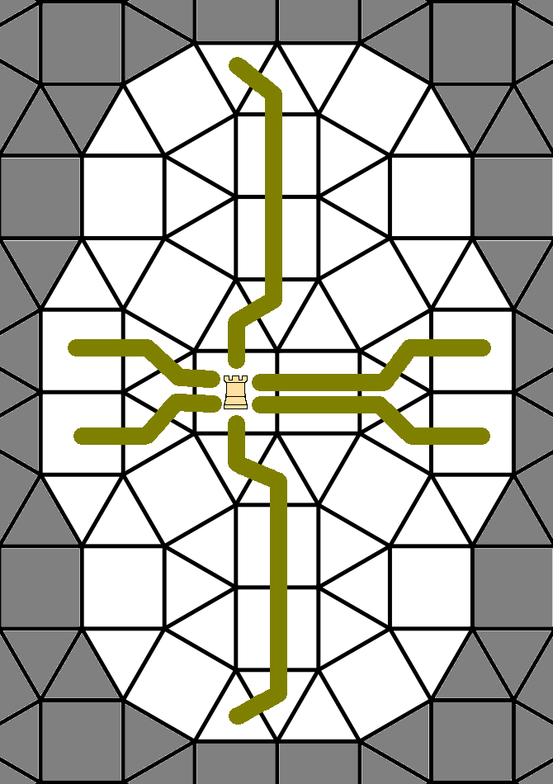The rook | 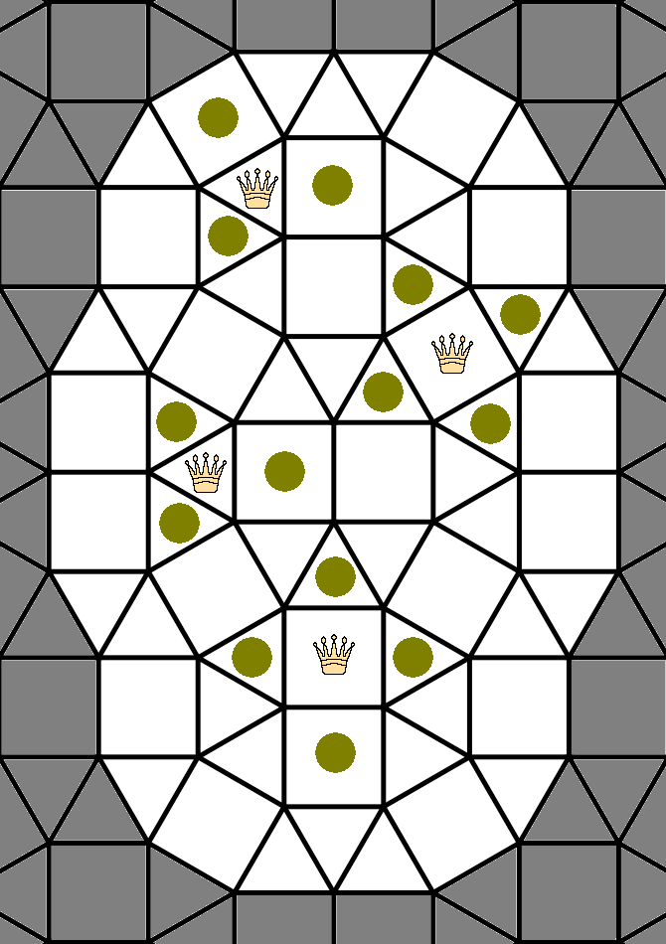The guard
The knight
A knight in Turtle Shell Chess may move or capture to any cell that it shares a corner with, as long as the cell in question does not share an edge with the cell the knight is in.

A knight, if in a triangle cell, may move to up to six different cells. If in a square cell, a knight might be able to move to up to eight different cells.
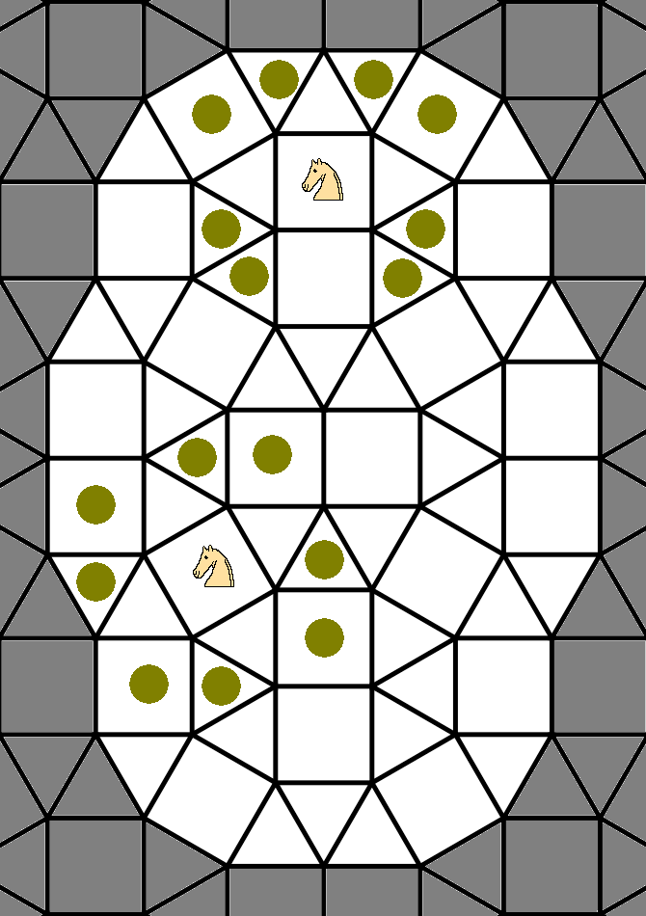 | 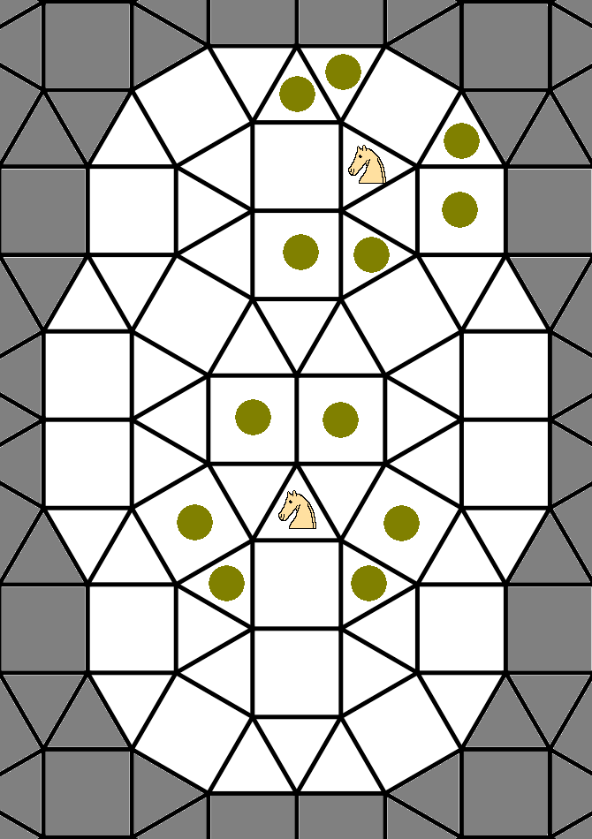
The pawn
A pawn has the same move and capture: It may move one square forward towards the opponent’s endzone along a file. If a pawn ends its move in the opponent’s promotion zone, it may, at the player’s discretion, promote in to a rook immediately after ending its move in the promotion zone. If a pawn ends its move in the opponent’s end zone, it must promote in to a rook immediately after ending its move.

For example, if the white player moves a pawn from C5 to C6, they may make the pawn on C6 a rook on the same turn the pawn moved from C5 to C6.

A pawn must have moved on the same turn when it is promoted.

A white pawn on the E2 triangle cell may move or capture to either the D3 cell or the E3 cell. A black pawn on the E7 triangle cell may move or capture to either the D6 cell or E6 cell. Otherwise, each pawn may only move to the cell immediately in front of it on the same file.

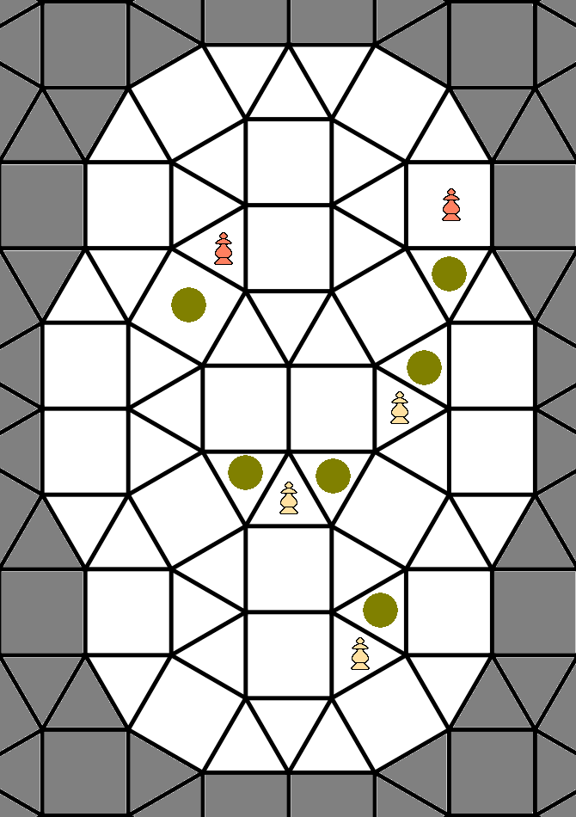
The pawn
The king
A king moves as a guard. If the opponent threatens to capture the king, the king is said to be in check and must make a move to stop the threat of capture. If it is not possible to stop the check (by either capturing the piece giving check, interposing a piece between a rook giving check and the king, or moving the king to a square not under threat of opponent capture), the king is under checkmate and the player giving checkmate has won the game.

If a king ends its turn on a square in the opponent’s end zone without being in check, the game is immediately won for the person who moved their king across the board.

Repetition of move
If making a move which recreates a position previously played in this game, with the same player having the move as the previous position, the attacking player must stop the loop. An attacking player is defined as the player who, for all board positions in the loop, just after the attacker has moved, more capture threats (including check) are on the board regardless of the color of the piece making the capture threat. This is calculated by adding together all possible capture moves for each unique board position in the loop per player. In case this sum is the same for both players, the player who gives check more often (i.e. has more king capture threats, where a double check is 2 threats) in the loop of moves is the player who must make a different move to break the loop. In case the sum of possible captures is the same for both players during the loop, and both players give the same total number of checks (0 or more) in the loop, the player whose move starts the loop must make a different move to break the loop.

This is a modified “Ko” rule. When playing with a computer, the computer would enforce this rule. When playing on a physical board, the rule would be more subjectively enforced: Someone appearing to attack an opponents piece resulting in a repeat of a previous position would be asked to stop the attack by making another move or forfeit the game.

Objective
The object of the game is to checkmate the opponent’s king, or to place one’s own king on a square in the opponent’s end zone without the king being in check. Stalemate is losing for the player giving stalemate.

Setup
In the initial setup, each side has seven pawns, two rooks, two knights, two guards, and one king, as shown both on the first page of this document and in the diagram to the right.
Notes
Some notes about this game:
- While a number of hexagonal chess variants have been invented, chess variants using other tilings are relatively rare. One such variant is Rhombic chess by Tony Paletta. Other variants are the variants by Dekle (Triangular chess, Tri-chess, Masonic chess, Trishogi, Masonic shogi, etc.)
- The knight is more like the ferz piece, but it is called the “Knight” here because that is a more familiar name, because “fers” means “queen” in Russian, and because the piece has more mobility with this tiling (6-8 squares instead of the four a ferz has on a square board).
- It’s possible to play Go with this board: One Go variant would be played inside the cells, where each piece would have three or four liberties (unless on the edge or next to another piece), depending on whether the cell was a square or triangle. It would also be possible to play Go on the corners of the cells; here each piece would normally have five liberties. In both cases, a larger board would be closer to 19x19 Go.
- There are 360 possible starting positions if we shuffle the pieces along the back row.
- Playing with Shogi style drops is also a rule I considered while inventing this variant. This is an optional rule, but not an official rule (so it can be played with normal chess pieces; just place a checker or coin under promoted pawns).
- A combination of the modified Ko rule and the end zone win rule greatly reduces (if not eliminates) draws. Because of the geometry of the board, one king can not block the other king from reaching the end zone (there is no opposition in Turtle Shell Chess).
- The “stop an attack if it causes repetition” rule is a simplification of similar rules in Xiangqi (Chinese chess). For an example of this in a real world game, let’s look at Fischer-Tal Leipzig 1960. Here, after 21... Qg4+ by Tal, the game was drawn because of 22. Kh1 Qf3+ 23. Kg1 Qg4+ 24. Kh1 Qf3+ and so on. Using Turtle Shell rules, since the loop begins at 22. Kh1 and repeats with 24. Kh1, we look at the number of possible capturing moves at each stage in the loop, where each ply in the loop is looked at precisely once: 22. 1 attack (Qh7xe7) 2 attacks (Qh7xe7; Qf3xh1) 23. 1 attack (Qh7xe7) 2 attacks (Qh7xe7; Qg4xg1) and the loop repeats on move 24 so we look no further. For both moves (4 plies) in the loop, the board has more threats when Black has moved (4 total across the loop: 2 attacks both times Black has moved) than when White has moved (2 total across the loop: 1 attack each time White has moved), so Black is the one who needs to break the loop if this 1960 Chess game had Turtle Shell repetition rules.

Copyright
I dedicate the rules of this game and all graphics and code illustrating this game to the public domain.
Optional Rules
Now that we have described the core rules for Turtle Shell Chess, let’s look at some optional rules. First, let’s look at some other possible pieces:

Other possible optional pieces include:

- A piece which moves forwards or backwards like a rook, but otherwise like a guard, akin to Chu Shogi’s Sugyo (vertical mover)
- A piece which combines a rook and knight (a cardinal or marshal, if you will; I would place them on D1 and D8).
- A piece which combines the guard and knight (a centaur).
- Some other piece ideas: Double move guard: Moves like a guard, but twice in one turn. Slightly more powerful than a knight.
- Semi-Cardinal: Moves like a rook when on a triangle tile. Moves like a knight when on a sqaure tile.
- Hybrid knight/guard: Moves like a guard on square tiles; moves like a knight on triangle tiles.
- Sideways pawns: Allow pawns to move one square sideways without capturing. Probably makes it a completely new game, just as Kramnik’s sideways pawns variant (normal chess, but pawns move sideways without capture) for a very different game.
- It is possible to have a reasonably intuititive color-bound bishop piece on this board; see the “diagonals” section below for details.
- Another piece type I will discuss in more detail below are the horizontal circle mover and the vertical circle mover, both of which move along circular paths on the Turtle Shell Chess board.

Diagonal moves
There are various possible ways to implement diagonal moves on this tiling. The one I find the most intuitive results in color-bound bishops: Bishops either stay on square cells, or they stay on triangle cells.

The rules for diagonal moves are as follows:

- Diagonal moves are colorbound: Any move that starts on a square ends on a square. Likewise, any move that starts on a triangle ends on a triangle.
- Diagonal moves go in four directions: NW, NE, SW, and SE, which are short for northwest, northeast, southwest, and southeast.

The rules for moving diagonally one of the directions are nearly the same for each direction, as follows; three illustrations on the next page also show example diagonal paths:

NW:

- If on a triangle and making a NW move, if there is a triangle sharing an edge to the north or west, go to the triangle.
- If on a triangle and making a NW move, and there is no triangle sharing an edge to the
Example diagonal paths
north nor west, go to a triangle one shares a corner with to the northwest of the origin triangle that shares only one edge with another triangle.
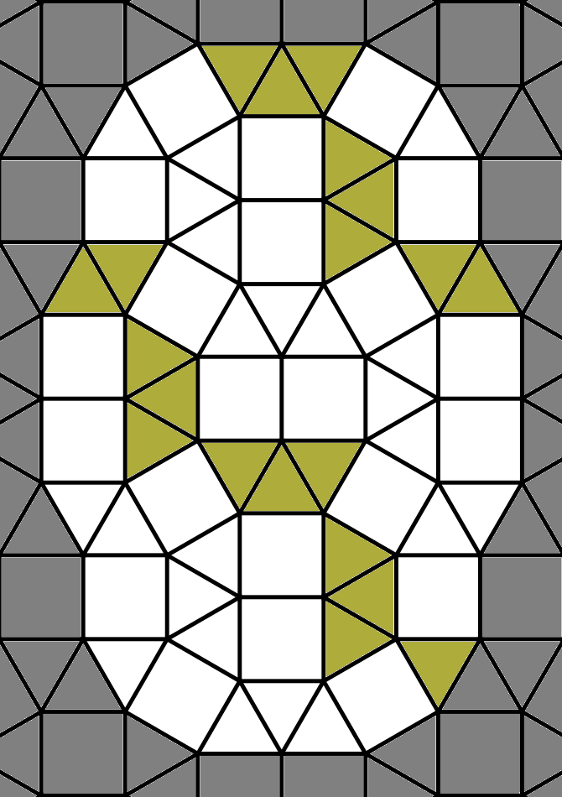
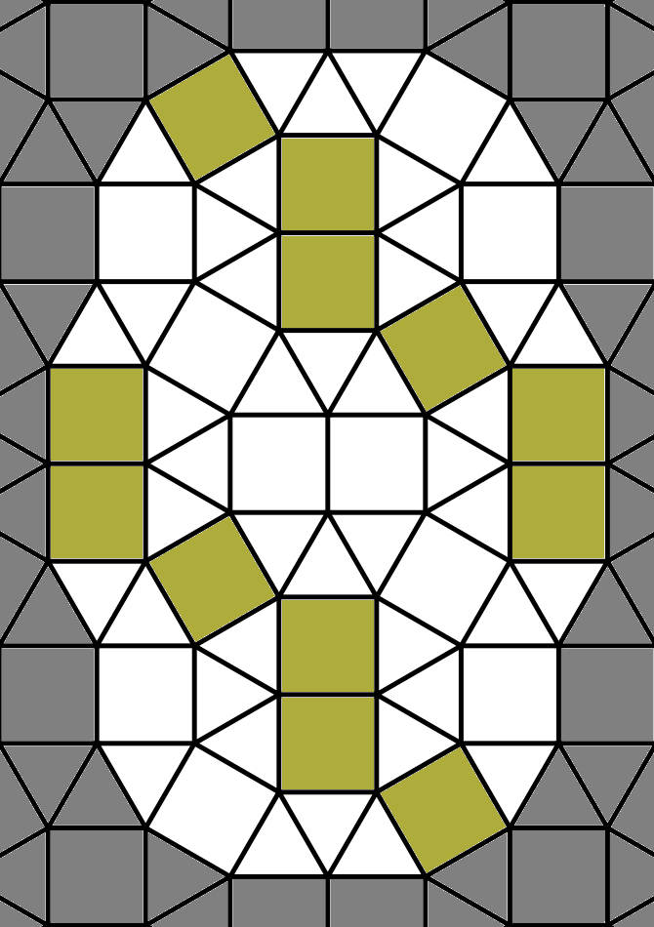
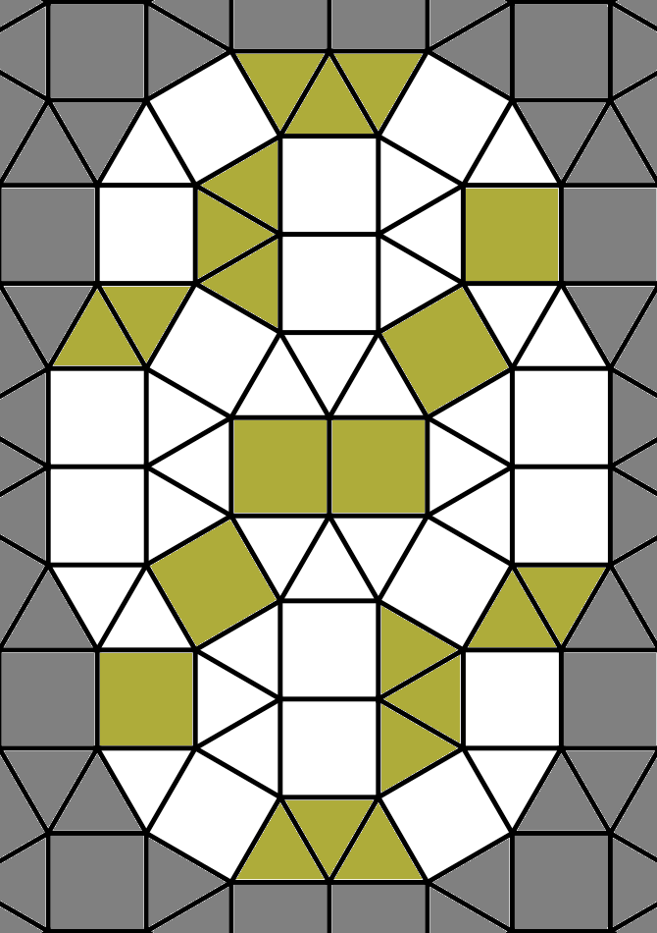
- If on a square and making a NW move, if there is a square which shares an edge to the north or west, go to that square.
- If on a square and making a NW move, if there is no square which shares an edge to the north nor east, go to the sqaure one shares a corner with to the northwest of the origin square.

NE:

- If on a triangle and making a NE move, if there is a triangle sharing an edge to the north or east, go to the triangle.
- If on a triangle and making a NE move, and there is no triangle sharing an edge to the north nor east, go to a triangle one shares a corner with to the northeast of the origin triangle that shares only one edge with another triangle.
- If on a square and making a NE move, if there is a square which shares an edge to the north or east, go to that square.
- If on a square and making a NE move, if there is no square which shares an edge to the north nor east, go to the sqaure one shares a corner with to the northeast of the origin square.

SW:

- If on a triangle and making a SW move, if there is a triangle sharing an edge to the south or west, go to the triangle.
- If on a triangle and making a SW move, and there is no triangle sharing an edge to the south nor west, go to a triangle one shares a corner with to the southeast of the origin triangle that shares only one edge with another triangle.
- If on a square and making a SW move, if there is a square which shares an edge to the south or west, go to that square.
- If on a square and making a SW move, if there is no square which shares an edge to the south nor east, go to the sqaure one shares a corner with to the southwest of the origin square.

SE:

- If on a triangle and making a SE move, if there is a triangle sharing an edge to the south or east, go to the triangle.
- If on a triangle and making a SE move, and there is no triangle sharing an edge to the south nor east, go to a triangle one shares a corner with to the southeast of the origin triangle that shares only one edge with another triangle.
- If on a square and making a SE move, if there is a square which shares an edge to the south or east, go to that square.
- If on a square and making a SE move, if there is no square which shares an edge to the south nor east, go to the sqaure one shares a corner with to the southeast of the origin square.

To clarify with triangles:

- If the origin triangle shares two edges with other triangles, the destination square will be a triangle one shares an edge with.
- The destination square, when moving across a diagonal corner instead of across an edge, will always be a triangle which only shares one edge with another triangle.

The result of this is that diagonal moves will be on a jagged path, alternating between moving straight along a clump of two squares or three triangles, then moving diagonally from one group of cells to another group.

Circular paths
Looking at the Turtle Shell Chess board, one may see paths that bend on themselves, resulting in circular paths on the board. First, there are four complete horizontal circular paths on the board, as well as four truncated (incomplete) horizontal circular paths.
One piece we can have is the horizontal circle mover which can move either as a guard, or clockwise along the horizontal circular paths, or counter-clockwise along the horizontal circular paths.

In addition to the horizontal circular paths—paths which are more wide than tall—there are vertical paths, which are more tall than wide. There are a number of possible vertical circular paths on the board, all but two of which are truncated.

This leads to the vertical circle mover which can move either as a guard, or clockwise along the vertical circular paths, or counter-clockwise along the vertical circular paths.

Below are images of the circular paths:

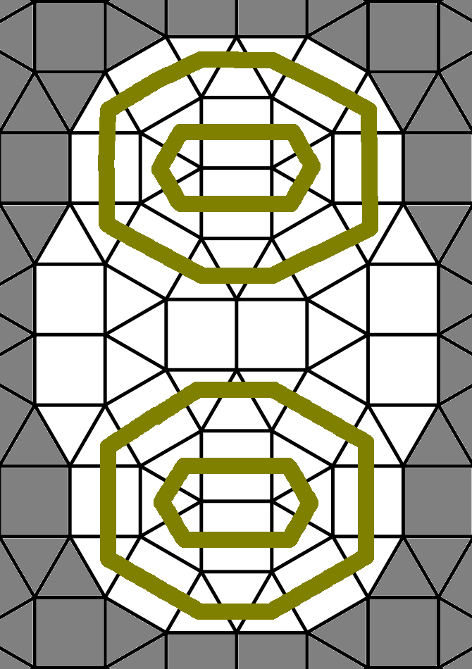  Horizontal circular paths | 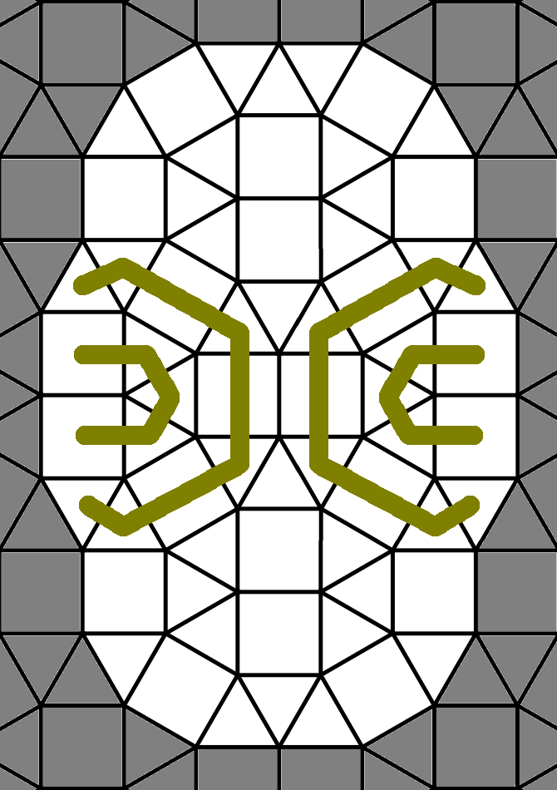Truncated horizontal circular paths
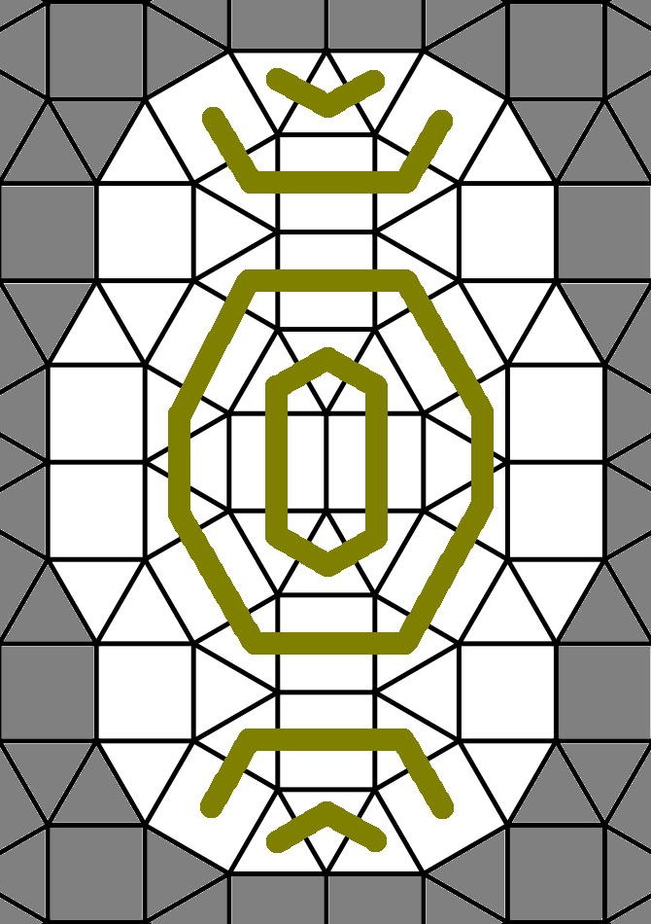  Vertical circular paths, mostly truncated | 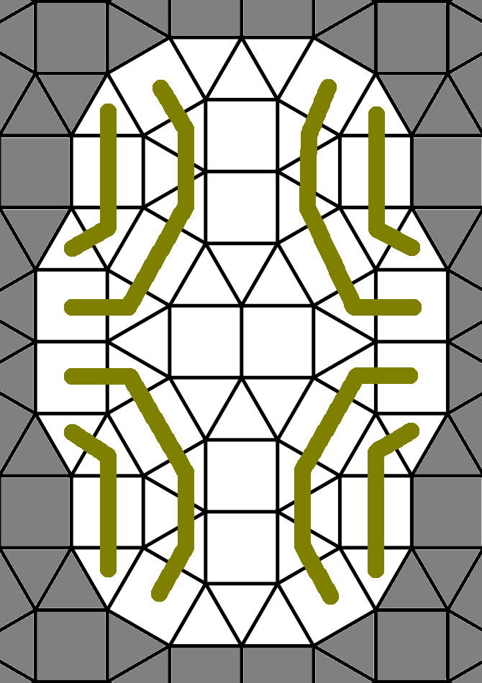  More vertical circular paths

