Storyboard – Booking

Home Page: https://samboy2002.github.io/ISCG6420-P1/index.html

# Sequence 1 – Enter Personal Details

(Date-picker, Radio buttons, Number-box)

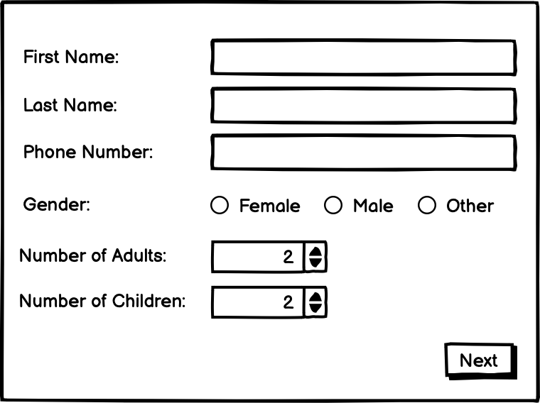

Customers start booking a room from their details and the number of people staying at the hotel.

# Sequence 2 – Enter Trip Details

(Range, Dropdown box, Radio buttons)

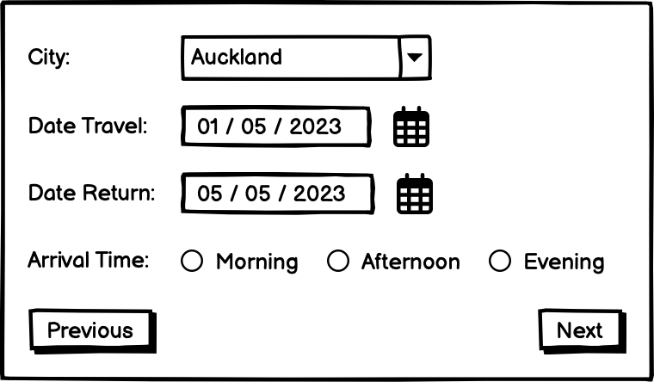

Customers enter the city they are from and choose the check-in date, check-out date, and the time they arrive at the hotel.

# Sequence 3 – Enter Accommodation Details

(Color-picker, Number box, Range)

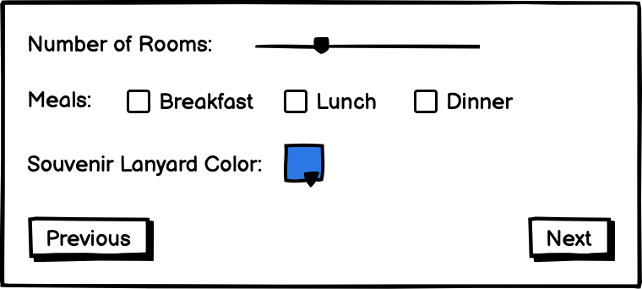

Customers choose the number of rooms they book, check the meals they need, and choose a color for the souvenir lanyard they received from the hotel.

# Sequence 4 – Preview Details

(Email, Checkboxes)

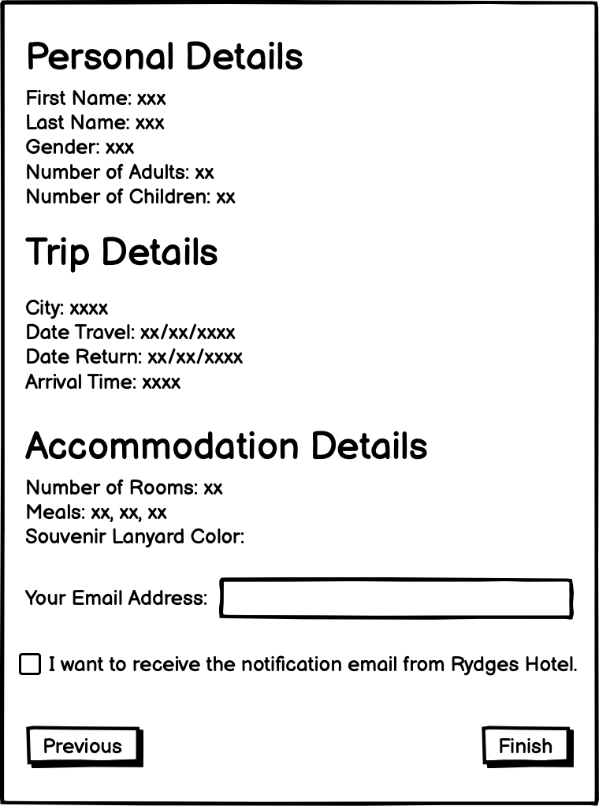

Customers check that all information is correct and enter their email addresses.

Customers will confirm if they receive the notification email from the hotel.