Wakatipu Boat Adventure

# The Basic Layout of the Page

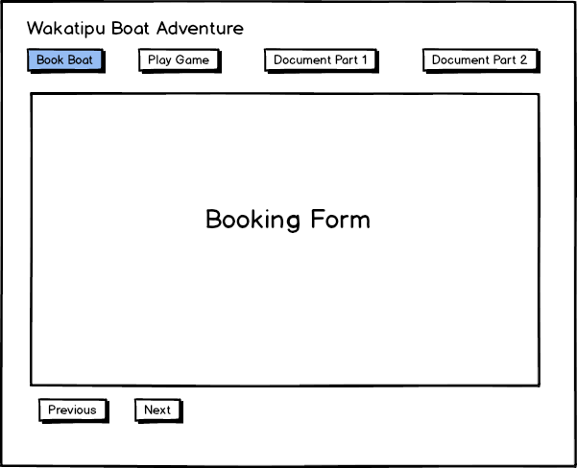This website provides a wizard page for users to book seats and meals when they want to join this adventure on the boat.

The home page will be displayed if the user clicks the ‘Book Boat’ button at the top.

Navigation buttons on the top can lead the user to different pages on the website.

The ‘Previous’ and ‘Next’ buttons can swap pages between the wizard of booking.

# The First Step of Booking: Basic Information Page

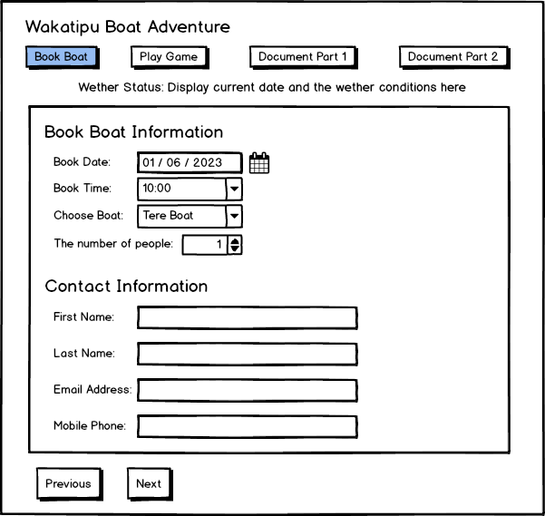As a user who wants to book the adventure, they will enter the detailed information on the first page, which includes the two parts of the booking form.

The current date and weather conditions are displayed under the navigation buttons.

The details of a booking include the fields below:

* Book Date – a date picker that can choose a date to book the adventure, which can be chosen in 4 days.
* Book Time – a combo box that can select the time of booking and can be chosen between 10 am and 2 pm.
* Choose Boat – a combo box that allows the user to choose a boat.
* The number of people – a number picker that allows the user to enter the number of people who want to enjoy this adventure.

In addition, user muse leaves their contact information at the first step, which includes:

* First Name – the first name of the user
* Last Name – the last name of the user
* Email Address – user’s email address will be used to receive notifications about this adventure.
* Mobile Phone – user’s mobile number, which will be used to contact the user if needed.

All the information will be saved in memory after the user clicks the ‘Next’ button that will be used in the following steps.

The ‘Previous’ button is disabled on the page because this page is the first step of booking.

# The Second Step of Booking: Choosing Seat on A Boat

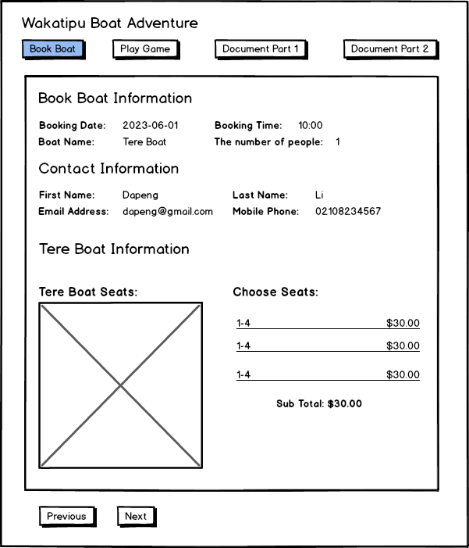The booking and contact information will be displayed at the top of the page.

At this step, the user will choose their seats on the boat they chose in the previous step.

If the user chooses a seat on the boat's layout, the seat number and price will be displayed on the bottom right of the page. As well as the subtotal will also be displayed there.

The price of each seat is different. The first two rows are $30.00, the following three are $25.00, and the rest seats are $20.00. The subtotal will be calculated dynamically based on the seats the user selects.

All seats will be filled in different colors to presentative different meanings. Green means the seat is available for the user. Blue is that seats have been chosen by other users, which means those seats are unavailable for the current user. Dark red means the seats have been chosen by the current user, who cannot choose repeatedly.

Light red is selected seats by the current user so that all light red seats will be displayed on the bottom right of the page. If the user clicks the light red seat, the seat will be back to green and removed from the choose seat list. Furthermore, the subtotal will be calculated again.

All seats the user selected will be saved in memory if the user clicks the ‘Next’ button that will be used in the following steps.

If the user clicks the ‘Previous’ button, the wizard page will return to the basic information page, where the user can modify their information.

# The Third Step of Booking: Order Meals

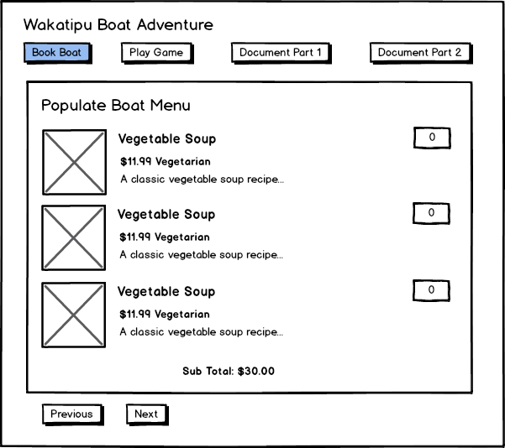After choosing seats, the user can order meals on the third step page.

Each item on the menu includes a name, price, category, and description that briefly introduces the features of the meal.

The user can enter a number for each item. The subtotal will be displayed following the menu and calculated when the user changes the number of a meal.

All meals are divided into three categories: Vegetable, Egg Free, and Gluten Free.

If the user clicks the ‘Previous’ button, the wizard page will return to the choosing seat page, where the user can change their selected seats.

# The Fourth Step of Booking: Order Confirmation

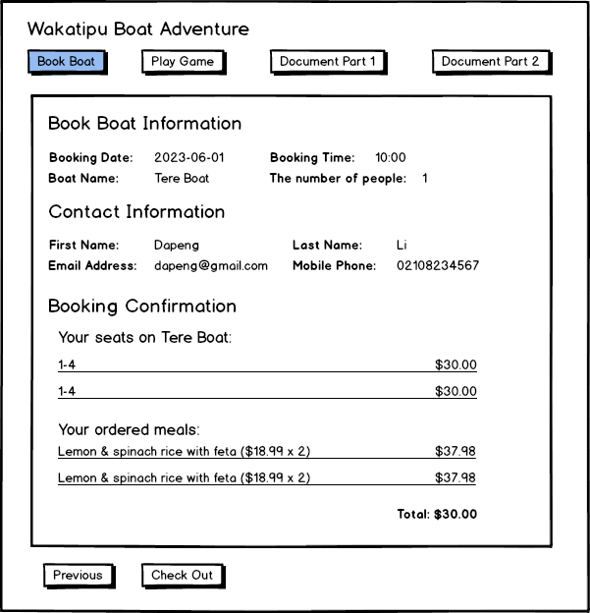

This page allows the user to confirm their order.

All information about the order will be displayed on the page, which includes booking information, contact information, selected seats, and ordered meals.

The total amount will be displayed at the bottom, which is the total cost of the adventure the user will pay.

If the user clicks the ‘Previous’ button, the wizard page will return to the ‘Order Meals’ page, where the user can change their meals.

If the user clicks the ‘Check-Out’ button, the order will be confirmed and does not allow to change.

# The Final Step of Booking: Booking Successful.

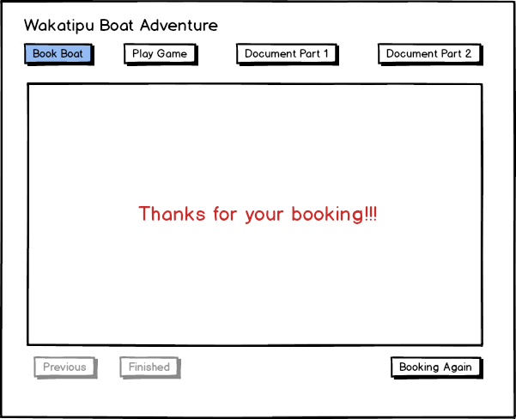When the user clicks the ‘Check-Out’ button, the success message will be displayed on the page, and the ‘Previous’ and ‘Check-Out’ buttons will be disabled.

The ‘Booking Again’ button will appear at the page's bottom right corner, allowing the user to book additional adventures.

The data for this booking will be stored in memory. If the user books another adventure with the same boat and the same date, all seats in this booking are unavailable.