Catch A Bugs Game

# Basic Screen Layout

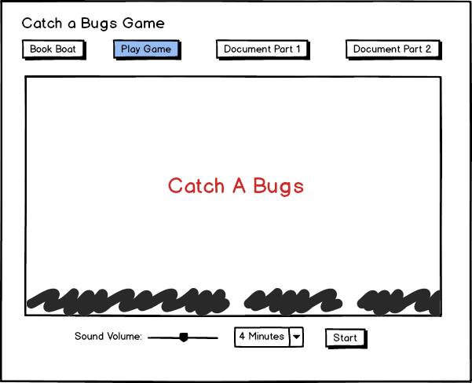

A canvas, the play area, is located at the center of the screen, and the game title is displayed at the center of the canvas.

At the bottom of the page, the game controls are displayed. A slider control can set the volume of the game’s sound. Users can select the duration they want to play the game from the combo box control and start it when they click the ‘Start’ button.

# Game Running

The title and the ‘Start’ button will disappear when the game starts running. The ‘Pause’ button will be displayed at the bottom of the page, which can pause the game when the user clicks it.

Mr. X will be displayed on the canvas, and several bugs will appear. Mr. X's movement is controlled using the keyboard arrow keys (left and right). The catch net is controlled using the space key. If a bug flies in the catch net and the space key is pressed, the bug will be caught and disappear.

The score and timer are displayed at the top of the canvas. The score will increase if Mr. X catches a bug and decrease if a bug touches Mr. X. The timer will reduce from the user's selected duration to zero. The game will end if the time is zero.

# Game Paused

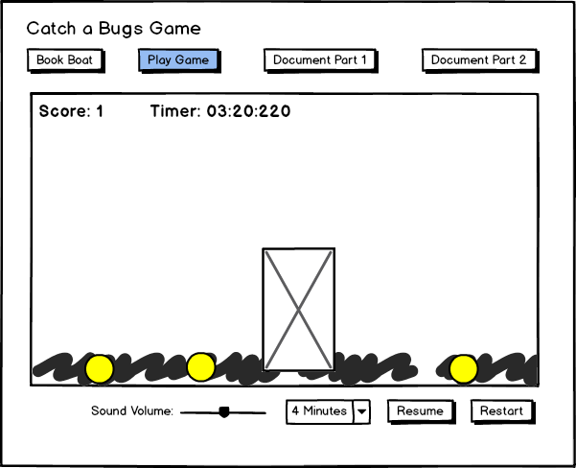The game will be paused if the user clicks the ‘Pause’ button during the game running.

Mr. X does not be moved, and all bugs will stop moving. The timer will stop.

The ‘Pause’ button will disappear, and the ‘Resume’ and ‘Restart’ buttons will appear.

The game will continue if the user clicks the ‘Resume’ button.

The game will restart if the user clicks the ‘Restart’ button, which means the game time can be reset to the user’s selected time length, and the score will be reset to zero.

# Bug’s Life Cycle

1. The bugs will appear at the bottom of the page and grow up in 5 seconds.
2. Bug’s color changes from yellow to red in 3 seconds.
3. The red bugs stay at the bottom for 4 seconds, then fly across the play area for 6 seconds.
4. A bug will disappear if Mr. X catches it.
5. A bug will disappear if it touches Mr. X.
6. A bug will disappear if it flies out of the play area.

# Game Sounds

1. A sound will play when the game starts to play.
2. A happy sound will play when a bug is caught.
3. A sad sound will play when a bug touches Mr. X.
4. A sound will play when the timer is over.