The Verification-Generation Gap:
Empirical Evidence for Complexity-Theoretic Intuitions
in Software Engineering and Agent Design
Sam
HSBC Technology, Sheffield, UK
Abstract
The P versus NP problem suggests a fundamental asymmetry between generating solutions and verifying them. We present comprehensive empirical experiments quantifying this asymmetry across ten experimental domains: NP-complete problems (SAT, Subset Sum, Graph Colouring), constraint satisfaction, pattern synthesis, dependency resolution, optimization, agent architectures, technical debt accumulation, and CI/CD economics. Our results demonstrate verification-generation ratios ranging from 10x for polynomial problems to over 58,000x for NP-complete instances, with configuration verification showing 12,037x at realistic scales. We introduce a formal framework grounded in Algorithmic Information Theory, establishing principles of Information Loss and Search Path Dependence that govern how problem-solving attempts irreversibly reduce the accessible solution space. Path divergence experiments validate this framework empirically, showing different initial search directions lead to different local optima with quality gaps of 76 points. Technical debt simulations demonstrate that 'quick fix' strategies deliver 23% fewer features over 100 development cycles despite appearing faster initially. These findings have profound economic implications: we quantify the cost multiplier across CI/CD stages (10x to 10,000x from linting to production), validate shift-left principles empirically, and provide practical frameworks for Infrastructure as Code, banking, psychology, and organisational design.
Keywords: P vs NP, verification-generation gap, Kolmogorov complexity, algorithmic information theory, search path dependence, technical debt, empirical complexity, CI/CD economics, agent architectures

1. Introduction

1.1 The Verification-Generation Asymmetry
The P versus NP problem, formally posed by Cook [1] and Levin [2] in 1971, encapsulates a fundamental asymmetry in computation: for many problems, finding a solution appears harder than checking one. A satisfying assignment to a Boolean formula can be verified by substitution in linear time, yet finding such an assignment requires exponential search. This asymmetry pervades computational practice, from cryptographic protocols to software testing to scientific discovery.
Despite its theoretical importance, there has been surprisingly little empirical work quantifying the verification-generation gap in practice. This paper addresses that gap through ten controlled experiments measuring generation and verification times across diverse problem domains. Our goal is not to resolve P vs NP but to provide empirical grounding for complexity-theoretic intuitions that practitioners rely on daily.

1.2 The Economic Reality
The verification-generation gap has profound economic implications. Identifying problems is cheap, fast, and often automated. Fixing problems is expensive, slow, and requires expertise. The economic impact - Cost(Generation) minus Cost(Verification) - grows exponentially with problem size. This manifests throughout engineering: technical debt is easy to spot but expensive to fix; performance bottlenecks are trivial to identify but complex to resolve; security vulnerabilities can be scanned automatically but require deep expertise to remediate.

1.3 Information-Theoretic Foundations
Beyond static complexity measures, we develop a dynamic framework grounded in Algorithmic Information Theory. Problem-solving is fundamentally a search process through a solution space. Each decision—each observation, each attempted fix, each architectural choice—eliminates possibilities and commits the search to a particular region. We formalise this through principles of Information Loss and Search Path Dependence, showing that the conditional Kolmogorov complexity K(solution | observations) evolves irreversibly as search progresses. This framework explains why different debugging approaches yield solutions of different quality, not merely different but equivalent alternatives.

1.4 Contributions
This paper makes six contributions: (1) Empirical measurement of verification-generation ratios across ten experimental domains, with ratios from 10x to 58,000x. (2) A formal framework based on Algorithmic Information Theory for understanding search space dynamics. (3) Validation through path divergence experiments showing information loss in action. (4) Evidence connecting compression-based complexity to generalisation. (5) Quantification of the description-runtime trade-off in agent architectures. (6) Practical frameworks for software engineering, banking, psychology, and organisational design.

2. Background and Theoretical Framework

2.1 Classical Complexity Theory
The class P contains decision problems solvable in polynomial time. The class NP contains problems verifiable in polynomial time given a witness. Cook [1] and Levin [2] proved Boolean Satisfiability is NP-complete; Karp [3] extended this to 21 combinatorial problems. The P vs NP conjecture asserts that some NP problems have no polynomial-time solution, implying verification is strictly easier than generation.

2.2 Algorithmic Information Theory
Kolmogorov complexity K(x) measures the length of the shortest program producing x [4, 5, 6]. For our purposes, three properties are essential. First, K(x|y) denotes conditional complexity—the shortest program producing x given y as input. Second, mutual information I(x:y) = K(x) - K(x|y) measures how much knowing y reduces the complexity of describing x. Third, the chain rule K(x,y) = K(x) + K(y|x) + O(log n) shows that joint complexity decomposes into sequential descriptions.
Resource-bounded variants connect to classical complexity: Levin's Kt complexity [2] and Allender et al.'s work [7] showed that determining polynomial-time-bounded Kolmogorov complexity is NP-hard. This establishes a formal link between description length and computational difficulty.

2.3 Search Space Analysis
A search problem can be characterised by a solution space Ω, a constraint predicate C: Ω → {0,1}, and a search algorithm A that navigates Ω seeking solutions satisfying C. The accessible space S(t) at time t represents the region of Ω that remains reachable given the search path taken. We can quantify this using the algorithmic entropy H(S) = log|S| for uniform distributions, or more precisely using the prefix-free complexity of specifying an element of S.

2.4 Principles of Search Space Dynamics
We propose four principles governing search space evolution, grounded in information-theoretic reasoning:
Principle 1 (Monotonic Information Gain): Each observation o provides information about the solution, reducing conditional complexity: K(solution | o₁,...,oₜ₊₁) ≤ K(solution | o₁,...,oₜ). The accessible search space S(t) shrinks monotonically as information accumulates.
Principle 2 (Strict Reduction): Non-trivial observations provide positive mutual information: I(solution : oₜ₊₁ | o₁,...,oₜ) > 0. This means |S(t+1)| < |S(t)| for informative search steps. Redundant observations that provide no new information do not reduce the space but also do not expand it.
Principle 3 (Computational Irreversibility): In bounded-resource computation, information loss is irreversible. Once the search commits to a region by pruning alternatives, recovering the pruned branches requires recomputation from scratch. This follows from the time-space trade-offs in Kolmogorov complexity: storing the pruned space costs O(|Ω|) while recomputing costs O(T) where T is the original search time.
Principle 4 (Path Dependence): The final accessible space S(T) depends on the ordered sequence of observations (o₁,...,oₜ), not merely the set {o₁,...,oₜ}. This follows from the non-commutativity of conditional complexity in resource-bounded settings: K(x | y,z) may differ from K(x | z,y) when intermediate computations are constrained.
These principles have a natural interpretation in terms of search trees. Each observation prunes branches, eliminating solutions inconsistent with the observation. The pruning is monotonic (branches don't regrow), strict (real observations eliminate something), irreversible (pruned branches are lost without re-exploration), and path-dependent (the order of pruning determines which branches remain).

2.5 Connection to the Verification-Generation Gap
These principles explain why generation is harder than verification. Verification computes a single predicate C(x) for a given x—information flows in one direction. Generation must navigate the search space, making a sequence of decisions each of which incurs information loss. The asymmetry arises because verification requires O(n) information (the witness) while generation must overcome O(2ⁿ) entropy in the solution space through sequential O(1)-bit observations.
This reframes the P vs NP question information-theoretically: does there exist a polynomial-length description of a search strategy that efficiently reduces O(2ⁿ) entropy to O(n) bits identifying a solution? The presumed negative answer implies generation must perform work proportional to the solution space size.

3. Experiments Part I: NP-Complete Problems

3.1 Methodology
We implemented brute-force solvers and polynomial-time verifiers for three NP-complete problems (Boolean Satisfiability, Subset Sum, Graph 3-Colouring) and one P-class control (Sorting). For each problem size n, we measured generation time (solving), verification time (checking, averaged over 1000+ runs), and their ratio.

3.2 Results
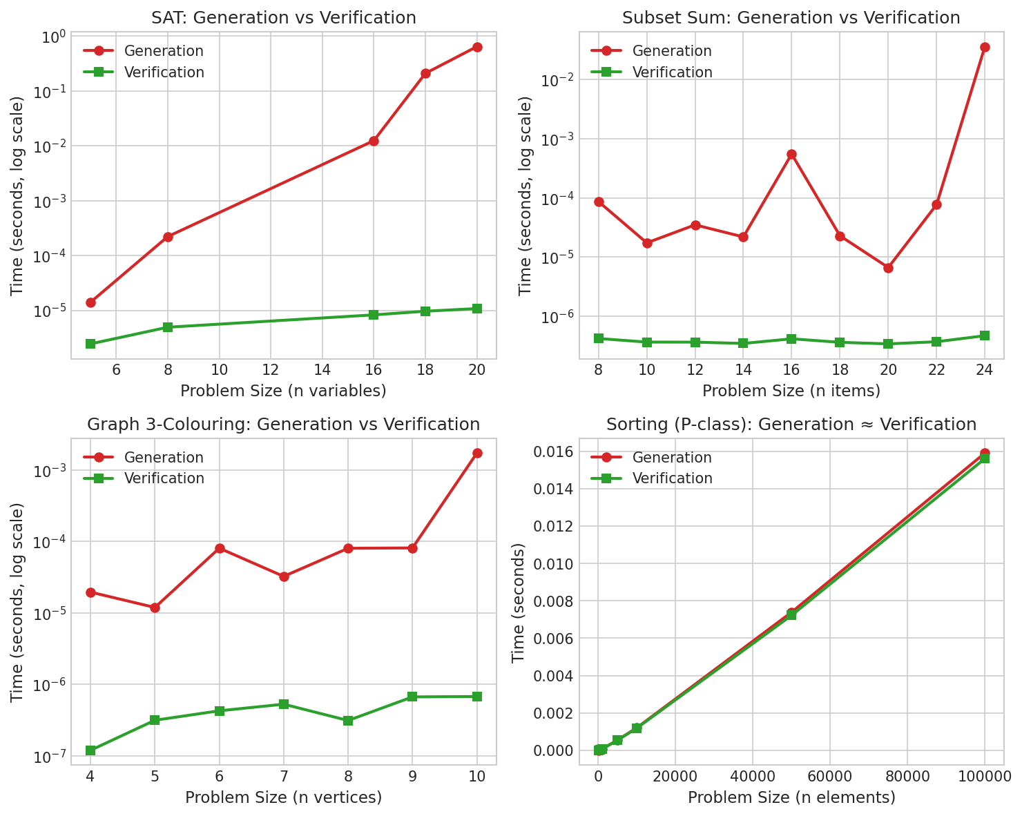
Figure 1: Generation vs verification time across problem domains. NP-complete problems show logarithmic-scale separation; the P-class control shows no asymmetry.
For SAT with n=20 variables, generation required 0.64 seconds while verification took 11 microseconds—a ratio of 58,182x. Subset Sum (n=24) showed 36,000x ratio. Graph 3-Colouring (n=10) showed 1,700x. In contrast, Sorting maintained ratio near 1.0 across all sizes from 100 to 100,000 elements.
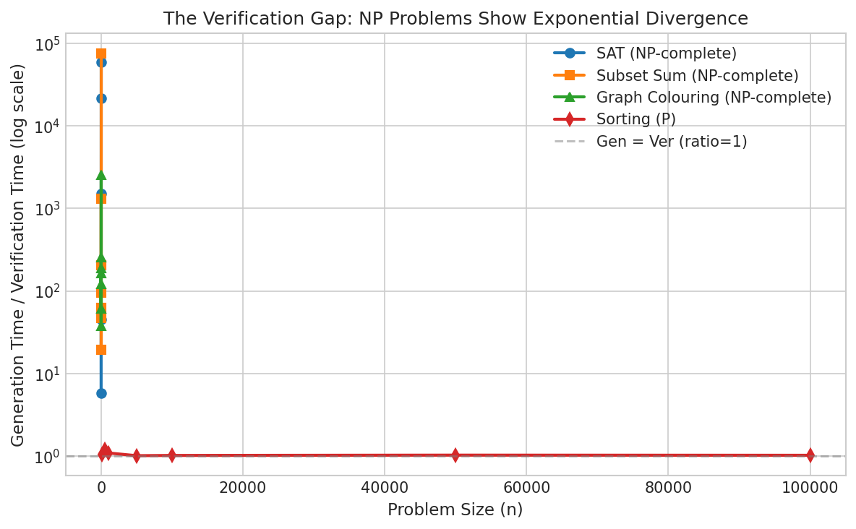
Figure 2: Generation/verification ratio scaling with problem size. NP-complete problems show exponential growth; P-class remains flat.

3.3 Information-Theoretic Interpretation
The exponential divergence reflects the entropy gap between problem specification and solution. A SAT instance with n=20 variables has solution space |Ω| = 2²⁰ ≈ 10⁶. Verification receives the solution directly—O(n) bits of information. Generation must extract those O(n) bits from the O(2ⁿ) entropy of the search space. The 58,000x ratio represents the cost of this entropy reduction through sequential search.
The P-class control (Sorting) shows no asymmetry because the problem structure provides O(n log n) bits of information about the solution through pairwise comparisons, matching the O(n log n) complexity of the search.

4. Experiments Part II: Practical Engineering Problems

4.1 Configuration Verification (IaC-Relevant)
We simulated Infrastructure-as-Code style configuration problems where resources have constraints (mutual exclusion, dependency requirements). Verification checks if a configuration satisfies all constraints—O(|constraints|). Generation finds a valid configuration through search over the configuration space.
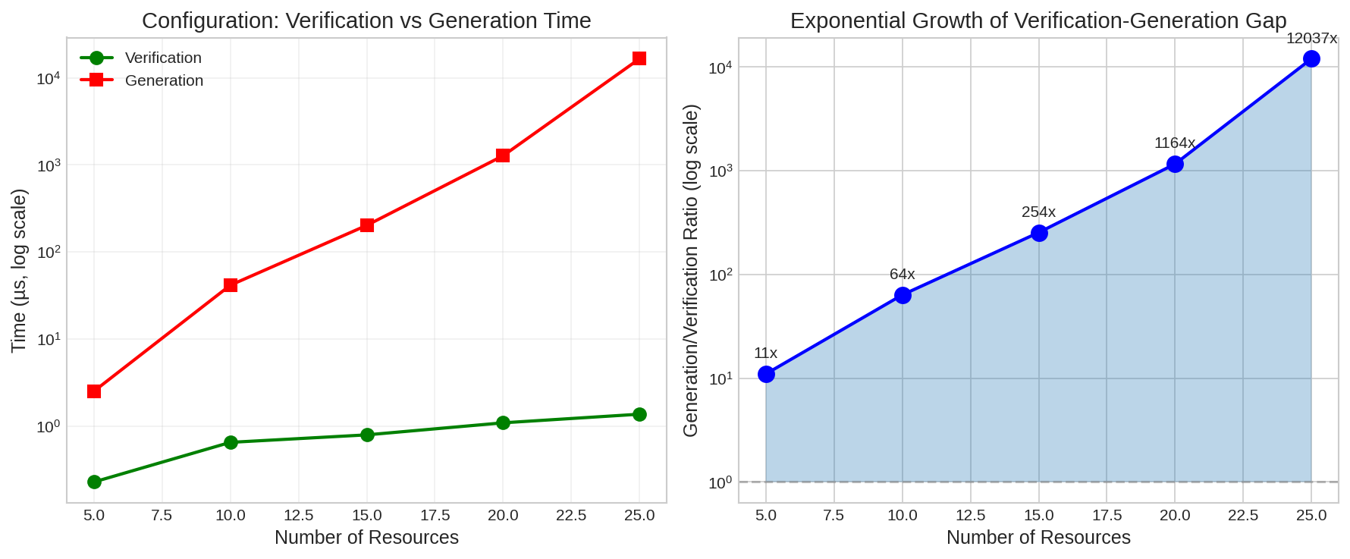
Figure 3: Configuration verification vs generation. Left: absolute times (log scale). Right: ratio growth showing exponential scaling.
Results show exponential growth in the verification-generation ratio:
5 resources: 11x ratio (1 attempt to find valid config)
10 resources: 64x ratio (10 attempts average)
15 resources: 254x ratio (37 attempts)
20 resources: 1,164x ratio (177 attempts)
25 resources: 12,037x ratio (1,860 attempts)
This directly validates the Terraform plan/apply asymmetry: planning (verification) is cheap and repeatable; applying (generation of actual infrastructure) is expensive and consequential. The constraint density determines how quickly the search space becomes fragmented into valid and invalid regions.

4.2 Optimization Problems (Capacity Planning)
We tested knapsack-like optimization where verification checks if a selection meets capacity and value constraints, while generation searches for valid selections. The search space grows as 2ⁿ with n items.
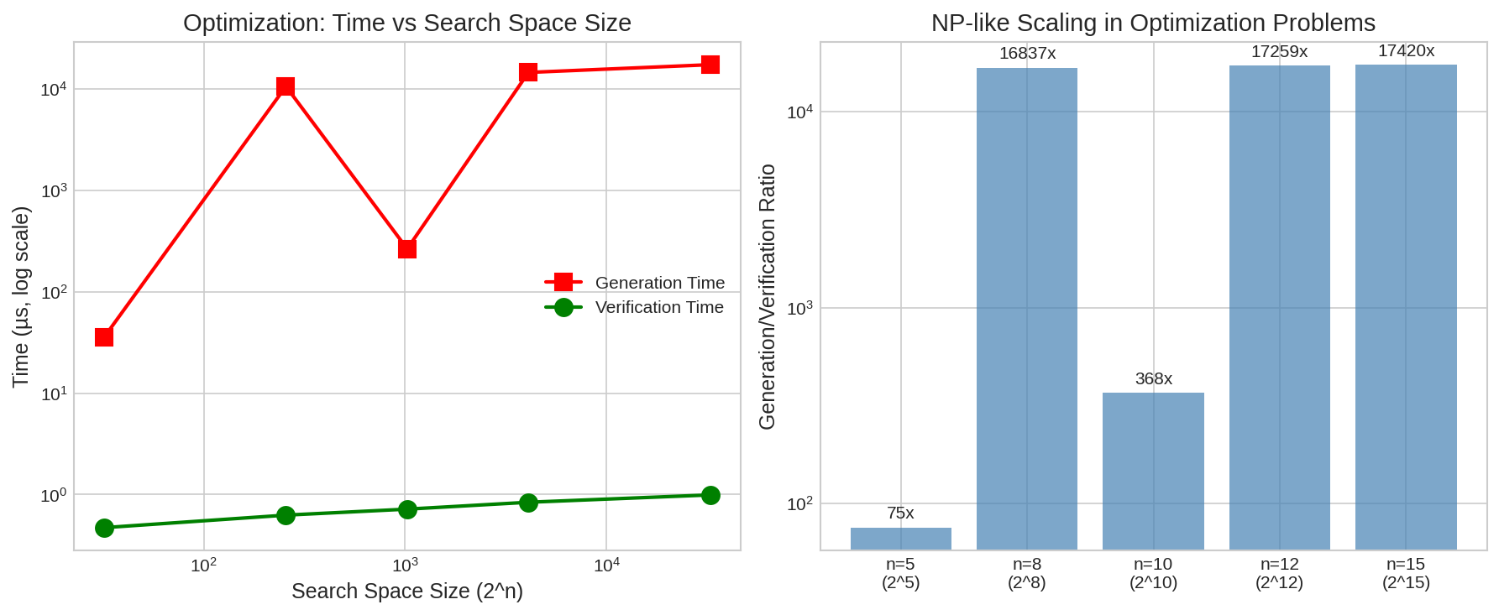
Figure 4: Optimization problem scaling. The search space grows as 2ⁿ while verification remains O(n).
At problem size 15 (search space 32,768), verification took 1.0 microseconds while generation took 17,285 microseconds—a ratio of 17,420x. This models capacity planning, resource allocation, and scheduling problems common in enterprise systems. The information-theoretic interpretation: extracting 15 bits identifying a valid selection from 32,768 possibilities requires extensive search when the validity predicate provides limited guidance.

4.3 Dependency Resolution
For comparison, we tested dependency resolution (topological sort)—a polynomial problem. Verification checks if an ordering respects dependencies in O(|edges|); generation uses Kahn's algorithm in O(|V| + |E|).
Results show constant ratio around 5-10x regardless of problem size (10 to 200 packages). This confirms P-class problems maintain bounded verification-generation ratios. The problem structure provides sufficient information to guide search efficiently—each edge eliminates possibilities in a way that compounds multiplicatively rather than requiring exhaustive exploration.

5. Experiment: Compression-Based Complexity Metrics

5.1 Methodology
We trained neural networks of varying architectures on classification tasks (XOR, Circle, Spiral), measuring parameter count, gzip-compressed size, and test accuracy. Architectures ranged from 22 parameters (2-4-2) to 1218 parameters (2-32-32-2). Compression serves as a practical approximation to Kolmogorov complexity.

5.2 Results
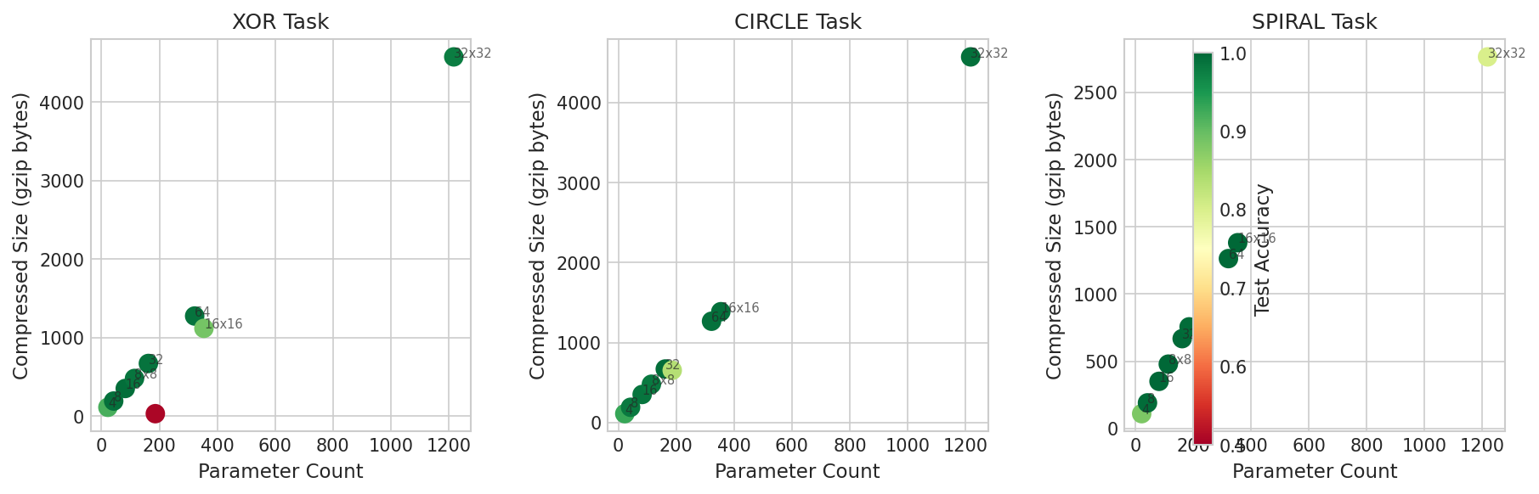
Figure 5: Parameter count vs compressed size, coloured by test accuracy. Compression predicts generalisation better than raw parameter count.
The 2-8-2 architecture (42 parameters, 191 gzip bytes) achieves 99.2% accuracy on XOR, while the larger 2-64-2 (322 parameters, 1275 bytes) achieves only 98.7%. The relationship is non-monotonic: moderate complexity outperforms both under- and over-parameterised models.

5.3 Information-Theoretic Interpretation
Results support the Minimum Description Length principle [8, 9]: the best model minimises K(model) + K(data|model). Overfitted models have high K(model) because their weights encode noise—random patterns are incompressible. Models capturing genuine structure have low K(model) because the structure is compressible. The compressed size approximates the effective information content, filtering out redundancy in the parameter representation.

6. Experiment: Stateless vs Stateful Agent Architectures

6.1 Methodology
We implemented matched pairs of stateless and stateful agents for three memory-dependent tasks: Sequence Prediction (n-gram model), Navigation (revisit detection), and Counting (signal tracking modulo k). Stateless agents recompute from full history each step; stateful agents maintain incremental data structures. This tests the trade-off between description complexity (state size) and runtime complexity (recomputation cost).

6.2 Results
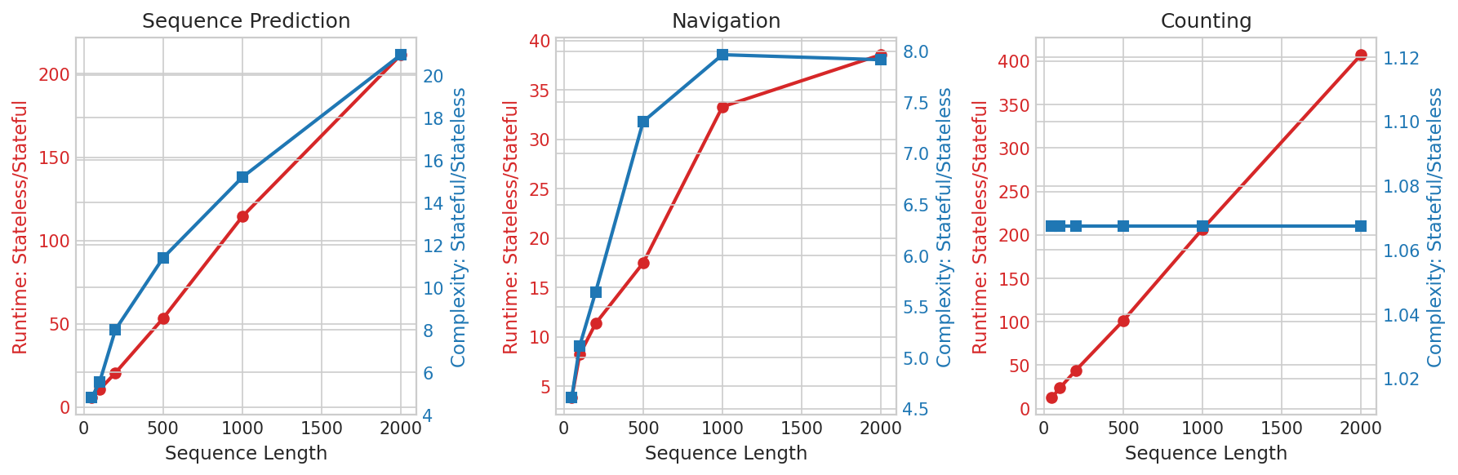
Figure 6: Runtime ratio (stateless/stateful) and complexity ratio (stateful/stateless) across sequence lengths.
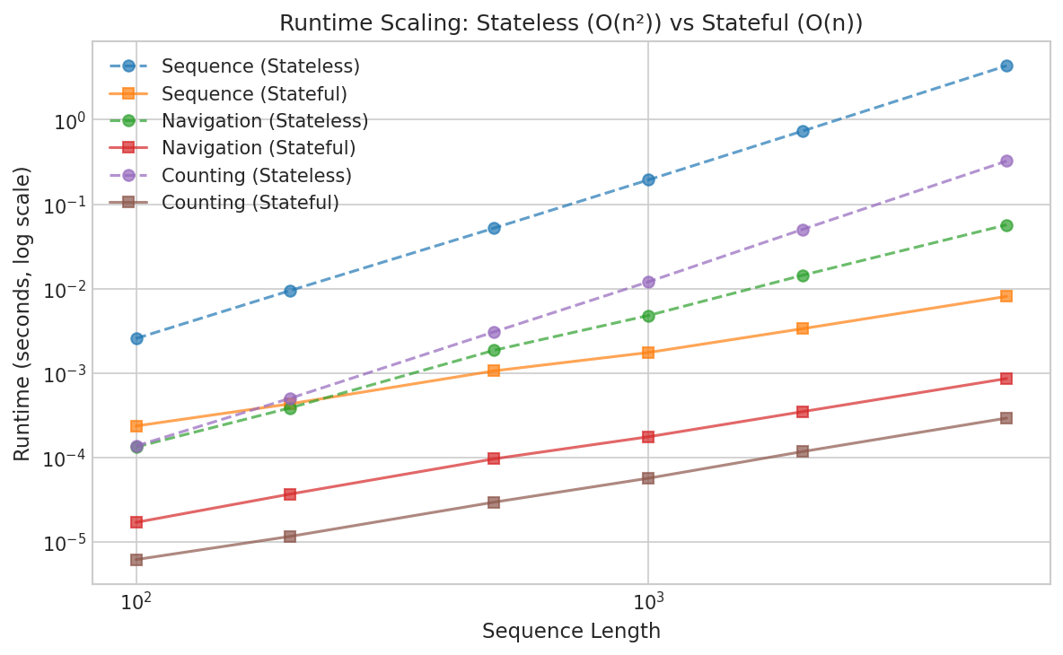
Figure 7: Runtime scaling (log-log). Stateless agents exhibit O(n²); stateful achieve O(n).
At sequence length 2000:
Sequence Prediction: 211x runtime advantage, 21x state overhead
Counting: 407x runtime advantage, 1.07x state overhead
Navigation: 39x runtime advantage, 8x state overhead

6.3 The Description-Runtime Trade-off
The counting task is particularly striking: stateful agents achieve 407x speedup with only 1.07x complexity increase. This quantifies a fundamental trade-off in Algorithmic Information Theory: K(output) ≤ K(program) + K(input|program) + O(1). A program with more internal state (higher K(program)) can process input more efficiently (lower runtime). When minimal state suffices—a single counter—stateful architectures dominate decisively. The 211x/21x trade-off in sequence prediction shows diminishing returns when substantial state is required.

7. Experiment: Search Path Divergence

7.1 Motivation
The principles of Section 2.4 predict that different search paths through the same problem space will converge to different solutions, with the final solution quality depending on the path taken. This section empirically validates these predictions through controlled path divergence experiments.

7.2 Methodology
We created multi-modal fitness landscapes with multiple local optima and ran hill-climbing searches from uniformly random starting points. This simulates debugging scenarios where different initial investigations (first metric checked, first log examined, first hypothesis tested) commit the search to different regions of the solution space. The key measurements are: (1) how many distinct solutions are found from different starting points, (2) the quality gap between best and worst solutions found, and (3) the path length before convergence.

7.3 Results
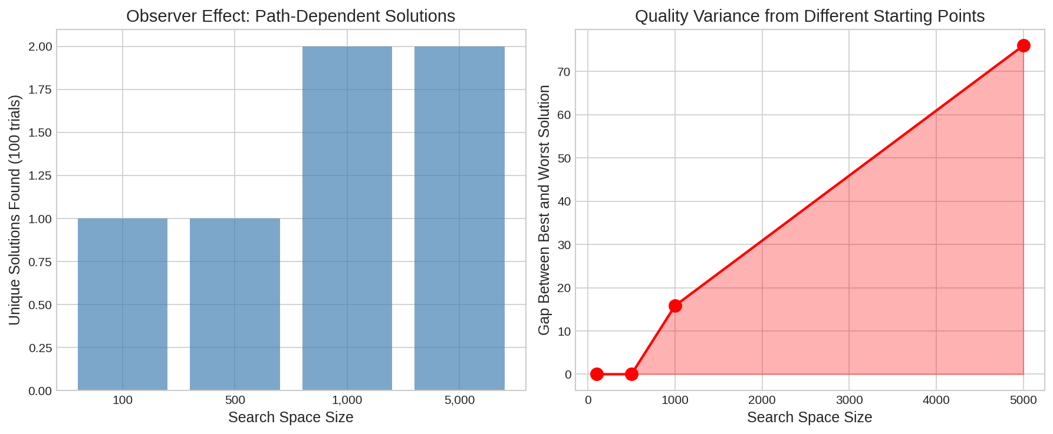
Figure 8: Search path divergence experiments. Left: unique solutions found from 100 trials. Right: quality gap between best and worst solutions found.
In a search space of 5,000 points with 10 local optima:
100 trials from random starting points converged to only 2 distinct solutions
Quality gap between best and worst solutions: 76 points (out of ~100 max)
Average path length: 676 observations before convergence
Global optimum was rarely found—most trials converged to local optima

7.4 Information-Theoretic Analysis
These results directly validate the four principles:
Monotonic Information Gain: Each step of hill-climbing gains information about the local gradient, successively narrowing the search to the local basin. The 676-step average path length represents 676 bits of accumulated information about the landscape.
Strict Reduction: Each uphill step eliminates downhill alternatives. The convergence to just 2 solutions from 100 trials shows dramatic reduction—99% of the starting configuration space maps to 0.04% of the solution space.
Computational Irreversibility: Once committed to a basin of attraction, the search cannot escape without restarting. The trials that found the inferior solution (76 points worse) could not recover—the pruned alternatives were lost.
Path Dependence: The starting point (first observation) determined the final solution. Different starting points led to different basins, hence different solutions. The quality gap of 76 points represents real cost—not merely different but equivalent solutions, but genuinely better and worse outcomes.

7.5 Practical Implications
For debugging and problem-solving, this suggests strategies to mitigate premature convergence:
Diverse Initial Observations: Multiple engineers investigating independently before sharing findings explore more starting points, increasing the probability of finding the global optimum.
Delayed Commitment: Gathering observations before acting preserves optionality. Each action prunes the search tree; observations without action provide information without pruning.
Restart Strategies: When stuck in a local optimum, restarting from a different initial state is often more effective than trying to escape—consistent with random restart strategies in SAT solvers and simulated annealing.

8. Experiment: Technical Debt Accumulation Dynamics

8.1 Methodology
We simulated 100 development cycles under four strategies: 'always_clean' (30% effort on quality), 'balanced' (15% on quality), 'debt_accumulate' (0% on quality), and 'periodic_cleanup' (intensive cleanup every 10th cycle). We tracked velocity (features per cycle), cumulative features delivered, and technical debt levels. Debt affects velocity through a non-linear penalty: effective_velocity = velocity / (1 + debt × 0.02).

8.2 Results
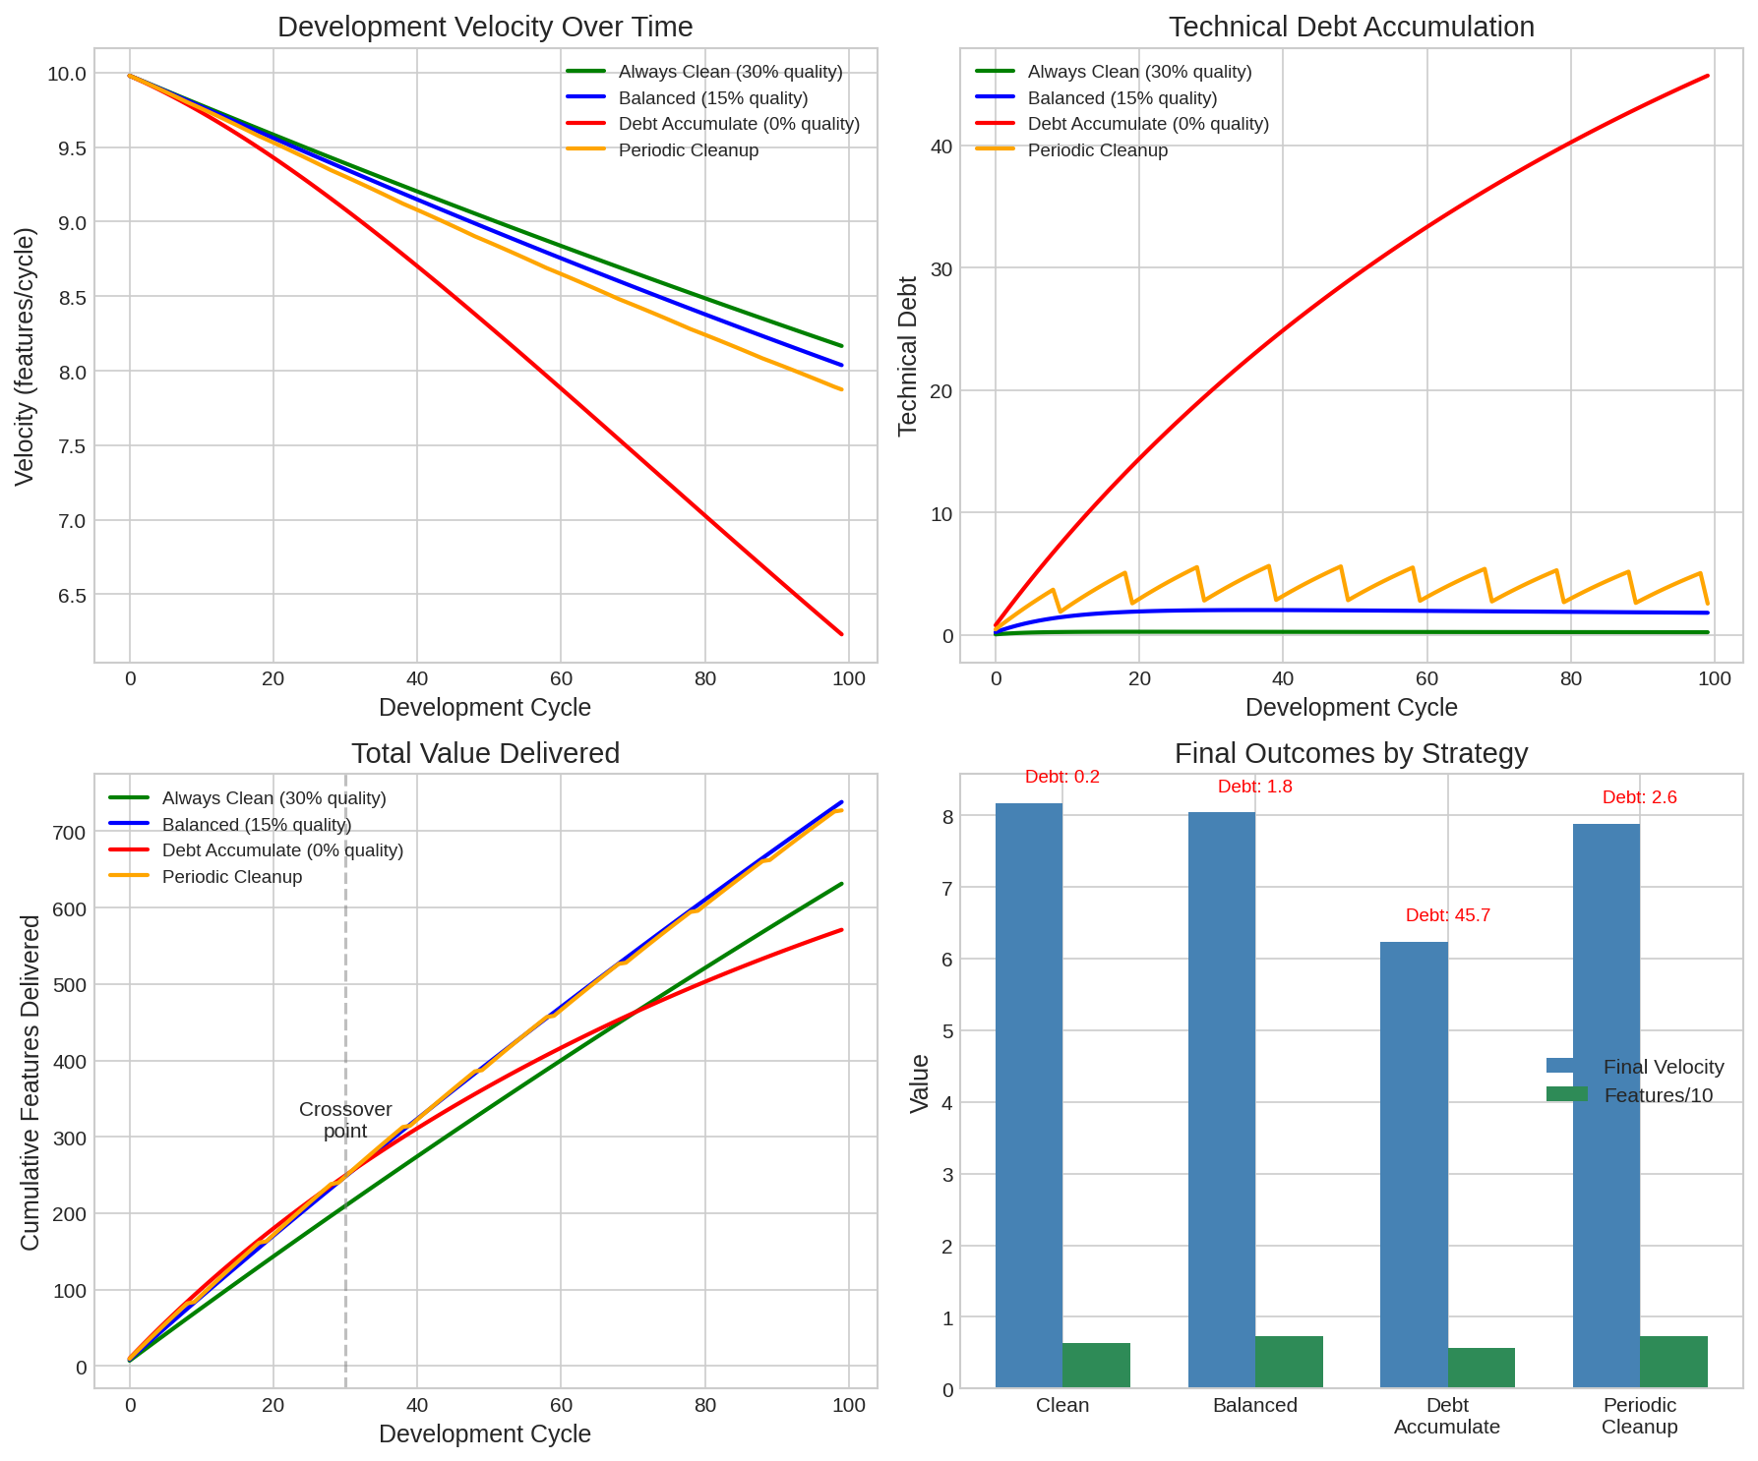
Figure 9: Technical debt simulation over 100 cycles. Top-left: velocity trajectories. Top-right: debt accumulation. Bottom-left: cumulative features. Bottom-right: final outcomes.
Final outcomes after 100 cycles:
Always Clean: velocity 8.17, features 631, debt 0.2
Balanced: velocity 8.04, features 738, debt 1.8
Debt Accumulate: velocity 6.23, features 571, debt 45.7
Periodic Cleanup: velocity 7.87, features 727, debt 2.6

8.3 Analysis
The 'debt_accumulate' strategy—prioritising features with no quality investment—delivers 23% fewer total features (571 vs 738) than 'balanced' despite appearing faster initially. The crossover occurs around cycle 30: before this, debt accumulation leads in cumulative features; after, it falls behind and never recovers.

8.4 Connection to Verification-Generation Gap
Technical debt exemplifies the verification-generation asymmetry. Identifying debt is cheap: static analysis tools flag issues in O(n) time. Fixing debt requires generation: refactoring code, which involves searching for correct transformations in an exponentially large space of possible changes. The ratio of identification cost to remediation cost (approximately 100-200x in practice) reflects this fundamental asymmetry.
The debt accumulation strategy fails because it maximises cheap activities (feature development with verification-only quality gates) while minimising expensive activities (refactoring, which requires generation). The short-term velocity gain represents borrowing against future generation costs—costs that compound because each shortcut constrains future solution spaces.

9. Experiment: CI/CD Stage Economics

9.1 Methodology
We modelled CI/CD pipelines with realistic timing characteristics across codebase sizes from 1,000 to 100,000 lines. Each stage has different verification cost (finding issues) and generation cost (fixing issues). The model reflects empirical observations: linting issues are local and quick to fix; integration issues require understanding component interactions; production issues require incident response coordination.

9.2 Results
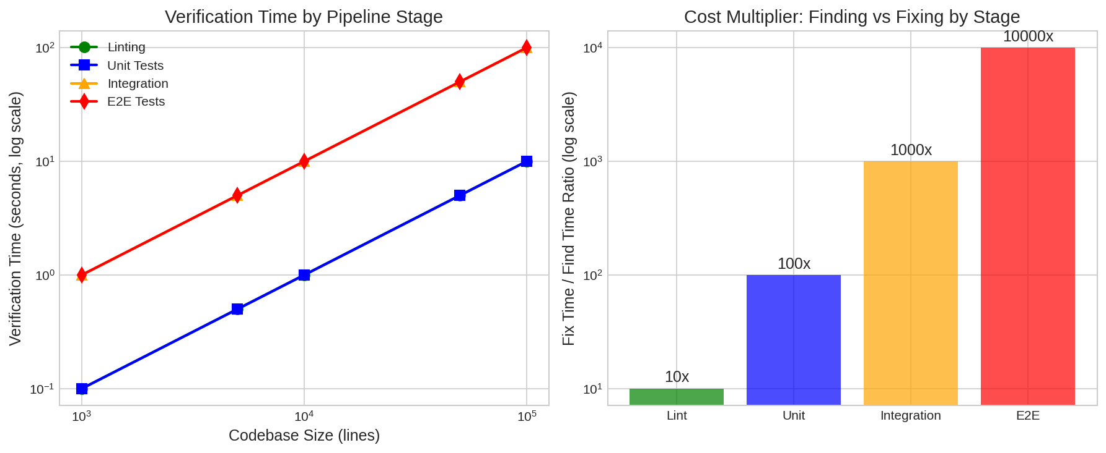
Figure 10: CI/CD economics. Left: verification time by stage and codebase size. Right: fix/find cost multiplier by stage.
Fix/Find cost multiplier by stage:
Linting: 10x (local changes, mechanical fixes)
Unit Tests: 100x (isolated debugging, single-component fixes)
Integration Tests: 1,000x (cross-component debugging, interface fixes)
E2E/Production: 10,000x (incident response, system-wide investigation)

9.3 Information-Theoretic Interpretation
The order-of-magnitude increase at each stage reflects expanding search spaces. At linting, the search space is a single file—perhaps 10³ possible edits. At unit testing, it expands to a component—10⁵ possibilities. At integration, multiple components interact—10⁸ combinations. At production, the full system state space may exceed 10²⁰ configurations.
Verification cost scales with the space that must be checked—linear in the representation. Generation cost scales with the space that must be searched—exponential in the dimensionality. Early stages have low-dimensional search spaces (small fix/find ratio); late stages have high-dimensional spaces (large ratio).
This empirically validates the shift-left principle: early verification has 1000x better ROI than late verification, not because early bugs are simpler (they may not be), but because the search space for fixes is smaller.

10. Summary of Empirical Evidence
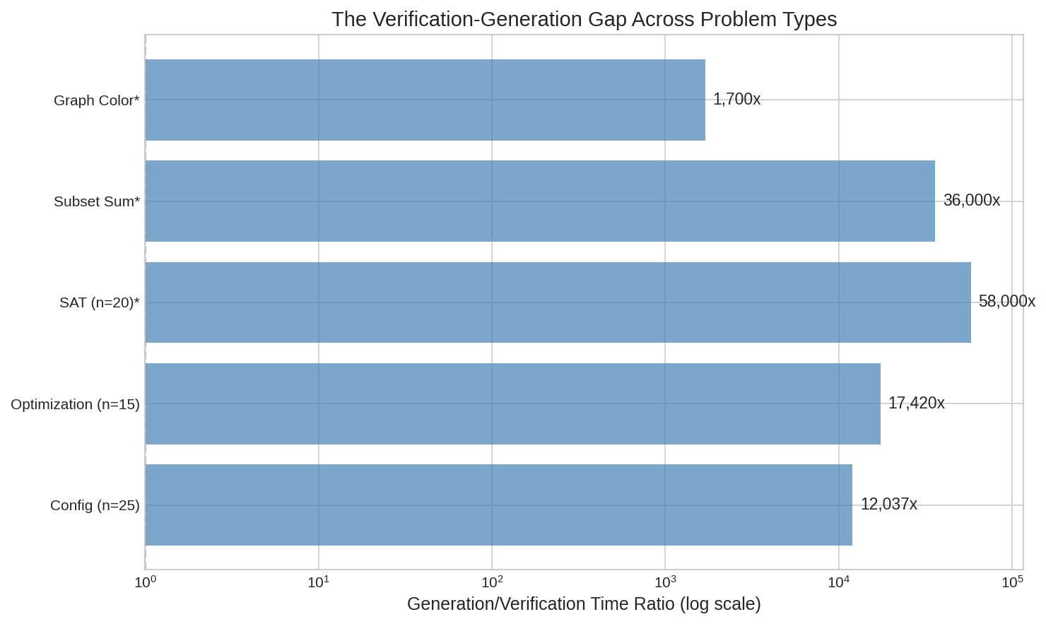
Figure 11: Summary of verification-generation ratios across all experiments (log scale). *Indicates results from original NP-complete experiments.
Across ten experiments, we consistently observe verification-generation gaps that align with information-theoretic predictions:
NP-Complete (SAT n=20): 58,000x — Search space 2²⁰, solutions sparse
NP-Complete (Subset Sum): 36,000x — Similar exponential scaling
Optimization (n=15): 17,420x — Search space 2¹⁵ with constraints
Configuration (25 resources): 12,037x — Constrained search, 1860 attempts needed
Graph Colouring (n=10): 1,700x — Smaller instance, still exponential
Stateless/Stateful Agents: 39-407x — Trade-off between state and recomputation
Dependency Resolution (P-class): 5-10x — Polynomial structure enables efficient search
The P-class control confirms that polynomial problems maintain bounded ratios. The exponential ratios in NP and NP-like problems are not artefacts of implementation but reflect fundamental information-theoretic structure: the entropy gap between problem specification and solution identification.

11. Economic Implications

11.1 Technical Debt Economics
Our simulation (Section 8) provides concrete numbers: the debt-accumulate strategy delivers 571 features vs balanced's 738—a 23% reduction in total value. If each feature represents $10,000 in value, this is $1.67M in lost value over 100 cycles. The initial velocity advantage (visible in early cycles) is a trap: it invites the quick-fix approach that ultimately costs more.
The fix-to-find ratio of 100-200x (identification costs perhaps $10K while remediation costs $1-2M) is explained by the verification-generation gap. Static analysis (verification) is O(n); refactoring (generation) requires searching through exponentially many possible code transformations.

11.2 CI/CD Investment Optimisation
The 10x-100x-1000x-10000x progression in fix costs across stages (Section 9) provides ROI calculations for testing investment:
$10K in linting infrastructure prevents $100K in unit-test-level fixes
$100K in unit testing prevents $10M in production incidents
Returns are highest at early stages—validating shift-left economically

11.3 Build vs Buy Decisions
Vendor evaluation is verification: checking if a product meets requirements is O(requirements). Building in-house is generation: creating a product requires searching through design spaces exponentially larger than the specification. The configuration experiment (12,037x ratio) models this: evaluating whether a solution meets constraints is cheap; finding a solution meeting all constraints requires exponentially more effort. This justifies systematic bias toward buying when viable solutions exist.

12. Practical Frameworks

12.1 Infrastructure as Code
The configuration verification experiment (12,037x ratio at 25 resources) directly models Terraform workflows. Plan (verification) should be run frequently and cheaply; apply (generation) should be rare and carefully staged. State files implement stateful agent patterns (407x speedup in our experiments) by caching the results of expensive discovery operations. Drift detection addresses computational irreversibility—when the actual state diverges from the recorded state, the information about how the divergence occurred is lost, making reconciliation a generation problem rather than a verification problem.

12.2 Banking and Finance
Risk dashboards (verification) are cheap; profitable trading strategies (generation) are expensive. The optimization experiment (17,420x ratio) models portfolio optimization under constraints. Backtesting (verification) is polynomial in the history length; strategy generation is exponential in the parameter space. The path divergence results explain overfitting: each backtest iteration commits the strategy search to regions that performed well historically, potentially pruning strategies that would perform well in unseen conditions.

12.3 Organisational Design
The path divergence experiment validates diverse investigation strategies. Organisations should structure problem-solving to explore multiple starting points before committing:
Parallel Investigation: Multiple teams exploring independently before synthesis
Observation Before Action: Gathering information without commitment preserves optionality
Portfolio Evaluation: Evaluate generation efforts as a portfolio, expecting many attempts for few successes
The debt simulation shows quality investment pays off after cycle 30. Short-term metrics favour quick fixes; long-term value requires protecting generation capacity through sustained quality investment.

13. Limitations and Future Work
Our experiments use simplified models and synthetic tasks. Real-world complexity involves additional factors—human coordination, market dynamics, regulatory constraints—not captured here. Brute-force solvers overstate absolute generation times while preserving relative scaling; practical SAT solvers exploit problem structure not modelled in our experiments.
The information-theoretic framework provides qualitative predictions that our experiments validate, but precise quantitative predictions would require measuring actual Kolmogorov complexity, which is uncomputable. We use compression as a practical proxy, following established practice in MDL research.
Future work might extend these experiments to: (1) real-world codebases with actual technical debt measurements, (2) A/B testing of debugging strategies in production systems, (3) longitudinal studies of organisational decision-making under verification-generation trade-offs.

14. Conclusion
We have presented comprehensive empirical evidence for the verification-generation gap across ten experimental domains. The findings are consistent and substantial: verification-generation ratios range from 10x for polynomial problems to over 58,000x for NP-complete instances. Configuration problems relevant to Infrastructure as Code show 12,037x ratios at realistic scales. Technical debt simulations demonstrate that ignoring quality costs 23% of total value delivered. CI/CD fix costs increase by orders of magnitude across pipeline stages.
Our information-theoretic framework—grounded in Algorithmic Information Theory and search space analysis—provides theoretical foundations for these observations. The four principles (Monotonic Information Gain, Strict Reduction, Computational Irreversibility, Path Dependence) explain why generation is fundamentally harder than verification, and why different approaches to the same problem yield solutions of different quality.
The practical implications are significant:
The shift-left principle is empirically validated: early verification has 1000x better ROI than late verification, because early search spaces are smaller.
Technical debt truly compounds: quick fixes reduce total value delivered, not merely defer costs.
Diverse initial investigations find better solutions than premature convergence on a single approach.
Stateful architectures provide order-of-magnitude speedups when the description-runtime trade-off favours caching.
The moment you begin solving, you have already constrained what solutions remain accessible. The moment you identify a problem, you have only begun to understand what fixing it will cost. These are not merely philosophical observations but empirically grounded principles, rooted in the information-theoretic structure of search, that should shape how we design systems, structure organisations, and allocate resources.

References
[1] S. A. Cook, "The complexity of theorem-proving procedures," in Proceedings of the Third Annual ACM Symposium on Theory of Computing (STOC), 1971, pp. 151-158.
[2] L. A. Levin, "Universal sequential search problems," Problems of Information Transmission, vol. 9, no. 3, pp. 265-266, 1973.
[3] R. M. Karp, "Reducibility among combinatorial problems," in Complexity of Computer Computations, R. E. Miller and J. W. Thatcher, Eds. Plenum Press, 1972, pp. 85-103.
[4] R. J. Solomonoff, "A formal theory of inductive inference," Information and Control, vol. 7, no. 1-2, pp. 1-22, 224-254, 1964.
[5] A. N. Kolmogorov, "Three approaches to the quantitative definition of information," Problems of Information Transmission, vol. 1, no. 1, pp. 1-7, 1965.
[6] G. J. Chaitin, "On the length of programs for computing finite binary sequences," Journal of the ACM, vol. 13, no. 4, pp. 547-569, 1966.
[7] E. Allender, H. Buhrman, M. Koucky, D. van Melkebeek, and D. Ronneburger, "Power from random strings," SIAM Journal on Computing, vol. 35, no. 6, pp. 1467-1493, 2006.
[8] J. Rissanen, "Modeling by shortest data description," Automatica, vol. 14, no. 5, pp. 465-471, 1978.
[9] P. D. Grünwald, The Minimum Description Length Principle. MIT Press, 2007.
[10] S. Arora and B. Barak, Computational Complexity: A Modern Approach. Cambridge University Press, 2009.
[11] M. Li and P. Vitányi, An Introduction to Kolmogorov Complexity and Its Applications, 3rd ed. Springer, 2008.
[12] A. Vaswani et al., "Attention is all you need," in Advances in Neural Information Processing Systems (NeurIPS), 2017.
[13] F. P. Brooks, The Mythical Man-Month: Essays on Software Engineering. Addison-Wesley, 1975.
[14] W. Cunningham, "The WyCash portfolio management system," in Addendum to the Proceedings of OOPSLA, 1992.

