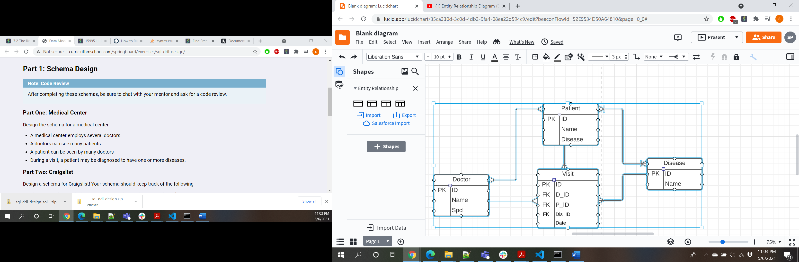

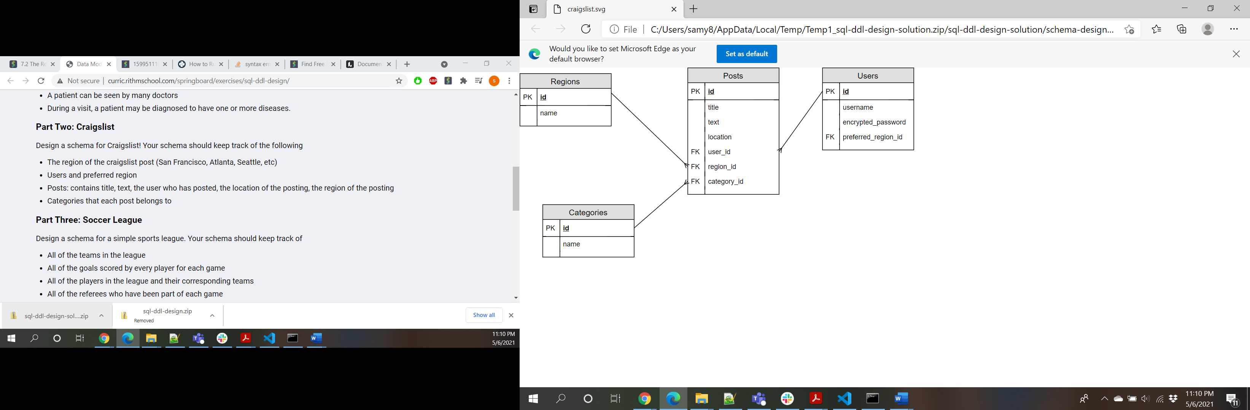

PostGres –

Superuser is postgres

Pwd is home

Also installed pgAdmin(GUI Tool) ..password for this is home

**Please set a master password for pgAdmin.  
This will be used to secure and later unlock saved passwords and other credentials.**

Installation Directory: C:\Program Files\PostgreSQL\13

Server Installation Directory: C:\Program Files\PostgreSQL\13

Data Directory: C:\Program Files\PostgreSQL\13\data

Database Port: 5433

Database Superuser: postgres

Operating System Account: NT AUTHORITY\NetworkService

Database Service: postgresql-x64-13

Command Line Tools Installation Directory: C:\Program Files\PostgreSQL\13

pgAdmin4 Installation Directory: C:\Program Files\PostgreSQL\13\pgAdmin 4

Stack Builder Installation Directory: C:\Program Files\PostgreSQL\13