On emotion detection

Samantha LAI

December 12, 2025

Abstract
This paper classifies short text into six emotions: sadness, joy, love, anger, fear, or surprise, addressing the limitations of coarse sentiment analysis for applications like mental health monitoring and empathetic chatbots. Using the dair-ai/emotion dataset, we establish a baseline with an SVM classifier and Bag-of-Words features. Improvements are made via error analysis and parameter tuning to resolve inter-class confusion. The work provides a richer, more actionable understanding of user intent beyond simple polarity.

1 Introduction
The pervasive nature of online platforms has transformed digital text into the primary vehicle for human interaction and expression. Within this vast stream of digital conversation from social media posts and product reviews to direct messages with conversational agents, understanding the underlying emotional state of the writer is a critical task. This insight is essential for various high-value applications, including mental health monitoring, customer relationship management, and the development of empathetic chatbots. Humans inherently use language to convey emotion, but accurately and automatically discerning this tone from informal, short-form text remains a complex challenge for computational systems.
Traditional Natural Language Processing (NLP) often focuses on tasks like topic modeling or basic sentiment analysis (classifying text as merely positive, negative, or neutral). While sentiment analysis is useful, it is a coarse measure that fails to capture the nuanced spectrum of human feeling necessary for sensitive applications. For instance, a "negative" message could indicate sadness or anger. This work uses machine learning to perform fine-grained emotion classification, predicting the emotional tone of a message into one of six distinct categories: sadness, joy, love, anger, fear, or surprise.
Previous papers have discussed whole-document topic modeling. This work uses machine learning to predict emotion given short, informal text from social media, leveraging the dair-ai/emotion dataset. Understanding the feasibility and accuracy of this prediction holds profound implications for NLP researchers. For technology platforms, emotion classification provides a deeper, actionable understanding of user state moving beyond generic negativity to identify specific emotional distress. This paper establishes a robust baseline using Bag-of-Words (BoW) features (for example unigrams and bigrams) and a Support Vector Machine (SVM) classifier.
This research also gives a better understanding of how well classical machine learning models can distinguish between subtle, semantically similar emotions (e.g., joy vs. love) through rigorous error analysis and subsequent parameter tuning of the feature engineering process, such as n-gram ranges. This paper provides an understanding of how well an automated system could reconstruct the final emotional intent from a user's text, thereby enhancing the intelligence and empathy of computational systems.

The rest of this paper is organized as follows. Background and related work are covered in Section 2. Section 3 outlines the dair-ai/emotion Dataset used in this study. The methodology for machine learning analysis, including the baseline model, is outlined in Section 4. There follows a detailed discussion of the analysis, including error analysis and optimization strategies, culminating in the final results being presented in Section 7. The paper concludes with a discussion of the findings in Section 8.

2 Related Work
Text-Based Emotion Detection (TBED) can be viewed as a specialized, more fine-grained extension of the long-studied field of Sentiment Analysis (SA) (Acheampong et al., 2020). Early work in SA typically focused on polarity classification categorizing text as positive, negative, or neutral (Acheampong et al., 2020). This coarse-grained approach often fails to capture the nuanced emotional states required by applied systems, such as differentiating a customer's anger from their disappointment in product reviews (Rafi, 2024). TBED addresses this limitation by classifying text into discrete emotional states, typically grounded in established psychological models such as Ekman’s six basic emotions: anger, fear, joy, sadness, surprise, and disgust (Acheampong et al., 2020).
Subsequent research in both SA and TBED has increasingly adopted learning-based approaches (Acheampong et al., 2020). This work follows studies that employ classical machine learning methods to establish performance baselines (Acheampong et al., 2020). In particular, the Support Vector Machine (SVM) classifier is a well-established choice for text classification and has demonstrated strong performance in high-dimensional feature spaces (Acheampong et al., 2020). Our work adopts the standard practice of coupling SVM with a Bag-of-Words (BoW) feature representation, which captures the frequency of unigrams and bigrams (Acheampong et al., 2020). Although modern deep learning models now represent the state of the art in emotion detection, the BoW-SVM combination remains a robust, interpretable, and necessary baseline for comparison (Acheampong et al., 2020).

3 Data Collection
The data used for this study is the dair-ai/emotion dataset, an open-source corpus readily available through the Hugging Face platform. As this is not a novel data collection effort, this section outlines the structure and key characteristics of the pre-existing dataset.

Data Description
The dataset consists of 20,000 English-language messages sourced from Twitter. Each message is labeled with a single emotional category, aligning with the project's goal of fine-grained emotion classification. The dataset is categorically divided into six primary emotions:
- 0 Sadness
- 1 Joy
- 2 Love
- 3 Anger
- 4 Fear
- 5 Surprise

Dataset Structure and Format
The corpus is provided in a Parquet format and is pre-split into the three necessary partitions for machine learning analysis, ensuring standardized evaluation:
Partition | Number of Examples | Purpose
Training Set | 16,000 | Used to train the SVM model.
Validation Set | 2,000 | Used for model tuning and hyperparameter selection.
Test Set | 2,000 | Used for final, unbiased performance evaluation.
This structure ensures that the performance metrics presented in later sections are derived from a test set that was completely unseen during the model training and tuning phases.

4 Procedure Outline
The objective of this paper is to train a classifier that can predict the fine-grained emotional tone of a text message, classifying it into one of six categories. This section outlines that process, from initial data segmentation to final model deployment.
Data preparation and initial feature selection are outlined in Section 5; this details the use of the dair-ai/emotion dataset and the process of selecting and creating features for the traditional machine learning baseline. This section also discusses the division of data into development, train, and test sets. In Section 6, exploratory data analysis is performed on initial training results to gain a fundamental understanding of the classification challenge.
Section 7 will present a baseline performance using a Support Vector Machine (SVM) classifier trained on the training dataset and run on the test dataset. Parametric optimization will be performed in Section 8; this includes a comparison of baseline and optimized performance through tuning of feature representation parameters (e.g., n-gram range) and error analysis. Finally, the optimized model is used to classify instances and provide a final evaluation on the dedicated test set. The results of this final analysis will be presented in Section 9.

5 Data Preparation
The data used for this study is the dair-ai/emotion dataset, consisting of 20,000 English-language Twitter messages. This section details the segmentation of this corpus and the feature engineering required for the initial analysis.

Data Segmentation
Since the dataset is pre-split, we utilize the given partitions for standard machine learning practice: the training set (16,000 instances) is used for model training, the validation set (2,000 instances) is used for hyperparameter tuning and optimization, and the test set (2,000 instances) is reserved for final, unbiased performance evaluation.
Feature Engineering
The next step was to prepare the text data for use in the training model. For the baseline model, I only selected unigrams as the baseline model. This way the model ignores word order, it effectively captures
the presence and frequency of unique emotional keywords.

6 Data Exploration

Initial Algorithm Benchmarking and Model Selection

I performed exploratory data analysis on the emotion classification task, the initial phase involved feature engineering within LightSide.
To establish a performance baseline for this multi-class text classification problem (six distinct emotions), I trained two conventional machine learning algorithms: Naive Bayes (NB) and Sequential Minimal Optimization (SMO), a method for training Support Vector Machines (SVM). Both models were trained and evaluated on the same split of the development dataset. The results, evaluated using Accuracy and the Cohen’s Kappa coefficient, are presented in Table 1.

Results and Initial Model Choice
Algorithm | Accuracy | Kappa (κ)
SVM | 0.8834 | 0.8467
Naïve Bayes | 0.8031 | 0.7383
Table 1: Evaluation Metrics for Initial Model Benchmarking
The SVM classifier demonstrated a substantially better performance, achieving a 17% relative improvement in accuracy and a significantly higher Kappa score compared to the Naïve Bayes model. This suggests that for the initial bag-of-words feature representation, the conditional independence assumption of the SVM model was more effective in distinguishing between the six emotion classes. The significant performance gap led to the decision to proceed with SVM as the baseline algorithm for further experimentation.

Confusion Matrix Analysis
The detailed classification performance of the chosen Naive Bayes model is summarized in the confusion matrix in Table 2. The indices correspond to the emotion labels from the dair-ai/emotion dataset (0: sadness, 1: joy, 2: love, 3: anger, 4: fear, 5: surprise).
Act\Pred | 0 | 1 | 2 | 3 | 4 | 5
0 | 4310 | 104 | 28 | 123 | 87 | 14
1 | 109 | 4917 | 211 | 49 | 47 | 29
2 | 25 | 235 | 1018 | 12 | 11 | 3
3 | 141 | 69 | 13 | 1862 | 69 | 5
4 | 98 | 40 | 21 | 84 | 1618 | 76
5 | 15 | 40 | 5 | 3 | 100 | 409

Table 2: SVM Confusion Matrix (Rows: Actual, Columns: Predicted)
The matrix analysis reveals critical areas of misclassification:

Overall Pattern
Class distribution of dataset is highly imbalanced, with Joy (class 1) being the largest class and Surprise (class 5) drastically underrepresented.
Each class shows a clear concentration of true positives, meaning the model is correctly identifying a substantial number of examples within each category. This indicates the model is learning meaningful emotional distinctions rather than defaulting to a single dominant class.

Class-by-Class Observations

Class 0: Sadness
- Strong number of true positives.
- Main errors spill into anger and joy.
- This suggests sadness is one of the easier classes, but still blends with other negative emotions.

Class 1: Joy
- One of the highest true-positive counts in the matrix.
- Errors mostly go into love and surprise.
- This implies joy is both well-represented and well-learned by the model.

Class 2: Love
- Lower true-positive count compared to sadness and joy.
- Many love examples are predicted as joy.
- Probably a typical pattern because love and joy share similar vocabulary and positive tone.

Class 3: Anger
- Moderate number of true positives.
- Frequent misclassifications into sadness.
- Indicates difficulty separating different negative emotional states.

Class 4: Fear
- True positives present, but not especially strong.
- Common misclassifications into sadness and anger.
- This reflects linguistic overlap in negative-affect expressions.

Class 5: Surprise
- The lowest true-positive count of all classes.
- Often mistaken for joy, fear, or love.
- Likely due to:
  - low representation of surprise in the dataset
  - more subtle or contextual cues needed to detect it

Insights

Positive emotions cluster
Love is frequently predicted as joy.
Surprise also tends to fall into positive categories when misclassified.

Negative emotions overlap
Sadness, anger, and fear often get mixed with one another.

Minority classes show weaker true-positive rates
Love and especially surprise have fewer correct predictions, which often happens when these classes have fewer training examples.

The model shows real learning
Every class has a meaningful number of true positives, which confirms that the classifier is distinguishing emotional categories instead of collapsing everything into the majority class.

The Naïve Bayes confusion matrix further highlighted similar patterns of misclassification but with overall lower true positive counts across all classes, reinforcing the decision to select the SVM model as the preferred baseline.
Act\Pred | 0 | 1 | 2 | 3 | 4 | 5
0 | 4113 | 159 | 110 | 121 | 87 | 76
1 | 206 | 4737 | 212 | 71 | 67 | 69
2 | 143 | 404 | 704 | 22 | 28 | 3
3 | 240 | 81 | 36 | 1695 | 76 | 31
4 | 221 | 87 | 32 | 80 | 1480 | 37
5 | 133 | 153 | 17 | 19 | 130 | 120

• Best Performance: Similar to SVM, Joy (1) has the highest number of correct classifications (4737).
• Worst Performance: Surprise (5) is poorly classified (only 120 correct classifications). Love (2) is also poorly classified (only 704 correct classifications).
• Common Misclassifications (Known Data):
- Sadness (0) is frequently misclassified as Joy (159 instances).
- Joy (1) is most often misclassified as Love (212 instances).
- Anger (3) is often misclassified as Sadness (240 instances)
Overall, the SVM model is the superior classifier for this task, but both models show significant weaknesses in classifying the Surprise and Love, also, in distinguishing between certain high-confusion pairs like Sadness/Joy.

7 Baseline Performance
The baseline performance of the SVM model is 88.34% Accuracy, marked by success in classifying dominant emotions (Sadness, Joy) and difficulty in handling nuanced or less frequent emotions (Love and Surprise) and managing cross-class confusion.
Here are some insights generated from examining some specific unigrams and their feature influence and feature weights.

1. Strong Semantic Predictors (Explaining Correctness)
These insights highlight features that the model successfully learned, contributing to the high True Positive counts for Sadness (4301) and Joy (4917). The model learned to assign high, correctly-directed weights to unambiguous emotional vocabulary.
- Unigram: 'ungrateful' (contributes to prediction of Class:Sadness)
  - Feature Weight: 2.403 (Positive weight for predicted Sadness)
  - Feature Influence: 2.98 (high feature influence for predicted Sadness)
  - Insight: The word has the highest positive Feature Weight for the predicted class sadness, confirming the model effectively learned the strong semantic link between this word and the Sadness emotion. Upon inspection of the horizontal and vertical difference matrix also reveals the unigram as helpful and non-problematic to the model. Even slightly helps with reducing the misclassification of sadness as surprise.

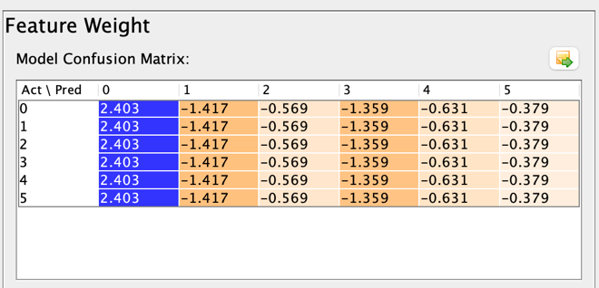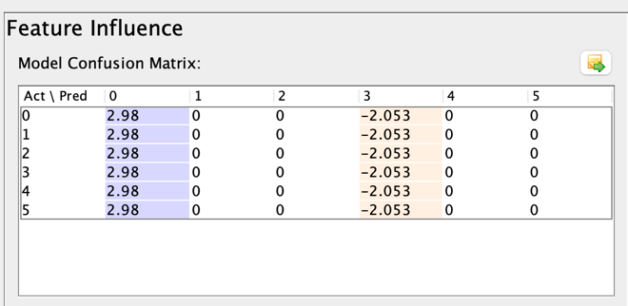
Feature wight and influence screenshot for “ungrateful”
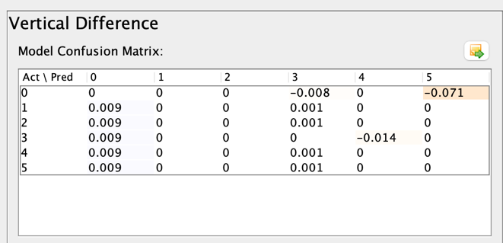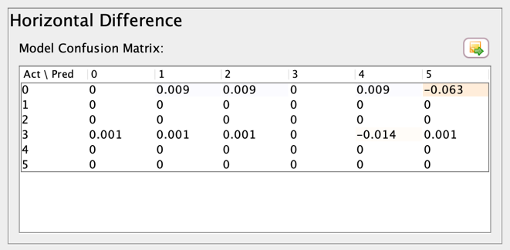
Vertical and horizontal difference screenshot for “ungrateful”
- Unigram: 'loved' (contributes to prediction of Love Class)
  - Feature Weight: 1.627 (Positive weight for predicting Love)
  - Feature Influence: 10.418 (high feature influence for predicting Love)
  - Insight: The obvious unigram “loved” serves as an interesting baseline for how strongly the model assesses strong indicators of classification success. Notably the feature influence of 10.418 is a very high number.
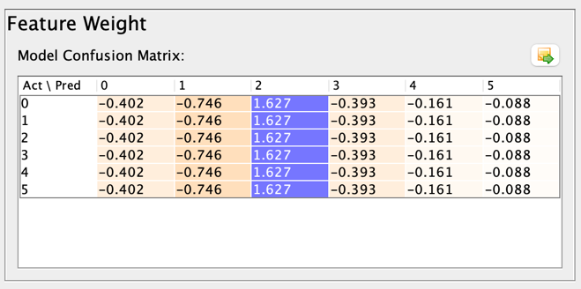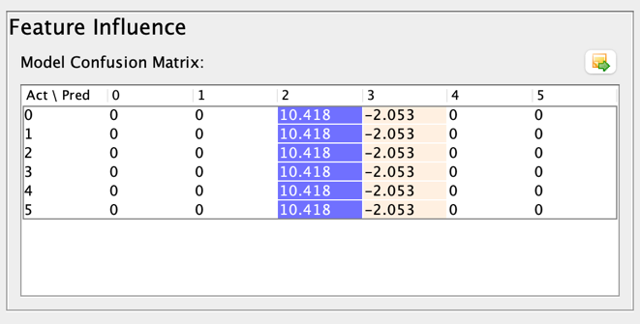
Feature weight and influence screenshot for “wedding”
- Unigram: 'passionate' (contributes to prediction of Love Class)
  - Feature Weight for (Love/2): 1.424 (Positive)
  - Feature influence (Love/2): 10.418 (Positive)
  - Insight: Once again feature influence of predicted class Love is very strong.
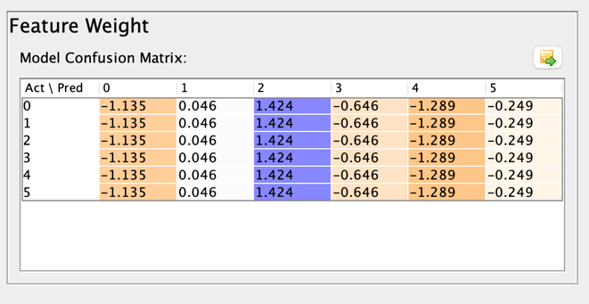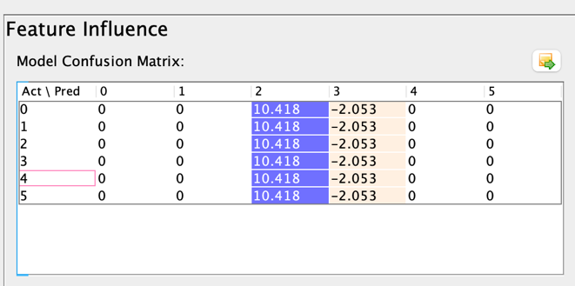
Feature influence and feature weight screenshot for “passionate”
- Unigram: 'until' (Confusing Unigram)
  - Feature Weight for (Surprise/5): 0.273 (Positive) and (Fear/4): 0.234
  - Feature Influence (Fear/4): 2.876 (Positive)
  - Insight: The weight for the class Surprise/5 0.207 is relatively strong compared to the feature weight of 0.066 for class Fear/4. But feature influence of predicted class Surprise/5 is 0 while it is 2.2 for Fear/4. This indicates a level of confusion. Furthermore, there are very few unigrams which serve as an indicator for the emotion surprise. Perhaps this is indicative of why the model performed poorly in classifying the surprise class.

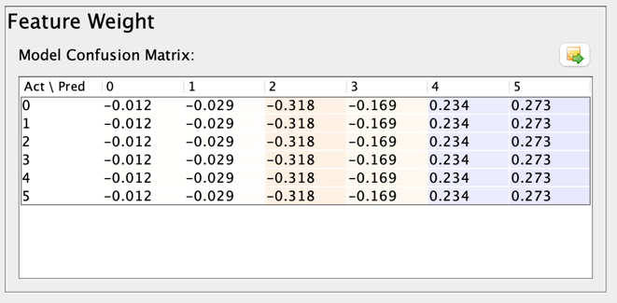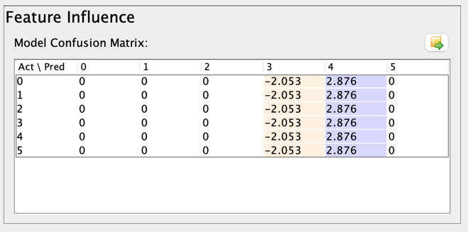
Feature influence and feature weight screenshot for “until”
In preparation of optimizing the SVM Model, these insights clearly indicate the limitation of building a sentiment classification model using only unigrams. While the baseline model performs relatively well with classifying strong positive and negative emotions such as joy and sadness, unigrams struggle to classify emotions that require more context to be defined; love, surprise. Hence this insight is important for further feature engineering and optimizing the model.

8 Optimization
To optimize the training model, I expanded the feature list to include the following features in Lightside. 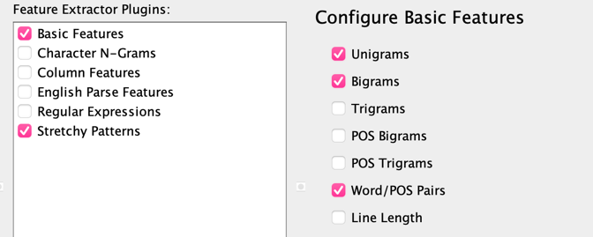
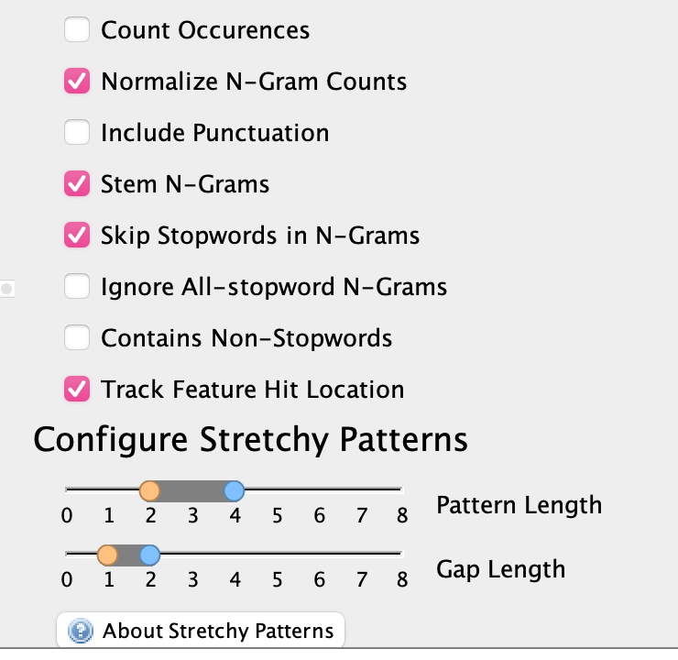
Screenshot of features included for optimized model
By expanding the features from only unigrams to bigrams, POS pairs and stretchy patterns the performance of the model improved significantly. 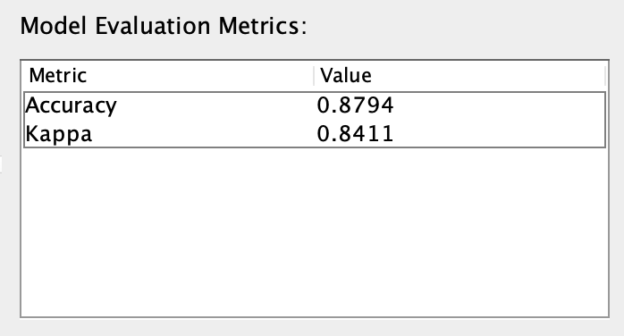
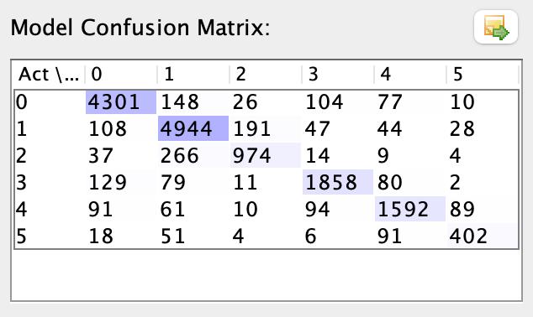
Screenshot of performance for optimized model
Using the compare models tab on Lightside it shows the baseline model was an insignificant improvement. Including bigrams reduced the model’s performance slightly.

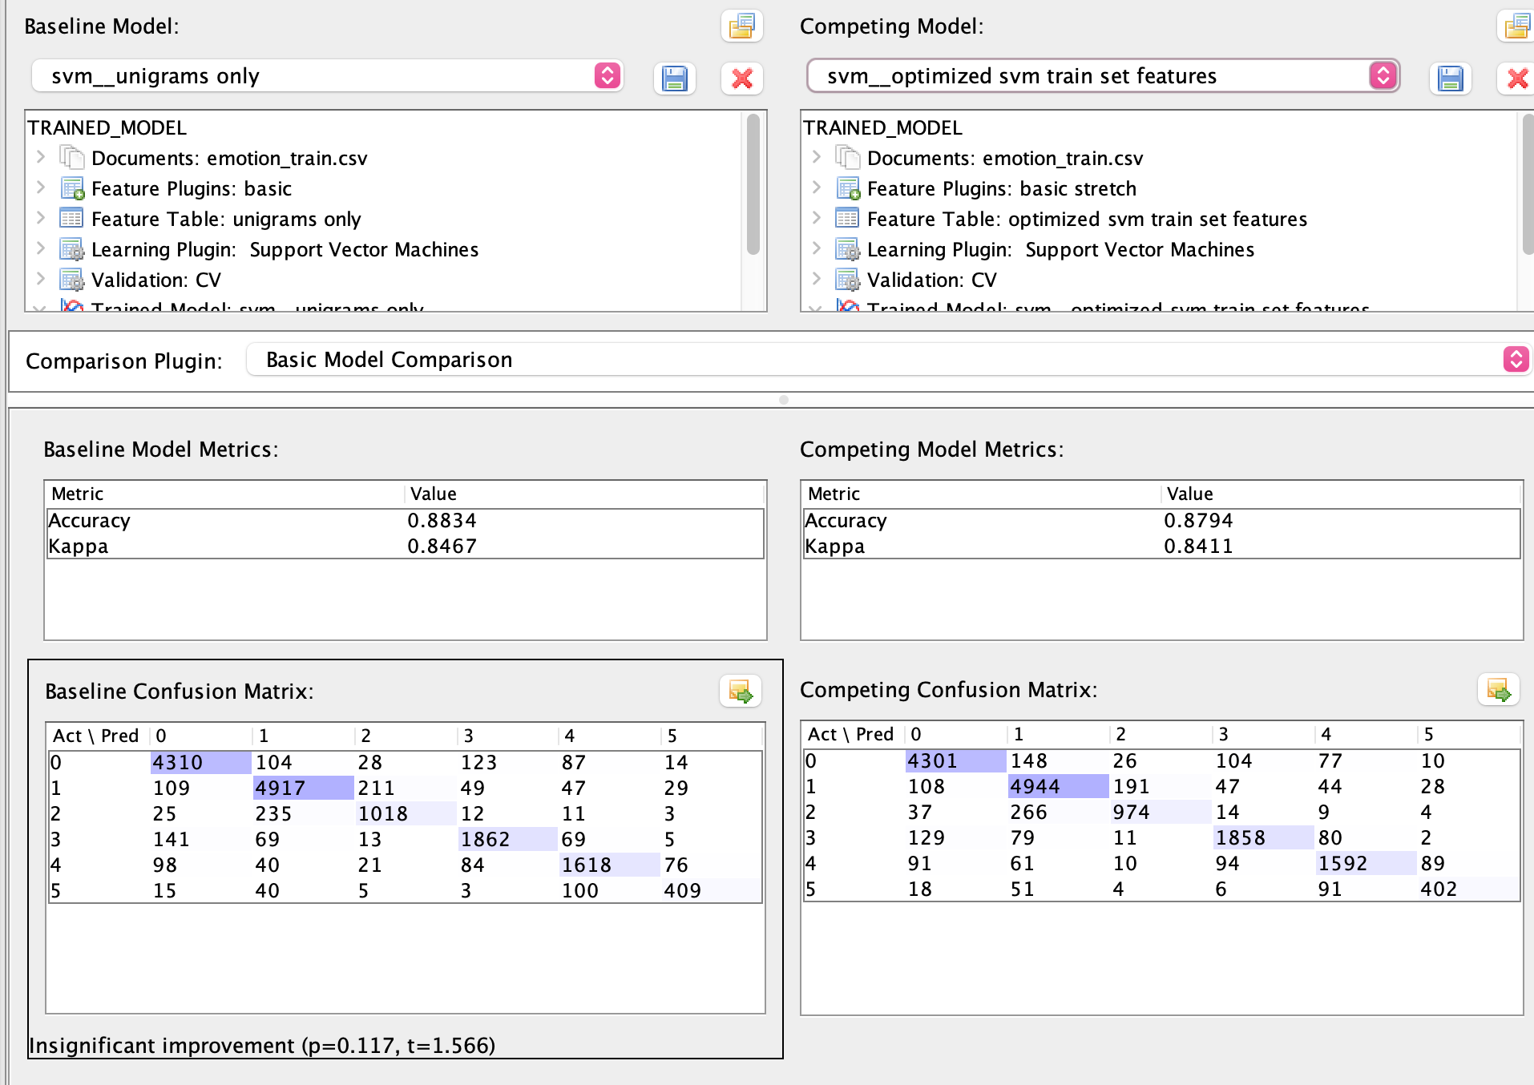
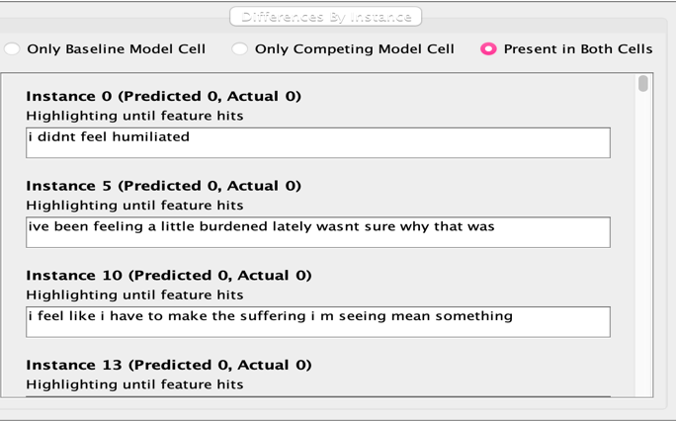
Looking at the individual instances that were correctly classified in both models the results are largely identical.
Upon closer inspection of the updated features, the bigrams, stretchy pattern features delivered mediocre results. Here’s an example of such features.
- Feature: all_night

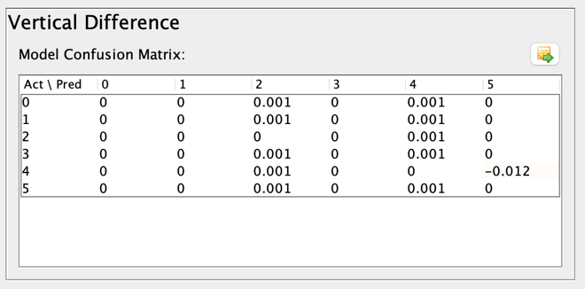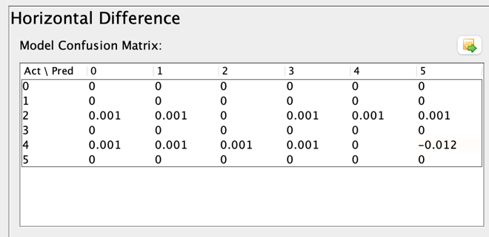
Screenshot of vertical/horizontal for feature: all_night
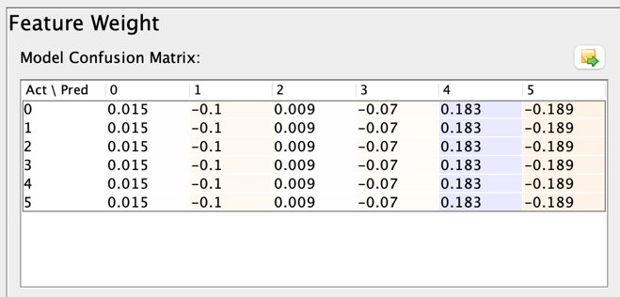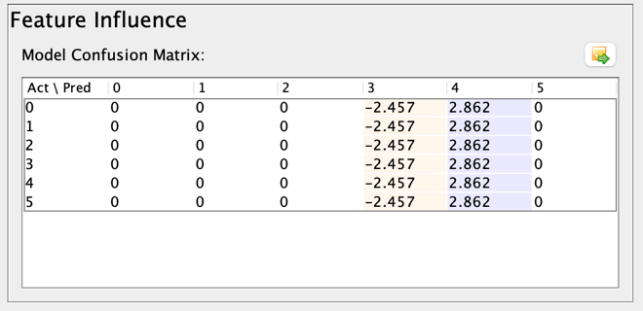

Screenshot of feature weight/influence for feature: all_night
This feature shows influence and weight on predicting the fear class; but upon closer inspection of the horizontal and vertical difference, the improvement is largely negligible.
Furthermore, after checking a lot of the newly added bigram features, many of the newly added features had no effect on the model at all.
Following my approach of adding more features to the baseline model, I used the cross validation set and built a SVM model using the newly added features and here are the results. 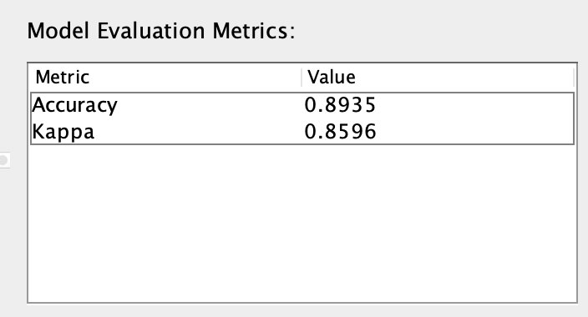
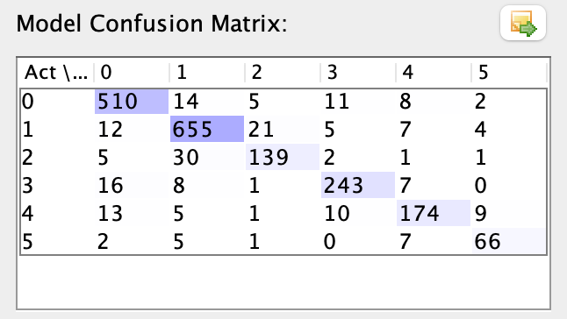

screenshot of performance for cross-validation model using unigrams and bigrams as features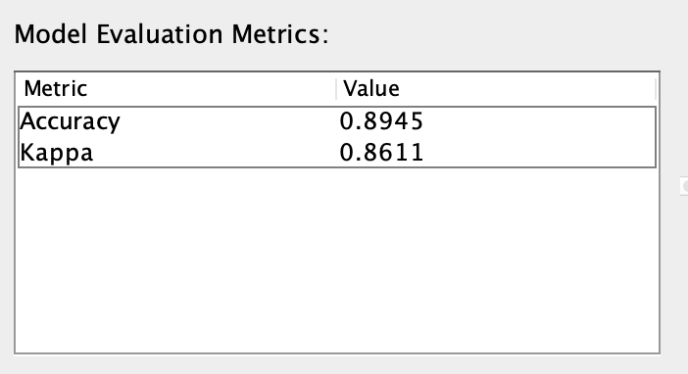
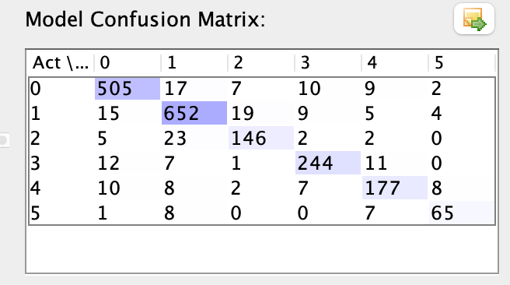
screenshot of performance for cross-validation model using only unigrams as features
Accuracy and Kappa both fared better in the validation set than the training set indicating that the model did not overfit. However, my feature engineering attempts were not successful in improving model performance, next up I will try parameters tuning in order to optimize the model.
In order to tune parameters on the SVM model I had to move my process over to WEKA. I repeated the preprocessing of the data by using the StringtoWordVector filter in WEKA for the text and the NumerictoNominal filter for the labels. Then I built the following baseline model using the 16,000 instances training set.
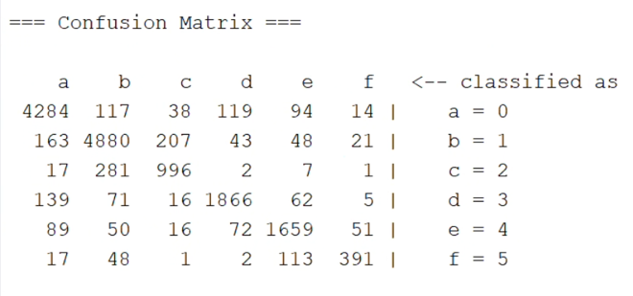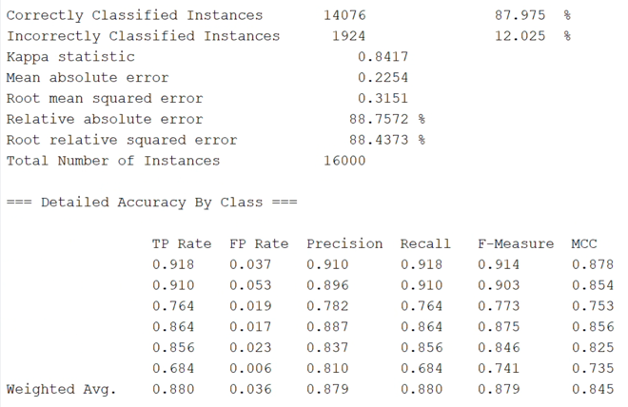Screenshot of WEKA SVM model(C=1.0) with only unigram features.
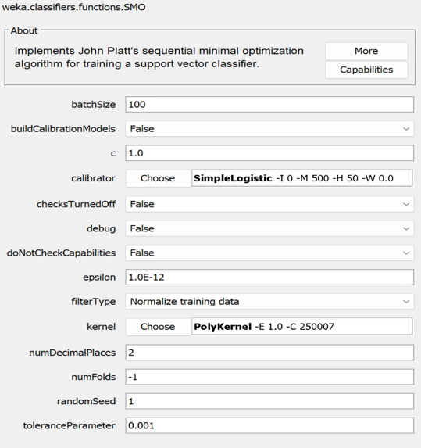
The WEKA SVM model (trained with the training set of 16,000 instances CV: 10 folds) performed similarly to the Lightside SVM model with 87.975% accuracy and 84.17% kappa. Similarly, with the Lightside results class 5: Surprise and class 2: Love are the weakest classes. Now, to see if parameter tuning would successfully optimize model performance; first, here are the baseline settings of the SMO algorithm in Weka.
screenshot of weka’s smo algorithm parameter settings
For parameter tunning, I decided to tune the complexity parameter (C). The preset was at 1.0, for the first iteration I changed it to 10.

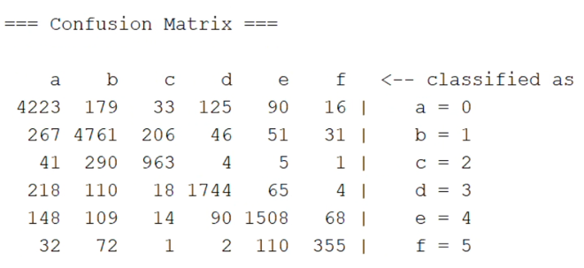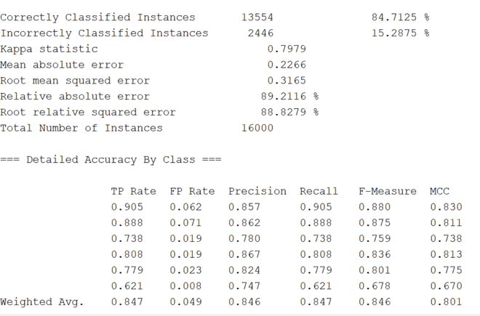
Screenshot of WEKA SVM model (C=10) with only unigram features.
Tuning C to 10 didn’t increase model performance. So, I proceeded to tune it towards the other direction, by tuning C to 0.1. This time model performance improved to 88.3312% accuracy and 84.51% kappa.
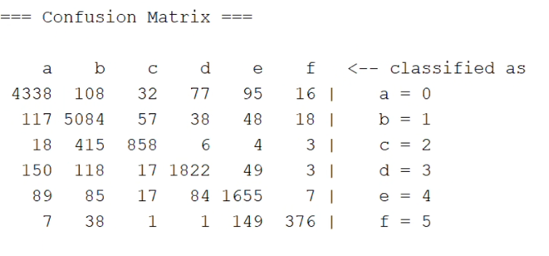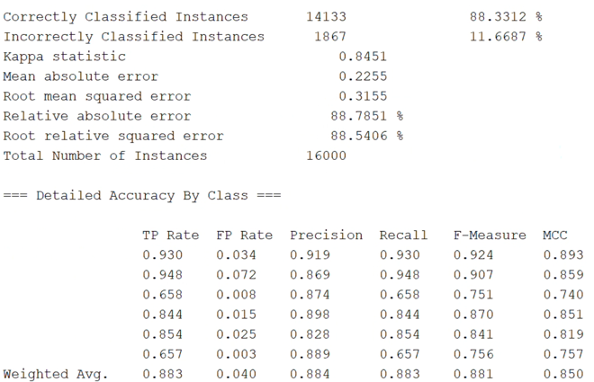

In SVM models, the complexity parameter C determines how strongly the model penalizes misclassified training examples and therefore directly influences the shape and flexibility of the decision boundary.
When C is large (e.g., C = 10), the model places a high penalty on misclassification. In high-dimensional text classification tasks with sparse unigram features, this often leads the model to fit noise or idiosyncratic word usage that does not generalize well, increasing the risk of overfitting and explaining why increasing C slightly degraded performance in cross-validation.
In contrast, when C is small (e.g., C = 0.1), the model allows some training errors in exchange for a wider, smoother margin. This softer constraint prevents individual noisy or ambiguous examples from exerting excessive influence on the decision boundary, the model achieves better generalization, which is reflected in the improved cross-validation and test accuracy observed at C = 0.1.

9 Final Result
For the final result,I used the 2000 instances test data set and used the optimized WEKA SVM model (C=0.1) and here are the results.
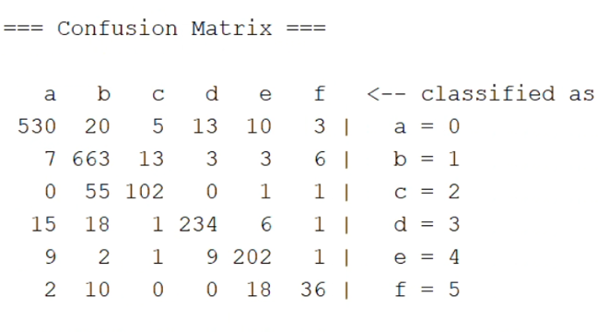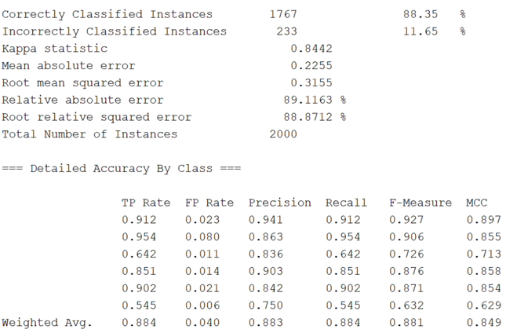
The model did very well on the test dataset, achieving a 88.35% accuracy and 84.42% kappa.

10 Discussion
The fact that the test accuracy (88.35%) is nearly identical to the cross-validation accuracy (88.33%) is a strong indicator of the model’s reliability and robustness.
First, this close alignment suggests minimal overfitting. Overfitting typically manifests as strong performance on training or cross-validation data followed by a noticeable drop on unseen test data. In this case, the optimized SVM model maintains virtually the same level of performance when evaluated on a fully held-out test set. This indicates that the classifier has not memorized idiosyncrasies of the training folds but has instead learned generalizable patterns in the emotion-related language.
Second, the results demonstrate stable generalization across datasets. The consistency between cross-validation and test performance implies that the statistical properties of the training and test sets are well matched and that the learned decision boundaries are robust to new samples drawn from the same distribution. This is particularly important for text classification tasks, where high-dimensional sparse feature spaces often lead to unstable models if regularization is insufficient.
Third, the alignment confirms successful parameter tuning. The selection of a lower complexity parameter (C = 0.1) improved performance during cross-validation and translated directly to improved test performance. For emotion classification, where many words appear across multiple emotion classes, this regularization effect is especially beneficial. By focusing on broader, more stable patterns rather than exact fits to training instances. Overall, the results demonstrate that for sparse, high-dimensional text data, stronger regularization via a lower C value can lead to more robust and generalizable models, even when using relatively simple unigram features.
Finally, this consistency strengthens the experimental validity of the study. Because performance gains observed during model selection are preserved on an independent test set, the reported improvements can be attributed to meaningful modeling choices rather than chance or data leakage. As a result, the findings provide a credible baseline for future feature engineering or model extensions, such as incorporating higher-order n-grams or alternative weighting schemes.

11 Reflection
Completing this project deepened my understanding of how modeling choices, rather than tools alone, drive performance in text classification. By reproducing preprocessing across LightSide and WEKA, I learned the importance of experimental consistency and how small differences in feature handling can affect results. Parameter tuning, particularly adjusting the SVM complexity parameter, showed how regularization plays a critical role in high-dimensional text data and can improve generalization without adding features. The alignment between cross-validation and test performance reinforced the value of proper evaluation practices and highlighted how reliable conclusions depend on separating model selection from final testing. Overall, the project emphasized careful methodology, error analysis, and interpretability as essential components of building effective NLP models.

References
[1] Rafi, A. H. (2024). Unveiling Customer Sentiments: A Comprehensive Analysis of Product Reviews on Amazon. ResearchGate.
[2] Acheampong, F. A., Wenyu, Z., & Nunoo-Mensah, H. (2020). Text-based emotion detection: Advances, challenges, and opportunities. Engineering Research Express, 2(4).

